
NAME:
Ahmad Raza (53302)
Atia Rahat (57325)
Zain Zaheer(53812)

PROGRAM:
BSSE-6

COURSE:
SPM

PROJECT:
Sales Point

DOCUMENT:
Lab 12

SUBMITTED TO:
Sir Waqar Mehmood

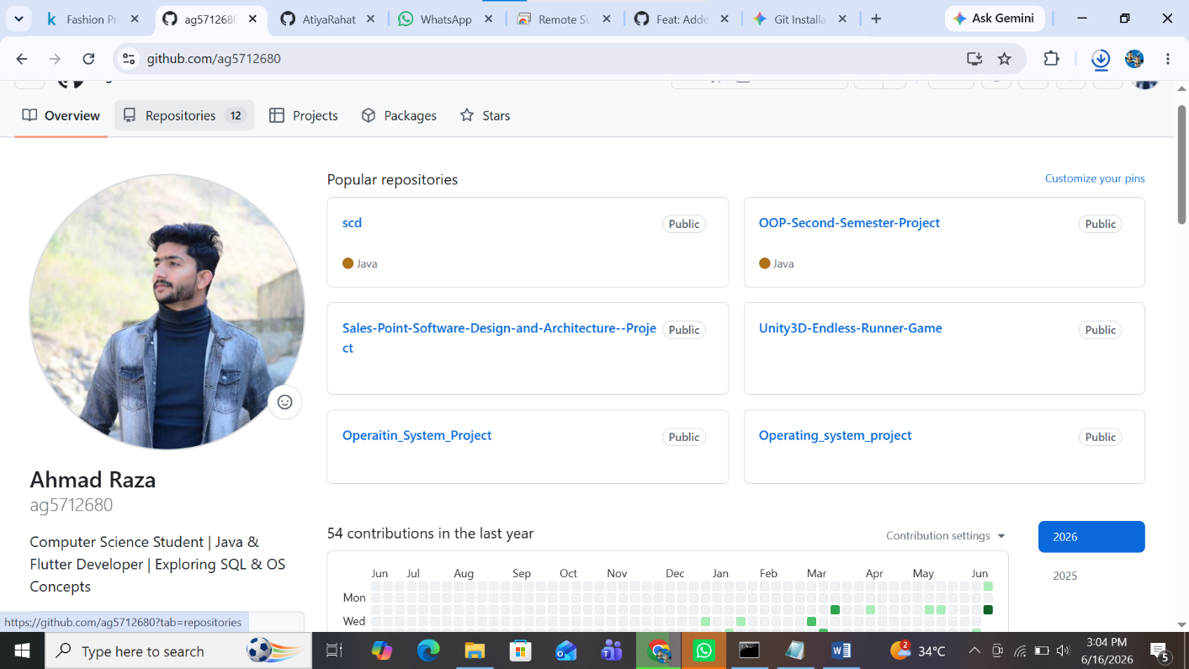
- Repository Setup:
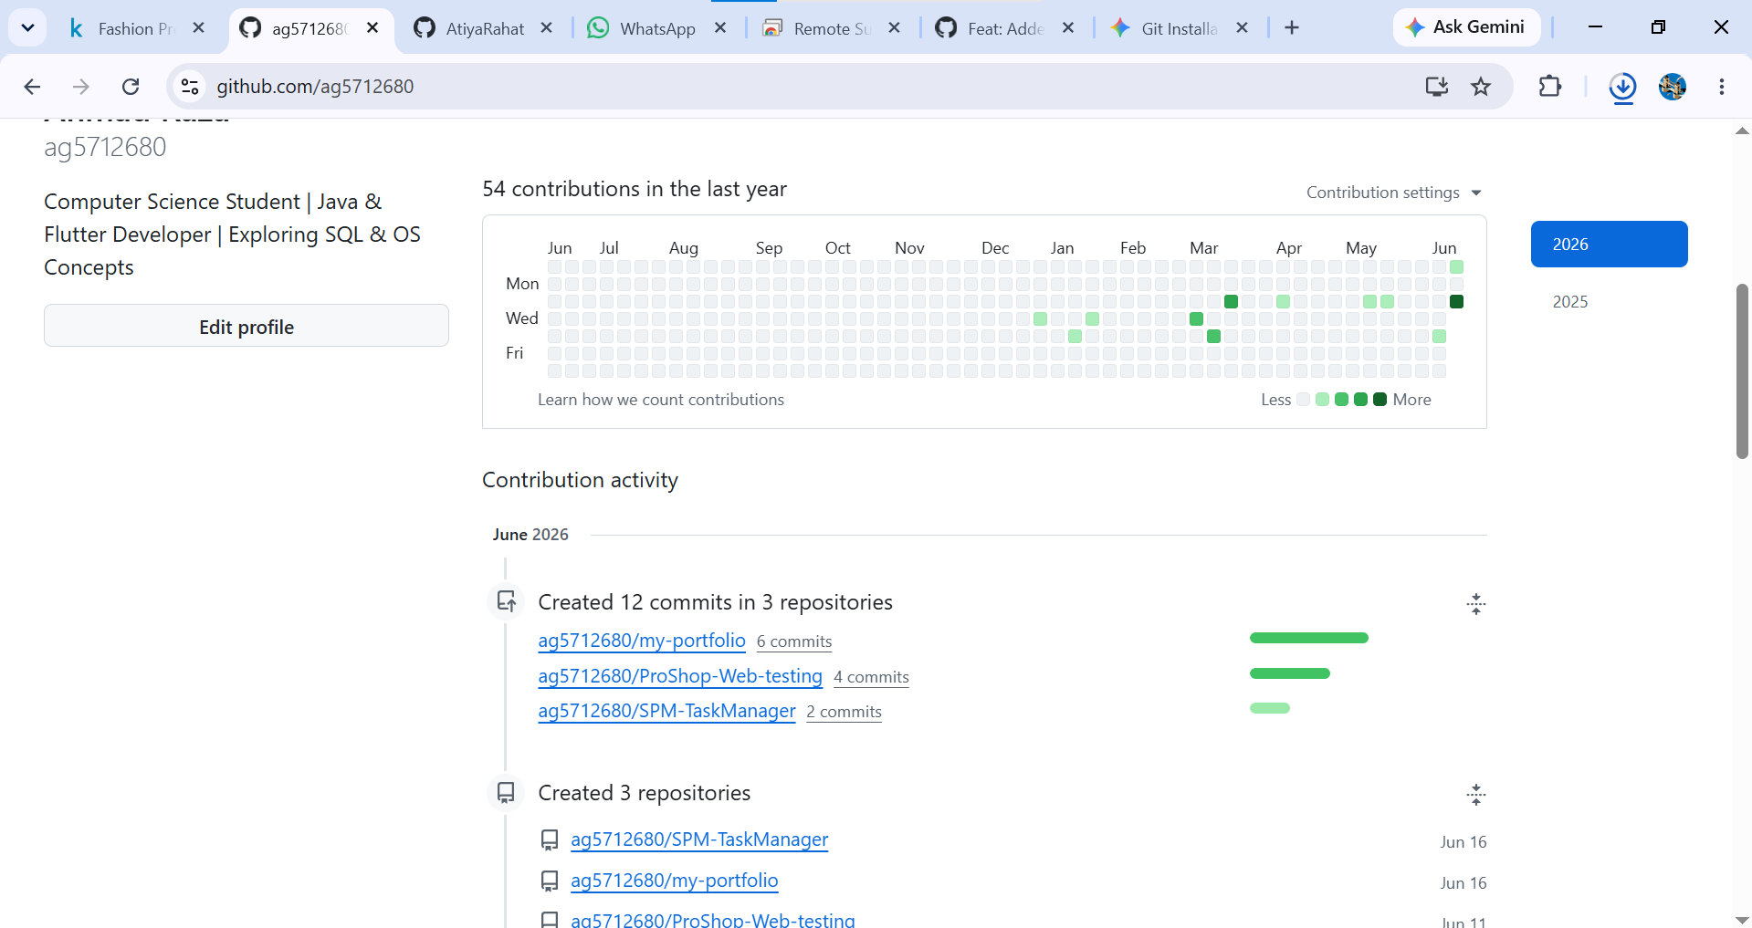

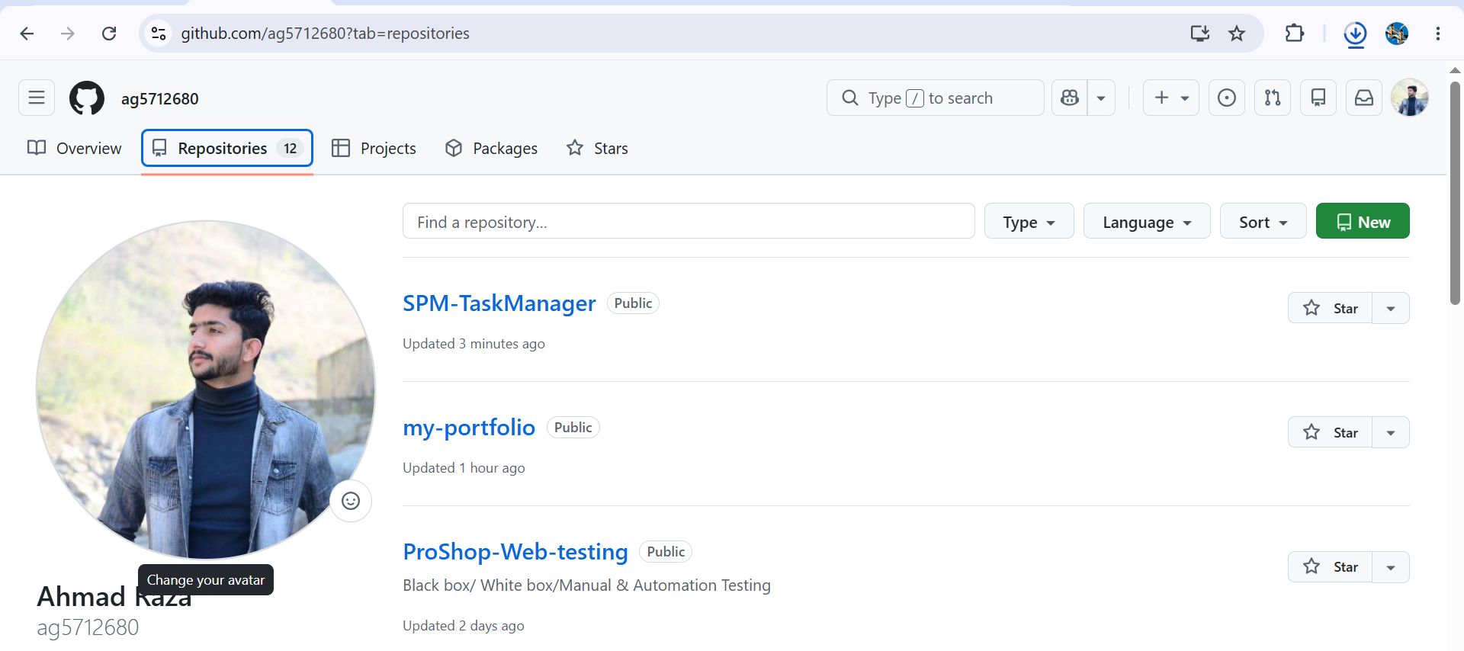
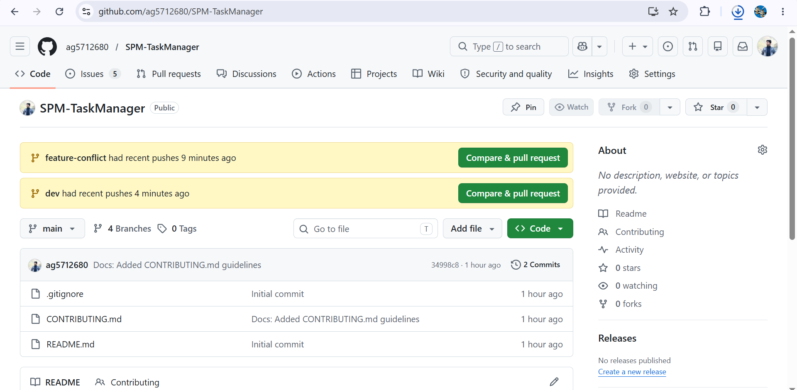
- Branching Strategy:
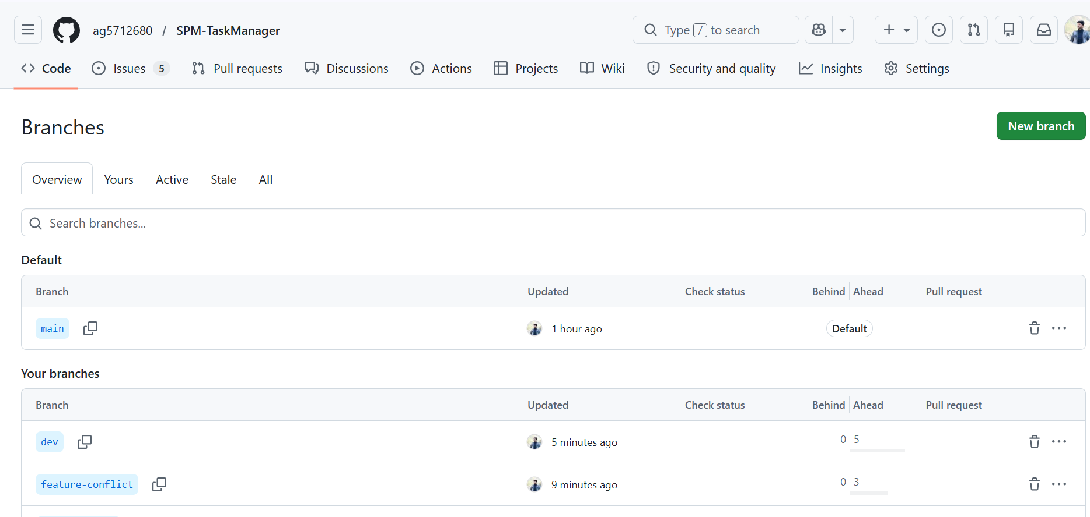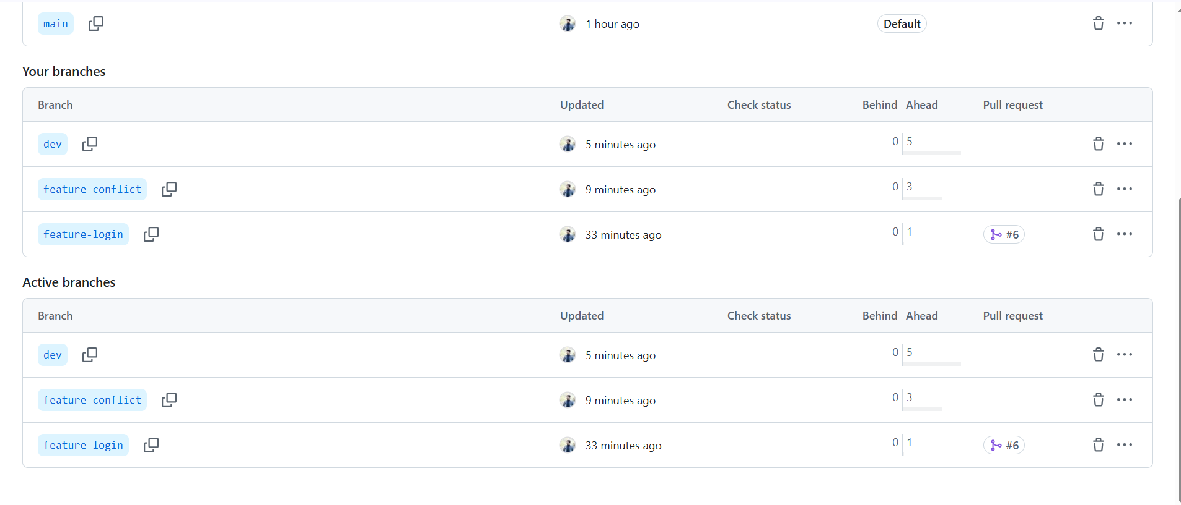

- Issue Tracking (Kanban Board):
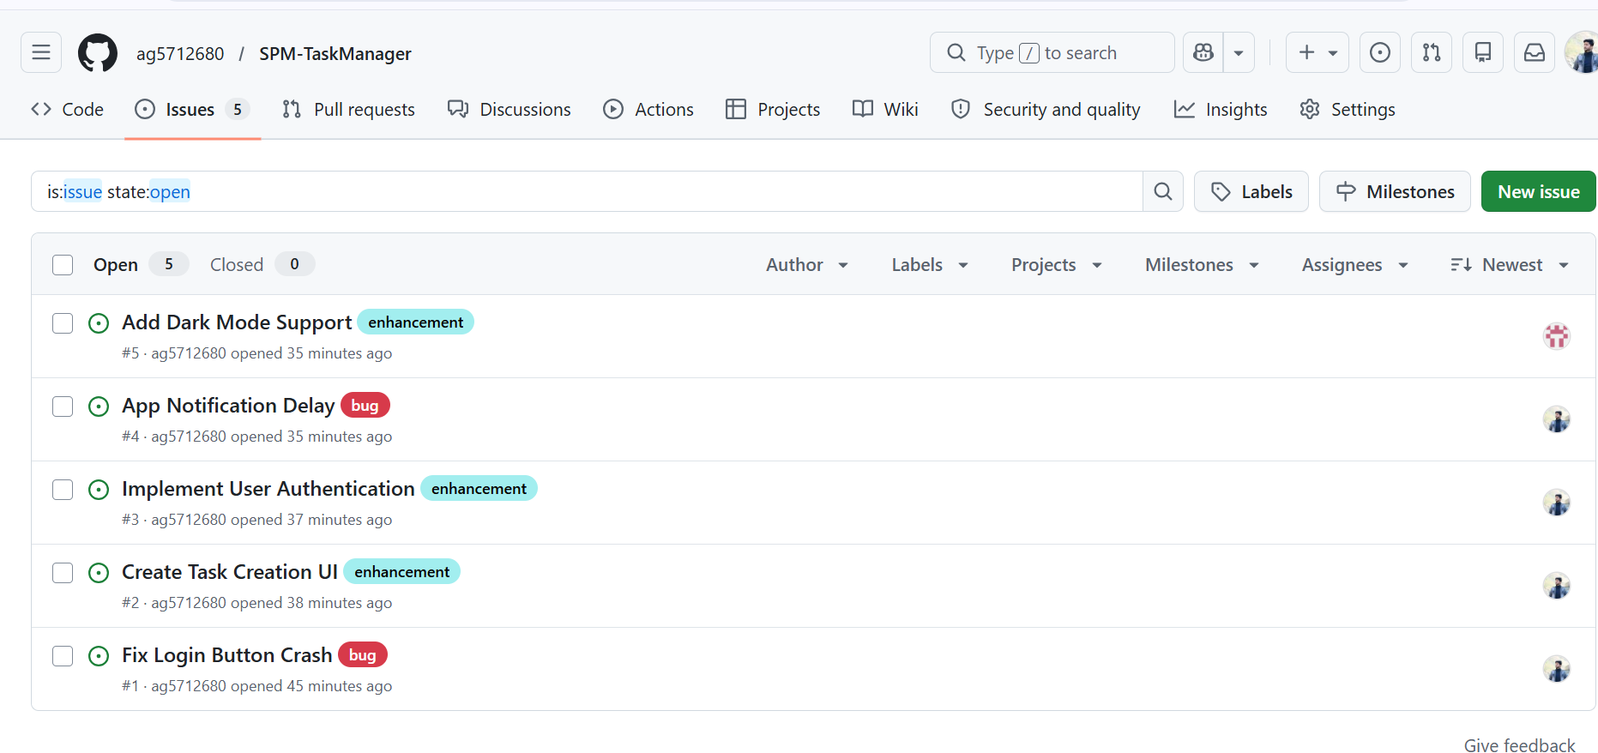
- Pull Request & Code Review (Task 4)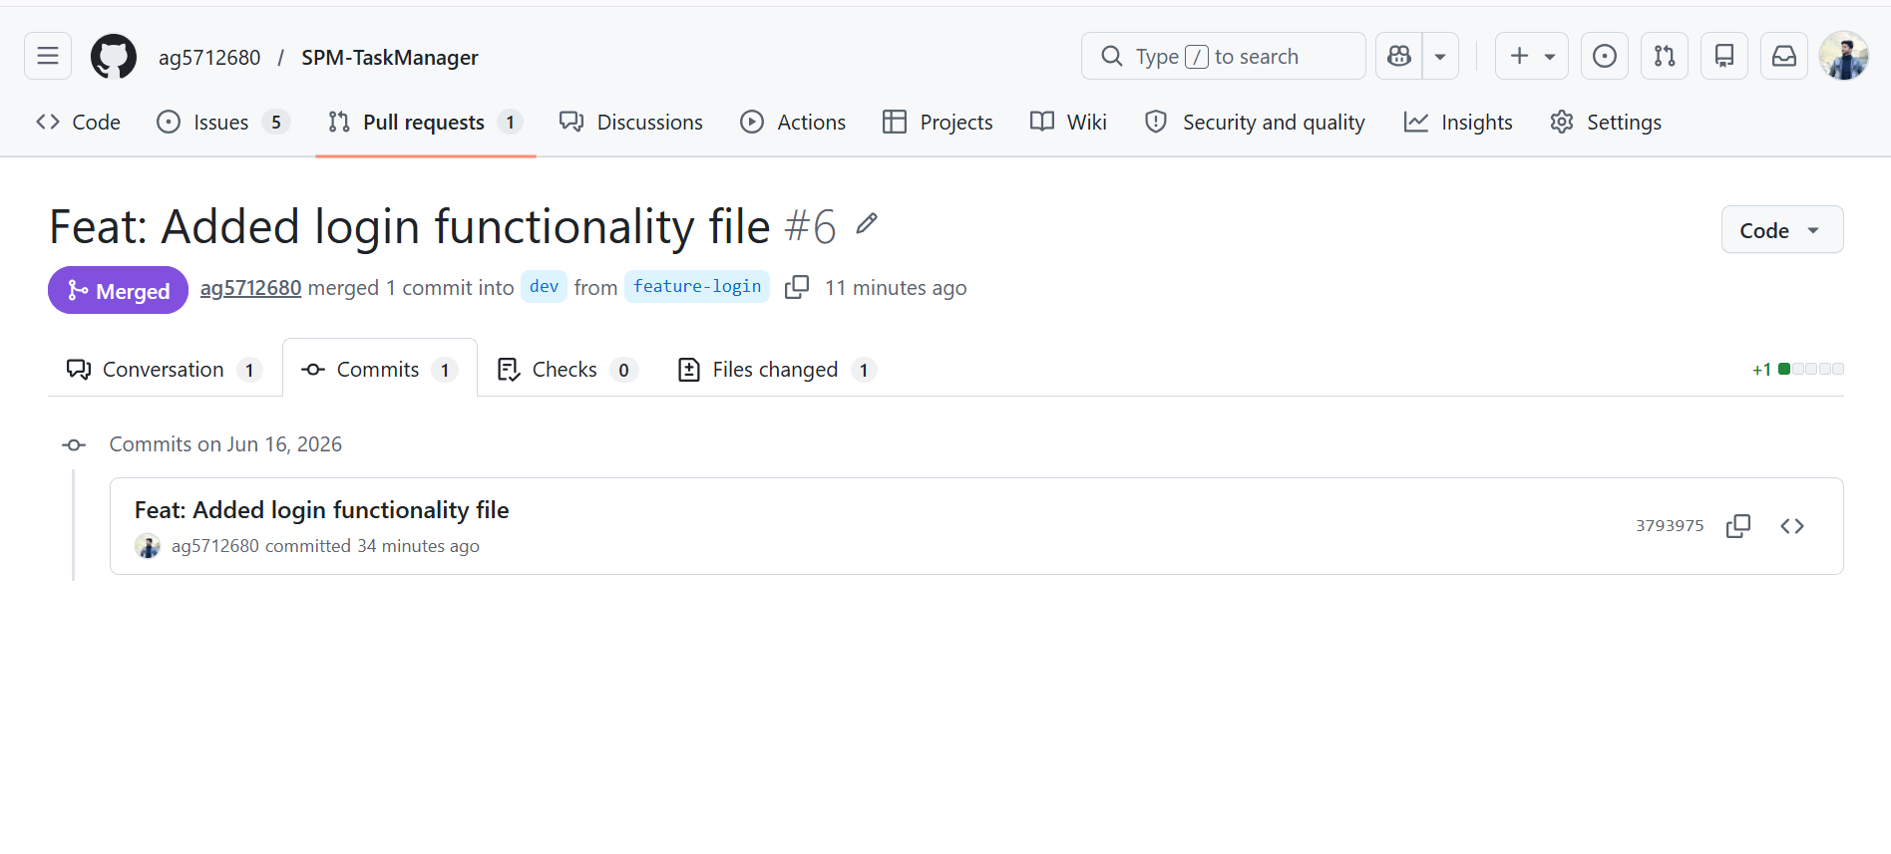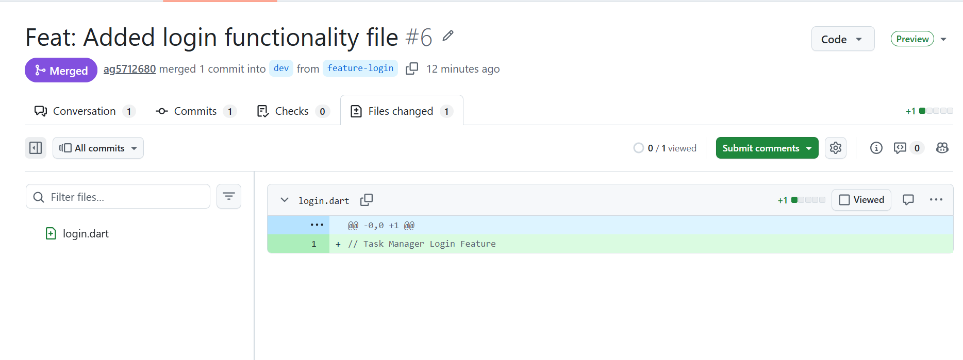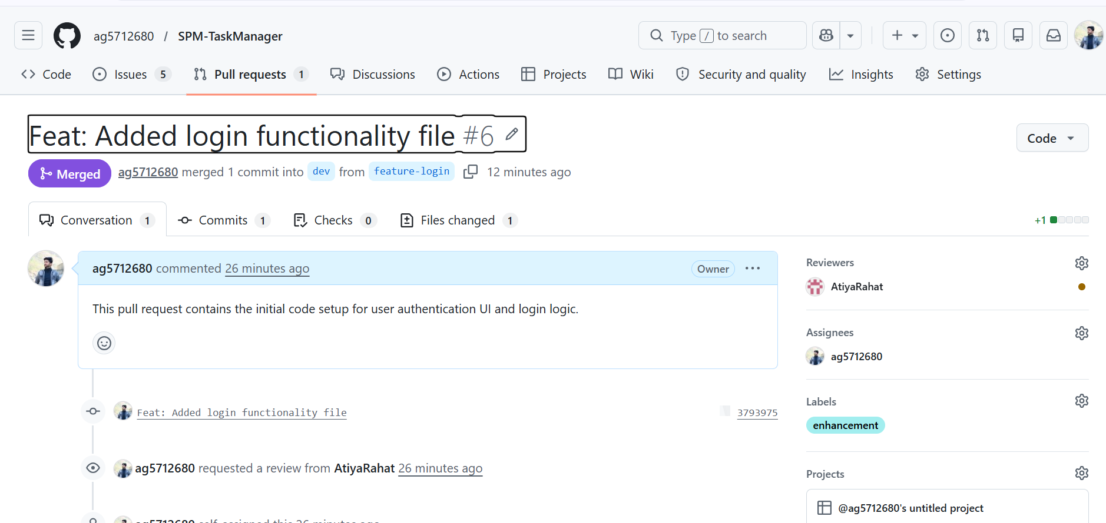

- Merge Conflict Resolution (Task 5):
