
NAME:
Ahmad Raza (53302)
Atia Rahat (57325)
Zain Zaheer(53812)

PROGRAM:
BSSE-6

COURSE:
SPM

PROJECT:
Sales Point

DOCUMENT:
Lab 6

SUBMITTED TO:
Sir Waqar Mehmood

Taigo.io
Add member

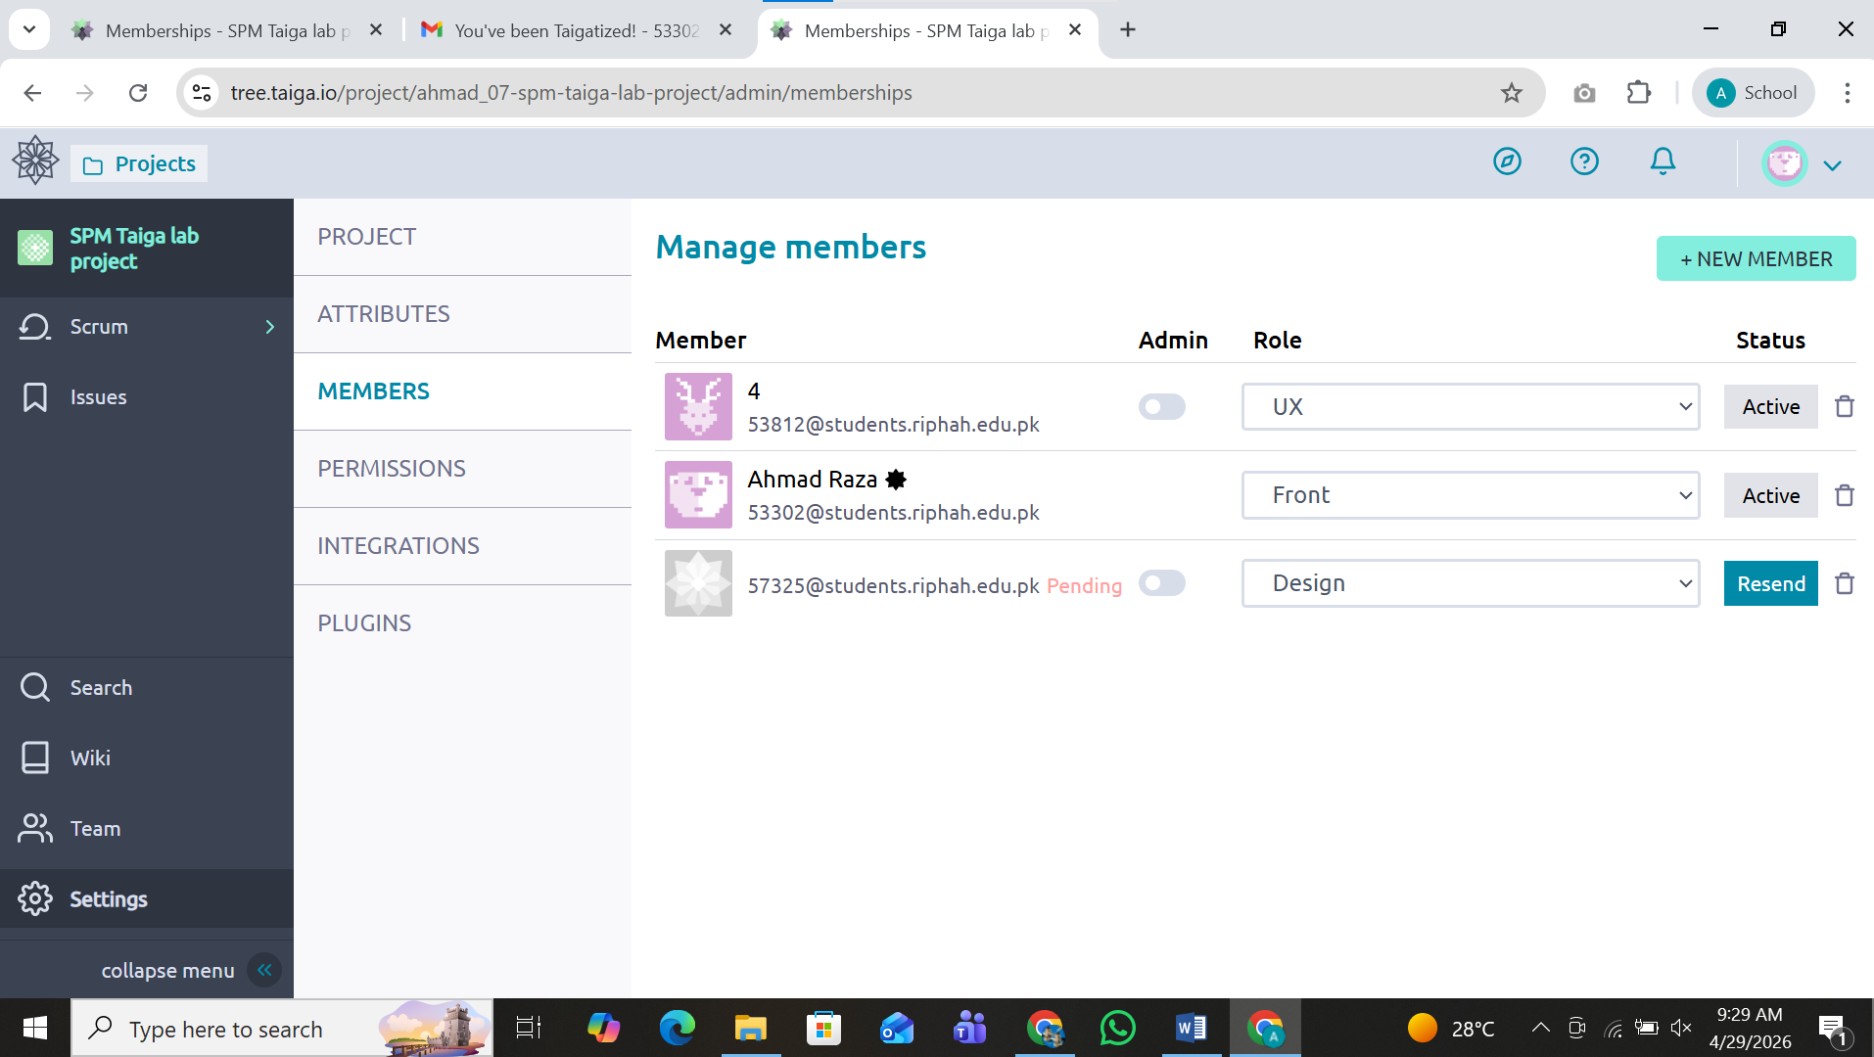

Add backlog

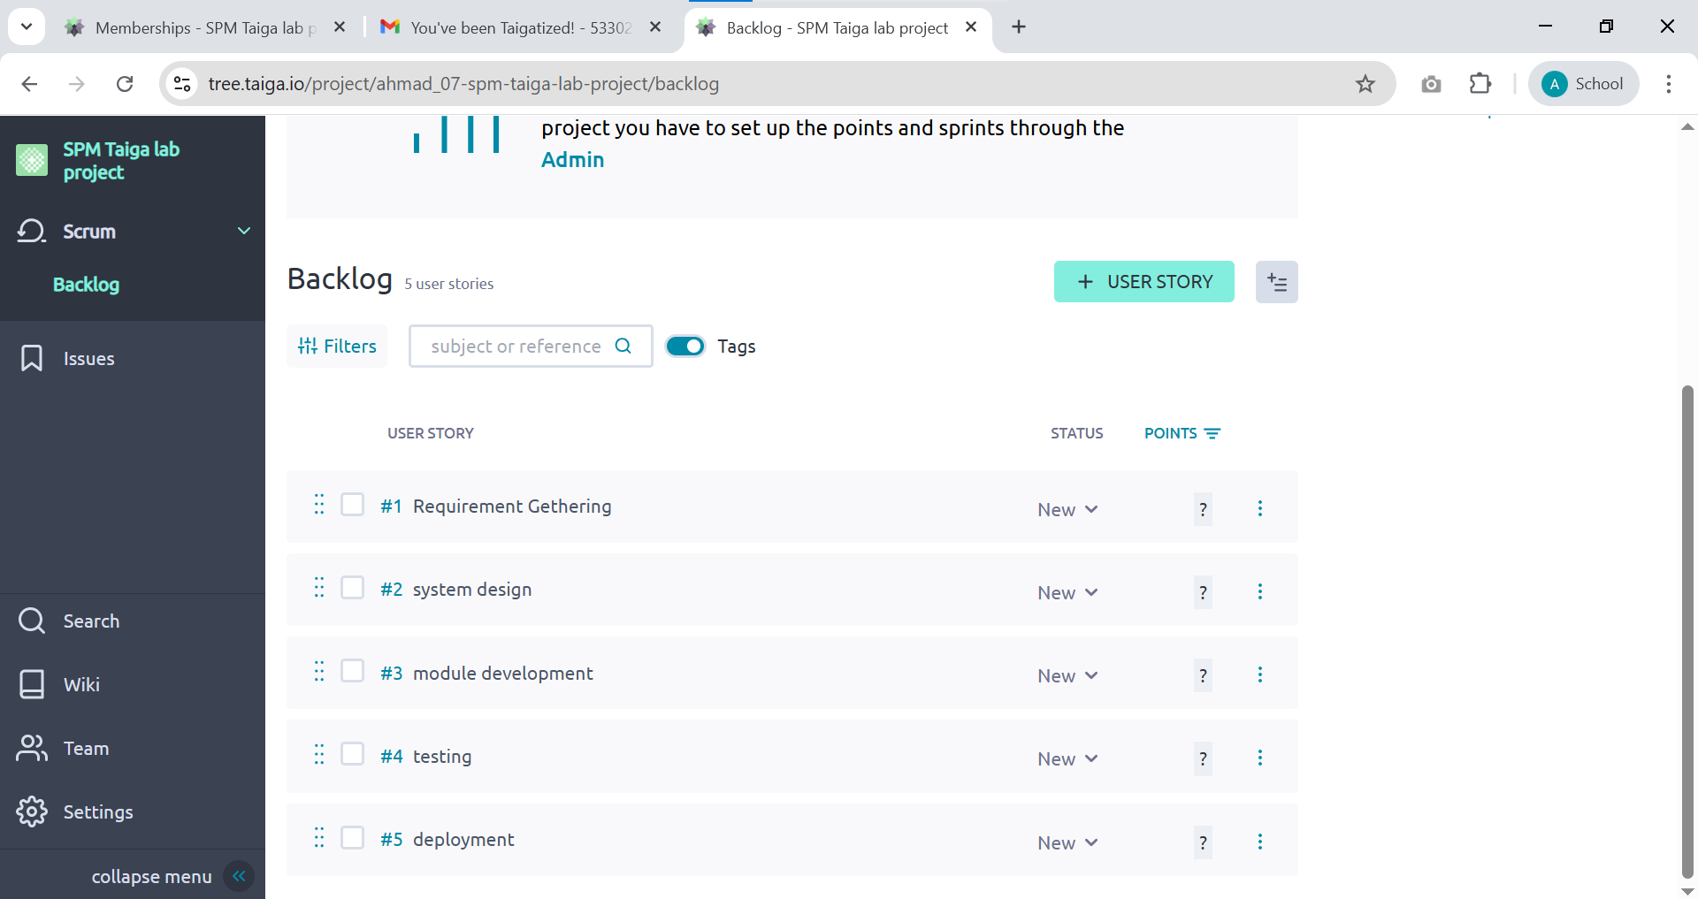

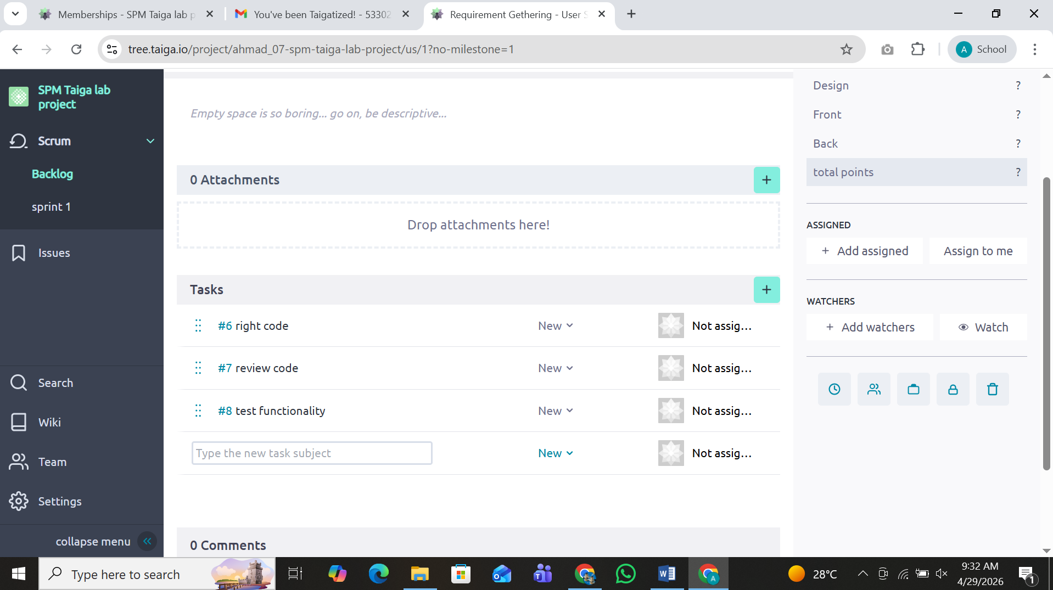

Add Sprint

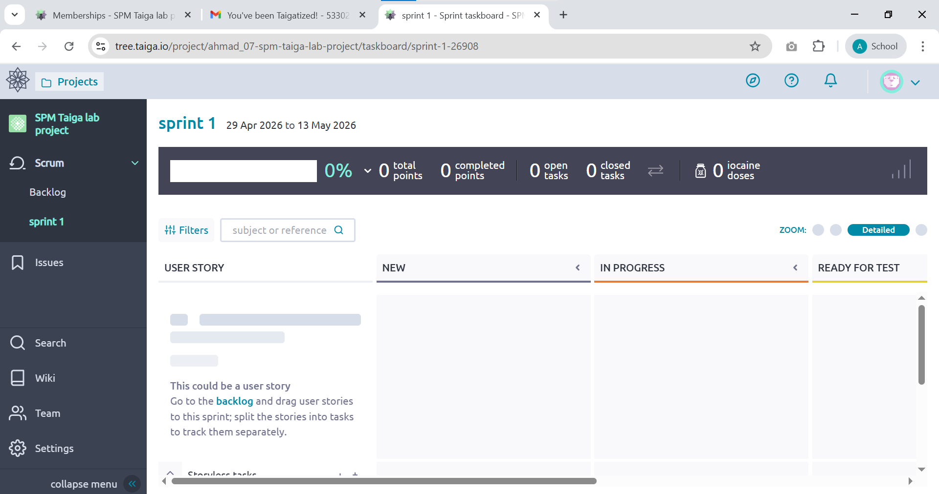

Sprints:

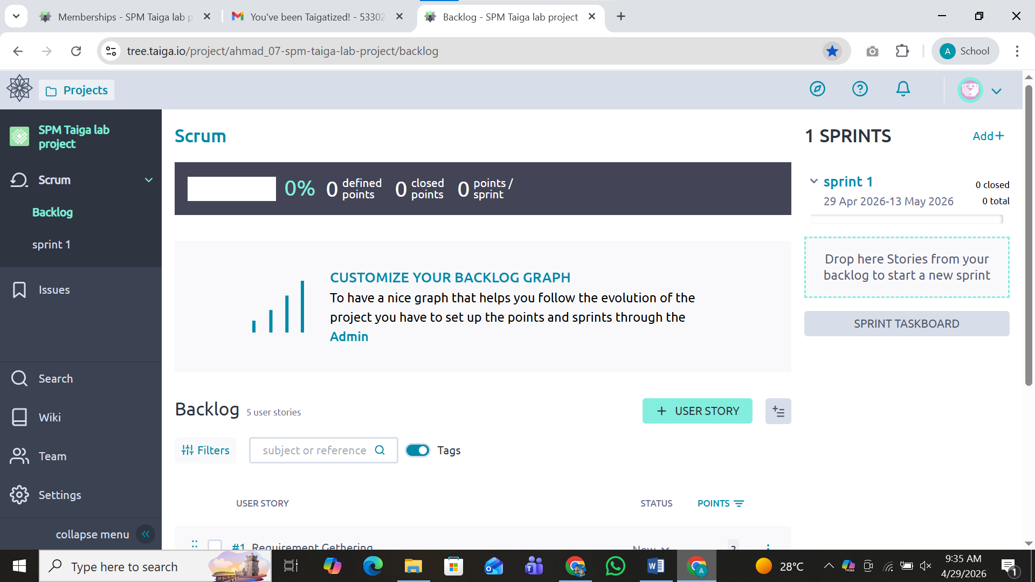

Assign task to members :

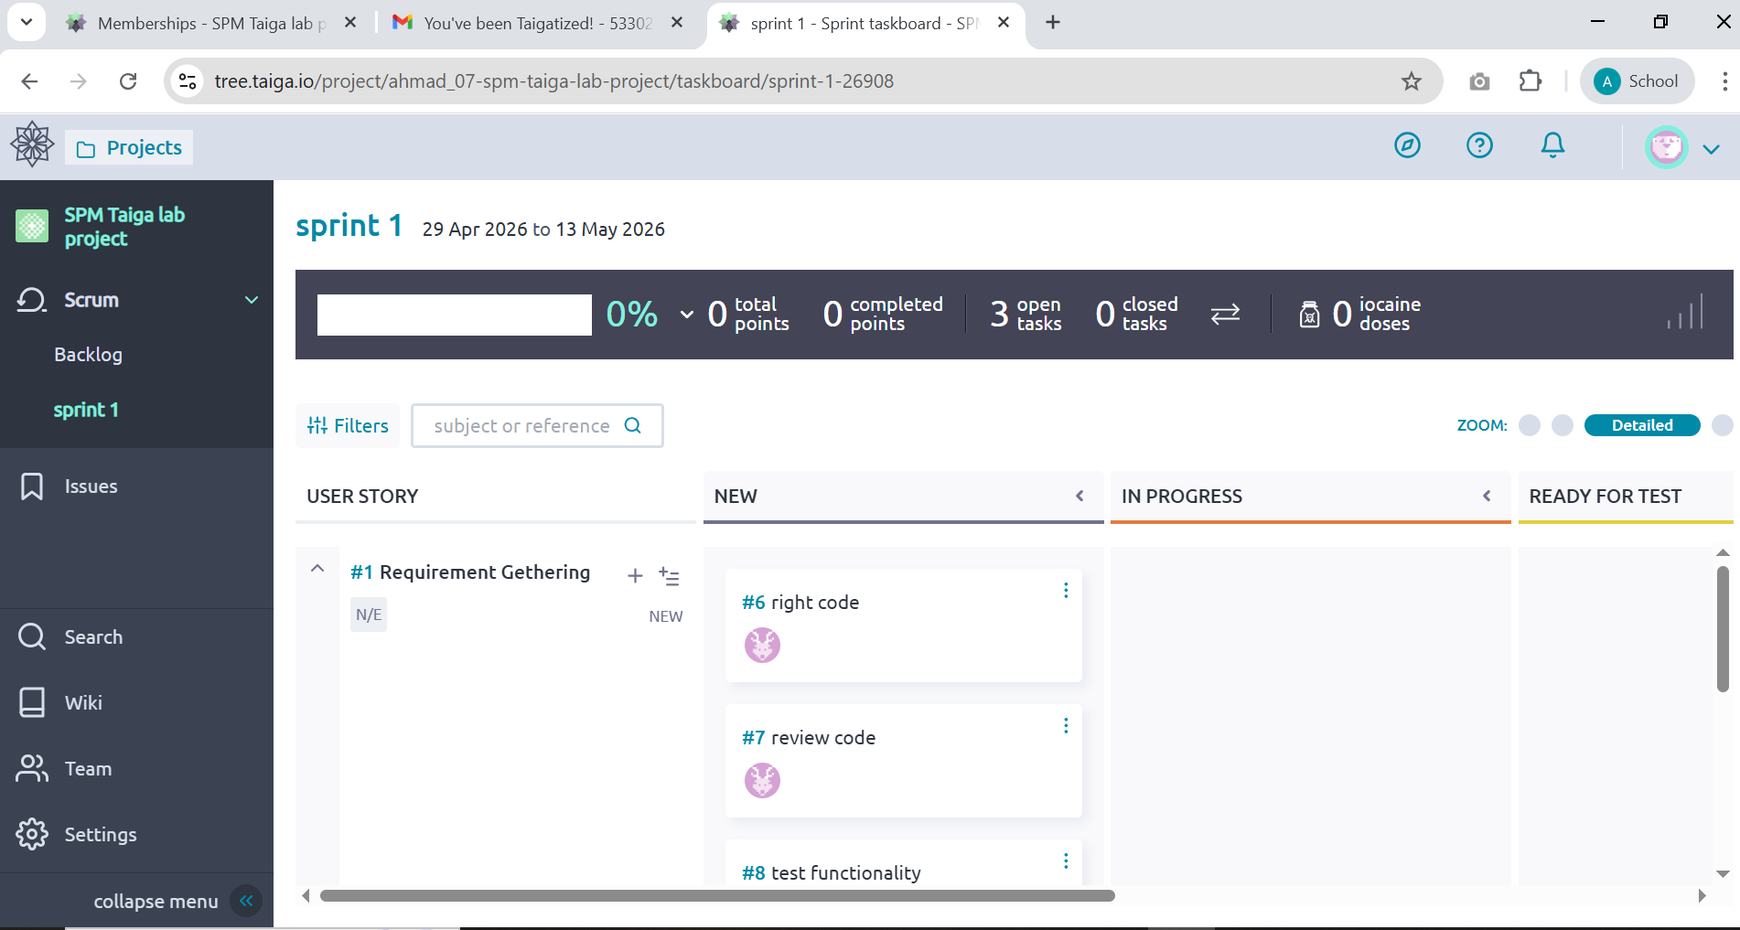

Task completed by members:

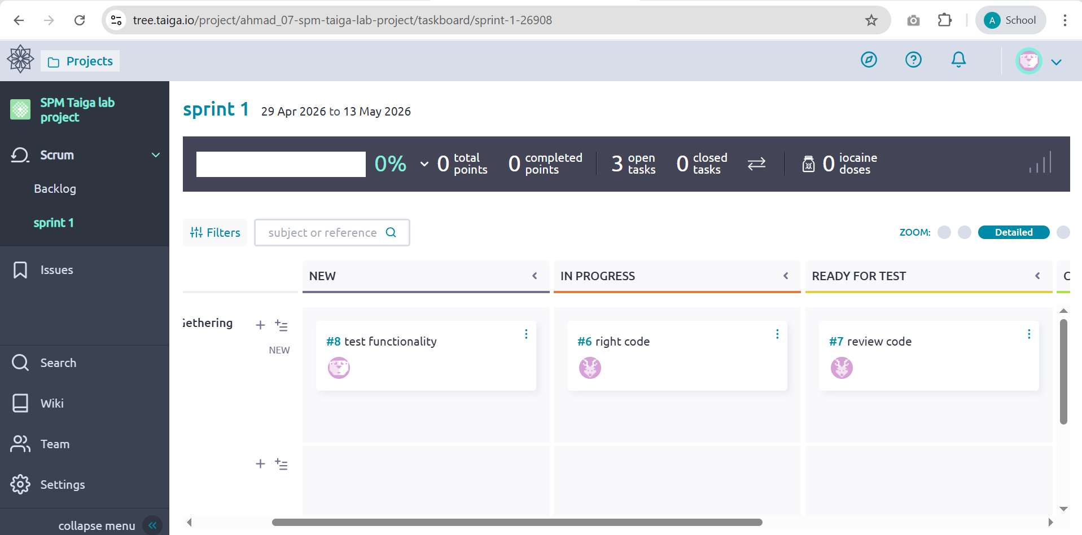

Verify email :

