1)

|  |  |  |  |  |  |  |  |  |  |
| --- | --- | --- | --- | --- | --- | --- | --- | --- | --- |
| 1 | 5000.01 | TRUE | 1000 | 10 | FALSE | 0.0825 | 4059.38 | ######## | TTFF |
| 2 | 2000 | TRUE | 1000 | 10 | FALSE | 0.0825 | 1732 | 8-11-12-22 | |
| 3 | 1250.01 | TRUE | 1000 | 10 | FALSE | 0.0825 | 1150.16 | 8-11-14-15-22 | |
| 4 | 350 | TRUE | 1000 | 10 | FALSE | 0.0825 | 340.9875 | 8-11-14-17-18-22 | |
| 5 | 349.99 | TRUE | 1000 | 10 | FALSE | 0.0825 | 378.86 | 8-11-12-17-20-22 | |
| 6 | 5000 | TRUE | 1000 | 10 | FALSE | 0.0825 | 4330 | MID RANGE VALUE | |
| 7 | 1999.99 | TRUE | 1000 | 10 | FALSE | 0.0825 | 1840.24 | MID RANGE VALUE | |
| 8 | 1250 | TRUE | 1000 | 10 | FALSE | 0.0825 | 1217.81 | MID RANGE VALUE | |
| 9 | 0 | TRUE | 1000 | 10 | FALSE | 0.0825 | 0 | EXTREME RANGE | |
| 10 | 20000 | TRUE | 1000 | 10 | FALSE | 0.0825 | 16237.5 | EXTREME RANGE | |
| 11 | 5000.01 | FALSE | 1000 | 10 | FALSE | 0.0825 | 5412.51 | MCDC | FTFF |
| 12 | 5000.01 | TRUE | 999 | 10 | FALSE | 0.0825 | 5412.511 | MCDC | TFFF |
| 13 | 5000.01 | TRUE | 999 | 11 | FALSE | 0.0825 | 4059.38 | MCDC | TFTF |
| 14 | 5000.01 | FALSE | 1000 | 11 | FALSE | 0.0825 | 4059.38 | MCDC | FTTF |
| 15 | 5000.01 | TRUE | 0 | 10 | TRUE | 0.0825 | 4059.38 | Extreme RANGE for MemberPoints | |
| 16 | 5000.01 | TRUE | 10000 | 10 | FALSE | 0.0825 | 4059.383 | Extreme RANGE for MemberPoints | |
| 17 | 5000.01 | TRUE | 1000 | 1 | FALSE | 0.0825 | 4059.383 | Extreme RANGE for Items | |
| 18 | 5000.01 | TRUE | 1000 | 50 | FALSE | 0.0825 | 4059.383 | Extreme RANGE for Items | |

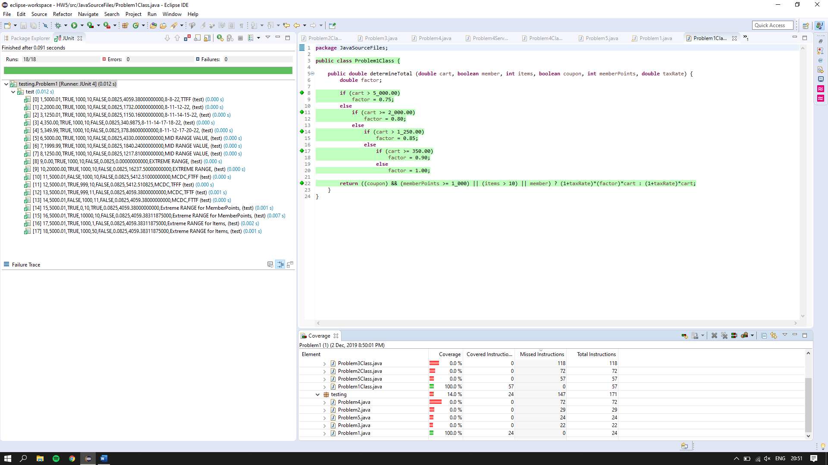

2)

|  |  |  |  |  |  |  |  |
| --- | --- | --- | --- | --- | --- | --- | --- |
| 1 | 1000.10 | 84.9 | TRUE | FALSE | 1.00 | 9-10-20-23 | TTFT |
| 2 | 500.00 | 84.9 | TRUE | TRUE | 1.05 | 9-12-13-23 | TTTT |
| 3 | 250.10 | 84.9 | TRUE | TRUE | 1.10 | 9-12-15-16-23 | TTTT |
| 4 | 100.00 | 84.9 | TRUE | TRUE | 1.25 | 9-12-15-18-19-23 | TTTT |
| 5 | 99.90 | 84.9 | TRUE | TRUE | 1.50 | 9-12-15-18-21-23 | TTTT |
| 6 | 99.90 | 49.9 | TRUE | FALSE | 1.50 | - | FTTT |
| 7 | 99.90 | 85 | TRUE | FALSE | 1.50 |  | TFTT |
| 8 | 99.90 | 84.9 | FALSE | FALSE | 1.50 | - | TTTF |
| 9 | 1000.00 | 84.9 | TRUE | TRUE | 1.05 | - | BV for distance |
| 10 | 499.90 | 84.9 | TRUE | TRUE | 1.10 | - | BV for distance |
| 11 | 250.00 | 84.9 | TRUE | TRUE | 1.25 | - | BV for distance |
| 12 | 99.90 | 50 | TRUE | TRUE | 1.50 | - | BV for speed |
| 13 | 0.00 | 84.9 | TRUE | TRUE | 1.50 | - | Extreme Range distance |
| 14 | 5000.00 | 84.9 | TRUE | FALSE | 1.00 | - | Extreme Range distance |
| 15 | 1000.10 | 0 | TRUE | FALSE | 1.00 | - | Extreme Range speed |
| 16 | 1000.10 | 150 | TRUE | FALSE | 1.00 | - | Extreme Range speed |

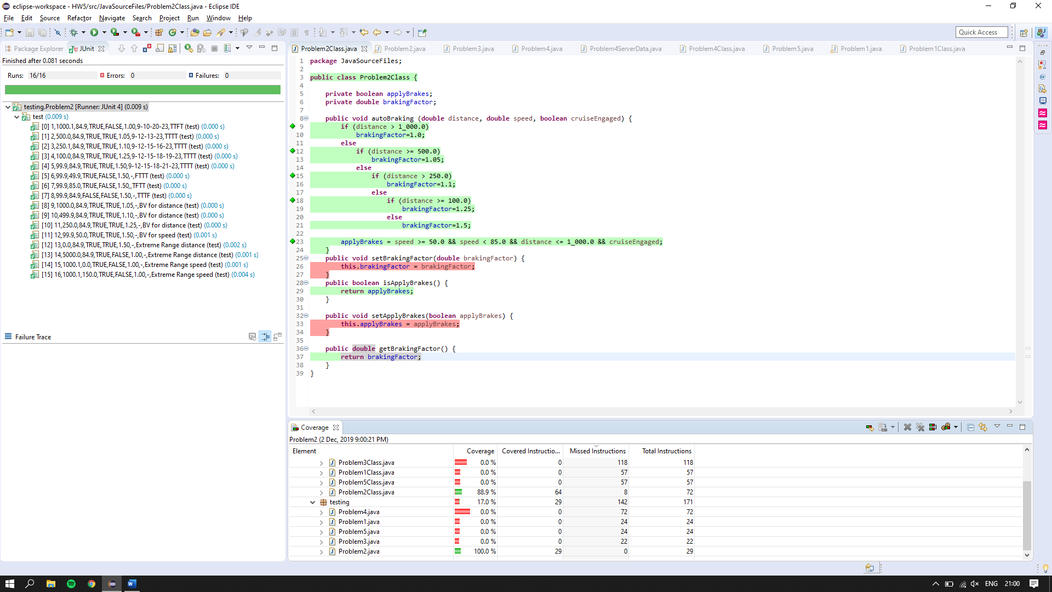

3)

|  |  |  |  |  |  |
| --- | --- | --- | --- | --- | --- |
| 1 | 1 | 1 | 2101 | 365 | TT for statement 8 and FTT for statement 9 |
| 2 | 1 | 1 | 2021 | 366 | FFT for statement 9 |
| 3 | 1 | 1 | 2401 | 366 | FTF for statement 9 |
| 4 | 1 | 1 | 2019 | 365 | TFT for statement 9 |
| 5 | 2 | 1 | 2100 | 31 | FT for statement 8 and FTT for statement 12 |
| 6 | 2 | 1 | 2020 | 31 | FFT for statement 12 |
| 7 | 2 | 1 | 2400 | 31 | FTF for statement 12 |
| 8 | 2 | 1 | 2019 | 31 | TFT for statement 9 |
| 9 | 3 | 31 | 2019 | 89 |  |
| 10 | 4 | 30 | 2019 | 119 |  |
| 11 | 5 | 31 | 2019 | 150 |  |
| 12 | 6 | 30 | 2019 | 180 |  |
| 13 | 7 | 31 | 2019 | 211 |  |
| 14 | 8 | 31 | 2019 | 242 |  |
| 15 | 9 | 30 | 2019 | 272 |  |
| 16 | 10 | 31 | 2019 | 303 |  |
| 17 | 11 | 30 | 2019 | 333 |  |
| 18 | 12 | 31 | 2019 | 364 |  |
| 19 | 1 | 2 | 2019 | 1 | TF for statement 8 |
| 20 | 1 | 1 | 2020 | 365 | BV |
| 21 | 1 | 1 | 2100 | 365 | BV |
| 22 | 1 | 1 | 2102 | 365 | BV |
| 23 | 1 | 1 | 2400 | 365 | BV |
| 24 | 1 | 1 | 2402 | 365 | BV |
| 25 | 2 | 1 | 2099 | 31 | BV |
| 22 | 2 | 1 | 2101 | 31 | BV |
| 23 | 2 | 1 | 2399 | 31 | BV |
| 24 | 2 | 1 | 2401 | 31 | BV |

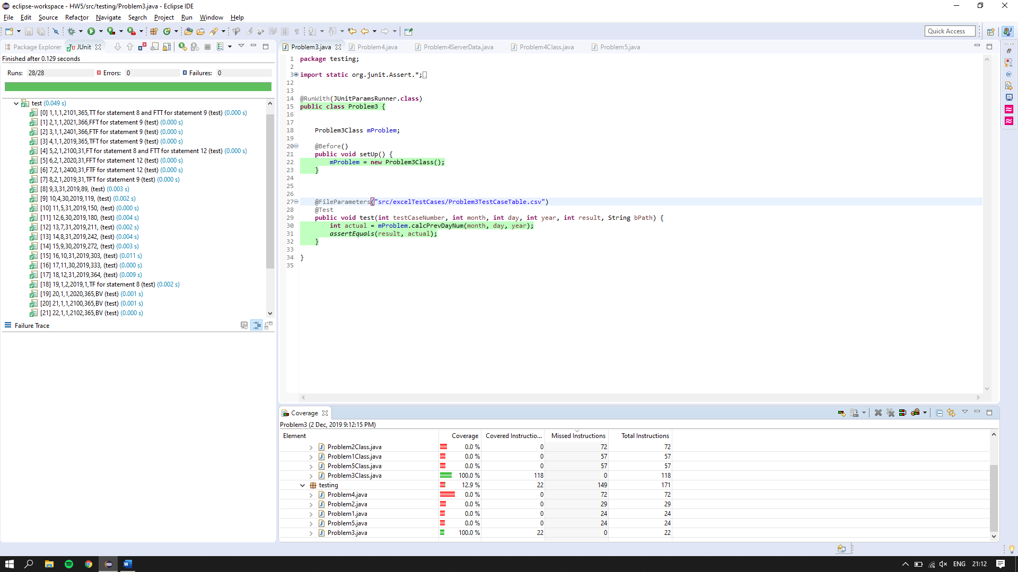

4)

|  |  |  |  |  |  |  |  |
| --- | --- | --- | --- | --- | --- | --- | --- |
| 1 | 0 | FALSE | FALSE | FALSE | FALSE | TRUE | 15-16-32 |
| 2 | 49.9 | FALSE | FALSE | FALSE | TRUE | FALSE | 15-18-19-32 |
| 3 | 75 | TRUE | FALSE | FALSE | FALSE | FALSE | 15-18-21-22-32 |
| 4 | 124.9 | TRUE | TRUE | FALSE | FALSE | FALSE | 15-18-21-24-25-32 |
| 5 | 250 | FALSE | TRUE | FALSE | FALSE | FALSE | 15-18-21-24-27-28-32 |
| 6 | 250.1 | FALSE | FALSE | TRUE | FALSE | FALSE | 15-18-21-24-27-30-32 |
| 7 | 0.1 | FALSE | FALSE | FALSE | TRUE | FALSE | - |
| 8 | 50 | TRUE | FALSE | FALSE | FALSE | FALSE | - |
| 9 | 75.1 | TRUE | TRUE | FALSE | FALSE | FALSE | - |
| 10 | 125 | FALSE | TRUE | FALSE | FALSE | FALSE | - |
| 11 | 1000 | FALSE | FALSE | TRUE | FALSE | FALSE | - |

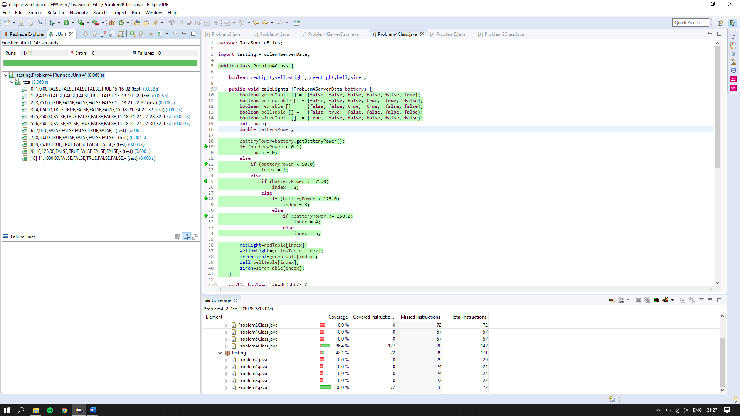

5)

|  |  |  |  |  |  |  |  |  |  |
| --- | --- | --- | --- | --- | --- | --- | --- | --- | --- |
| 1 | 5000.01 | TRUE | 999 | 10 | FALSE | 0.0825 | 5412.51 | ######## | TFFF |
| 2 | 2000 | TRUE | 999 | 10 | FALSE | 0.0825 | 2165 | 8-11-12-22 | |
| 3 | 1250.01 | TRUE | 999 | 10 | FALSE | 0.0825 | 1353.14 | 8-11-14-15-22 | |
| 4 | 350 | TRUE | 999 | 10 | FALSE | 0.0825 | 378.88 | 8-11-14-17-18-22 | |
| 5 | 349.99 | TRUE | 999 | 10 | FALSE | 0.0825 | 378.86 | 8-11-14-17-20-22 | |
| 6 | 5000 | TRUE | 999 | 10 | FALSE | 0.0825 | 5412.5 | - |  |
| 7 | 1999.99 | TRUE | 999 | 10 | FALSE | 0.0825 | 2164.99 | - |  |
| 8 | 1250 | TRUE | 999 | 10 | FALSE | 0.0825 | 1353.13 | - |  |
| 9 | 0 | TRUE | 999 | 10 | FALSE | 0.0825 | 0 | - |  |
| 10 | 20000 | TRUE | 999 | 10 | FALSE | 0.0825 | 21650 | - |  |
| 11 | 5000.01 | FALSE | 999 | 10 | FALSE | 0.0825 | 5412.51 | - | FTFF |
| 12 | 5000.01 | FALSE | 999 | 10 | TRUE | 0.0825 | 4059.38 | - | FTFT |
| 13 | 5000.01 | FALSE | 999 | 11 | FALSE | 0.0825 | 4059.38 | - | FTTF |
| 14 | 5000.01 | TRUE | 1000 | 10 | FALSE | 0.0825 | 4059.38 | - | TTFF |

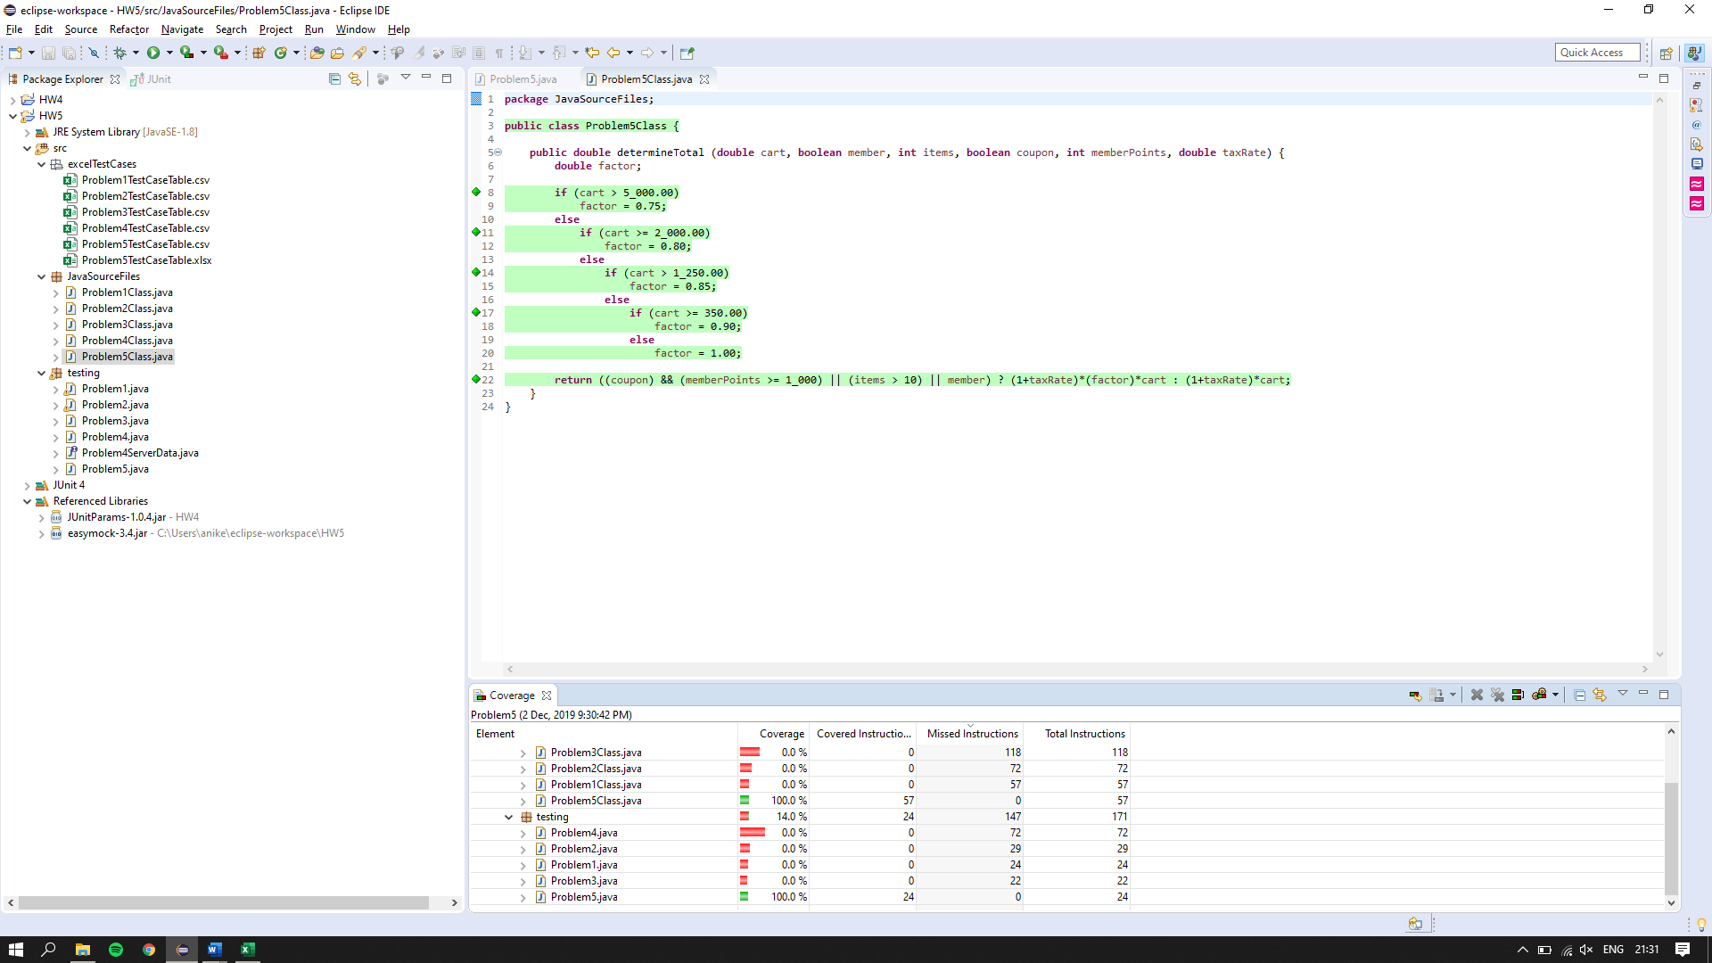

**PIT summary for Problem 5**

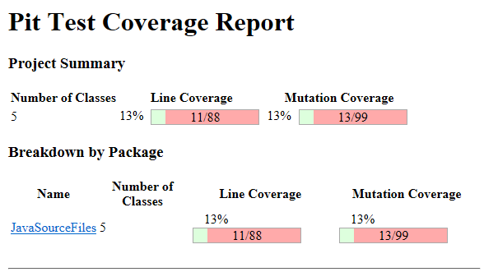

**PIT Summary for Problem 1**

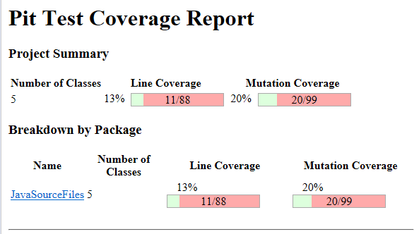

Analysis:

In problem 1 we have 18 test cases that properly test the entire code along with the extreme and mid-range values. In problem 5 we have missed a few test cases and hence the PIT coverage is low.