Brokerage Firm

Brokerage Firm

**Final Project**

**CIS 199**

**Dr. Maruping**

**Documentation**

**4/24/2012**

Albin George

Brokerage Firm documentation. Code available online at http://github.com/ag993

Contents

Creating a New Customer Account 1

New Investments 2

View/Edit Customer Information 5

Buy / Sell Shares 6

To Purchase or sell Stock Shares 6

Closing a Customer Account 8

# 

# Creating a New Customer Account

Figure 1

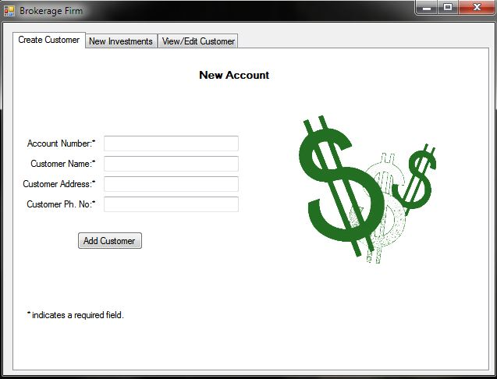

The program upon being started will present the screen above.

* Enter the Account number for the new customer. (Alphanumeric)
* Enter the Customer Name.
* Enter the Customer Address. (Alpha Numeric)
* Enter the Customer Phone Number

Then click on “Add Customer” button and it shall bring up a pop up box confirming the successful creation of the customer account.

# New Investments

Figure 2

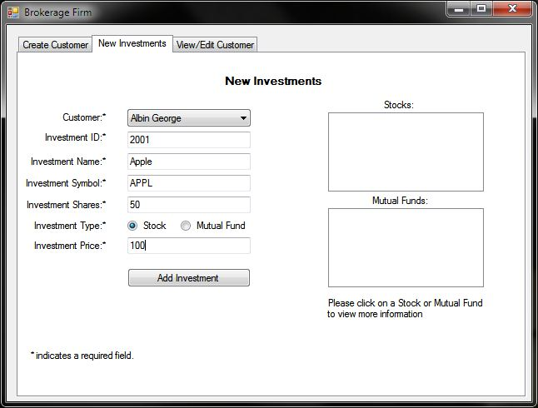

* Select a customer from the Drop down List.
* Enter a unique Investment ID. (Alphanumeric)
* Enter an investment Name. (Alphanumeric)
* Enter the Investment Symbol. (Alphanumeric)
* Enter Investment Shares. (Numeric value only)
* Select an investment type (Stock or Mutual Fund)
* Enter the price of that investment. ($100 should be entered as 100)

Upon clicking the “Add Investment” button, the software should produce a successful purchase pop up message and then add your investment to the appropriate textbox. As shown below:

Figure 3

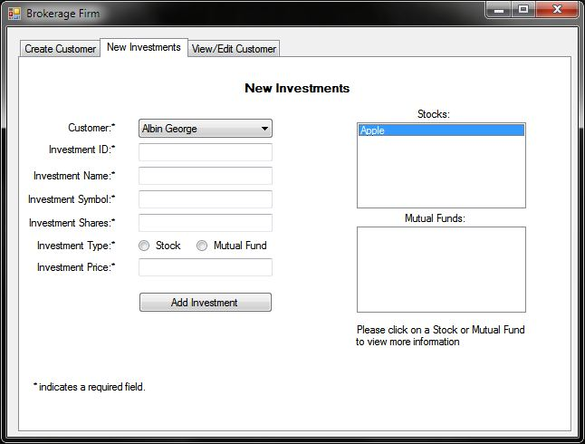

Furthermore, once the investment has been added as a stock or mutual fund you can click on an individual item to view more information about it in a pop-up box as shown below.

Figure 4

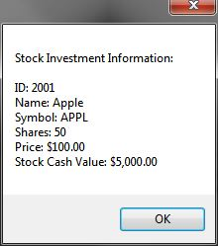

# View/Edit Customer Information

Figure 5

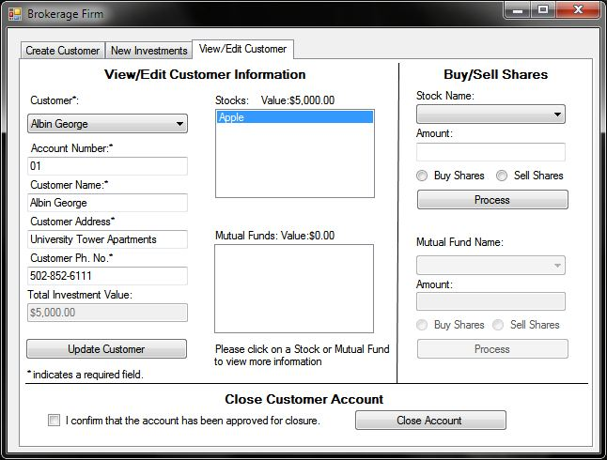

Upon selecting a customer from the drop down list on the “View/Edit Customer” tab, it populates basic information about the account such as Account Number, Name, Address, and Phone Number. These fields can be updated from here by making the necessary changes and hitting the “Update Customer” button. NOTE: You may not leave any of these items blank.

Furthermore, selecting a customer loads their investment information of Stocks and Mutual Funds in their respective List Boxes. The Disabled textbox under “Phone Number” and above the “Update Customer” button shows the “Total Investment Value” also known as the customer’s Total Cash Value.

Also, above each List Box the value of all the current stocks and mutual funds is also shown and clicking on an individual stock or mutual funds shows more information as in figure 4.

# Buy / Sell Shares

Figure 6

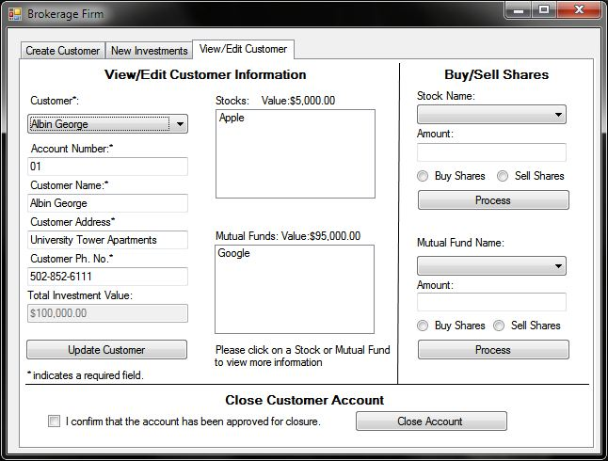

On the “View/Edit Customer” tab, upon selecting a customer the appropriate Buy/Sell capacity enables depending on what kind of shares the customer owns. For example: In Figure 5 only Stocks are enabled because the customer only owns stocks of “Apple”. Unlike Figure 6, in which both Stocks and Mutual Funds are enabled because the customer owns stocks in Apple and Google Mutual Funds.

## To Purchase or sell Stock Shares

* Select the appropriate stock from the Stock Drop down list.
* Enter the amount of shares to buy or sell.
* Select if you want to buy or sell shares.
* Hit the “Process” Button to complete transaction.

Figure 7

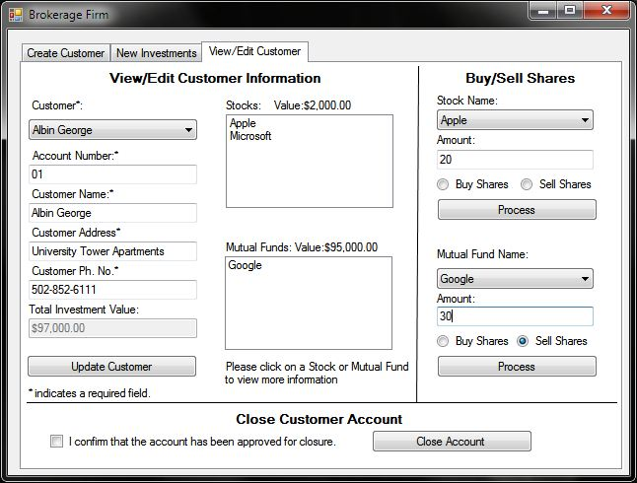

# Closing a Customer Account

Figure 8

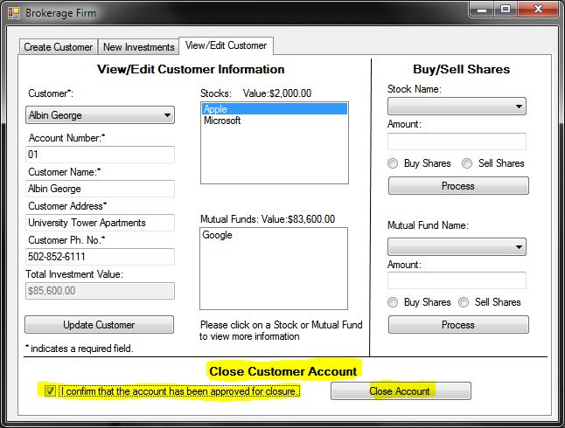

In order to close a customer account, proceed to the “View/Edit Tab”.

* Check mark the acknowledgement statement.
* Click the “Close Account” button. If successful it will show you a pop-up message with confirmation.