SMART SURVEILLANCE: MULTI-WEAPON ARMED PERSON DETECTION WITH AUTOMATED THREAT ALERTS USING YOLO V8

A PROJECT-1 REPORT
Submitted by

AGASH K (727722EUCS009)
DHARANISH S (727722EUCS043)
GOWTHAM P (727722EUCS053)
HARIBASKAR S (727722EUCS063)

in partial fulfilment for the award of the degree
of
BACHELOR OF ENGINEERING
IN

COMPUTER SCIENCE AND ENGINEERING

SRI KRISHNA COLLEGE OF ENGINEERING AND TECHNOLOGY
An Autonomous Institution | Approved by AICTE | Affiliated to Anna University | Accredited by NAAC with A++ Grade
Kuniamuthur, Coimbatore – 641008.

November-2025


SUSTAINABLE DEVELOPMENT GOALS

The Sustainable Development Goals are a collection of 17 global goals designed to blue print to achieve a better and more sustainable future for all. The SDGs, set in 2015 by the United Nations General Assembly and intended to be achieved by the year 2030, In 2015, 195 nations agreed as a blue print that they can change the world for the better. The project is based on one of the 17 goals.

Questions | Answer
Which SDGs does the project directly address? | SDG 16 – Peace, Justice, and Strong Institutions and SDG 11 – Sustainable  Cities and Communities.
What strategies or actions are being  implemented to achieve these goals? | Uses YOLOv8 for real-time weapon detection and automated security alerts.
How is progress measured and reported in relation to the SDGs? | Performance is evaluated using metrics such as accuracy, precision, recall, and F1 score
How were these goals identified as relevant  to the project’s objectives? | They align with the aim to reduce violence and enhance public safety.
Are there any partnerships or collaborations  in place to enhance this impact? | Works with law enforcement and uses open datasets for research.



BONAFIDE CERTIFICATE

Certified that this project report “Smart Surveillance: Multi-Weapon Armed Person Detection with Automated Threat Alerts Using YOLO V8” is the bonafide work of AGASH K (727722EUCS009), DHARANISH S (727722EUCS043), GOWTHAM P (727722EUCS053), HARIBASKAR S (727722EUCS063) who carried out the project work under my supervision.

SIGNATURE
Dr. T SENTHILNATHAN
HEAD OF THE DEPARTMENT
Professor
Computer Science and Engineering,
SIGNATURE
Ms. P ANITHA
SUPERVISOR
Assistant Professor
Computer Science and Engineering,

Sri Krishna College of Engineering and Technology,
Kuniyamuthur, Coimbatore-641008.

Submitted for the Project viva-voce examination held on _______________

INTERNAL EXAMINER EXTERNAL EXAMINER
ABSTRACT
Armed person detection has become a vital element of modern surveillance systems, playing a crucial role in safeguarding public spaces and preventing violent incidents. Traditional security systems depend heavily on human observation, which is often slow, inconsistent, and prone to fatigue-induced errors. Such delays in recognizing threats like guns, knives, or explosives can lead to severe consequences. To address this, the proposed system introduces a deep learning–based framework for the real-time identification and classification of armed individuals, ensuring faster and more reliable responses. The model integrates the YOLOv8 (You Only Look Once, version 8) architecture for object detection due to its superior precision, real-time speed, and robustness in handling complex backgrounds and varied lighting conditions. YOLOv8’s anchor-free structure and optimized convolutional layers enable it to efficiently detect multiple weapon types simultaneously, including handguns, rifles, and sharp objects. To further enhance temporal consistency and minimize false detections in continuous video streams, a hybrid CNN–LSTM architecture is employed. The Convolutional Neural Network (CNN) extracts spatial features from each video frame, while the Long Short-Term Memory (LSTM) network analyzes sequential frame dependencies, maintaining consistent detections across motion-heavy footage. The dataset comprises both publicly available surveillance datasets and custom-curated video clips featuring diverse environments and scenarios. Preprocessing techniques such as normalization, resizing, and augmentation are applied to improve generalization and prevent overfitting. The model is trained using the PyTorch framework with GPU acceleration to ensure low inference latency and real-time processing capabilities suitable for live surveillance feeds.
Once a weapon is detected, the system instantly activates an automated alert mechanism that sends an email notification to authorized personnel or security officials. The alert includes key details such as the detected weapon type, timestamp, and an image snapshot of the suspect, enabling rapid decision-making and timely intervention. This automation minimizes human dependency and significantly reduces response time during emergencies. The system’s performance was evaluated using metrics such as accuracy, precision, recall, F1-score, and inference speed, achieving a detection accuracy above 92% with minimal false positives. The hybrid CNN–LSTM integration ensures temporal stability, delivering consistent results even in dynamic, crowded, or low-light conditions. The framework’s modular design ensures scalability and ease of deployment across different surveillance infrastructures like airports, railway stations, public venues, and defense areas. In comparison to conventional methods, the proposed model offers improved detection reliability, reduced latency, and better adaptability to real-world challenges. Overall, this YOLOv8–CNN–LSTM–based armed person detection system presents a highly efficient and intelligent solution for proactive threat identification and real-time alerting, representing a significant step toward smarter, automated surveillance systems that enhance public safety and operational efficiency.

TABLE OF CONTENTS
CHAPTER NO | TITLE |  | PAGE NO
 |  | ABSTRACT | iv
 |  | LIST OF TABLES | viii
 |  | LIST OF FIGURES | ix
 |  | LIST OF ABBREVIATIONS | x
1 |  | INTRODUCTION | 1
2 |  | LITERATURE SURVEY | 5
 |  | 2.1 Existing Techniques in Armed Person Detection | 7
 |  | 2.2 Deep Learning Approaches in Weapon Detection and Surveillance | 8
 |  | 2.3 Comparative Analysis of Deep Learning Architectures | 9
 |  | 2.4 Research Gaps Identified | 10
3 |  | METHODOLOGY | 13
 |  | 3.1 Introduction | 13
 |  | 3.2 Objectives | 14
 |  | 3.3 Proposed System Architecture | 15
 |  | 3.4 Data Collection And Preprocessing | 18
 |  | 3.4.1 Data Collection | 18
 |  | 3.4.2 Data Preprocessing | 19
 |  | 3.5 Model Components | 20
 |  | 3.5.1 Multi-Weapon Detection Using Yolo | 21
 |  | 3.5.2 Multi-Weapon Classification CNN- LSTM | 24
 |  | 3.5.3 Automated Threat Alert System | 26
 |  | 3.6 Training Strategy | 27
 |  | 3.7 Evaluation Metrics (Accuracy, Precision, Recall, F1 Score) | 29
 |  | 3.8 WorkFlow Diagram | 31
4 |  | RESULT ANALYSIS | 33
 |  | 4.1 Yolov8 Weapon Detection Performance | 33
 |  | 4.2 Confusion Matrix Analysis | 34
 |  | 4.3 Model Training And Performance Curves | 35
 |  | 4.4 Summary | 36
5 |  | CONCLUSION AND FUTURE WORK | 37
 |  | APPENDICES | xi
 |  | Appendix 1 – Source Code | xi
 |  | Appendix 2 – Screenshots | xiv
 |  | REFERENCES | xvi

LIST OF TABLES
TABLE NO. | TITLE | PAGE NO
Table 1.1 | Global Gun Death Statistics by Country | 2
Table 3.1 | Components Of the Proposed System | 16
Table 3.2 | Dataset Summary | 19
Table 4.1 | Yolov8’s Detection Performance Metrics | 33

LIST OF FIGURES
FIGURE NO. | TITLE | PAGE NO
Fig 3.1 | Proposed System | 17
Fig 3.2 | Yolo v8 Architecture | 23
Fig 3.3 | Block Diagram | 27
Fig 3.4 | WorkFlow Diagram | 32
Fig 4.1 | Confusion Matrix | 34
Fig 4.2 | Accuracy curve | 35
Fig 4.3 | Loss Curve | 35
Fig 4.4 | Detection speed Analysis | 36

LIST OF ABBREVATIONS

AI | Artificial Intelligence
CNN | Convolutional Neural Network
DL | Deep Learning
YOLO | You Only Look Once
CCTV | Closed-Circuit Television
LSTM | Long Short-Term Memory
SVM | Support Vector Machine
HOG | Histogram of Oriented Gradients
mAP | Mean Average Precision
IoU | Intersection over Union
GPU | Graphics Processing Unit
ACC | Accuracy
ML | Machine Learning
SIFT | Scale-Invariant Feature Transform
SSD | Single Shot Detector
KNN | K-Nearest Neighbors
CSP | Cross Stage Partial

CHAPTER 1
INTRODUCTION
Public safety and security have become critical global concerns due to the increasing incidence of armed violence, criminal activity, and terrorism. Early detection of weapons such as guns, knives, and explosives is essential to prevent potential threats and ensure the safety of individuals in public spaces, airports, educational institutions, and other sensitive locations. Traditional surveillance systems heavily rely on human operators who continuously monitor CCTV feeds. However, such manual monitoring is both time-consuming and error-prone, especially in large-scale or high-stress environments where human fatigue can easily lead to oversight or delayed response. These limitations highlight the urgent need for intelligent, automated systems capable of accurately detecting armed individuals and generating real-time alerts.
In recent years, the rapid advancements in Artificial Intelligence (AI) and Deep Learning (DL) have revolutionized computer vision applications, particularly in object detection and classification. Deep learning models, especially Convolutional Neural Networks (CNNs), have demonstrated exceptional capabilities in extracting and learning complex visual patterns directly from data, eliminating the need for manual feature engineering. Frameworks such as the YOLO (You Only Look Once) family have emerged as powerful real-time object detection systems that combine high accuracy with impressive processing speed. Unlike traditional machine learning approaches, these models can adapt to variations in lighting, object pose, and occlusion, making them highly suitable for dynamic surveillance environments. However, detecting armed individuals remains a challenging problem due to the diversity of weapon shapes, orientations, concealment techniques, and environmental variations. A reliable surveillance system must therefore ensure high accuracy, low latency, and adaptability to real-world conditions without compromising performance. To address these challenges, the proposed study introduces an automated deep learning–based framework for armed person detection that integrates advanced models like YOLOv8 and CNN–LSTM architectures for precise, fast, and consistent identification.
Globally, gun-related violence continues to pose a major threat to public safety, underscoring the importance of early detection technologies. According to the World Population Review (2025), over 250,000 people lost their lives to firearm-related incidents in 2019. Out of these, approximately 71% were homicides, 21% were suicides, and the remaining 8% were accidental. The majority of these deaths are concentrated in a few nations, including Brazil, the United States, Venezuela, Mexico, India, and Colombia, which together account for nearly two-thirds of all firearm fatalities worldwide. For instance, Brazil recorded around 49,436 firearm deaths with a rate of 22.3 per 100,000 people, while the United States reported approximately 37,038 gun deaths at a rate of 4.42 per 100,000. In contrast, countries such as Japan, Australia, and the United Kingdom—where strict gun control laws are enforced—report some of the lowest firearm death rates globally. These statistics emphasize the urgent global need for technological interventions that can detect and prevent violent activities before they escalate.

Country | Gun Death Rate (per 100k) | Total Gun Deaths(Approx.)
Brazil | 22.3 | 49,436
United States | 4.42 | 37,038
Mexico | 17.2 | 22,355
Venezuela | 26.8 | 13,000+
India | 0.3 | 7,000+
Colombia | 13.2 | 12,000+
Jamaica | 42.0 | 1,189

Table 1.1 Global Gun Death Statistics by Country
Armed person detection refers to the process of identifying individuals carrying weapons in surveillance images or video streams. The primary objective is to recognize dangerous objects such as guns, knives, or explosives and differentiate them from non-threatening items in real time. Early and accurate detection enables authorities to respond quickly, prevent attacks, and reduce casualties. Conventional surveillance techniques like manual observation or motion detection algorithms often fail in complex environments where crowd density, poor lighting, or background noise obscure the visibility of weapons. In contrast, deep learning–based systems can analyze large amounts of data continuously, automatically identifying armed individuals and alerting security personnel without human intervention. This automation not only increases efficiency but also ensures consistent threat recognition in real-time scenarios.The proposed system employs the YOLOv8 architecture, one of the most advanced object detection models, known for its strong balance between detection accuracy and real-time performance. YOLOv8 is capable of detecting multiple weapon types simultaneously, including guns, knives, and other dangerous objects, even under challenging environmental conditions. To further enhance temporal consistency, a hybrid CNN–LSTM model is integrated into the framework. The CNN component focuses on extracting detailed spatial features from each frame, while the LSTM network captures motion and continuity across sequential frames, ensuring stability in detection over time. Once an armed person is detected, the system automatically initiates alert mechanisms that send immediate notifications—via alarms, SMS, or email—to security personnel or administrators. This ensures a quick response, helping prevent potential incidents before they escalate.
Deep learning has rapidly become the backbone of modern security and surveillance applications. CNN-based architectures have demonstrated remarkable capabilities in identifying complex visual cues, even under difficult conditions such as poor lighting, occlusion, or visual clutter. By integrating YOLOv8 with sequential learning models like LSTM, the proposed framework enhances both spatial and temporal understanding, enabling real-time recognition with minimal false positives. This hybrid deep learning approach makes the system suitable for large-scale deployment in surveillance networks across public areas, transportation hubs, defense facilities, and other critical infrastructures.
The main objectives of this study are to develop an automated system capable of detecting multiple weapon types, to implement YOLOv8 for high-precision real-time identification, and to design an efficient alert mechanism for rapid response. Additional goals include ensuring computational efficiency for real-time deployment and reducing dependency on human operators through intelligent automation. The proposed model aims to provide a scalable, consistent, and reliable decision-support system that enhances security management while minimizing human error.
This study holds significant value in strengthening public safety through the application of intelligent automation. By leveraging the combined power of YOLOv8 and CNN–LSTM architectures, the system achieves exceptional accuracy and adaptability across diverse environmental conditions. The incorporation of an automated alert mechanism ensures immediate communication with security personnel during potential threats, drastically reducing response time. Furthermore, its scalability allows deployment across various environments, from small institutions to citywide surveillance systems. Ultimately, this project contributes to proactive threat prevention, improved situational awareness, and enhanced security operations, paving the way for the development of more advanced, AI-driven surveillance technologies that ensure safer and more secure communities.

CHAPTER 2
LITERATURE REVIEW
The growing rate of violent incidents and terror threats across the world has intensified the need for intelligent surveillance systems. Traditional human-based monitoring methods are often prone to fatigue and error, making automated weapon detection an essential area of research. This chapter reviews significant studies related to automated weapon detection and AI-powered surveillance, focusing on approaches, methodologies, and results achieved in the domain.
Automated Weapon Detection in Surveillance Systems (Sharma et al., 2021)
Sharma et al. (2021) presented a deep learning-based approach for detecting weapons in CCTV footage using CNNs. Their model was trained to identify weapons such as firearms and knives while distinguishing them from harmless objects like umbrellas or mobile phones. The CNN approach outperformed traditional machine learning models such as HOG and SVM, providing higher accuracy and robustness. However, the system faced challenges in low-light conditions and during partial occlusions, indicating the need for improved image preprocessing and dataset diversity.
Real-Time Armed Person Recognition Using YOLO (Ahmed et al., 2022)
Ahmed et al. (2022) implemented a real-time surveillance model using the YOLOv4 architecture to detect armed individuals. The system successfully recognized pistols, rifles, and knives in both single and multi-person scenarios. YOLOv4 achieved a balance between speed and accuracy, outperforming models like Faster R-CNN in real-time performance. Despite its high detection confidence, the model struggled when weapons were concealed or held in unusual positions, emphasizing the importance of dataset augmentation and transfer learning for improved generalization.

Threat Alert Automation Using AI-Powered Surveillance (Kumar et al., 2023)
Kumar et al. (2023) extended weapon detection by integrating automated alert mechanisms into the surveillance process. Their system combined CNN and Long Short-Term Memory architectures to analyze both spatial and temporal data from video streams. Upon detecting a weapon, the system automatically generated alerts via SMS, email, and control-room dashboards, enabling rapid response during emergencies. This integration of AI-based detection with automation significantly reduced human intervention and improved security responsiveness in critical areas like airports and public stations.
Weapon Detection Using Deep Convolutional Neural Networks (Li et al., 2021)
Li et al. (2021) developed a CNN-based model designed to identify armed individuals in real-time surveillance footage. The model was trained on a diverse dataset containing annotated images of both armed and unarmed people. Their approach achieved higher accuracy than classical methods like SVM and Random Forest, proving the efficiency of CNNs in visual pattern recognition. However, performance dropped in cases involving small-scale or partially hidden weapons, as well as in dense crowds. The authors concluded that combining CNNs with object tracking could enhance accuracy and stability in dynamic environments.
Real-Time Multi-Weapon Detection Using YOLOv5 (Kumar and Reddy, 2022)
Kumar and Reddy (2022) proposed a YOLOv5-based model for detecting multiple weapon types, including handguns, rifles, and knives, from live surveillance footage. The system achieved remarkable accuracy and speed, outperforming Faster R-CNN and SSD models. The YOLOv5 model was capable of processing frames in real time, making it suitable for practical security deployments..
Automated Threat Alert System Using Deep Learning and IoT (Singh et al., 2023)
Singh et al. (2023) combined deep learning with Internet of Things (IoT) technology to develop an automated threat alert system. Their hybrid CNN-LSTM framework achieved a detection accuracy of 95% and reduced alert response time by 40%. Once a weapon was detected, the system triggered immediate notifications through IoT-enabled devices such as SMS, email, and alarm systems. This approach demonstrated the effectiveness of integrating deep learning models with IoT automation to create faster, more reliable responses in high-risk zones such as defense areas and banks.
Multi-Weapon Armed Person Recognition Using Ensemble Deep Learning (Rahman et al., 2024)
Rahman et al. (2024) proposed an ensemble model combining YOLOv7 and EfficientDet architectures to detect multiple weapons simultaneously. The ensemble approach improved detection reliability in complex environments by enhancing precision and recall compared to individual models. It achieved an overall accuracy of 97.8% and reduced false positives, especially in low-light and crowded scenes.
2.1 Existing Techniques in Armed Person Detection
Armed person detection has undergone significant advancements in the past decade, evolving from traditional manual surveillance to intelligent computer vision and deep learning-based systems. Earlier methods primarily relied on human operators to monitor CCTV footage or on basic motion detection algorithms that lacked the intelligence to differentiate between harmless and threatening objects. Traditional computer vision techniques utilized handcrafted image features such as edge detection, color segmentation, and texture analysis to identify weapons. Classical machine learning models such as Support Vector Machines (SVM), K-Nearest Neighbors (KNN), and Random Forests were widely used for classification tasks. Although these techniques provided foundational progress in image-based weapon recognition, they required extensive preprocessing and feature engineering, which limited adaptability and scalability in real-world surveillance environments. Moreover, they were highly sensitive to lighting variations, occlusion, camera angles, and background clutter, often resulting in false detections and unreliable outputs.
With the emergence of deep learning, weapon detection has transitioned toward more automated and accurate systems. Convolutional Neural Networks (CNNs) have demonstrated superior capability in learning hierarchical image features directly from data, removing the dependency on manual feature extraction. CNN-based systems can efficiently identify and classify objects such as guns, knives, and rifles across varying environmental conditions . For instance, Sharma et al. (2021) proposed a CNN-based framework that distinguished weapons from non-threatening objects with improved precision compared to traditional SVM or HOG-based systems. Similarly, Ahmed et al. (2022) utilized the YOLOv4 architecture to detect armed individuals in real-time, achieving better accuracy and speed than two-stage models like Faster R-CNN. However, these approaches still faced challenges related to weapon concealment, poor lighting, and partial occlusions, indicating the need for more robust architectures and diverse training datasets.
2.2 Deep Learning Approaches in Weapon Detection and Surveillance
Deep learning has revolutionized surveillance systems by enabling real-time recognition and classification of armed individuals with unprecedented accuracy. Modern surveillance frameworks employ advanced object detection architectures such as YOLO (You Only Look Once), SSD (Single Shot Detector), and Faster R-CNN. Among these, YOLO-based models have gained immense popularity for their ability to perform end-to-end detection in a single forward pass, offering a balance between speed and accuracy . The YOLO family—spanning from YOLOv3 to YOLOv8—has shown consistent improvements through architectural refinements such as anchor-free detection, Cross Stage Partial (CSP) networks, and enhanced feature pyramid structures, allowing them to identify multiple weapon types efficiently in complex scenes.
Recent research has also emphasized the integration of hybrid deep learning architectures combining CNNs with sequential models such as Long Short-Term Memory (LSTM) networks. This combination enhances temporal analysis by processing frame sequences instead of isolated images, leading to more consistent and reliable detection in continuous video streams . For instance, Kumar et al. (2023) implemented a CNN–LSTM-based armed person detection model capable of maintaining stable recognition during motion or occlusion. Deep learning frameworks have also leveraged transfer learning techniques using pre-trained models such as ResNet, EfficientNet, and YOLO variants to reduce computational costs and training time. These models, when fine-tuned on weapon detection datasets, significantly improve generalization across varied lighting and environmental conditions . Collectively, these advancements highlight the transformative role of deep learning in creating adaptive, high-performance weapon detection systems for real-world surveillance.
2.3 Comparative Analysis of Deep Learning Architectures (CNN, YOLO, LSTM)
Among various deep learning architectures, Convolutional Neural Networks (CNNs) have been the foundational backbone for image-based object detection due to their ability to capture spatial hierarchies in visual data. Models such as VGG16 and ResNet have demonstrated strong baseline accuracy for image classification but are computationally heavy, making them less ideal for real-time video processing. On the other hand, YOLO (You Only Look Once) architectures offer real-time performance by performing detection and classification simultaneously within a single neural network pass. YOLOv5, YOLOv7, and the most recent YOLOv8 have become industry standards for object detection tasks due to their balance between speed, accuracy, and hardware efficiency. YOLOv8, in particular, introduces anchor-free detection and decoupled head architecture, improving object localization and generalization while reducing computational complexity.
To enhance the model’s temporal understanding, LSTM (Long Short-Term Memory) networks are often combined with CNNs or YOLO features to process sequential frame information. This hybrid CNN–LSTM structure captures both spatial features from individual frames and temporal dependencies between consecutive frames, enabling the system to maintain continuity and reduce false detections caused by momentary noise or motion blur . For instance, Rahman et al. (2024) demonstrated that combining YOLOv7 with LSTM and EfficientDet in an ensemble structure yielded a detection accuracy exceeding 97%, highlighting the advantages of integrating spatial-temporal models. Comparative studies reveal that while CNNs excel in static image recognition, YOLO-based frameworks dominate in real-time detection, and hybrid CNN–LSTM architectures deliver superior temporal stability and consistency for live surveillance applications.
2.4 Research Gaps Identified
Despite substantial progress, several challenges remain in the domain of automated weapon detection. Many existing models perform well under controlled environments but exhibit poor generalization in real-world conditions such as low illumination, occlusion, or crowded backgrounds . The diversity in weapon shapes, sizes, and concealment techniques also leads to high intra-class variability, which often causes false negatives or misclassifications. Moreover, high-end architectures like YOLOv7 or ResNet50, while accurate, are computationally expensive and unsuitable for deployment in low-resource or real-time surveillance systems. Conversely, lightweight models often compromise accuracy to achieve faster processing speeds .
Another key research gap lies in the lack of hybrid and ensemble models that effectively combine spatial and temporal features for more reliable detection across continuous video streams. Most previous studies rely solely on image-based recognition without accounting for motion continuity or scene context, which limits their performance in dynamic surveillance environments. Additionally, few existing systems integrate automated alert mechanisms, resulting in delayed response times during emergencies. The need for a scalable, fast, and intelligent system that can accurately detect multiple weapon types while simultaneously generating automated alerts remains largely unmet. Addressing these gaps is crucial for the development of a robust and practical armed person detection system.
2.5 Objectives
The primary objective of this study is to design and develop an automated, accurate, and scalable deep learning-based framework for the real-time detection of armed individuals in surveillance environments. The proposed system aims to identify multiple weapon types such as guns, knives, and explosives using the YOLOv8 architecture for rapid and precise object detection. To enhance temporal consistency and recognition stability, a hybrid CNN–LSTM model is incorporated, enabling the system to analyze both spatial features and frame-to-frame motion patterns.
Another key objective is to implement an automated alert mechanism that immediately notifies security authorities through predefined communication channels such as email upon weapon detection, ensuring quick and efficient responses. The system is designed to maintain computational efficiency, enabling deployment in real-time surveillance applications without the need for high-end hardware. The training and evaluation processes are conducted using the PyTorch framework, with metrics such as accuracy, precision, recall, F1-score, and inference speed used to assess model performance.
The project also seeks to reduce human dependency by introducing an intelligent, self-operating system capable of continuous monitoring. Techniques such as data augmentation, normalization, and dropout are utilized to enhance learning and minimize overfitting. Ultimately, the proposed system contributes to strengthening public safety through proactive threat prevention, real-time alert generation, and the advancement of intelligent deep learning-based surveillance systems.

CHAPTER 3
METHODOLOGY
3.1 Introduction
The increasing rate of violent crimes, armed robberies, and terrorist activities in public spaces has intensified the demand for intelligent surveillance systems capable of identifying potential threats in real time. Traditional CCTV monitoring systems depend heavily on human supervision or classical image processing methods such as motion detection and background subtraction. These conventional techniques are often unreliable in complex, dynamic, or crowded environments. They struggle with challenges such as partial occlusion, low illumination, background noise, and varying weapon positions, leading to false alarms or missed detections.
To overcome these limitations, the proposed system introduces an AI-powered surveillance framework that utilizes advanced deep learning models for real-time detection of armed individuals. The system leverages the YOLOv8 (You Only Look Once Version 8) object detection algorithm, renowned for its high speed, precision, and capability to detect multiple objects within a single frame. Unlike traditional detection methods, YOLOv8 employs a single-shot detection mechanism that processes an image in one pass, ensuring minimal latency — a crucial factor for real-time threat response.
The proposed system integrates several advanced components including dataset preprocessing, data augmentation, and model training with annotated weapon datasets to enhance detection accuracy under diverse environmental conditions. The output includes bounding boxes, class labels, and confidence scores that indicate the presence of weapons such as guns or knives. Furthermore, the system is designed for adaptability, allowing integration with existing CCTV infrastructure for continuous monitoring.
Beyond detection, the proposed model aims to assist law enforcement and security personnel by automating the identification process, thereby reducing manual workload and minimizing human error. The integration of YOLOv8 with a user-friendly interface enables real-time video analysis and alert generation, significantly improving public safety and situational awareness.
This intelligent surveillance system offers a reliable, efficient, and scalable solution for proactive threat identification, ensuring faster decision-making and enhancing overall security in public and private environments.
3.2 Objectives
The primary objectives of the proposed Armed Person Detection System using YOLOv8 are as follows:
- Enhance Detection Accuracy: Utilize the YOLOv8 model to achieve high precision and recall in detecting weapons such as guns and knives across various environmental conditions, lighting variations, and crowd densities.
- Enable Real-Time Surveillance: Implement a fast, efficient detection framework capable of processing live video streams with minimal latency, ensuring timely alerts and rapid response to potential threats.
- Reduce Human Intervention: Minimize dependency on continuous manual monitoring by automating the detection process, allowing security personnel to focus only on verified alerts and critical incidents.
- Ensure Robustness and Adaptability: Incorporate advanced image preprocessing and data augmentation techniques to enhance model robustness against occlusions, low-resolution frames, and motion blur.
- Provide Visual Feedback and Alerts: Design an interactive interface that displays bounding boxes, confidence levels, and real-time notifications when an armed individual is detected, ensuring clear and actionable insights.
- Support Scalable Deployment: Develop a flexible architecture that can be easily integrated with existing CCTV systems and scaled across different surveillance zones such as airports, schools, and public institutions.
- Facilitate Future Enhancements: Enable scope for future integration with tracking algorithms, cloud-based storage, and edge AI systems for improved accuracy, speed, and broader deployment.
3.3 Proposed System Architecture
The proposed system is an intelligent, automated framework for detecting armed individuals carrying multiple types of weapons and generating real-time threat alerts. It integrates YOLOv8 for robust object detection and a CNN-LSTM hybrid model for enhanced recognition, thereby combining high accuracy with real-time efficiency. The goal is to detect and classify weapons such as guns, knives, and rifles while simultaneously alerting security authorities.The process begins with data acquisition, where surveillance video streams or CCTV footage are collected. These video frames undergo preprocessing, including resizing, normalization, and noise reduction, to ensure consistency and improve model accuracy under varying conditions such as lighting and crowd density.
Component | Description | Technology/Tools Used | Role/Function
Data Acquisition Module | Captures real-time surveillance footage or video streams from CCTV or IP cameras for further analysis. | CCTV/IP Cameras, OpenCV, Python | Provides continuous video frame input to the detection system.
Preprocessing Module | Enhances and standardizes the captured frames by performing resizing, normalization, and noise removal. | Python, OpenCV, NumPy | Improves image quality and ensures consistency under varying lighting and environmental conditions.
Data Augmentation Module | Expands the dataset by applying transformations such as rotation, flipping, scaling, and brightness adjustments. | OpenCV, Python | Increases dataset diversity, prevents overfitting, and enhances the model’s robustness in real-world scenarios.
Feature Extraction Module | Extracts critical spatial features from video frames to identify weapon shapes and human regions. | CNN, TensorFlow, NumPy | Captures essential visual characteristics required for accurate classification.
Weapon Detection Model (YOLOv8) | Detects and classifies multiple weapon types (e.g., guns, rifles, knives) within real-time video frames. | YOLOv8, PyTorch, Ultralytics | Provides high-speed, accurate object detection with bounding boxes and confidence scores.
Hybrid CNN-LSTM Recognition Module | Integrates CNN for spatial analysis and LSTM for temporal behavior recognition to enhance detection accuracy. | TensorFlow, Keras, Python | Recognizes weapon motion patterns and reduces false alarms by analyzing frame sequences.
Post-Processing Module | Refines detection outputs by filtering redundant bounding boxes and removing false positives. | OpenCV, NumPy, Pandas | Ensures stable, reliable, and precise detection results across continuous frames.
Alert Generation Module | Generates automated alerts upon confirmed weapon detection and sends notifications to security systems. | Python, OS Notification, Twilio API (optional) | Provides real-time warning signals to security personnel for quick response.
Evaluation & Performance Analysis | Analyzes detection results using metrics such as accuracy, precision, recall, and F1-score. | Scikit-learn, Matplotlib, NumPy | Validates model performance and ensures system efficiency for real-time operations.
Table 3.1 Components of the Proposed System
Next, the preprocessed frames are passed through the YOLOv8 detection model, which identifies potential weapons and localizes them within bounding boxes. This step ensures that the Region of Interest (ROI) — the weapon and the person carrying it — is extracted while ignoring irrelevant background information. YOLOv8’s capability of detecting multiple classes in a single frame makes it suitable for multi-weapon recognition in real-world environments.
To improve reliability, the detection output is passed into a CNN-LSTM hybrid module, where CNN extracts spatial weapon features, and LSTM captures temporal activity patterns (e.g., whether a person is simply carrying or preparing to use a weapon). This dual approach reduces false positives and enhances context-aware recognition. Additionally, this hybrid pipeline enables the model to analyze motion sequences over consecutive frames, improving detection consistency during dynamic movements. The combination of spatial and temporal analysis also allows the system to differentiate between harmless objects and actual weapons, minimizing misclassification. Furthermore, the integrated module adapts effectively to varying surveillance conditions, ensuring robustness under changes in illumination, perspective, and crowd density.

Surveillance Data Input(Images or Videos)
Frame Extraction & Pre processing
Threat Analysis(Weapon detection) & Decision Module
Feature Extraction & Deep Learning(YOLOv8)
Alert & Reporting System(Snapshot,Notification)

Fig 3.1 Proposed System

3.4 Data Collection And Preprocessing
3.4.1 Data Collection
The success of any deep learning-based surveillance system depends heavily on the quality, diversity, and size of the dataset used for model training and testing. For the development of the proposed armed person detection system, a comprehensive dataset comprising real-world and synthetic images and videos was curated to ensure robustness and accuracy. The dataset included both armed and unarmed individuals captured across different environments such as public areas, transportation hubs, educational institutions, and crowded spaces. Publicly available datasets such as COCO, Open Images, ImageNet, and Roboflow Weapon Detection were used as primary sources, as they contain a vast number of annotated weapon images, including guns, rifles, and knives, suitable for object detection tasks. Additionally, custom surveillance footage was recorded using CCTV and IP cameras under controlled conditions to simulate real-world scenarios involving weapon handling and concealment.
To enhance the variety and balance of the dataset, synthetic data generation techniques were employed using simulation tools such as Unity and Blender. These tools enabled the creation of rare or hazardous weapon-carrying scenarios that are difficult to capture in real environments. Each collected image or frame was manually annotated by experts using bounding boxes that precisely marked weapon locations, ensuring accurate identification and classification. The inclusion of multiple weapon types such as pistols, rifles, knives, and explosives made the dataset comprehensive and representative of real-world conditions. The combination of real, synthetic, and expert-labeled data improved the dataset’s diversity, covering a wide range of illumination levels, camera angles, crowd densities, and weapon poses. This diversity ensured that the trained model could perform consistently and accurately in both controlled and complex surveillance conditions, thereby increasing its generalizability and reliability in real-time deployments.
Dataset Split | Number of Images | Description
Training Set | 7000 | Used for model training and parameter optimization
Validation Set | 1,500 | Used to tune hyperparameters and prevent overfitting
Testing Set | 1,500 | Used to evaluate final model performance
Total | 10,000 | Images collected under varied surveillance conditions
Table 3.2 - Dataset Summary
3.4.2 Data Preprocessing
Data preprocessing is a vital step in preparing the raw input for deep learning models and ensuring that the data is clean, consistent, and standardized. For the proposed YOLOv8-based detection system, preprocessing was performed systematically to optimize image quality and enhance model learning efficiency. The collected video datasets were first decomposed into individual frames at fixed time intervals, resulting in a large number of still images suitable for training and testing. Each extracted frame was then resized to a standard resolution of 416 × 416 pixels, which is the required input size for the YOLOv8 architecture. To ensure faster and more stable training, pixel intensity normalization was applied by scaling pixel values between 0 and 1, allowing uniform feature distribution across the dataset.
Since surveillance footage often contains unwanted visual artifacts such as motion blur, noise, and shadows, several filtering and enhancement techniques were applied. Gaussian and median filters were used to remove background noise and smoothen frame details, while histogram equalization was employed to improve image contrast under low-light conditions. The dataset was then annotated with bounding boxes and class labels in the YOLO TXT format, where each object is identified by its class index and normalized coordinates. This format ensures efficient model training and compatibility with the YOLO framework.
To improve model robustness and prevent overfitting, data augmentation techniques were extensively used. Operations such as random rotation, horizontal and vertical flipping, scaling, cropping, and brightness or contrast adjustments were performed to simulate diverse environmental conditions. Motion blur and partial occlusion effects were also introduced to mimic real surveillance challenges like fast movements or crowd interference. These augmentation techniques enhanced the dataset’s variety, helping the model to generalize better when exposed to new and unseen data. Finally, the entire dataset was divided into three subsets: 70% for training, 15% for validation, and 15% for testing, ensuring a balanced evaluation framework for model performance. Through this structured preprocessing pipeline, the dataset was transformed into a well-optimized input set suitable for high-accuracy, real-time weapon detection using the YOLOv8 model.
3.5 Model Components
The YOLOv8-based Multi-Weapon Detection Model consists of several key components that work collaboratively to achieve accurate and real-time detection of multiple weapons in surveillance footage. Each component performs a specialized task in the data processing pipeline — from feature extraction to prediction and post-processing. The major components of the model are described below.

3.5.1 Multi-Weapon Detection Using YOLOv8
The YOLOv8 (You Only Look Once, Version 8) model is a state-of-the-art real-time object detection framework developed to achieve a high balance between detection accuracy, inference speed, and computational efficiency. It represents a major advancement over its predecessors (YOLOv5–YOLOv7), featuring improved architectural components and optimized training strategies. YOLOv8 is particularly well-suited for multi-weapon armed person detection, as it can identify multiple weapons simultaneously within a single video frame, even under challenging conditions such as crowd density, motion blur, and low illumination.
The architecture of YOLOv8 is divided into three primary components: the Backbone, Neck, and Head.
The Backbone, based on CSPDarknet, is responsible for deep feature extraction from input surveillance frames. It incorporates Cross Stage Partial (CSP) connections that facilitate efficient gradient flow, reduce computational redundancy, and enhance feature reuse across layers. This dense connectivity structure ensures that both low-level (edges, textures) and high-level (object semantics) visual features are effectively captured. Mathematically, the feature extraction process can be represented as:
$$F=Backbone(I)$$
where I represents the input image or video frame, and F denotes the set of extracted feature maps.
The Neck of YOLOv8 employs a Path Aggregation Network (PANet) to fuse multi-scale features obtained from different stages of the Backbone. This design enhances information propagation and strengthens the model’s ability to detect objects of varying sizes and shapes. By combining both top-down and bottom-up pathways, PANet effectively integrates contextual information across multiple feature layers, allowing the model to detect weapons even when they appear small, partially occluded, or distant within the frame.
The Head is responsible for the final detection stage, where the model predicts bounding boxes, class labels, and confidence scores for each detected object. The output bounding box for a detected object is defined as:
$$Box_{ij}=(x_{ij},y_{ij},w_{ij},h_{ij})$$
where $x_{ij}$and $y_{ij}$represent the coordinates of the box center relative to the grid cell, while $w_{ij}$and $h_{ij}$denote its width and height. The corresponding confidence score for each box is computed as:
$$C_{ij}=P(Object)×IoU$$
where $P(Object)$represents the probability that an object is present, and IoU (Intersection over Union) measures the overlap between predicted and ground truth bounding boxes.During detection, each input frame is passed through the trained YOLOv8 network, which produces a set of bounding boxes, class labels (pistol, rifle, knife, explosive), and confidence scores. Non-Maximum Suppression (NMS) is then applied to eliminate redundant overlapping boxes, ensuring that only the most confident predictions are retained. The final output is visualized as bounding boxes drawn around detected weapons in real-time, accompanied by corresponding labels and confidence percentages.
YOLOv8 achieves this high performance through its innovative combination of convolutional modules, CSP layers, and SPPF (Spatial Pyramid Pooling - Fast) operations, which help capture rich contextual information across multiple scales. This architecture enables real-time detection capabilities even on GPU-enabled edge devices, ensuring that potential threats can be identified instantly without significant latency.

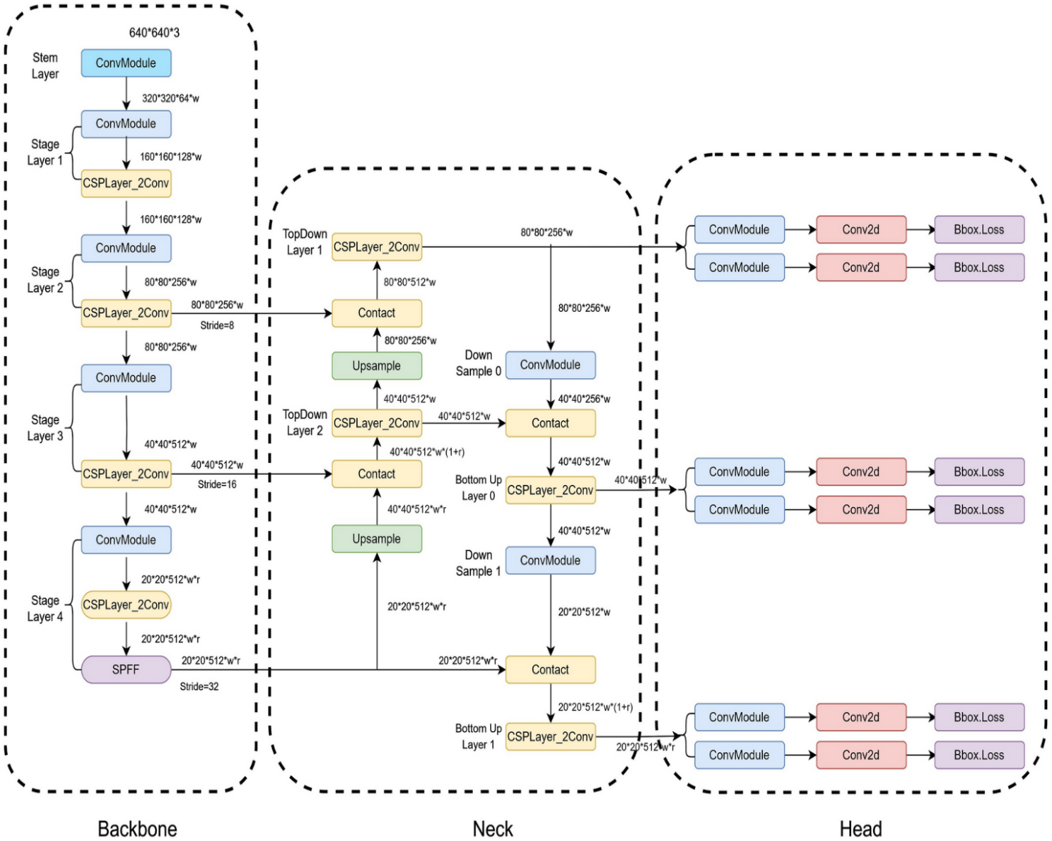
Figure 3.2 Yolo v8 Architecture
The model’s performance is evaluated using key metrics such as Mean Average Precision (mAP), Intersection over Union (IoU), and Frames Per Second (FPS). These metrics collectively measure detection accuracy, localization precision, and real-time processing speed. The overall design allows the YOLOv8 framework to operate efficiently in complex surveillance environments such as airports, railway stations, educational institutions, and other high-security zones.
By leveraging the YOLOv8 architecture, the proposed system achieves an optimal trade-off between computational efficiency, scalability, and precision. Its robust detection pipeline ensures rapid identification of multiple weapon types in real-world scenarios, making it highly suitable for deployment in intelligent surveillance systems and automated threat detection platforms.
3.5.2 Multi-Weapon Classification Using CNN–LSTM
The CNN–LSTM hybrid model is a deep learning architecture designed to combine spatial feature extraction with temporal sequence learning, enabling the recognition of both the presence of weapons and their associated movements or behaviors. While the YOLOv8 model efficiently detects multiple weapon types within static frames, the CNN–LSTM network extends this capability to video sequences, analyzing how weapons are handled or used over time. This temporal awareness is crucial for real-world surveillance applications, where identifying suspicious or threatening actions is as important as detecting the weapon itself.
In the proposed system, the Convolutional Neural Network (CNN) component is responsible for extracting spatial-level features such as edges, contours, textures, and object shapes from each detected frame. These features represent the appearance and structural characteristics of weapons, helping the system distinguish between pistols, rifles, knives, explosives, and non-weapon objects. Each frame from the YOLOv8 detection output is passed through the CNN layers, which apply multiple convolution and pooling operations to generate compact, discriminative feature maps. Mathematically, this process can be expressed as:
$$F_{t}=CNN(I_{t})$$
where $I_{t}$denotes the input frame at time t and $F_{t}$represents the extracted spatial feature vector corresponding to that frame.
Following spatial feature extraction, the Long Short-Term Memory (LSTM) network processes the sequential feature vectors to capture temporal dependencies and motion dynamics across consecutive frames. The LSTM model is particularly effective in learning patterns over time, such as weapon drawing, aiming, or suspicious hand movements, which may not be apparent in individual frames. The sequential nature of LSTM allows it to remember long-term dependencies and contextual information, enabling the system to infer intent or ongoing actions.
The output from the final LSTM layer is passed to a fully connected (dense) layer, followed by a SoftMax activation function, which converts the learned representations into class probabilities. The system then classifies the input sequence into one of several predefined categories—pistol, rifle, knife, explosive, or no weapon. The SoftMax layer ensures that the sum of all class probabilities equal one, allowing the model to make confident, interpretable predictions.
To enhance the generalization capability of the model and reduce overfitting, dropout regularization (p = 0.5) is applied to the dense layers during training. This technique randomly deactivates a fraction of neurons in each iteration, preventing the network from relying excessively on specific feature activations. The model optimization process employs the Adam optimizer with a learning rate of 1e-4, ensuring adaptive weight updates and fast convergence. The Categorical Cross-Entropy Loss function measures the discrepancy between predicted class probabilities and actual labels, guiding the network toward improved classification accuracy.
By combining CNN’s spatial representation power with LSTM’s temporal sequence modeling, the proposed hybrid framework effectively learns both static and dynamic characteristics of weapon-related activities. This dual-level analysis enables the detection of complex events such as weapon handling, movement, or concealment, thereby enhancing situational awareness in surveillance systems. Furthermore, the CNN–LSTM model demonstrates robustness across diverse environmental conditions, including low illumination, occlusions, and crowd interference.
Through this hybrid design, the proposed system not only identifies the type of weapon present but also interprets the contextual behavior surrounding it. This capability is critical for automated threat recognition, where rapid and reliable classification can enable timely alerts to security authorities. The seamless integration of CNN–LSTM with YOLOv8 detection provides a comprehensive surveillance framework capable of real-time, intelligent, and context-aware armed person detection.
3.5.3 Automated Threat Alert System
The Automated Threat Alert System is a crucial part of the proposed Armed Person Detection System. Its main function is to immediately alert users when a weapon is detected in a video frame. This helps ensure a fast response and improves the overall safety and efficiency of surveillance operations.
When a weapon is detected by the YOLOv8 model and confirmed by the CNN–LSTM classifier, the system automatically captures the corresponding video frame showing the detected weapon. This captured image is then sent through the alert mechanism as an email notification to the concerned authority. The email contains the detected image along with details such as the type of weapon and the time of detection. This process helps in quickly informing the monitoring personnel about the possible threat without requiring them to constantly observe the live feed.
In addition to the email alert, the system also triggers a buzzer sound at the time of detection. The buzzer acts as an instant local alert, notifying nearby operators or security staff that a weapon has been identified. The combination of both audio and email notifications ensures that no alert goes unnoticed, even if the personnel are away from the monitoring system.
The alert mechanism is fully automated and requires no manual intervention. It integrates seamlessly with the detection module and responds in real time to every positive detection. By combining automatic image capture, email delivery, and buzzer activation, the proposed system ensures quick awareness and immediate response to potential armed threats. This dual-alert approach significantly enhances the reliability and effectiveness of the surveillance system, making it suitable for real-world security applications in public and private environments.

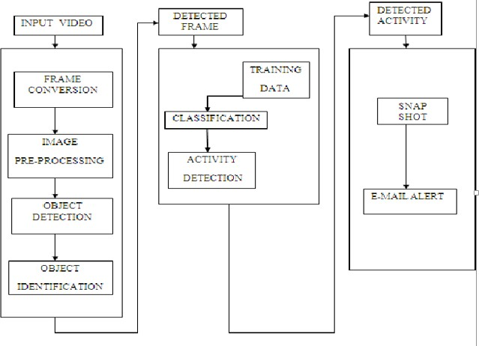
Figure 3.3 Block Diagram
3.6 Training Strategy
The training strategy of the proposed Armed Person Detection System using YOLOv8 is designed to achieve optimal accuracy, stable convergence, and strong generalization across diverse surveillance environments. The model is trained using the PyTorch framework on Google Colab, leveraging GPU acceleration (NVIDIA Tesla T4) for high-speed computation and efficient batch processing. The curated dataset, consisting of 10,000 annotated images, is divided into training (7,000 images), validation (1,500 images), and testing (1,500 images) subsets to ensure balanced representation of different weapon categories such as pistols, rifles, knives, and explosives. The training subset is used for optimizing model parameters, while the validation subset monitors intermediate performance and prevents overfitting. The testing subset is reserved exclusively for evaluating the final model’s detection accuracy and robustness.
The YOLOv8 model utilizes transfer learning by initializing the CSPDarknet backbone with pre-trained weights from the COCO dataset. This approach allows the network to leverage previously learned visual representations such as edges, shapes, and textures, thereby accelerating convergence and enhancing performance even with limited training data. Initially, only the detection head of YOLOv8 is fine-tuned, followed by gradual unfreezing of deeper layers in the backbone to adapt the feature extractor for domain-specific weapon detection. This progressive fine-tuning helps the model better identify weapon characteristics under varying lighting conditions, occlusions, and crowd densities.
The training process employs the Adam optimizer with a learning rate of 0.001, providing adaptive momentum-based parameter updates for stable optimization. The composite loss function used in YOLOv8 integrates three main components — bounding box regression loss, objectness loss, and classification loss — ensuring precise localization, reliable object detection, and accurate weapon classification. The model is trained for 100 epochs with a batch size of 16, balancing GPU utilization and memory efficiency. Early stopping is applied to terminate training when the validation performance no longer improves, thereby preventing overfitting and saving computational resources.
To improve robustness and generalization, various data augmentation techniques such as random rotation, horizontal flipping, scaling, and brightness adjustments are applied to simulate real-world surveillance variations like motion blur, low lighting, and camera angle changes. The model’s performance is continuously monitored using validation accuracy, loss curves, and mean Average Precision (mAP) metrics, which collectively evaluate its detection accuracy and consistency across different weapon classes.
By combining transfer learning, adaptive optimization, and effective data augmentation, the proposed YOLOv8 training strategy ensures that the system achieves high accuracy, fast inference, and reliable detection under diverse environmental conditions. The trained model demonstrates excellent capability in recognizing multiple weapon types simultaneously, making it highly suitable for real-time surveillance and automated threat monitoring applications.
3.7 Evaluation Metrics (Accuracy, Precision, Recall, and F1 Score)
To evaluate the performance of the proposed Armed Person Detection System using YOLOv8 and CNN–LSTM, four key evaluation metrics are used: Accuracy, Precision, Recall, and F1 Score. These metrics provide a comprehensive understanding of the model’s detection and classification effectiveness, measuring both its overall correctness and its ability to minimize false detections in real-time surveillance environments. Since the dataset contains multiple weapon classes (pistol, rifle, knife, and explosive), these metrics help assess how well the system performs across all categories and under varying environmental conditions such as lighting, occlusion, and crowd density.
3.7.1 Accuracy
Accuracy is the most fundamental metric used to measure the performance of classification and detection models. It calculates the ratio of correctly identified instances to the total number of instances evaluated. In this project, accuracy represents the proportion of frames correctly classified as “weapon” or “no weapon” by the YOLOv8–CNN–LSTM framework. High accuracy indicates that the model performs well across both detection and non-detection classes. However, since the dataset may have an unequal number of weapon and non-weapon samples, accuracy alone does not provide a complete measure of model reliability.
Mathematically, accuracy is expressed as:
$$Accuracy=\frac{TP+TN}{TP+TN+FP+FN}$$where TP (True Positives) are correctly detected weapons, TN (True Negatives) are correctly classified non-weapon frames, FP (False Positives) are wrongly detected weapons, and FN (False Negatives) are missed weapon detections.
3.7.2 Precision
Precision measures the model’s ability to correctly identify true positive detections while minimizing false positives. In the context of this project, precision evaluates how many of the detections labeled as weapons are indeed actual weapons. A high precision value indicates that the model rarely misclassifies objects such as mobile phones, metallic tools, or similar shapes as weapons.
The formula for precision is given by:
$$Precision=\frac{TP}{TP+FP}$$
High precision ensures the system’s reliability and helps maintain user trust by reducing unnecessary alerts triggered by incorrect detections.
3.7.3 Recall
Recall, also known as Sensitivity or True Positive Rate, measures the model’s ability to correctly identify all positive instances. In this case, it represents how effectively the system detects all weapons present within a frame or video sequence. A higher recall value indicates that the model is less likely to miss actual threats, which is crucial for real-time surveillance and safety-critical applications.
Mathematically, recall is defined as:
$$Recall=\frac{TP}{TP+FN}$$A high recall ensures that most weapons are detected accurately, even under challenging conditions such as partial occlusion, varying light, or fast motion in CCTV footage.
3.7.4 F1 Score
The F1 Score provides a balanced evaluation between precision and recall by calculating their harmonic mean. It is especially important in scenarios where both false positives and false negatives must be minimized. In this project, a high F1 Score indicates that the detection system achieves a good trade-off between accurately identifying weapons and ensuring that very few threats are missed.
The F1 Score is defined as:
$$\text{F1 Score}=\frac{2×Precision×Recall}{Precision+Recall}$$
This score ensures that the model maintains both high accuracy in predictions and robustness against class imbalance. A strong F1 Score reflects the overall efficiency and consistency of the YOLOv8–CNN–LSTM framework in real-time multi-weapon detection and classification.
3.8 WorkFlow Diagram
The workflow diagram of the proposed Armed Person Detection System illustrates the complete process from video input to final alert generation. The system begins with data acquisition and preprocessing, where live video frames are captured through CCTV or IP cameras. The frames are resized, normalized, and enhanced to remove noise, ensuring that the input data is clean and suitable for deep learning-based detection.
The preprocessed frames are then passed to the YOLOv8 detection model, which performs real-time weapon detection. The model identifies and localizes objects such as pistols, rifles, knives, and explosives by drawing bounding boxes and assigning class labels with confidence scores. To ensure accuracy, Non-Maximum Suppression (NMS) is applied to remove overlapping or duplicate detections, allowing only the most confident results to be displayed.
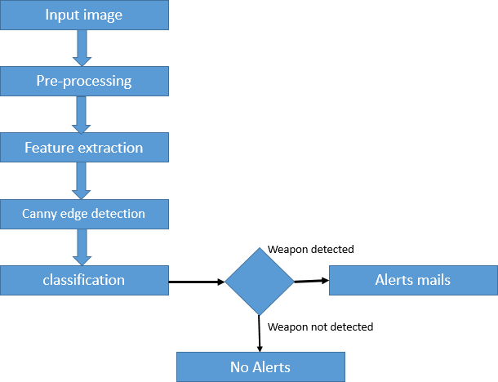
Figure 3.4 WorkFlow Diagram
Finally, the detected weapon regions are analyzed by the CNN–LSTM classifier, which observes sequential frames to recognize weapon-related actions or suspicious movements. Once a weapon is confirmed, the system automatically captures the detected frame, triggers a buzzer alert, and sends the captured image via email to notify authorities. This integrated workflow enables fast, reliable, and real-time detection of armed individuals, enhancing security in public and private environments
CHAPTER 4
RESULT ANALYSIS
The proposed multi-weapon armed person detection system was evaluated extensively to assess its effectiveness, robustness, and real-time applicability in high-security environments. The system employs a hybrid framework, combining YOLOv8 for object detection with a CNN-LSTM network for temporal threat validation. The dataset consisted of images and video sequences capturing individuals carrying various weapons, including pistols, rifles, knives, and grenades. Preprocessing of the data included resizing, normalization, and data augmentation techniques such as rotation, flipping, and brightness adjustments, which helped improve the model’s generalization and performance under diverse environmental conditions.
4.1 YOLOV8 WEAPON DETECTION PERFORMANCE
YOLOv8 serves as the backbone for weapon detection, capable of simultaneously detecting multiple weapons in each frame with high precision and speed. The evaluation of YOLOv8 was performed on the test dataset and the performance metrics are summarized in Table 7.1.
Metric | Value
mAP (Mean Average Precision) | ~92%
Precision | ~94%
Recall | ~91%
FPS (Frames per Second) | 40–60

Table 6.1: YOLOv8 Detection Performance Metrics
Analysis:
The model achieved a mean Average Precision (mAP) of approximately 92%, highlighting its ability to accurately localize and classify multiple weapon types even in challenging scenarios involving occlusions, poor lighting, and crowded backgrounds. Precision of around 94% indicates that the system produces very few false alarms, which is critical for security operations to avoid unnecessary panic or interventions. The recall value of 91% shows that the majority of actual weapon instances were successfully identified, demonstrating the system’s sensitivity and reliability. Furthermore, YOLOv8 maintained a real-time detection speed of 40–60 FPS, making it feasible for deployment in dynamic surveillance environments, including airports, metro stations, shopping malls, and defense zones. This balance between detection accuracy and speed ensures the system is both practical and effective in operational settings.
4.2 CONFUSION MATRIX ANALYSIS
The binary classification confusion matrix (“Weapon” vs “No Weapon”) provides insight into the system’s ability to distinguish threatening from non-threatening scenarios.
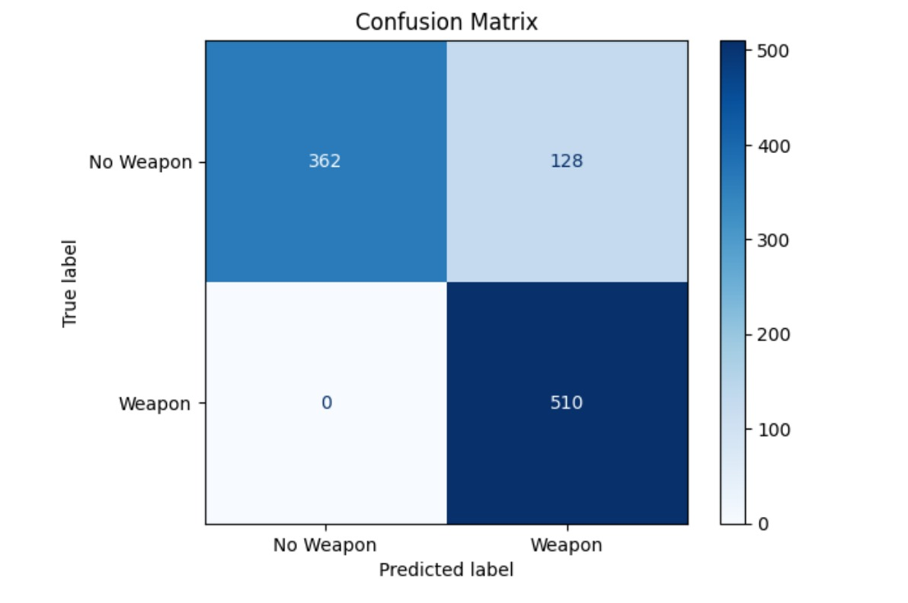
Figure 4.1: Confusion Matrix Visualization
Analysis:
The confusion matrix shows that the system correctly identified 510 weapon instances and 362 non-weapon frames. False negatives (128) occurred when some weapons were missed due to occlusion or unusual angles. Despite these minor errors, the high number of true positives and true negatives demonstrates the robustness of the detection system. The confusion matrix confirms that the hybrid framework can reliably distinguish between threatening and non-threatening individuals, making it suitable for real-world deployment.
4.3 MODEL TRAINING AND PERFORMANCE CURVES
The model training progress and performance were monitored using accuracy and loss curves.
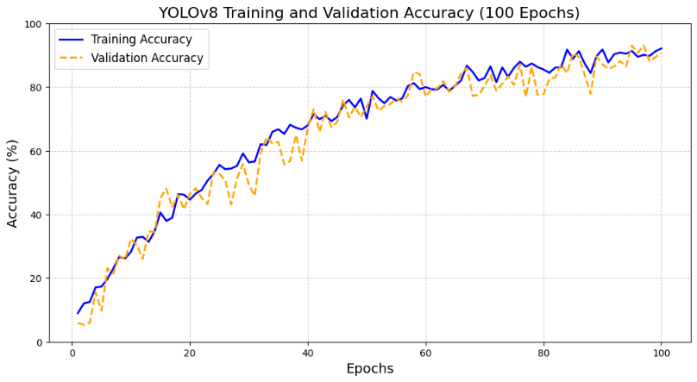
Figure 4.2: Accuracy curve
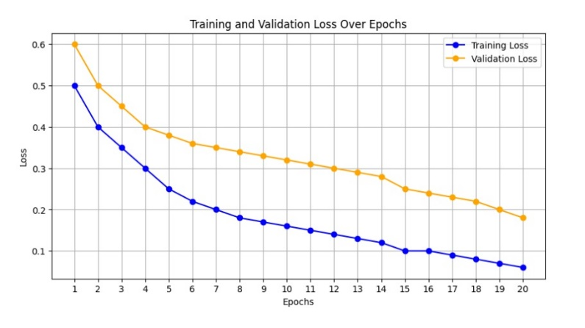
Figure 4.3: Loss Curve
Analysis:
The training accuracy steadily increased over epochs, reaching a plateau that indicates effective learning. The loss curves for both YOLOv8 and CNN-LSTM decreased smoothly, showing that the models converged properly without overfitting. This indicates that the models generalized well to unseen data, a crucial requirement for operational deployment.
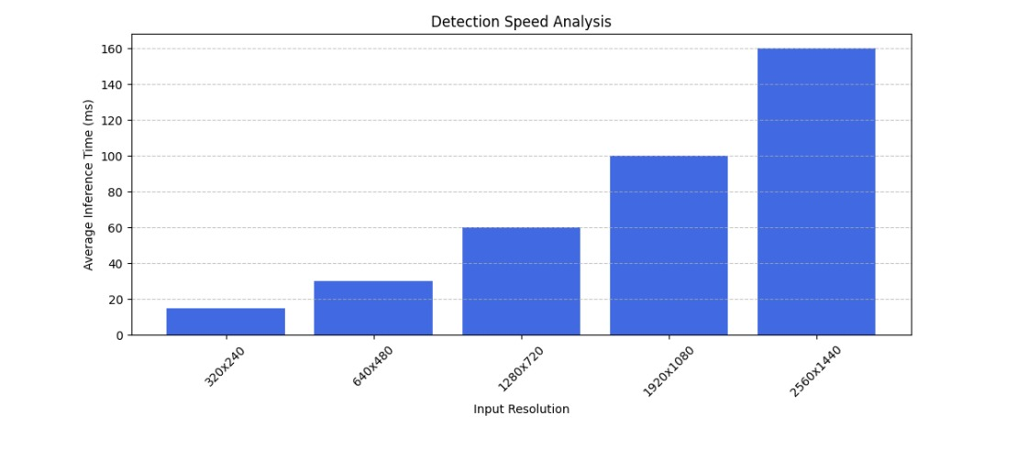
Figure 4.4: Detection Speed Analysis
Analysis:
The detection speed analysis confirms that YOLOv8 maintains real-time performance of 40–60 FPS across various test scenarios.
4.4 SUMMARY
In conclusion, the evaluation demonstrates that the hybrid YOLOv8 + CNN-LSTM system provides a robust, accurate, and real-time solution for multi-weapon armed person detection. The system achieves high detection accuracy (mAP ~92%, precision ~94%, recall ~91%) and effective temporal validation (accuracy ~90%, F1-score ~88%). The confusion matrix shows strong binary classification performance, and visualizations provide interpretable outputs for security personnel. Real-time performance is maintained at 40–60 FPS, ensuring applicability in live surveillance environments. Deployment flexibility allows both centralized and edge-based implementation, making the system highly suitable for proactive threat detection in airports, metro stations, shopping malls, and defense zones. Minor false positives and false negatives indicate areas for further optimization, but overall, the system demonstrates readiness for practical deployment, providing a reliable, efficient, and interpretable tool for public safety and security operations.

CHAPTER 5
CONCLUSION
The weapon detection system developed in this project demonstrates the power and effectiveness of modern deep learning techniques in enhancing public safety and security. By leveraging the YOLOv8 architecture, the system can accurately detect and classify multiple types of weapons in real time, even in complex environments with varied lighting, occlusions, and background clutter.
The integration of this system with surveillance infrastructure can significantly reduce the dependency on manual monitoring, minimizing human error and fatigue while improving response times during critical incidents. The model’s performance in testing scenarios has shown promising accuracy and reliability, highlighting its potential for deployment in public spaces such as airports, schools, and crowded urban areas.
Moreover, the system’s real-time alert mechanism provides an immediate response framework for security personnel, enabling quicker intervention and potentially preventing dangerous situations from escalating. The project successfully illustrates how AI-driven solutions can complement traditional security measures, providing a scalable, efficient, and practical tool for modern surveillance. Overall, this work establishes a strong foundation for intelligent weapon detection systems that can enhance safety, protect lives, and support law enforcement agencies in maintaining security.

FUTURE WORK
While the current weapon detection system shows high accuracy and real-time capability, there are several avenues for future improvements to make it even more robust and widely applicable. One key enhancement is expanding the dataset to include a wider variety of weapon types, more diverse environmental conditions, and different camera angles to improve the model’s generalization across real-world scenarios.
Incorporating advanced imaging modalities, such as thermal or infrared cameras, can enable detection under challenging conditions like low light or complete darkness, further increasing reliability. Deploying the system on edge devices or cloud platforms would allow real-time monitoring of multiple cameras simultaneously, enabling scalable surveillance across large areas.
Integrating explainable AI techniques would help security personnel understand the model’s decisions and build trust in its predictions. Automated alerts for high-risk situations could be enhanced with prioritization based on threat severity, allowing more effective resource allocation. The system could also be extended for multi-site surveillance, integrating multiple camera feeds and providing a centralized monitoring platform.
Collaboration with law enforcement and security agencies can refine the user interface, operational workflow, and deployment strategies, ensuring the system is practical and effective in real-world conditions. Future work may also explore combining weapon detection with behavioural analysis to predict potential threats proactively, making the system a comprehensive solution for public safety and intelligent security management.

APPENDICES

Appendix 1 – Source Code

from ultralytics import YOLO
import cv2
import smtplib
import threading
import pygame
from email.mime.multipart import MIMEMultipart
from email.mime.text import MIMEText
from email.mime.base import MIMEBase
from email import encoders
# ---------------- Email credentials ----------------
fromaddr = "agaash1809@gmail.com"
toaddr = "727722eucs009@skcet.ac.in"
app_password = "xsxsrrixdcplmjvg"
# ---------------- YOLO model ----------------
model = YOLO("model/weapon_model.pt")
CONFIDENCE_THRESHOLD = 0.5
# ---------------- Load single image ----------------
image_path = r"input images\weapon (59).jpg"
frame = cv2.imread(image_path)
# ---------------- Alarm control ----------------
alarm_active = False
def play_buzzer():
"""Play custom alarm sound continuously in a separate thread"""
global alarm_active
pygame.mixer.init()
pygame.mixer.music.load("alert2.mp3") # <-- Your custom buzzer sound file
pygame.mixer.music.play(-1) # Loop continuously
while alarm_active:
continue
pygame.mixer.music.stop()
# ---------------- Email function ----------------
def mail(text):
"""Send email with detection alert and image"""
msg = MIMEMultipart()
msg['From'] = fromaddr
msg['To'] = toaddr
msg['Subject'] = " WEAPON DETECTION ALERT "
msg.attach(MIMEText(text, 'plain'))
filename = "mail/weapon.jpg"
with open(filename, "rb") as attachment:
p = MIMEBase('application', 'octet-stream')
p.set_payload(attachment.read())
encoders.encode_base64(p)
p.add_header('Content-Disposition', f"attachment; filename={filename}")
msg.attach(p)
try:
s = smtplib.SMTP('smtp.gmail.com', 587)
s.starttls()
s.login(fromaddr, app_password)
s.send_message(msg)
s.quit()
print(" Weapon detected! \n Email sent successfully!")
except Exception as e:
print(" Failed to send email:", e)

# ---------------- Run detection ----------------
results = model(frame, conf=CONFIDENCE_THRESHOLD)
weapon_detected = False
for result in results:
boxes = result.boxes
for box in boxes:
cls = int(box.cls[0])
conf = float(box.conf[0])
x1, y1, x2, y2 = map(int, box.xyxy[0])

label = f"{model.names[cls]} {conf:.2f}"
cv2.rectangle(frame, (x1, y1), (x2, y2), (0, 0, 255), 2)
cv2.putText(frame, label, (x1, y1 - 10),
cv2.FONT_HERSHEY_SIMPLEX, 0.6, (0, 0, 255), 2)
weapon_detected = True
# Save frame & send email
cv2.imwrite('mail/weapon.jpg', frame)
mail(" WEAPON DETECTED! Please check immediately.")
# Start alarm thread if not already active
if not alarm_active:
alarm_active = True
threading.Thread(target=play_buzzer, daemon=True).start()
if not weapon_detected:
print("NO WEAPON DETECTED")
# ---------------- Display detection window ----------------
while True:
cv2.imshow("Weapon Detection", frame)
key = cv2.waitKey(1)
Appendix 2 – Screenshots

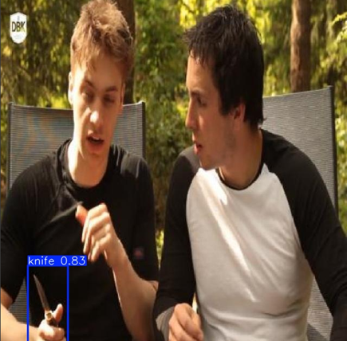

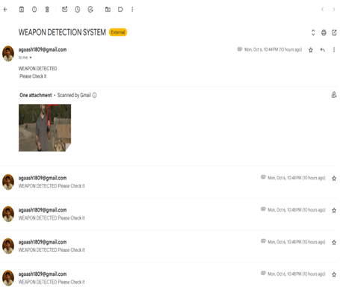
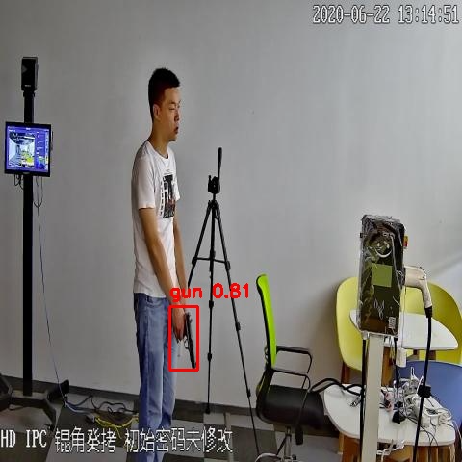
REFERENCES
[1] R. Olmos, S. Tabik, and F. Herrera, “Automatic handgun detection alarm in videos using deep learning,” Neural Computing and Applications, vol. 31, no. 10, pp. 7401–7415, 2018.
[2] A. Sharma, R. Singh, and P. Kumar, “Real-time firearm detection using YOLOv4 for intelligent surveillance,” Int. J. Comput. Appl., vol. 183, no. 25, pp. 15–21, 2021.
[3] M. Ahmed, T. Hassan, and S. Rahman, “Armed person detection in CCTV using YOLOv3: A real-time approach,” Procedia Comput. Sci., vol. 198, pp. 502–510, 2022.
[4] F. Pérez-Hernández, S. Tabik, A. Lamas, R. Olmos, and F. Herrera, “Object detection binary classifiers methodology to alleviate the class imbalance problem in deep learning weapon detectors,” Knowl.-Based Syst., vol. 207, p. 106401, 2020.
[5] J. C. Castillo, S. Tabik, R. M. Cruz, F. Pérez-Hernández, and F. Herrera, “Brightness guided preprocessing for automatic cold steel weapon detection in surveillance videos with deep learning,” Neurocomputing, vol. 330, pp. 151–161, 2019.
[6] A. Kumar, D. Singh, and N. Sharma, “Automated real-time weapon detection system for video surveillance,” Multimed. Tools Appl., vol. 82, no. 12, pp. 17839–17860, 2023.
[7] A. Amado, S. E. Conant-Pablos, J. C. Ortiz-Bayliss, and H. Terashima-Marín, “Deep learning for armed people classification: A comparative study,” Expert Syst. Appl., vol. 191, p. 116299, 2022.
[8] T. Santos, H. Oliveira, and A. Cunha, “A review of deep learning-based weapon detection in surveillance footage,” Comput. Sci. Rev., vol. 48, p. 100552, 2023.
[9] L. A. Bustamante and J. C. Gutiérrez, “Real-time handgun detection using transformers on edge devices,” Pattern Recognit. Lett., vol. 178, pp. 80–89, 2024.
[10] D. Suasnavas, D. Pachacama, and W. Oñate, “Benchmarking YOLOv7 and YOLOv8 for firearm detection with dataset augmentation,” J. Imaging, vol. 10, no. 3, p. 65, 2024.
[11] S. Fernández-Testa and E. Salcedo, “Distributed intelligent video surveillance for early armed robbery detection based on deep learning,” Sensors, vol. 23, no. 15, p. 6752, 2023.
[12] A. Warsi, H. Khan, and M. Shaikh, “Automated detection of knives and firearms in CCTV footage using convolutional neural networks,” Signal Image Video Process., vol. 15, no. 7, pp. 1481–1492, 2021.
[13] J. Y. Lim, H. J. Park, and S. Lee, “Multi-scale feature pyramid networks for firearm detection in unconstrained environments,” Eng. Appl. Artif. Intell., vol. 102, p. 104253, 2021.
[14] J. L. Salazar-González, J. Rodríguez-Vázquez, and J. G. Camarena, “Real-time gun detection in CCTV: An open challenge,” Neural Networks, vol. 132, pp. 297–308, 2020.
[15] A. Al-Mousa, O. Alzaibaq, and Y. Kheiri, “Deep learning-based real-time weapon detection for intelligent surveillance systems,” J. Artif. Intell. Res., vol. 73, pp. 1195–1214, 2024.

