ASSIGNMENT-1
Real-Time City Noise Monitoring System

NAME : AGASH K
ROLL NO : 727722eucs009
SUBJECT: INTERNET OF EVERYTHING

Real-Time City Noise Monitoring System

Introduction
Noise pollution is one of the most underrated yet harmful environmental hazards affecting urban populations today. With rapid urbanization, vehicular traffic, industrial zones, and social activities like festivals, cities are increasingly experiencing high decibel levels beyond safe thresholds defined by organizations like the WHO.
The concept of a Real-Time City Noise Monitoring System leverages the Internet of Everything (IoE) to detect, monitor, and report sound levels across city zones using connected smart sensors. This real-time data helps in noise regulation, health protection, and long-term city planning.

Detailed Description
The system uses distributed sensor nodes, each equipped with sound sensors and microcontrollers, deployed at strategic urban locations—like schools, hospitals, traffic junctions, and residential areas. These sensors continuously measure decibel levels and send the data wirelessly to a centralized server or cloud platform.
Authorities can access this information via a web or mobile dashboard, where they can see historical trends, receive alerts, and identify areas where noise exceeds regulatory limits. Citizens may also be provided a basic app to report or view localized noise data.

Goals of the Project
- Detect excessive noise pollution in real time
- Help city officials enforce noise regulation policies
- Support long-term urban development through data analytics
- Educate and empower citizens through awareness

Functional Specifications
Feature | Description
Real-Time Monitoring | Data updated every 30 seconds to 1 minute
GPS-Based Location Tagging | Each data point is associated with exact geo-coordinates
Remote Configuration | Admins can modify sensor thresholds remotely
Alert System | Notification to authorities when dB level crosses limit
Data Analytics | Graphs, heatmaps, time-series analysis of noise trends
Secure Access | Encrypted data transmission and role-based access control

Technical Specifications
- Sensor Range: 30 dB to 130 dB (suitable for all environments)
- Accuracy: ±1.5 dB
- Microcontroller: ESP32 (dual-core, Wi-Fi + Bluetooth enabled)
- Connectivity Options: Wi-Fi (urban), LoRa (rural), GSM (fallback)
- Power Supply: 5V DC with solar charging capability and Li-Ion battery
- Data Transmission Rate: Every 30s or based on events
- Weatherproofing: IP65-rated enclosures to withstand outdoor conditions
- Cloud Integration: AWS IoT Core, Firebase, or Azure IoT Hub

Hardware Architecture

Component Overview
- Sound Sensor (e.g., MAX4466 or MEMS Microphone): Detects ambient sound and converts it to an analog signal.
- Microcontroller (ESP32): Processes the signal, checks thresholds, formats data, and communicates with the server.
- GPS Module (e.g., NEO-6M): Adds location information to every sound reading.
- Wireless Communication (Wi-Fi/GSM/LoRa): Sends the data packet to the cloud server.
- Power Management Module:
- Solar Panel (12V 10W)
- Battery Backup (3.7V 2500mAh)
- Charge Controller for efficient switching

Deployment Example
- Mounted on lamp posts, rooftops, or traffic signal poles
- Solar panel placed above the sensor for continuous charging
- Compact weatherproof casing with UV-resistant material

Software Architecture
Firmware (Sensor-Side Software)
- Written in Arduino C++
- Handles ADC (Analog to Digital Conversion), threshold logic, communication protocols
- Performs self-checks and reconnects if transmission fails
- Encrypts payload before sending
Cloud Backend
- Hosted on AWS, Azure, or Firebase
- Receives incoming data from each node via MQTT/HTTP
- Stores it in a real-time database (e.g., Firebase Realtime DB or MongoDB)
- Runs background jobs to flag anomalies (via AWS Lambda / Node.js)
Frontend Interface
- Built using ReactJS or Angular
- Displays:
  - Heatmaps of noise levels
  - Time-series graphs (line/bar)
  - List of top noise hotspots
- Admin access to:
  - Set thresholds
  - Check sensor health
  - Download historical reports

Role | Features
Admin | Full access, manage nodes, download data
City Officer | View dashboards, respond to alerts
Citizen | Read-only view of local noise levels

Block Diagram
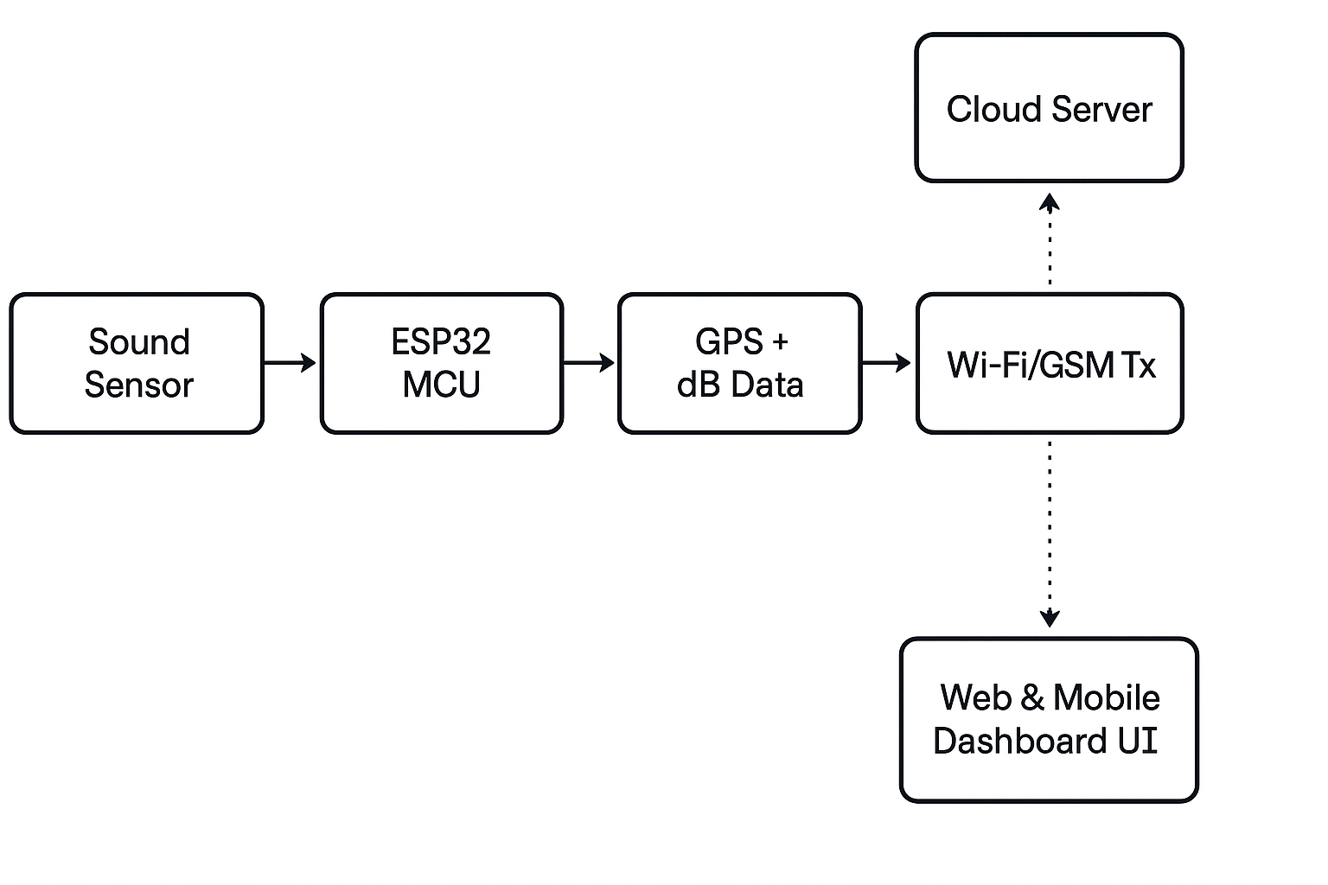
Explanation
- Sensor Layer: Measures ambient sound and passes it to the microcontroller.
- Processing Layer (MCU): Applies filtering, checks thresholds, tags location using GPS.
- Communication Layer: Uses a network protocol to transmit structured data to the cloud.
- Cloud Layer: Stores data and sends notifications if values cross defined decibel thresholds.
- User Interface: Allows stakeholders to visualize, analyze, and respond in real time.

Advantages and Disadvantages
Advantages
- Real-Time Awareness: Immediate detection of noise hotspots.
- Data-Driven Governance: Helps authorities make informed decisions.
- Scalability: Easy to add more sensors as city expands.
- Energy-Efficient: Solar-powered system lowers maintenance cost.
- Health Benefits: Reduces risk of noise-induced hearing loss, stress, etc.
- Community Engagement: Citizens get involved and informed via dashboards.
Disadvantages
- Cost of Initial Setup: High number of nodes needed for full coverage.
- Connectivity Issues: Network outages can affect real-time reporting.
- Sensor Drift: Calibration may degrade over time.
- Privacy Concerns: Sensors could be misunderstood as audio recorders.
- Maintenance: Outdoor equipment prone to damage from weather and pollution.

Conclusion
The Real-Time City Noise Monitoring System is a prime example of how the Internet of Everything can contribute to smart and sustainable urban living. With its ability to provide real-time, location-aware data, it serves not only as a monitoring tool but also as a catalyst for awareness, governance, and health improvement.
Noise pollution, often overlooked, has a profound impact on mental health, communication, and community well-being. This system provides a technological solution that aligns with smart city initiatives and public welfare.
Future Enhancements
- AI-based Pattern Recognition: Forecast future trends or detect abnormal patterns (e.g., construction noise at night).
- Integration with Police & Municipality: Auto-report violations to respective departments.
- Mobile Alerts to Citizens: Notify users when noise exceeds safe limits nearby.
- Voice-Activated Feedback: Enable citizens to interact with the system using voice commands.
- Blockchain-based Data Ledger: For transparency and legal accountability in case of disputes.

