Course Work Answer Book
UNIVERSITY COURSE WORK

REGISTRATION NUMBER |  |  |  |  |  |  |  |  | VU-BSF-2603-1452-DAY
Title of The Program (eg BBA, BSC, BPH, BSWA) |  |  |  |  |  |  |  |  |  |  |  |  | BSF
Bachelor of Science in Software Engineering
Department |  |  |  | Other Depts in Faculty of Science and Technology
Faculty | Faculty of Science and Technology
Year Of study (YrI , YrII, YrIII, or YrIV) |  |  |  |  |  |  |  |  |  |  | 1
Module Code and Name |  |  |  |  |  |  | 1203 ST
Programming Fundamentals
Semester |  |  | 2
Retake: |  | Yes |  |  | ☐ |  |  | No |  | ☐ |  | (Tick whichever is applicable)
Date of Course Work |  |  |  |  |  | Mon Aug 31 2026 00:00:00 GMT+0300 (East Africa Time)
DIRECTIONS TO CANDIDATES (Turn to page ii for more instructions). |  |  |  |  |  |  |  |  |  |  |  |  | FOR USE BY EXAMINERS ONLY
 |  |  |  |  |  |  |  |  |  |  |  |  | Question Number | Internal Examiner | External Examiner
- Leave margin blank.
- Begin each answer on a fresh page.
- Write the number of each question and theCandidate's Number at the top of each page.

- Write the numbers of the questionswhich you have attempted, with subsections where necessary, in the spacesprovided below

 |  |  |  |  |  |  |  |  |  |  |  |  | TOTAL

NUMBER OF QUESTIONS you have answered in the order in which you have written them

How and where should I submit my Course Work script?
Every student will be required to submit their Course Work via VClass Students Portal E.g. you go to www.vclass.ac and login, to your account, then on the left sidebar menu click on Course Work.
Under Course Work you will see the following: -
- Instructions for that particular Course Work with time required to finish your Course Work as per instructions,
- A student will be required to download the question paper and the answer sheet provided by the university within the same module Course Work, or a student can be required to attempt structured questions within the system depending on how the Course Work was set.
- Submission of answered questions is done,
- Student is required to click to consent to show that the answered Course Work belongs to them.
- Note that if Course Work is for download, a student will be required to download the question paper and answer sheet, do their Course Work within the given stipulated time.
- Required to scan and upload back the answered booklet through the same portal as per format available.
- Course Work uploaded will directly be received by the Registry department.
- Students here are required to use VClass e-Learning systemfor all Course Work and for any failure they can contact the Registry department for guidance.
- No late submission will be accepted.
Avoid any malpractice because this will attract severe penalties such as invalidating the answered script whose consequences will attract retakes.
1.Step-by-step screenshots demonstrating the operation of the developed system.
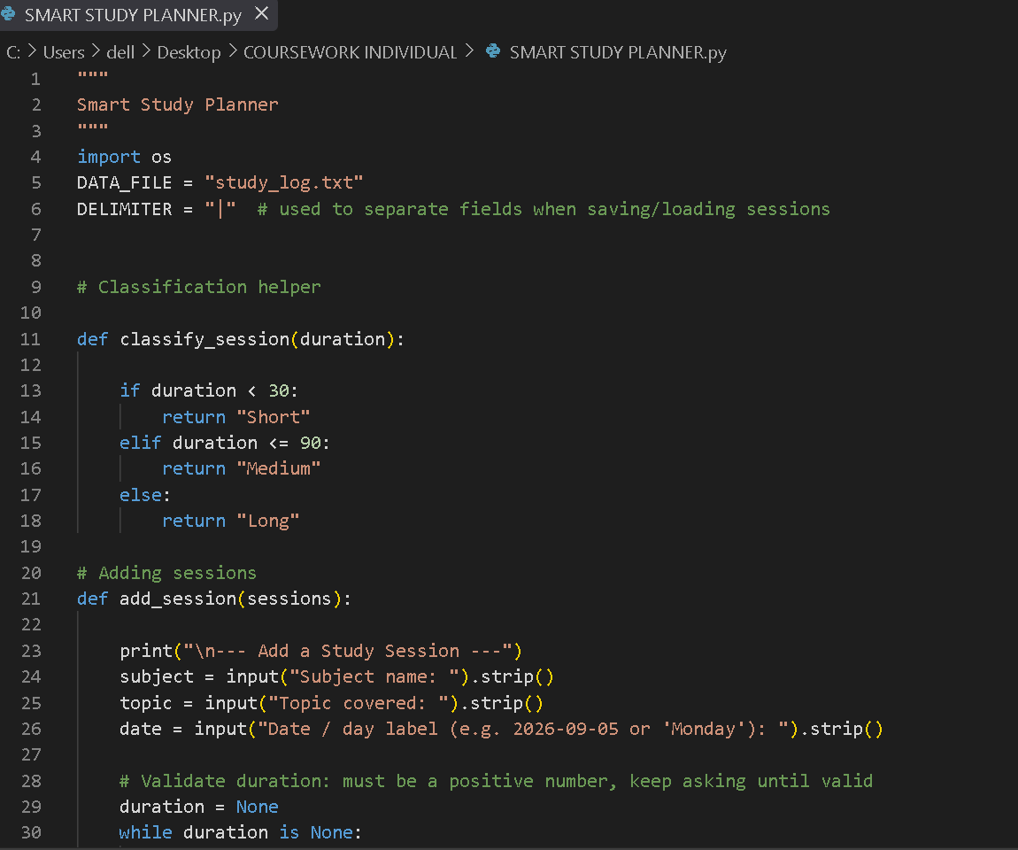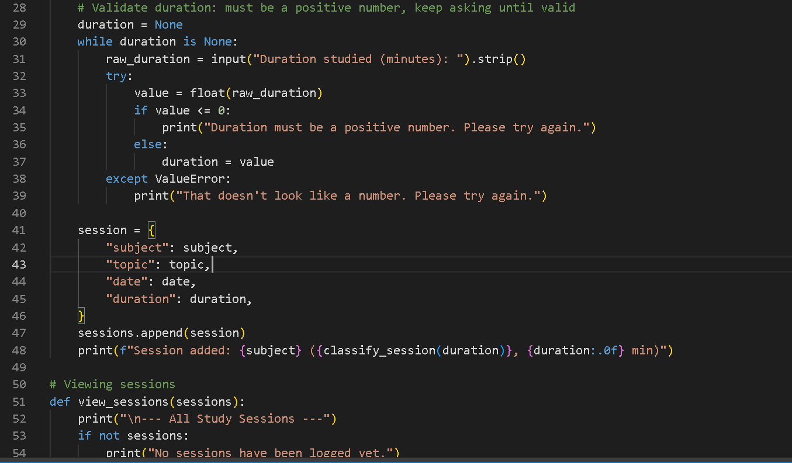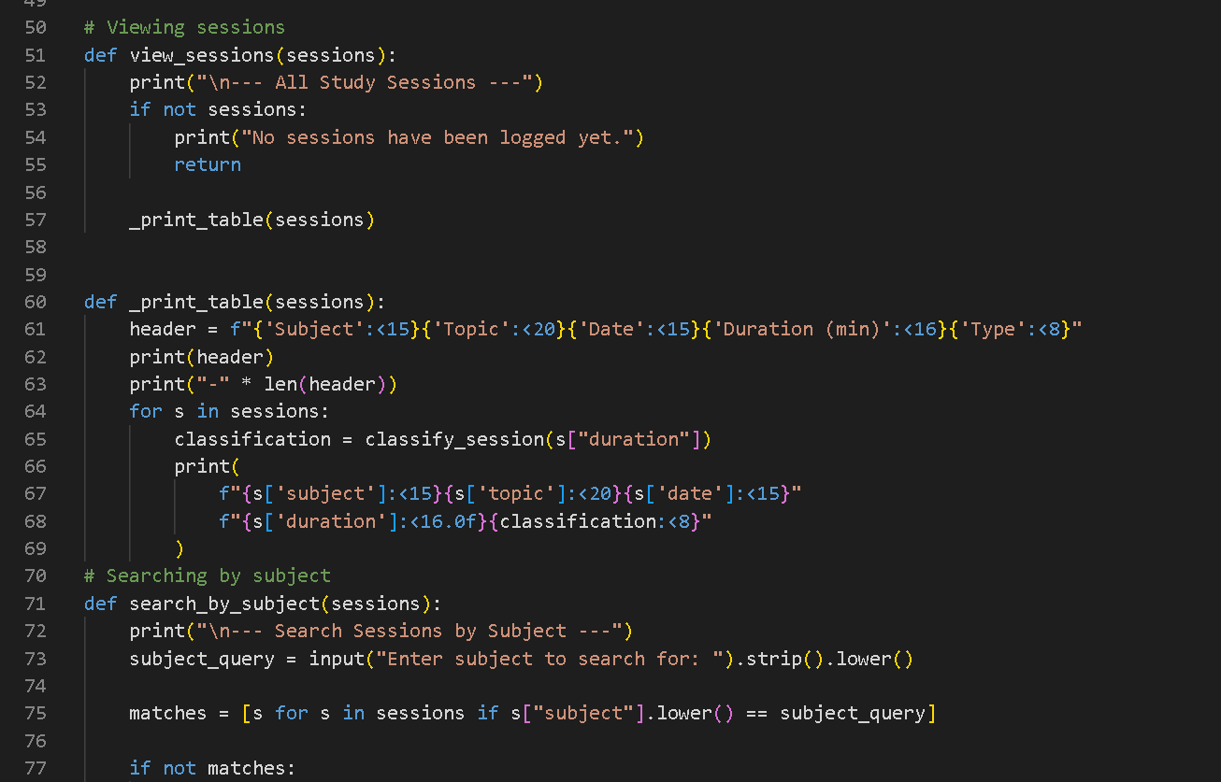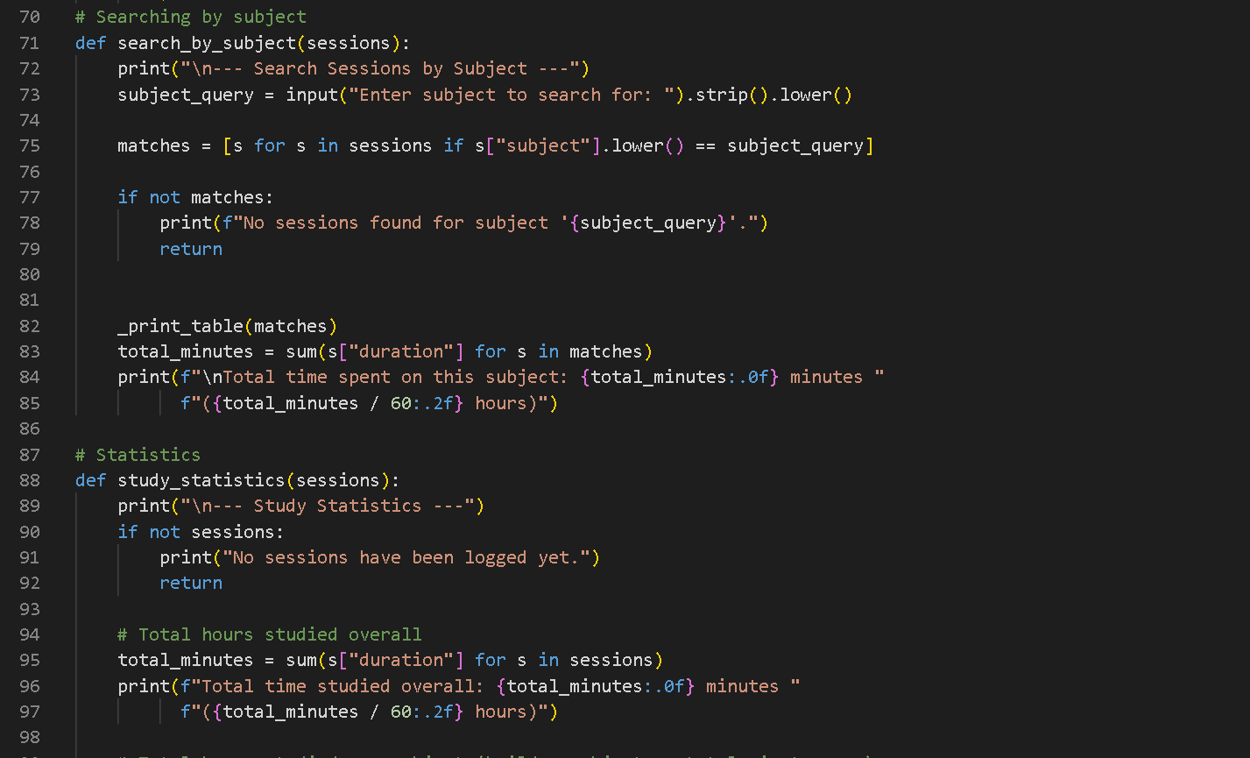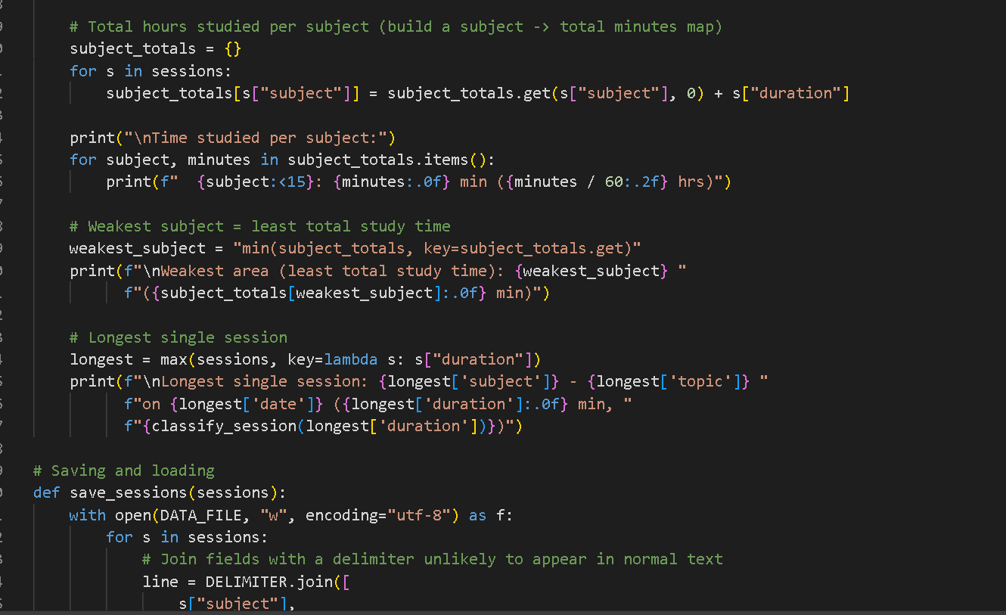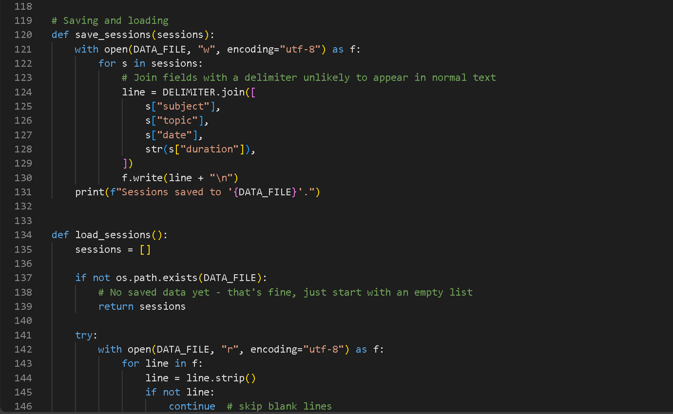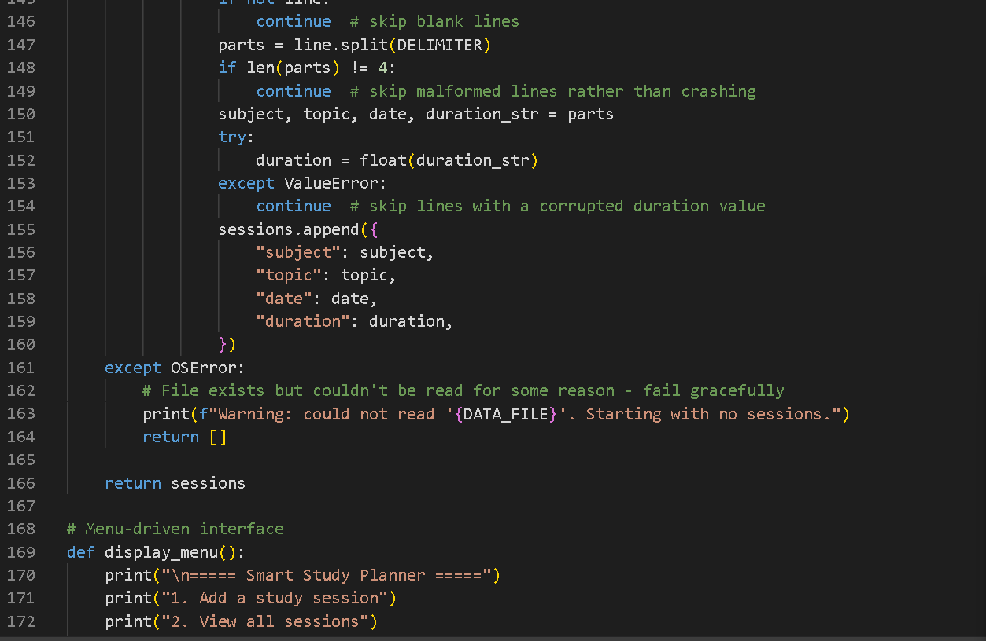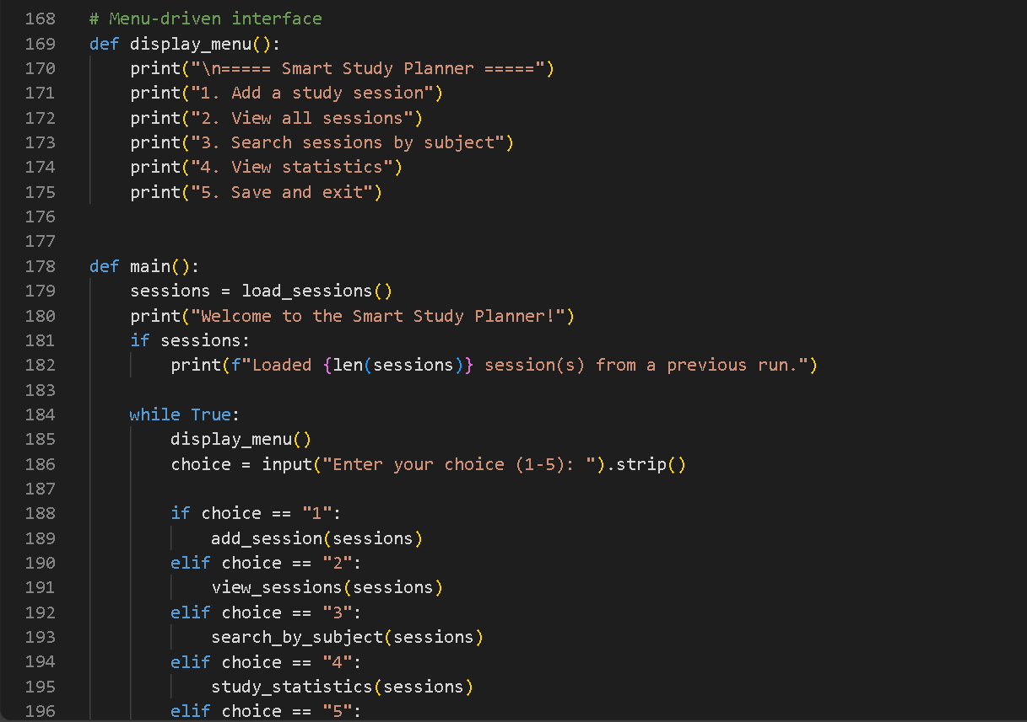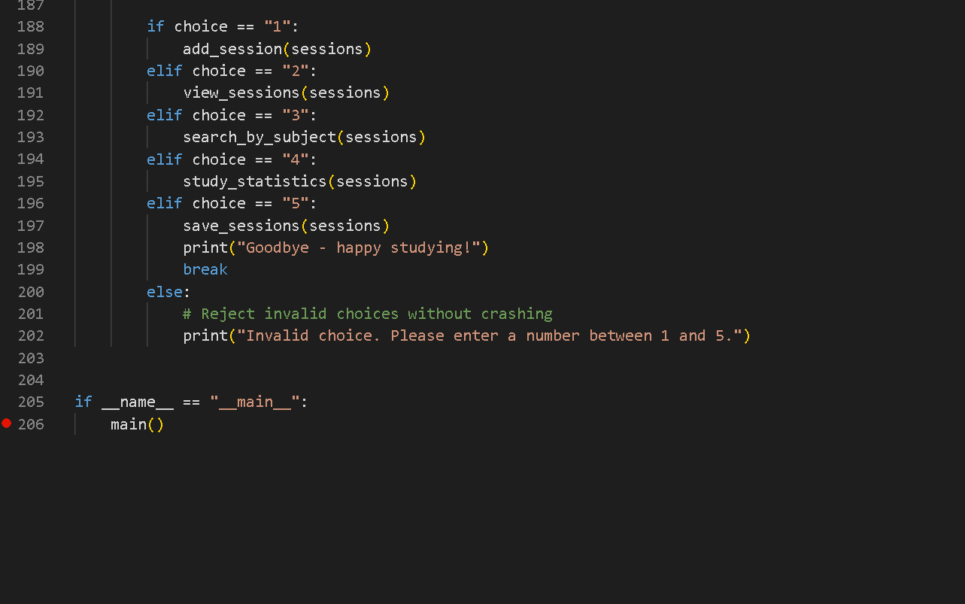

THIS IS HOW IT DISPLAYS IT’S RESULTS
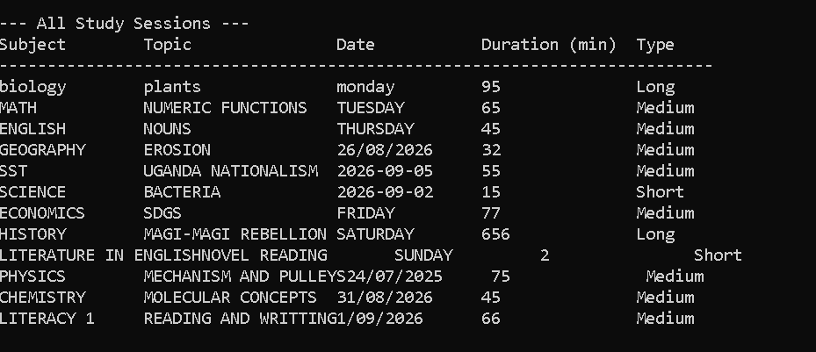

SMART STUDY PLANNER – BRIEF REPORT
Introduction
The Smart Study Planner is a console-based Python application designed to help students record, manage and analyse their study sessions during a semester. The system allows users to enter information about the subject, topic, date and duration of each study session.
Objectives
The main objectives of the system are to:
- Record study sessions for different subjects.
- Display all recorded study sessions in an organised format.
- Search for study sessions by subject.
- Calculate total study time and study time per subject.
- Identify the subject with the least study time.
- Identify the longest study session.
- Save study records so that they remain available when the program is run again.
System Features
The program uses a menu-driven interface with five options: adding a study session, viewing all sessions, searching by subject, viewing statistics, and saving and exiting.
Each study session is stored as a dictionary inside a list. The duration is validated to ensure that only positive numbers are accepted.
The classify_session() function categorises sessions into three groups: Short for sessions under 30 minutes, Medium for sessions from 30 to 90 minutes, and Long for sessions over 90 minutes.
The search feature performs case-insensitive subject matching and calculates the total time spent on the selected subject.
The statistics feature calculates the overall study hours, study hours per subject, the subject with the least study time, and the longest individual study session.
File Storage
The application uses a file named study_log.txt to store study session records. When the program starts, it automatically loads existing records from the file. If the file does not exist, the program continues normally without producing an error.
Conclusion
The Smart Study Planner demonstrates the use of important Python programming concepts including functions, lists, dictionaries, loops, conditional statements, input validation, file handling and exception handling. The system provides a simple way for students to monitor their study habits and identify subjects that may require more attention.

