*qMTLab*: a Software for Data Simulation, Analysis and Visualization

*qMTlab* is a powerful, open source, scalable, easy to use and intuitive software for qMT data simulation, fitting and analysis. The software consists of two parts: 1) a qMT data simulator, and 2) a qMT data fitting and visualization interface. The simulation part allows end users to easily simulate qMT data using the above described methods, evaluate how well these models perform under known parameters input, determine the most appropriate acquisition protocol and evaluate how fitting constraints impact the results. The data fitting part provides a simple interface to import real-world qMT data, fit them using the selected fitting procedure, and visualize the resulting parameters maps.

1. Installing qMTLab

qMTLab can be downloaded freely here:

<https://github.com/jfcabana/qMTLab/archive/master.zip>

Alternatively, if you have a GitHub account (free) and wish to contribute to the software, you can go to

<github.com/jfcabana/qMTLab/>

and fork the repository to your own account. If you made any contribution to the software that you feel should be included in the master, please do a pull request so that we can include your modifications.

Once you have downloaded the qMTLab-master.zip file, extract its content on your computer, in an easy to access location. Start Matlab, navigate to the folder you just extracted, and in the Command window, type ‘qMTLab’ and hit enter. After a few seconds of loading, you should be presented with a graphical user interface (gui) that will allow you to perform various tasks.

1. Interface

When you first launch *qMTLab*, you will be presented with a blank interface. The interface consists of three columns, or panels. On the left, you have the *Menu panel*, in the center you have the *Main panel*, and on the right, in a separate floating window, you have the *Options panel*.

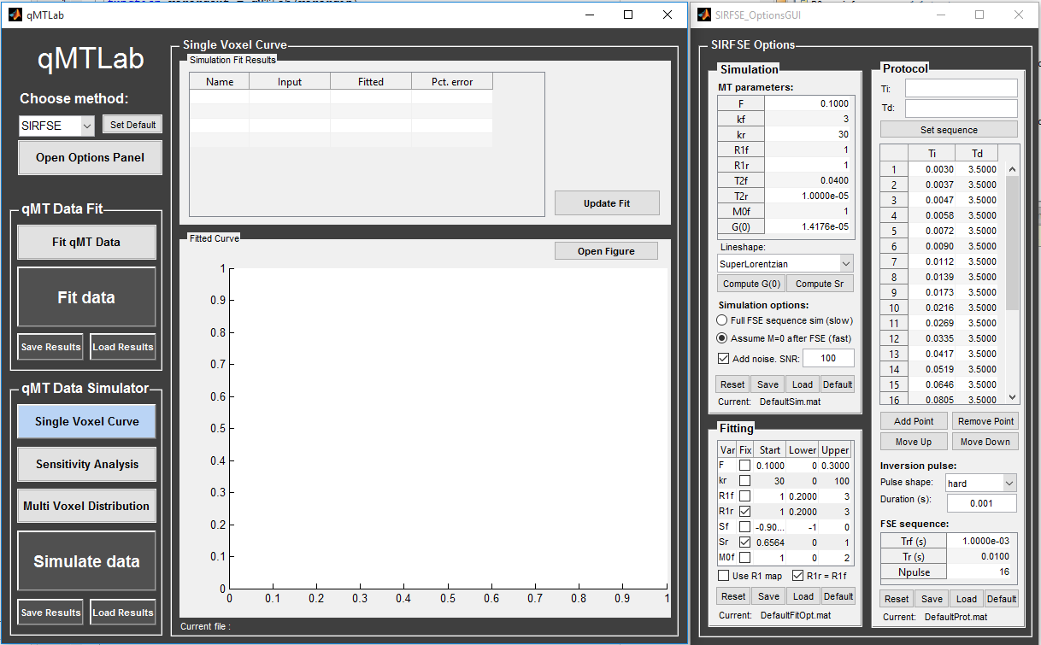

* 1. Menu panel

The *Menu panel* is where you can choose the task you want to perform. It is divided in three sub-groups: Method, qMT Data Fit and qMT Data Simulator.

* + 1. Method

At the top, you will find a drop-down menu where you can choose the qMT acquisition method that you want to be working with. At the moment, you can choose between ‘SIRFSE’ for selective inversion recovery-fast spin echo, ‘SPGR’ for the MT prepared Spoiled gradient echo or ‘bSSFP’ for balanced steady-state free precession. Note that your Matlab working directory will change in the background to the sub-directory of the currently selected method, and that the *Options panel* will update to the appropriate window according to your selection.

If you plan to be working mainly with a particular method, select it from the drop-down menu first, and the click on the ‘Set Default’ button next to it. Next time you open *qMTLab*, your preferred method will be selected by default.

Clicking on the ‘Open Options Panel’ below the method drop-down menu will open the *Options panel* window and set its position on the right side of the *Main panel*. This is useful to bring back the *Options panel* window to the front if its hidden behind another window, to reset it position if you have resized the windows, or to reopen it in case you closed it.

* + 1. qMT Data Fit

Clicking on the light gray ‘Fit qMT Data’ button will change the *Main panel* to the *Fit qMT Data* view. This is where you can load your qMT data files for fitting and for viewing the resulting parameters maps. Refer to section ??? for more information.

Click the big ‘Fit Data’ button only when you have selected your data files, set up your protocol and fitting options and are ready to begin the fitting process, which, depending on the size of your data, can take from a few minutes to a couple of hours. The ‘Save Results’ button will prompt you to save a .mat file with the results of your data fit. ‘Load Results’ will load previously saved results and display them.

* + 1. qMT Data Simulator

The three light gray buttons allows you to choose between three different data simulation mode: ‘Single Voxel Curve’, ‘Sensitivity Analysis’ and ‘Multi Voxel Distribution’. Clicking on any one of these buttons will bring the corresponding interface to the *Main panel*. When any of these interface are active, click the big dark gray ‘Simulate Data’ button will launch the simulation using the current setting. The ‘Save Results’ button will prompt you to save a .mat file with the current simulation results. ‘Load Results’ will load previously saved simulation results and display them in the appropriate panel.

The *Single Voxel Curve* panel is a simple interface to simulate MT data from a single voxel, using the defined MT parameters and protocol. It is the fastest way to evaluate various acquisition protocol, the performance of the model and fitting options under various circumstances. Once the appropriate protocol and fitting options are determined, you may be interested to evaluate in more details how the model responds to varying input parameters. Refer to section ??? for more information.

The *Sensitivity Analysis* simulation allows you to systematically vary *one* MT parameter, over a defined range and number of points, while keeping the others fixed. For each simulated data point, noise is added with a given SNR, and the fit is run multiple times while adding randomly distributed noise. This allows you to evaluate the variance of the fit at each point. When the simulation is done, a plot shows any variable input parameters as the independent variable, as well as the mean values and variance of any fitted parameters. Refer to section ??? for more information.

The *Multi Voxel Distribution* is a tool to simulate any number of voxels, where any parameters are allowed to be varied simultaneously. You can choose how many voxels to simulate and which parameters are to be normally distributed, with its mean value and variance. The results can be displayed in a number of ways such as distribution histograms, scatter plots of input vs fitted parameters, error histograms, root-mean-squared error bar graphs, etc. Refer to section ??? for more information.

* 1. Main panel

The *Main panel* is where the simulation or fit results are displayed. The view for this panel changes correspondingly to the task selected in the *Menu panel*. Please refer to the corresponding task for more information: *Fit qMT Data, Single Voxel Curve, Sensitivity Analysis, Multi Voxel Distribution.*

* 1. Options panel

This is where you can set up all the parameters that are related to the simulation, the fitting and the protocol. The *Options panel* is displayed in a separate window than the *Menu panel* or *Main panel*. This is because each qMT acquisition method has its own particular options, and this window needs to be changed correspondingly. It can also be closed at any time, if it is not currently needed, to provide for a simpler interface. The *Options panel* consists of three sub-groups of options: ‘Simulation’, ‘Fitting’ and ‘Protocol’. At the bottom of all these sub-groups you will find buttons to ‘Reset’ the changes you made, ‘Save’ the current settings as a .mat file, ‘Load’ a .mat file of settings, or go back to the ‘Default’ settings.

* + 1. Simulation

As the name implies, this is where you set up all the options related to the simulations. At the top of this group, the ‘MT parameters’ table is where you define all the parameters that describe the two-pool model of MT. You will also find options that are specific to how the simulation is actually performed. More info in ???.

* + 1. Fitting

This is where you set up your fitting routine options. You will find a table listing all the variables that are available for fitting in the current method, a tick box to select which variables are to be held fixed, a starting value and lower/upper bounds. Depending on the method, additional options may be available. See ??? for more information.

* + 1. Protocol

Here you can (must) define the acquisition protocol that you wish to simulate, or in the case of data fitting, the protocol you used to acquire the data. See ??? for more information.

1. Data fitting

*qMTLab* provides a convenient interface to fit your qMT data and visualize the parameters maps. To ensure that the results are successful, you’ll need to define the appropriate protocol, as it was used for data acquisition, and to format your qMT data in the way *qMTLab* expect it to be.

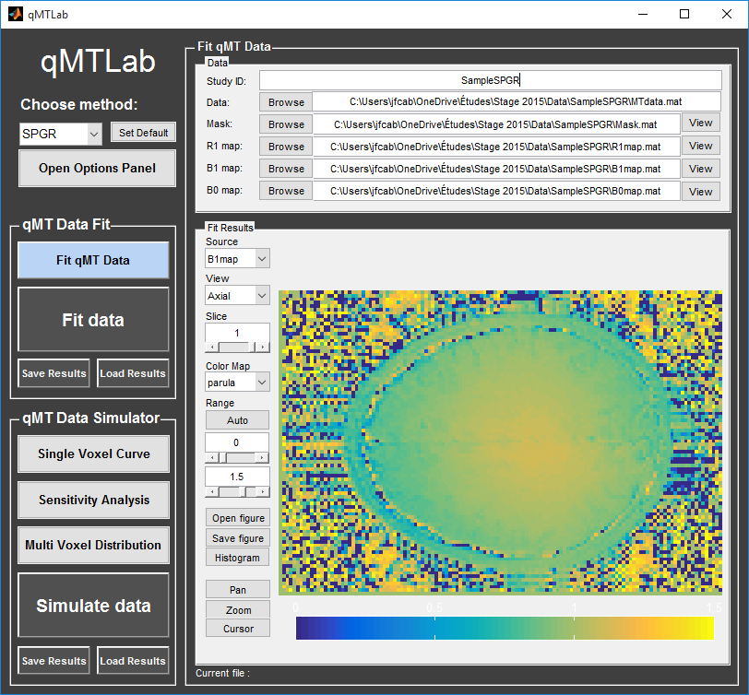

Figure 1 – Data fitting interface

* 1. Data format

As the file format used across sites can vary significantly, the way to ensure compatibility with *qMTLab* is to accept only native .mat files. You may want to write a small Matlab script that will take care of the format conversion if you plan to integrate *qMTLab* as part of your regular workflow. Your files should be respect the following:

* A .mat file containing a single array of data.
* The name of the file can be anything, but the array it contains should be named appropriately: MTdata (for the actual MT data array) or R1map / B1map / B0map / Mask respectively for a R1 / B1 / B0 or Mask file. Names are case-sensitive.
* For single slice (2D) imaging, MTdata is a 3D array with size [nx, ny, ndata], where nx/ny is the number of voxels in the x/y direction, and ndata is the number of data points for each voxel. For volume imaging (3D), MTdata is a 4D array with size [nx, ny, nz, ndata], where nx/ny/ndata are a above, and nz is the number of voxels in the z direction.
* Other files (R1map / B1map / B0map / Mask) are formatted the same as MTdata, but without the last dimension (ndata).
* In the case of MT-SPGR, MTdata should be **normalized**, i.e. MTdata is m = M/M0, where M is the measured signal when an MT pulse is applied, and M0 is the measured signal using the same acquisition sequence, but without the MT pulse.
* R1map is an (optional) map with actual R1 values (in s-1).
* B1map is an (optional) map scaled such that pulse flip angle (α, in degrees) correction at each voxel is given by: α’ = α × B1map.
* B0map is an (optional) map scaled such that pulse offset (Δ, in Hz) correction at each voxel is given by: Δ’ = Δ + B0map.
* Mask is an (optional) logical map with 0 for masked voxels and 1 for voxels to be fitted.
* If your data can be acquired with various protocols, it is possible to include the protocol in the MTdata .mat file, so the appropriate protocol is automatically defined when you load your file. To do so, first define and save your protocols (see section ???), and then load it as structure named ‘Prot’ and save this structure along with the MTdata array (see example ???).
  1. Procedure

1. Select the acquisition method of your qMT data using the ‘Method’ drop-down menu in the *Menu panel*.
2. In the *Menu panel*, click on ‘Fit qMT data’ to display the fitting interface in the *Main panel*.
3. Enter a name for your study in the ‘Study ID’ box.
4. Load your MT data by clicking the browse button beside the ‘Data:’ line, or enter the full file path to it in the textbox. Note that by default, *qMTLab* looks for files in the ‘Data’ subfolder of the current active method (e.g.qMTLab/ SPGR/Data/).
5. If you have a Mask / R1 / B1 or B0 map, load them using the browse button or by entering the full file path in the appropriate text box. You can view any of these maps by click its ‘View’ button.
6. If a ‘Prot’ structure defining the acquisition protocol was saved inside the MTdata .mat file, the appropriate protocol options should have loaded in the *Options panel*. Ensure it is correctly defined. If no ‘Prot’ structure was given, define or load the appropriate protocol in the *Options panel* (see section ??? for details).
7. Define your fitting options in the *Options panel* (see section ??? for details).
8. In the *Menu panel*, click on ‘Fit data’ to start the fitting process.
9. Once the fitting is done, a temporary file will be saved in the ‘FitResults’ subfolder of the current active method (e.g.qMTLab/ SPGR/FitResults/). You can save the current fit results by clicking ‘Save Results’ in the ‘qMT data fit’ section of the *Menu panel*.
10. Use the controls in the ‘Fit Results’ section to visualize the results (see ??? for details).
    1. Viewing the fit results

Once you have finished fitting your qMT data, or when you load previously saved fit results by clicking ‘Load Results’ in the ‘qMT data fit’ section of the *Menu panel*, the maps will be displayed in the ‘Fit Results’ section. Controls are on the left side of the figure to navigate the maps:

* Source: select the parameter map to display
* View: select the side from which to view the data (available only on 3D maps)
* Slice: navigate through the z direction of the current view (available only on 3D maps)
* Color Map: choose the color scheme to use from a set of pre-defined Malab colormaps
* Range: Control the colormap min/max values. Clicking ‘Auto’ will set the min/max values using the min/max of the currently displayed image. Top textbox/slider allows you to manually set the Min value, while bottom textbox/slider are for the Max value
* Open figure: open the current figure in a new window
* Save figure: save the current figure
* Histogram: open a new window with an histogram of the voxels in the currently selected slice (note that zooming in on a particular section while still produce an histogram of the full slice)
* Pan: change the cursor mode to ‘Pan’. Click and hold inside the figure to move around. Double click inside the figure to reset view. Clicking again the Pan button will turn off pan mode.
* Zoom: change the cursor mode to ‘Zoom. Click and hold inside the figure to draw a region to zoom in on. Double click inside the figure to reset view. Clicking again the Zoom button will turn off zoom mode.
* Cursor: change the cursor mode to ‘Data Cursor’. Click on a voxel to display info (X/Y is the position of the voxel, index is the value of the map at this point, RGB is the mapped color code).

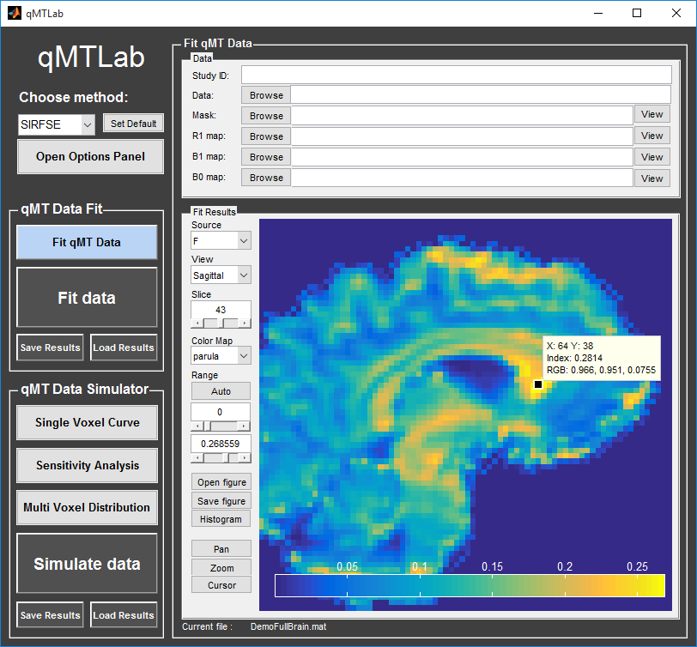

Figure 2 – Fit Results Viewer

1. SIMULATION