Test Automation – Plan

Overview:
This project has been developed to fulfil an automation assignment efficiently within tight time constraints. The primary goal is to automate the provided test scenarios and showcase their results effectively using a robust framework. The deliverables encompass automated test scripts, logging and comprehensive execution reports.
Scope:
The scope of the automation assessment project involves creating a robust automation framework. Key objectives include designing a modular architecture, developing test scripts with the Page Object Model pattern, integrating behavior-driven development with Cucumber, managing test data effectively, generating comprehensive reports. This holistic approach ensures the creation of a flexible and scalable automation framework that meets the project's objectives.

Requirements:
The project requires automation scripts to automate adding items to the cart on the Amazon website. These scripts will focus solely on web-based automation testing. Below are the test scenarios implented as part of this assessment:
Below are the scenarios which are automated as part of this project
- Adding a Monitor item to the cart and verifying sub totalTo validate adding a 1 item from the search list to cart
- Adding a Laptop item to the cart and verifying sub totalTo validate adding a 2 item from the search list to cart
- Adding a multiple items to the cart and verifying sub total

Test Automation – Design & Development

Automation Tools:
The automation framework for this project utilizes Maven project structure with Java and Selenium, complemented by TestNG for test execution and reporting.
Key components include:
Maven Project Structure: Organizes dependencies and facilitates build automation.
TestNG: Manages test execution with annotations for setup, teardown, assertions, and reporting.
Selenium WebDriver: Empowers creation and execution of test cases across various languages, browsers, and OS.
Log4j: Provides a flexible logging framework for Java applications. Java: Primary programming language for development.
ExtentReports : It is reporting library, that provides comprehensive and customizable reports for test automation frameworks.
Cucumber: To facilitate Behaviour-Driven Development (BDD), enables to write executable specifications in plain text and automate them as tests to ensure alignment with desired system behaviour.

Design Approach :
The framework adheres to the Page Object Model (POM) design pattern, featuring a structure where every page corresponds to a dedicated Page Object housing relevant locators and methods. Locators are meticulously organized within their respective pages to promote ease of maintenance. Business logic and common functionalities are encapsulated within Step Definition classes, while Page Action and Validation classes manage interactions with web elements.
Furthermore, the framework seamlessly incorporates BDD Cucumber for composing test cases in human-readable format and leverages TestNG for efficient build and extent reports for result .

Automation Solution & Framework:
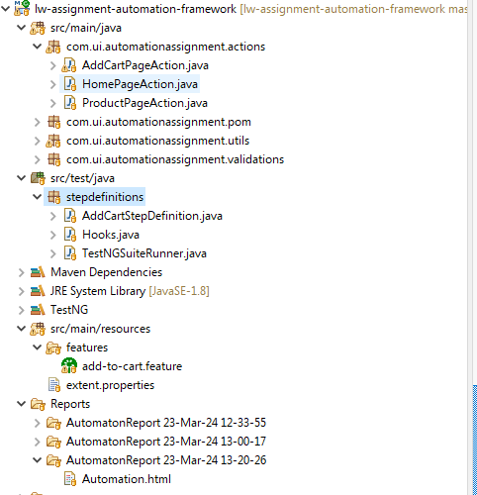
Automation Project components
Feature: Test scenarios based on modules are articulated in Gherkin BDD language, with each feature encapsulating a specific functionality
Step Definitions: Business logic is implemented in step definitions to seamlessly integrate scenarios with corresponding action methods
Actions/Validation: Common method implementations across the project are consolidated in one location for improved maintainability.
PAGEOBJECT: All locators and methods related to respective pages are organized within dedicated page classes
Validations: Encompasses validation implementations specific to each page and associated methods.
Utils: Includes common and reusable methods essential for the project's functionality
Reports: Utilizes ExtentReports to comprehensively capture and present the results of features and individual scenarios.
pom.xml: Defines the project configuration, dependencies, build settings, and other project-related information.

Installation Guide:
- Download and Setup the java8 version - Click here
- Download the IDE for develop /debug code
- Integrate with TestNG , Cucumber, Log4j, Reports
Steps to execute :
- Clone the project from the GitHub repo - Link
- Go to your project directory from terminal and run following commands
- mvn clean install
- Go to TestNGSuiteRunner.java in eclipse and right click to run as TestNG test

Test Results :
Report : 
Extent Report are used to captured & present the result for each test scenario and feature.
