
Staggered Schedules:
Cost -Effective Solution to Increased Learning Time
Brooklyn Generation
Brooklyn, NY
Brooklyn Generation has emerged as a nationwide model for cost effectively adding time. Without raises in teacher pay or time, and within the confines of union contracts, Brooklyn Generation has lengthened the traditional school year from180 to 200 days. Despite the longer year, school administrators have creatively restructured the school calendar to provide all teachers with three months of vacation each year.
Brooklyn Generation High School Basic Info
Address | 6565 Flatlands Avenue  Brooklyn, NY 11236  Tel: 718.968.4200
Started | 2007
Grades served | 9 – 12
Principal | Terri Grey
School Day | 9:00 – 4:00
School Year | 200 days
Website | http://www.generationschools.org/
Performance | 2009-2010 NY State Report Card
In addition to a month-long summer vacation in August, each teacher receives two separate four week breaks from the classroom staggered throughout the school year, allowing the school to remain open and serve all students from September to July. In 2004, three years before the first Generation School opened, the model earned the Echoing Green Prize as one of the “World’s Emerging Social Innovations.” In its first year, Brooklyn Generation achieved promising results, scoring in the top five among 40 comparison schools in attendance, credit accumulation, and Regents Exam Pass rates—ranking first in test scores within their comparison group.

What Does the Generation School Day Look Like for Students and Teachers?
- Students receive two Foundation courses (85 minute core academic period) and three Studio courses (60 minute electives or support period). Daily instructional time: 5 hours 50 minutes.
- Teachers teach one Studio and two Foundation courses. Daily instruction: 3 hours 50 minutes
- Teachers have two hours of collaboration time daily during Studio courses
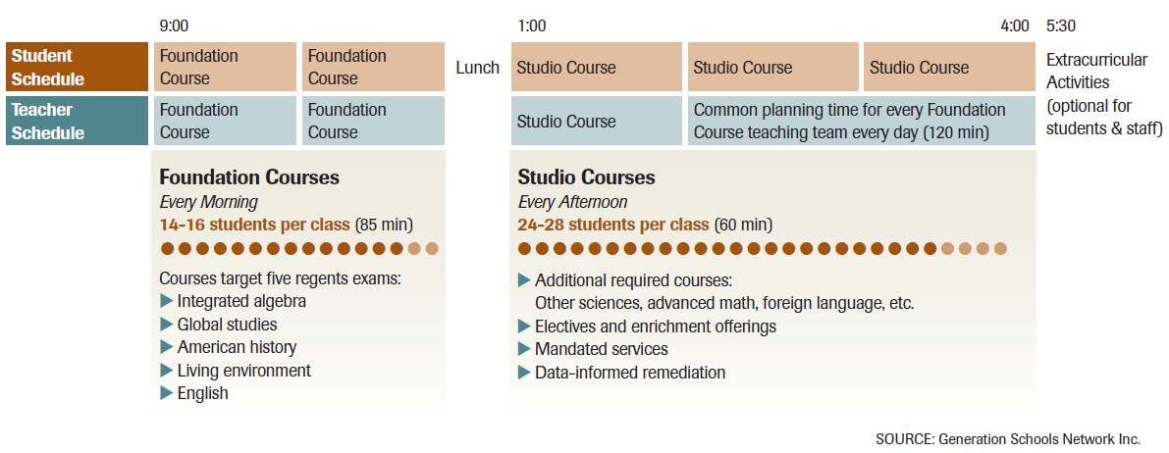
- Student teacher ratios: Foundation course (14-16:1); Studio course (24-28:1)

When Do Teachers Get Vacations in Generation’s 200 Day School Year?

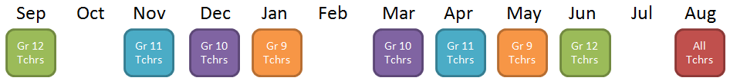

- Each teacher teaches 180 school days, with three separate vacation periods, which include:
  - One month summer vacation in August
  - Two separate four week breaks throughout the school year, consisting of:
    - Three weeks of vacation
    - One week of team planning and professional development
    - Staggered throughout the year by grade level
- Union agreed to a side addendum to the teachers’ contract to enable this teacher schedule
Teacher Vacation Schedule

What do Students Do When Their Teachers are Gone?
- During each four week period while teachers are out, their students participate in month long Intensives, modeled after university intersession periods
  - Connect core curriculum to career possibilities and the world beyond high school
  - Expose students to colleges and universities
  - Staffed by Intensives team of certified teachers and guidance counselor who rotate to different grade levels
    - Intensive teachers are on vacation during October and February
- Utilize partnerships with colleges, corporations, community organizations, and public agencies
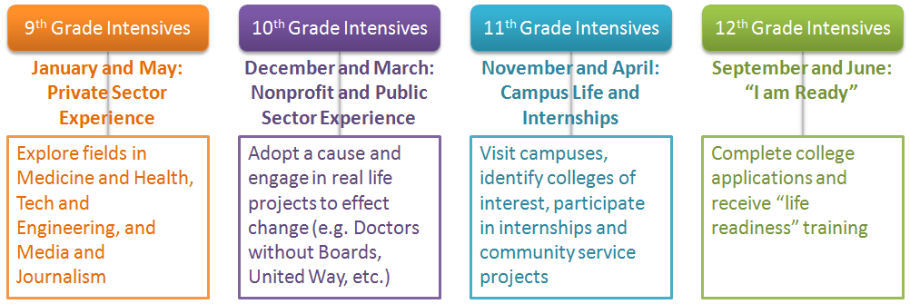

What were Some Tradeoffs to Staffing and Scheduling?
- Few deans of discipline, athletic directors, or special program managers
- Nearly 90% of full time professional staff are teachers, many of whom play a dual role
  - Math teacher also teaches Physical Education
  - Technology teacher is also the Athletic Director
  - Teachers are trained in SPED, ELL, compliance monitoring, guidance, and data analysis

