
Hybrid Model: Incorporating Technology
Rocketship Schools
San Jose, CA
In 2010, the two Rocketship schools posted an Academic Performance Index of 925 and 886 out of 1,000—#5 and #15 in the state among schools serving low income populations.

The charter management organization, Rocketship Education, has been recognized across the country for effectively adopting adaptive technology into its longer school day. Starting at 8:00 am and ending at 4:00 pm each day, Rocketship schools provide six hours of classroom instruction and two hours of enrichment during the school day, with an additional two hours of tutoring after school for struggling students. Its two schools, Mateo Sheedy Elementary and Sí Se Puede Academy, serve predominantly low income (>70% qualify for free and reduced lunch) and limited English proficient (82%) K - 5 students. These schools have achieved promising results over the past 2009-2010 school year.
- Rocketship Mateo Sheedy Elementary (RMS) earned an API score of 925 for the second consecutive year, exceeding surrounding schools in the San Jose Unified District and matching results in more affluent schools in the Palo Alto School District.
- Rocketship Sí Se Puede Academy (RSSP) earned an API score of 886 in its first year of operation
- The two Rocketship schools rank 5th and 15th, respectively, among all California schools with 70% or more students qualifying for free and reduced meals.
- Sí Se Puede Academy (RSSP) was the top school in this category, for new schools which opened in the fall of 2009.
In September 2010, Rocketship opened a third school, Los Sueños, and will open two more in 2011. The organization hopes to expand to 30 schools by 2015.
Rocketship’s Hybrid School Model
Rocketship’s hybrid school platform combines traditional classroom teaching with tutors and technology to meet the needs of each student. This enables teachers to maximize classroom time for instruction, guided practice and extending critical thinking skills, while tutors and technology provide additional independent practice, assessment and remediation/acceleration. In addition, the hybrid school model creates significant cost savings, which are reinvested in programs and people, including: Academic Deans, Leadership Training, Response to Intervention, and higher teacher pay—Rocketship teachers receive salaries 20 percent higher than surrounding districts. Finally, the hybrid school model enables Rocketship schools to operate solely on traditional public school funding.

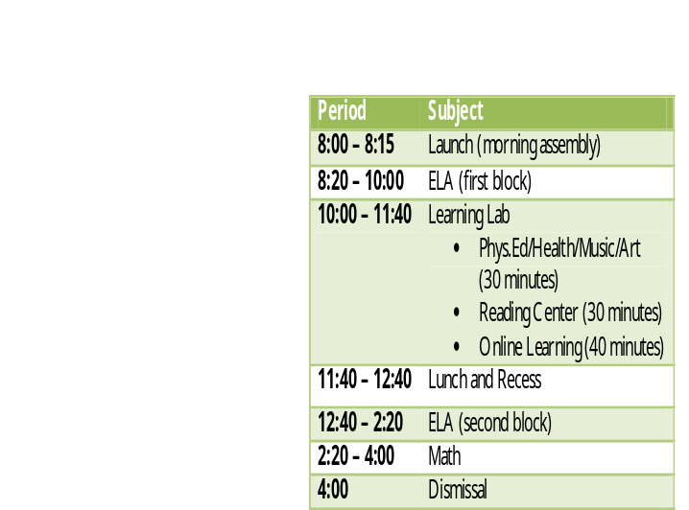

Rocketship’s Schedule Each day, all students receive instruction throughout four learning blocks, each lasting an hour and 40 minutes. This includes two blocks of ELA, one block of math, and one block of Learning Lab. Learning lab and Reading Center are staffed by non instructional staff, allowing classroom teachers to meet and plan during the Learning Lab period each day.
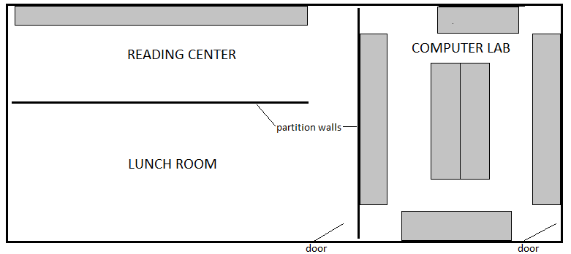
Physical Layout of Learning Lab
Grey shaded areas represent computer banks, including approximately 20 computers in the Reading Center and 50 in the Computer Lab. The Learning Lab period is broken up into three components:
- 30 minutes of physical education/health/music/art which takes place in the Lunch Room or in the school’s playground
- 40 minutes of Reading Center
- 30 minutes of Online Learning in the Computer Lab, during which up to two classes of students occupy the space each period
Technology Use at Learning Labs The Learning Lab block utilizes technology to provide individualized ELA and math content to students and daily assessment data to teachers. Each day, after the PE/Health/Music/Art, students read small book(s) (approximately 12 pages), and complete a short five to ten question quiz to assess literacy and comprehension through adaptive software such as Accelerated Reader, during Reading Center. Both the books and assessments are aligned to a Development Reading Assessment (DRA) score, providing teachers with daily updates on each student’s reading progress. School wide ELA assessments every eight weeks are also administered during Reading Center time. These ongoing assessments enable teachers to track student progress, and provide targeted supports early before students fall behind. Rocketship also uses these assessments to identify the bottom 20% of students for after-school ELA intervention with tutors. During Learning Lab, students use online content from providers such as Dreambox, Reasoning Mind, and Headsprout for additional ELA and math practice. Since these programs are adaptive in real-time, each student can progress at a pace that matches their specific learning needs.
Adaptive Instructional Software at Rocketship
Content Provider | Website | Grades* | Subjects
Accelerated Reader | www.renlearn.com | PreK-12 | Reading
Headsprout | www.headsprout.com | K-1 | ELA
Dreambox | www.dreambox.com | K-3 | Math
Reasoning Mind | www.reasoningmind.org | 2-7 | Math
*Grades which content providers target, not necessarily grades the content provider serves at Rocketship

