**Q4I Conference @ Griffiss Institute / AFRL, Rome NY June 25-27, 2024**

**tl;dr:** quantum technologies experience good traction outside of computing, but utility scale computing (for most apps) is perhaps still a decade away

**Summary:** Growing academic / defense quantum research presence in Rome NY primarily centered around heterogeneous quantum networking. At the conference heard of no current deployable quantum computing apps in development - still all pathfinding. Workforce development and controlling the hype are important to growth and sustainability.

**Recommend:** Continue to watch this space, selectively invest in staff development, but otherwise remain business app and domain focused, compute implementation agnostic. Medium-term consider demonstrators via partnerships with winning hardware companies (see DARPA benchmarking below). Leverage the small community and local relationships, and attend Q4I next year.

**Next Steps:** July - quantum CFD @ VKI, IBM Qiskit training; Sept - IEEE Quantum; debriefs to follow

**Details:**

The Army, Navy, Air Force, and DARPA were all represented. While the AFRL is more involved in quantum information and computing, the Army and Navy are more focused on other applications of quantum technology - in magnetics, materials and their defects, and since trapped ions are sensitive to their environment, using Rydberg states as RF receivers.

AFRL’s Information Directorate is based in Rome headed by Dr. Soderberg, part of a growing quantum research presence in NY state. Griffiss Institute is the open science lab, across the street is AFRL, and some staff have joint appointments. As of now, they have no deployable apps on quantum computers - it's all still pathfinding (same as at IonQ, says Dr. Yamada), and Soderberg pessimistically estimates that utility is 10 years off. As such, AFRL has an active K-12 STEM program, are open to discuss collaboration, and are actively tamping down the hype. It's worth noting that the Rome facility also includes a large aerodrome, and is one end of a 50-mile FAA-approved drone corridor.

Rather than compete with the emerging quantum computer industry, AFRL is focused on quantum networking - the technical papers presented at the conference were heavy on that topic, the lab tour centered around photonics (on-chip) and trapped ions for networking including at the edge (e.g. drone-mounted). To scale up a quantum computer, it may be necessary to network smaller nodes, and sometimes advantageous to have those nodes be heterogeneous even at the qubit level. So we saw and heard of projects / papers to increase the distribution of entanglement (Rome has 5k and 10k test loops), entangle photons and ions or ions of different kinds (Rome is installing an IonQ machine with a custom photonics interface).

Dr. Altipeter from DARPA emphasized that in their funding process they want to hear, in a hype-less manner, “what is the killer app?”, “why will it change the world”, or “how is it x% better than current”. This must be stated as clear requirements, with measurable indicators of success, in implementation agnostic algorithmic terms, and only then mapping it to suitable hardware with some plausible roadmap to implementation. Altipter also sees no useful deployable apps in the NISQ era, with a resulting DARPA down selection of research areas that suggests Fermi-Hubbard solid state modeling, magnetic field modeling, chemical catalysis and other chemical processes.

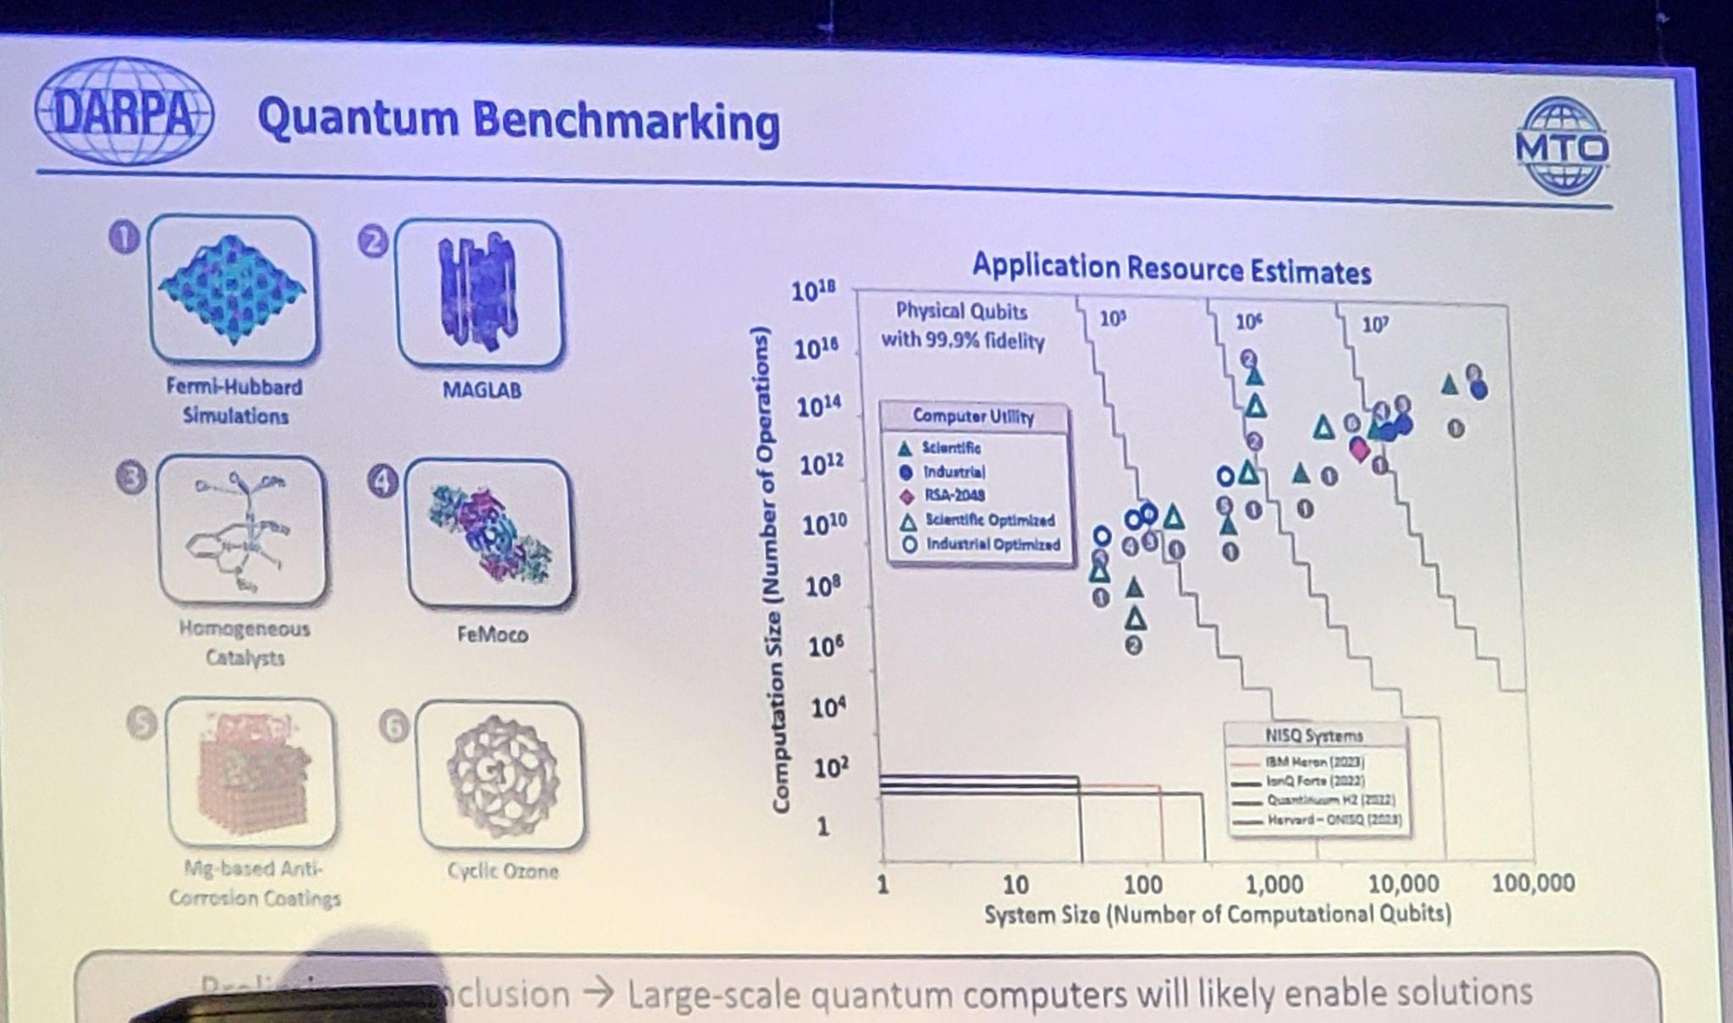

In the following DARPA slide showing machine size and utility, the lower left corner of the red box represents Shor’s algorithm breaking RSA, with most non-scientific industrial applications (including CFD) inside that box. Algorithmic improvements including in compiler optimization might alter this landscape.

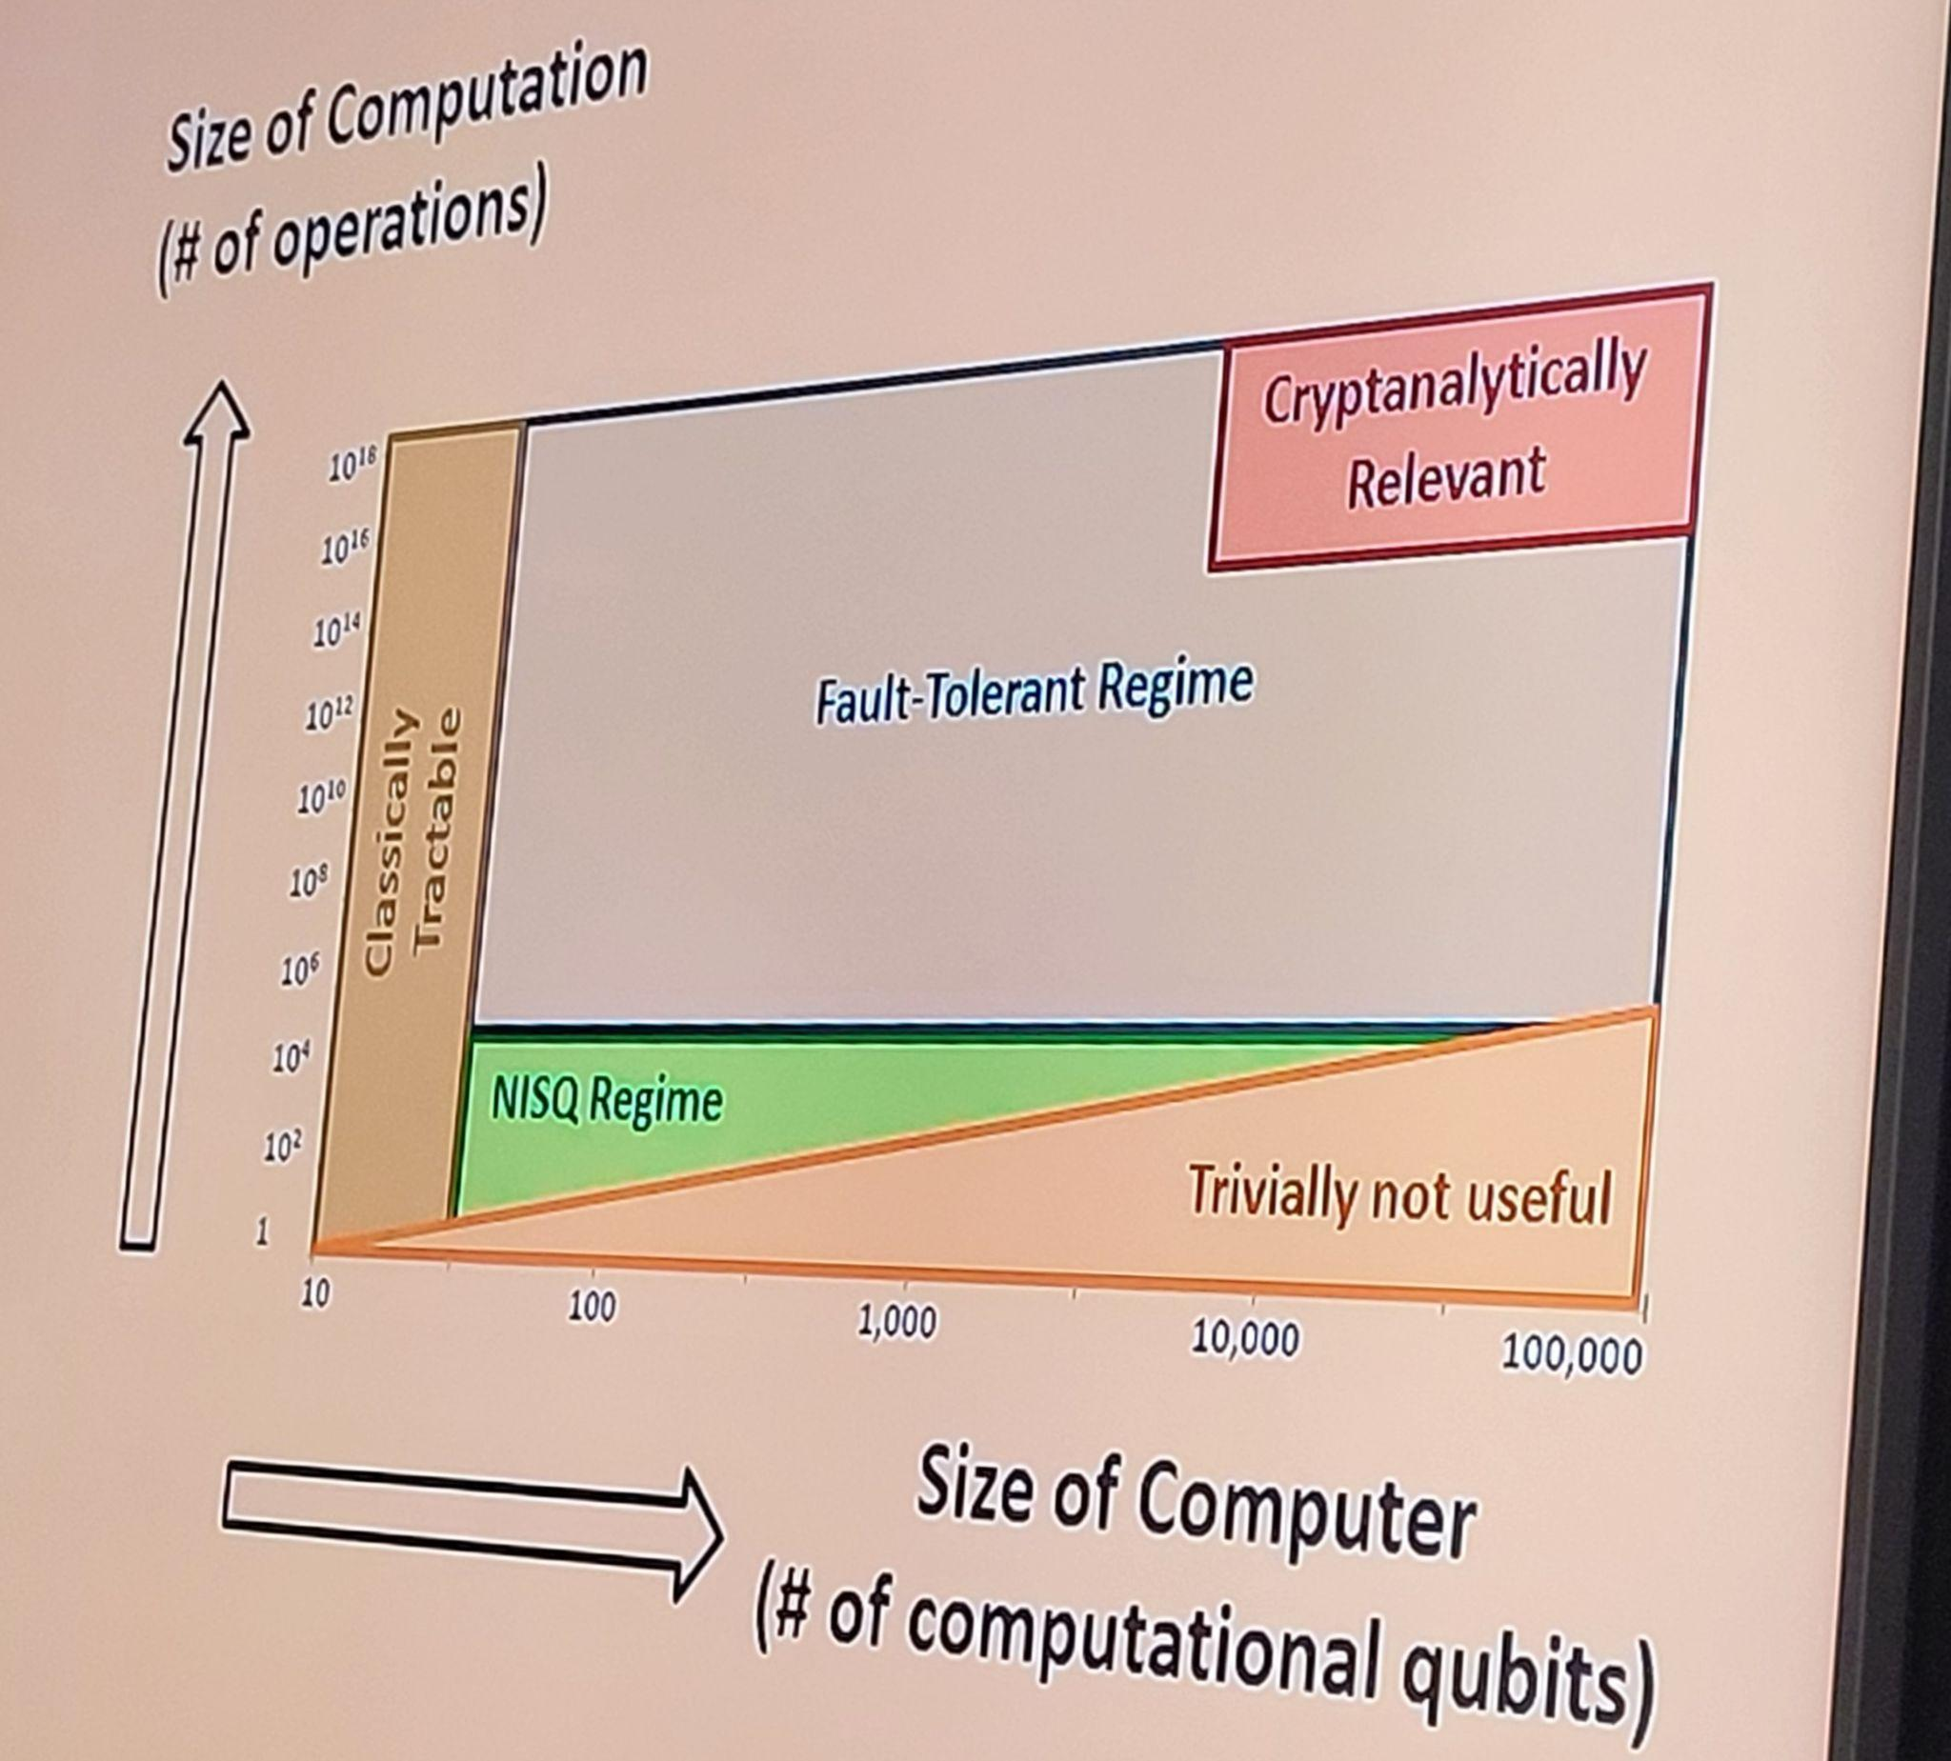

DARPA notably staffs a team of quantum promoters and skeptics probing the efficacy of various hardware approachesand the secret sauce of specific vendors - DARPA wants “no strategic surprise”. This is handled via application-driven benchmarks and sizing estimation - <https://www.darpa.mil/news-events/2024-06-20>, e.g. for incompressible CFD <https://arxiv.org/pdf/2406.06323>, and e.g. bake-offs between IBM (superconducting) & IonQ (trapped ion) <https://arxiv.org/pdf/2406.11771>.

Rounding out the conference, the Canadians in government and academics represented their close-knit community well, and it was noted that a slow research cadence due to complexity of configuration and rarity of hands-on hardware is the primary impediment. Other presentations of note included papers on multiplexing QPU controls to get around the 1-to-1 limitations imposed by the no cloning theorem (“pretty machines that don’t scale”), and a presentation of “close enough” qubit simulators to get around the otherwise exponential growth which claims to somewhat performantly handle 100 qubits on commodity hardware.

Our next steps include a week in July of focused presentations by Von Karman Institute on quantum for CFD (in spite of recent reports cited above that quantum for CFD is a long ways off), two weeks part-time in July of IBM Qiskit-centric training on quantum software development (algorithms as well as nuts and bolts), and a week in September at the IEEE quantum conference. Report-outs to the team will be made at various intervals.

In the meantime, we continue to track the arxiv and other sources of research and industry news, with special attention to potential aerospace use cases and to personal interests including emerging heterogeneous software architectures, and workforce development.

Andy Gallo