M M I D I S P L A Y

I N T E R F A C E P A N E L

**11-01-001-6**

C O N T E N T S

1 Components 3

2 System Level Block Diagram 3

3 Hardware Setup 3

3.1 for usage . . . . . . . . . . . . . . . . . . . . . . . . . . . . 3

3.2 for programming . . . . . . . . . . . . . . . . . . . . . . . 3

4 Programming Instructions 4

4.1 Arduino Uno Setup . . . . . . . . . . . . . . . . . . . . . . 4

|  |  |  |  |  |  |  |  |  |  |  |  |  |  |  |  |  |  |  |
| --- | --- | --- | --- | --- | --- | --- | --- | --- | --- | --- | --- | --- | --- | --- | --- | --- | --- | --- |
| Installing software . . . . . . | | | | | | . | . | . | . | . | . | . | . | . | . | . | . | 4 |
| Installing additional libraries | | | | | | . | . | . | . | . | . | . | . | . | . | . | . | 5 |
| Connecting board . . . . | | | . | . | . | . | . | . | . | . | . | . | . | . | . | . | . | 5 |
| Install the board drivers | | | . | . | . | . | . | . | . | . | . | . | . | . | . | . | . | 5 |
| Open your first sketch . | | | . | . | . | . | . | . | . | . | . | . | . | . | . | . | . | 6 |
| Select your board type and port . . . . . . . . . . 6 | | | | | | | | | | | | | | | | | | |
|  | Upload the program . | . | . | . | . | . | . | . | . | . | . | . | . | . | . | . | . | 7 |
| 4.2 | Upload our program . . . . . | . | . | . | . | . | . | . | . | . | . | . | . | . | . | . | . | 8 |
| 4.3 | Upload bmp in memory card | . | . | . | . | . | . | . | . | . | . | . | . | . | . | . | . | 8 |

5 Setup Required 8

5.1 Subsection . . . . . . . . . . . . . . . . . . . . . . . . . . . 9

5.1.1 Subsubsection . . . . . . . . . . . . . . . . . . . . . 9

5.1.2 Table . . . . . . . . . . . . . . . . . . . . . . . . . . 9

5.2 Figure Composed of Subfigures . . . . . . . . . . . . . . . 10

6 Setup files (Software) 11

1

A B S T R A C T

This module consists of an TFT touchscreen shield mounted on Ar- duino Uno. This is used to display the name and manufacturer of any product.

|  |  |  |
| --- | --- | --- |
| 1 | 1. | C O M P O N E N T S  2.4” TFT Touch Shield for Arduino |
|  | 2. | Arduino Uno |
|  | 3. | USB Type A (male) to Type B (male) cable |
|  | 4. | 5.0V , 1A power supply with USB Type A (female) connector |
|  | 5. | micro-SD card (less than or equal to 4GB) |

2 S Y S T E M L E V E L B L O C K D I A G R A M

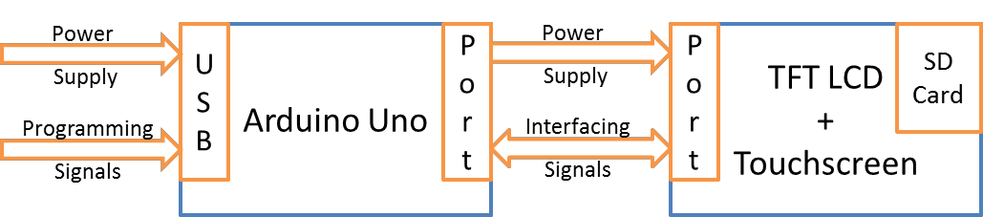

**Figure 1:** System level block diagram

3 H A R D W A R E S E T U P

**3.1 for usage**

As shown in figure 1 the TFT Touch Shield is plugged onto Arduino Uno ports for interfacing. Vdd and Gnd pins on both boards should be matched for proper mounting. *If you are setting up arduino uno first time on this computer, do not mount TFT touchsreen shield on the arduino board yet. It will be mounted after arduino uno setup section.*

**3.2 for programming**

The USB cable’s Type B end is connected to the Arduino Uno board and this cable provides both the power and programming signals. In case one wants to program the module, USB Type A end or cable should be connected to a computer else it should be connected to a

5V , 1A power supply. In both cases Arduino and LCD screen should power up and you should be able to see red lights on Arduino board and backlight or any random display on LCD.

4 P R O G R A M M I N G I N S T R U C T I O N S

**4.1 Arduino Uno Setup**

If the module is connected to computer for programming, following instructions need to be followed

**i n s t a l l i n g s o f t W a r e** The Arduino Uno is programmed using the Arduino Software (IDE), Arduino’s Integrated Development Environ- ment. Double click on *arduino-1.8.5-windows.exe* and please allow the driver installation process when you get a warning from the operat- ing system.

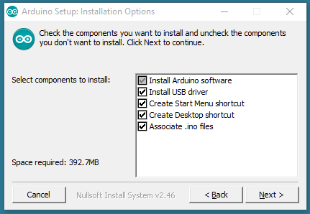

Choose the components to install

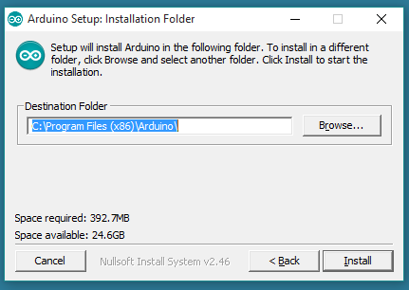

Choose the installation directory (we suggest to keep the default one)

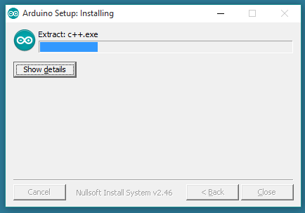

The process will extract and install all the required files to execute properly the Arduino Software (IDE)

**i n s t a l l i n g a d d i t i o n a l l i b r a r i e s** Unzip libraries.rar and copy the folders *SPFD5408* − *master* etc to

*C* : *ProgramFiles*(*x86*)*Arduino*\*libraries*

**c o n n e c t i n g b o a r d** Connect your Uno board with an A B USB

cable; sometimes this cable is called a USB printer cable

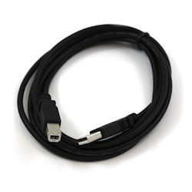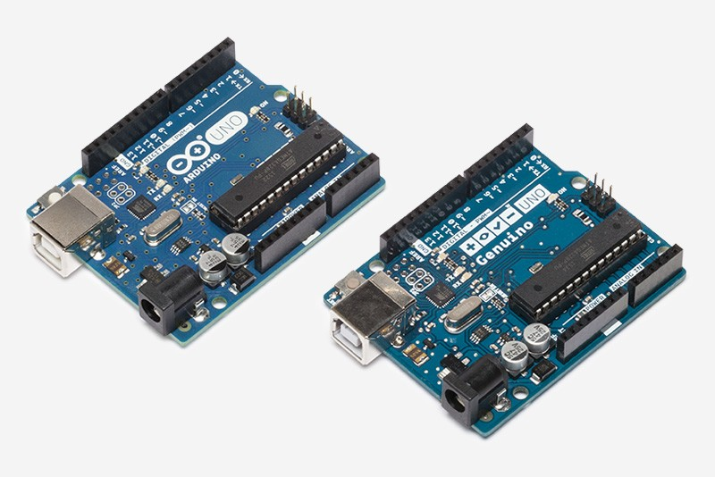

The USB connection with the PC is necessary to program the board and not just to power it up. The Uno automatically draw power from either the USB or an external power supply. Connect the board to your computer using the USB cable. The green power LED (labelled PWR) should go on.

**i n s t a l l t H e b o a r d d r i V e r s** If you downloaded and expanded the Zip package or, for some reason, the board wasn’t properly recognized, please follow the procedure below.

*•* Click on the Start Menu, and open up the Control Panel.

*•* While in the Control Panel, navigate to System and Security. Next, click on System. Once the System window is up, open the Device Manager.

*•* Look under Ports (COM & LPT). You should see an open port named "Arduino UNO (COMxx)". If there is no COM & LPT section, look under "Other Devices" for "Unknown Device".

*•* Right click on the "Arduino UNO (COmxx)" port and choose the

"Update Driver Software" option.

*•* Next, choose the "Browse my computer for Driver software" option.

*•* Finally, navigate to and select the driver file named "arduino.inf", located in the "Drivers" folder of the Arduino Software download (not the "FTDI USB Drivers" sub-directory). If you are using an old version of the IDE (1.0.3 or older), choose the Uno driver file

named "Arduino UNO.inf"

*•* Windows will finish up the driver installation from there.

**o p e n y o u r f i r s t s K e t c H** Open the LED blink example sketch:

File > Examples > 01.Basics > Blink.

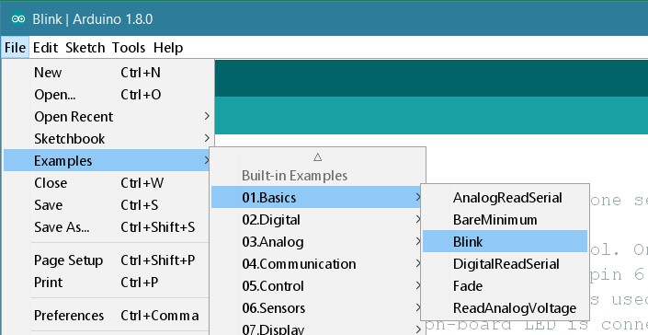

**s e l e c t y o u r b o a r d t y p e a n d p o r t** You’ll need to select the entry in the T ools > Board menu that corresponds to your Arduino or Genuino board.

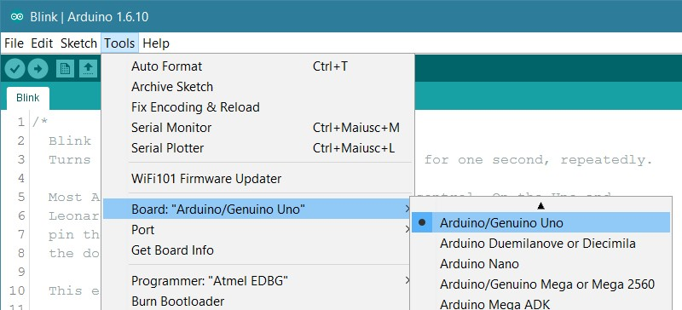

Select the serial device of the board from the Tools | Serial Port menu. This is likely to be COM3 or higher (COM1 and COM2 are usually reserved for hardware serial ports). To find out, you can disconnect your board and re-open the menu; the entry that disappears should be the Arduino or Genuino board. Reconnect the board and select that serial port.

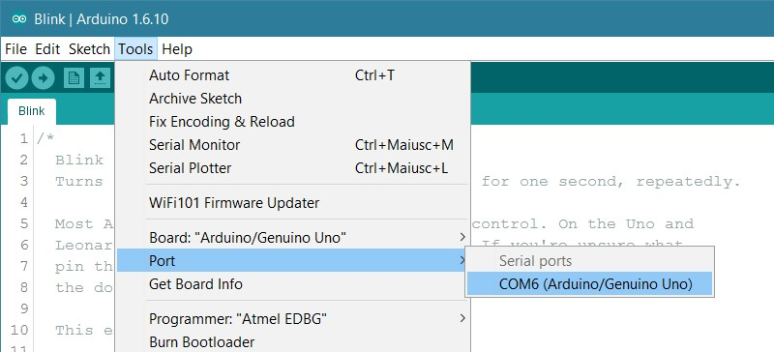

**u p l o a d t H e p r o g r a m** Now, simply click the "Upload" button in the environment. Wait a few seconds - you should see the RX and TX leds on the board flashing. If the upload is successful, the message "Done uploading." will appear in the status bar.

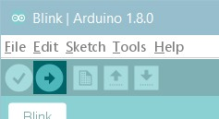

A few seconds after the upload finishes, you should see the pin 13 (L) LED on the board start to blink (in orange). If it does, congratulations! You’ve gotten Arduino or Genuino up-and-running. If you have problems, please see the [troubleshooting suggestions](https://www.arduino.cc/en/Guide/Troubleshooting).

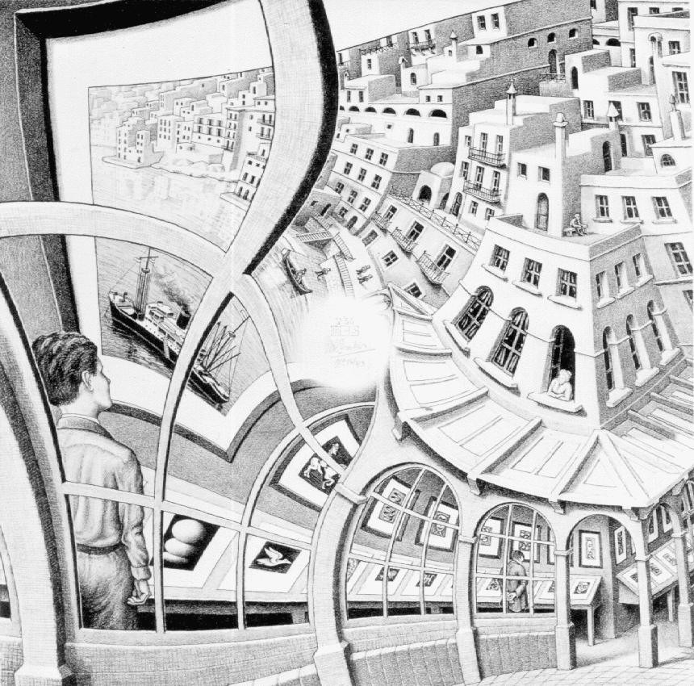

**Figure 2:** An example of a floating figure (a reproduction from the *Gallery of prints*, M. Escher, from <http://www.mcescher.com/>).

**4.2 Upload our program**

*•* Open *tftpaint.ino* in Arduino by double clicking the file

*•* Click the upload button (looks like *forward arrow* symbol)

**4.3 Upload bmp in memory card**

*•* Copy files *screen.bmp, screen2.bmp, screen3.bmp* to the memory card (less than or equal to 4 GB)

*•* Insert the memory card to slot in LCD

5 S E T U P R E Q U I R E D

Reference to Figure 2.

Suspendisse vitae elit. Aliquam arcu neque, ornare in, ullamcorper quis, commodo eu, libero. Fusce sagittis erat at erat tristique mollis. Maecenas sapien libero, molestie et, lobortis in, sodales eget, dui. Morbi ultrices rutrum lorem. Nam elementum ullamcorper leo. Morbi dui. Aliquam sagittis. Nunc placerat. Pellentesque tristique sodales est. Maecenas imperdiet lacinia velit. Cras non urna. Morbi eros pede, suscipit ac, varius vel, egestas non, eros. Praesent malesuada, diam id pretium elementum, eros sem dictum tortor, vel consectetuer odio sem sed wisi.

**5.1 Subsection**

Sed feugiat. Cum sociis natoque penatibus et magnis dis parturient montes, nascetur ridiculus mus. Ut pellentesque augue sed urna. Vestibulum diam eros, fringilla et, consectetuer eu, nonummy id, sapien. Nullam at lectus. In sagittis ultrices mauris. Curabitur malesuada erat sit amet massa. Fusce blandit. Aliquam erat volutpat. Aliquam euismod. Aenean vel lectus. Nunc imperdiet justo nec

dolor.

**5.1.1 *Subsubsection***

Etiam euismod. Fusce facilisis lacinia dui. Suspendisse potenti. In mi erat, cursus id, nonummy sed, ullamcorper eget, sapien. Praesent pretium, magna in eleifend egestas, pede pede pretium lorem, quis consectetuer tortor sapien facilisis magna. Mauris quis magna varius nulla scelerisque imperdiet. Aliquam non quam. Aliquam porttitor quam a lacus. Praesent vel arcu ut tortor cursus volutpat. In vitae pede quis diam bibendum placerat. Fusce elementum convallis neque. Sed dolor orci, scelerisque ac, dapibus nec, ultricies ut, mi. Duis nec dui quis leo sagittis commodo.

**W o r d** Definition

**c o n c e p t** Explanation

**i d e a** Text

Etiam euismod. Fusce facilisis lacinia dui. Suspendisse potenti. In mi erat, cursus id, nonummy sed, ullamcorper eget, sapien. Praesent pretium, magna in eleifend egestas, pede pede pretium lorem, quis consectetuer tortor sapien facilisis magna. Mauris quis magna varius nulla scelerisque imperdiet. Aliquam non quam. Aliquam porttitor quam a lacus. Praesent vel arcu ut tortor cursus volutpat. In vitae pede quis diam bibendum placerat. Fusce elementum convallis neque. Sed dolor orci, scelerisque ac, dapibus nec, ultricies ut, mi. Duis nec dui quis leo sagittis commodo.

*•* First item in a list

*•* Second item in a list

*•* Third item in a list

**5.1.2 *Table***

Aliquam lectus. Vivamus leo. Quisque ornare tellus ullamcorper nulla. Mauris porttitor pharetra tortor. Sed fringilla justo sed mauris. Mauris tellus. Sed non leo. Nullam elementum, magna in cursus sodales, augue est scelerisque sapien, venenatis congue nulla arcu et

pede. Ut suscipit enim vel sapien. Donec congue. Maecenas urna mi, suscipit in, placerat ut, vestibulum ut, massa. Fusce ultrices nulla et nisl.

**Table 1:** Table of Grades

Name

|  |  |  |
| --- | --- | --- |
| First name | Last Name | Grade |
| John | Doe | 7.5 |
| Richard | Miles | 2 |

Reference to Table 1.

**5.2 Figure Composed of Subfigures**

Reference the figure composed of multiple subfigures as Figure 3 on the following page. Reference one of the subfigures as Figure 3b on the next page.

Nulla in ipsum. Praesent eros nulla, congue vitae, euismod ut, commodo a, wisi. Pellentesque habitant morbi tristique senectus et netus et malesuada fames ac turpis egestas. Aenean nonummy magna non leo. Sed felis erat, ullamcorper in, dictum non, ultricies ut, lectus. Proin vel arcu a odio lobortis euismod. Vestibulum ante

ipsum primis in faucibus orci luctus et ultrices posuere cubilia Curae; Proin ut est. Aliquam odio. Pellentesque massa turpis, cursus eu, euismod nec, tempor congue, nulla. Duis viverra gravida mauris. Cras tincidunt. Curabitur eros ligula, varius ut, pulvinar in, cursus faucibus, augue.

Nulla mattis luctus nulla. Duis commodo velit at leo. Aliquam vulputate magna et leo. Nam vestibulum ullamcorper leo. Vestibulum condimentum rutrum mauris. Donec id mauris. Morbi molestie justo et pede. Vivamus eget turpis sed nisl cursus tempor. Curabitur mollis sapien condimentum nunc. In wisi nisl, malesuada at, dignissim sit amet, lobortis in, odio. Aenean consequat arcu a ante. Pellentesque porta elit sit amet orci. Etiam at turpis nec elit ultricies imperdiet. Nulla facilisi. In hac habitasse platea dictumst. Suspendisse viverra aliquam risus. Nullam pede justo, molestie nonummy, scelerisque eu, facilisis vel, arcu.

Curabitur tellus magna, porttitor a, commodo a, commodo in, tortor. Donec interdum. Praesent scelerisque. Maecenas posuere sodales odio. Vivamus metus lacus, varius quis, imperdiet quis, rhoncus a, turpis. Etiam ligula arcu, elementum a, venenatis quis, sollicitudin sed, metus. Donec nunc pede, tincidunt in, venenatis vitae, faucibus vel, nibh. Pellentesque wisi. Nullam malesuada. Morbi ut tellus ut

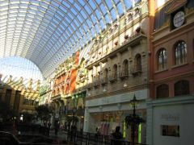

**(a)** A city market. **(b)** Forest landscape.

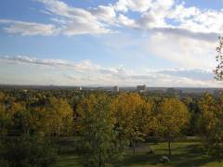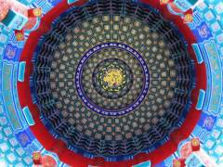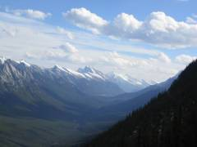

**(c)** Mountain landscape. **(d)** A tile decoration.

**Figure 3:** A number of pictures with no common theme.

pede tincidunt porta. Lorem ipsum dolor sit amet, consectetuer adipiscing elit. Etiam congue neque id dolor.

Donec et nisl at wisi luctus bibendum. Nam interdum tellus ac libero. Sed sem justo, laoreet vitae, fringilla at, adipiscing ut, nibh. Maecenas non sem quis tortor eleifend fermentum. Etiam id tortor ac mauris porta vulputate. Integer porta neque vitae massa. Maecenas tempus libero a libero posuere dictum. Vestibulum ante

ipsum primis in faucibus orci luctus et ultrices posuere cubilia Curae; Aenean quis mauris sed elit commodo placerat. Class aptent taciti sociosqu ad litora torquent per conubia nostra, per inceptos hymenaeos. Vivamus rhoncus tincidunt libero. Etiam elementum pretium justo. Vivamus est. Morbi a tellus eget pede tristique commodo. Nulla nisl. Vestibulum sed nisl eu sapien cursus rutrum.

6 S E T U P F I L E S ( S O F T W A R E )

A statement requiring citation [1].

Lorem ipsum dolor sit amet, consectetuer adipiscing elit. Ut purus elit, vestibulum ut, placerat ac, adipiscing vitae, felis. Curabitur dictum gravida mauris. Nam arcu libero, nonummy eget, consectetuer id, vulputate a, magna. Donec vehicula augue eu neque.

Pellentesque habitant morbi tristique senectus et netus et malesuada fames ac turpis egestas. Mauris ut leo. Cras viverra metus rhoncus sem. Nulla et lectus vestibulum urna fringilla ultrices. Phasellus eu tellus sit amet tortor gravida placerat. Integer sapien est, iaculis in, pretium quis, viverra ac, nunc. Praesent eget sem vel leo ultrices bibendum. Aenean faucibus. Morbi dolor nulla, malesuada eu, pulvinar at, mollis ac, nulla. Curabitur auctor semper nulla. Donec varius orci eget risus. Duis nibh mi, congue eu, accumsan eleifend, sagittis quis, diam. Duis eget orci sit amet orci dignissim rutrum. Nam dui ligula, fringilla a, euismod sodales, sollicitudin vel, wisi. Morbi auctor lorem non justo. Nam lacus libero, pretium at, lobortis vitae, ultricies et, tellus. Donec aliquet, tortor sed accumsan bibendum, erat ligula aliquet magna, vitae ornare odio metus a mi. Morbi ac orci et nisl hendrerit mollis. Suspendisse ut massa. Cras nec ante. Pellentesque a nulla. Cum sociis natoque penatibus et magnis dis parturient montes, nascetur ridiculus mus. Aliquam tincidunt urna. Nulla ullamcorper vestibulum turpis. Pellentesque cursus luctus mauris.

Nulla malesuada porttitor diam. Donec felis erat, congue non, volutpat at, tincidunt tristique, libero. Vivamus viverra fermentum felis. Donec nonummy pellentesque ante. Phasellus adipiscing semper elit. Proin fermentum massa ac quam. Sed diam turpis, molestie vitae, placerat a, molestie nec, leo. Maecenas lacinia. Nam ipsum ligula, eleifend at, accumsan nec, suscipit a, ipsum. Morbi blandit ligula feugiat magna. Nunc eleifend consequat lorem. Sed lacinia nulla vitae enim. Pellentesque tincidunt purus vel magna. Integer non enim. Praesent euismod nunc eu purus. Donec bibendum quam in tellus. Nullam cursus pulvinar lectus. Donec et mi. Nam vulputate metus eu enim. Vestibulum pellentesque felis eu massa.

Some mathematics in the text: cos π = −1 and α.

R E F E R E N C E S

[1] A. J. Figueredo and P. S. A. Wolf. Assortative pairing and life history strategy - a cross-cultural study. *Human Nature*,

20:317–330, 2009.