***# Introduction:-***

**Face mask detection had seen significant progress in the domains of Image processing and Computer vision, since the rise of the Covid-19 pandemic.**

**Many face detection models have been created using several algorithms and techniques.**

**The approach in this project uses deep learning, TensorFlow, Keras, and OpenCV to detect face masks.**

**Convolutional Neural Network, Data augmentation are the key to this project.**

**Concept :-**

***# Open CV***

**OpenCV uses machine learning algorithms to search for faces within a picture.**

**OpenCV is the most popular library for computer vision. Originally written in C/C++, it now provides bindings for Python.**

**After Installing OpenCV**

**Some useful Command**

**> import cv2**

**> # Read the image**

**image = cv2.imread(imagePath)**

**gray = cv2.cvtColor(image, cv2.COLOR_BGR2GRAY)**

**> # Detect faces in the image**

**faces = faceCascade.detectMultiScale(**

**gray,**

**scaleFactor=1.1,**

**minNeighbors=5,**

**minSize=(30, 30),**

**flags = cv2.cv.CV_HAAR_SCALE_IMAGE)**

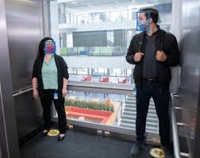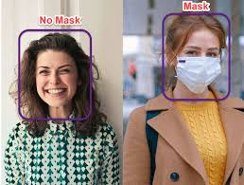

***# Deep Learning***

**Face detection is a problem in computer vision of locating and localizing one or more faces in a photograph.**

