**SQL**

1. To select the itemname, whose warranty period is less than 3 years and

detefopurchase is in 2016.

2. To display all the items whose name starts with “c”.

3. To list the item in ascending order of the date of purchase WHERE quantity is more

than 3.

4. To increase the cost of all the items by 10 %

5. Display items bought between May 2014 to Dec 2016.

6. Display device wise total cost to the company.

7. Display device wise average cost for devices having total sum of quantity greater

than 5.

8. To display itemname, quantity along with supplier details.

9. Insert a record of your choice in table lab

10. Command to create table supplier

11. Display items whose warranty has expired

12. DISPLAY ITEM NAME, DATEOF PURCHASE, SUPPLIERNAME FOR ITES COSTING MORE

THAN 10000;

13. Display Supplier name wise total quantity

14. Change the length of Supplier Address as char(50).

15. Give the output of the following sql commands:

A. Select min(distinct quantity) from lab;

B. Select max(warranty) from lab where operational =1;

C. Select sum(costperitem) from lab;

D. Select count(*) from lab group by warranty;

**OUTPUTS:**

**1.** To select the itemname, whose warranty period is less than 3 years and

detefopurchase is in 2016.

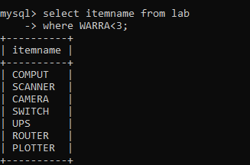

**2.** To display all the items whose name starts with “c”.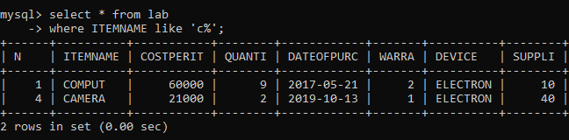

**3.** To list the item in ascending order of the date of purchase WHERE quantity is more

than 3.

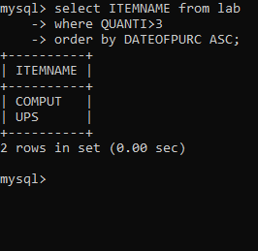

**4.** To increase the cost of all the items by 10 %.

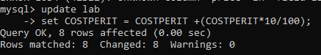

**5.** Display items bought between May 2014 to Dec 2016.

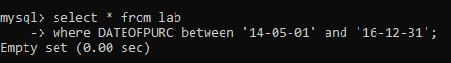

**6.** Display device wise total cost to the company.

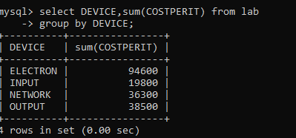

**7.** Display device wise average cost for devices having total sum of quantity greater

than 5.

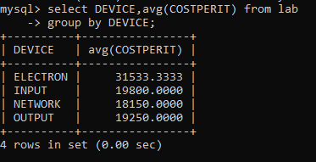

**8.** To display itemname, quantity along with supplier details.

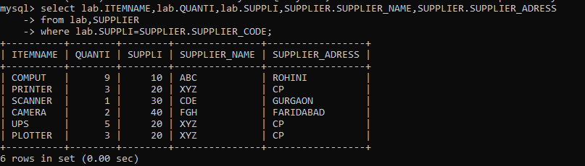

**9.** Insert a record of your choice in table lab.

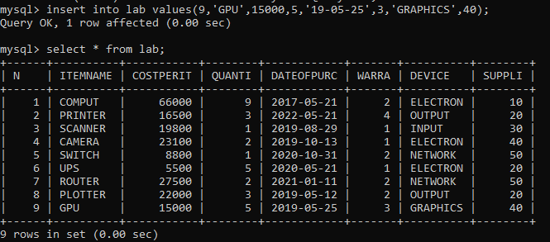

**10.** Command to create table supplier

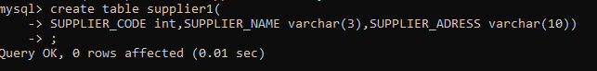

**11.** . Display items whose warranty has expired.

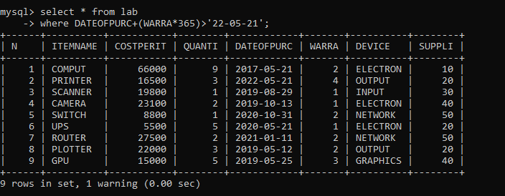

**12.**DISPLAY ITEM NAME, DATEOF PURCHASE, SUPPLIERNAME FOR ITES COSTING MORE

THAN 10000.

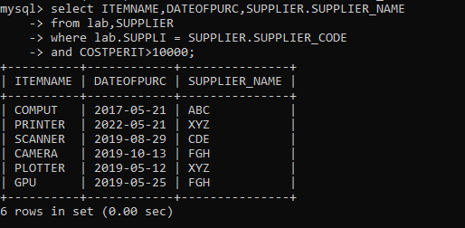

**15**

**A** Select min(distinct quantity) from lab;

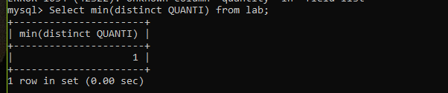

**C** Select sum(costperitem) from lab;

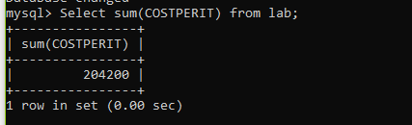

**D** Select count(*) from lab group by warranty;

