Topic:  
To Supply Leftover Food to Poor

## BY:

**Agam Srivastava**

[**agamsrivastava786@gmail.com**](mailto:agamsrivastava786@gmail.com)

## Project Dashboard:

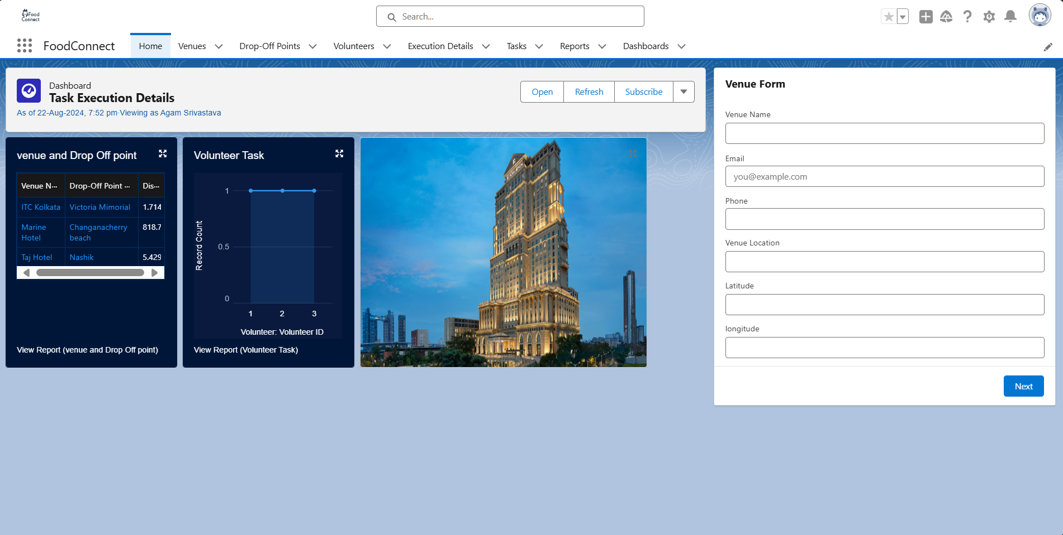

## Project Abstract

The "To Supply Leftover Food to the Poor" project leverages Salesforce technology to create a streamlined and efficient platform for distributing surplus food to underprivileged communities. The application is designed to manage and optimize the entire food supply chain, from collection to distribution, using a series of interconnected tabs:

1. **Venue Object:** The Venue object stores details about locations where surplus food is available for pickup.
2. **Drop-oﬀ Point Object:** The Drop-off Point object designates specific locations where volunteers can deliver the collected food for distribution to those in need.
3. **Volunteer Object:** The Volunteer object holds information about the individuals responsible for transporting food from collection sites to drop-off points.
4. **Task Object:** The Task object oversees all assignments given to each volunteer, ensuring clear communication and accountability.
5. **Execution Detail Object:** The Execution Detail object logs information about completed tasks, including feedback and ratings, to track performance and enhance processes.

These features provide real-time insights and analytics, enabling better decision-making and resource allocation. The user interface, developed with the Lightning App Builder, ensures a seamless experience for volunteers and administrators alike, facilitating the efficient execution of tasks and the timely delivery of food to those in need. The project aims to reduce food waste while addressing hunger, making a positive impact on society.

|  |  |  |
| --- | --- | --- |
|  | **INDEX Page** |  |
| **Topics**  Introduction |  | **Page no**  04 |
| **Creation of Object** |  | **04-05** |
| **Creating multiple tabs** |  | **05** |
| **The Lightening App Page** |  | **05-06** |
| **Creation of Relationship Fields in Objects** |  | **06-11** |
| **Creation of Flows** |  | **11-12** |
| **Creation of Trigger** |  | **12-13** |
| **Creation of Proﬁles** |  | **13** |
| **Creation of Users** |  | **13-14** |
| **Creation of Public Group** |  | **14-15** |
| **Creation of Report Types** |  | **15** |
| **Creation of Reports** |  | **15-16** |
| **Creation of Dashboard** |  | **16-17** |
| **Applying Sharing Rules** |  | **17-18** |
| **Creation of Home Page** |  | **19** |
| **Conclusion** |  | **20** |

## Introduction

The "To Supply Leftover Food to the Poor" application is a practical solution designed to connect surplus food with those in need. Developed on the Salesforce platform, this app helps communities efficiently collect and distribute leftover food, aiming to reduce hunger and minimize waste. The app coordinates volunteers who transport food from various collection sites to designated drop-off points, ensuring it reaches people in need.

With user-friendly features like tracking food collection sites, managing volunteer tasks, and monitoring food deliveries, the app provides an effective way to prevent food waste. Its dashboards and real-time reports allow volunteers and coordinators to quickly evaluate and improve their efforts. This project demonstrates how technology can be used to make a positive social impact, turning a simple idea into a practical tool for change.

## Task 1: Creation of Object

### Venue:

1. Go to Object Manager > Create > Custom Object.
2. Label: Venue, Plural: Venues.
3. Record Name: Venue Name, Data Type: Text.
4. Enable Reports, Field History Tracking, Activities, Search.
5. Click Save.

### Drop-Oﬀ Point:

1. Go to Object Manager > Create > Custom Object.
2. Label: Drop-Oﬀ Point, Plural: Drop-Oﬀ Points.
3. Record Name: Drop-Oﬀ Point Name, Data Type: Text.
4. Enable Reports, Field History Tracking, Activities, Search.
5. Click Save.

### Task:

1. Go to Object Manager > Create > Custom Object.
2. Label: Task, Plural: Tasks.
3. Record Name: Task Name, Data Type: Text.
4. Enable Reports, Field History Tracking, Activities, Search.
5. Click Save.

### Volunteer:

1. Go to Object Manager > Create > Custom Object.
2. Label: Volunteer, Plural: Volunteers.
3. Record Name: Volunteer Name, Data Type: Text.
4. Enable Reports, Field History Tracking, Activities, Search.
5. Click Save.

### Execution Detail:

1. Go to Object Manager > Create > Custom Object.
2. Label: Execution Detail, Plural: Execution Details.
3. Record Name: Execution Detail Name, Data Type: Text.
4. Enable Reports, Field History Tracking, Activities, Search.
5. Click Save.

## Task 2: Creating multiple tabs

### To create a Tab (Venue):

1. Go to Setup and search for Tabs.
2. Click New under Custom Object Tabs.
3. Choose Venue, pick a tab style, and click Next.
4. Keep the default settings for proﬁles and click Next.
5. Uncheck the box for adding to Custom App, but check Append tab to user’s existing personal customizations.
6. Click Save.

Same steps were followed to create tabs for Drop-Oﬀ Point, Task, Volunteer, and Execution Detail.

## Task 3: The Lightening App Page

### To create a Lightning App Page, go to the Setup page and search for “App Manager” in the Quick Find bar. Select “App Manager” and click New Lightning App.

Fill in the app details:

1. App Name: FoodConnect
2. Developer Name: Auto-populated
3. Image: Optional (add if desired)
4. Primary Color Hex Value: Default
5. Click Next.

* On the App Options page, set Navigation Style to Standard Navigation and click Next.
* On the Utility Items page, keep the defaults and click Next. Add Navigation Items:
* Search and add the following items: Home, Venue, Drop-Oﬀ Point, Task, Volunteer, Execution Details, Reports. Use the ar button to move them and click Next.

To add User Proﬁles Search for System Administrator in the proﬁles search bar, add it using the ar button, and click Save & Finish.

## Task 4: Creation of Relationship Fields in Objects

Creation of Lookup Relationship Field on Volunteer Object:

1. Go to Setup > Object Manager.
2. Search for and select the Volunteer object.
3. Click Fields & Relationships > New.
4. Choose Lookup Relationship and select Drop-Oﬀ-Point as the related object.
5. Click Next.
6. Set Field Name to Drop_Oﬀ_point and let the Field Label auto-generate.
7. Click Next > Next > Save.

### Creation of Master-Detail Relationship Field on Execution Details Object:

1. Go to Setup > Object Manager.
2. Search for and select the Execution Details object.
3. Click Fields & Relationships > New.
4. Choose Master-Detail Relationship and select Volunteer as the related object.
5. Click Next.
6. Set Field Name to Volunteer and let the Field Label auto-generate.
7. Click Next > Next > Save.

### Creation of Master-Detail Relationship Field on Execution Details Object:

1. Go to Setup > Object Manager.
2. Search for and select the Execution Details object.
3. Click Fields & Relationships > New.
4. Choose Master-Detail Relationship and select Task as the related object.
5. Click Next.
6. Set Field Name to Task and let the Field Label auto-generate.
7. Click Next > Next > Save.

### Creation of Lookup Relationship Field on Drop-Oﬀ Point Object:

1. Go to Setup > Object Manager.
2. Search for and select the Drop-Oﬀ Point object.
3. Click Fields & Relationships > New.
4. Choose Lookup Relationship and select Venue as the related object.
5. Click Next.
6. Set Field Name to Venue and Field Label to Venue c.
7. Click Next > Next > Save.

### Creation of Lookup Relationship Field on Task Object:

1. Go to Setup > Object Manager.
2. Search for and select the Task object.
3. Click Fields & Relationships > New.
4. Choose Lookup Relationship and select Venue as the related object.
5. Click Next.
6. Set Field Name to Sponsored By and let the Field Label auto-generate.
7. Click Next > Next > Save.

### Creation of Lookup Relationship Field on Task Object:

1. Go to Setup > Object Manager.
2. Search for and select the Task object.
3. Click Fields & Relationships > New.
4. Choose Lookup Relationship and select Drop-Oﬀ Point as the related object.
5. Click Next.
6. Set Field Name to Drop-Oﬀ Point and let the Field Label auto-generate.
7. Click Next > Next > Save.

### Creation of ﬁelds for the Venue object:

1. To add fields to the Venue object, begin by navigating to Setup and selecting Object Manager. Search for "Venue" and choose it. Then, go to "Fields & Relationships" and click on "New" to create a new field.
2. Begin by creating a new field and choose "Email" as the data type, then click "Next." Enter "Contact Email" as both the field label and field name, ensuring you check the "Required" option. Click "Next" twice, then select "Save & New" to proceed with adding another field.
3. Next, add a Phone field by selecting "Phone" as the data type and clicking "Next." Set "Contact Phone" as the field label and field name, mark it as required, then click "Next," "Next" again, and finally "Save & New" to add another field.
4. After that, create a Geolocation field by selecting "Geolocation" as the data type and clicking "Next." Use "Location" for both the field label and name, set the decimal places to 4, and add a description such as "Enter the Geolocation of your Venue." Continue by clicking "Next," "Next," and then "Save & New" to proceed with adding another field.
5. Lastly, create a Long Text Area field by choosing "Long Text Area" as the data type and clicking "Next." Set the field label to "Venue Location" and the field name to "Venue_Location". Finish the setup by clicking "Next," "Next" again, and then "Save & New."

### Creation of ﬁelds for the Drop-Oﬀ point object:

1. To create fields for the Drop-Off Point object, navigate to Setup, access the Object Manager, search for "Drop-Off Point," and select it. Then, go to "Fields & Relationships" and click on "New."
2. First, add a Geolocation ﬁeld. Choose "Geolocation" as the data type and click Next. Set the ﬁeld label to "Location 2" and provide a description like "Enter the Geolocation of the Drop-Oﬀ Point." Choose "Decimal" for Geolocation Options and set Decimal Places to 4. Click Next twice, then Save & New.
3. Next, create a Formula ﬁeld. Select "Formula" as the data type, click Next, and use "distance calculation" for the ﬁeld label and "distance_calculation" for the ﬁeld name. Set the Formula Return Type to "Number" and enter the formula

DISTANCE(Location_2_c, Venuer.Location_c, 'km'). Proceed with Next, Next, then Save & New.

1. Then, add a Picklist field. Select "Picklist" as the data type, click "Next," and use "State" for both the field label and name. Enter the state names as individual values, each on a new line. Mark the field as required, then click "Next" twice, and "Save & New."
2. Finally, for the Task object, repeat the steps by searching for "Task" in Object Manager. Add a Number field by choosing "Number" as the data type and clicking "Next." Set the field label and name to "Distance," with a length of 14 and 4 decimal places. Make the field required, click "Next" twice, and complete with "Save & New."

### Creation of ﬁelds for the Task object:

1. To create various fields in the Task object, start by navigating to Setup, then click on Object Manager. Search for "Task" and select it. Go to "Fields & Relationships" and click "New."
2. Begin by adding an Auto Number field. Select "Auto Number" as the data type, click "Next," and set the Field Label to "Task ID." Use the display format "TASK-{0}" and start the numbering at 1. Make the field required, then click "Next" twice, followed by "Save & New."
3. Next, add a Date field. Choose "Date" as the data type, click "Next," and set the Field Label to "Date." Mark it as required, then click "Next" twice, and "Save & New."
4. Then, create a Picklist (Multi-Select) field. Select "Picklist (Multi-Select)" as the data type, click "Next," and set the Field Label and Name to "Food Category." Enter options like "Veg," "Non-Veg," "Salad," and "Snack," each on a new line. Mark the field as required, click "Next" twice, then "Save & New."
5. Add a Number field next. Choose "Number" as the data type, click "Next," and set the Field Label to "Number of People Served." Make it required, click "Next" twice, and then "Save & New."
6. Next, create a Text field. Select "Text" as the data type, click "Next," and set the Field Label to "Name of the Person." Click "Next" twice, then "Save & New."
7. Add a Phone field. Choose "Phone" as the data type, click "Next," and set the Field Label to "Phone." Proceed by clicking "Next" twice, then "Save & New."
8. Then, create a Picklist field for ratings. Select "Picklist" as the data type, click "Next," and set the Field Label to "Rating." Enter values from 1 to 5, each on a new line. Click "Next" twice, then "Save & New."
9. Finally, add a Long Text Area field. Choose "Long Text Area" as the data type, click "Next," and set the Field Label to "Feedback." Complete the setup by clicking "Next" twice, then finish with "Save & New."

### Creation of ﬁelds for the Volunteer object:

1. To create fields in the Volunteer object, start by going to Setup, clicking on Object Manager, and searching for "Volunteer." Select the Volunteer object, then navigate to "Fields & Relationships" and click "New."
2. First, add an Auto Number field to uniquely identify each volunteer. Choose "Auto Number" as the data type, click "Next," and set the Field Label to "Volunteer ID." Make the field required, then click "Next" twice and "Save & New."
3. Next, create a Picklist field for gender. Select "Picklist" as the data type, click "Next," and set the Field Label to "Gender." Enter the values "Female" and "Male," each on a separate line. Click "Next" twice and "Save & New."
4. Then, add a Lookup Relation field for the Volunteer Owner Name. Choose "Lookup Relation" as the data type, click "Next," and set the related object to "Users." Set the Field Label to "Owner Name," click "Next" twice, and finish with "Save & New."
5. Next, create a Date field to capture availability. Select "Date" as the data type, click "Next," and set the Field Label to "Available On." Mark it as required, then click "Next" twice and "Save & New."
6. Add a Number field for age. Choose "Number" as the data type, click "Next," and set the Field Label to "Age." Make it required, then click "Next" twice and "Save & New".
7. Create an Email field to store the volunteer's email address. Select "Email" as the data type, click "Next," and set the Field Label to "Email." Mark it as required, then click "Next" twice and "Save & New".
8. Add another Number field for the contact number. Choose "Number" as the data type, click "Next," and set the Field Label to "Contact Number." Make it required, then click "Next" twice and "Save & New”.
9. Create a Text Area (Long) field for the address. Select "Text Area (Long)" as the data type, click "Next," and set the Field Label to "Address." Click "Next" twice and "Save & New”.
10. Finally, add a Date field for the date of birth. Choose "Date" as the data type, click "Next," and set the Field Label to "Date of Birth." Click "Next" twice and complete with "Save & New".

### Creation of ﬁelds for the Execution Details object:

1. To add a new field to the Execution Details object, start by going to Setup and then clicking on Object Manager. Type "Execution Details" into the search bar to find and select the object. This will take you to the object's detail page where you can customize fields and relationships.
2. Next, go to "Fields & Relationships" and click "New" to begin creating a new field. Choose "Auto Number" as the data type, which will automatically generate unique identifiers for each execution record, helping you keep track of tasks or actions efficiently.
3. In the following step, enter the field details. Set the Field Label to "Execution ID" to clearly define the field's purpose. The Field Name will be auto-generated from the label. Make sure to check the required checkbox to ensure that every record will have this field filled out, which will help keep execution details properly identified and logged.
4. Finally, complete the process by clicking "Next," "Next" again, and then "Save & New" if you want to create more fields. This will finalize the creation of the Execution ID field, which is essential for organizing and accessing execution records in your Salesforce system.

## Task 5: Creation of Flows

### Create Flow to create a record in Venue object:

To create a new Flow, go to Setup, type "Flow" in the Quick Find box, and select "New Flow." Choose "Screen Flow" and click "Create."

Add a screen element by clicking the ‘+’ icon, and set the Screen Properties with the

label "Venue Details" and API Name "Venue_Details." Add components to the screen:

1. **Text Component** for "Venue Name" (API Name: "Venue_Name")
2. **Email Component** for "Email" (API Name: "Contact_Email")
3. **Phone Component** for "Phone" (API Name: "Contact_Phone")
4. **Text Component** for "Venue Location" (API Name: "Venue_Location")
5. **Number Components** for "Latitude" (API Name: "Latitude") and "Longitude" (API Name: "Longitude")

Click "Done."

Add a "Create Record" element by clicking the ‘+’ icon. Set the label to "Create Venue Record" (API Name: "Create_Venue_Record"), select "One" record to create, and map ﬁelds using values from the screen components:

1. Contact_Email c : {!Contact_Email.value}
2. Contact_Phone c : {!Contact_Phone.value}
3. Name : {!Venue_Name}
4. Venue_Location c : {!Venue_Location}
5. Location Latitude s : {!Latitude}
6. Location Longitude s : {!Longitude}

Save the ﬂow with the label "Venue Form" with API Name "Venue_Form."

## Task 6: Creation of Trigger

### Create a Trigger:

1. Logged into my Trailhead account and clicked on the gear icon in the top right corner.
2. Chose "Developer Console" from the dropdown menu, which opened a new console window.
3. In the Developer Console, went to "File" > "New" > "Trigger."
4. Named the trigger "DropOﬀTrigger" and selected "Drop-Oﬀ Point" as the sObject.
5. Clicked "Submit" to create the trigger.

**T ask 7: Creation of Proﬁles**

1. I went to the setup page and entered "Profiles" in the Quick Find bar.
2. I selected "Profiles" from the search results to access the list of profiles.
3. I clicked on the "S" section to locate the Standard Platform User profile.
4. I then clicked the "Clone" button next to the Standard Platform User profile.
5. In the Clone Profile settings, I named the new profile "NGOs Profile" and clicked "Save".

## Task 8: Creation of Users

### Creation of User1:

Navigated to the setup page and typed "Users" in the Quick Find bar. Clicked on "Users" and then selected "New User."

Filled in the General Information with:

1. First Name: Iksha Foundation
2. Last Name: Iksha_Foundation
3. Alias: iiksh
4. Email: (Entered my email address)
5. Username: [ikshafoundation@sb.com](mailto:ikshafoundation@sb.com) (used a unique username)
6. Nickname: Auto populated
7. User License: Salesforce Platform
8. Proﬁle: NGOs Proﬁle
9. Active: Checked

Clicked "Save" to create the user.

### Creation of User2, User3:

1. Created two more users by repeating the steps from the previous activity.
2. For each user, used a unique combination of ﬁrst and last names based on diﬀerent NGOs.
3. Ensured both users had the Salesforce Platform license and were assigned the "NGOs Proﬁle."
4. Filled in the details with the same email format and diﬀerent usernames for each new user.
5. Checked the "Active" box and clicked "Save" to complete the user creation.

## Task 9: Creation Public Groups

### Creation of Public Group 1:

Went to the setup page and typed "Public Groups" in the Quick Find bar. Clicked on "Public Groups" and then hit "New" to create a new group.

Under Group Information, entered the following details:

1. Label: Iksha
2. Group Name: Iksha
3. Checked the box for "Grant Access Using Hierarchies." In the Search, selected "Users."

Added "Iksha Foundation" and "System Administrator" to the Selected Members list.

Clicked "Save" to ﬁnalize the new public group.

### Creation of Public Group 2:

1. Created two additional public groups following the same steps as before.
2. Named each new group based on the other two users from the previous activities.
3. For each group, entered a unique label and group name, and checked "Grant Access Using Hierarchies."
4. Selected "Users" in the Search and added the respective users to the Selected Members list.
5. Clicked "Save" to complete the creation of these public groups.

## Task 10: Creation of Report Types

### Creation of Report Types:

I navigated to the setup page and searched for "Report Types" in the Quick Find bar. I clicked on "Report Types," then selected "Continue," and chose "New Custom Report Type.."

In the "Deﬁne the Custom Report Type" , ﬁlled out the details as follows:

1. Primary Object: Venues
2. Report Type Label: Venue with DropOﬀ with Volunteer
3. Report Type Name: Venue_with_DropOﬀ_with_Volunteer
4. Description: Venue with DropOﬀ with Volunteer
5. Store in Category: Other Reports
6. Deployment Status: Deployed   
     
   Clicked "Next" to proceed.

Under "Click to relate another Object," I chose "Drop-Off Points" and selected the option "A records may or may not have related B records." Then, I added another related object by selecting "Volunteers." Finally, I clicked "Save" to finish creating the custom report type.

## Task 11: Creation of Reports

### Creation of Report on Venue with Drop-Oﬀ Point with Volunteer:

Opened the FoodConnect app and navigated to the Reports tab. Clicked on New Folder and entered:

1. Folder Label: Custom Reports
2. Folder Unique Name: CustomReports

Opened the Custom Reports folder and clicked on New Report.

Selected the Report Type: Venue with DropOﬀ with Volunteer, then clicked Start Report.

In GROUP S, added Volunteer Name.

In Columns, added Venue Name, Drop-Oﬀ point Name, and Distance. Clicked on Save & Run and entered:

1. Report Name: venue and Drop Oﬀ point.
2. Report Unique Name: Auto Populated

Clicked on Select Folder, chose Custom Reports, and clicked Save to ﬁnish.

### Creation of Report on Tasks with Execution Details and Volunteers:

Opened the FoodConnect app and navigated to the Reports tab. Opened the Custom Reports folder and clicked on New Report.

Selected the Report Type: Volunteers with Execution Details and Tasks, then clicked Start Report.

In GROUPS, added Volunteer ID.   
In Columns, added the following:

1. Volunteer: Volunteer Name
2. Task: Task Name
3. Execution Detail: Execution Detail Name
4. Volunteer: Owner Name
5. Task: Date
6. Task: Rating

Clicked on Save & Run and entered:

1. Report Name: Volunteer Task
2. Report Unique Name: Auto Populated

Clicked on Select Folder, chose Custom Reports, and clicked Save to complete the report setup.

## Task 12: Creation of Dashboard

### Adding venue and Drop Oﬀ point Report to the Dashboard:

Opened the FoodConnect app and navigated to the Dashboards tab. Created a New Folder with the following details:

1. Folder Label: Custom Dashboards
2. Folder Unique Name: Auto Populated

Opened the Custom Dashboards folder and clicked on New Dashboard. Entered the Name as Organization Details.

Clicked on Widget and selected Chart or Table.

In Select Report, chose the venue and Drop Oﬀ point Report, then clicked Select.

In Add Component, conﬁgured the following:

1. Display As: Lightning
2. Component Theme: Dark (Optional)

Clicked on Save to complete the dashboard setup.

To add the Volunteer Task Report to the dashboard, I clicked on Widget and selected Chart to add a new component.

In the Select Report section, I chose the Volunteer Task Report and clicked Select. In the Add Component menu, I configured it to display as a Line Chart and opted for a Dark theme for the component (optional).

Finally, I clicked Save to complete the process and add the line chart to the dashboard.

### Adding a Picture to the Dashboard (Optional):

Clicked on Widget and chose. Browsed for the picture to upload.

After selecting the picture, saved it as Task Execution Details. Selected the Custom Dashboards folder and clicked Save.

## Task 13: Applying Sharing Rules

### Creation of sharing rules:

Navigated to setup and typed Sharing Settings in the Quick Find box. Clicked on Sharing Settings.

Scroll down to ﬁnd Drop-Oﬀ Point Sharing Rules and clicked on New next to it. Named the rule:

1. Label: Rule 1
2. Rule Name: Rule_1

Selected "Based on criteria" as the rule type. Set the criteria:

1. Field: Distance
2. Operator: less than
3. Value: 15

Chose to share with Public Groups and selected Iksha. Clicked Save.

Next, created another rule:

1. Label: Rule 2
2. Rule Name: Rule_2

Selected "Based on criteria" for the rule type. Set the criteria:

1. Field: Distance
2. Operator: greater than
3. Value: 15
4. Field: Distance
5. Operator: less or equal
6. Value: 30

Shared with Public Groups and chose NSS. Clicked Save. Finally, set up a third rule:

1. Label: Rule 3
2. Rule Name: Rule_3

Selected "Based on criteria" for the rule type. Set the criteria:

1. Field: Distance
2. Operator: greater than
3. Value: 30
4. Field: Distance
5. Operator: less or equal
6. Value: 50

Shared with Public Groups and chose Street Cause. Clicked Save.

## Task 14: Creation of Home Page

* I navigated to Setup and typed Lightning App Builder into the Quick Find box.
* Then, I clicked on Lightning App Builder and selected the “New” option.
* I selected Home Page and named it HOME Page.
* I chose the Standard Home Page layout.
* In the Components section, I searched for Flow and dragged it to the right side.
* I set the Flow to Venue Flow.
* Next, I searched for Dashboard and dragged it to the top of the right side.
* I clicked on Save and Activation, then chose App Default.
* I clicked on Add Assignments.
* I added the FoodConnect App and saved the changes.
* The FoodConnect Home Page now appears as follows.

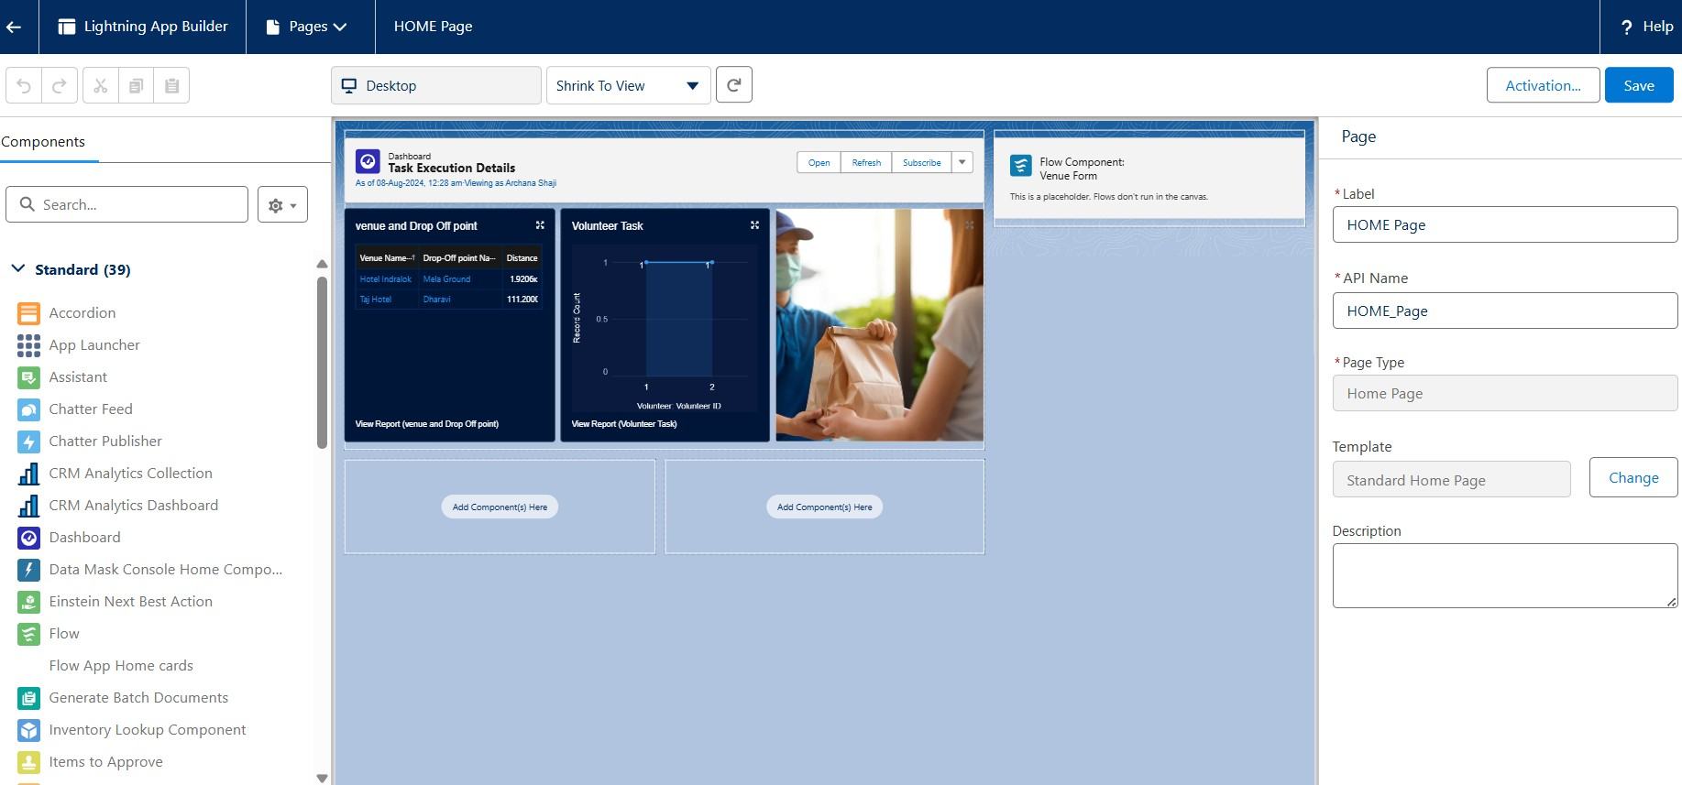

# Conclusion

By using the Salesforce platform, the project developed an efficient and transparent system for handling surplus food donations. This system improved coordination with volunteers and ensured that food was delivered to beneficiaries on time. As a result, it effectively addressed food insecurity and made the most of the available resources.

# Thank You