**EXPT. 12 MINI-PROJECT**

**(HOSTING)**

**APPOINTMENT SCHEDULING SYSTEM**

**ABSTRACT:**

Appointment Scheduling System helps the patients to book appointment for the Dentist, Homeopathic and Physiotherapist from their homes. When the website opens, the user fill in the details of their area and the symptoms. Automatically the practitioners nearby will be listed with their reviews in the new webpage .A brief description of the practitioners will be present and the patient can view the schedule of the practitioner’s free time. Patient can book a slot for the appointment of the practitioner he chooses. The patient types in his/her details and can also pay the visiting charges online if he/she wishes to. The practitioner in turn will get to know the patient’s details and the appointments scheduled

**DESCRIPTION:**

We will have a database supporting appointment time and date. Above all, we hope to provide a comfortable user experience along with the best Experience available. . It has two parts, the front end application which will show all the data upfront to the client, and the back end which will manage the information about the system as a whole.

An Appointment Scheduling system contains the following information as shown below.

* Doctor description:

Doctor visits the website and signs up his/her details. Doctor provides his details and then waits for patients to schedule his/ her appointment. Doctor gets a unique login id and password to check his daily appointments.

* Patient selects area:

Patient enters his pin code and the type of doctor he wants to consult. The database throws all the doctors in his/her area.

* Doctor selection:

Patient can select a doctor according to doctor’s description. Patient then selects appointment slot and fills his details up. Appointment gets booked accordingly.

* Appointment Check:

Patient as well as Doctor can login using id and password and check the appointment details in case of cancellation patient can mail accordingly.

It is very user friendly and easy to use.

**USER INTERFACES:**

Front end software: HTML, JavaScript, CSS, PHP, JQuery

Back end software: MYSQL

**DATABASE**

Our database consists of the following tables viz.:

Doctor, Patient, appoint.

**PATIENT MODULE**

As the goal of the system is to make the process of appointment scheduling as simple as possible for the patient, the functionality provided through the Appointment scheduling system is restricted to that which most pertinent to accomplish the desired task. All of the functions outlined above, with the exceptions of account creation and management, will be used every time an Appointment is booked. The Patient should be able to do the following functions:

* Navigate through the different tabs
* Select any tab from the menu.
  + Enter area code and doctor type
  + Select a doctor from the list
  + Select an appropriate appointment time.
  + Enter his details
  + Book the appointment
  + Log in to his account
  + Check appointment details
* **​**Get doctors details for further communication

**DOCTOR MODULE**

As it is an appointment scheduling system. The system should provide doctor’s ease in scheduling his appointments better than the traditional process. The doctor gets all of the details booked by the patient whenever he logs in. The doctor should be able to perform the following functions:

* Get the sign up page.
* Fill his details
* Log in to his account
* View his details
* View appointment details
* Get details of the patients for any further communication.
* Ease in accessing different tabs of website.

**XAMPP HOSTING**

XAMPP stands for Cross-Platform (X), Apache (A), MySQL (M), PHP (P) and Perl (P). It is a simple, lightweight Apache distribution that makes it extremely easy for developers to create a local web server for testing purposes. Everything you need to set up a web server – server application (Apache), database (MySQL), and scripting language (PHP) – is included in a simple extractable file. XAMPP is also cross-platform, which means it works equally well on Linux, Mac and Windows. Since most actual web server deployments use the same components as XAMPP, it makes transitioning from a local test server to a live server is extremely easy as well.

XAMPP has four primary components. These are:

**1. Apache:** Apache is the actual web server application that processes and delivers web content to a computer. Apache is the most popular web server online, powering nearly 54% of all websites.

**2. MySQL:** Every web application, howsoever simple or complicated, requires a database for storing collected data. MySQL, which is open source, is the world’s most popular database management system. It powers everything from hobbyist websites to professional platforms like WordPress..

**3. PHP:** PHP stands for Hypertext Preprocessor. It is a server-side scripting language that powers some of the most popular websites in the world, including WordPress and Facebook. It is open source, relatively easy to learn, and works perfectly with MySQL, making it a popular choice for web developers.

**4. Perl**: Perl is a high-level, dynamic programming language used extensively in network programming, system admin, etc. Although less popular for web development purposes, Perl has a lot of niche applications.

Different versions of XAMPP may have additional components such as phpMyAdmin, OpenSSL, etc. to create full-fledged web servers.

**STEPS:**

Considering that the XAMPP server is already installed on the device, the following steps are to be followed.

1. Log into your routers web page Find both your real IP (What everyone else uses) and your local IP(only you use this one). Be sure to write both of these numbers down.
2. Put Online!
3. Actually putting the website online is the easiest part. Just click on the "Put online" icon in the task bar menu. To find your website at home, type in your 192.168.1.x IP address. To find it anywhere else, type in your xxx.xxx.xx.xxx IP address. Your website will always be up as long as your computer and internet connection are on.
4. Open your port 80 for forwarding
5. Locate your site. Now in your "Web Server" open your browser and type in the address bar, http://localhost/ Your page will be served by the Internet on your browser.
6. Get the IP of your home. That is the address of your broadband given by your Internet Service Provider, on the Internet. Ask a friend of yours to type it in his browser. Your site is open to public now.

**TO ADD A RULE IN THE WINDOWS FIREWALL FOR PORT 80, DO THE FOLLOWING:**

1. Go to the Control Panel and launch "Windows Firewall"
2. Go to "Advanced Settings"
3. Select "Inbound Rules" in the left pane
4. Select "New Rule" in the right pane
5. In the New Inbound Rule Wizard, select "Port" as Rule Type, then click on "Next" Select "TCP and put "80" (and any other ports you want to open) in "Specific local ports", then click on "Next"
6. Select "Allow the connection", then click on "Next"
7. Select the network location where the rule should apply (select them all if you're not sure), then click on "Next"
8. Give a name and an optional description

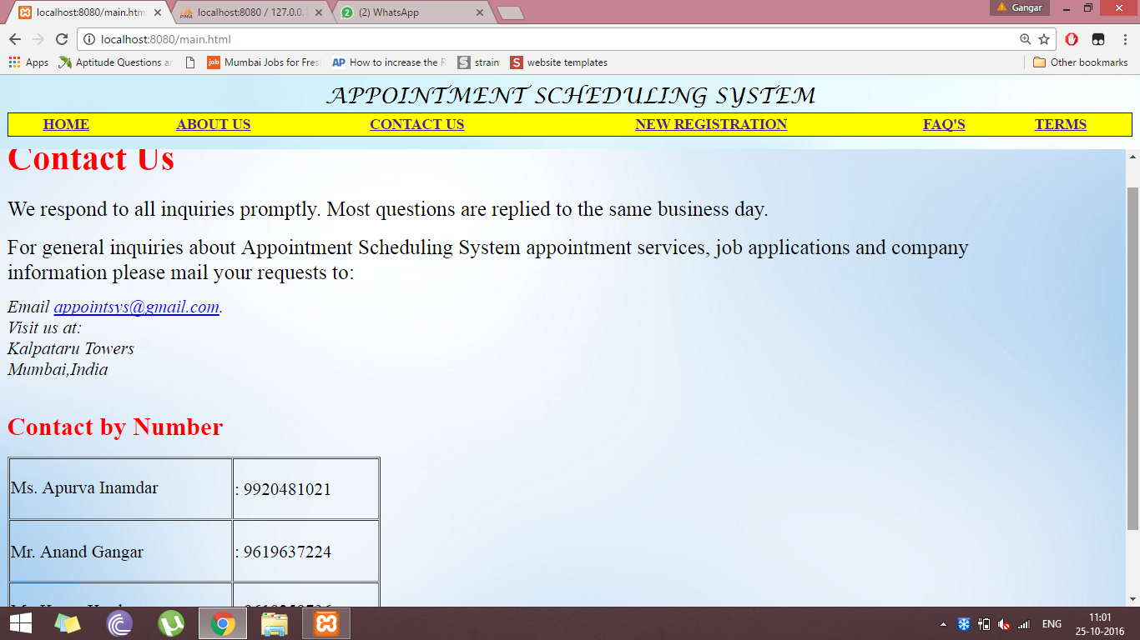

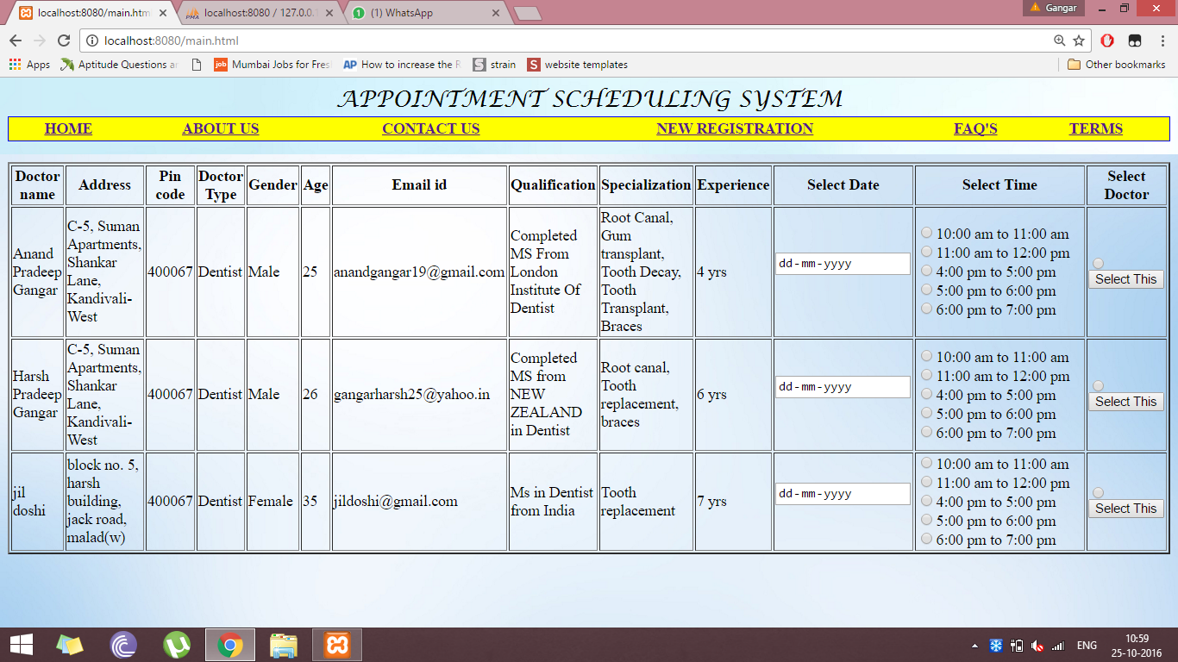

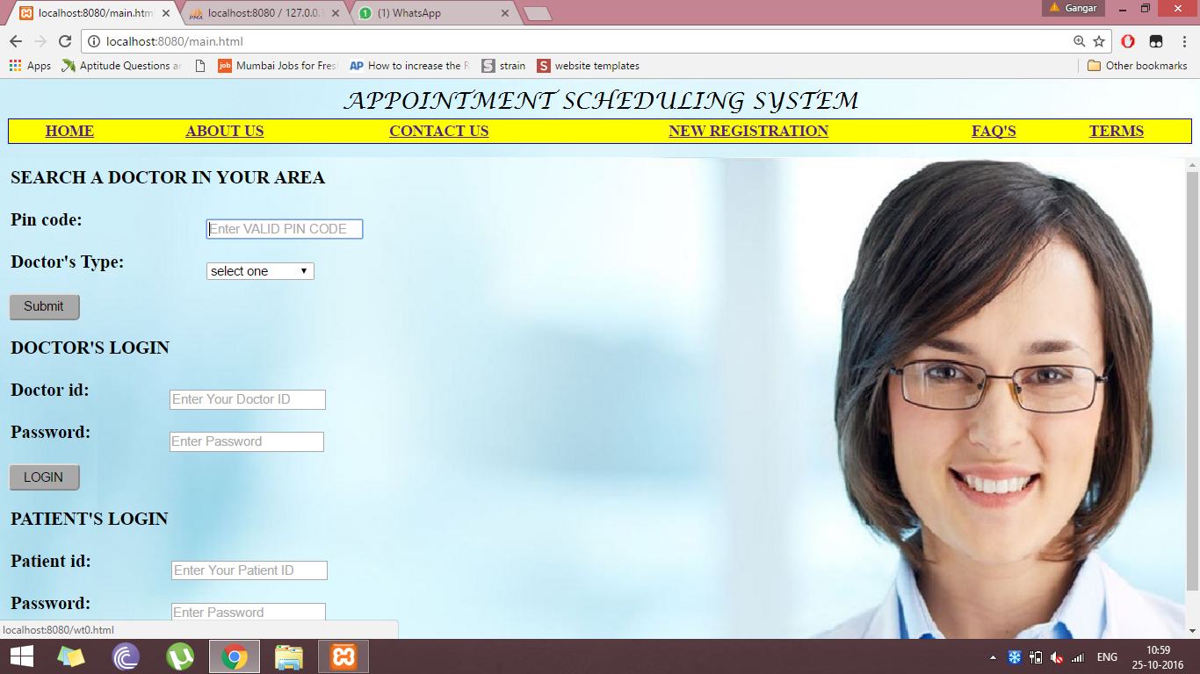

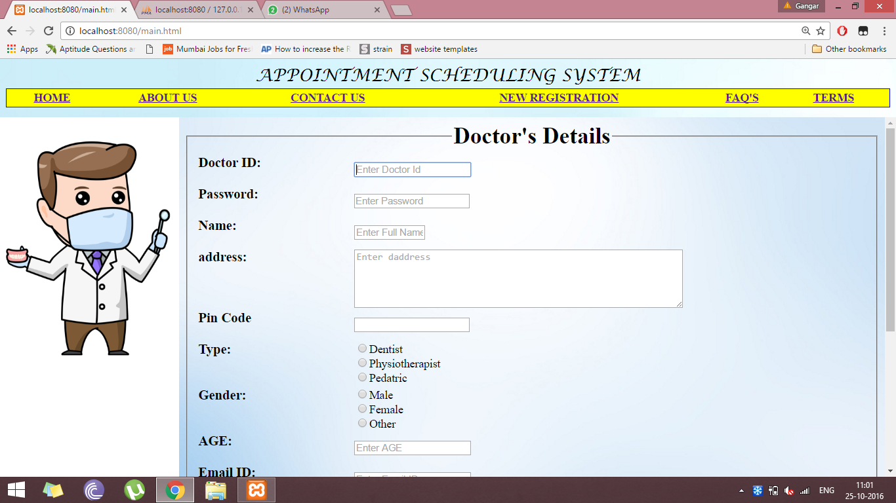

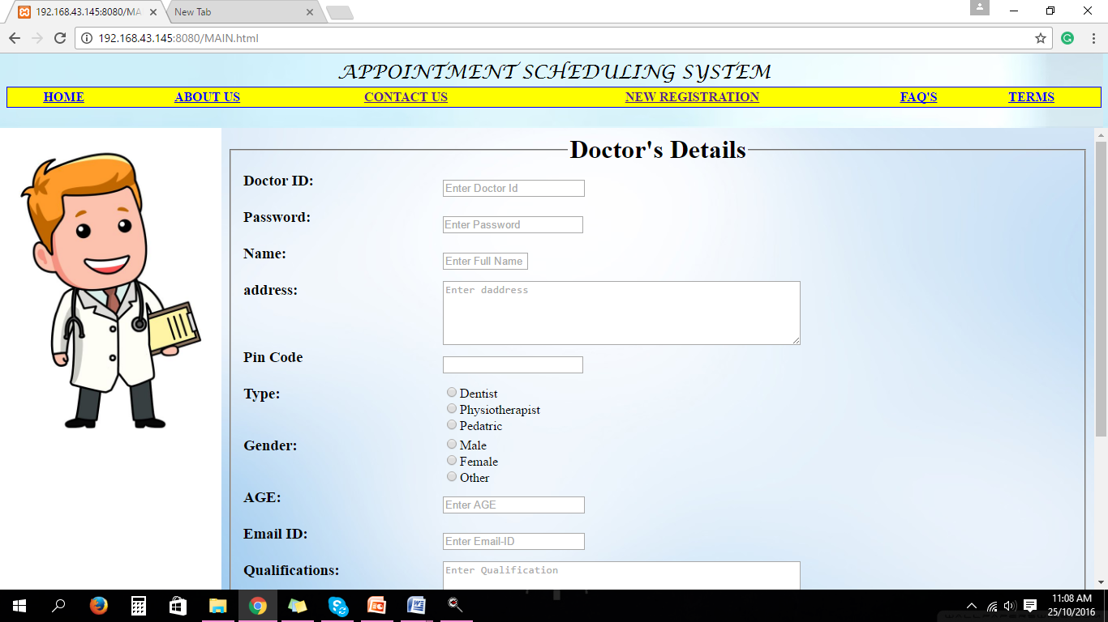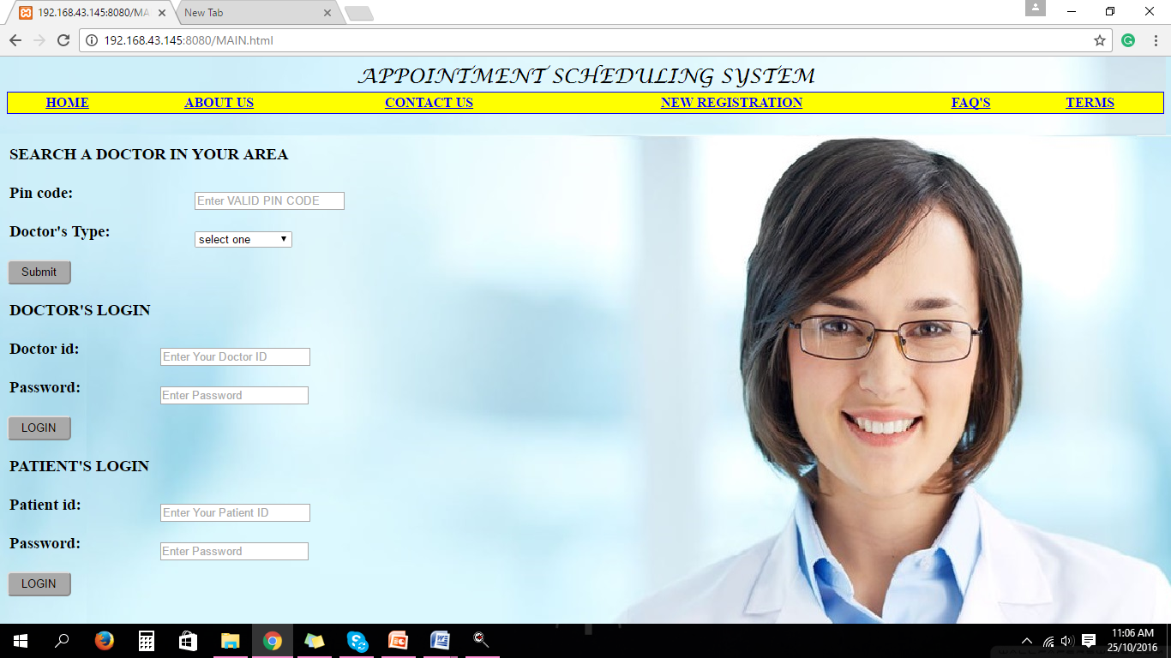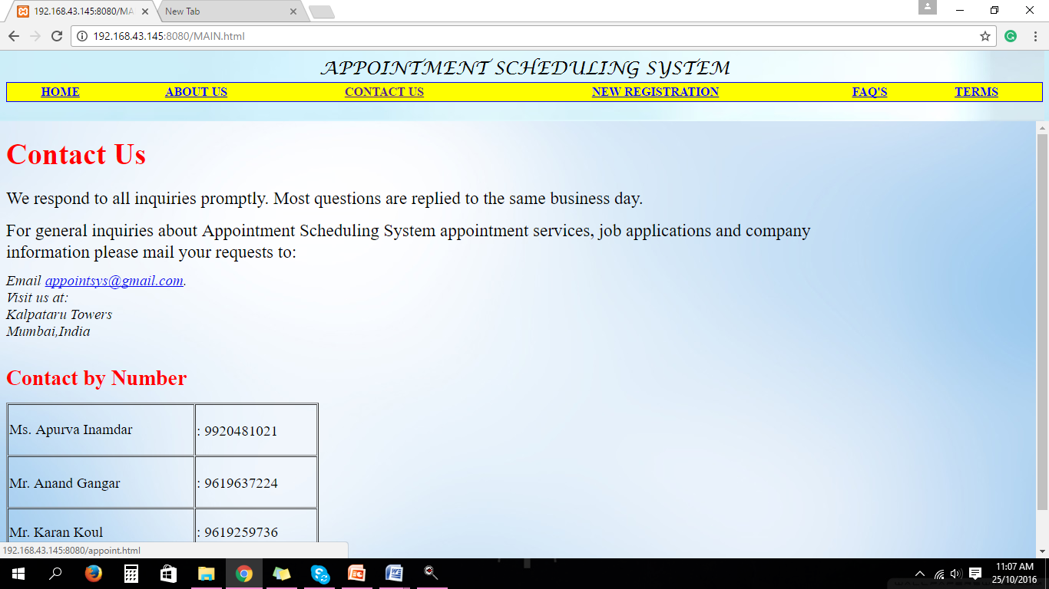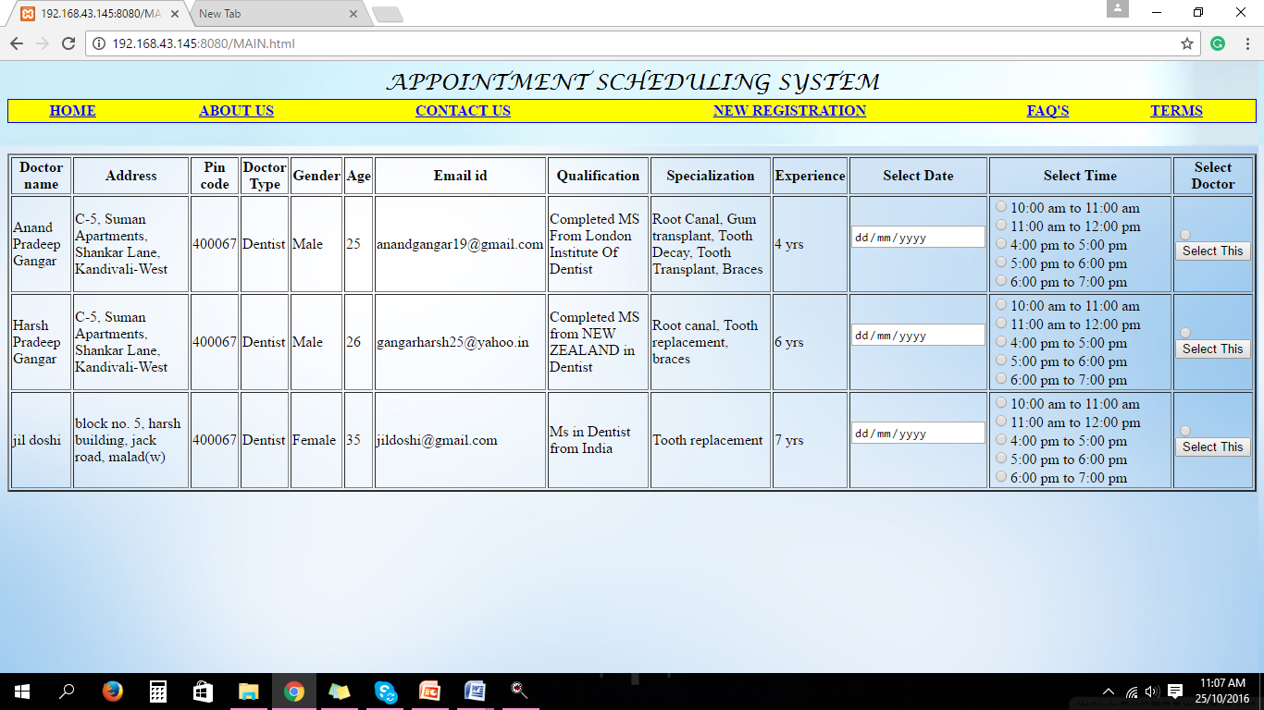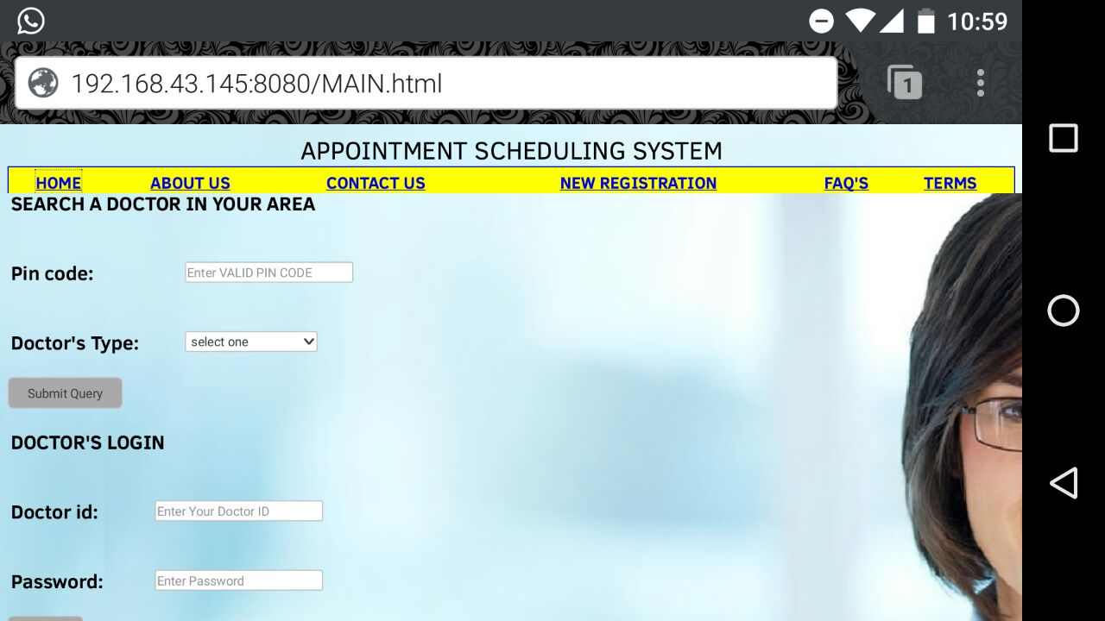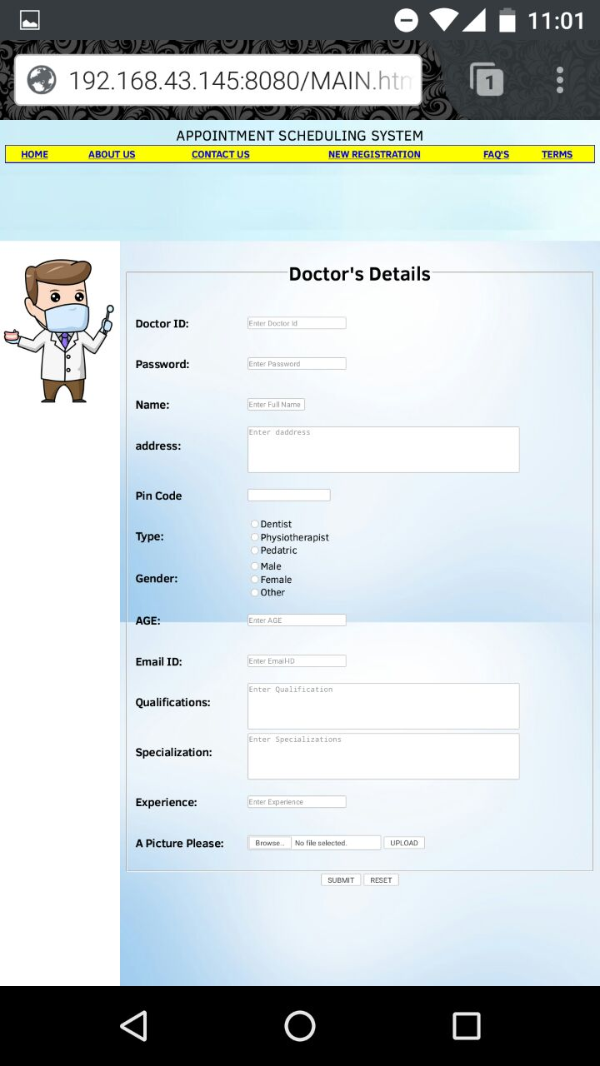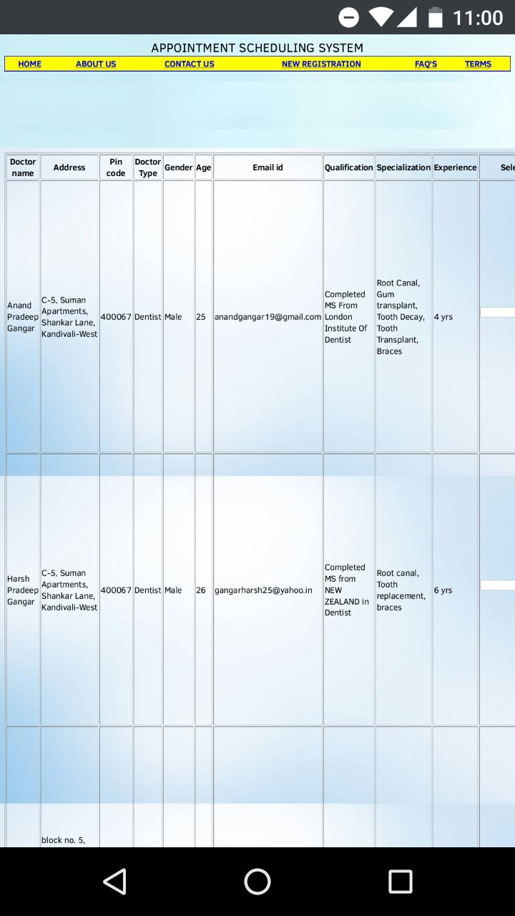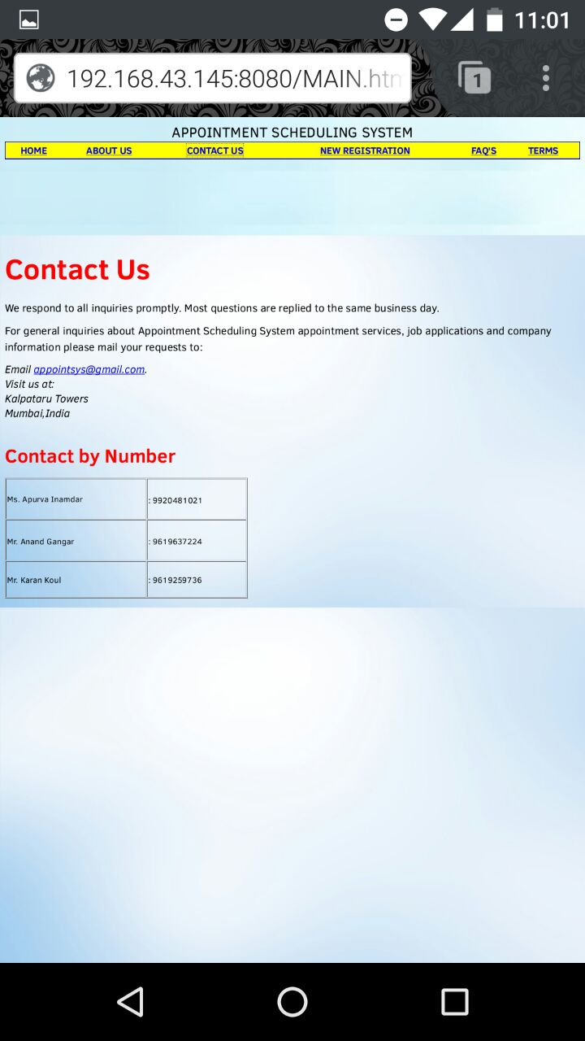

CONCLUSION

Thus, we implemented the computer networking project by hosting our “appointment scheduling system” on our own server. Hosting means to store (a website or other data, in this case, a website) on a server or other computer so that it can be accessed over the Internet. The project was implemented successfully.