Create a full stack React/Express/MongoDB app using Docker

In this article, I will walk through the process of containerizing a React FrontEnd, a Node / Express API, and a MongoDB database using Docker containers in a simple way.

What is Docker?

Docker is one of the most important technologies at the moment. It lets us run apps inside containers that are mostly isolated from “everything”.
Each container is like an individual virtual machine stripped out of everything that is not needed to run your app. This makes containers very light, fast and secure.
Containers are also meant to be disposable. If one goes rogue, you can kill it and make another just like it with no effort thanks to the container images system.
Another thing that makes Docker great is that the app inside containers will run the same in every system (Windows, Mac, or Linux). This is awesome if we are developing on our machine and then we want to deploy it to some cloud provider like GCP or AWS.
Containerizing our app with Docker is as simple as creating a Dockerfile for each of our apps to first build an image, and then running each image to get the containers live.

Containerize our Client
To build our Client image we will be needing a Dockerfile. Let’s create one:
- Open the React / Express App in the code editor.
- Navigate to the Client folder.
- Create a new file named Dockerfile.
- Place this code inside it

This will instruct docker to build an image (using these configurations) for our Client.

Containerize our API
To build our API image we will be needing another Dockerfile. Let’s create it:
- Navigate to the API folder.
- Create a new file named Dockerfile.
- Place this code inside it
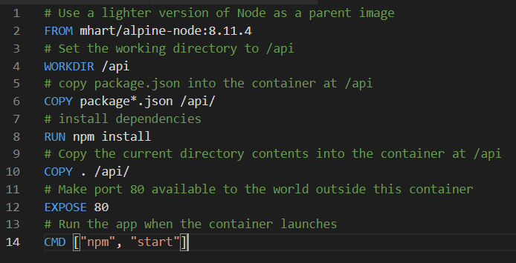

Docker Compose
We could run each individual container using the Dockerfiles. In our case we have 3 containers to manage, so we will use docker-compose instead. Compose is a tool for defining and running multi-container Docker applications.
Let me show you how simple it is to use it:
- Open the React/Express App in preferred code editor.
- On our App main folder, create a new file and name it docker-compose.yml.
- Write this code in the docker-compose.yml file:

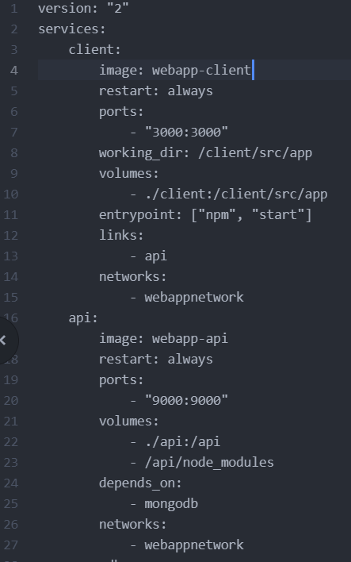

Basically, I’m telling Docker that I want to build a container called client, using the image webapp-client (which is the image we defined on our Client Dockerfile) that will be listening on port 3000. Then, I’m telling it that I want to build a container called api using the image webapp-api (which is the image we defined on our API Dockerfile) that will be listening on port 9000.

Add a MongoDB database

To add a MongoDB database is as simple as adding these lines of code to our docker-compose.yml file:

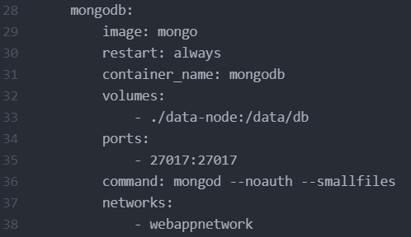

This will create a container using the official MongoDB image.

Create a shared network for our containers

To create a shared network for the container just add the following code to our docker-compose.yml file:
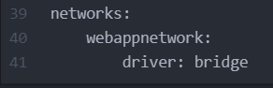

Notice that we have already defined each container of our app to use this network.
In the end, our docker-compose.yml file should be something like this:

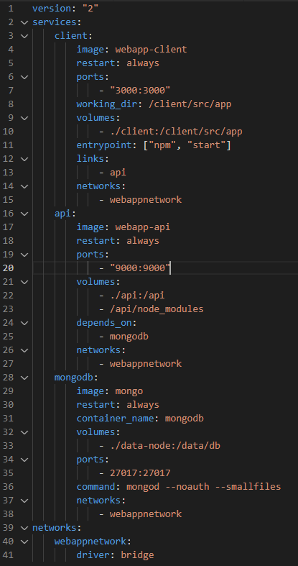

In the docker-compose.yml file, the indentation matters. Be aware of that.

Get the containers running

- Now that we have a docker-compose.yml file, let’s build our images. Go to the terminal and on our App’s main directory run:
docker-compose build
2. Now, to make Docker spin up the containers, just run:

docker-compose up

And… just like magic, we now have our Client, our API, and our Database, all running in separated containers with only one command. How cool is that?

Connect your API to MongoDB
- First, let’s install Mongoose to help us with the connection to MongoDB. On your terminal type:
npm install mongoose

2. Now create a file called testDB.js on our API routes folder and insert this code:

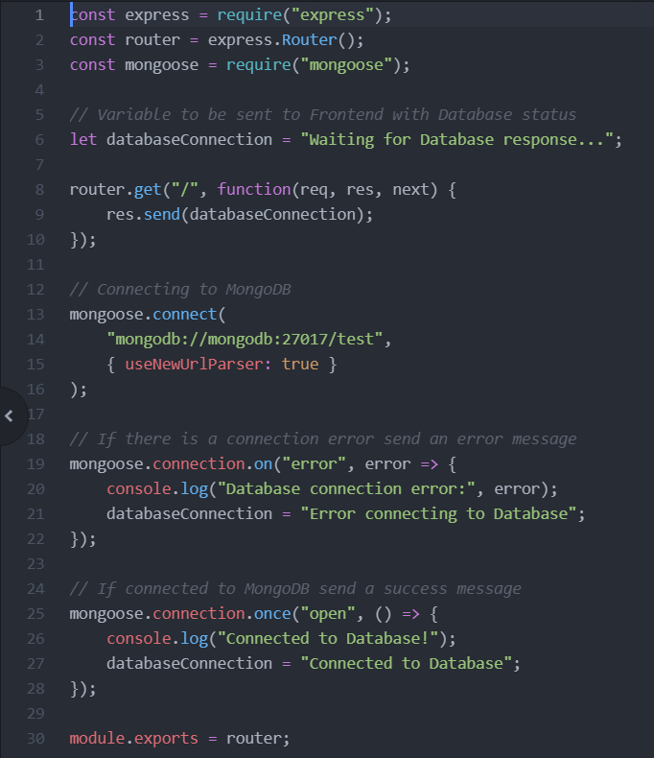
Ok, let’s see what this code is doing. First, I import Express, ExpressRouter, and Mongoose to be used on our /testDB route. Then I create a variable that will be sent as a response telling what happened with the request. Then I connect to the database using Mongoose.connect(). Then I check if the connection is working or not, and change the variable (I’ve created earlier) accordingly. Finally, I use module.exports to export this route so that I’m able to use it on app.js file.
3. Now we have to “tell” Express to use that route we’ve just created. On your API folder, open the app.js file and insert this two lines of code:
var testDBRouter = require("./routes/testDB");
app.use("/testDB", testDBRouter);
This will “tell” Express that every time there is a request to the endpoint /testDB, it should use the instructions on the file testDB.js.
4. Now let’s test if everything is working properly. Go to the terminal and press control + C to bring your containers down. Then run docker-compose up to bring them back up again. After everything is up and running, navigate to http://localhost:9000/testDB we should see the message
Connected to Database.
In the end, your app.js(api/app.js ) file should look like this:

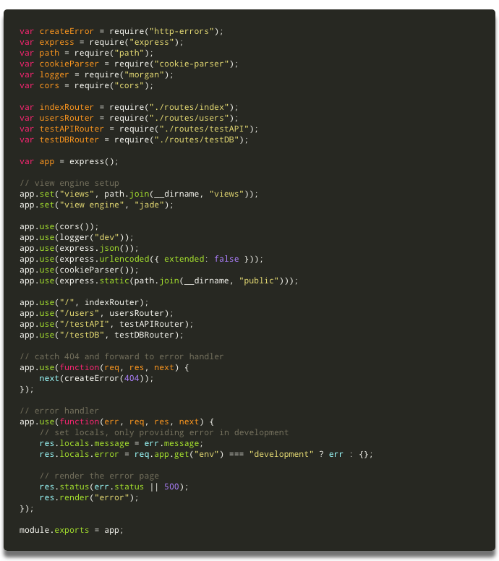
API is now connected to the database. But our FrontEnd doesn’t know yet. Let’s work on that now.

Make a request from React to the Database
To check if the React app can reach the Database let’s make a simple request to the endpoint you defined on the previous step.
- Go to your Client folder and open the App.js file.
- Now insert this code below the callAPI() method:
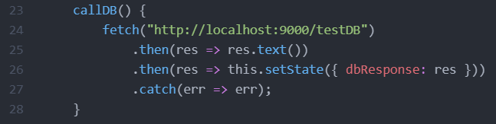
This method will fetch the endpoint you defined earlier on the API and retrieve the response. Then it will store the response in the state of the component**.**
3. Add a variable to the state of the component to store the response:
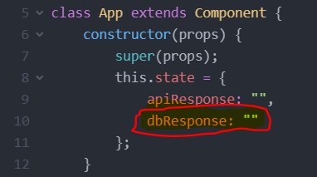

4. Inside the lifecycle method **componentDidMount(), **insert this code to execute the method you’ve just created when the component mounts:
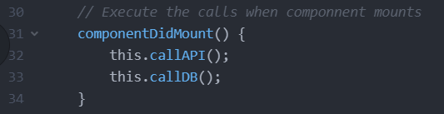

5. Finally, add another <;p> tag after the one you already have to display the response from the Database:
In the end, your App.js(client/App.js ) file should end up like this:
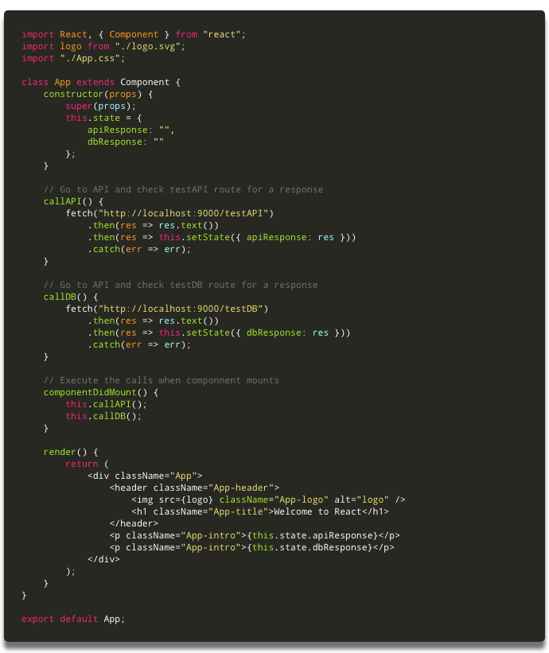

Finally, let’s see if everything is working
On the browser, go to http://localhost:3000/ and if everything is working properly, we should see these three messages :
- Welcome to React
- API is working properly
- Connected to Database
Something like this:
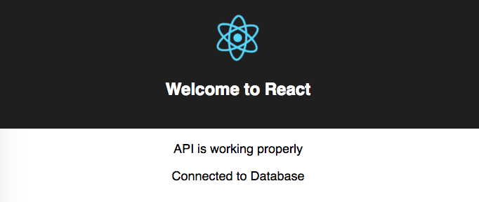

http://localhost:3000/

Congratulations!!!
We now have a full stack app with a React FrontEnd, a Node/Express API and a MongoDB database. All running inside individual Docker containers that are orchestrated with a simple docker-compose file.

