1. Create an HTML page to validate Name and Email. (Use Bootstrap, JQuery wherever applicable)

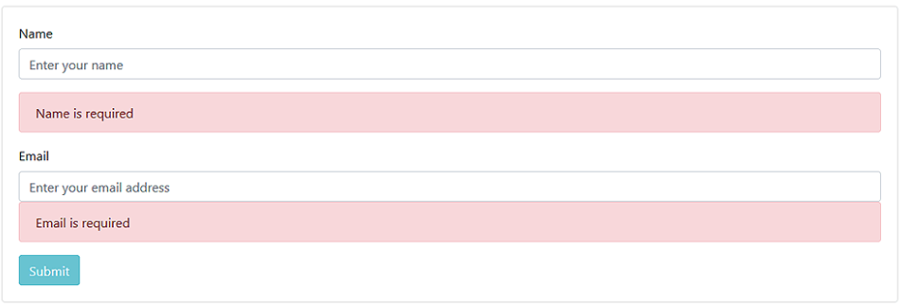

2. If the name and email entered are correct it should dynamically add the details to the below table. The table should look like below:



Question 1 and 2:

<html>

<head>

    <link rel="stylesheet" href="css/bootstrap.css">

    <style>

        table,

        tr,

        td {

            border: 1px solid black;

            margin-left: 20px;

        }

    </style>

    <script type="text/javascript">

        function add_row() {

            td1 = document.createElement('td1');

            td2 = document.createElement('td2');

            td1.add(document.getElementById("uname").value);

            td2.add(document.getElementById("email").value);

            tr.appendChild(td1);

            tr.appendChild(td2);

            table.appendChild(tr);

        }

    </script>

</head>

<body>

    <form class="form-group" onsubmit="add_row()">

        <div class="container">

            <div class="row">

                <div class="cod md-3">Name:<br><input type="text" id="uname" class="form-control"

                        placeholder="Enter your name" required></div>

            </div>

            <div class="row">

                <div class="cod md-3">Email:<br><input type="email" id="email" class="form-control"

                        placeholder="Enter your email address" required></div>

            </div>

            <div class="row">

                <div class="cod md-3">

                    <div class="btn-toolbar">

                        <button class="btn btn-primary">Submit</button>

                    </div>

                </div>

            </div>

        </div>

    </form>

    <table>

        <tr>

            <td> Name </td>

            <td> Email </td>

        </tr>

    </table>

</body>

</html>

1. Create a user form like below and perform the validation as shown in the below images:

**Image - 1-4**

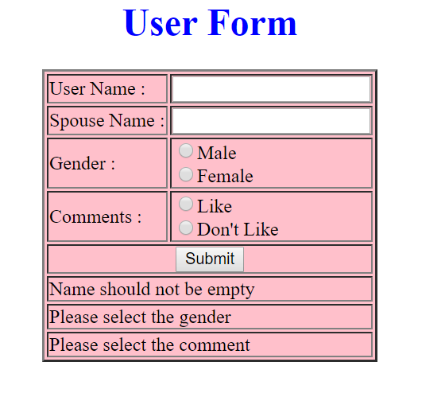

**Image - 2-4**

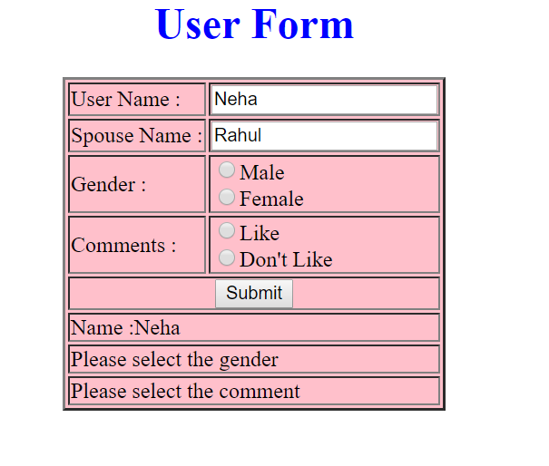

**Image - 3-4**

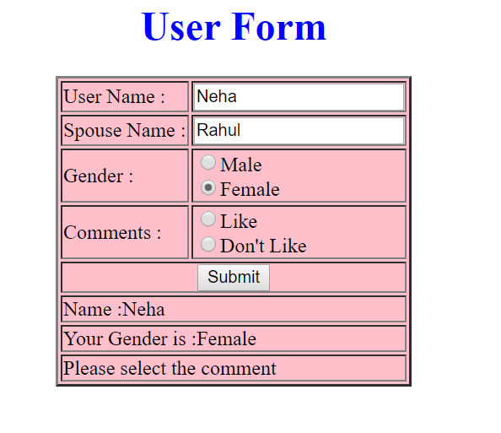

**Image - 4-4 (Success)**

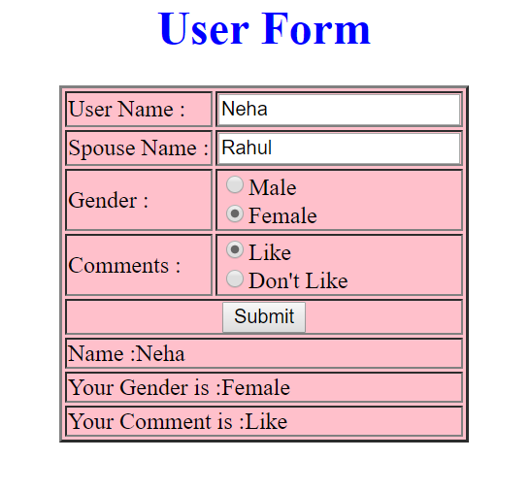

<html>

<head>

    <style type="text/css">

        table {

            border: 5px solid black;

        }

        tr,

        td {

            border: 1px solid black;

            padding: 10px;

            font-size: 20px;

        }

        #div4 {

            text-align: center;

            font-size: 30px;

        }

    </style>

</head>

<script type="text/javascript">

    function check() {

        var uname = document.getElementById("uname").value;

        var sname = document.getElementById("sname").value;

        var div1 = document.getElementById("div1")

        var div2 = document.getElementById("div2")

        var div3 = document.getElementById("div3")

        var div4 = document.getElementById("div4")

        with (document.forms[0]) {

            if ((uname.value == "") || (sname.value == "")) {

                div1.innerHTML = "<font color=red>Name should not be empty</font>";

                return false

            }

            if ((gender[0].checked) == false && (gender[1].checked) == false) {

                div1.innerHTML = "Name: " + document.getElementById("uname").value;

                div2.innerHTML = "<font color=red>Please select the gender</font>";

                return false

            }

            if ((comment[0].checked) == false && (comment[1].checked) == false) {

                var t;

                if (gender[0].checked) {

                    t = gender[0].value;

                }

                else {

                    t = gender[1].value;

                }

                div2.innerHTML = "Your Gender is :" + t;

                div3.innerHTML = "<font color=red>Please select the comment</font>";

                return false

            }

            var s;

            if (comment[0].checked) {

                s = comment[0].value;

            }

            else {

                s = comment[1].value;

            }

            div3.innerHTML = "Your Comment is :" + s;

            div4.innerHTML = "<font color=green>Your details are successfully saved</font>";

            return false;

        }

    }

</script>

<body>

    <h2>

        <center>User Form</center>

    </h2>

    <form onsubmit="return check()">

        <table cellspacing="10" cellpadding="10" align="center">

            <tr>

                <td>User Name:</td>

                <td><input type="username" name="username" id="uname" /></td>

            </tr>

            <tr>

                <td>Spouse Name:</td>

                <td><input type="username" name="spname" id="sname" /></td>

            </tr>

            <tr>

                <td>Gender: </td>

                <td>

                    <input type="radio" name="gender" id="gender" value="Male" />Male

                    <input type="radio" name="gender" id="gender" value="Female" />Female

                </td>

            </tr>

            <tr>

                <td>Comments: </td>

                <td>

                    <input type="radio" name="comment" id="comment" value="Like" />Like

                    <input type="radio" name="comment" id="comment" value="Don't Like" />Don't Like

                </td>

            </tr>

            <tr>

                <td align="center" colspan="2">

                    <input type="submit" value="Submit">

                </td>

            </tr>

            <tr>

                <td colspan="2">

                    <div id="div1">Name should not be empty</div>

                </td>

            </tr>

            <tr>

                <td colspan="2">

                    <div id="div2">Please select the gender</div>

                </td>

            </tr>

            <tr>

                <td colspan="2">

                    <div id="div3">Please select the comment</div>

                </td>

            </tr>

        </table>

    </form>

    <div id="div4"></div>

</body>

</html>

4.

CyberShoppe, Inc. sells toys and books in the United States. It has three branches in different parts of the country. Currently, the three branches maintain data on their local computer systems. The IT manager at CyberShoppe has identified that a centralized data repository on the products sold through its   
e-commerce site is required. The data from all branches must be collated and housed in a centralized location. This data must be made available to the Accounts and Sales sections at the individual branches, regardless of the hardware and software platforms being used at the branches.

1. In addition, the sales personnel require access to the data using palmtops and cellular phones. The product details of CyberShoppe consist of the product name, a brief description, the price, and the available quantity on hand. A product ID uniquely identifies each product. Create a responsive web page to capture these details.
2. The various products at CyberShoppe are purchased from their suppliers through their branch offices. The purchase order details are sent to the head office to generate reports. To ensure that the data can be accessed across all hardware and software used at the head office, the branch offices. On receiving this data, the head office needs to verify that all branches have specified the required information in a consistent format.

The purchase order details sent by the branch offices include the product ID, order ID, date of the purchase order, name and address of the supplier, quantity ordered, and price per unit.

1. The product Id must start with P following by 5 digits
2. The order Id must start with OD followed by 4 digits
3. The remaining fields are mandatory.
4. The look and feel should be consistent throughout the website.

Use jQuery, Bootstrap, JavaScript .

<html>

<script type="text/javascript">

    function check() {

        var pid = document.getElementById("pid").value;

        var oid = document.getElementById("oid").value;

        var name = document.getElementById("name").value;

        var address = document.getElementById("address").value;

        var qo = document.getElementById("qo").value;

        var ppu = document.getElementById("ppu").value;

        if (pid.length == 0) {

            alert("Product Id cannot be empty")

            return false

        }

        if (pid.charAt(0) != 'P' || pid.length != 6) {

            alert("Invalid Product Id")

            return false

        }

        if (oid.length == 0) {

            alert("Order Id cannot be empty")

            return false

        }

        if (oid.charAt(0) != 'O' || oid.charat(1) != 'D' || oid.length != 6) {

            alert("Invalid Order Id")

            return false

        }

        if (name.length == 0 || address.length == 0 || qo.length == 0 || ppu.length == 0) {

            alert("The remaining fields are mandatory")

            return false

        }

    }

</script>

<body bgcolor="black" text="white">

    <h2>

        <center>CyberShoppe, Inc. </center>

    </h2>

    <form onsubmit="return check()">

        <table cellspacing="10" cellpadding="10" align="center">

            <tr>

                <td>Product Id</td>

                <td><input type="text" name="pid" id="pid" /></td>

            </tr>

            <tr>

                <td>Order Id </td>

                <td><input type="text" name="oid" id="oid" /></td>

            </tr>

            <tr>

                <td>Date of order purchase </td>

                <td><input type="date" name="dop" id="dop" /></td>

            </tr>

            <tr>

                <td>Name of Supplier</td>

                <td><input type="text" name="name" id="name" /></td>

            </tr>

            <tr>

                <td>Address of Supplier</td>

                <td><input type="text" name="address" id="address" /></td>

            </tr>

            <tr>

                <td>Quantity ordered</td>

                <td><input type="text" name="qo" id="qo" /></td>

            </tr>

            <tr>

                <td>Price Per Unit</td>

                <td><input type="text" name="ppu" id="ppu" /></td>

            </tr>

            <tr>

                <td align="center">

                    <input type="submit" value="Submit">

                </td>

            </tr>

        </table>

    </form>

</body>

</html>