Alex Gangwish

ME 333 Final Report

3/15/2017

28.4.1.)

1. I use SPI3, which utilizes pins SCK3 (D1), SDI3 (D2), SDO3 (D3), and /SS3 (D9)

2. I use ADC1 with pin AN1 (B1)

3. I use OC3 (D2) to create the PWM and Port D pin D10 to control the direction on the H-bridge

4. I used Timer 2 for the 5kHz ISR and Timer 4 for the 200 Hz ISR. I set both priorities to 5 with sub-priority 0 so the routines would not interrupt each other.

5. 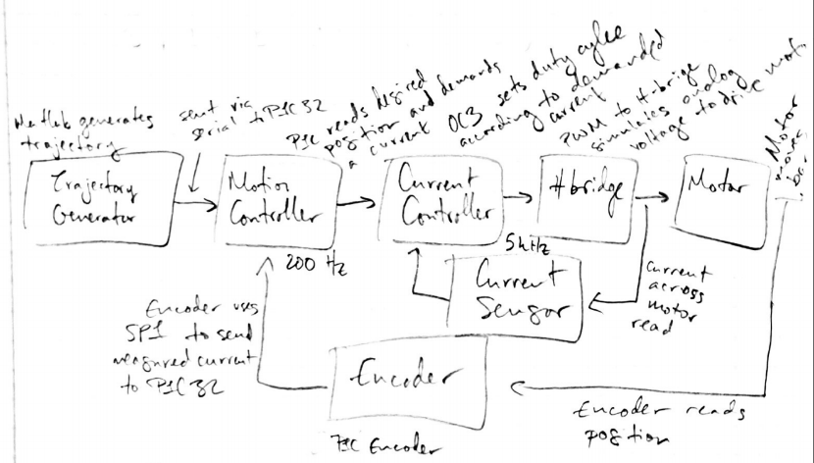

6.

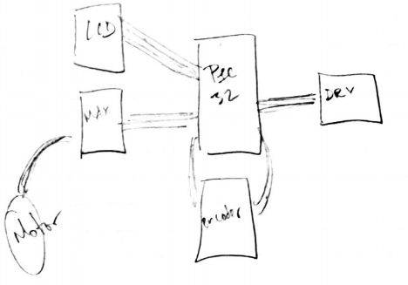

28.4.7.)

2. Imax = 2V / R = 12V / 12Ohms ~ 1 A max current

3. Vmax = 15x10^-3 \* 1 = 15mV

4. G = 1.65 / (15x10^-3) ~ 110. I used resistors with values 2.2M and 18K to get a gain of around 123.

5. I chose R = 820 and C = 1 uF, which creates a cutoff frequency around 194.1 Hz.

6.

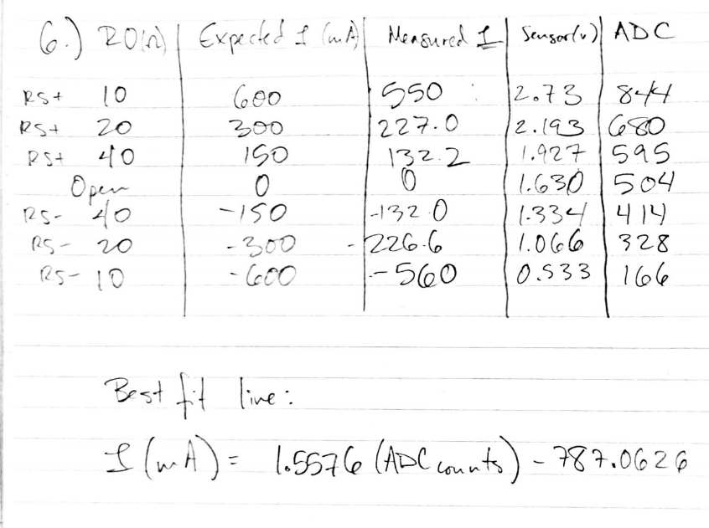

28.4.9)

8.

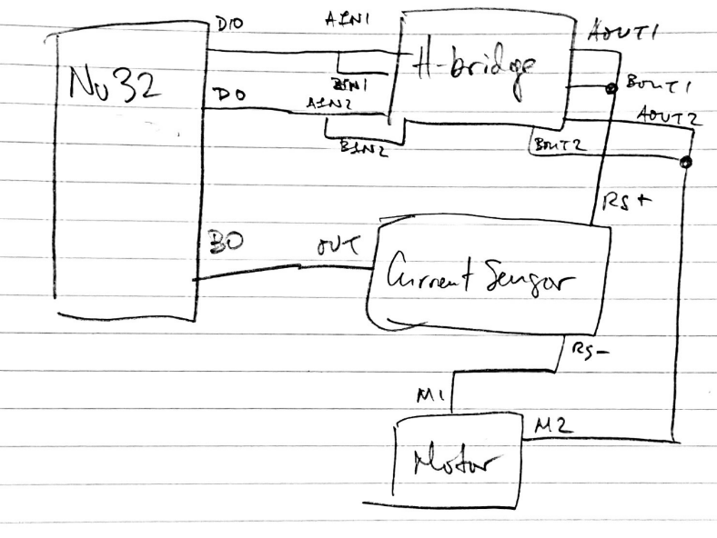

28.4.10

5. ITEST

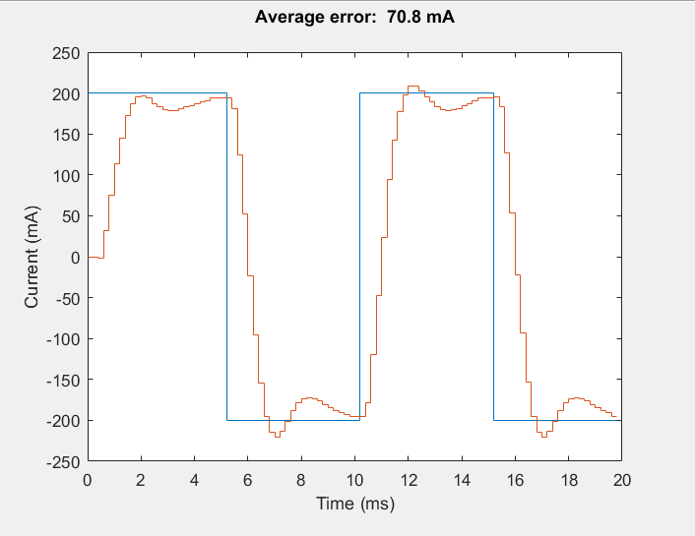

Control Gains: Kp = 0.4, Ki = 0.05

Demands current in mA (i.e. requests 300 to get .3 A)

PWM duty cycles between -100 and 100 (as a percentage)

28.4.12)

5.

STEP

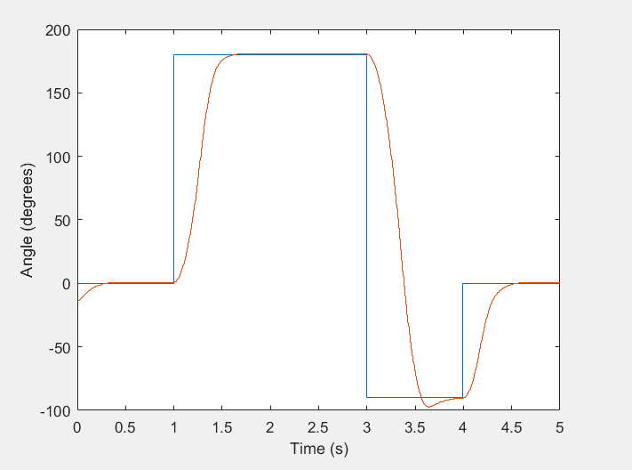

Blue = desired, orange = actual

CUBIC

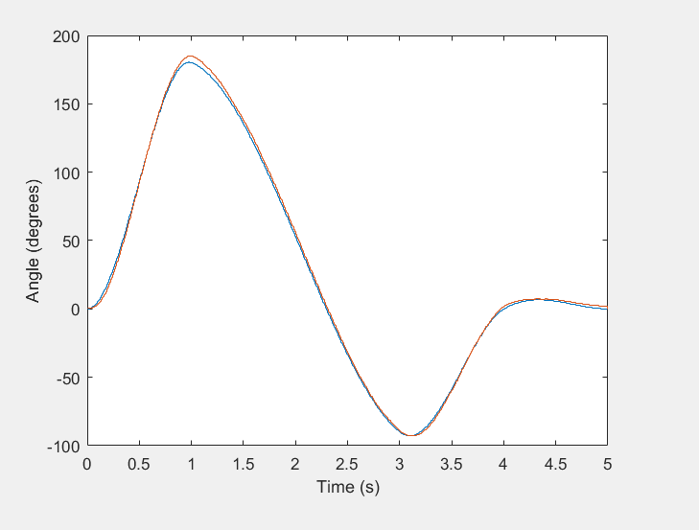

Blue = desired, orange = actual.

Control gains: Kp = 3, Ki = 0, Kd = 80

Demands angles in 1/10th degrees (i.e. requests 900 to get 90 degrees)