POS Agent Fraud Detection at Nigerian Scale, DAT 608
Group 1, DAT 608 Topics: 4, 5, 6, 7, 10
Course: DAT 608 Big Data Technologies, Pan-Atlantic University, MDS4
Submitted by: Oluwaseun David Aganran (Mat. No: 25120133003)
Links: GitHub Release (v0.1.0) | Jira Board (DAT608-GRP1)
The following provides the documentation and flow of how the POS agent fraud detection solution was created by our group this semester. All figures, thresholds, and filenames were taken from the actual repository, as opposed to the original proposal, and are as they are currently implemented in the system.
PROBLEM STATEMENT / SOLUTION
The large number of card transactions conducted each day by Nigerian POS agents have to be detected at the moment the transaction occurs rather than once it has been settled, since fraud in the form of cloning cards, collusion among agents, and false reversals must be flagged before any money is lost.
A stream pipeline was created that streams all transactions through Kafka, scores them according to two blended models into one probability, tiers that probability into an alert, and sends it to the dashboard to be acted on within seconds instead of days.
I. Project Documentation & Architecture
Objective: To classify each Nigerian POS transaction as having a certain level of risk of being fraudulent within a hundred milliseconds; to tier this classification into an actual alert (critical at 0.85 and above, high at 0.60, medium at 0.30, and low below that); and to show anything of interest to a human within thirty seconds of the transaction.
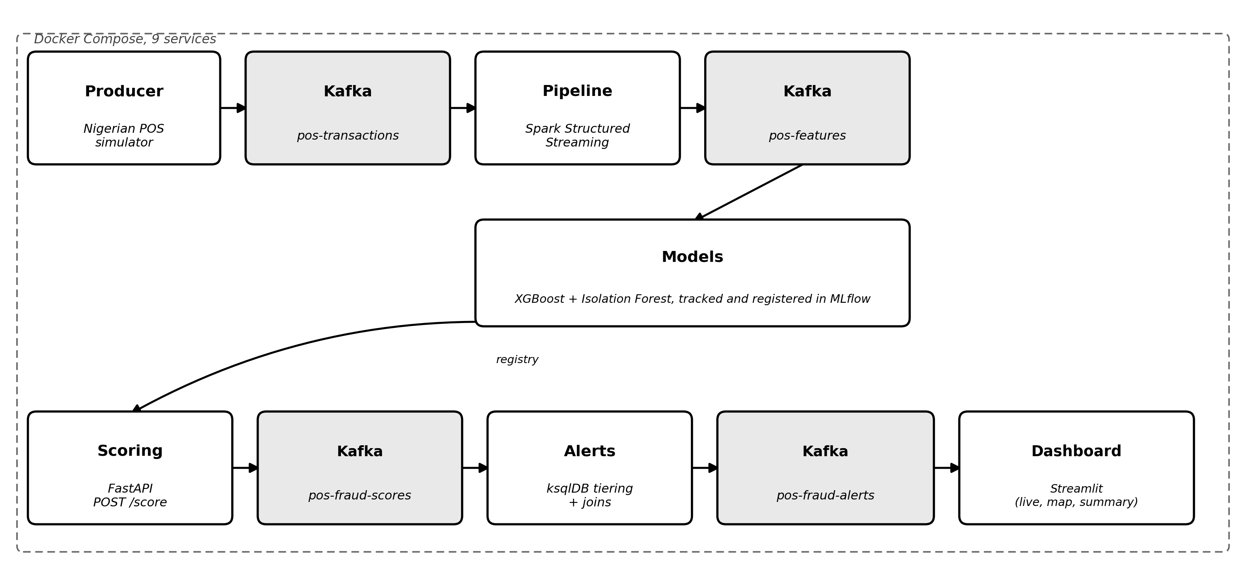
Figure 1: End-to-end pipeline architecture. Every service, Kafka topic, and technology named here matches the live system, not a proposed one.
Data Ingestion Strategy:
- Synthetic Transaction Generator: a Python script in producer/ creates realistic POS transactions in Nigeria, including state and LGA level geography and distribution of card BINS based on published data from NIBSS and EFInA, amounts in Naira (₦), classified into three fraud patterns - cloned_card, agent_collusion, and fake_reversal, and posts every new one to the pos-transactions Kafka topic at the very instant of its creation. First iteration of the generator was not producing any detectable fraud signal, so it was rewritten to add a unique velocity/geography feature to every pattern before running any models against it.
- Streaming Path: the streaming script producer/kafka_producer.py runs non-stop and posts each transaction with a timestamp right away, so that the fraud pipeline never has to wait on a batch job.
- Batch Path: a different script generated a static training set of 30,008 transactions, 571 of which are truly fraudulent, used for off-line model training independent of the live streaming path.
- Reference Data: a fixed terminal and merchant reference data set (data/reference/terminals.xlsx and merchants.xlsx) is joined against each scored transaction in ksqlDB, meaning that the alert includes a merchant’s actual name and physical address, not just their ID.
- Nigerian Data Sources: the distributions for the transaction level data were based on the interbank settlement statistics from NIBSS and the EFInA financial inclusion survey data, which are the two datasets that report transaction-level data and demographics and not just aggregate statistics. The CBN financial stability statistics and NBS population and economic data were reviewed but not used, as our synthetic data generator required distributions at the transaction level and card BIN level, which only NIBSS and EFInA publish.
Technical Architecture & Tooling:
- Data Transport & Processing: All the transactions are transported by Apache Kafka, while Spark Structured Streaming processes windowed fraud features on top of Kafka. That is the place where we discovered and solved many practical issues this semester – a Docker base image that was lost upstream, the lack of a Kafka connector jar, a Spark UDF built without a prior Spark session, and windowed features that turned out to be impossible to compute on a raw DataFrame in streaming fashion and had to be moved inside the foreachBatch.
- Modelling Engine: XGBoost (supervised, F1 score 0.78, precision 0.85, recall 0.72 on a hold-out split with 5-fold cross-validation) and Isolation Forest (unsupervised, trained only on non-fraudulent data) are managed and registered in MLflow, then blended 70/30 in the scoring phase. We discovered that when we were adding some additional amount-based features to XGBoost, the anomaly correlation of the Isolation Forest model significantly weakened, so we filed that as an open issue instead of just ignoring it.
- Storage: Git tracked Excel workbooks (data/*.xlsx, six of them: transactions_raw, features, fraud_scores, alerts, and the two reference tables) replace a live database, using an openpyxl and filelock pattern so concurrent writers cannot corrupt a file, and so every pull request carries its data changes and reviewers can diff data the same way they diff code.
- Presentation & Alerting: ksqlDB filters and joins scored transactions into a four tier alert stream, a Streamlit dashboard shows live alerts, a colour coded terminal map, and fraud summary metrics, and Docker Compose runs all nine services together, of which five (producer, pipeline, scoring, alerts, and dashboard) are our own custom built images.
Engineering Process & Verification:
- Continuous Integration: each pull request is automatically run through flake8 and pytest, along with a separate task that launches the full nine-service stack on a GitHub-hosted runner. This task is the only thing to find the infrastructure problems listed above, as no previous step had ever started the services.
- Sprint & Ticket Process: development was tracked using Jira, with the relevant criteria defined, and an audit done of all tickets against the live code to identify four tickets that were no longer accurate based on the code itself.
- Dependency Hygiene: Of the 24 dependency update pull requests created this semester, we tested and merged those that could be safely deployed, leaving only two outstanding pull requests, both for specific reasons (missing a Spark base image of the correct version, and backend updates in MLflow 3.x)
- Release: The system is tagged and released as v0.1.0 on GitHub, with all four application images built and released.
II. Implementation Flow (VS Code / Python)
It was all done end-to-end using VS Code and Python. No Posit IDE, no R, no R Shiny here. Below are five steps that more or less resemble what was done and how we did it, including all issues we faced while developing.
Environment setup: the GitHub monorepo was cloned, a virtual Python environment was created for each of the services, and .env.example was renamed to .env for storing secrets and ports. It takes only one command for Docker Compose to launch nine services, Zookeeper, Kafka, ksqlDB, MLflow, and five custom application images, but making sure that the client outside of the Docker network can actually communicate with Kafka involved a change in the way the broker was advertising itself.
ETL Pipeline (Python): producer/ produces and publishes transactions to Kafka. pipeline/ is the Spark Structured Streaming task which reads the topic, calculates velocity_1h, geo_jump_km, bin_spend_rate, terminal_reversal_count, and amount_vs_bin_avg_ratio, and saves the results both to data/features.xlsx and to Kafka. We documented, rather than hid, one real limitation here: each live micro batch only sees its own window, not a true trailing history, while the offline batch path that actually trained the models computes genuine full history windows.
3. Modelling (Python): Our training scripts in the models/ folder train XGBoost and Isolation Forest on the transformed features, log all metrics, and register both models with MLflow. XGBoost was trained to an F1 score of 0.78 on the holdout set. We found and solved an actual version conflict – a particular combination of xgboost and scikit-learn pins that caused MLflow’s model logging to fail silently. The issue was confirmed by training again and checking that the F1 score is still the same.
4. Scoring Service (FastAPI): The scoring service uses both registered models in MLflow and exposes the POST /score endpoint. It combines XGBoost probability and normalised Isolation Forest score at 70 percent to 30 percent into one fraud_probability, maps it to an alert tier (critical – 0.85 and above, high – 0.60, medium – 0.30, low – less), and gives a response in about a hundred milliseconds on the 95th percentile, measured using our own benchmark script with the real registered models, not a mock one.
5. Dashboard & Alerts (Streamlit): ksqlDB streams filtered, scored transactions with medium and higher alert tiers, joins terminal and merchant information, and sends them to data/alerts.xlsx and the fraud_alerts topic. The Streamlit dashboard reads that file every five seconds and shows Live Alerts, a colour-coded Terminal Map, a top five at-risk terminals panel, and a Fraud Summary panel. We measured one real transaction end to end, from its own Kafka timestamp to its alert landing in the workbook, at roughly twenty-eight seconds total, a real margin under our thirty-second target rather than an assumed one.

