ITEC 4550

Assignment – Enhanced Pizza Party App in Android

Modify the Pizza Party MVC app to have the following appearance:

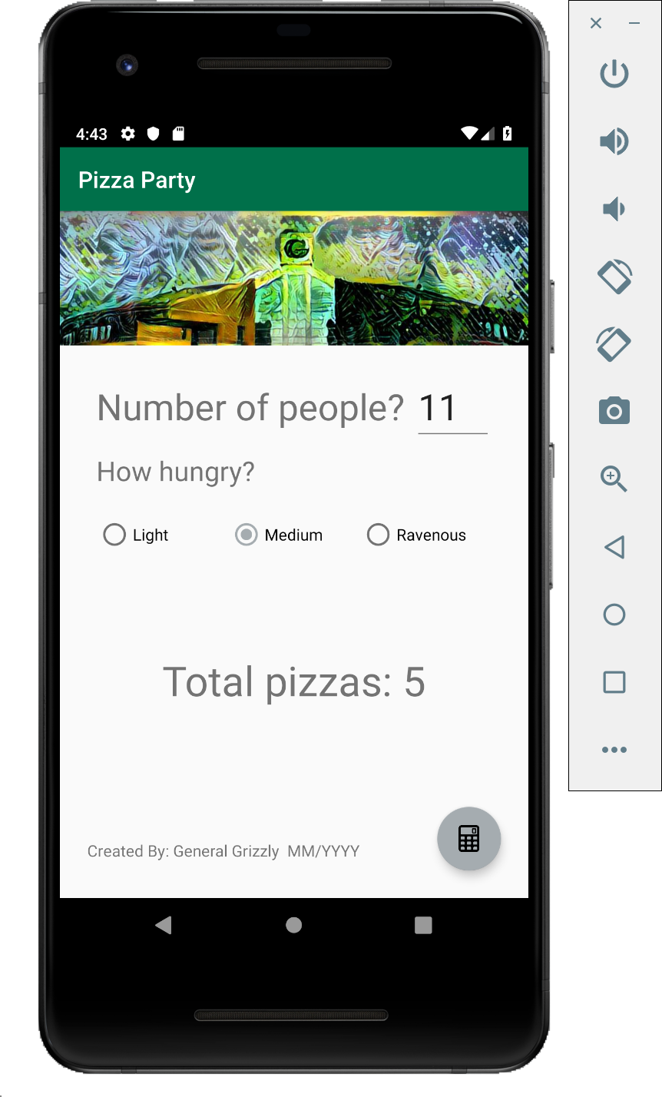

Your app should follow that illustration.

Your implementation must:

- Appear as shown above
- Change colors to use GGC colors. Primary should be green, primary dark should be black, accent should be silver. Colors are defined here
- Use margins of 32dp for “Total Pizzas …”, and above
- Use side margins of 24 the “Created By” text and Floating Action Button
- Use your name and current date in the “Created By” text

A demonstration of a sample demo video of the working app can be viewed here.

Submission Info

Your D2L Dropbox submission must include:

- a URL for your project page. Submissions missing this item receive a grade of zero.
- Zip file with your entire android project. Missing archives or archives in non-supported formats (rar, tgz, bzip, 7z, etc) will receive a grade of zero.

Your project page must:

- Include a demonstration video. Submissions missing this item receive a grade of zero.
- Follow the course project/assignment template
- Be accessible (check your links!)

You project page must not:

- Contain your source code
- Reveal information that could aid someone wishing to cheat. (Incidental view of your source code in recorded video is ok, but do try to avoid it).

Rubric

Points | Description
10 | Change launcher icon
10 | Replace the button with a Floating Action Button (FAB)
10 | FAB has a calculator graphic
10 | App still functions as it did before the UI edits
10 | Includes banner image (B Building)
10 | Colors changed to GGC Colors
10 | Fab has proper offsets (24dp from bottom and right)
10 | Created By present and correct
10 | Add a log statement that outputs a verbose log message every time a pizza calculation is performed. The log statement should use a static variable named TAG with your app’s name
10 | Describe one improvement you suggest for this user interface. Place this suggestion in the comments area in D2L when submitting.

Hints

Complete Chapters 1 and 2 in the textbook before starting this assignment

Remember to use the Log class and the logcat to debug your app

Your demo video should highlight and describe each item in the rubric

Be sure that I can access your project page and your demo video

Assets

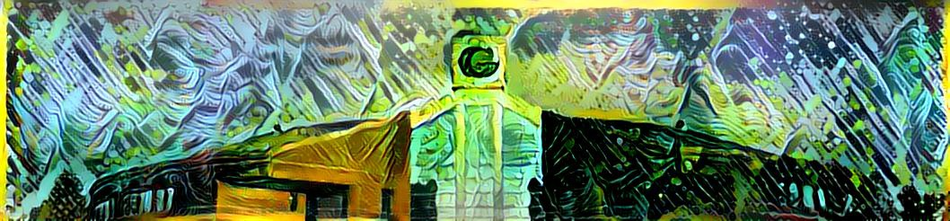

- 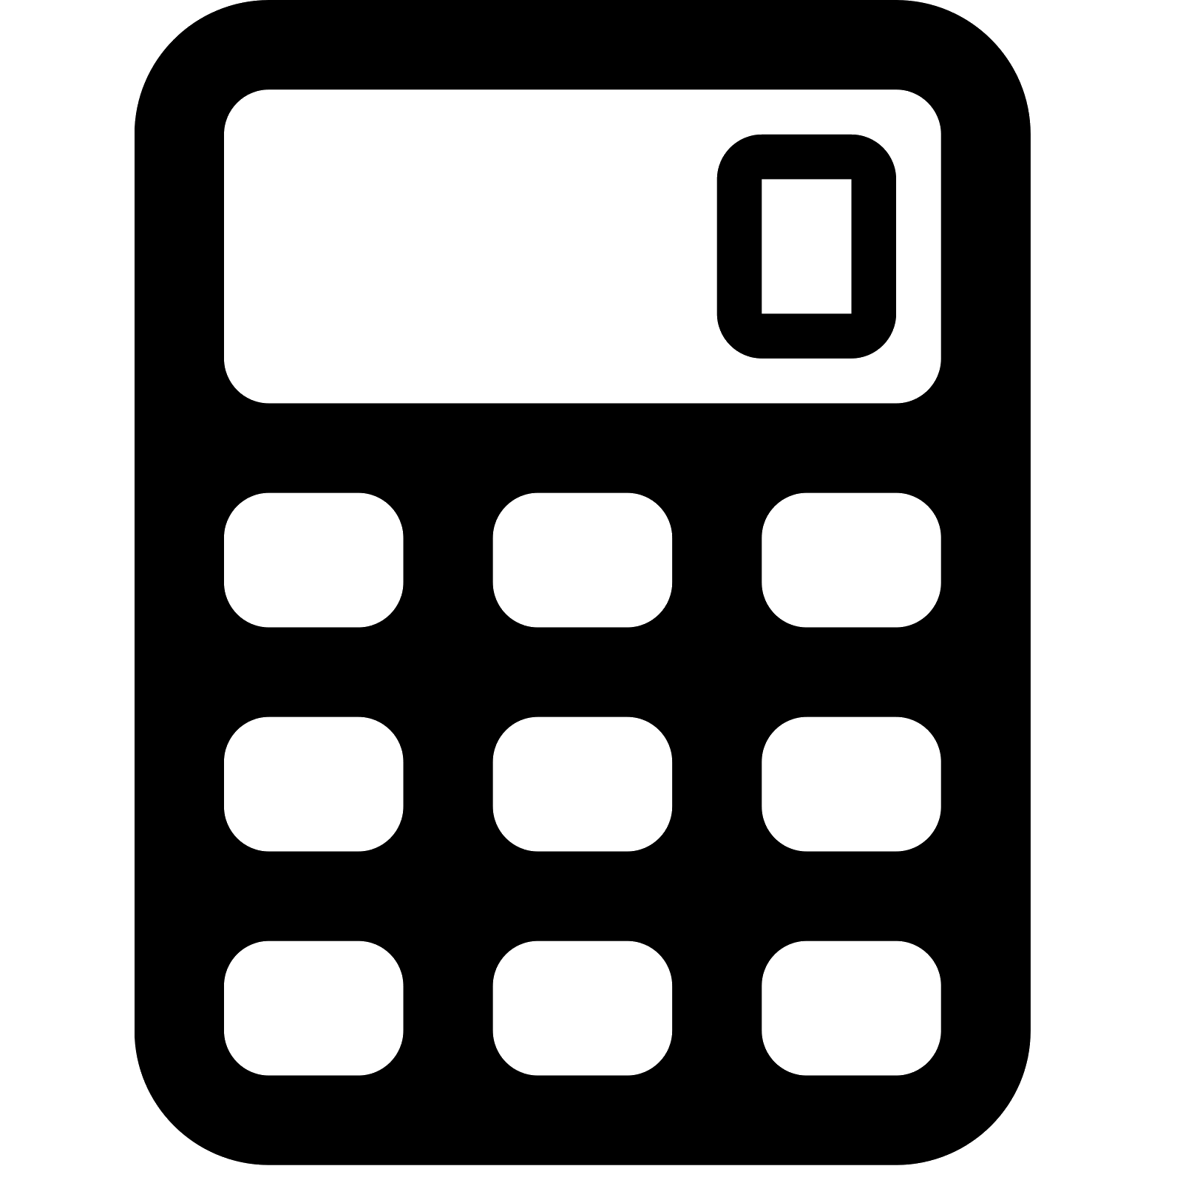

https://www.materialui.co/icon/local-pizza

