HELP AVAILIABILITY
Monday to Friday 9:00pm – 12:00am
Saturday 5:00pm – 12:00am
Sunday 9:00pm – 12:00am

INSTALLATION OF SQL SERVER 2014
- Plug flash in
- Open folder and open sub folder called SQL_Server_2014_enterprise_core_edition_with_SP1_x64

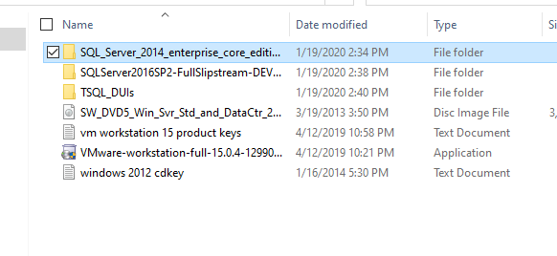

- Right click, select run as administrator and select YES/RUN when a window pops up

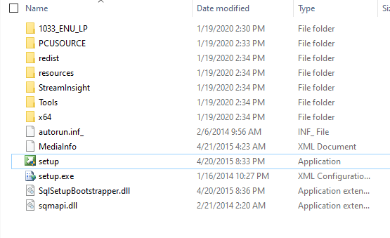

- On new pop up window select INSTALLATION on the left side and pick first option (New SQL Server stand-alone installation or add features to an existing installation)

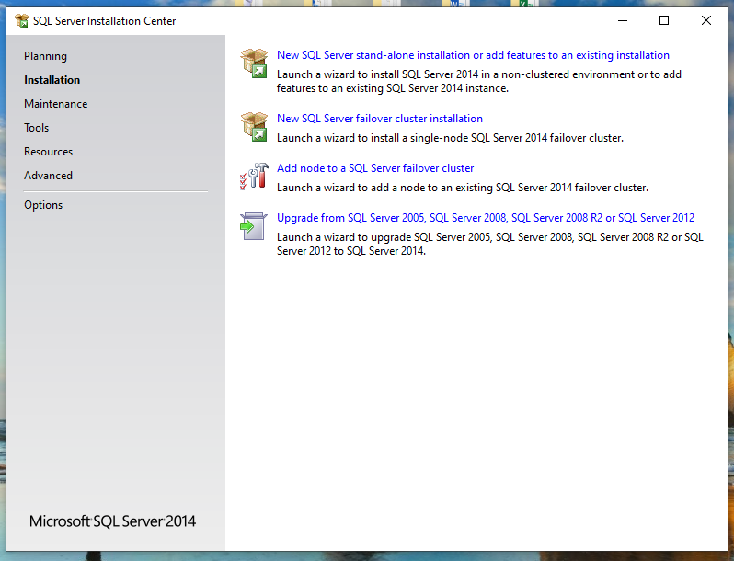

- On product key menu click NEXT

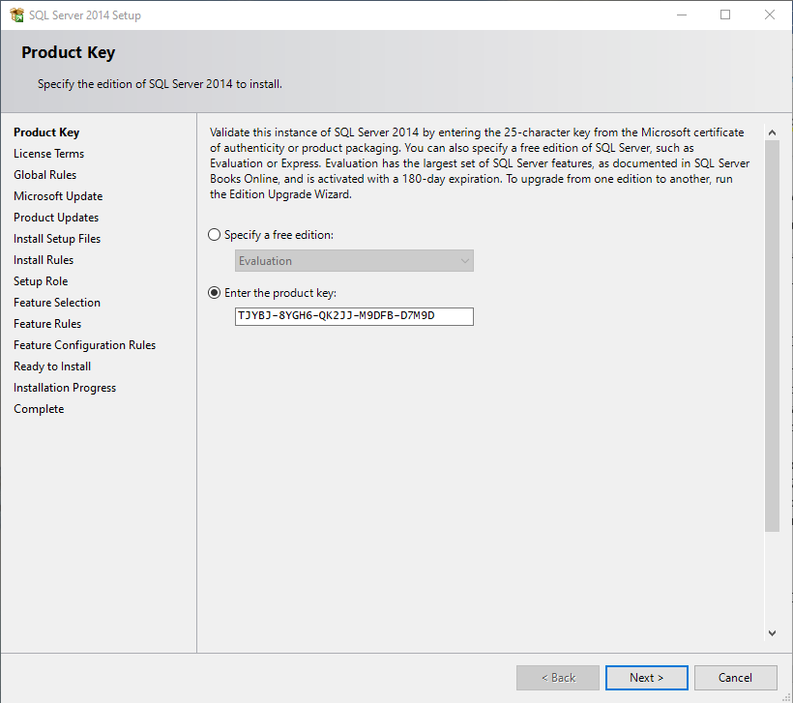

- On license Terms select only (I accept the license terms) and click next

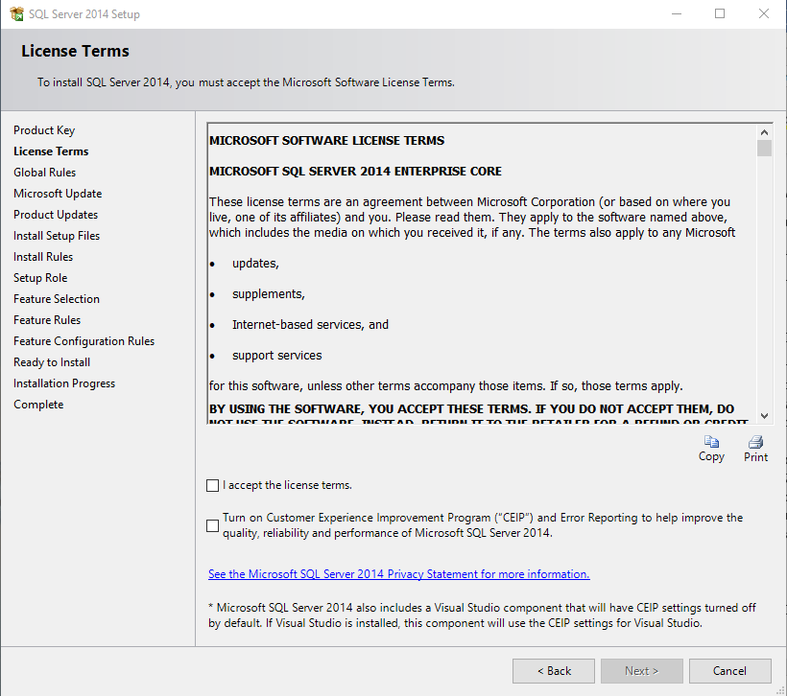

- On global rules menu if Restart computer shows (failed) restart the computer

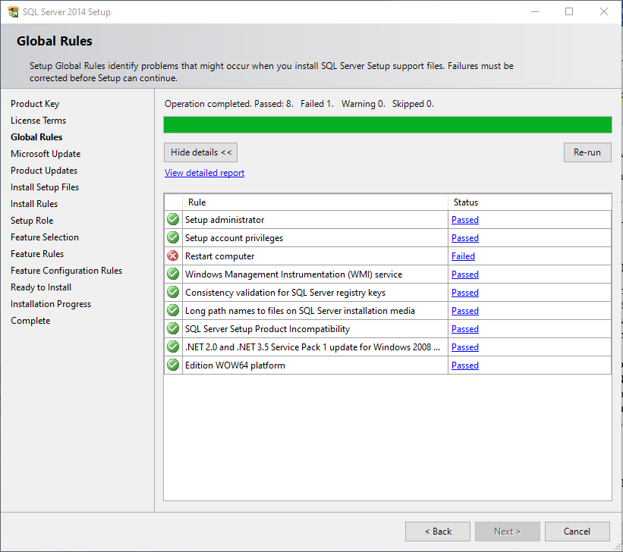

- After restarting computer go through steps 1 – 7 again and click next

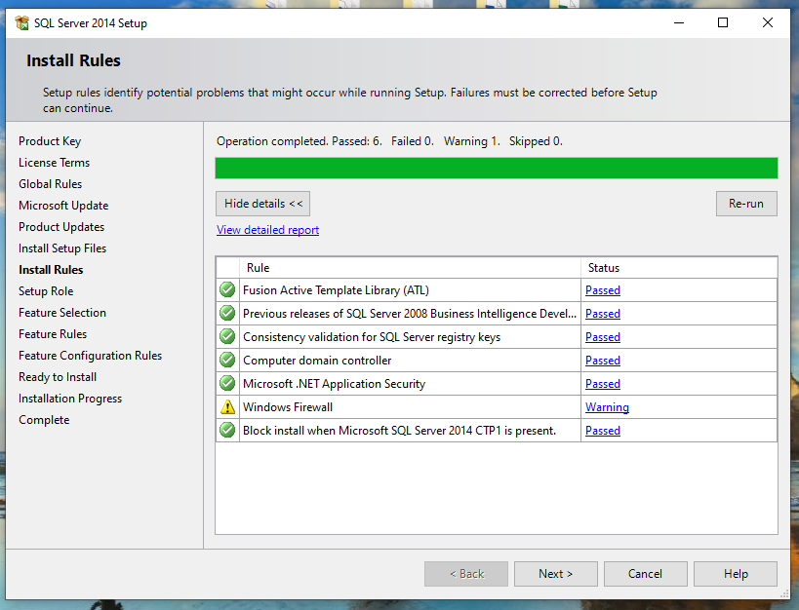

- At setup role select (SQL Server Feature Installation)

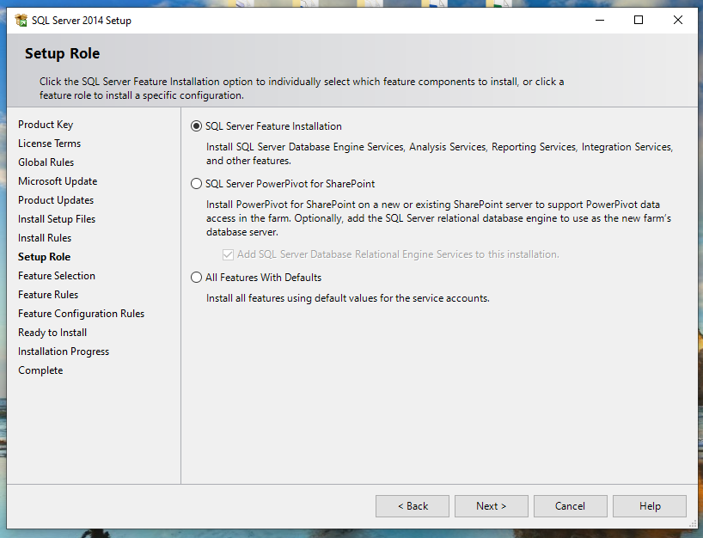

- At Feature selection
- Under INTANCE FEATURES select
  - Database Engine Services
  - SQL Server Replication

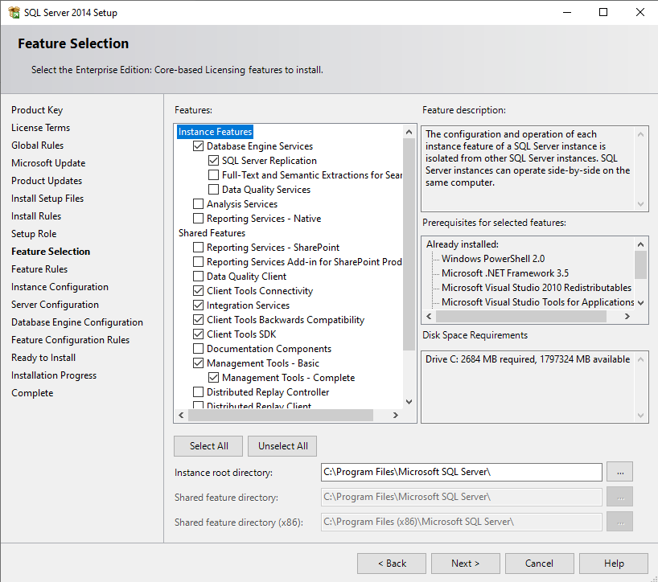

- Under SHARED FEATURES select
  - Client tools connectivity
  - Integration Services
  - Client tools backwards compatibility
  - Client tools SDK
  - Management tools – Basic & management tools – complete
  - SQL Client Connectivity SDK
And click NEXT

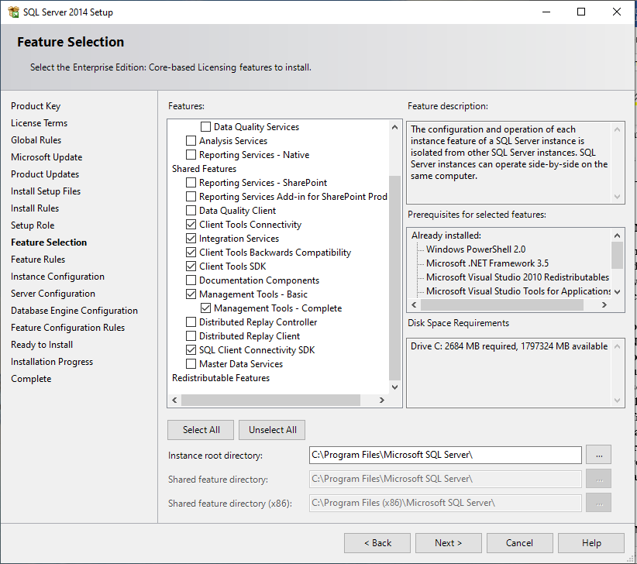

- If .NET framework is missing, follow steps below
- Open browser and paste https://www.microsoft.com/enus/download/details.aspx?id=49981
- Click download
- Run the.exe file
- Click download and install
- After it is done switch back to installation setup no need to start the installation over, click back and next again

- At instance configuration select DEFAULT instance and click next

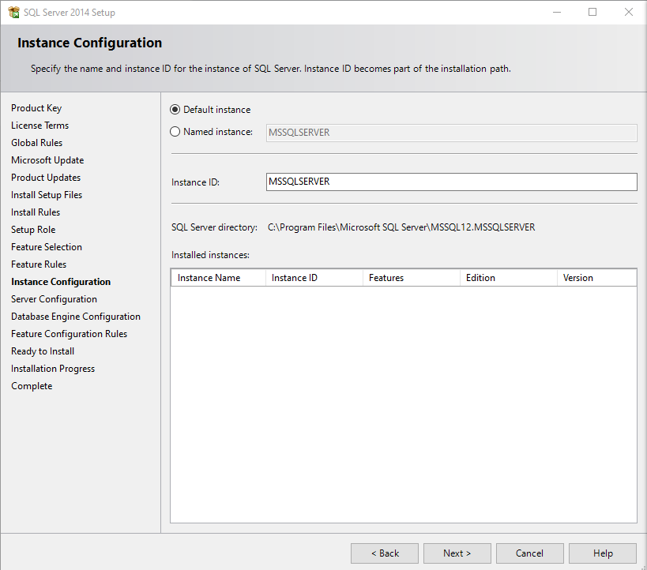

- At server configuration
- For SQL Server agent change to Automatic
- For SQL Server database engine change to Automatic
- For SQL Server integration services 12.0 change to Automatic
- For SQL Server Browser change/leave at Disabled
And click next

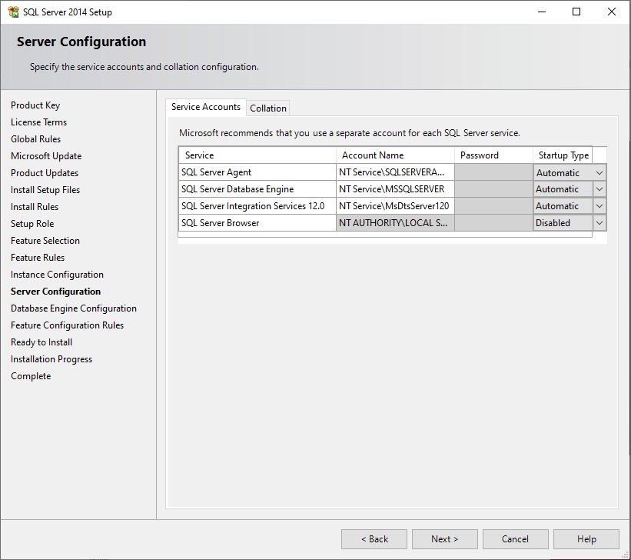

- At database engine configuration
- Under server configuration
  - Select windows mixed mode (SQL Server authentication and Windows authentication)
  - Type values for Enter password and Confirm password
  - Click Add current user

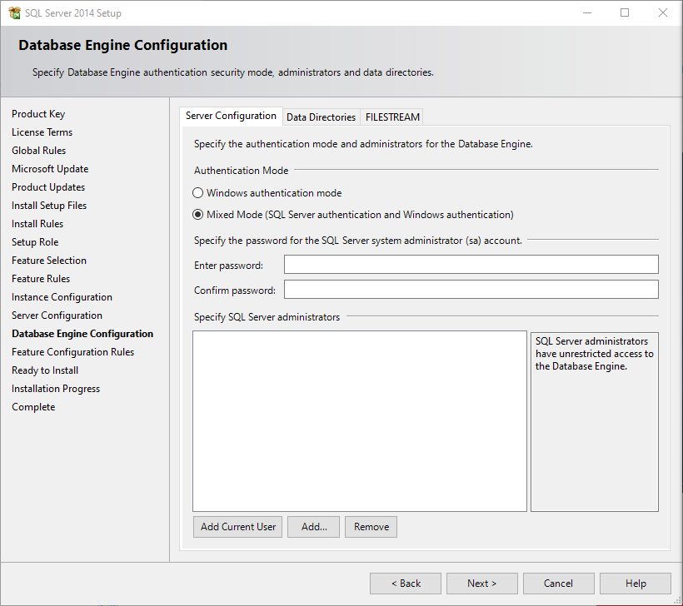

- Under Data directories
  - Navigate to already created folders/create new folders by typing in new path

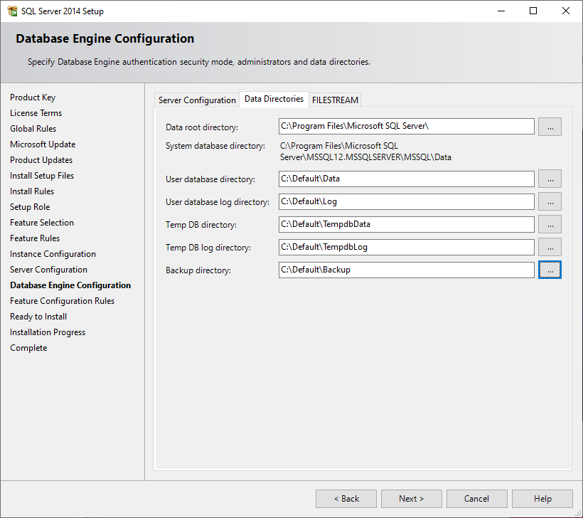

- Under FILESTREAM
  - Do nothing and click Next

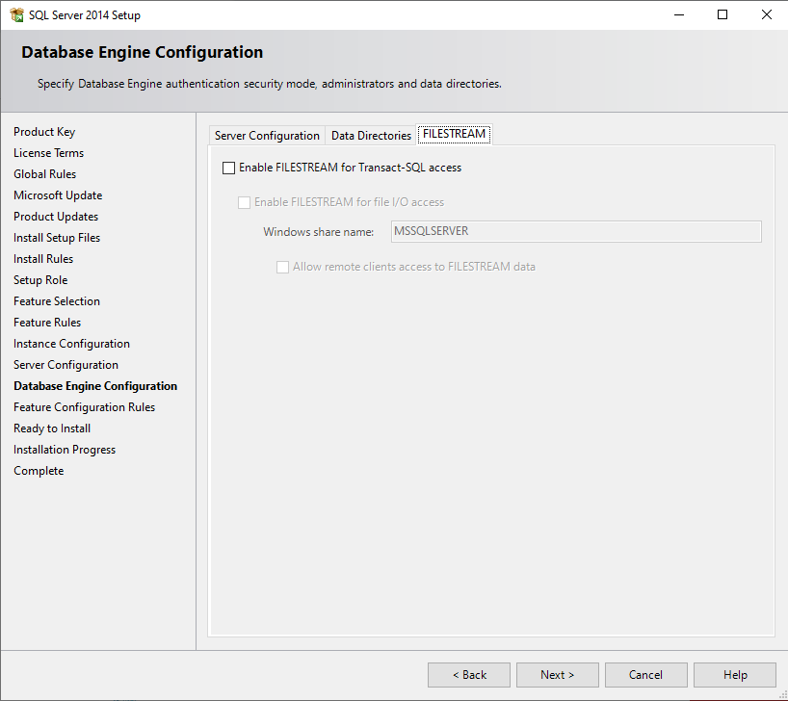

- Now click install

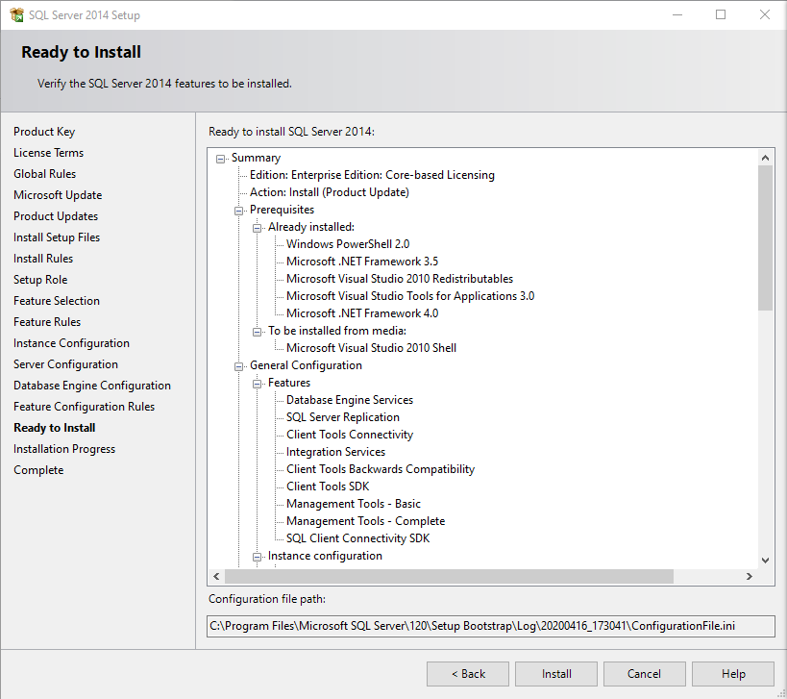

- This will take a couple of minutes

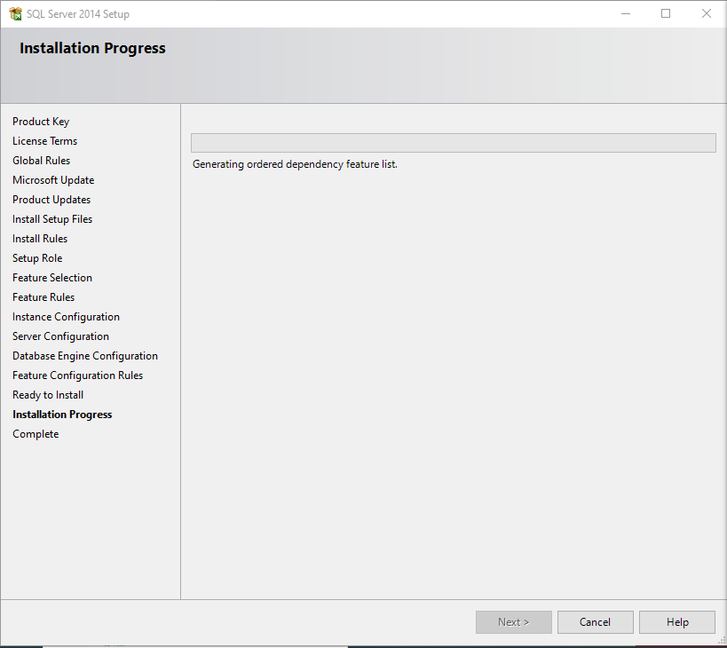

- Confirmation of installation

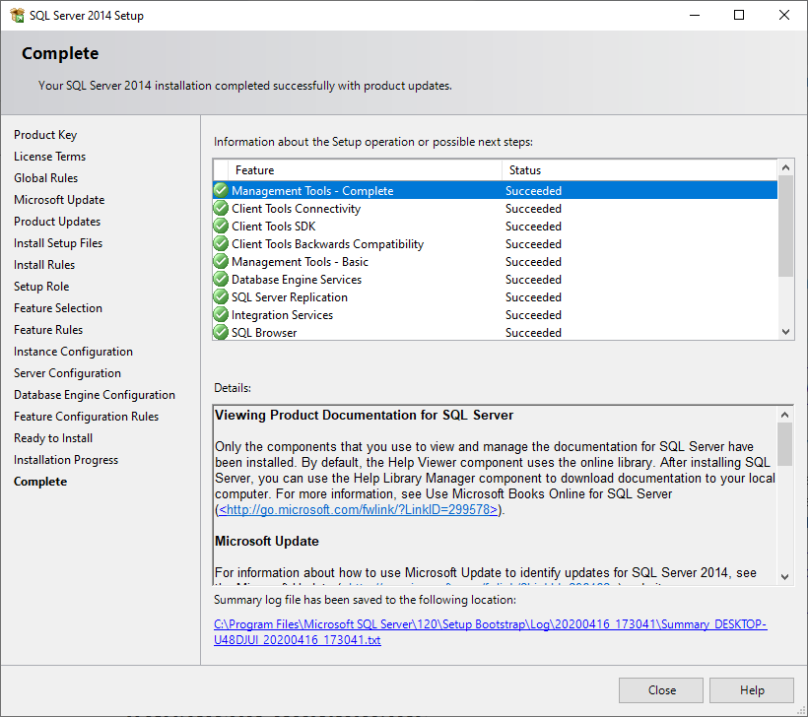

- Look up management studio and launch the application When open click on connect

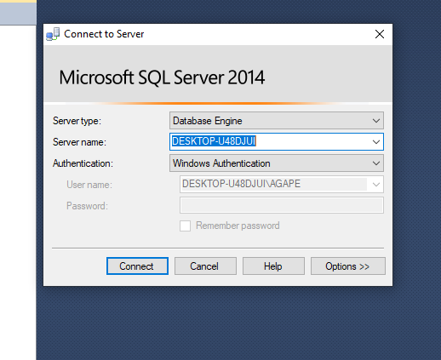

RUNNING CUMMULATIVE AND SP UPDATE
- Open browser and paste https://sqlserverbuilds.blogspot.com/

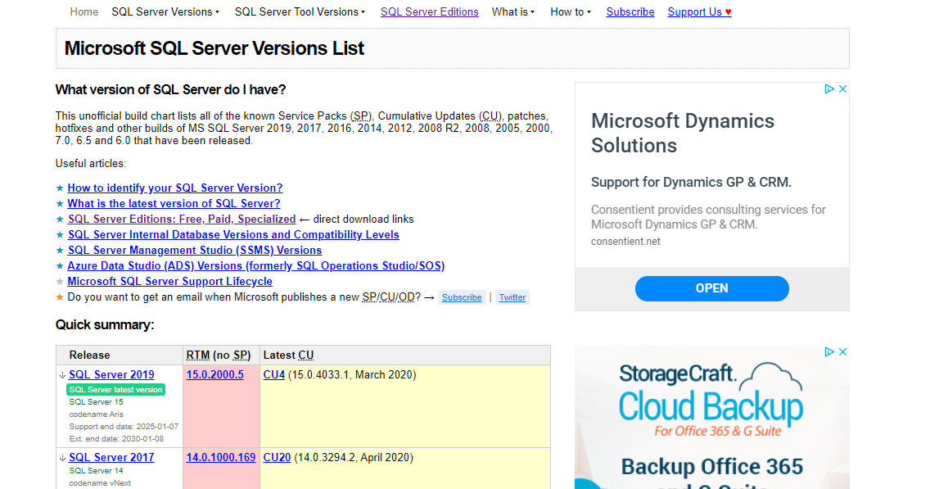

- Scroll to Microsoft SQL server 2014 builds and click on latest SP

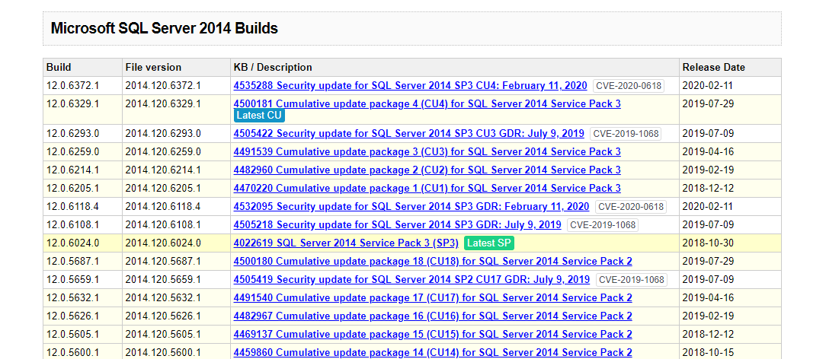

- Click on the first link

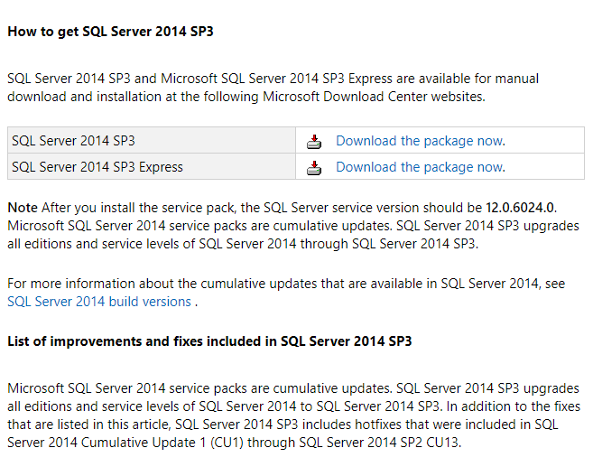

- Click download

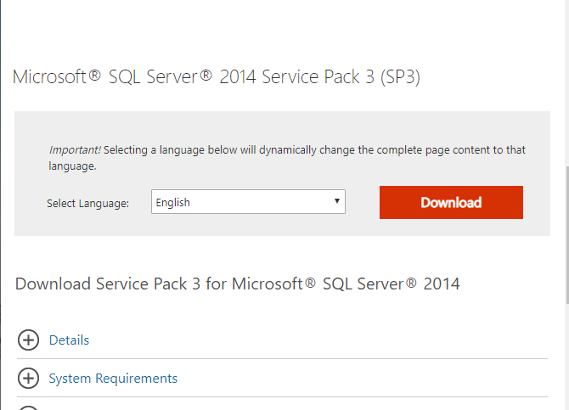

- Select x64 and click next

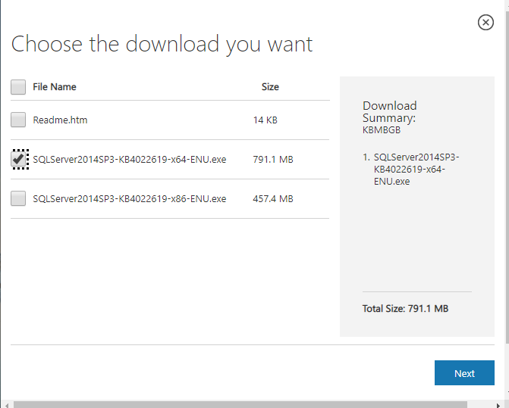

- Run downloaded file

- After extraction click yes on dialog box or window

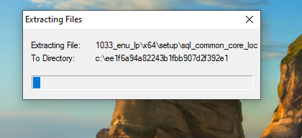
- Click I accept the license and click next

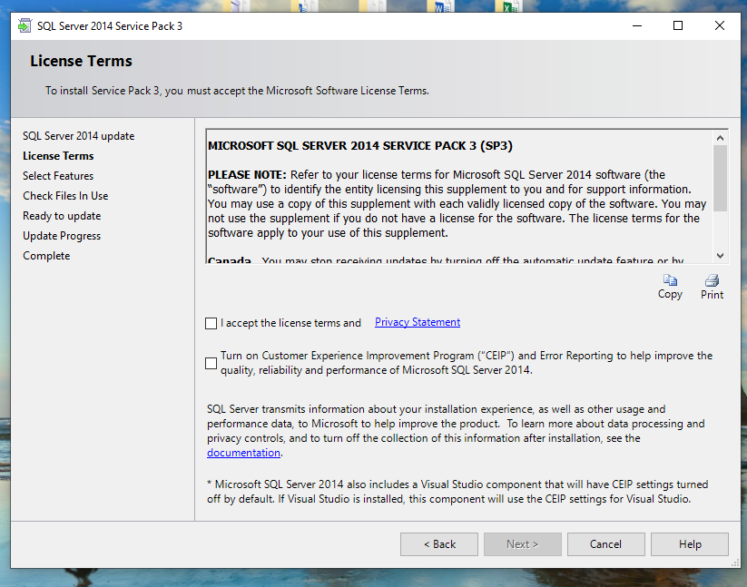

- On select features click next

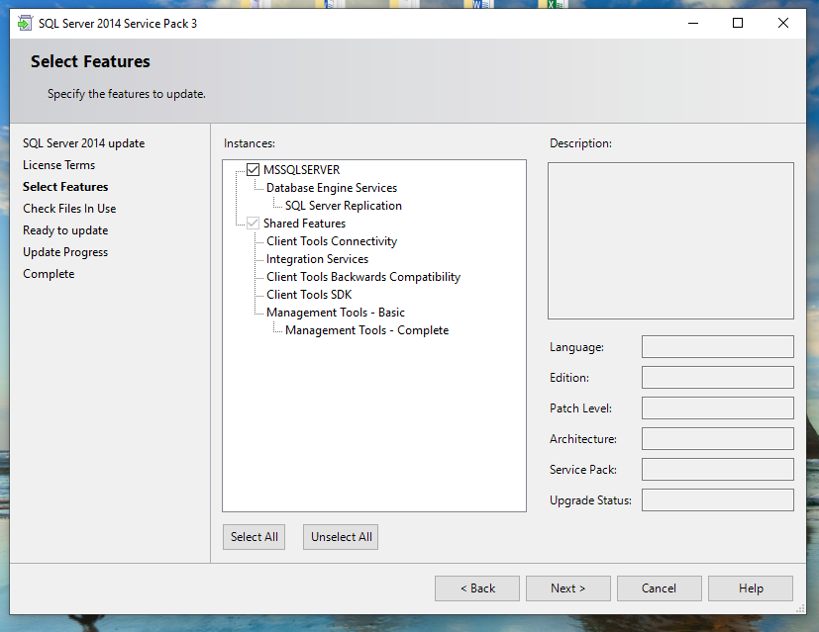

- And next again

- Finally click update

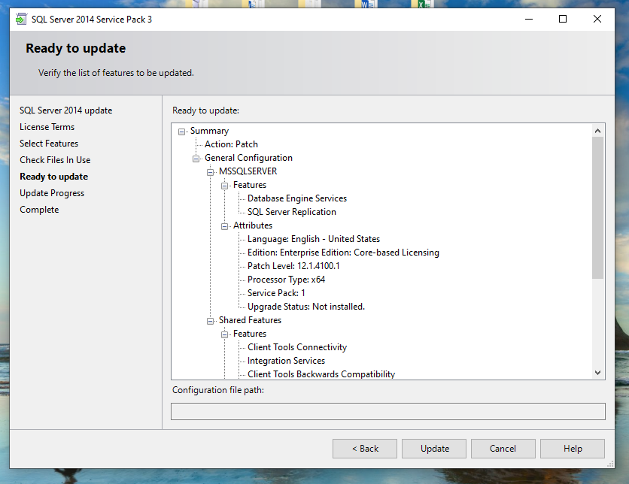

- Update will take a couple of minutes

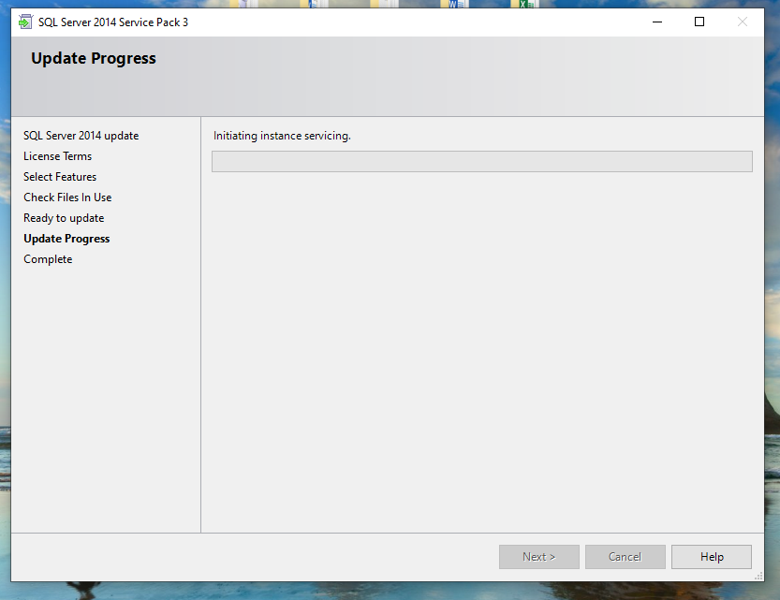

- Completion screen

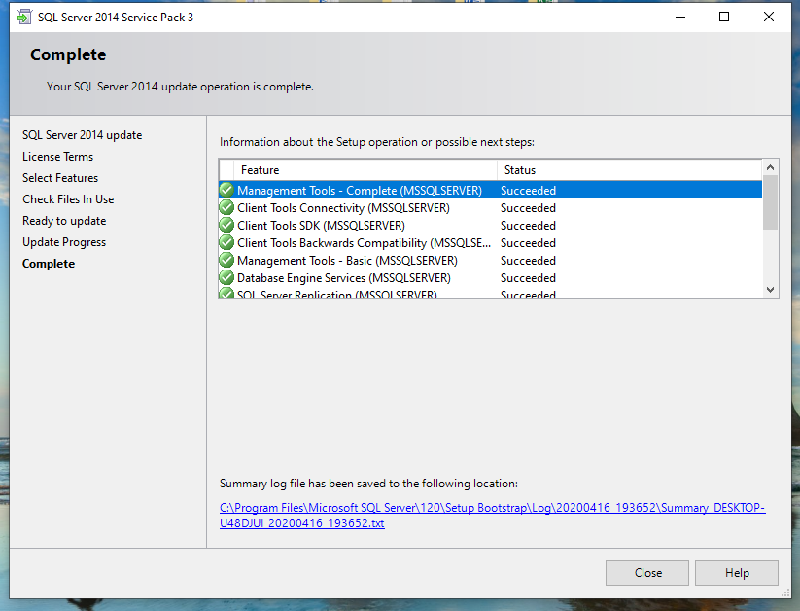

- Proof of completion (change in build numbers)

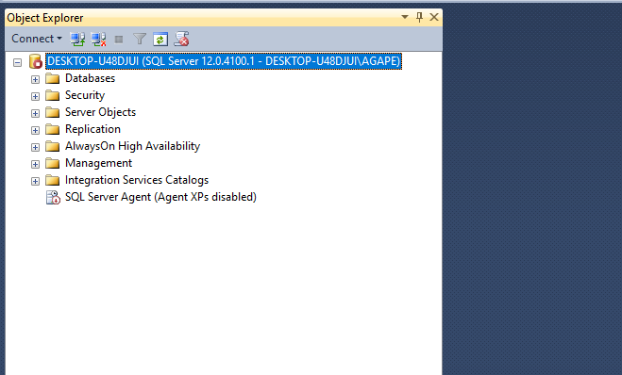
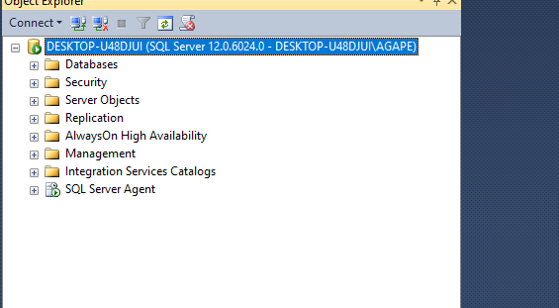
- It might require a restart

INSTALLING CUMMULATIVE UPDATE
- While its installing SP go back to the website and click on latest CU
- Scroll until you see this link
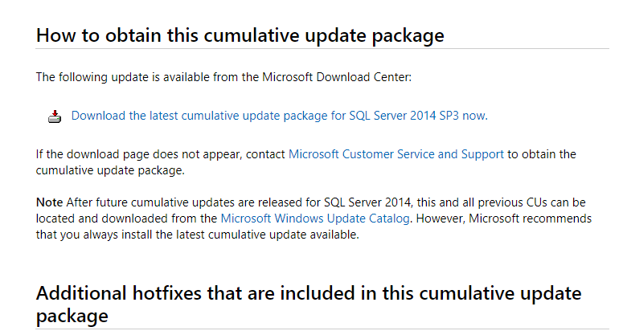

- Click on download
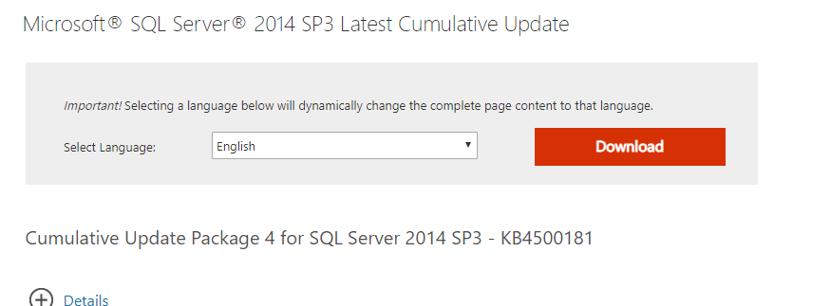

- After download run .exe file

- After extraction click yes on dialog box

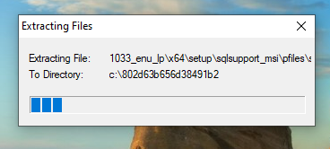

- Click I accept license term and Next

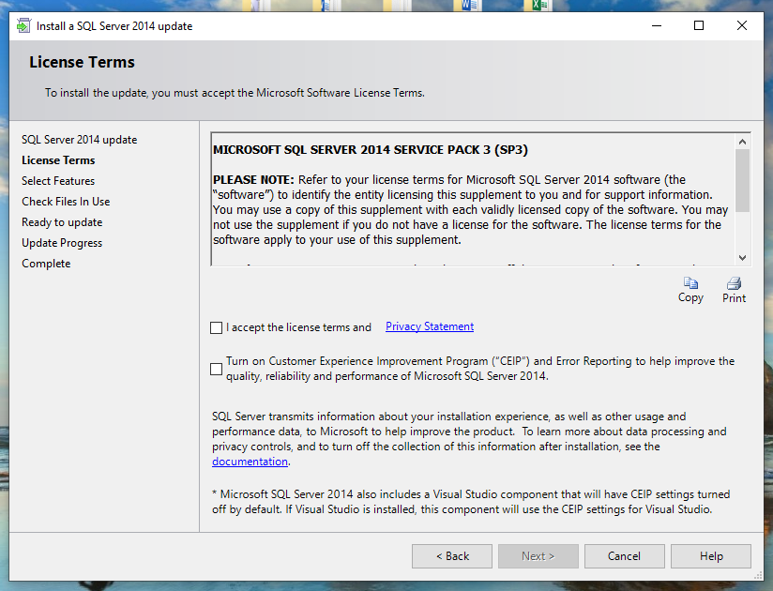

- And next again

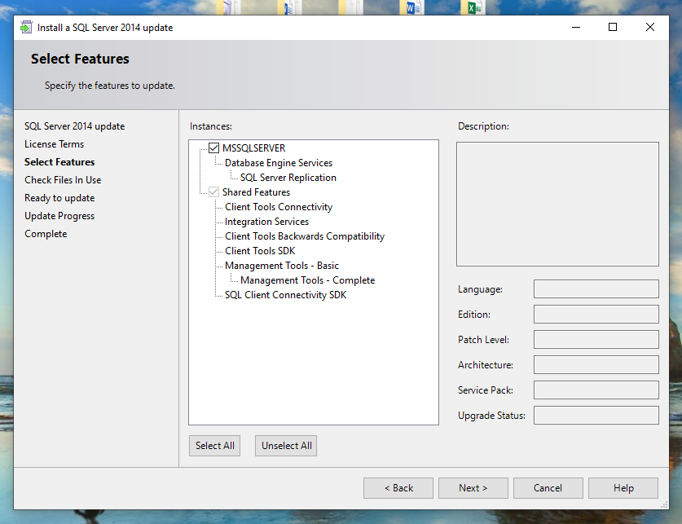

- And next again

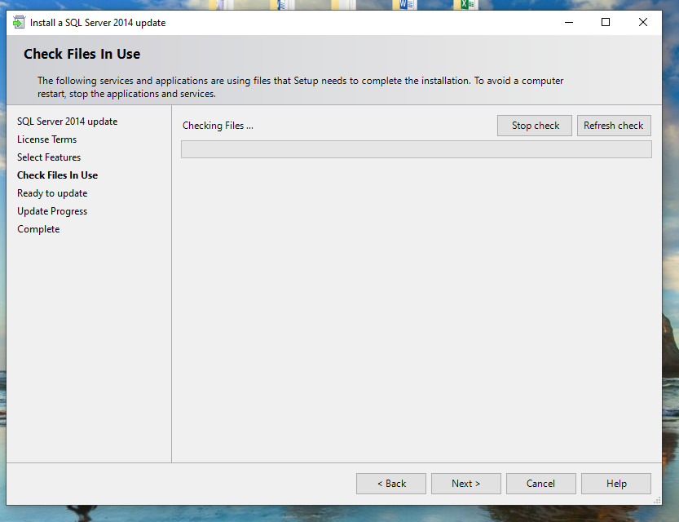

- Click update

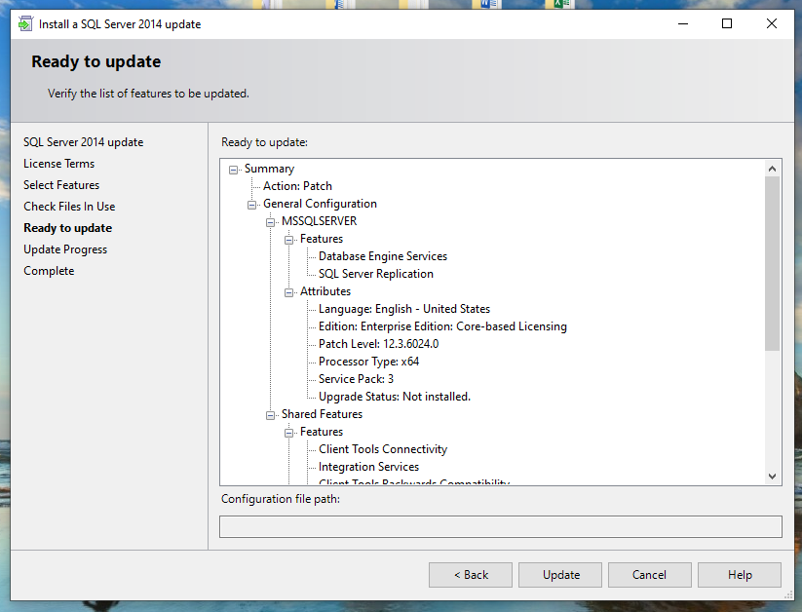

- Update will take a few minutes

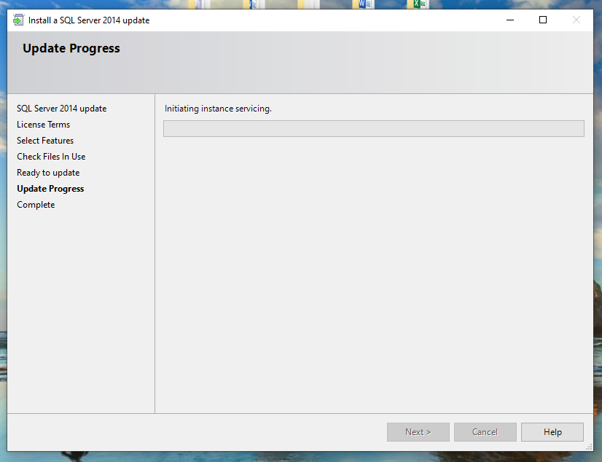

- Completion screen

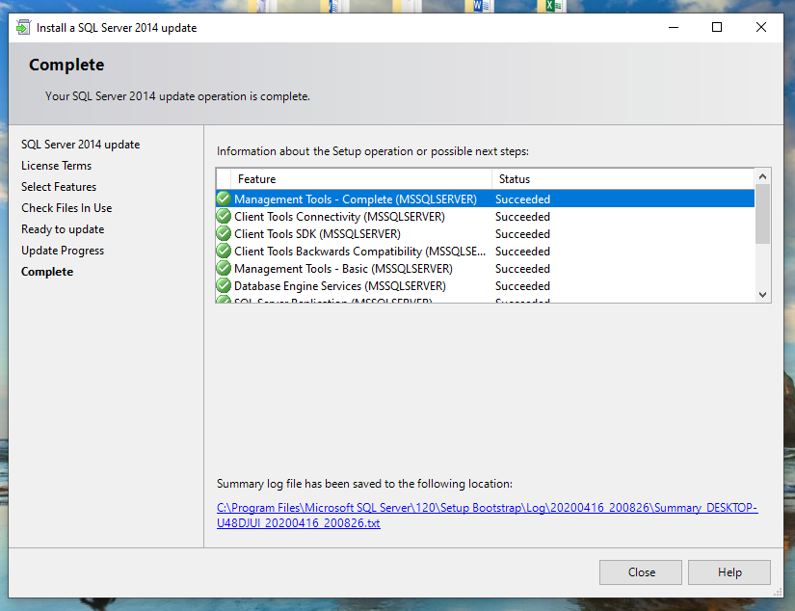

- Proof of completion (change in build numbers)


