- Two ways of creating a database
TSQL Script

- Right click on server name and select NEW QUERY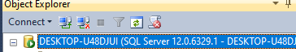
- You should see this
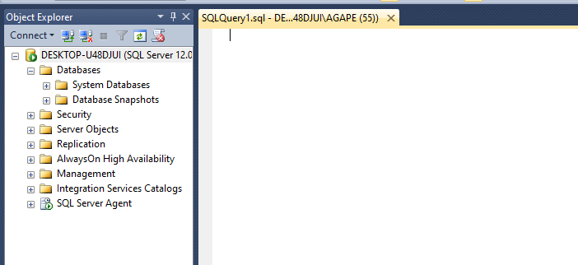
- Type Command “CREATE DATABASE database_name;” and click execute
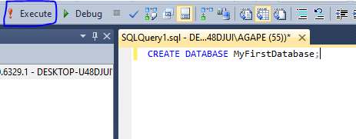
- Then select database and click refresh/f5
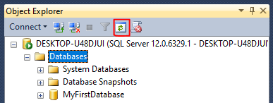
GUI
- Right click on database and select “NEW DATABASE”
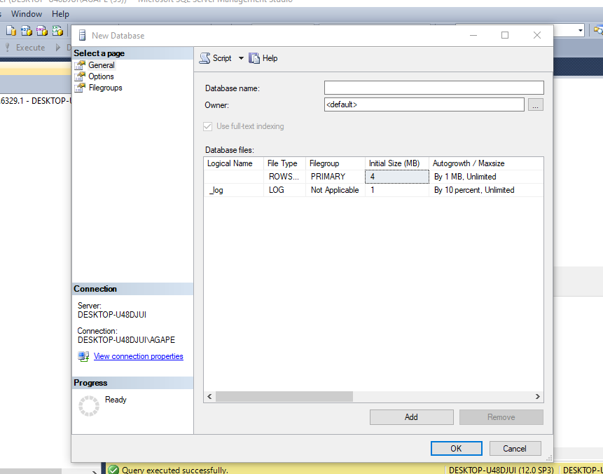
- Type MySecondDatabase into Database name and click ok
- Refresh again/ click f5
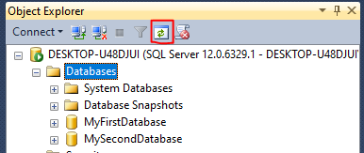

- To go into the properties tab, right click on the Created database “MyFirstDatabase/MySecondDatabase” and select properties
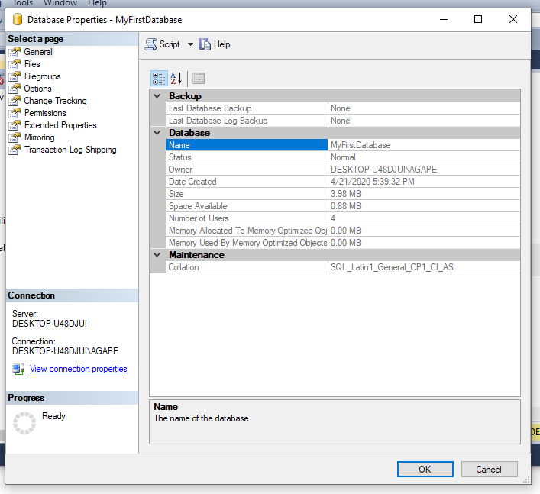

- On the Files tab select browse
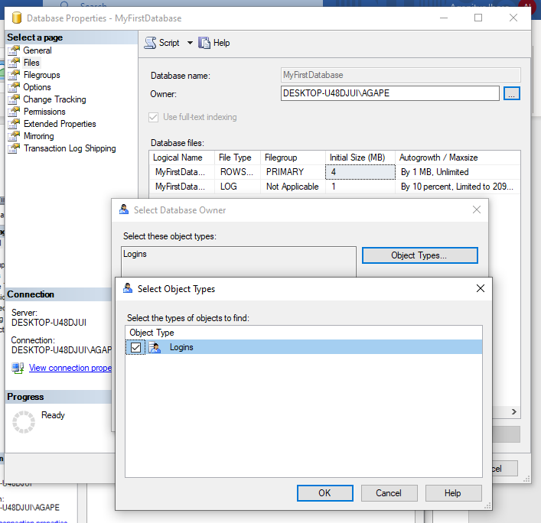

- Discussion of File Tab, right click on database and click properties, then select Files
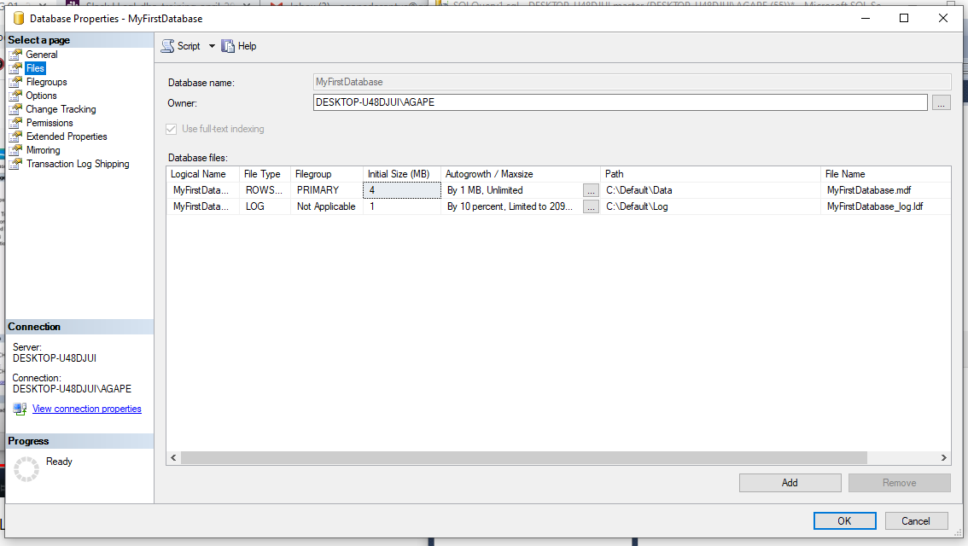

- To add a new DATA FILE or LOG FILE click ADD
- For data file change file type to ROWS
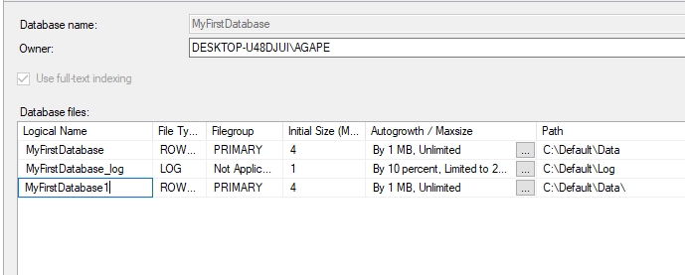
- For log files change file type to LOG
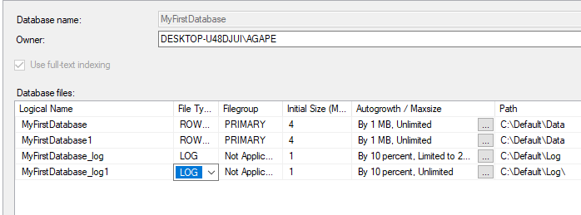
- Click on FILEGROUPS to switch to file group tab
- Click Add Filegroup to create a new filegroup
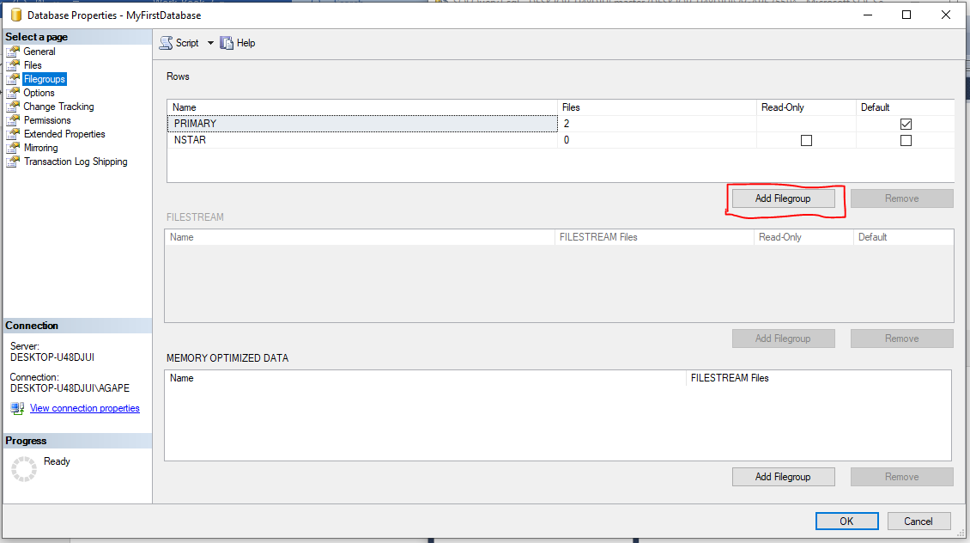

- Discussion of File Tab, right click on database and click properties, then select Files
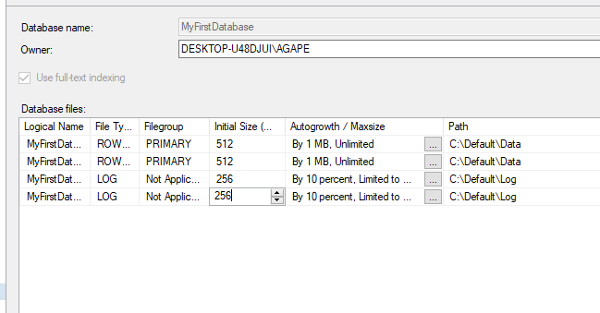
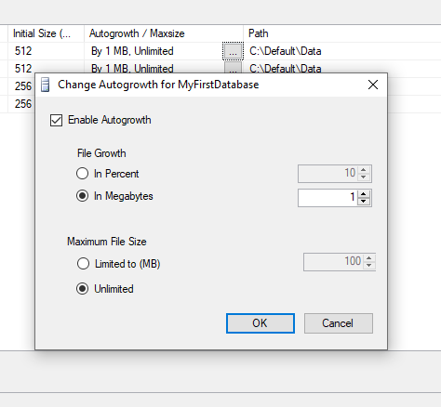
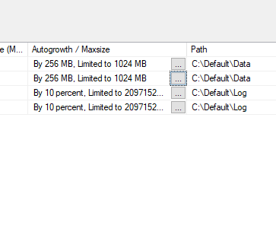

- Changing the path of a file, click on browse (…) available when creating a new file
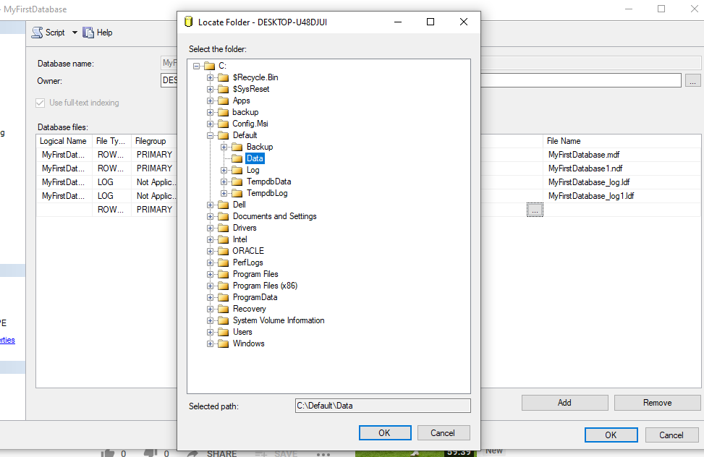

- For discussion on OPTIONS TAB click Options on the left side
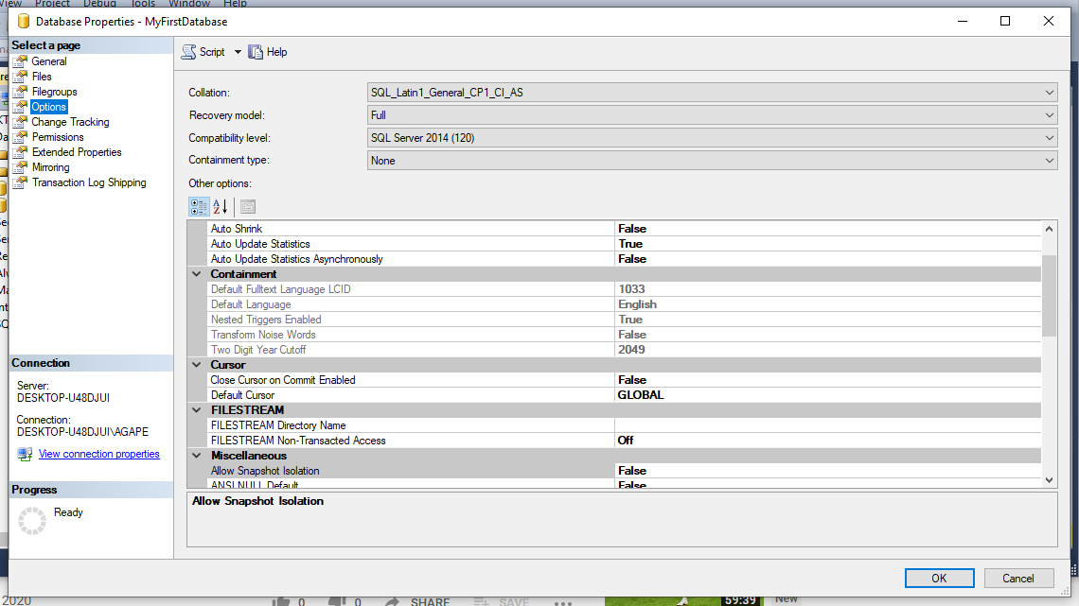

- Click on Recovery model drop down menu to change from FULL, to SMALL, to BULK LOGGED
- Click on Compatibility drop down menu to change

- Scroll down to state for next activity
- First Change Database Read Only to TRUE
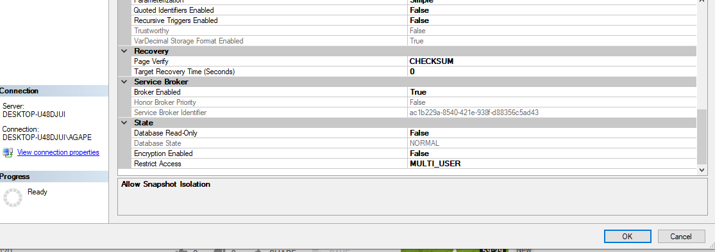
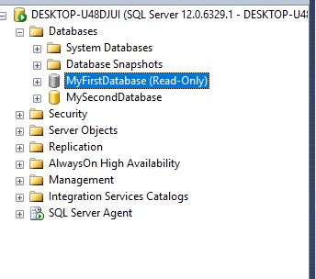

- Go back to properties, select options, scroll to state and change back to FALSE
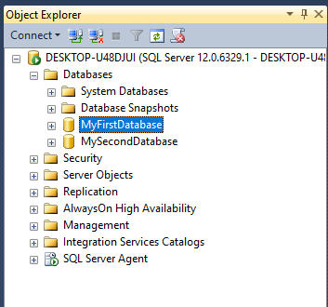

- Right click on database, select properties, select options, and change Restrict Access to SINGLE_USER by clicking on arrow facing down (\/)
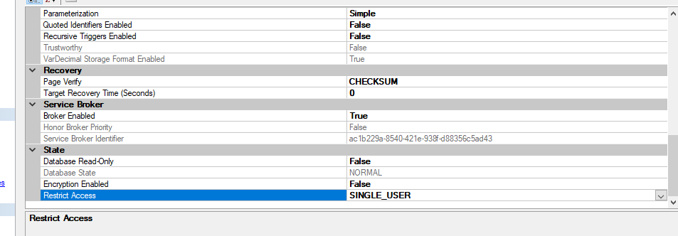

- Proof of change
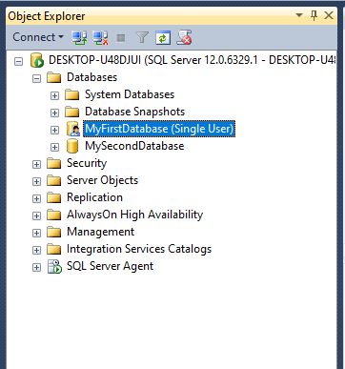

- Next go back to Restrict Access under State and change to RESTRICTED_USER
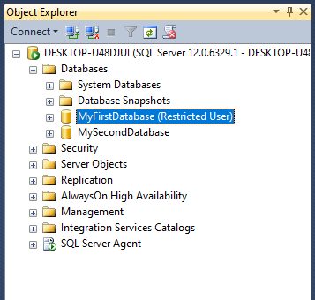

- To take a database offline Right click on database Select task, then select take offline
- Proof of completion
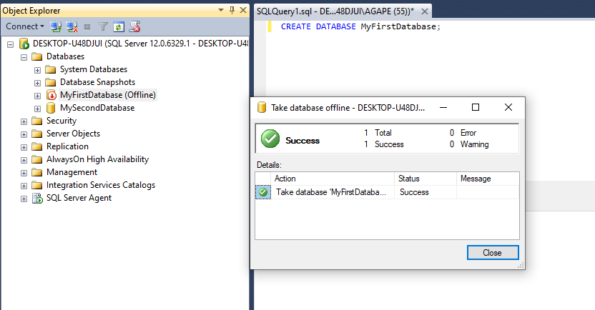
- Repeat Steps to bring online
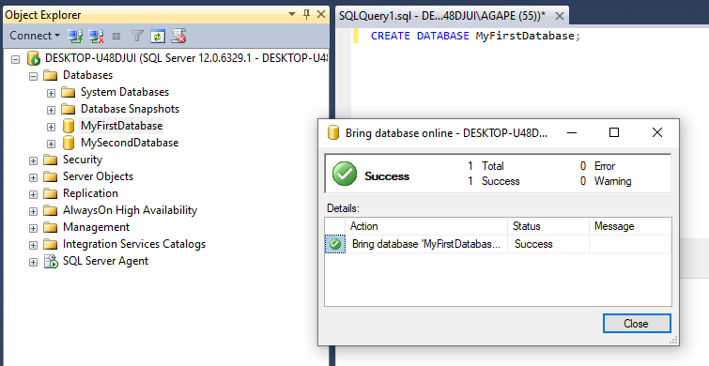

- To create a new table, expand a user database “MyFirstDatabase/MySecondDatabase”
- Right click on table, select new, then select table
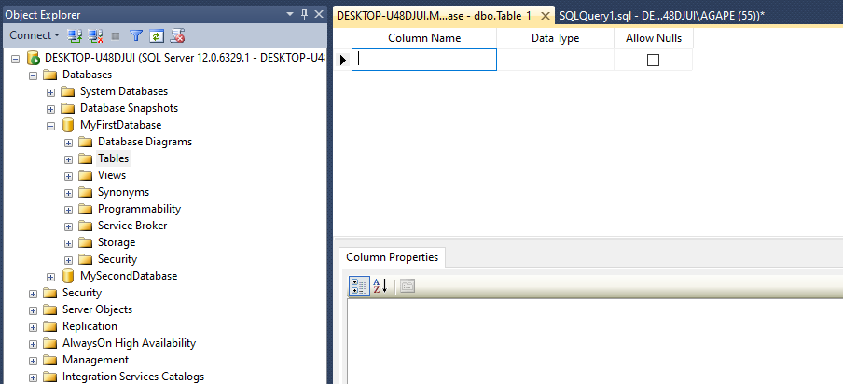

- Fill in columns (NOTE: do not use space) when tying in column name
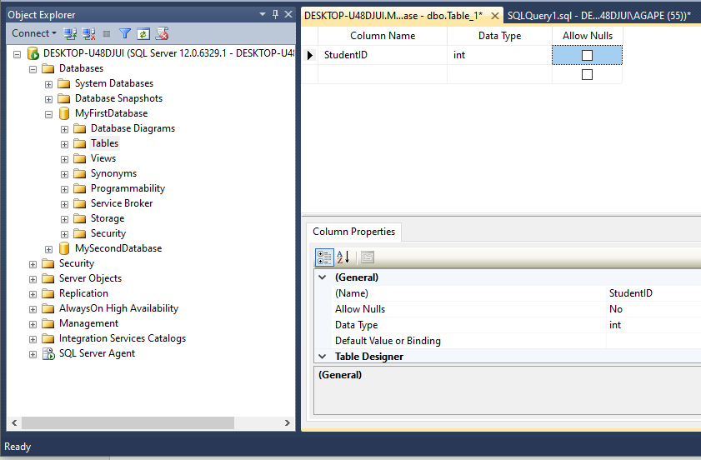

- To change Identify Specification, scroll down to IS IDENTITY and change to YES
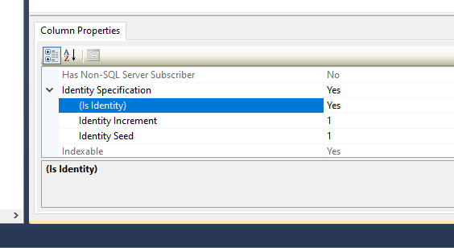

- Fill columns as needed
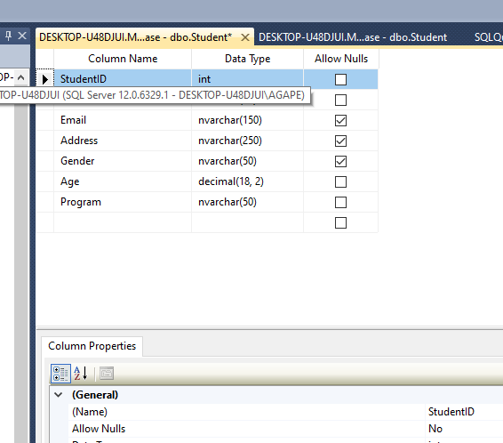

- To set Primary key, Right click and select first option Set Primary Key
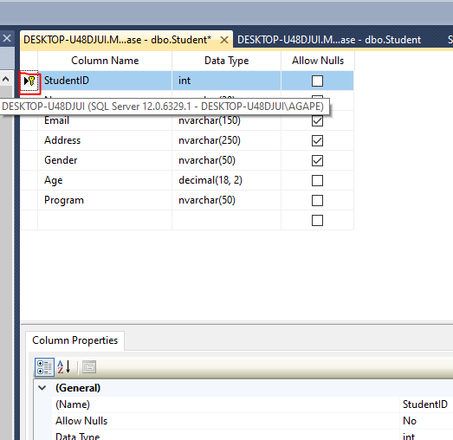

- To Save table click ctrl S/ select floppy disk looking icon
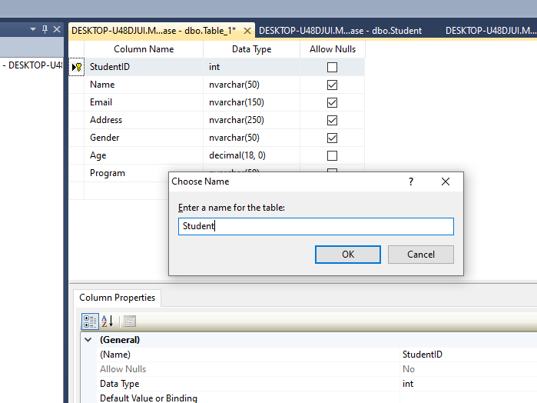

- To see table select Tables and refresh
