- Adding records to the table
GUI
- Right click on the table and Select EDIT TOP 200 ROWS
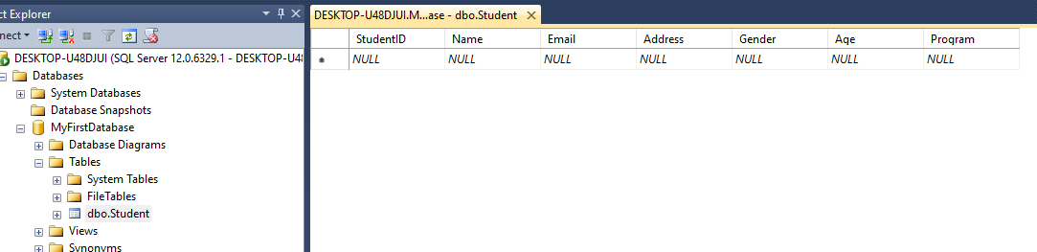
- To add values manually click on column and type in value
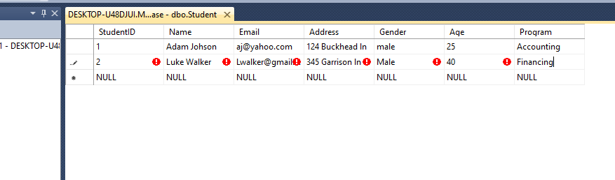
- To make changes to structure of table right click on table and select
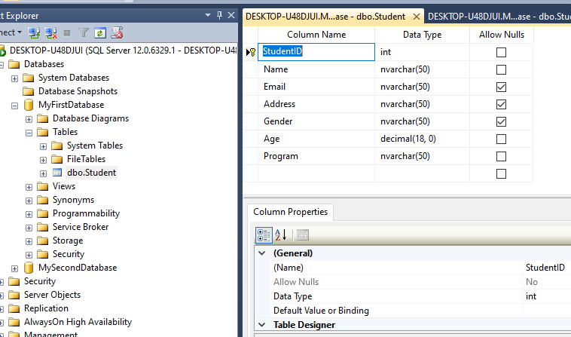

- To allow future change to table structure, click on tools select options, click designers, and uncheck “Prevent saving changes that require table re-creation”
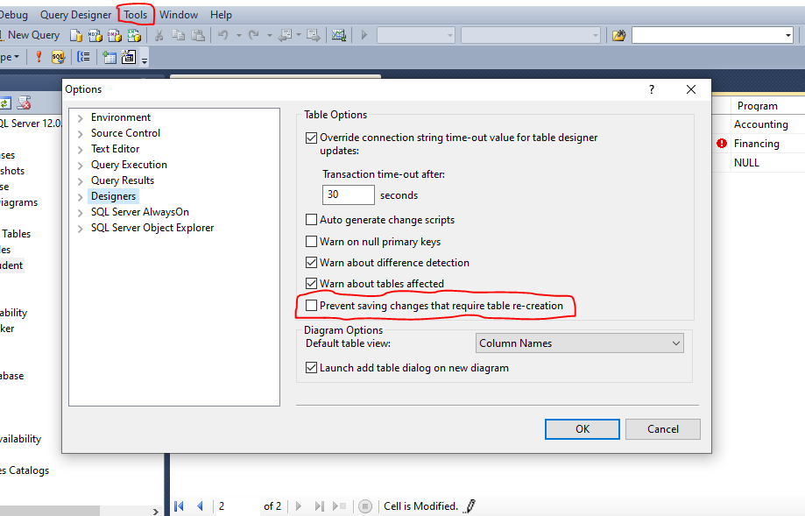

- Downloading random data
- Type/copy and paste https://mockaroo.com/ into browser

- Click on each field name to rename it
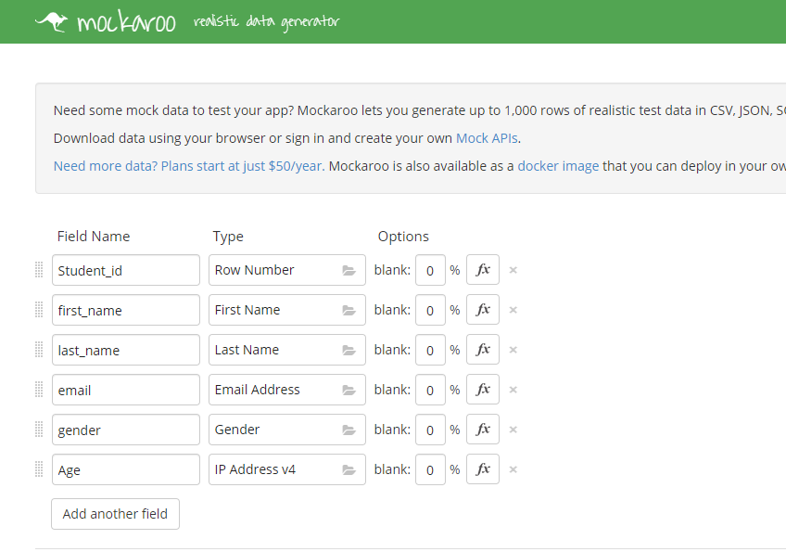
- Click folder looking icon to change contents of Field name
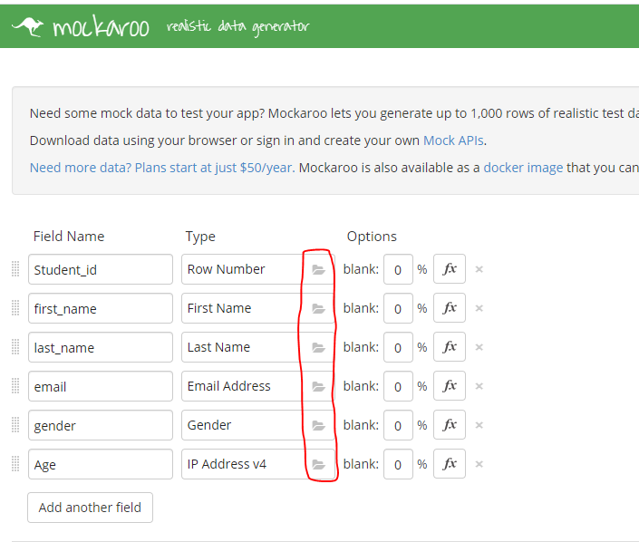
- Type in desired type into search box
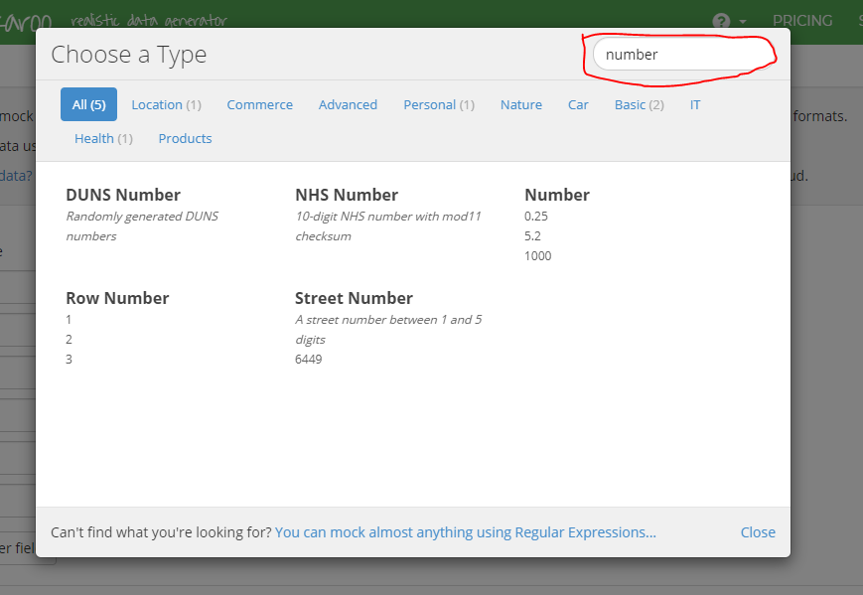

- Change format to SQL, name the table, and check include create table
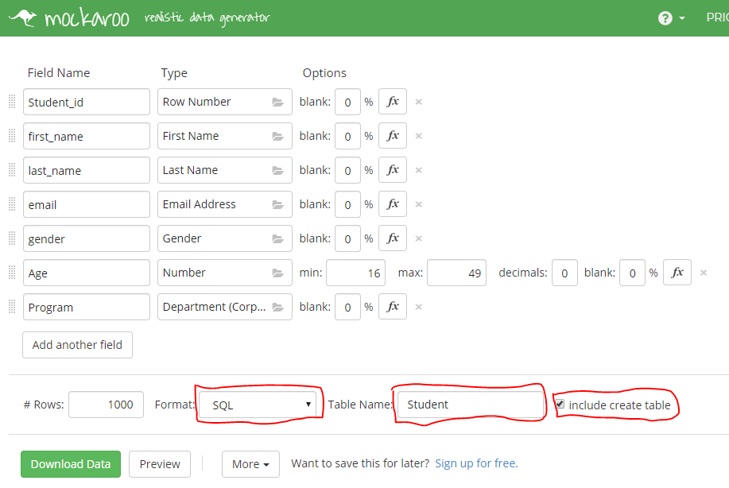
- Next click download data
- Right click on downloaded file and select open with notepad
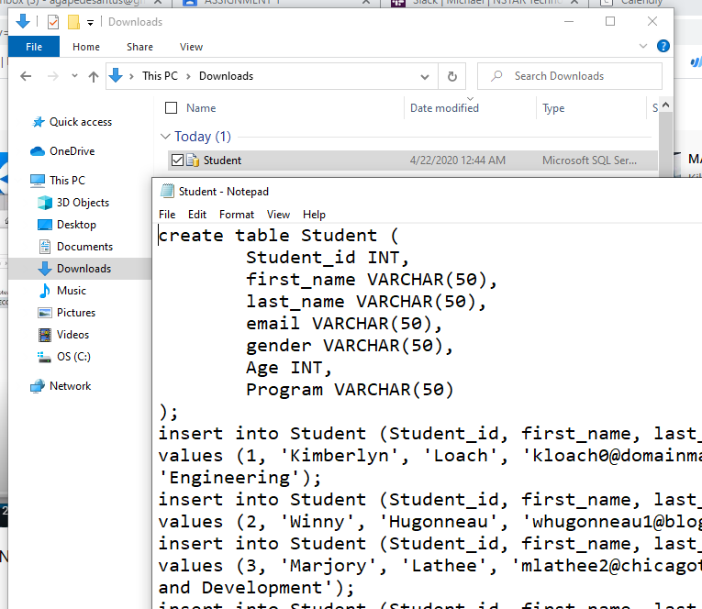

- Copy the contents and paste in management studio
- To paste in management studio, Right click on desired database and select NEW QUERY, paste in TSQL script
- Or click on New Query paste in TSQL Script and Specify Database to store table, by changing from MASTER to MyFirstDatabase/MySecondDatabase
- Then click on EXECUTE/F5
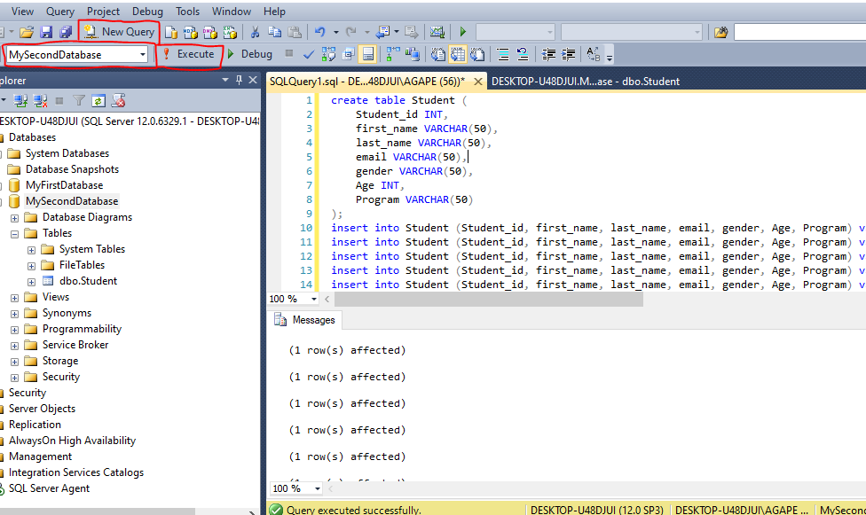

- For confirmation right click on table and select EDIT TOP 200 ROWS
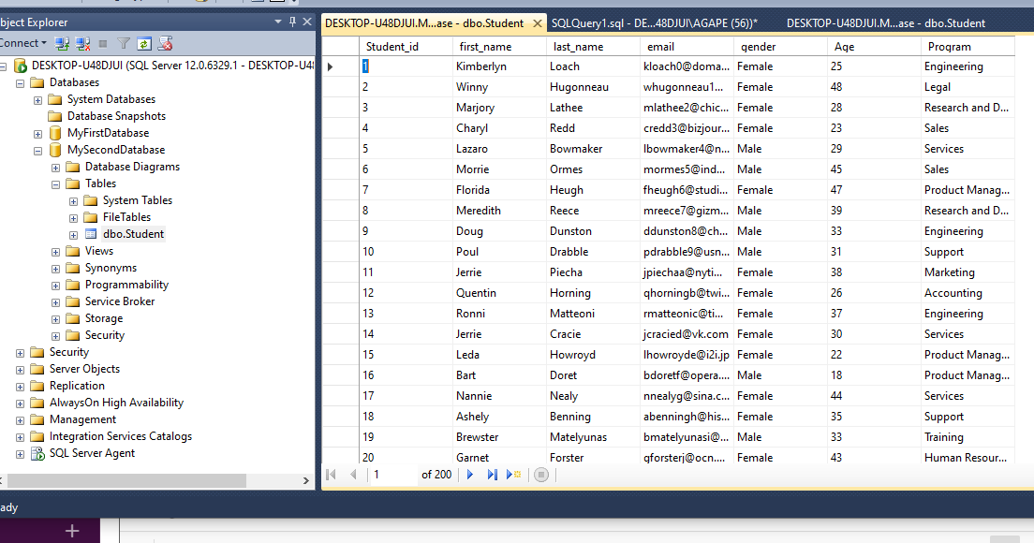

- To create a clustered index, expand tables, expand table created, right click on index, select new index, and select clustered index
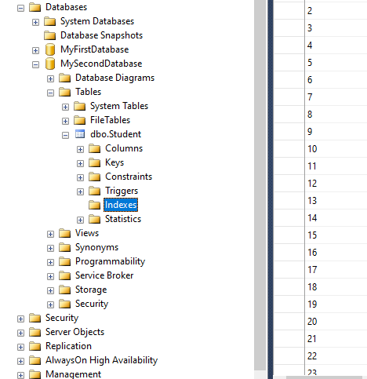

- Name the index, and select column to be indexed, click ok and ok again
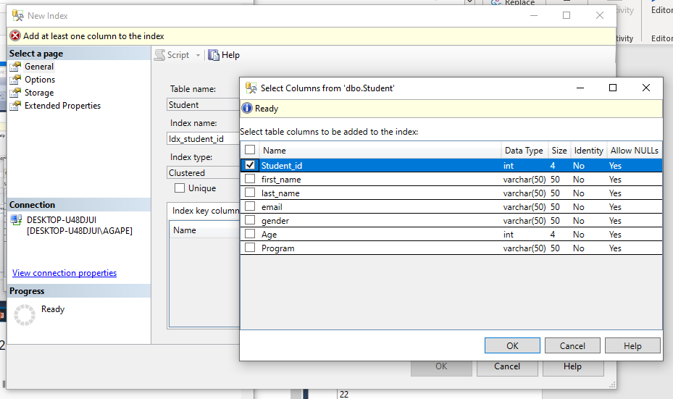
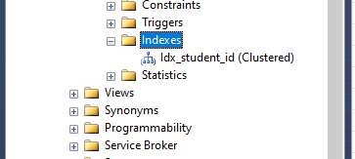

- Right click on newly created index and select properties
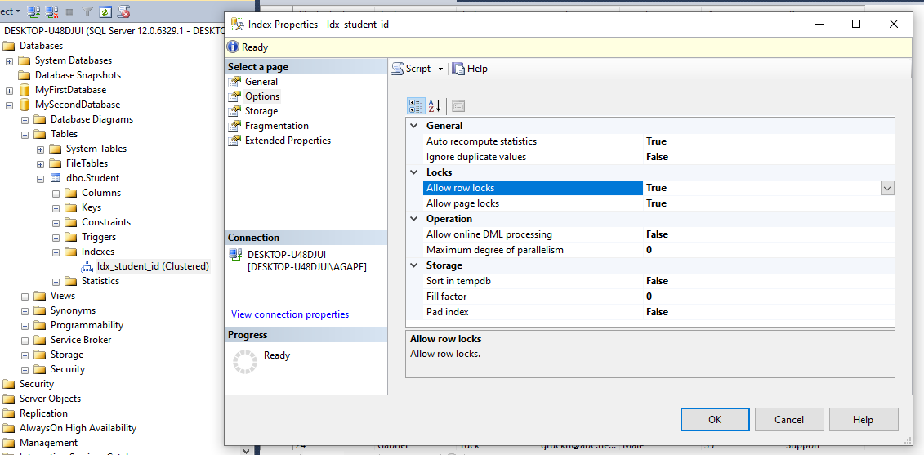
- Under storage set Fill Factor to 80
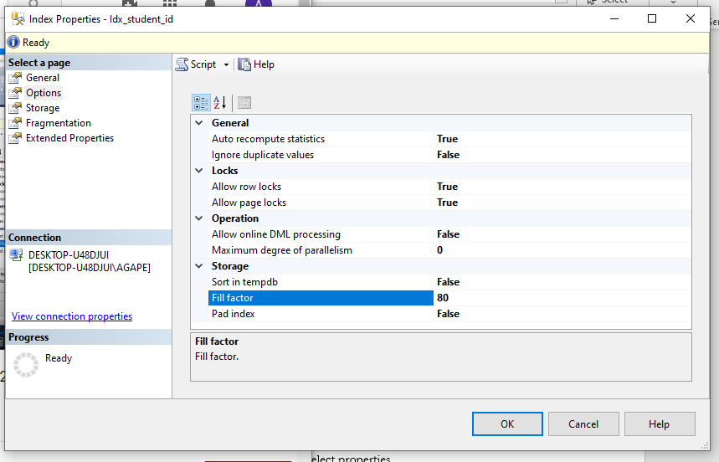

- To create a Non-Clustered index, right click on index and select Non-Clustered
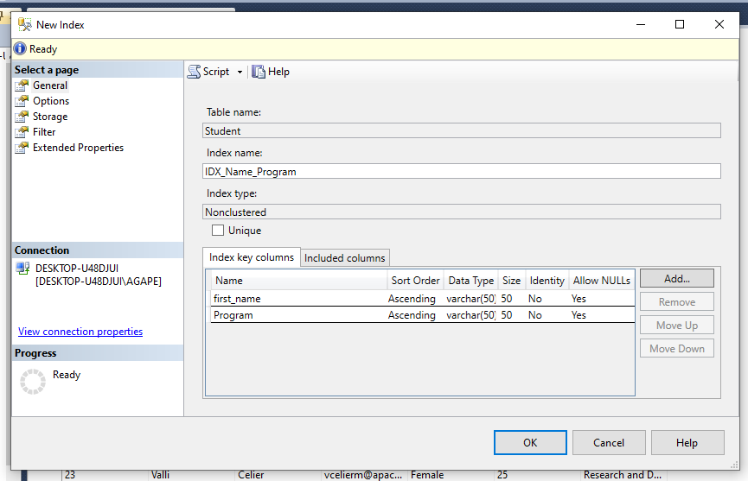

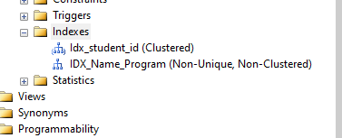

- To Rebuild or Reorganize and index Right click on index
- Rebuild
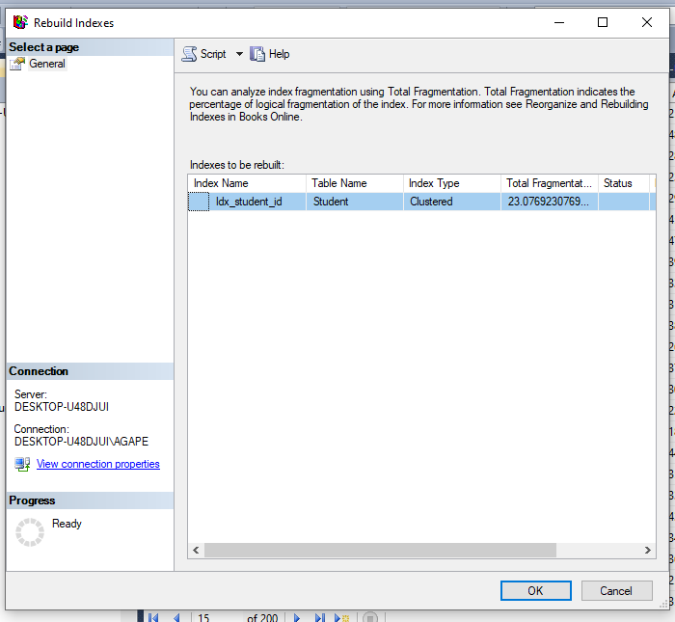

- Reorganize
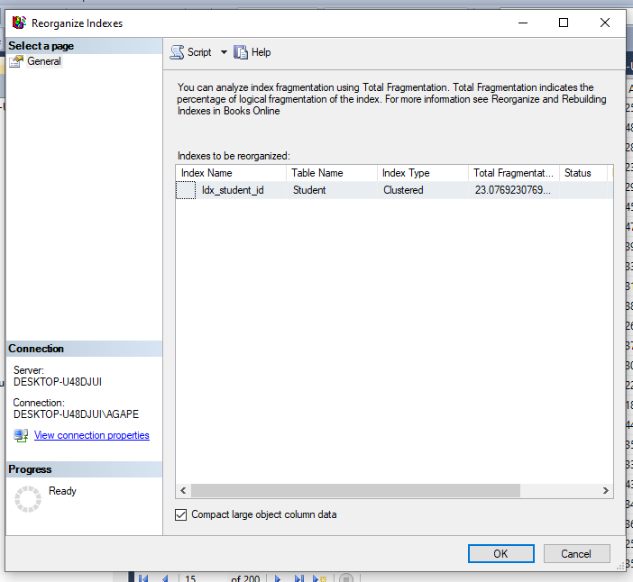

- T-SQL SCRIPTS
- Use two dashes to make a comment ‘--’
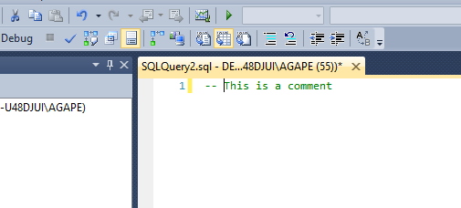
- THE T-SQL SCRIPTS WILL BE PROVIDED

