- To back up a database right click on the database click task and select backup
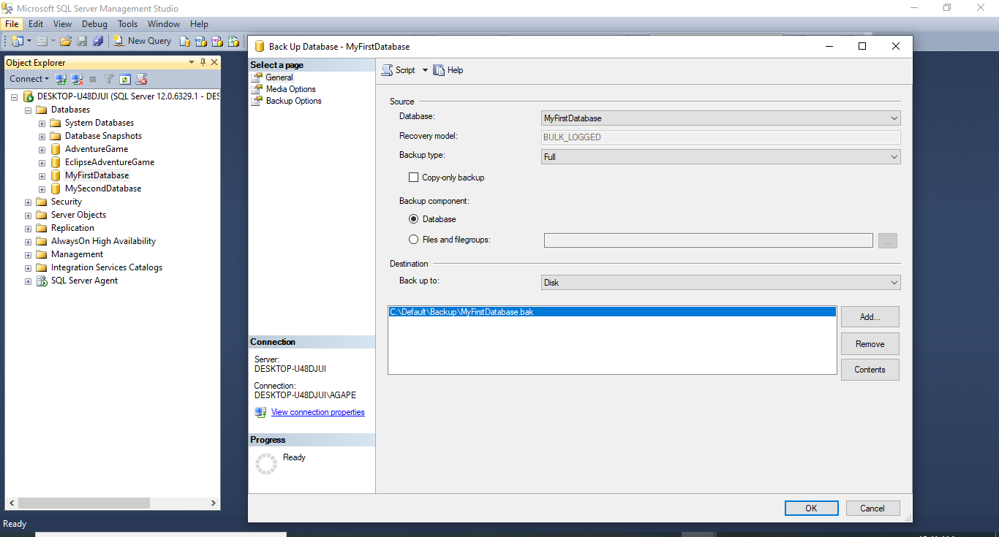

- Select desired back up type
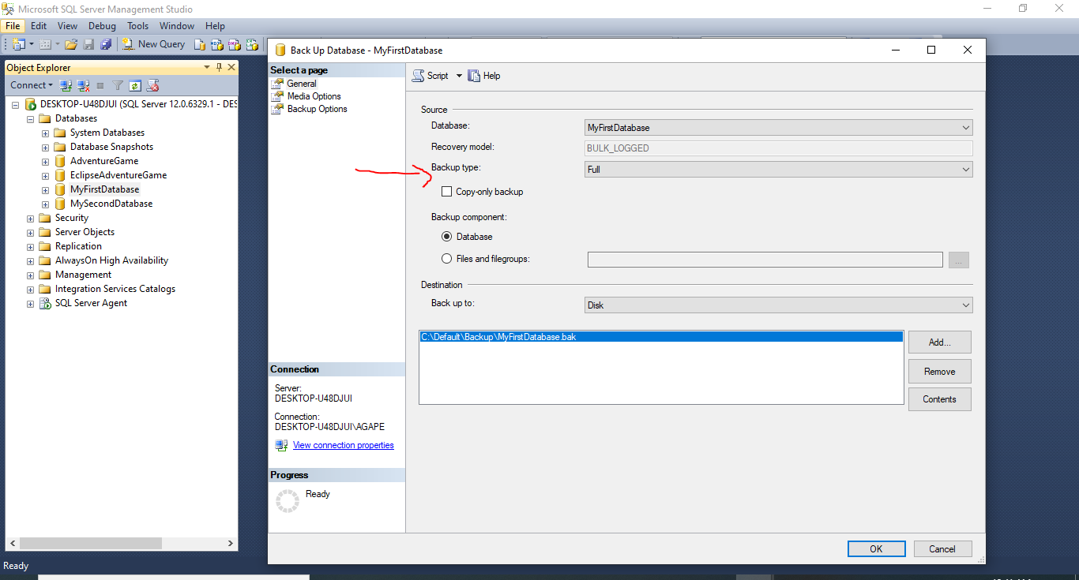

- For back up to leave on disk
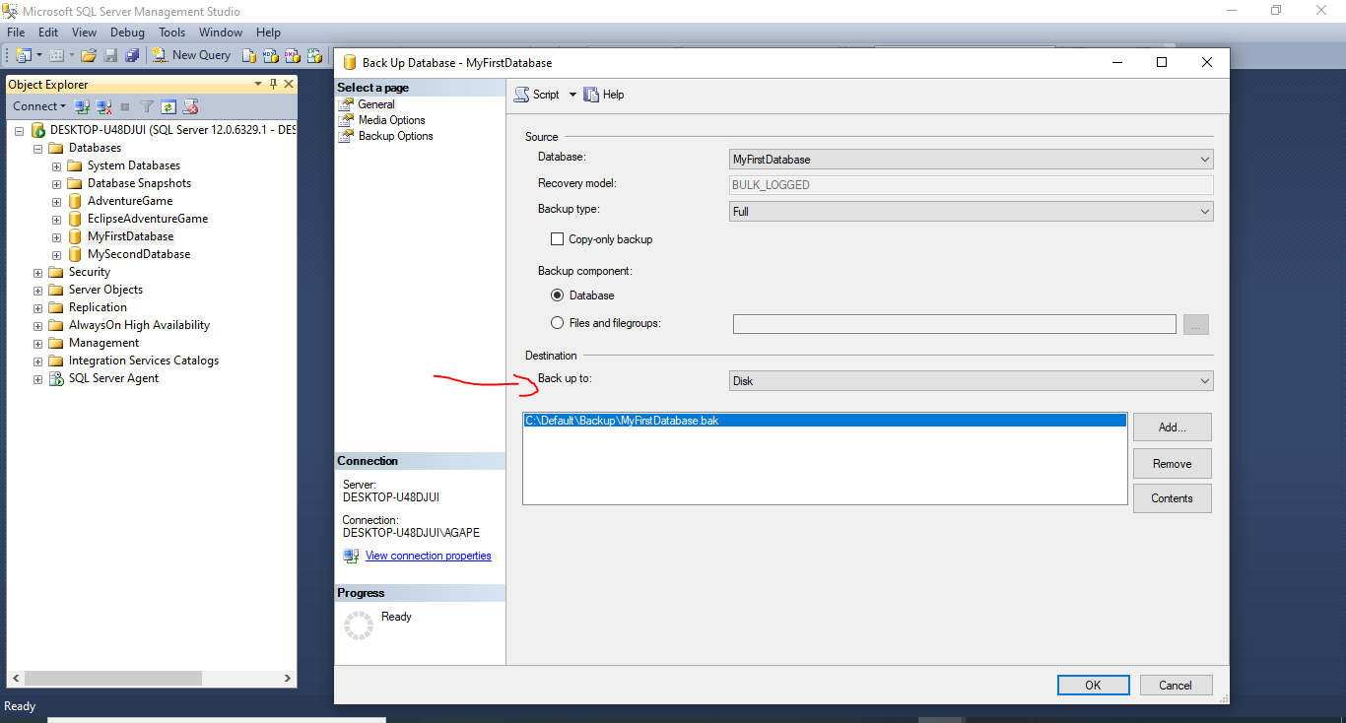

- Next go to backup path if the path is not the desired back up path click Remove and click on Add
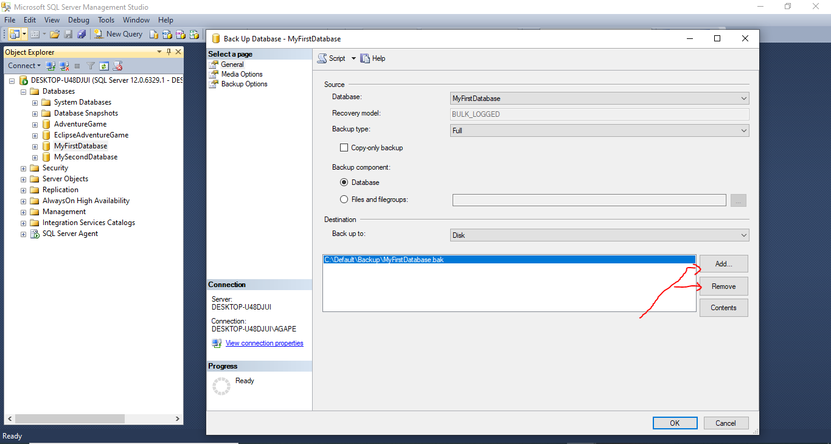

- Next browse to desired path
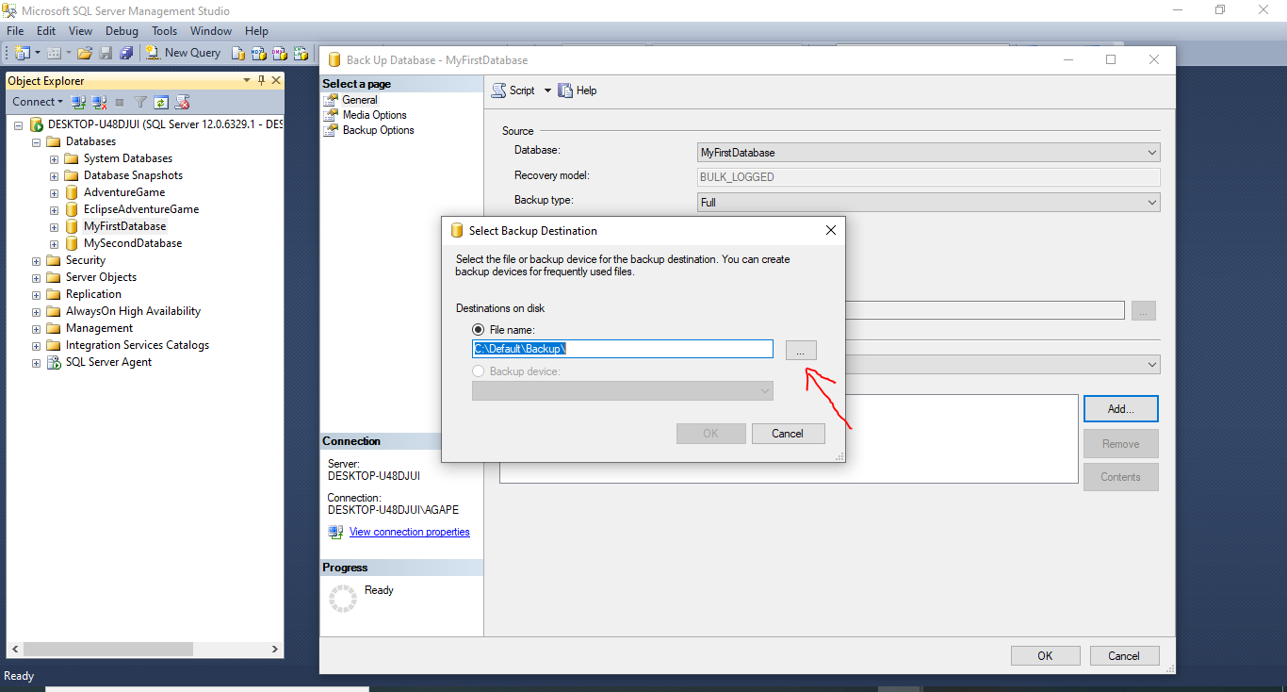

- Next select path and name backup
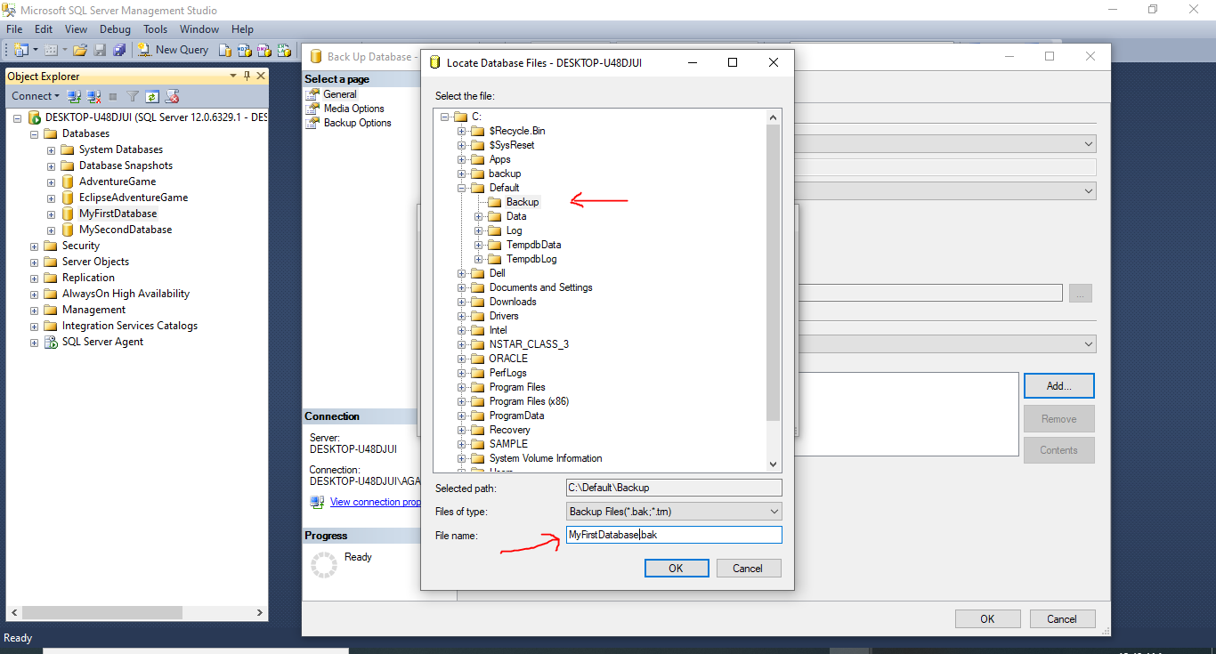

- Next click ok, and ok again.

- While still in backup menu change set backup compression to compress backup
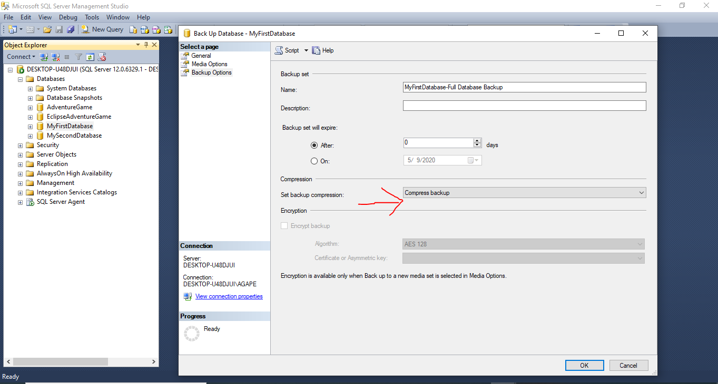

- Completion screen
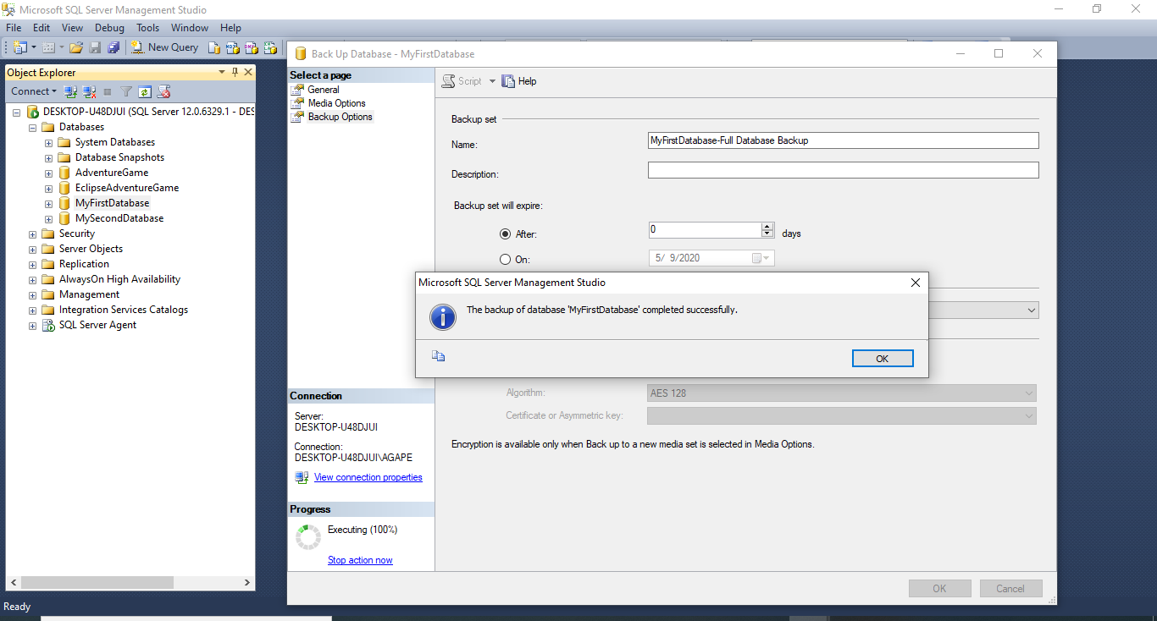

- To confirm back up right click on desired database go to properties, and on last database backup a date is shown
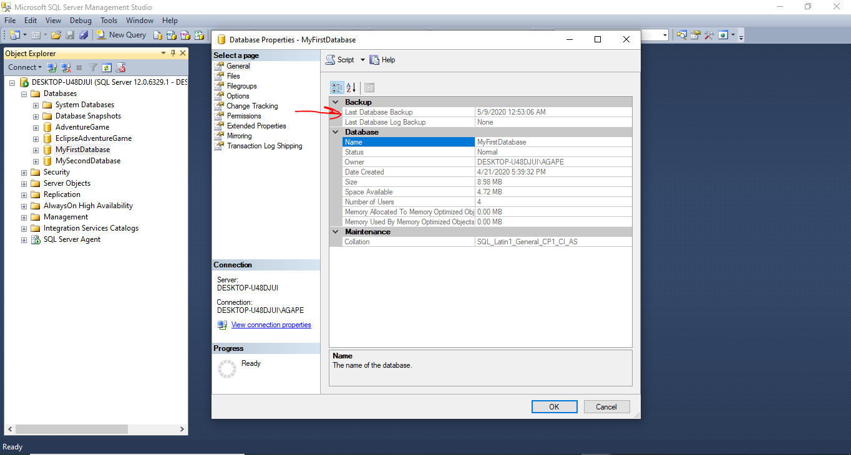

- For next activity right click on my second database and click on options and change recovery model form full to simple, and click ok
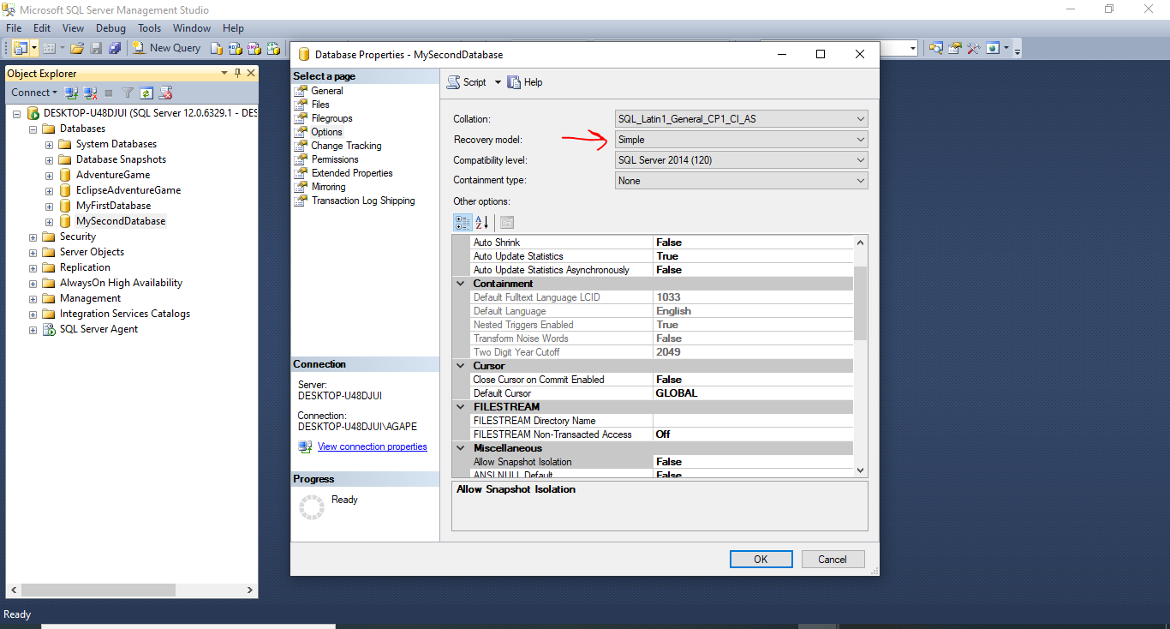

- Attempt to backup database and the only options available under back up type would be full and deferential

- Next open a new query window type DROP DATABASE MyFirstDatabase and execute
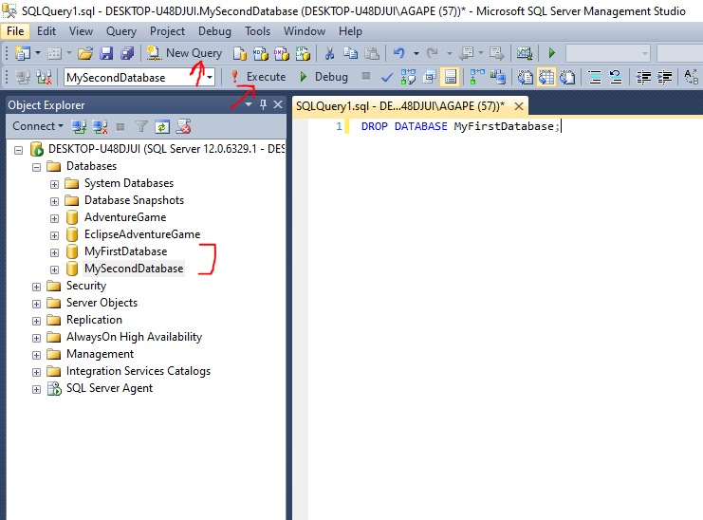

- Click on your server and refresh the database is has been dropped
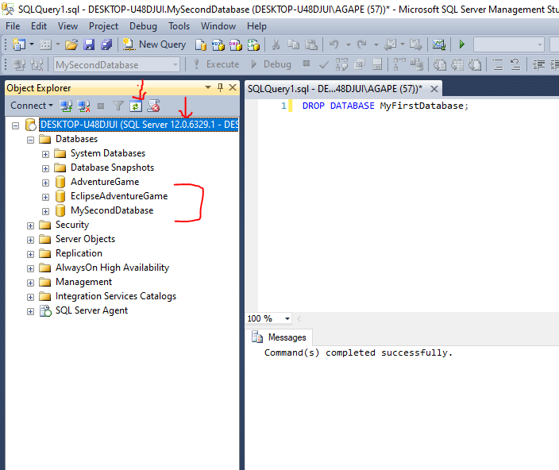
- To restore a database, right click on databases and click restore database
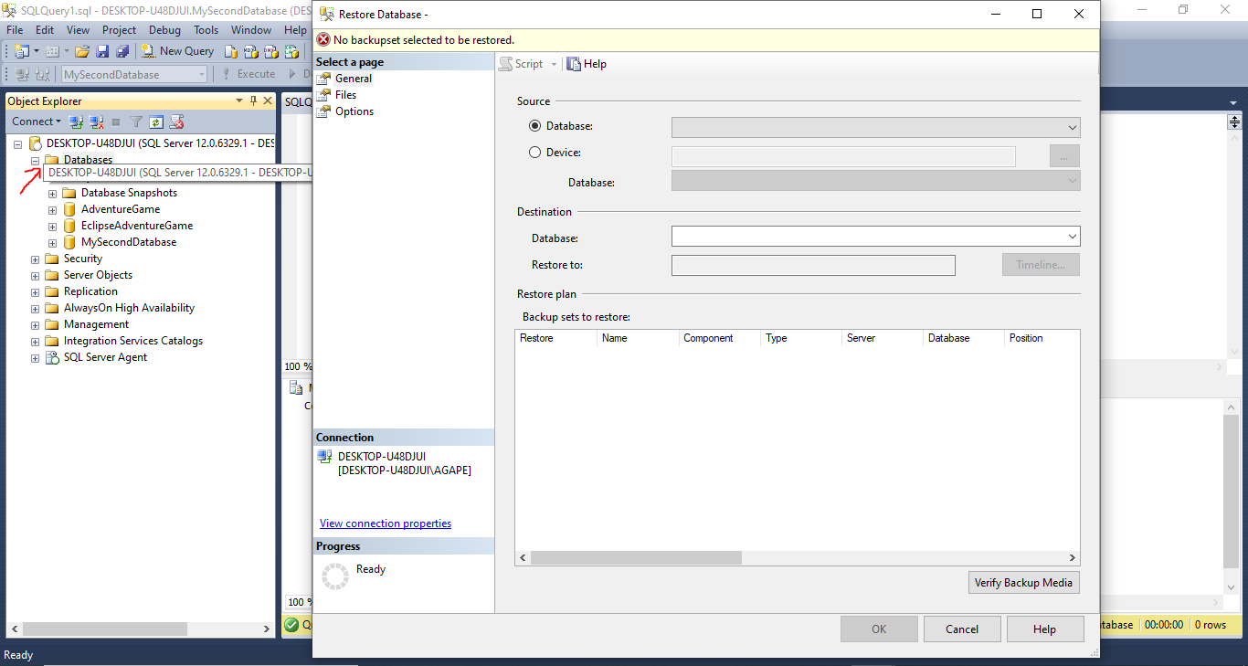

- Next click on device and browse
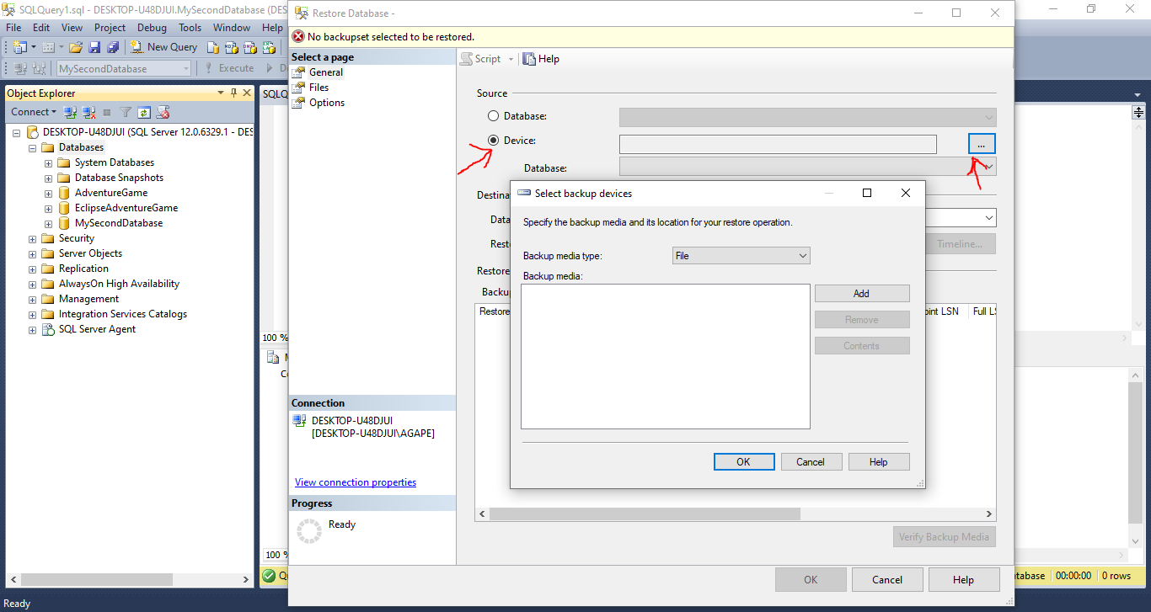

- Next click on Add and select desired database
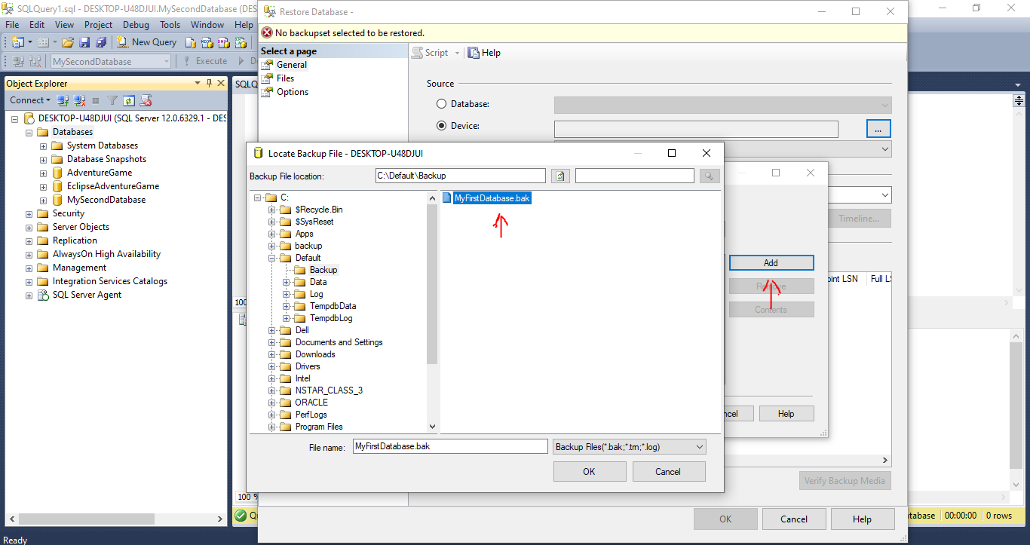

- And click ok
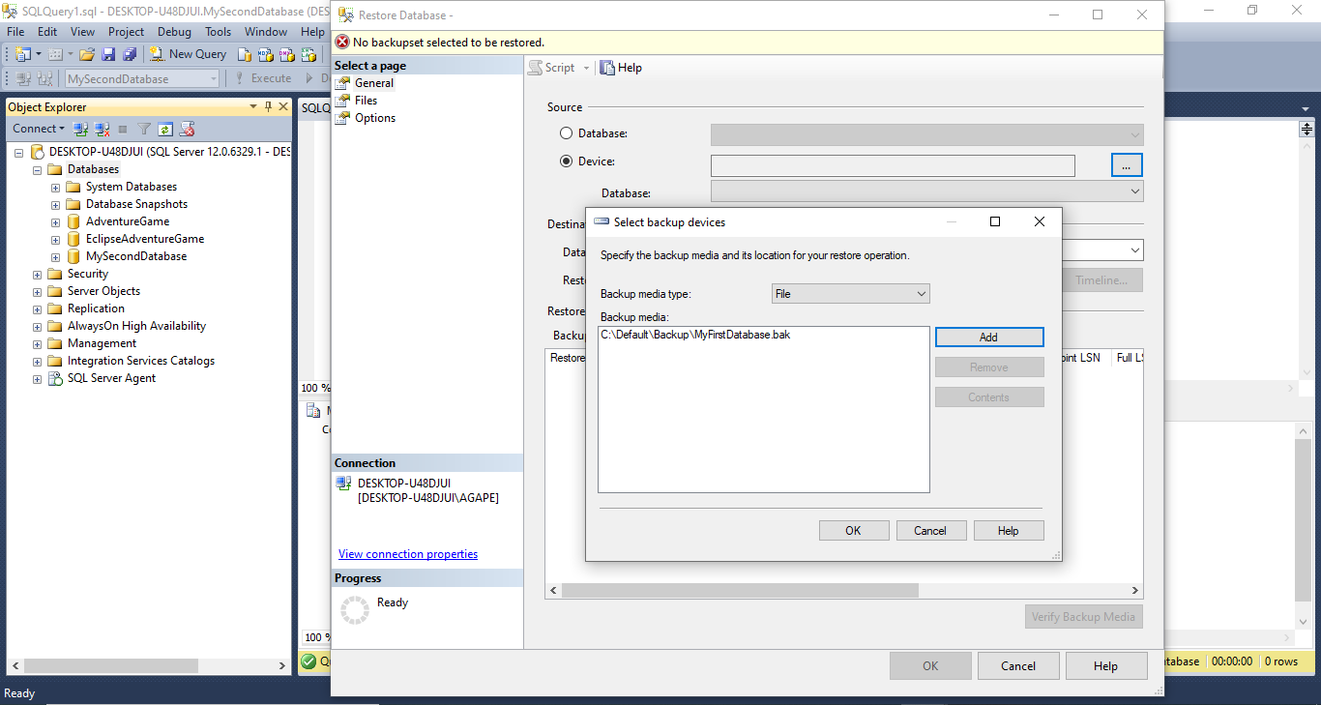
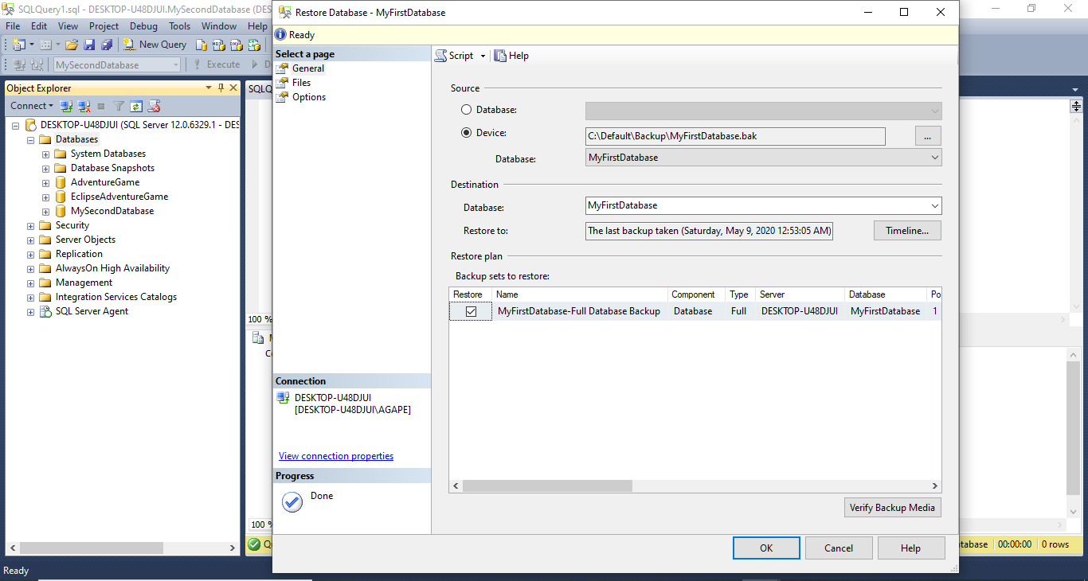

- To see new, restore location of files click on files
- To adjust file location click relocate if desired
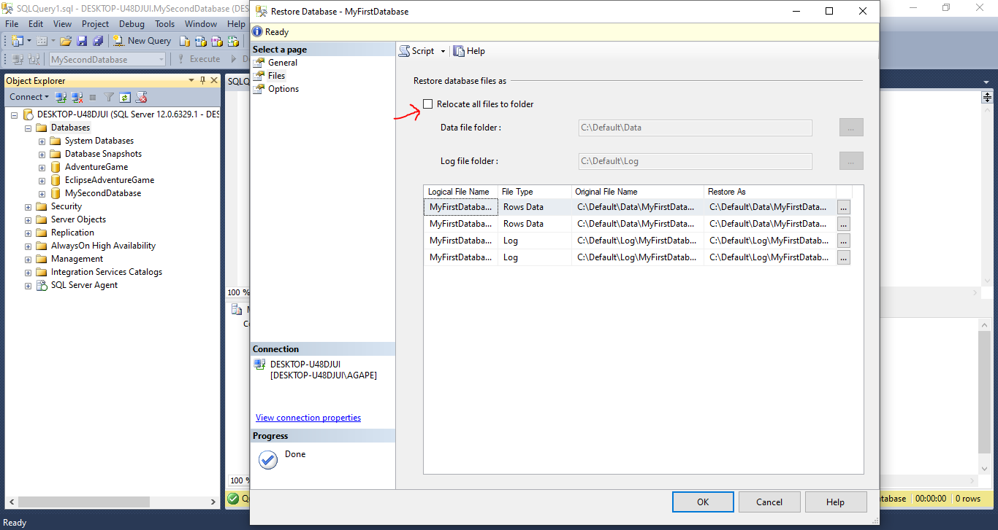

- Next click on options, change as desired
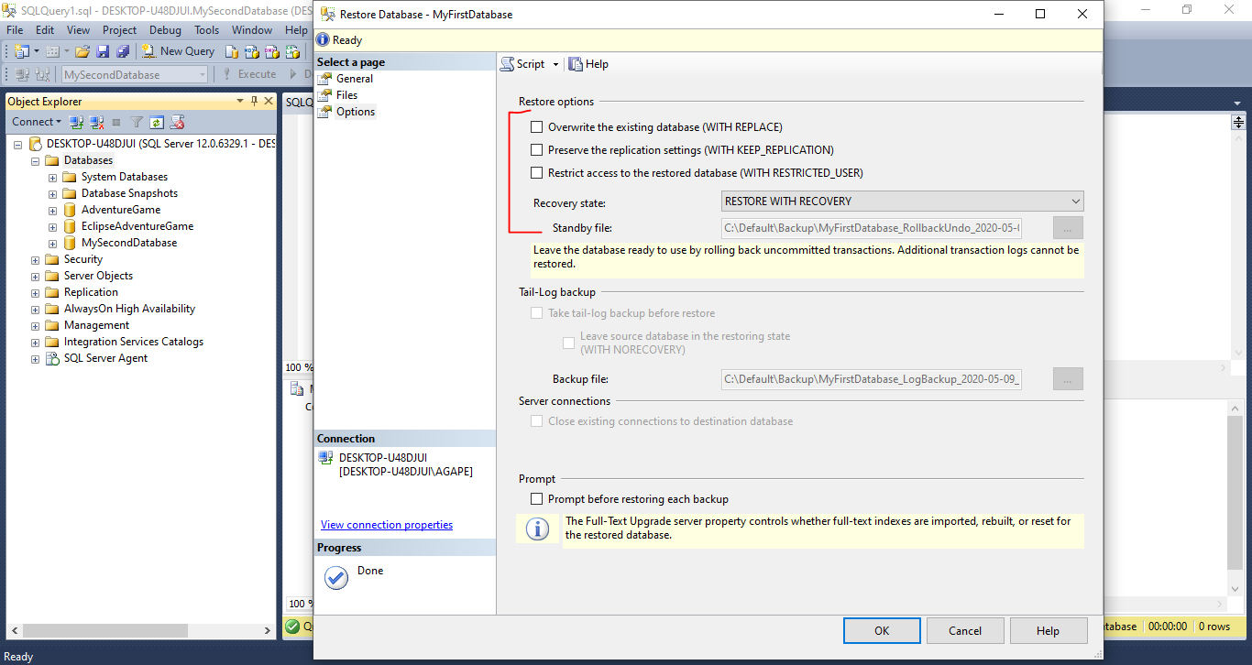

- Click Script, and select New Query Editor Menu to script out the backup or click ok to back up with GUI

- If script option was selected, close GUI and click execute
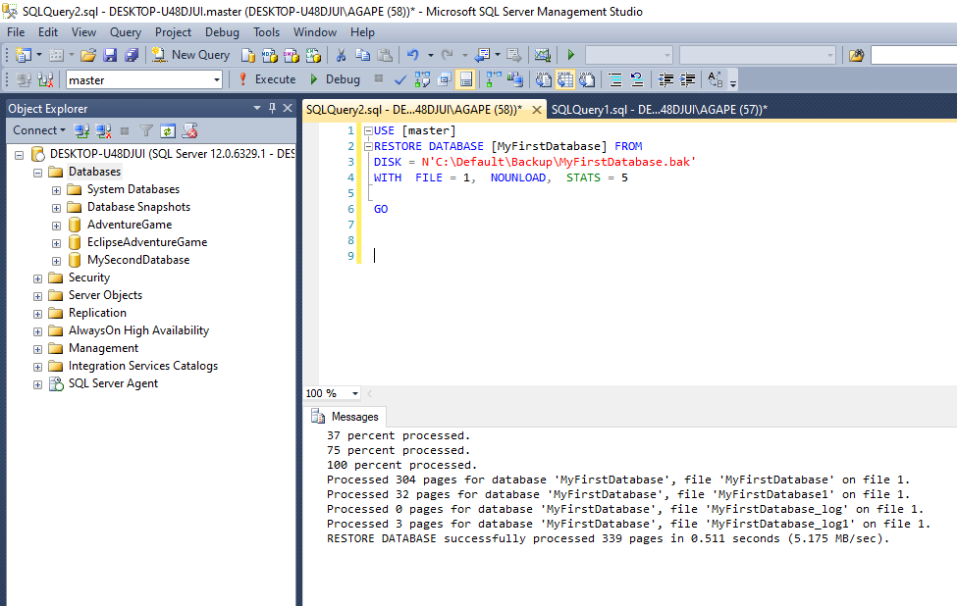

- Next expand management right click on maintenance plan and select Maintenance plan wizard
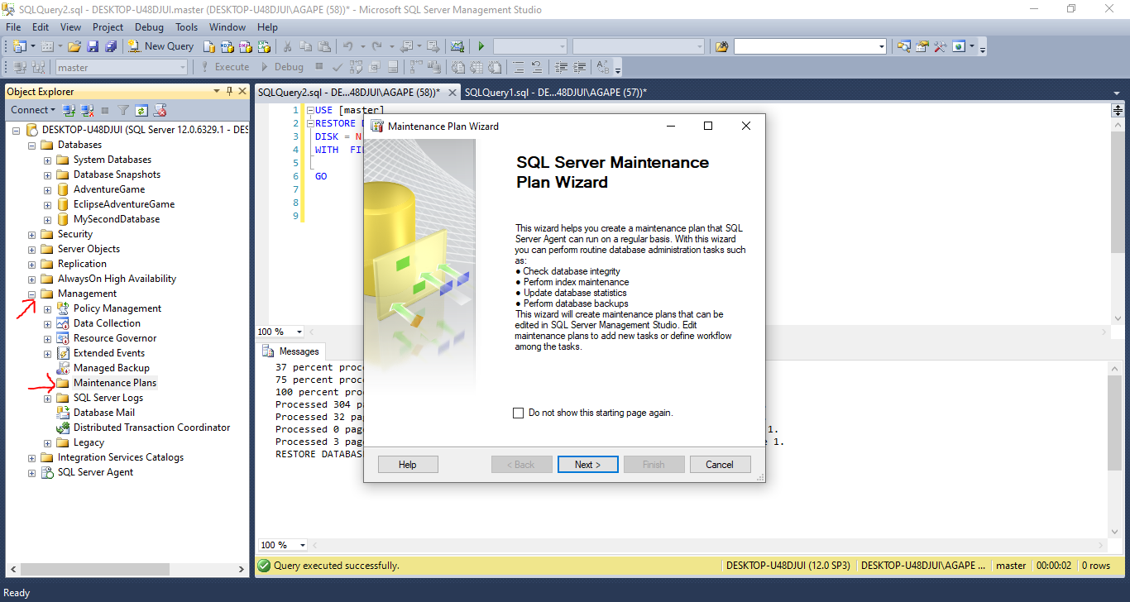

- Now click on Next, Name maintenance plan as desired. And click on change to change the schedule
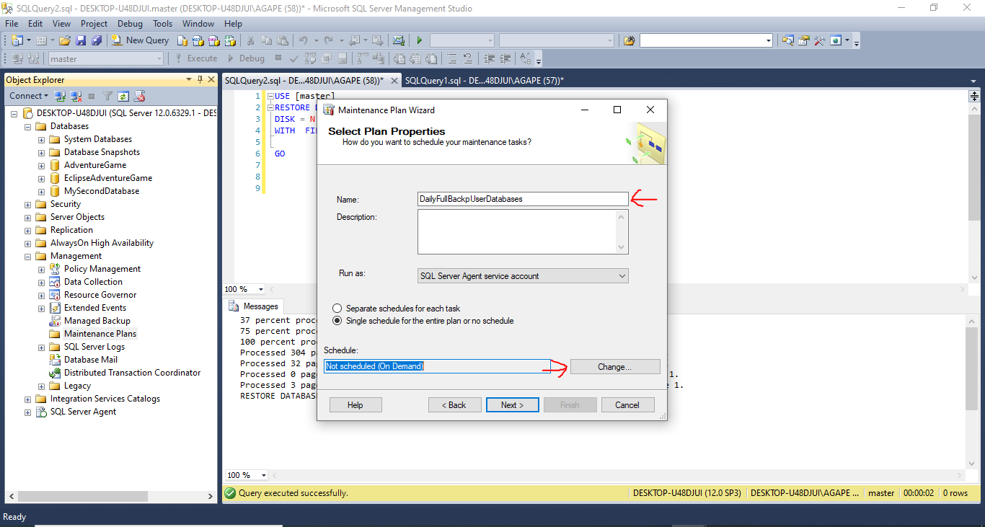

- Leave schedule type on recurring, change Frequency occurs to daily, set time as desired, give it no end date, and click ok.
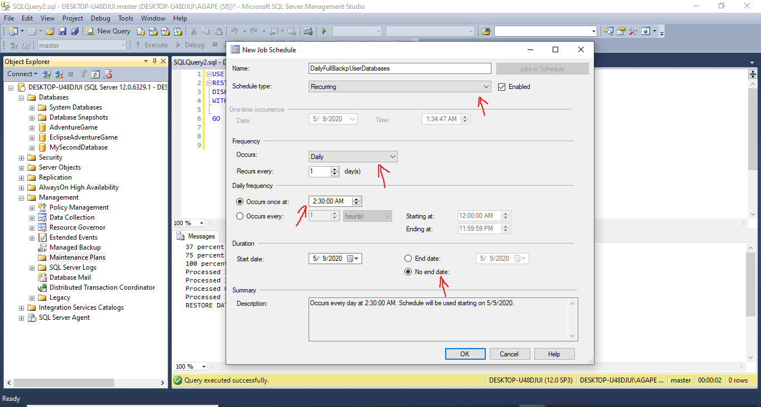

- Click next, and select desired maintenance type and click next
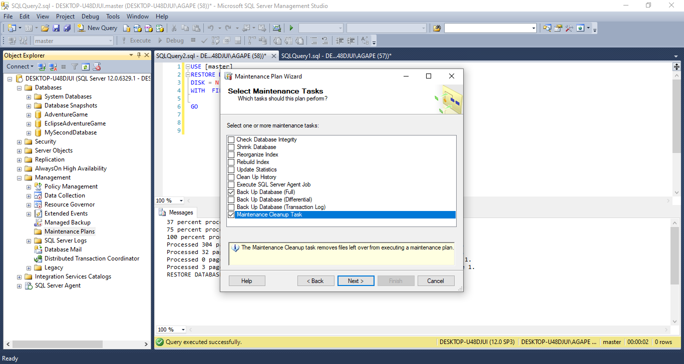

- Use move up and move down button to set the task that occurs first and click next
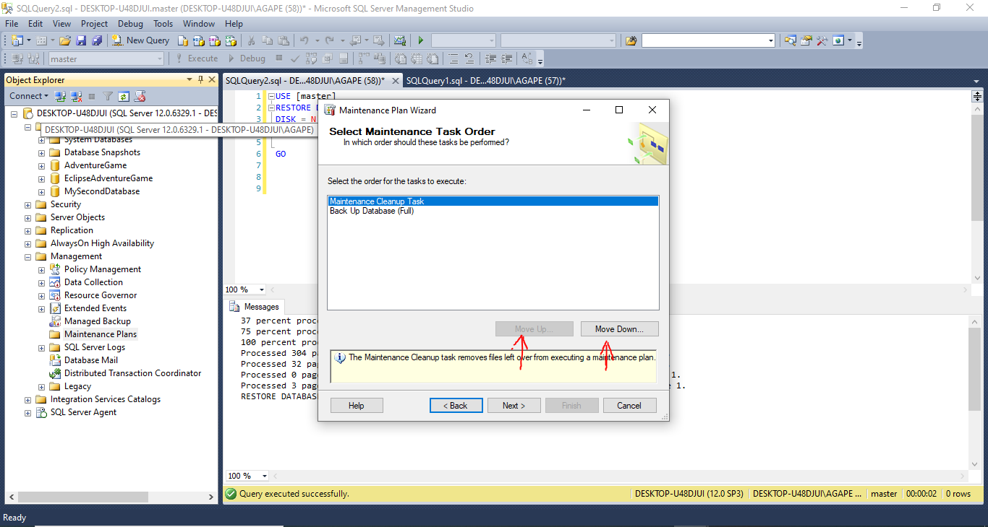

- In general, under databases, click on the drop down and select what kind of database to backup and click ok
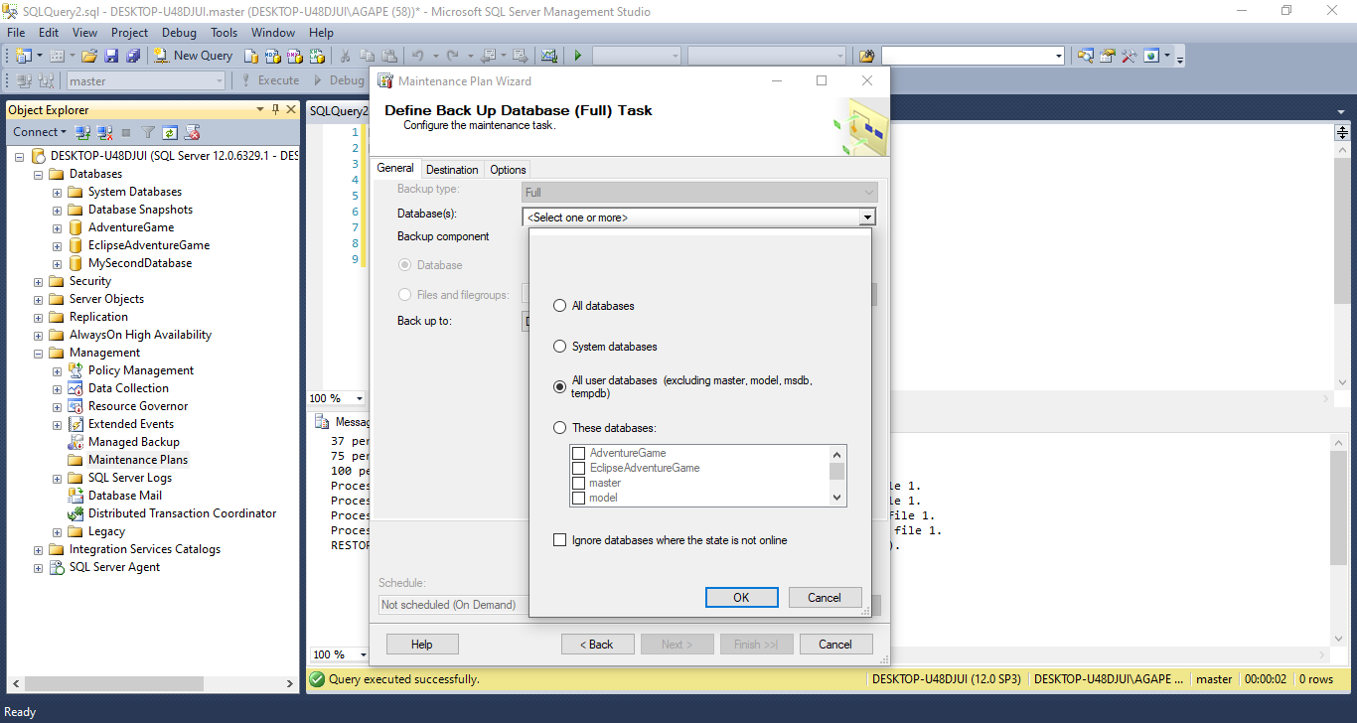

- Under destination, check create a sub directory for each database if desired
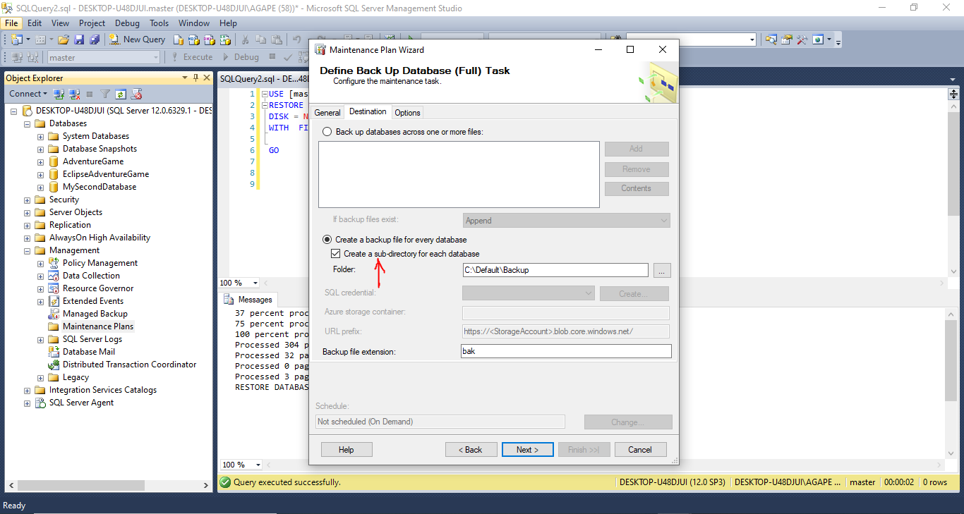

- Go to options and select compress, and click next
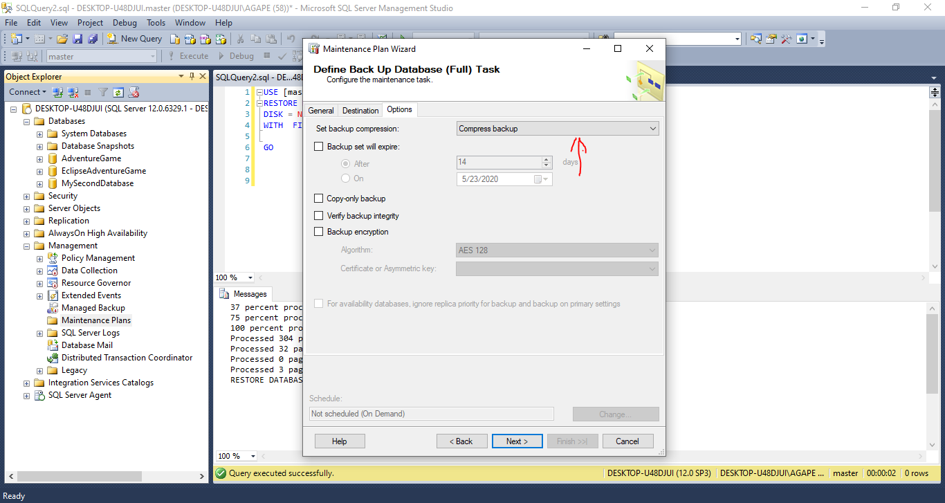

- Next browse to path of backups, set file extension, check include first level folders, set age of files to be deleted and click next
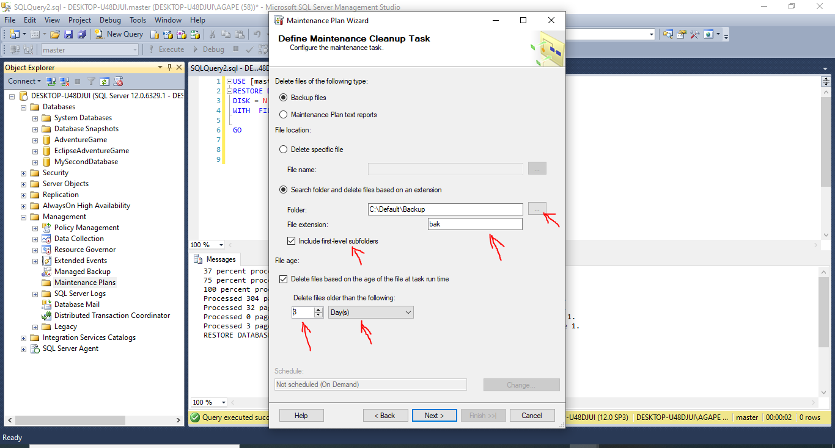

- And next
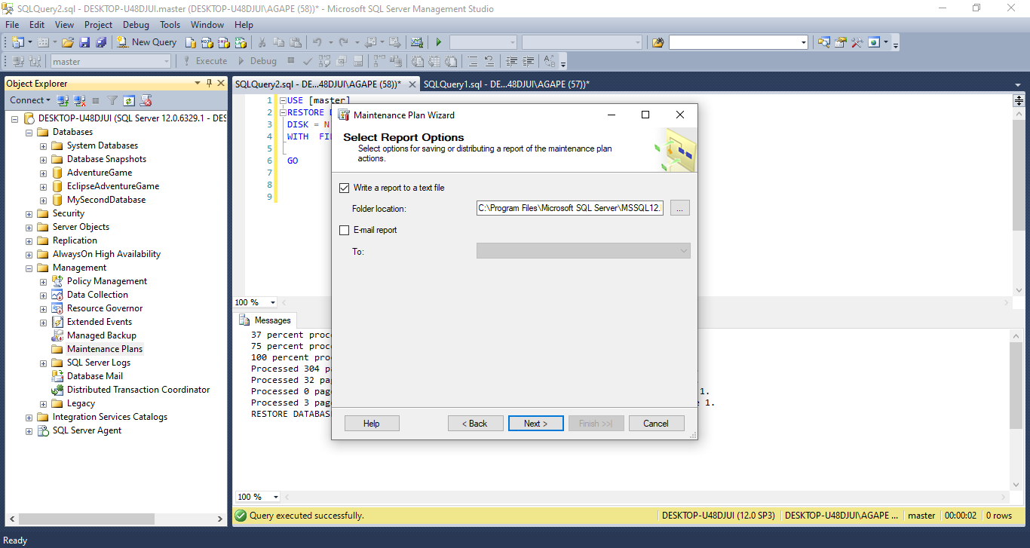

- And finish
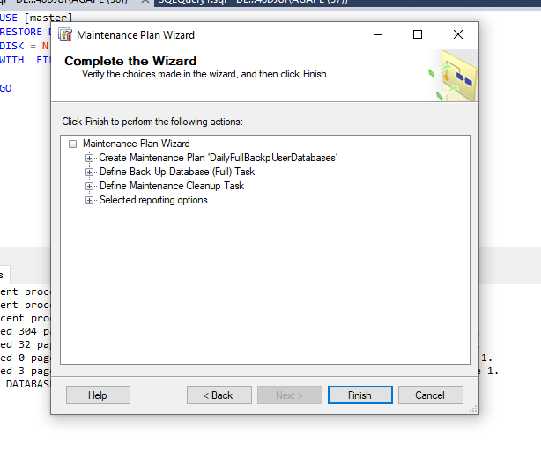
- And close
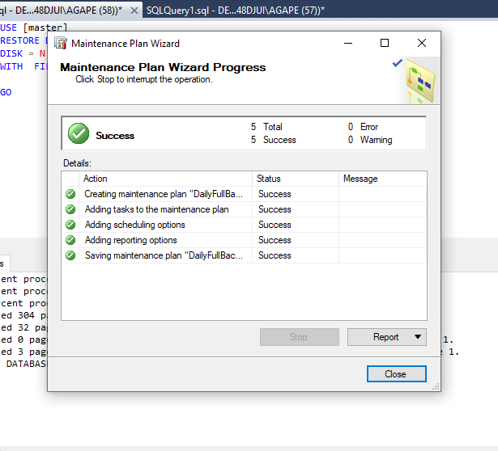
- Confirmation of process
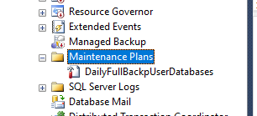

- To manually run a maintenance plan right click on the maintenance plan and click execute
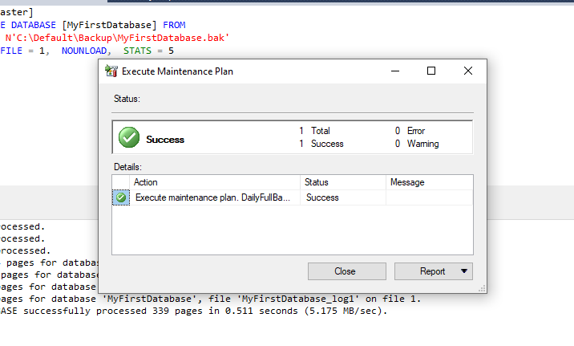
- Navigate to backup location to see backed up files
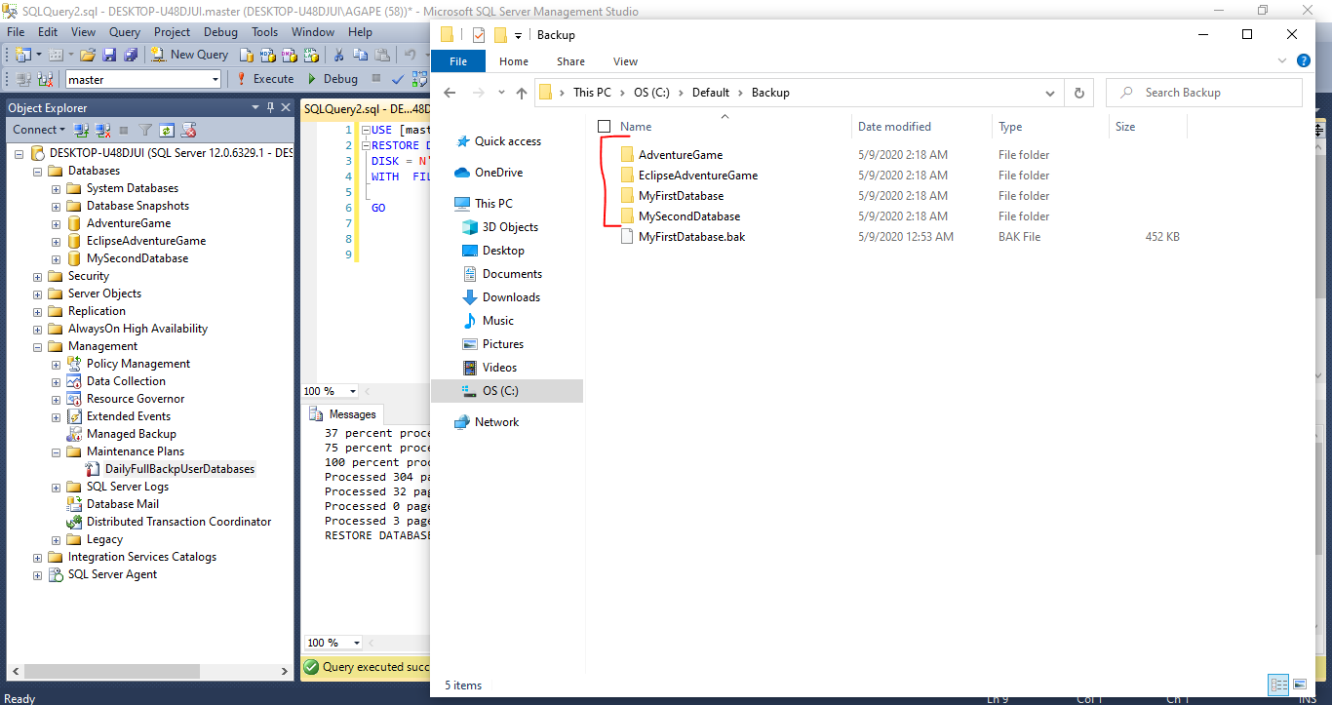
- To see the jobs tab, expand SQL server agent and expand jobs
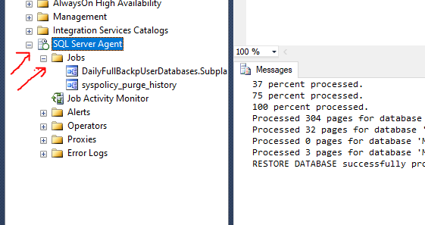

- TO create a job, right click on jobs and select new job
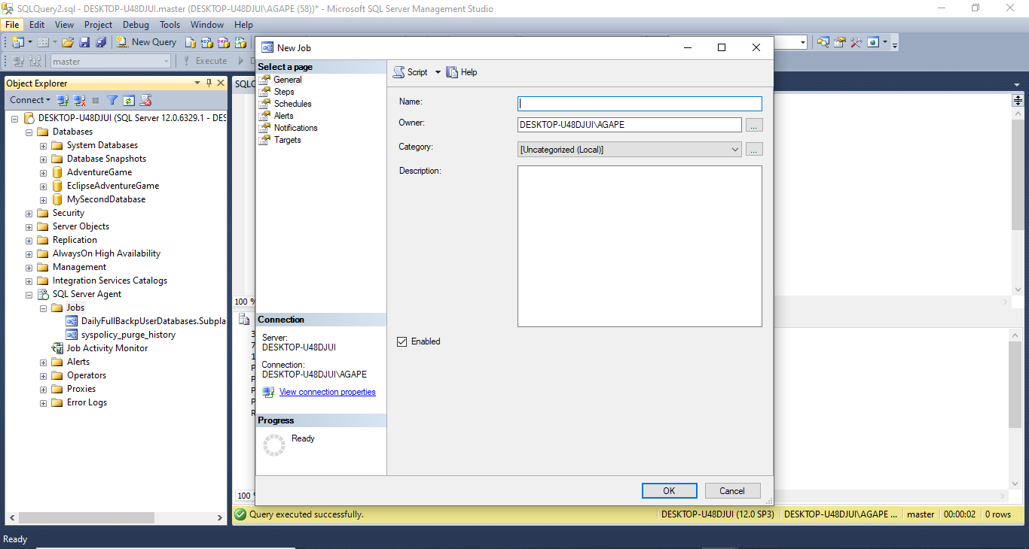

- Name the job, change owner to sa if asked, and click on steps
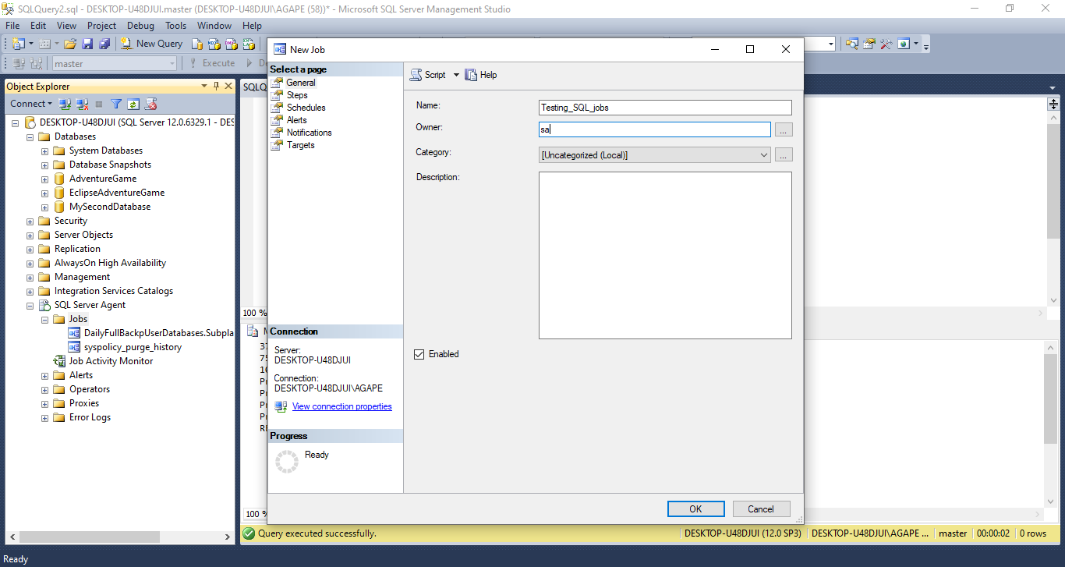

- Scripts for steps will be provided

- On steps click on new
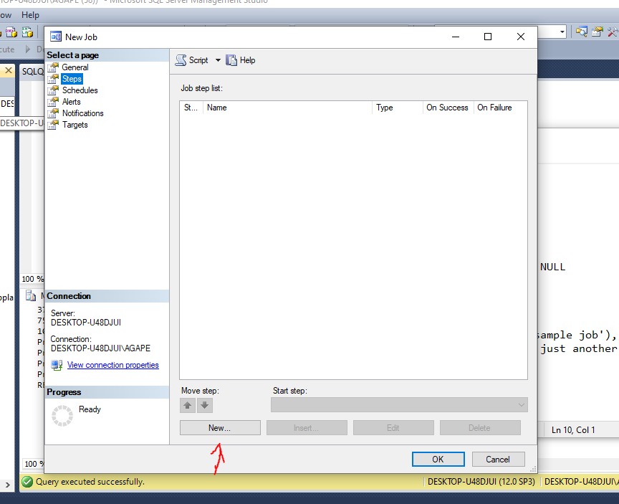

- For step name call it CREATE NEW DATABASE, and paste in command, in command section, parse command to check authenticity
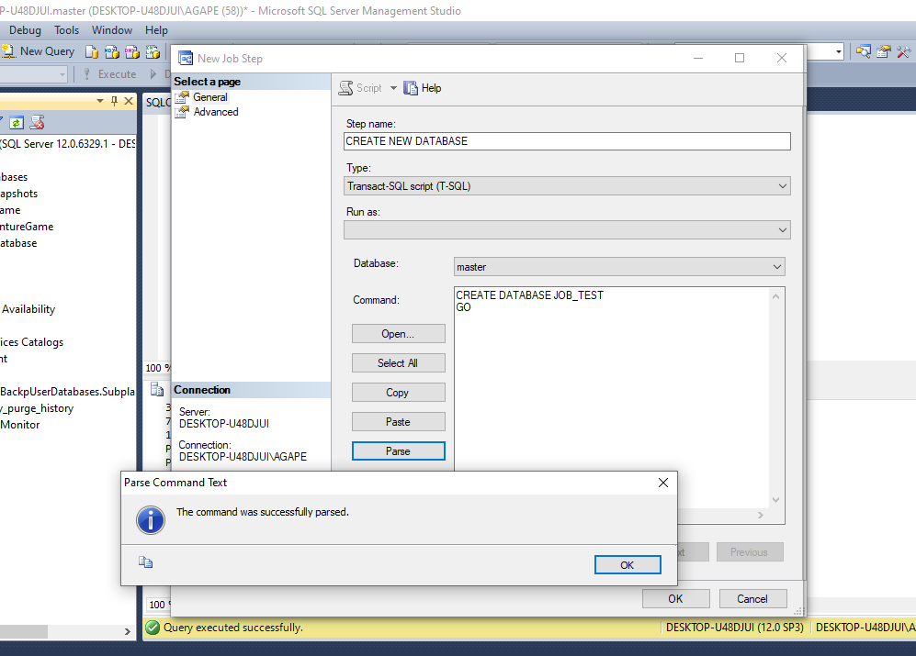

- In the same tab click on ‘advanced’ on success, ‘go to next step’, on failure ‘quit the job reporting failure’ and click ok
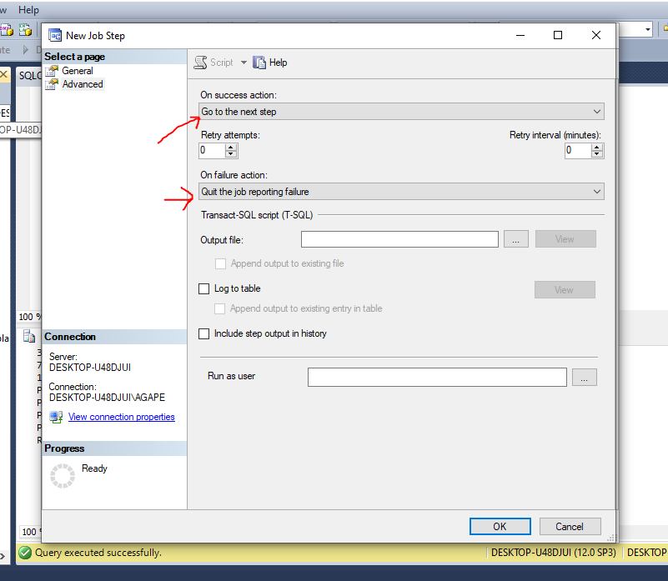
- Click new again
- Name this new step, CREATE TABLE, paste in command, clicking on parse causes an error because database JOB_TEST has not yet been created that’s fine
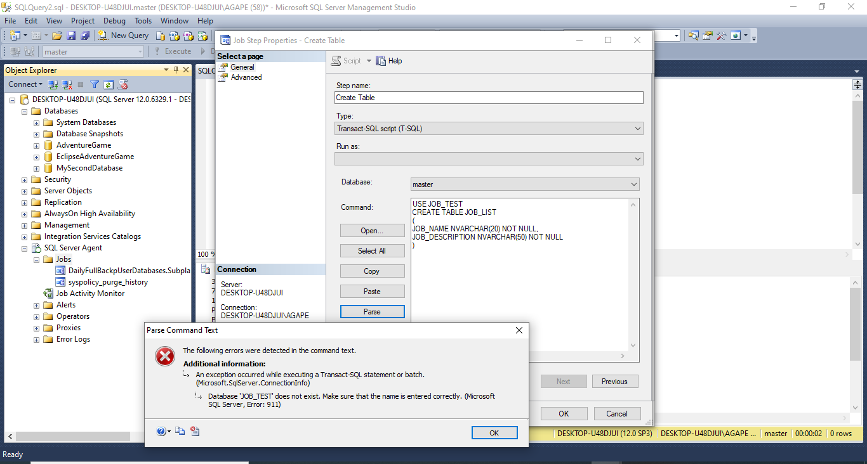

- In the same tab click on ‘advanced’ on success, ‘go to next step’, on failure ‘quit the job reporting failure’ and click ok

- Click new again
- Name this new step, INSERT INTO TABLE, paste in command, clicking on parse causes an error because database JOB_TEST has not yet been created that is fine
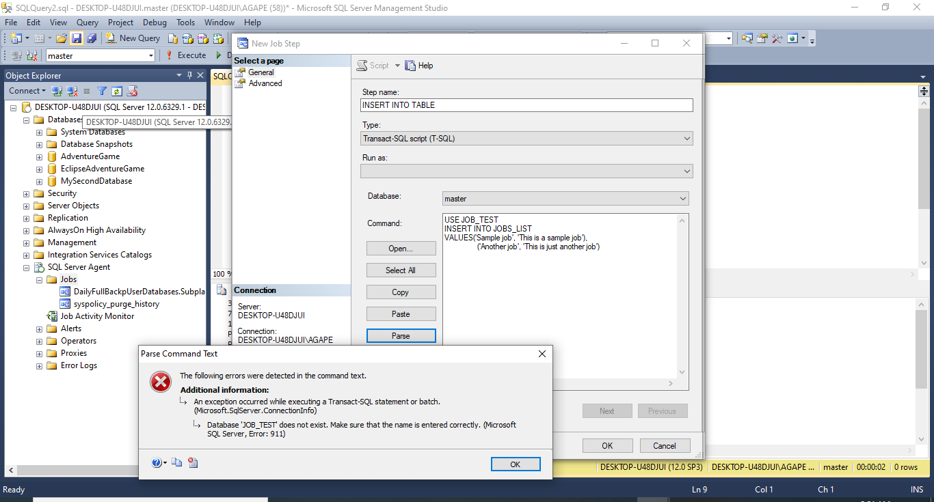

- In the same tab click on ‘advanced’ on success, ‘quit the job reporting success’, on failure ‘quit the job reporting failure’ and click ok
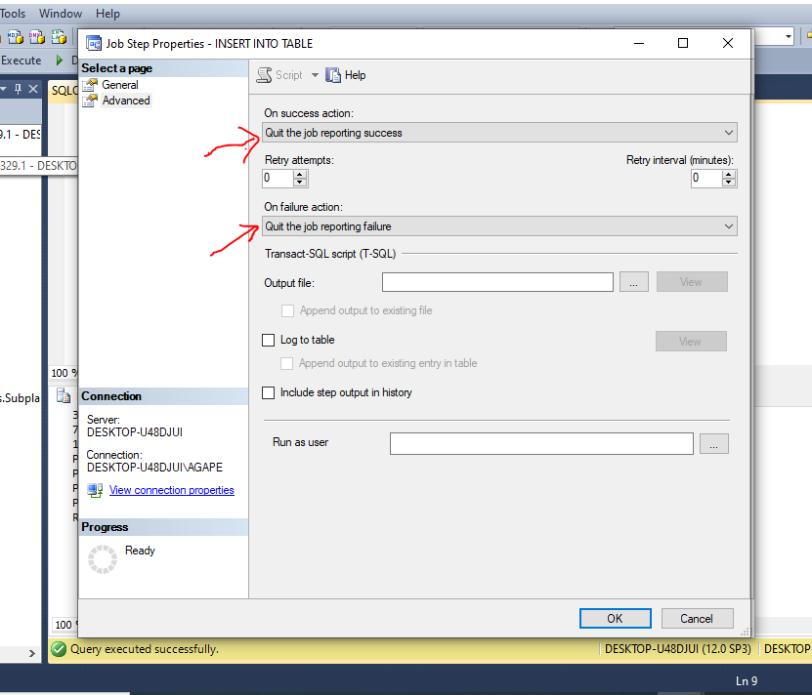
- This should be your final screen
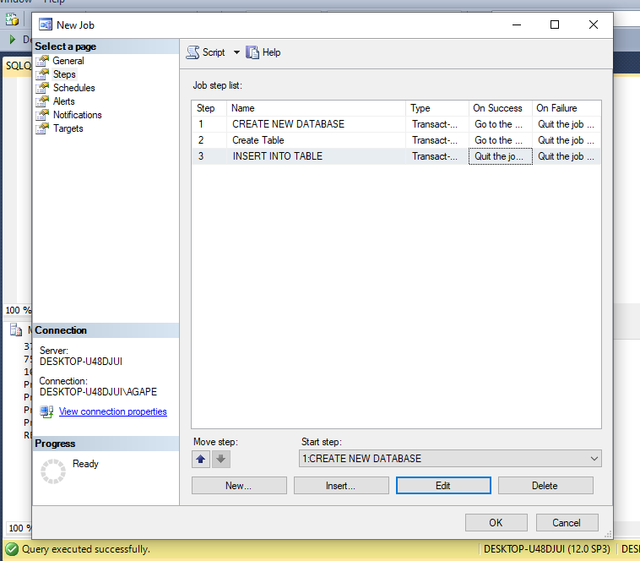

- Next go to schedule and pick new
- Name the schedule Test_Job, change schedule type to one time, set date as desired, and click ok, and ok again
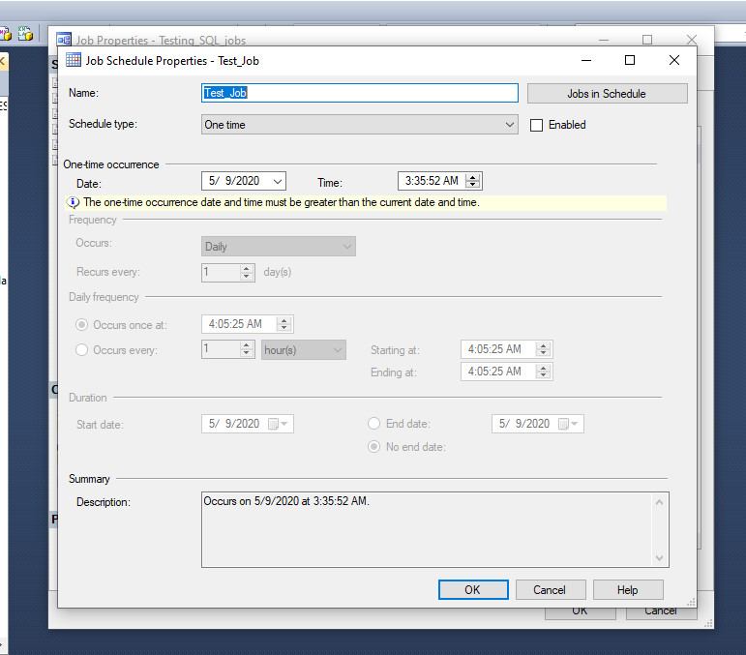
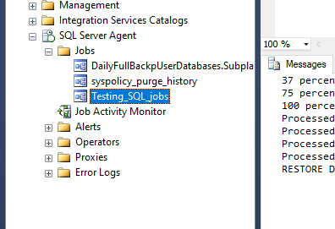
- To manually execute a job right click on job and click start job at step

- Select desired step and click start
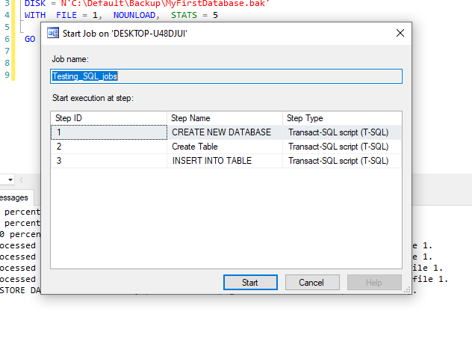

- The job should succeed showing all three steps completed
- If there is an error, right click on job and select view job history
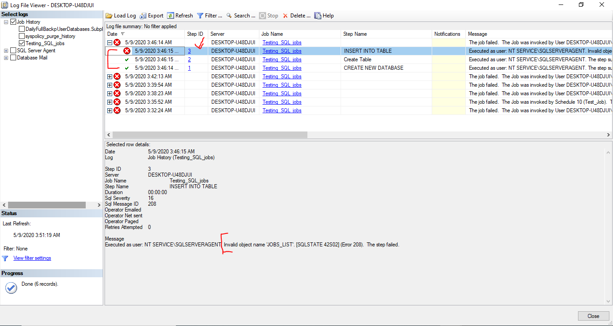
- My job failed on step 3
- Click on the step to see the reason why it failed
- At the bottom it says ‘there is an invalid object named JOBS_LIST’
- In step 2 I created a table called JOB_LIST and am inserting records into a table called JOBS_LIST hence the error
- To edit a job right click and click on properties
- To fix my error I took out the ‘S’ to match the already created table called JOB_LIST
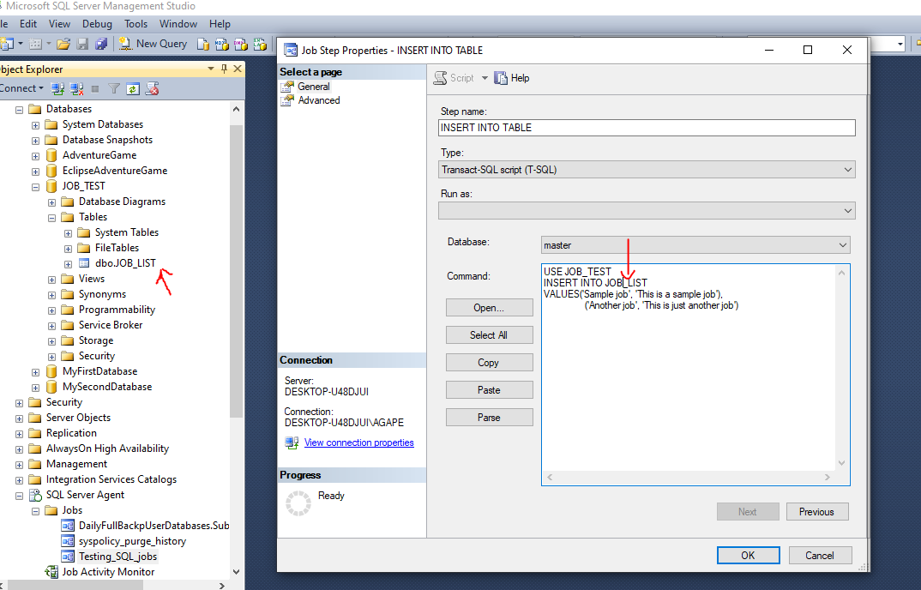

- Click ok, and ok again
- Now since the job failed at step 3 run the job from step 3 not 1

- To manually execute a job right click on the job and click start job at step
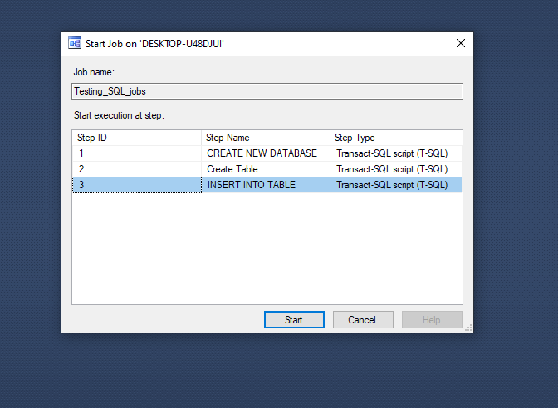

- Now click close
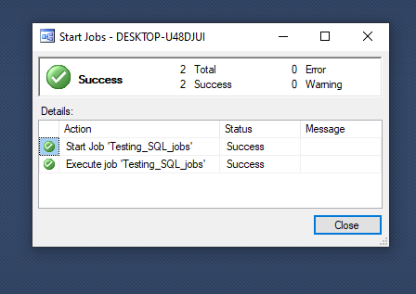

- To see the newly inserted records right click on the table and click SELECT TOP 1000 ROWS
