- To create a new login, expand security, and expand logins
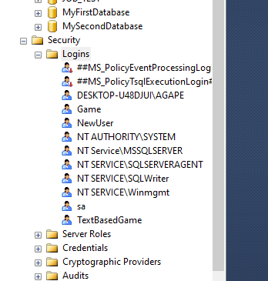

- Next right click on logins and select new logins
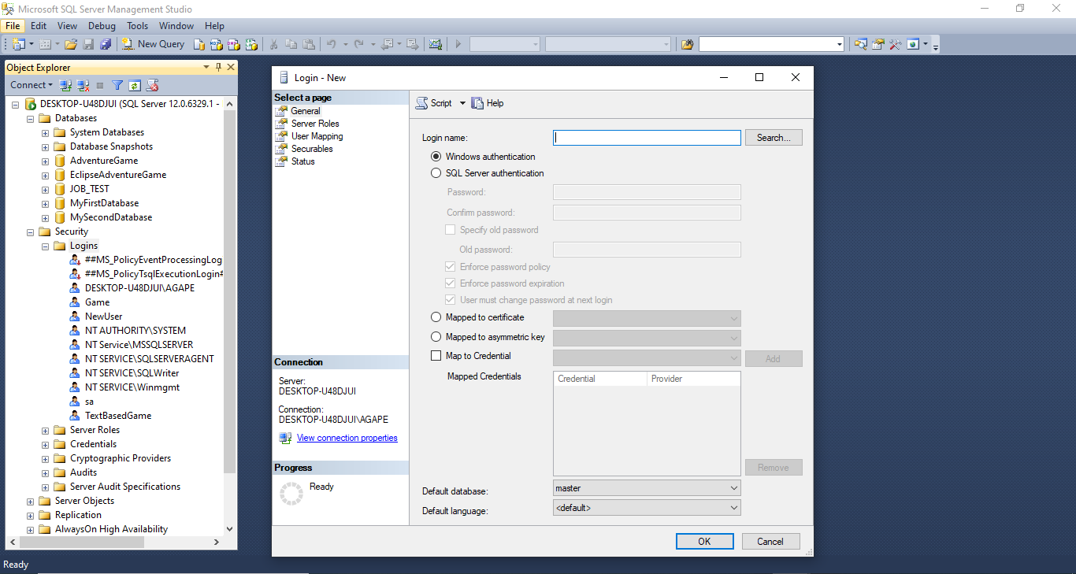

- To create a login Using windows authentication click search to find other users, type in the user, and select check names and click ok
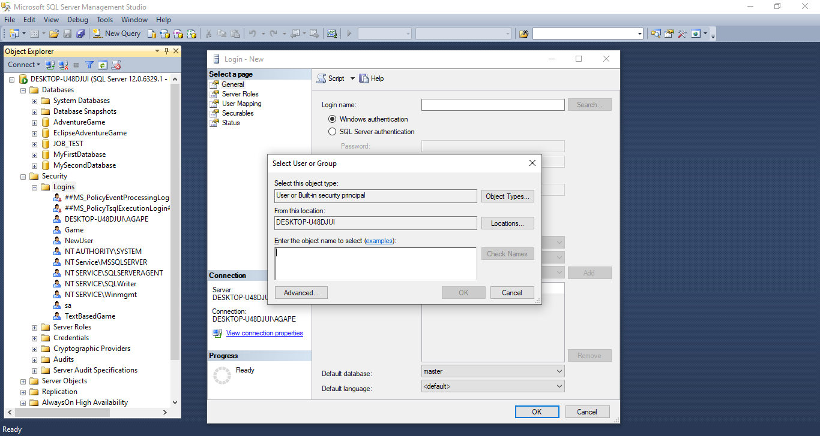

- To create a login Using SQL server authentication
- Name the login Nstar_Sql
- Specify password
- Uncheck enforce password policy
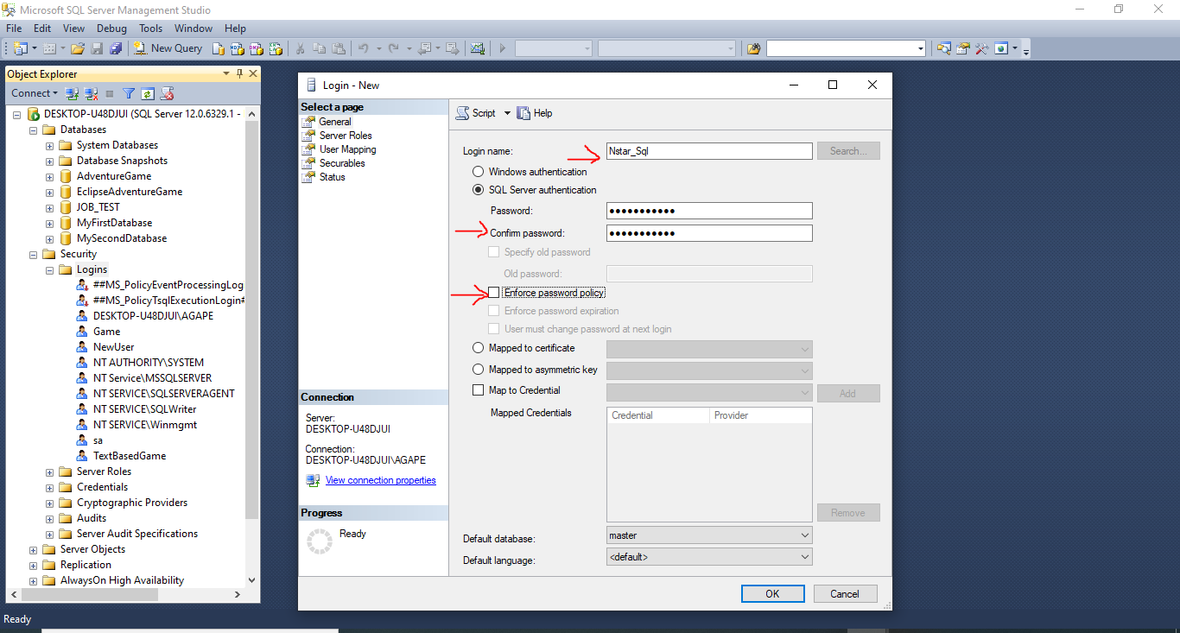

- On the left it says select a page switch to Server Roles
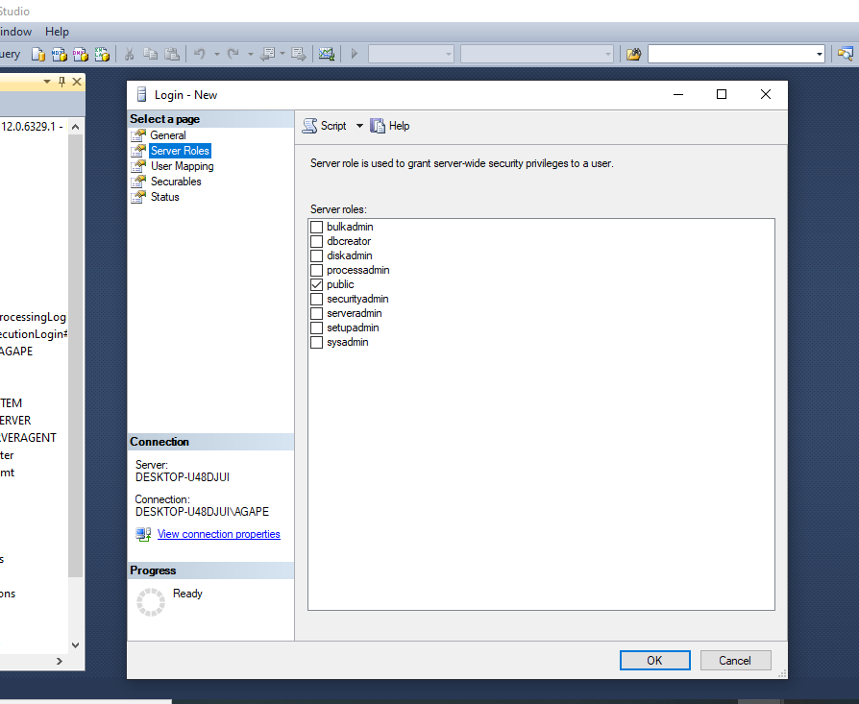

- Select desired server roles

- Next switch to User Mapping
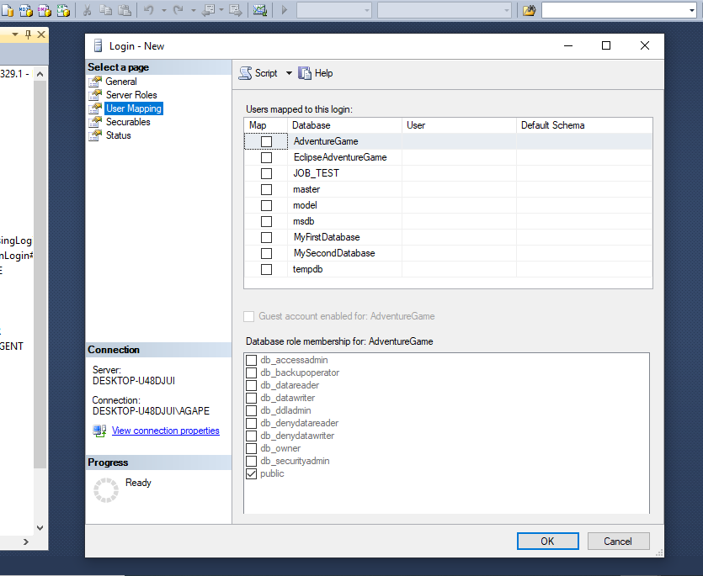

- Select MyFirstDatabase and under Database role membership select db_datareader and db_datawriter and click ok
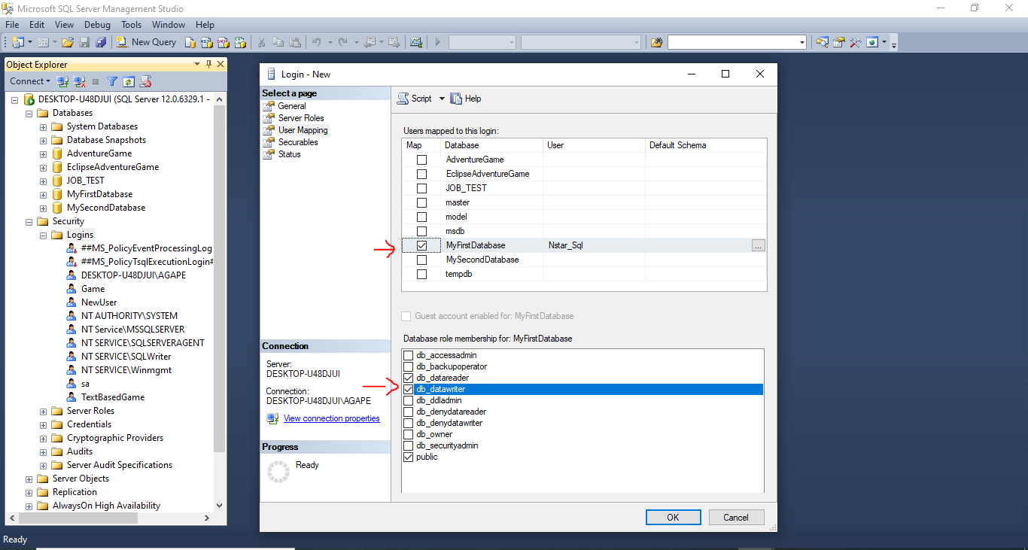
- Login created
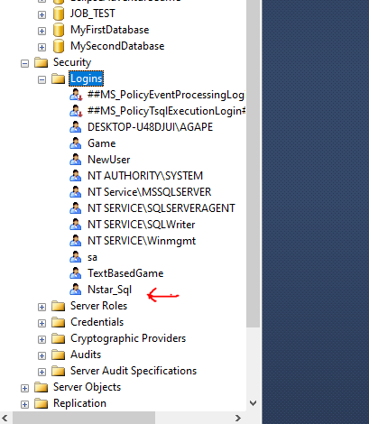

- To sign in with new login, click connect, switch authentication to SQL server authentication, specify login and password and click connect
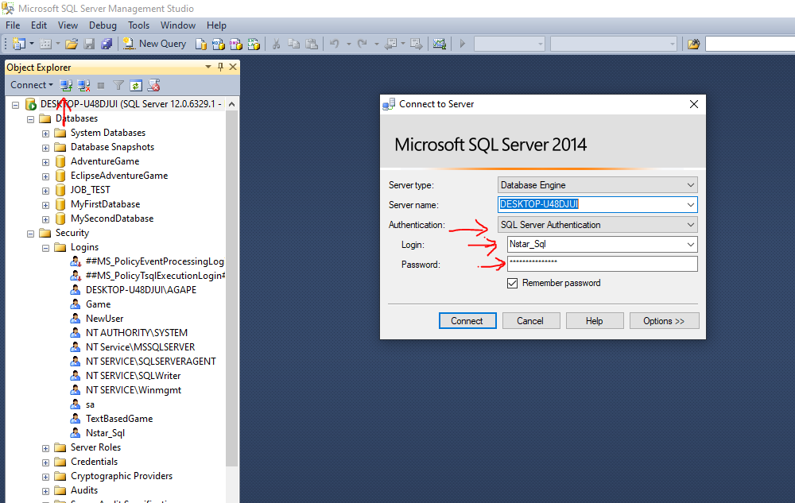

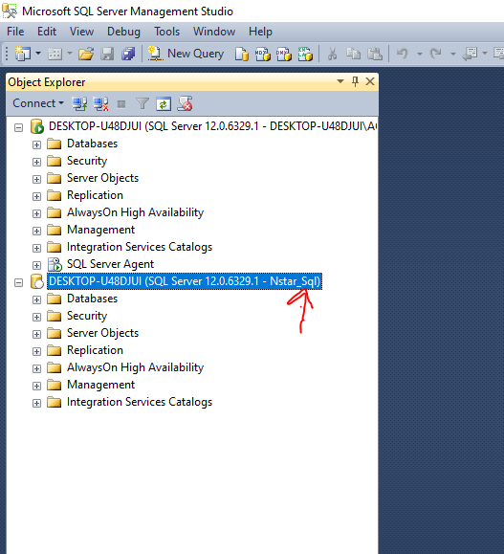

- To edit the properties of a login in the instance where the login was created right click on the login and go to properties
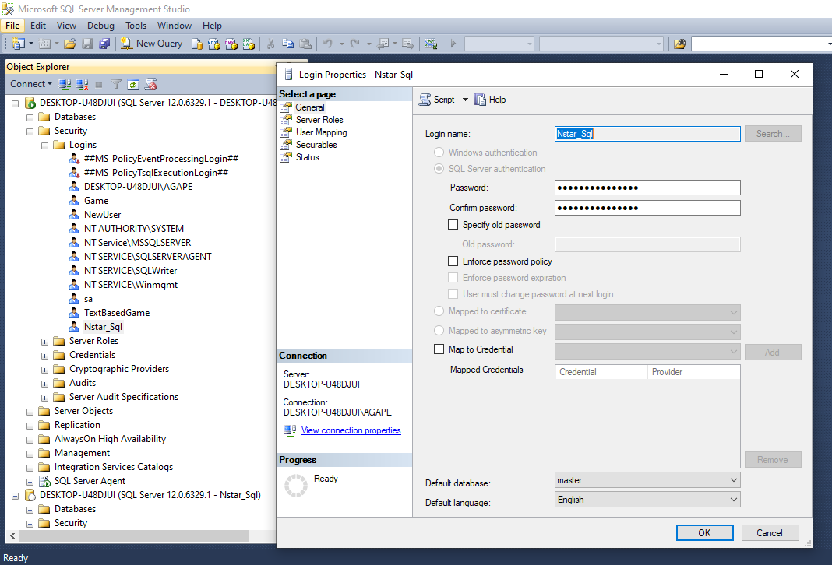

- To see a list of permissions, Right click on MyFirstDatabase select properties, and select permissions
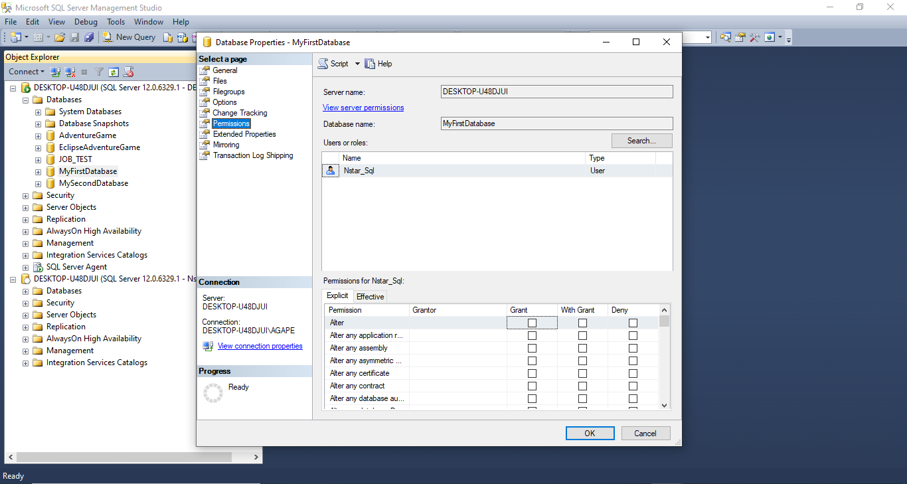
- After selecting desired permission click ok

