ОПИП

ПОИТ, 3к

**Протокол WebDAV**

1. **WebDAV**: Web Distributed Authoring and Versioning – расширение протокола HTTP/HTTPS, поддерживающее совместную работу по управление файлами на удаленных web-северах; применяется для создания сетевой файловой системы; в системах документооборота (document management system).
2. **WebDAV**: альтернатива FTP, SMB.
3. **WebDAV**: OS X (Apple) iDisk, Яндекс.Диск, Box.net, Google Drive, Amazon Microsoft IIS, Apache HTTP Server, Dropbox.
4. **WebDAV**: в Windows WebDAV API C++.
5. **WebDAV**: **унаследованные HTTP-методы**
6. **WebDAV**: **GET** – скачать файл.
7. **WebDAV**: **PUT** – загрузить файл на сервер.
8. **WebDAV**: **DELETE** – удалить серверный объект.
9. **WebDAV**: RFC 2291, RFC 4918, RFC 3648, RFC 3744, RFC 3253.

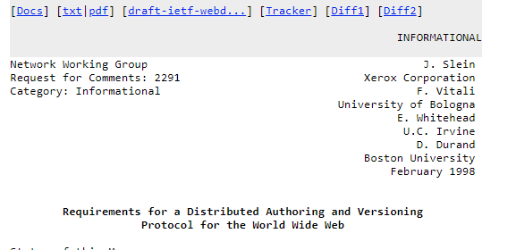

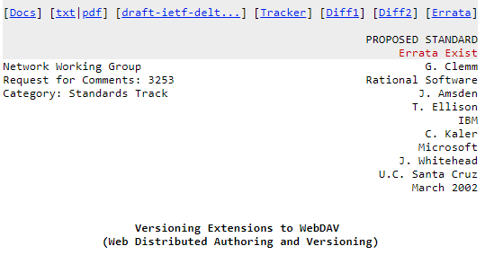

1. **WebDAV**: **RFC 3253**
2. **WebDAV RFC 3253**: **BASELINE-CONTROL**
3. **WebDAV RFC 3253: CHECKOUT**
4. **WebDAV RFC 3253: CHECKIN**
5. **WebDAV RFC 3253: LABEL**
6. **WebDAV RFC 3253: MERGE**
7. **WebDAV RFC 3253: MKACTIVITY**
8. **WebDAV RFC 3253: MKWORKSPACE**
9. **WebDAV RFC 3253: REPORT**
10. **WebDAV RFC 3253: UNCHECKOUT**
11. **WebDAV RFC 3253: UPDATE**
12. **WebDAV RFC 3253: VERSION-CONTROL**

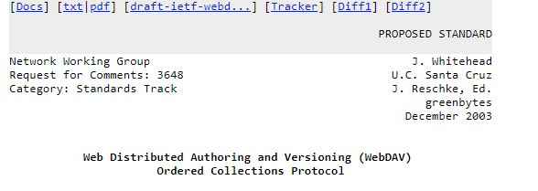

1. **WebDAV**: **RFC 3648**
2. **WebDAV** **RFC 3648: ORDERPATH**

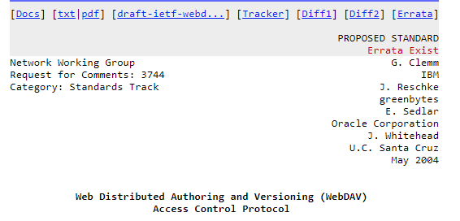

1. **WebDAV**: **RFC 3744**
2. **WebDAV** **RFC 3744: ACL**

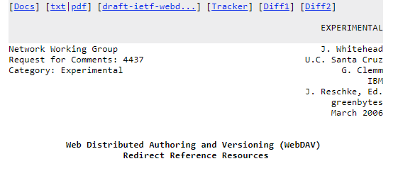

1. **WebDAV**: **RFC 4437**
2. **WebDAV** **RFC 4437: UPDATEREDIRECTREF**

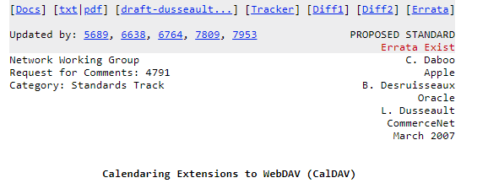

1. **WebDAV**: **RFC 4791**
2. **WebDAV** **RFC 4791: MKCALENDAR**

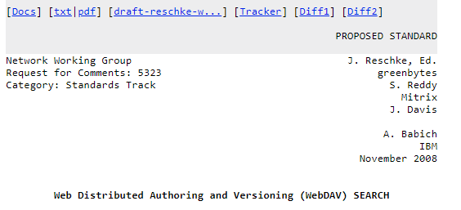

1. **WebDAV**: **RFC 5323**
2. **WebDAV** **RFC 5323: SEARH**

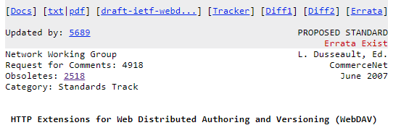

1. **WebDAV RFC 5618: PROPFIND** – получить свойства серверного объекта в XML-формате.
2. **WebDAV RFC 5618: PROPPATCH** – изменить свойства серверного объекта.
3. **WebDAV RFC 5618: MKCOL** – создать папку на сервере.
4. **WebDAV RFC 5618: COPY** – копировать на сервере.
5. **WebDAV RFC 5618: MOVE** – переместить на сервере.
6. **WebDAV RFC 5618: LOCK**  – заблокировать серверный объект.
7. **WebDAV RFC 5618: UNLOCK** – разблокировать серверный объект.

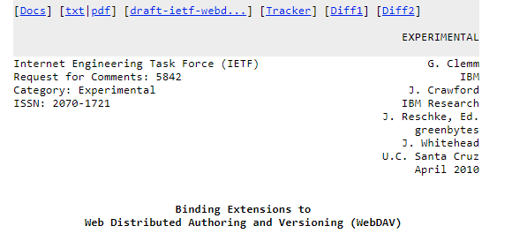

1. **WebDAV RFC 5842: BIND**.
2. **WebDAV RFC 5842: REBIND**.
3. **WebDAV RFC 5842: UNBIND**.
4. **WebDAV:** Яндекс.Диск

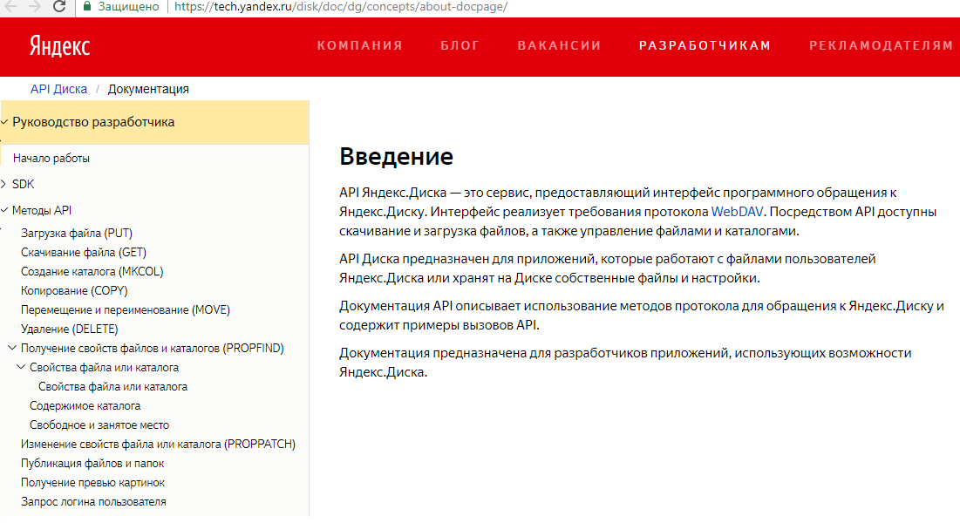

1. **WebDAV:** Яндекс.Диск, зарегистрироваться и получить имя и пароль
2. **WebDAV:** Яндекс.Диск - создать папку

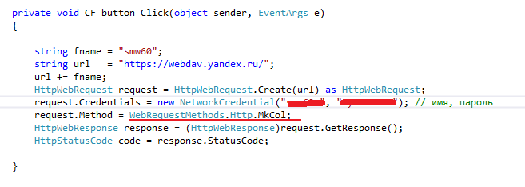

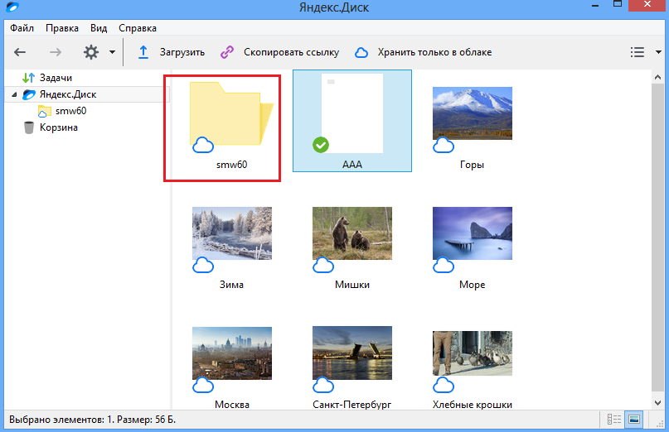

1. **WebDAV:** Яндекс.Диск - скачать файл

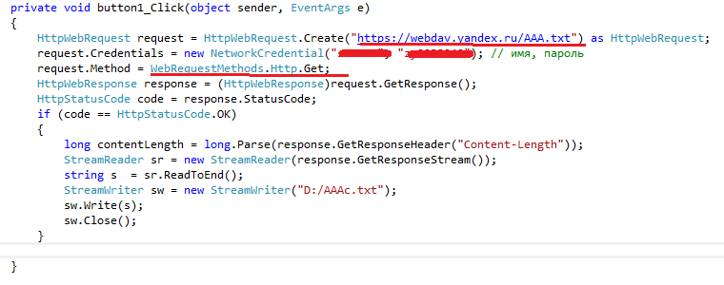

1. **WebDAV:** Яндекс.Диск - удалить файл

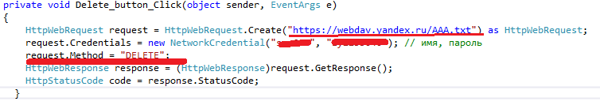

1. **WebDAV:** Яндекс.Диск - удалить папку

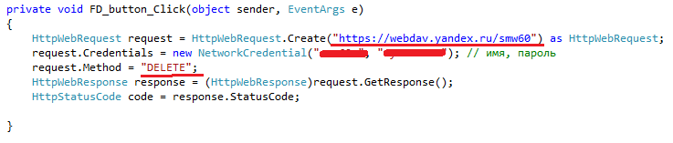

1. **Методы**
2. HTTP Request Methods
3. The following 39 HTTP Request Method values were found in [all available webconcepts.infospecifications](http://webconcepts.info/specs). Please be advised that the table shown here is maintained and compiled from [Web Concepts](http://webconcepts.info/) sources. The [official HTTP Request Method registry](http://www.iana.org/assignments/http-methods/http-methods.xhtml#methods) is maintained by the [*Internet Assigned Numbers Authority (IANA)*](http://www.iana.org/).

| **HTTP Request Method** | **Specification** |
| --- | --- |
| [ACL](http://webconcepts.info/concepts/http-method/ACL) | [**RFC 3744**: Web Distributed Authoring and Versioning (WebDAV) Access Control Protocol](http://webconcepts.info/specs/IETF/RFC/3744) |
| [BASELINE-CONTROL](http://webconcepts.info/concepts/http-method/BASELINE-CONTROL) | [**RFC 3253**: Versioning Extensions to WebDAV (Web Distributed Authoring and Versioning)](http://webconcepts.info/specs/IETF/RFC/3253) |
| [BIND](http://webconcepts.info/concepts/http-method/BIND) | [**RFC 5842**: Binding Extensions to Web Distributed Authoring and Versioning (WebDAV)](http://webconcepts.info/specs/IETF/RFC/5842) |
| [CHECKIN](http://webconcepts.info/concepts/http-method/CHECKIN) | [**RFC 3253**: Versioning Extensions to WebDAV (Web Distributed Authoring and Versioning)](http://webconcepts.info/specs/IETF/RFC/3253) |
| [CHECKOUT](http://webconcepts.info/concepts/http-method/CHECKOUT) | [**RFC 3253**: Versioning Extensions to WebDAV (Web Distributed Authoring and Versioning)](http://webconcepts.info/specs/IETF/RFC/3253) |
| [CONNECT](http://webconcepts.info/concepts/http-method/CONNECT) | [**RFC 7231**: Hypertext Transfer Protocol (HTTP/1.1): Semantics and Content](http://webconcepts.info/specs/IETF/RFC/7231) |
| [COPY](http://webconcepts.info/concepts/http-method/COPY) | [**RFC 4918**: HTTP Extensions for Web Distributed Authoring and Versioning (WebDAV)](http://webconcepts.info/specs/IETF/RFC/4918) |
| [DELETE](http://webconcepts.info/concepts/http-method/DELETE) | [**RFC 7231**: Hypertext Transfer Protocol (HTTP/1.1): Semantics and Content](http://webconcepts.info/specs/IETF/RFC/7231) |
| [GET](http://webconcepts.info/concepts/http-method/GET) | [**RFC 7231**: Hypertext Transfer Protocol (HTTP/1.1): Semantics and Content](http://webconcepts.info/specs/IETF/RFC/7231) |
| [HEAD](http://webconcepts.info/concepts/http-method/HEAD) | [**RFC 7231**: Hypertext Transfer Protocol (HTTP/1.1): Semantics and Content](http://webconcepts.info/specs/IETF/RFC/7231) |
| [LABEL](http://webconcepts.info/concepts/http-method/LABEL) | [**RFC 3253**: Versioning Extensions to WebDAV (Web Distributed Authoring and Versioning)](http://webconcepts.info/specs/IETF/RFC/3253) |
| [LINK](http://webconcepts.info/concepts/http-method/LINK) | [**Internet Draft snell-link-method**: HTTP Link and Unlink Methods](http://webconcepts.info/specs/IETF/I-D/snell-link-method) |
| [LOCK](http://webconcepts.info/concepts/http-method/LOCK) | [**RFC 4918**: HTTP Extensions for Web Distributed Authoring and Versioning (WebDAV)](http://webconcepts.info/specs/IETF/RFC/4918) |
| [MERGE](http://webconcepts.info/concepts/http-method/MERGE) | [**RFC 3253**: Versioning Extensions to WebDAV (Web Distributed Authoring and Versioning)](http://webconcepts.info/specs/IETF/RFC/3253) |
| [MKACTIVITY](http://webconcepts.info/concepts/http-method/MKACTIVITY) | [**RFC 3253**: Versioning Extensions to WebDAV (Web Distributed Authoring and Versioning)](http://webconcepts.info/specs/IETF/RFC/3253) |
| [MKCALENDAR](http://webconcepts.info/concepts/http-method/MKCALENDAR) | [**RFC 4791**: Calendaring Extensions to WebDAV (CalDAV)](http://webconcepts.info/specs/IETF/RFC/4791) |
| [MKCOL](http://webconcepts.info/concepts/http-method/MKCOL) | [**RFC 4918**: HTTP Extensions for Web Distributed Authoring and Versioning (WebDAV)](http://webconcepts.info/specs/IETF/RFC/4918) |
| [MKREDIRECTREF](http://webconcepts.info/concepts/http-method/MKREDIRECTREF) | [**RFC 4437**: Web Distributed Authoring and Versioning (WebDAV): Redirect Reference Resources](http://webconcepts.info/specs/IETF/RFC/4437) |
| [MKWORKSPACE](http://webconcepts.info/concepts/http-method/MKWORKSPACE) | [**RFC 3253**: Versioning Extensions to WebDAV (Web Distributed Authoring and Versioning)](http://webconcepts.info/specs/IETF/RFC/3253) |
| [MOVE](http://webconcepts.info/concepts/http-method/MOVE) | [**RFC 4918**: HTTP Extensions for Web Distributed Authoring and Versioning (WebDAV)](http://webconcepts.info/specs/IETF/RFC/4918) |
| [OPTIONS](http://webconcepts.info/concepts/http-method/OPTIONS) | [**RFC 7231**: Hypertext Transfer Protocol (HTTP/1.1): Semantics and Content](http://webconcepts.info/specs/IETF/RFC/7231) |
| [ORDERPATCH](http://webconcepts.info/concepts/http-method/ORDERPATCH) | [**RFC 3648**: Web Distributed Authoring and Versioning (WebDAV) Ordered Collections Protocol](http://webconcepts.info/specs/IETF/RFC/3648) |
| [PATCH](http://webconcepts.info/concepts/http-method/PATCH) | [**RFC 5789**: PATCH Method for HTTP](http://webconcepts.info/specs/IETF/RFC/5789) |
| [POST](http://webconcepts.info/concepts/http-method/POST) | [**RFC 7231**: Hypertext Transfer Protocol (HTTP/1.1): Semantics and Content](http://webconcepts.info/specs/IETF/RFC/7231) |
| [PRI](http://webconcepts.info/concepts/http-method/PRI) | [**RFC 7540**: Hypertext Transfer Protocol Version 2](http://webconcepts.info/specs/IETF/RFC/7540) |
| [PROPFIND](http://webconcepts.info/concepts/http-method/PROPFIND) | [**RFC 4918**: HTTP Extensions for Web Distributed Authoring and Versioning (WebDAV)](http://webconcepts.info/specs/IETF/RFC/4918) |
| [PROPPATCH](http://webconcepts.info/concepts/http-method/PROPPATCH) | [**RFC 4918**: HTTP Extensions for Web Distributed Authoring and Versioning (WebDAV)](http://webconcepts.info/specs/IETF/RFC/4918) |
| [PUT](http://webconcepts.info/concepts/http-method/PUT) | [**RFC 7231**: Hypertext Transfer Protocol (HTTP/1.1): Semantics and Content](http://webconcepts.info/specs/IETF/RFC/7231) |
| [REBIND](http://webconcepts.info/concepts/http-method/REBIND) | [**RFC 5842**: Binding Extensions to Web Distributed Authoring and Versioning (WebDAV)](http://webconcepts.info/specs/IETF/RFC/5842) |
| [REPORT](http://webconcepts.info/concepts/http-method/REPORT) | [**RFC 3253**: Versioning Extensions to WebDAV (Web Distributed Authoring and Versioning)](http://webconcepts.info/specs/IETF/RFC/3253) |
| [SEARCH](http://webconcepts.info/concepts/http-method/SEARCH) | [**RFC 5323**: Web Distributed Authoring and Versioning (WebDAV) SEARCH](http://webconcepts.info/specs/IETF/RFC/5323) |
| [TRACE](http://webconcepts.info/concepts/http-method/TRACE) | [**RFC 7231**: Hypertext Transfer Protocol (HTTP/1.1): Semantics and Content](http://webconcepts.info/specs/IETF/RFC/7231) |
| [UNBIND](http://webconcepts.info/concepts/http-method/UNBIND) | [**RFC 5842**: Binding Extensions to Web Distributed Authoring and Versioning (WebDAV)](http://webconcepts.info/specs/IETF/RFC/5842) |
| [UNCHECKOUT](http://webconcepts.info/concepts/http-method/UNCHECKOUT) | [**RFC 3253**: Versioning Extensions to WebDAV (Web Distributed Authoring and Versioning)](http://webconcepts.info/specs/IETF/RFC/3253) |
| [UNLINK](http://webconcepts.info/concepts/http-method/UNLINK) | [**Internet Draft snell-link-method**: HTTP Link and Unlink Methods](http://webconcepts.info/specs/IETF/I-D/snell-link-method) |
| [UNLOCK](http://webconcepts.info/concepts/http-method/UNLOCK) | [**RFC 4918**: HTTP Extensions for Web Distributed Authoring and Versioning (WebDAV)](http://webconcepts.info/specs/IETF/RFC/4918) |
| [UPDATE](http://webconcepts.info/concepts/http-method/UPDATE) | [**RFC 3253**: Versioning Extensions to WebDAV (Web Distributed Authoring and Versioning)](http://webconcepts.info/specs/IETF/RFC/3253) |
| [UPDATEREDIRECTREF](http://webconcepts.info/concepts/http-method/UPDATEREDIRECTREF) | [**RFC 4437**: Web Distributed Authoring and Versioning (WebDAV): Redirect Reference Resources](http://webconcepts.info/specs/IETF/RFC/4437) |
| [VERSION-CONTROL](http://webconcepts.info/concepts/http-method/VERSION-CONTROL) | [**RFC 3253**: Versioning Extensions to WebDAV (Web Distributed Authoring and Versioning)](http://webconcepts.info/specs/IETF/RFC/3253) |

1. **тт**
2. **тт**
3. **тт**
4. **тт**