LoB Kwazy Kwistmas Kwiz 2016
Puzzle sheet

Team # | Team name | Round #

- Complete this sequence: D D P V C C D?
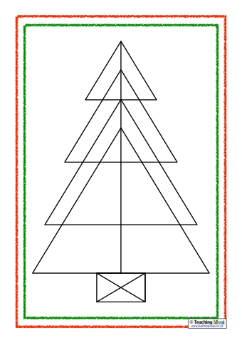
- How many triangles can you find in this Christmas tree?
- There are 50 American states. Four begin with the letter ‘W’. What are they?
- Using the numbers 2, 6, 7, 9, 10 and 25, and only addition, subtraction, division and multiplication, make the number 578.
- Archimedes was playing with his boat in the bath. His boat sank. Did the water level in the bath go up, did it go down, or did it stay the same?

- Make one cut and one cut only to divide this figure into two symmetrical parts:
- Name the five busiest airports in Europe (based on the total number of passengers each year). We’ll accept the airport name or the city.
- Which 4-letter word could not be spoken in Biblical times? Hints: It does not begin with an F. It can be spelt several ways. It is still forbidden in some communities today.
- What is the next term in this sequence: Thousand, Million, Trillion, ...?
- In your bedroom, you have a drawer with 2 red, 4 yellow, 6 purple, 8 brown, 10 white, 12 green, 14 black, 16 blue, 18 grey, and 20 orange socks. It is dark (because the electricity has been turned off, because you backed too many Kickstarters this month), so you cannot distinguish between the colors of the socks. How many socks do you need to take out of the drawer to be sure that you have at least three pairs of socks of the same color?

