LoB Kwazy Kwistmas Kwiz 2018

Round 1: Askew flags
Below are the flags of current nations. However, the flags have been rotated and resized to squares. Identify those nations. Note: the flags have not been flipped or inverted, only rotated. They have not been rotated 360 degrees.
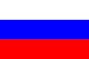 | 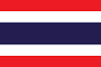 | 3.  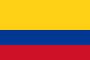
4.   | 5.  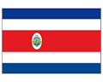 | 6.  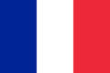
7.   | 8.  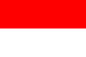 | 9.  