LoB Kwazy Kwistmas Kwiz 2019
Questions & answers

All correct answers score 1 point unless otherwise stated.

Round 1 (slow)
It’s a crossword!
Clarifications
- 14 across: “most abundant substance found in plants”
- 4 down: “a 1000 of these”
Score:
There are 30 clues/words. 1 point for each, but we’ll start counting from 15.
- A quick verbal reply: retort
- 2nd largest city in Poland: lodz
- Latin for "thus": sic
- The Queen of the Swans in "Swan Lake": odette
- The science that studies fish: ichthyology
- The 3 colors of the vertical stripes on Mexico's flag: greenredwhite
- In the Bible, the third son born to Adam & Eve: seth
- 1980s Norwegian pop group: aha
- Fruit related to plantains: banana
- 'yes' but in another european language: sim
- Wood for sheep?: catan
- A cure all: panacea
- LoB venue (2 words): madhatter
- Won the first Eurovision Song Contest in 1956: switzerland
- Fruit is used to make Slivovitz: plums
- Fluid that lubricates cartilage in joints: synovial
- Flower traditionally used to treat insomnia: valerian
- Most abundant substance found in the plant: cellulose
- Orange street in Monopoly: vine
- JAT airways is the national carrier of this country: serbia
- Standard atmospheric pressure at sea level is about 1000: millibar
- No, you're the traitor: resistance
- German newspaper: stern
- Agate with bands of white & brown, black or red: onyx
- Grassland named from the Dutch for "field": veld
- An optional course: elective
- Office or role in Christian churches: deacon
- UK Prime Minister after Churchill: eden
- In chemistry, the process in which colloids come out of suspension as floc or flakes: flocculation
- Forbidden, unmentionable, from Tongan: taboo

Round 2 (fast): General knowledge
- In films, which character has the surname Rockatansky?
Mad Max
- From 1903 to 1958, every Pope except for one took which name?
Pius.
- What is the only anagram of the word 'English’?
Shingle
- What is the chemical symbol for tin?
Sn
- The national flag of which European country is composed of nine blue and white horizontal stripes, and a white cross on a blue field?
Greece
- Which hospital is the the oldest in Britain? Above its entrance is the only public statue of King Henry VIII in London.
St Bartholomew's Hospital, commonly known as Barts.
- The most northern Mcdonalds restaurant in the world is in which country?
Finland
- Christmas is celebrated on the 25th of December. Who is the patron saint remembered on the 26th of December?
Stephen
- In which fictional land was it always winter but never Christmas?
Narnia, from The Lion, the Witch and the Wardrobe`
- Roman numeral symbol for 500
D

Round 3 (slow): Anagrams
Here’s a list of anagrams. Solve them!
- SACRA NONCE: Carcasonne
- GLOSSY FADS IF EXTERMINATED: Xia Legends of a Drift System
- FIGHT HORNIER: High Frontier
- A SYNDICATING HARM AT US: Cards Against Humanity
- HAVE MONGOL: Gloomhaven
- FATHOMING A DEACON: Food Chain Magnate
- NO LAVA: Avalon
- IRE LET SLIPSTREAM: Imperial Settlers
- BE BOUT US: Subbuteo
- TIN PLAIDS SIR: Spirit Island
- CYCLING A PEE DAM: Pandemic Legacy
- AHA EXCRETORY FLAG: Race For The Galaxy
- CARTILAGE AT TACT LABS: Battlestar Galactica

Round 4 (fast): Off by one
In this round, we will be giving points for slightly incorrect answers. Correct answers will score zero. Answers that are just next to or adjacent to the correct answers will score a point. For example , if I asked how many years LoB had been running and the answer was (technically) 12 years, you would be marked correct if you wrote 11 or 13 years. If I asked you what building we were in, You were score if you named the building next to it.
- A perfect game in bowling is what score?
300 (score 299 and 301)
- How many limbs does a lobster have, including claws?
10 (score 9 and 11). Curiously, most drawings show them with 8: 6 legs and 2 claws
- What the most common letter in the English language?
E (score D & F, and T for being the second most common)
- In which decade of the 20th century was London’s population at a minimum?
The 1900s (Score 1890s and 1910s)
- Which London tube station is the busiest?
King's Cross St. Pancras (Score Caledonian Rd, Angel, Farringdon, Highbury & Islington, Russell Square, Euston, Euston Square or St Pancras and Waterloo for the second busiest)
- The airline Aerolíneas originates from and in based in which country?
Argentina (score Bolivia, Brazil, Chile, Paraguay, and Uruguay)
- In units hundreds of miles, what’s the distance between London and Paris?
292 miles, hence 300. (Score 200 and 400)
- What musical instrument is the largest in the violin family?
The instruments are, in order or size, violin, viola, cello, and double bass. Hence ‘cello; will be scored.
- WHat’s the address of the White House?
1600 Pennsylvania Avenue, so we’ll accept 1599 or 1601.
- How many years has LoB been running?
13 (score 12 and 14)

Round 5 (slow): Logos
Draw the logos or symbols associated with the following companies or organisations or entities, indicating the colors were necessary.
- Chrome web browser
- FedEx
- Instagram
- StarbucksPepsi
- Pepsi
- Mastercard
- GE
- NASA
- Virgin Media
- Levis
Score:
- 1 point for essentially correct (recognisable, right shape, most of the colors correct)
- .5 point: for vaguely correct (recognisable if you know what it is)

Jumper contest!

Round 6 (fast): Set collection
In this round, I’ll be asking for sets or lists of things. You can give up to 5.
Score:
- A set of three: ½ point
- A set of four: 1 point
- A set of five or more: 1 ½ points
- Name the English beginning with the letter D?
Derbyshire, Devon, Dorset, Durham
- What the colours of the balls used in a game of snooker, excluding white and black and red.
Yellow, green, brown, blue, pink
- As of yesterday (at 11:30pm) the 5 top ranked games on boardgamegeek were Gloomhaven, Pandemic Legacy Season 1, Terraforming Mars, Through the Ages and Brass Birmingham. What were numbers 6 to 10?
Twilight Struggle, Twilight Imperium, Stars Wars Rebellion, Gaia Project and Scythe.
- What are the prime numbers that are greater than 50 and less than 100?53,59,61,67,71,73,79,83,89,97
- What are the most populous countries in the world?
China, India, USA, Indonesia, Brazil.
- In East Asian or Chinese tradition, the 5 elements are?
Water, fire, earth, wood, and meta. No wind.
- There are seven Canary Islands. Asides from Gran Canaria, the others are?
Fuerteventura, Tenerife, Lanzarote, La Palma, La Gomera, El Hierro
- What are the most common languages spoken in London?
Sources conflict so I’ve been generous: English, Polish, Gujerati , Bengali, , French, Punjabi, Urdu.
- What are the top grossing films in the UK for 2019?
Again, sources conflict, so I’ve been generous: Avengers Endgame, The Lion King, Frozen II, Spiderman: Far From Home, Toy Story 4, Captain Marvel, Aladdin, Joker.
- Largest weapons manufacturers in the world?
Again, conflict, etc: Lockheed Martin, Boeing, Northrop Grumman, Raytheon, General Dynamics, BAE systems, Airbus
- What the guards regiments in the British Army?
Coldstream, Welsh, Irish, Scots and Grenadier

Round 7 (slow): Kickstopper
(If we need to skip a round, this is it)
They say everyone has a game inside. In this round we’ll give you the chnace to prove. We’ll give you a handful of cards with word on them. You then have 5 minutes to create a pitch for a game, using those words.
The pitch must be a game title and a description that you can deliver in less than a minute
You can trade or swap cards with other teams.
Judging will be by popular acclaim and earn you 1 to 5 points. Before your pitch, you will say what words you had.

Round 8 (fast): Speed Round

- Brisbane is the largest city in which Australian state?
Queensland
- Used to relieve itchiness, what colour is calamine lotion?
Pink
- What day of the week is the American holiday of Thanksgiving celebrated?
Thursday (always the 4th Thursday in November)
- Canary Wharf is located in which London borough?
Tower Hamlets
- Which country do swallows migrate to when they leave Britain for the winter?
South Africa (and Namibia)
- Umberto II was the last King of which country?
Italy
- How many continents does the equator cross?
Three (Asia, Africa, and South America)
- What is the first belt used in the standard belt colour system for karate?
White
- Which country is the third most populated in the world?
USA
- Which two letters represent the postal code area of Edinburgh?
EH

Handouts

Cards for Kickstopper

deck-builder | tumescent | LoBsters | many paths to victory
euro-game | ferrets | Jacob | strategic depth
asymmetrical | Brexit | LoBsterCon | combo
worker placement | casual racism | Agricola competition | family game
drafting | homicide | Essen | gateway game
miniatures | trading grain | co-op | gimmicky
kickstarter | gloomy medieval dude | auction | rich theme
collectible | awkward | balls | solo
hidden information | historical | deduction | traitor mechanic
Cthulhu | replayability | civilization | booty
stretch goals | social | upchuck | shenanigans
Prince Andrew | micro-game | illegal sex act | turgid
trick taking | elves | drawing | raw sewage
legacy game | expansion | cards | bamboozle
duck | Franco-Prussian war of 1857 | AI | roleplaying

Solution: Logos
  1. Google Chrome browser | 2. FedEx courier delivery  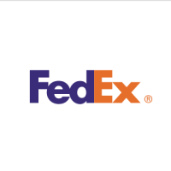 |     3. Instagram
4. Starbucks  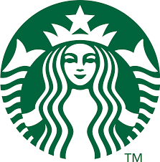 | 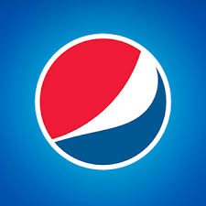  5. Pepsi | 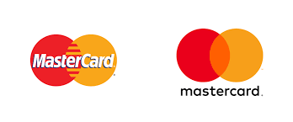  6. Mastercard
  7. GE |   8. NASA
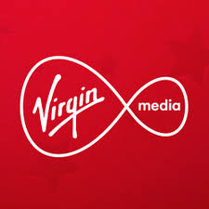  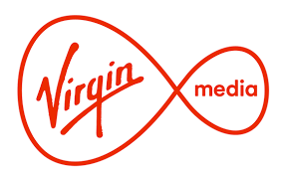  9. Virgin Media | 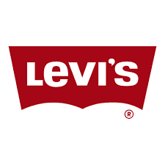  10. Levis

1. SACRA NONCE: Carcasonne
2. GLOSSY FADS IF EXTERMINATED: Xia Legends of a Drift System
3. FIGHT HORNIER: High Frontier
4. A SYNDICATING HARM AT US: Cards Against Humanity
5. HAVE MONGOL: Gloomhaven
6. FATHOMING A DEACON: Food Chain Magnate
7. NO LAVA: Avalon
8. IRE LET SLIPSTREAM: Imperial Settlers
9. BE BOUT US: Subbuteo
10. TIN PLAIDS SIR: Spirit Island
11. CYCLING A PEE DAM: Pandemic Legacy
12. AHA EXCRETORY FLAG: Race For The Galaxy
13. CARTILAGE AT TACT LABS: Battlestar Galactica

