LoB Kwazy Kwistmas Kwiz 2019
Round 3: Logos
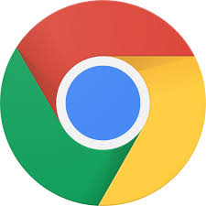  1. Google Chrome browser | 2. FedEx courier delivery  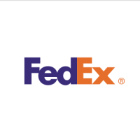 | 3. Instagram
4. Starbucks | 5. Pepsi | 6. Mastercard
7. GE | 8. NASA
9. Virgin Media | 10. Costa Coffee / Levis / Snapchat / Cisco / DELL

