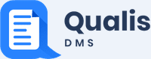
DMS - USER MANUAL
Version 8.0.6


CONTENTS
1 Preface 9
1.1 Audience 9
1.2 Conventions 9
1.2.1 Commands 9
1.2.2 Keyboard 9
1.2.3 Notes 10
1.2.4 Warning 10
1.2.5 Callout 10
1.2.6 Description 10
1.2.7 Hyperlink 10
2 Qualis DMS Core Capabilities 11
2.1 Centralized Document Access 11
2.2 Version Control 11
2.3 Audit Trail 12
2.4 Attribute & Property Linking 13
2.5 Quick Releasing & Printing 13
3 Getting Started 14
3.1 Login to Qualis DMS 14
3.2 The User Interface 15
3.2.1 The Explorer 16
4 Masters 18
4.1 Overview 18
4.2 Contacts 19
4.2.1 Country Master 19
4.3 Configuration 21
4.3.1 FTP Config 21
4.3.2 Password Policy 25
4.3.3 Password Policy Master 25
4.3.4 E-sign Control 29
4.4 User Management 30
4.4.1 Designation 30
4.4.2 User Role 32
4.4.3 Users 33
4.4.4 Mapping User Account to Role(s) 35
4.4.5 Screen Rights 40
4.4.6 Control Rights 42
4.4.7 Audit Trail Log 43
4.5 Organisation 45
4.5.1 Setting up Organisational Hierarchy 45
4.5.2 Site Master 45
4.5.3 Department Master 47
4.5.4 Lab Master 49
4.5.5 Section Master 51
4.5.6 Organisation Master 53
4.6 Mail 55
4.6.1 Mail Host 55
4.6.2 Mail Template 56
4.6.3 Mail Config 58
4.6.4 Mail Alert Transaction 61
4.6.5 Mail Status 62
4.7 Document Management 64
4.7.1 Workflows 64
4.7.2 Document Category 71
4.7.3 Tag Master 73
4.8 Document Initiation 76
4.8.1 Add Document 76
4.8.2 Add Version 78
4.8.3 Add or Remove Users to the Review Workflow 79
4.8.4 Add Attachments 79
4.8.5 Add Comments 83
4.8.6 Tag Setting 83
4.8.7 Initiate Document 85
4.9 Document Review 87
4.9.1 Review Attached Document 87
4.9.2 Add Review Comments 88
4.9.3 Complete Review 89
4.1 Approving Documents 91
4.1.1 Effective Date 92
4.1.2 Releasing the Document 94
4.1.3 Viewing Initiation History 95
4.1.4 Viewing Transaction History 95
4.2 Document Category View Rights 96
4.2.1 Section Based Document Rights 96
4.2.2 User Based Document Rights 97
4.3 Document Request 99
4.1 Document Response 101
4.2 Printing the Document 103
4.2.1 Test Print 105
4.3 Document Repository View 106
4.4 Document Search 107
5 Dash Board 109
5.1 Dashboard Rights 109
5.2 Alert Rights 110
TABLE OF FIGURES
FIGURE: - Qualis DMS – Log in Screen 14
FIGURE: - User Interface Components 15
FIGURE: - Opening an item from the Explorer 16
FIGURE: - Hiding Explorer Pane 17
FIGURE: - Country Master Screen 19
FIGURE: - Add Country Dialog 20
FIGURE: - Edit Country Dialog 20
FIGURE: - FTP Config Master Screen 21
FIGURE: - Add FTP Config Dialog 22
FIGURE: - Edit FTP Config Dialog 23
FIGURE: - Set Default Option 23
FIGURE: - Confirmation Dialog 24
FIGURE: - Alert Dialog 24
FIGURE: - Password Policy Master Screen 26
FIGURE: - Add Password Policy Dialog 26
FIGURE: - Edit Password Policy Dialog 27
FIGURE: - Copy Password Policy Dialog 28
FIGURE: - Esign Control Screen 29
FIGURE: - Designation Master Screen 30
FIGURE: - Add Designation Dialog 31
FIGURE: - Edit Designation Dialog 31
FIGURE: - User Role Tab 32
FIGURE: - Add User Role Dialog 32
FIGURE: - Edit User Role Dialog 33
FIGURE: - Users Tab 34
FIGURE: - Add User Screen 35
FIGURE: - Adding User Role Screen 36
FIGURE: - Add User Role Dialog 36
FIGURE: - Edit User Role Dialog 37
FIGURE: - Password Reset - Confirmation Dialog 37
FIGURE: Enter New Password To Login Dialog 38
FIGURE: - Adding Deputy User Screen 39
FIGURE: - Add Deputy User Dialog 39
FIGURE: Approve Deputy User - Confirmation Dialog 40
FIGURE: - Screen Rights Screen 41
FIGURE: - Add and Remove Screen Dialog 42
FIGURE: - Control Rights Screen 42
FIGURE: - Control Name Dialog 43
FIGURE: - Audit Trail Log Screen 44
FIGURE: - Site Master Screen 46
FIGURE: - Add Site Dialog 46
FIGURE: - Edit Site Dialog 47
FIGURE: - Department Master Screen 48
FIGURE: - Add Department Dialog 48
FIGURE: - Edit Department Dialog 49
FIGURE: - Lab Master Screen 50
FIGURE: - Add Lab Dialog 50
FIGURE: - Edit Lab Dialog 51
FIGURE: - Section Master Screen 52
FIGURE: - Add Section Dialog 52
FIGURE: - Edit Section Dialog 53
FIGURE: - Organisation Master Screen 54
FIGURE: - Organisation Structure 54
FIGURE: - Mail Host Screen 55
FIGURE: - Add Mail Host Screen 56
FIGURE: - Email Template Screen 57
FIGURE: - Add Mail Template Screen 57
FIGURE: - Email Config Screen 59
FIGURE: - Add Email Config Screen 60
FIGURE: - Mail Alert Transaction Screen 62
FIGURE: - Email Status Screen 62
FIGURE: - Document Workflow Screen 64
FIGURE: - Add Workflow Dialog 65
FIGURE: - Review Workflow - Add and Remove Role Level Dialog 66
FIGURE: - Review Workflow - Add and Remove Users Dialog 67
FIGURE: - Role and Users Added to the Review Workflow 68
FIGURE: - Approval work flow - Add and Remove Role Level Dialog 69
FIGURE: - Adding Step Code 69
FIGURE: - Approval workflow - Add and Remove Users Dialog 70
FIGURE: - Role and Users Added to the Approval Workflow 71
FIGURE: - Document Category Screen 72
FIGURE: - Add Document Category Dialog 72
FIGURE: - Tag Master Screen 74
FIGURE: - Tag Master Dialog 74
FIGURE: - Document Initiation Screen 76
FIGURE: - Add Document Screen 77
FIGURE: - Document Added 78
FIGURE: - Adding a Document Version 79
FIGURE: - Document Version Added 79
FIGURE: - Adding Attachments 80
FIGURE: - File Attachment Dialog 80
FIGURE: - File Attached 81
FIGURE: File Editor 81
FIGURE: Uploading Training Attachment 82
FIGURE: Downloading Training Attachment 82
FIGURE: - Add Comments Dialog 83
FIGURE: - Add / Remove Tags Dialog 84
FIGURE: - Tag Setting Tab Showing Tags Added 85
FIGURE: - Initiate Document 86
FIGURE: - Document Review Screen 87
FIGURE: Adding Review Comments 88
FIGURE: Comments Dialog 88
FIGURE: - Complete Reviewing the Document 89
FIGURE: - Reviewed Document 89
FIGURE: - Address Review Comments and Complete 90
FIGURE: - Document Completed Status after Review 90
FIGURE: - Document Approval Screen 91
FIGURE: - Document Approval Screen Showing Approved Status 92
FIGURE: - Setting Effective Date 92
FIGURE: - Choose Effective Date Dialog 93
FIGURE: - Document Initiation Screen Showing Effective Date 93
FIGURE: - Releasing the Document 94
FIGURE: - Released Document 94
FIGURE: - Initiation History Tab 95
FIGURE: - Transaction History Tab 95
FIGURE: - Document Category View Rights Screen 96
FIGURE: - Add and Remove Document Category Dialog 97
FIGURE: - Add and Remove Document Category Dialog 98
FIGURE: - Document Request Screen 99
FIGURE: - Request Transaction Dialog 100
FIGURE: - Document Request Screen – Request Added 100
FIGURE: - Document Response Screen 101
FIGURE: - Tag Values Dialog 102
FIGURE: - Document Response 102
FIGURE: - Request Transaction Dialog 103
FIGURE: - Printing Document 1 104
FIGURE: - Printing Document 2 104
FIGURE: - Alert Dialog 105
FIGURE: - Document Repository View 106
FIGURE: - Document Search 107
FIGURE: - Dashboard Rights Screen 109
FIGURE: - Add / Remove Dashboard 110
FIGURE: - Alert Rights Screen 111
FIGURE: - Add / Remove Dashboard 112

Preface
This guide provides instructions about configuring and using Qualis DMS.
This preface contains these topics:
- Audience
- Conventions

Audience
Qualis DMS user manual is intended for administrators or anyone using Qualis DMS.

Conventions
The following text conventions are used in this document:

Commands
When a command is referred to in the manual, the following distinctions have been made:
When menu commands are referred to, the manual will refer you to the menu bar – E.g. “Choose File from the menu bar and then Print”.
When dialog field options and menus are referred to, the following style has been used for the text – “In the Page Range section of the Print dialog, click the Current Page option” and then clicks Ok.

Keyboard
Keys are referred to throughout the manual in the following way:
[ENTER] – denotes the return or enter key, [DELETE] – denotes the Delete key and so on.
Where a command requires two keys to be pressed, the manual displays this as follows:
[CTRL][P] – this means press the letter “p” while holding down the Control key.

Notes
Within each section, any items that need further explanation or extra attention devoted to them are denoted by shading. For example:
Note: “Qualis DMS will not let you close a screen or window that you haven’t already saved changes to without prompting you to save.”

Warning
Within each section, any items that need warning or extra attention devoted to them are denoted by shading in yellow. For example:
Warning! : If you click Close before saving will close the FTP Configuration screen without saving the configuration.

Callout
Callouts are used to denote an action or describe something in the interface.
Click here

Description
This style denotes the sequence that follows an action. In general, a screen shot appears under the style that denotes the result of an action. For Example: The Add User screen appears as shown in the figure.

Hyperlink
Clicking on hyperlinks will help the user to go to the topic directly in the same document.
Example: Click here to see how to setup Password Policy.

Qualis DMS Core Capabilities
Qualis DMS’s rich and scalable features are the foundation for a successful clinical/lab document management system:
- Centralized Document Access
- Version Control
- Audit Trail
- Attribute & Property Linking
- Quick Publishing & Printing

Centralized Document Access
Managing and sharing documents in a workgroup, between departments or across remote sites using folders in Windows Explorer is difficult and prone to error. The process of creating, editing, sharing and storing documents is left to each individual user and the results are chaos, wasted time, costly errors and lost productivity.
Qualis DMS serves as your single source for document access and control, enabling users to find documents located anywhere while ensuring version control, an automated approval process and an audit trail for each document throughout its lifecycle. QUALIS DMS makes it easy to control access to your documents, while enabling organized, efficient document sharing and collaboration across your local or global enterprise.

Version Control
Manual methods of document version control are difficult and prone to error, and mistakes are costly. In companies without document control, it is common to find multiple versions of a document across the organisation. You may have a copy of a document on the network, a copy on a user’s hard drive and paper copies as well, making it virtually impossible to determine which the correct version is. If an incorrect version makes it to a client, contractor or the manufacturing floor, it can end up as an expensive and unfortunate mistake.
Qualis DMS serves as your central point for document access and automatically ensures users always access the latest version. Qualis DMS also saves previous versions and maintains the historical metadata so you can access a snapshot in time as well as the complete document history. Qualis DMS maintains an audit trail for each document throughout its lifecycle.
- Ensure all users always have access to the latest version of every document
- Automatically save as many previous versions of your files and associated metadata as you choose
- Ensure an audit trail for each document is maintained throughout its lifecycle

Audit Trail
Maintaining a complete audit trail for each document throughout its lifecycle is important not only for internal analysis and process optimization, but also for compliance with industry standards and regulations. Qualis DMS electronic Audit Trail provides your company a simple method to understand the complete history of each document. Authorized users can see the ongoing activity history of a file, including what action was taken, by whom, and the date and time the action occurred.
Complying with industry standards is important, time-consuming and expensive. Leveraging Qualis DMS’s electronic information tracking capabilities dramatically reduces the time and effort it takes to gain and maintain certification, and dramatically increases your organisation’s chances of successfully passing audits.
- Maintain a complete record of every action that takes place to a file throughout its lifecycle
- Streamline compliance with industry quality standards and regulations
- Protect your organisation in legal situations with a proven record of the actions executed on a given document
- Filter the audit trail display to search for specific activities to a document
- Limit the commands the Audit Trail stores, if desired
- Export the audit trail for archival or reporting purposes

Attribute & Property Linking
Qualis DMS has a bi-directional link to attributes or properties contained within your documents. This link ensures that important information already contained within your documents is populated into the DMS database, and that as changes are made to those documents, the database is automatically updated.

Quick Releasing & Printing
Qualis DMS enables quick release and printing documents to hard copy. In addition Qualis DMS enables:
- Print or publish any selection of documents on-demand
- Publish to Qualis DMS Library or to a network folder or ftp site
- Ensure your output is generated from the correct file version
- Provides an Audit Trail for Releasing/Printing activities
- Set permissions determine who has rights to output which file
- Set option to request /grant permissions to print and reprint

Getting Started

Login to Qualis DMS
To login to Qualis DMS, follow these steps:
- Open Browser, in the address bar, type “http://20.117.165.172:8090/DMSWeb/” and then press ENTER. Qualis DMS login screen appears as shown in the figure:
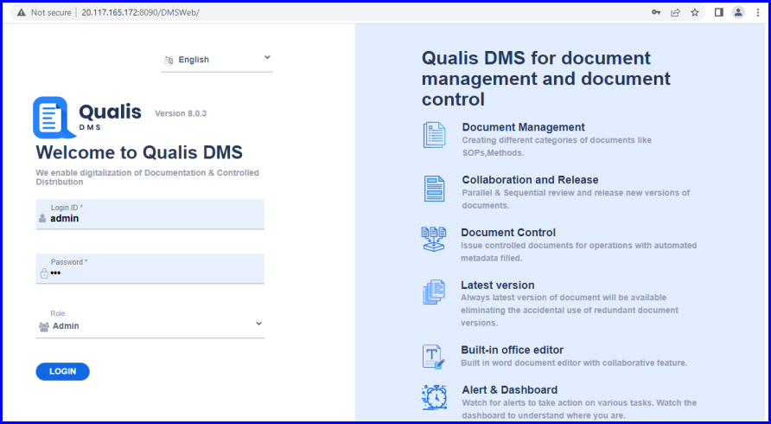
FIGURE: - Qualis DMS – Log in Screen
- In the Login ID field, type the login id received from your administrator.
- In the Password field, type valid password.
- In the Role, select your role.
- Click LOGIN.
On successful login, Qualis DMS Dashboard appears.

The User Interface
The figure below highlights the main components of the Qualis DMS user interface.
(1) The Explorer pane, used for accessing commonly-used items such as menus and options. You will access menus from here.
(2) The Workspace area, which displays tabbed pages opened from the Explorer.
(3) Action menu that contains Add, Edit, Delete common options that are available for most of the masters, transactions and settings.
(4) Filter/Search tool that most of the tabbed pages contain, which you can use to filter, sort and refine the information displayed.
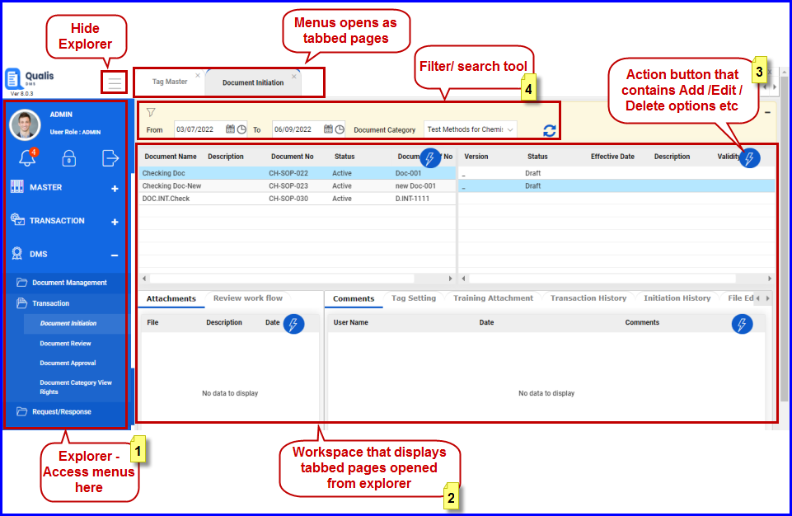
FIGURE: - User Interface Components

The Explorer
At the left of the user interface, the Explorer provides quick and easy access to commonly used tools.

To open an item from the Explorer:
- Click the item. The relevant information is displayed on a tabbed page in the Workspace as shown in the figure:
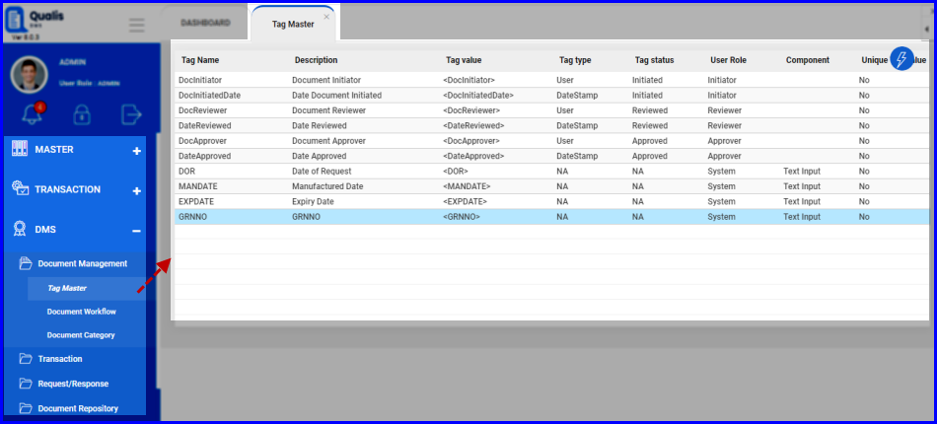
FIGURE: - Opening an item from the Explorer

The Workspace
The Workspace is the center of activity in Qualis DMS. Here, you can work with masters, manage documents and search for and display information. Items displayed in the Workspace open on tabbed pages.
When you first open Qualis DMS, the Home tabbed page is displayed.
- To open an item in the Workspace, click an item in the Explorer.

To hide the Explorer:
- Click that appears on the top of the Explorer.
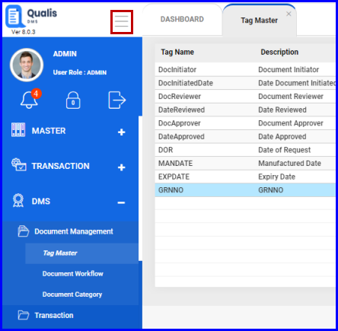
FIGURE: - Hiding Explorer Pane

Masters

Overview
Masters in Qualis DMS are used to store and maintain data outside a process and refer it in process using "Master" field type in the form. For example when you store a sample, you may want to look up the storage data such as organisation, department, lab, site, section etc. In this example storage location data can be created and managed as a master. Also user data can be created and managed as a master.
In Qualis DMS you can add/create masters, edit master details and delete existing masters.
Qualis DMS allows you to create and manage following masters:
Contact Management
Country is created and managed as master.
Configuration Management
FTP Configurations, Password Policy, E-Sign Control are configured and managed.
User Management
Users, Role, Control and Designation are created and managed as masters.
Organisation Management
Organisation, Department, Site, Lab, and Section etc are created and managed as masters.

Contacts

Country Master
Country master is used to add and manage countries. Country details are used in user master.

Adding a New Country
To create a new country, follow these steps:
- On the Explorer, click MASTER, Contacts and then click Country. The Country master screen appears as shown in the figure:
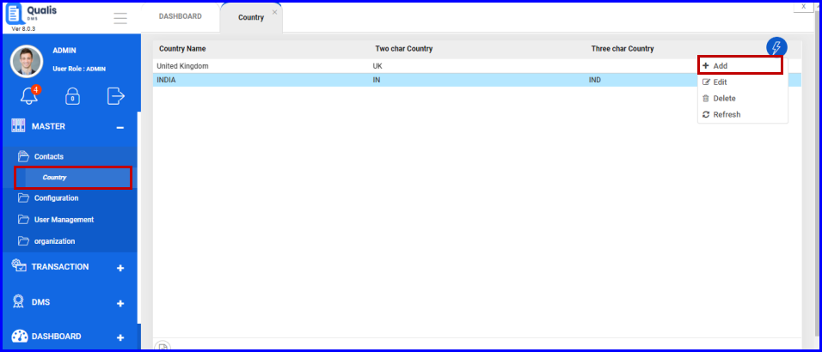
FIGURE: - Country Master Screen
In the country master screen you can see the list of countries created. Also options to add, edit and delete countries appear as shown in the above figure.
- Click action menu and then click Add. The Add Country dialog appears as shown in the figure:
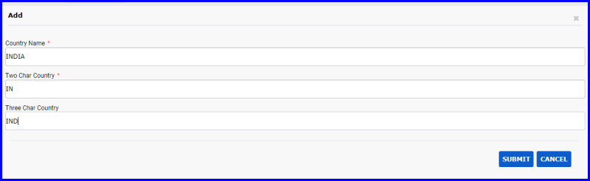
FIGURE: - Add Country Dialog
- In the Country Name field, type the country name you want to add.
- In the Two Char Country field, type the two character code of the country.
- In the Three Char Country field, type the three character code of the country.
- Click SUBMIT.
You can see the country you just created listed in the country master.

Editing and Deleting Country
- To edit a country, in the Country master screen, select the country to edit, click action menu and then click Edit. In the Edit Country dialog, do required changes and then click SUBMIT.
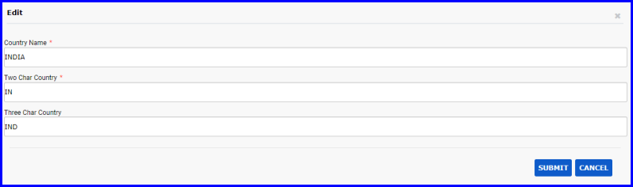
FIGURE: - Edit Country Dialog
- To delete a country, in the Country master screen, select the country you want to delete, click action menu and then click Delete.

Configuration

FTP Config
FTP Config master is used to create and manage FTP Configurations that are used for file upload.

Creating a FTP Config
To create a new FTP Config, follow these steps:
- On the Explorer, click MASTER, Configuration and then click FTP Config. The FTP Config master screen appears as shown in the figure:
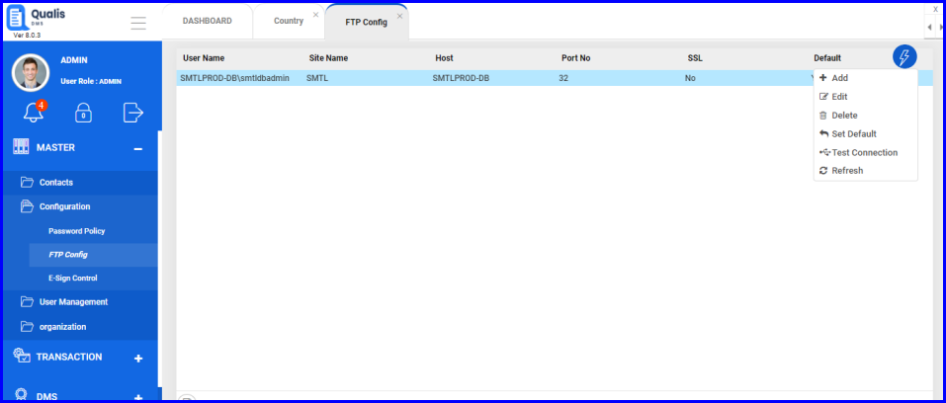
FIGURE: - FTP Config Master Screen
In the FTP Config master screen you can see the list of FTP Configurations created. Also options to add, edit and delete FTP Configs appear in the action menu as shown in the above figure.
- Click action menu and then click Add. The Add FTP Config dialog appears as shown in the figure:
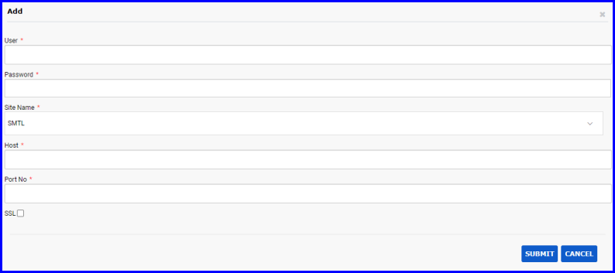
FIGURE: - Add FTP Config Dialog
- In the User field, type the name of the machine/server where you want to upload the files.
- In the Password field, type the password of the machine/server.
- In the Site Name field, select the name of the site.
- In the Host field, type the Host Name/IP address of the machine/server.
- In the Port No field, type the port number.
- Click to enable the SSL option if required.
- Click SUBMIT.
You can see the FTP Configuration you created listed in the FTP Config master.

Editing and Deleting FTP Configs
- To edit a FTP Configuration, in the FTP Config master screen, select the FTP Configuration to edit, click action menu and then Edit. In the Edit FTP Config dialog, do required changes and then click SUBMIT.

FIGURE: - Edit FTP Config Dialog
- To delete a FTP Configuration, in the FTP Config master screen, select the FTP Configuration you want to delete, click action menu and then click Delete.

Set Default
You can set a FTP configuration as default one. To do so, follow these steps:
- In the FTP Config master screen, select the FTP Configuration, click action menu and then Set Default as shown in the figure:
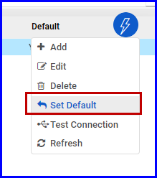
FIGURE: - Set Default Option

Test Connection
You can test connection for FTP configuration. To do so, follow these steps:
- In the FTP Config master screen, select the FTP Configuration, click action menu and then Test Connection. The Confirmation Dialog appears as shown in the figure:
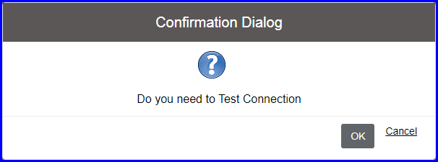
FIGURE: - Confirmation Dialog
- Click OK. If the connection is successful, you can see the success message as shown in the figure:
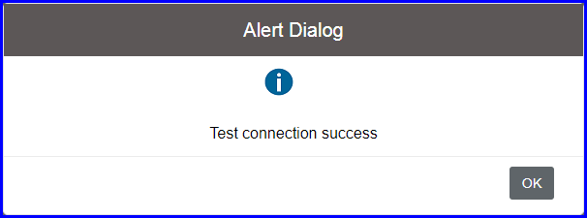
FIGURE: - Alert Dialog

Password Policy
Password policy can be set to control user authentication behavior. Password policy is must for regulatory compliance and also depends on the organisation policy defined for the individual applications.
Qualis DMS enables you to create password policies for each role. You can also create multiple password policies for a role.
When you create a policy it will be in the Draft status. You need to approve the policy to enforce. When a new policy is approved for a role, the existing policy will retire automatically.
Note: When a new password policy is approved for a role, the password policy of the entire users in that user role will be changed.

Password Policy Master
Password Policy master is used to create and manage Password Policies.

Creating a New Password Policy
To create a new Password Policy, follow these steps:
- On the Explorer, click MASTER, Configuration and then click Password Policy. The Password Policy master screen appears as shown in the figure:
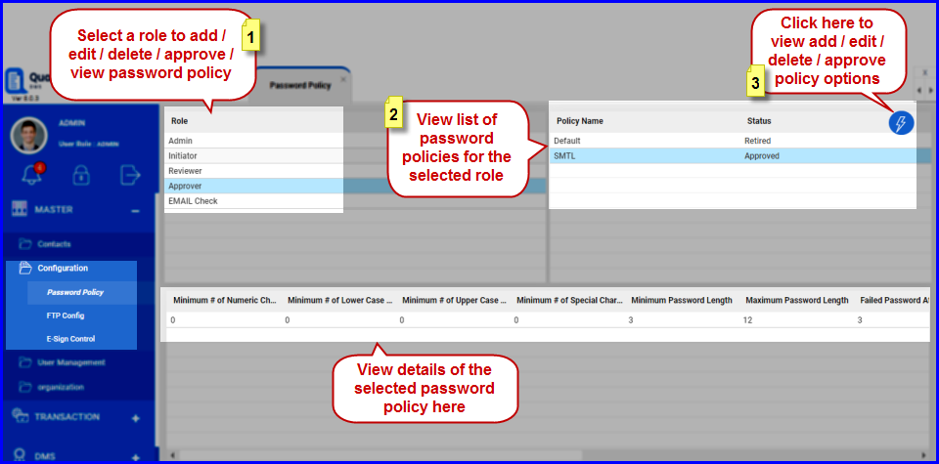
FIGURE: - Password Policy Master Screen
In the Password Policy master screen you can see the list of Password Policies created for a role. Also options to add, edit, delete, approve and copy policy appear as shown in the above figure.
- Select the Role from the list you want to add password policy.
- Click action menu and then click Add. The Add Password Policy dialog appears as shown in the figure:
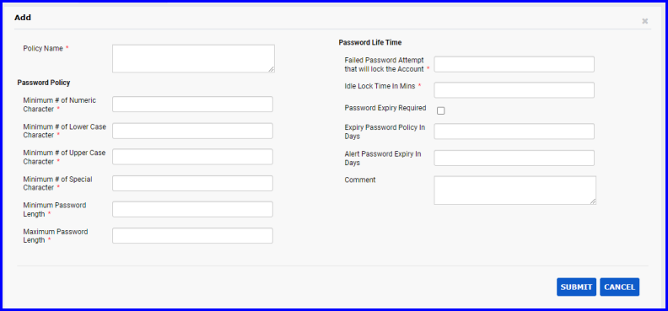
FIGURE: - Add Password Policy Dialog
- In the Policy Name field, type the name for the policy you want to create.
- Fill in all fields appropriately as follows:
- Setup basic rules for the password such as Minimum # of Numeric Character, Minimum number of Lowercase Character, Minimum number of Uppercase Character, Minimum Number of Special Character, Minimum Password Length and Maximum Password Length.
- Under Password Life Time, fill the following:
- In the Failed Password attempt that will lock the Account field, type number of failed attempts after which the application will be locked.
- In the Idle Lock Time in Mins field, type number of minutes after which the system will be locked.
- Click to check the Password Expiry Required check field to enable password expiry option. If this option is enabled, then the following two fields are enabled and becomes mandatory.
- In the Expiry Password Policy in Days field, type number of days the password is valid. After which the password would be expired. An alert shall be sent to the user to reset the password.
- In the Alert Password Expiry in Days field, type number of days before which the password expiry alert will be sent to the user.
- In the Comment field, type your comments if any.
- Click SUBMIT.
You can see the Password Policy you created listed in the Password Policy master.

Editing and Deleting Password Policy
Only policies in the “Draft” status can be updated and deleted.
- To edit a password policy, in the Password Policy master screen, select the role, select the password policy, click action menu and then click Edit. In the Edit Password Policy dialog, do required changes and then click SUBMIT.
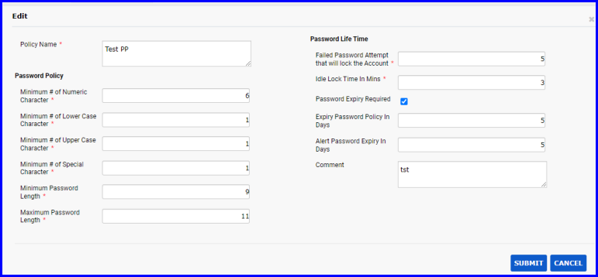
FIGURE: - Edit Password Policy Dialog
- To delete a password policy, in the Password Policy master screen, select the role, select the password policy you want to delete, click action menu and then click Delete.

Approving Password Policy
Policies in the “Draft” status can be approved.
- To approve a password policy, in the Password Policy master screen, select the role, select the password policy, click action menu and then click Approve. In the Confirmation dialog click Ok.

Copying Password Policies
You can copy password policy to multiple roles.
- To copy a password policy, in the Password Policy master screen, select the role; select the password policy, click action menu and then click Copy.
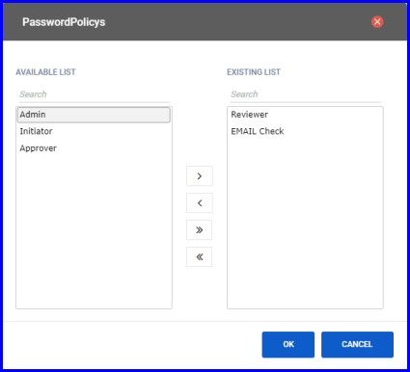
FIGURE: - Copy Password Policy Dialog
- In the Copy Password Policy dialog, under AVAILABLE LIST select the roles and click to copy the policy.
Now the selected password policy is copied to all the selected roles.

E-sign Control
E-Sign Rights screen helps you to set E-Sign authentication at the control level for a selected screen.
To define E-Sign rights, follow these steps:
- On the Explorer, click MASTER, click Configuration and then click E-Sign Control. The E-Sign Control screen appears as shown in the figure:
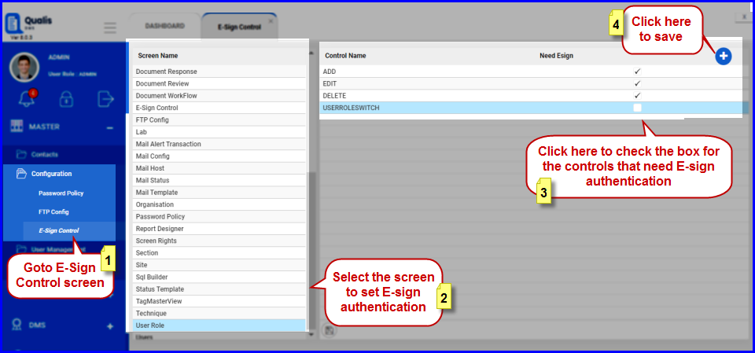
FIGURE: - Esign Control Screen
- Under Screen Name, select a screen. You can see the list of controls in the selected screen.
- Click to enable the check field under Need Esign of the respective control that requires E-Sign authentication and then click .
Note: When you click the control with E-sign authentication in the transactions the E-Sign dialog pops up for authentication.

User Management
Qualis DMS allows you to create users, roles, assign multiple roles to users, assign screen level and control level permissions to refine access to your lab information.
User roles and permissions
Qualis DMS users are assigned user roles, which in turn control their permissions and access to DMS tools and their ability to view, add, modify, and delete documents and other DMS data.

Designation
Designation master is used to create and manage designations that are used in user management, and workflows.

Creating a Designation
To create a new designation, follow these steps:
- On the Explorer, click MASTER, User Management and then click Designation. The Designation master screen appears as shown in the figure:
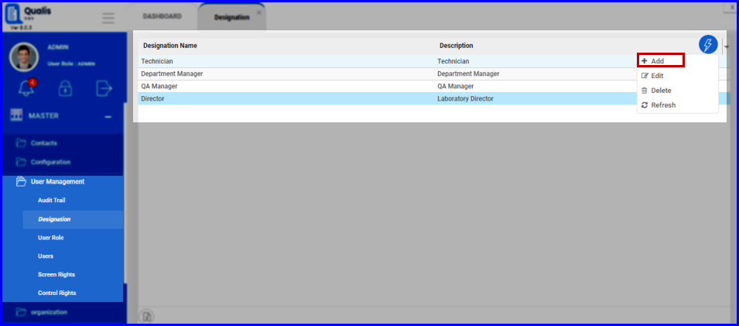
FIGURE: - Designation Master Screen
In the Designation master screen you can see the list of designations created. Also options to add, edit and delete designations appear as shown in the above figure.
- Click action menu and then click Add.. The Add Designation dialog appears as shown in the figure:
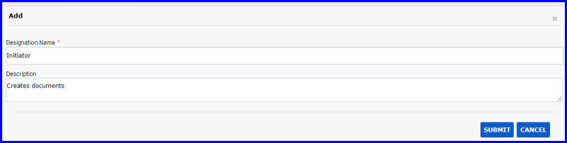
FIGURE: - Add Designation Dialog
- In the Designation Name field, type the name for the designation.
- In the Description field, type the description.
- Click SUBMIT.
You can see the designation you created listed in the Designation master.

Editing and Deleting Designations
- To edit a designation, in the Designation master screen, select the designation, click action menu and then click Edit. In the Edit Designation dialog, do required changes and then click SUBMIT as shown in the figure:
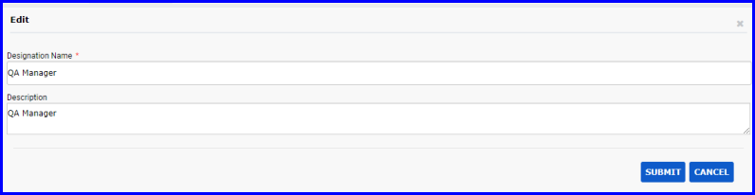
FIGURE: - Edit Designation Dialog
- To delete a designation, in the Designation master screen, select the designation you want to delete, click action menu and then click Delete.

User Role
To create a new role, follow these steps:
- On the Explorer, click MASTER, click User Management and then click User Role. The User Role tab appears as shown in the figure:
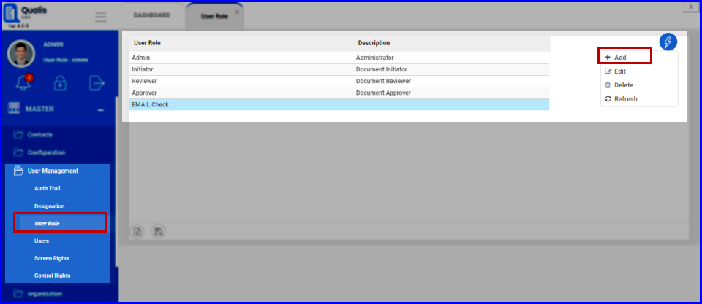
FIGURE: - User Role Tab
- In the User Role tab, click action menu and then click Add. The Add User Role dialog appears as shown in the figure:
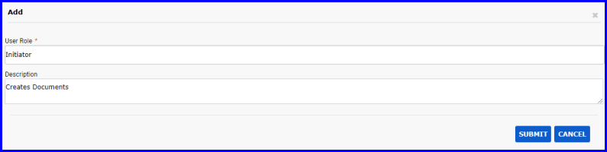
FIGURE: - Add User Role Dialog
- In the User Role field, type name for the role you want to create.
- In the Description field, type description.
- Click SUBMIT.
You can see the role you created listed in the user role master.

Editing and Deleting User Roles
- To edit a role, in the User Role master screen, select the role, click action menu and then click Edit. In the Edit Role dialog, do required changes and then click SUBMIT.
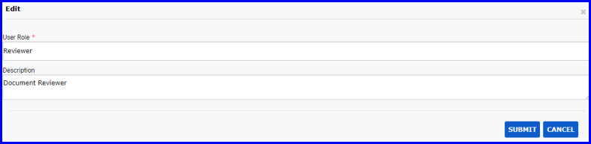
FIGURE: - Edit User Role Dialog
- To delete a role, in the User Role master screen, select the role you want to delete, click action menu and then click Delete.

Users
To create a new user account, follow these steps:
- On the Explorer, click MASTER, click User Management and then click Users. The Users tab appears as shown in the figure:
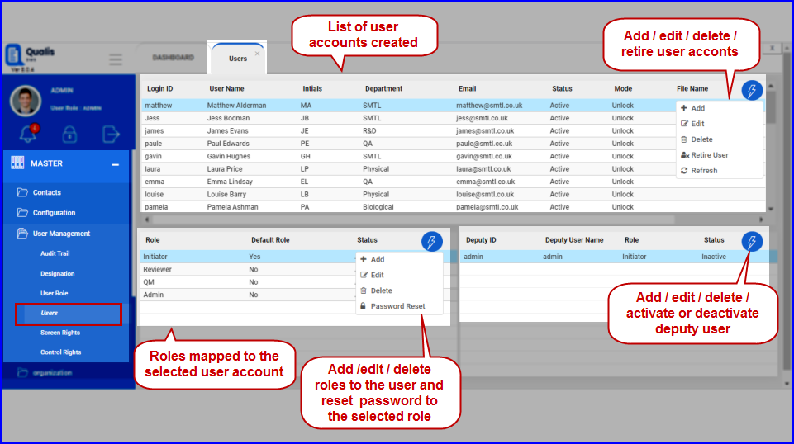
FIGURE: - Users Tab
- In the Users tab, click action menu and then click Add. The Add Users screen appears as shown in the figure:
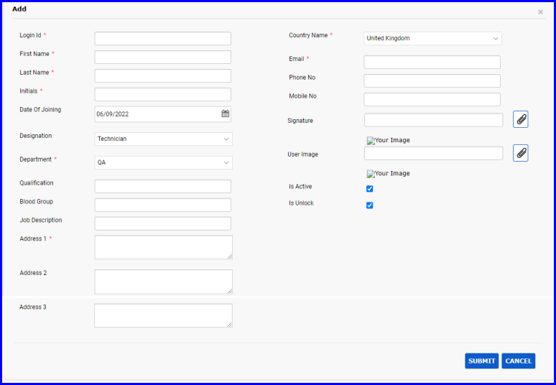
FIGURE: - Add User Screen
- Type the Login Id, First Name, Last Name, Initials, Department, Address 1, Country Name, E-mail and other fields as required.
- Click SUBMIT.
The new user account is created and listed in the grid in the Users screen.
Now you can assign role(s) to the user account. You can map multiple roles to a user account and set a role as default role.

Mapping User Account to Role(s)
To map user account to a role, follow these steps:
- In the Users screen, select the user account to assign a role.
- Under Role, click action menu and then click Add as shown in the figure:
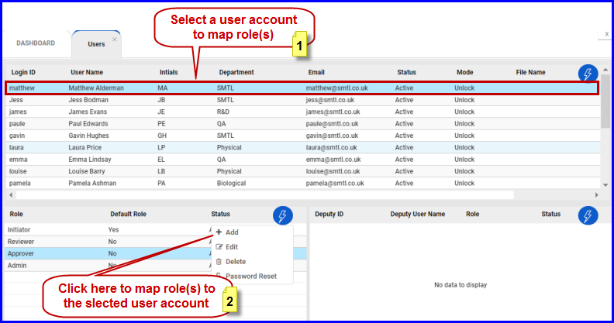
FIGURE: - Adding User Role Screen
The Add User Role dialog appears as shown in the figure:
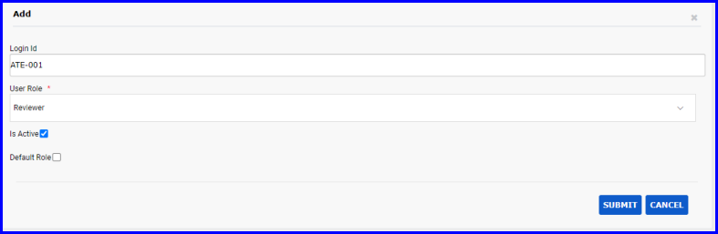
FIGURE: - Add User Role Dialog
- In the User Role list field, select the role you want to assign to the user.
- Click Is Active to make the role active to the user.
- Click to check Default Role field to make this role default role for the user.
- Click SUBMIT. The selected role is assigned to the user.
Note: You can map multiple roles to a user out of which only one can be a default role.

Editing and Deleting User Roles Assigned
- To edit a role assigned to the user, in the Users screen, select the user, under Role, select the role to edit, click action menu and then click Edit. In the Edit User Role dialog, do required changes and then click SUBMIT.
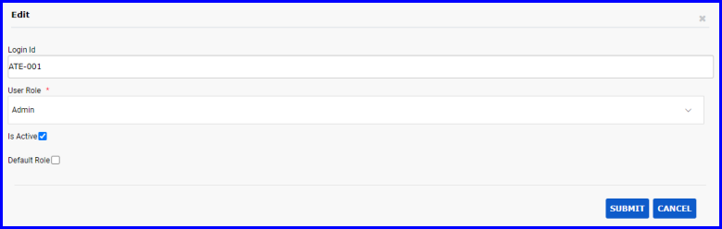
FIGURE: - Edit User Role Dialog
- To delete a role assigned to the user, in the Users screen, select the user, select the role to delete, click action menu and then click Delete. You cannot delete default role assigned to the user.

Reset Password
- To reset password, in the Users screen, select the user, under Role, select the role to reset password, click action menu and then click Password Reset. The Confirmation Dialog appears as shown in the figure:
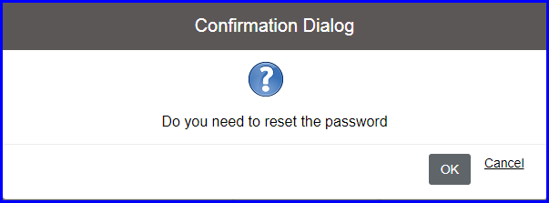
FIGURE: - Password Reset - Confirmation Dialog
- Click OK. Next time, when the user logs in using the selected role, the system will prompt to create new password as shown in the figure:
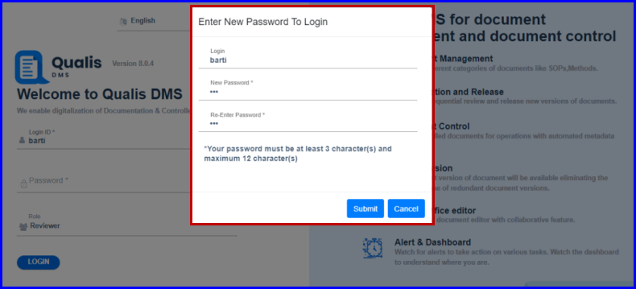
FIGURE: Enter New Password To Login Dialog

Mapping Deputy Users to User
You can add deputy users to a selected user account. To do so, follow these steps:
- In the Users screen, select the user account to assign deputy user.
- Under Role, select the role to assign the deputy users(The user shall be mapped to multiple roles. Select a role to which you want to map deputy user(s))
- Click action menu and then click Add as shown in the figure:
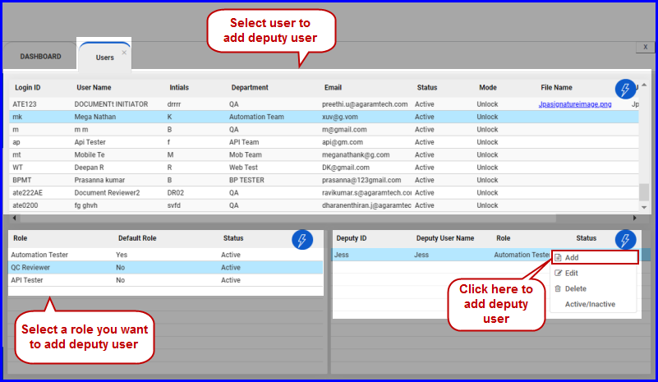
FIGURE: - Adding Deputy User Screen
The Add Deputy User dialog appears as shown in the figure:
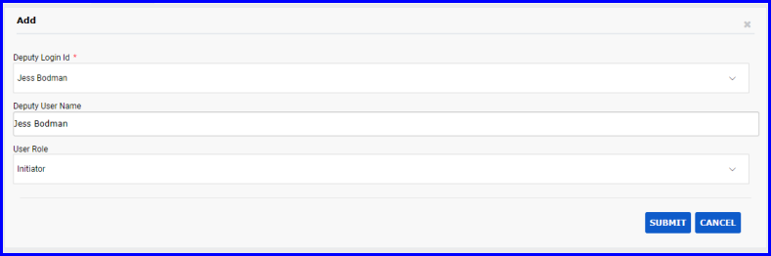
FIGURE: - Add Deputy User Dialog
- In the Deputy Login Id field, select the user/login id you want to add as deputy user.
- In the User Role field, select the role.
- Click SUBMIT. The selected role is assigned to the user as deputy user.
Note: You can map multiple deputy users to a user.

Activate / Deactivate Deputy User
- To activate/deactivate deputy users, in the Users screen, select the user, under Role, select the role, select the deputy user, click action menu and then click Active/Inactive. The Confirmation Dialog appears as shown in the figure:
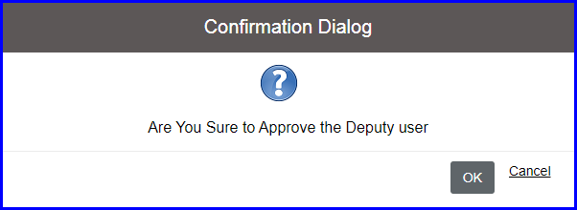
FIGURE: Approve Deputy User - Confirmation Dialog
- Click OK. The selected deputy user is activated / deactivated.

Screen Rights
To define screen level permissions for roles and users, follow these steps:
- On the Explorer, click MASTER, click User Management and then click Screen Rights. The Screen Rights screen appears as shown in the figure:
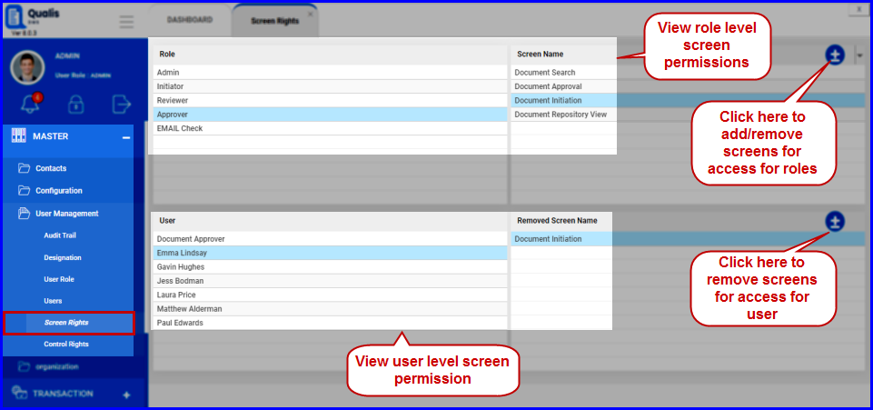
FIGURE: - Screen Rights Screen
- Select a role from the left side. You can see the list of screen that the role has permissions.
- To add or remove screens from/to the list, click . The Screen Name dialog appears as shown in the figure:
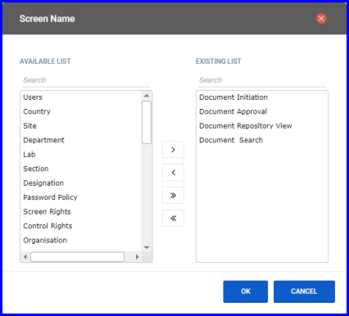
FIGURE: - Add and Remove Screen Dialog
- Use thearrows to add or remove the screens to grant/revoke permissions.
- Click OK.
Same way, you can revoke screen permissions for the users.

Control Rights
To define control level permissions for roles and users, follow these steps:
- On the Explorer, click MASTER, click User Management and then click Control Rights. The Control Rights screen appears as shown in the figure:
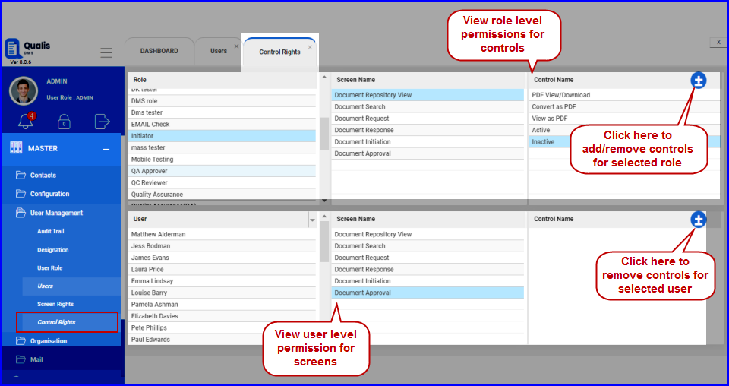
FIGURE: - Control Rights Screen
- Select a role from the left side. You can see the list of screens and the list of controls in the selected screen that the role has permissions.
- To add or remove controls from/to the list, click. The Control Name dialog appears as shown in the e figure:
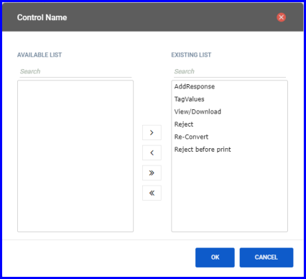
FIGURE: - Control Name Dialog
- Use thearrows to add or remove the controls to grant/revoke permissions.
- Click OK.
Same way, you can revoke permissions for controls for the users.

Audit Trail Log
Audit Trail menu helps you to view audit trail log. Also enables you to filter records based on date range, user and module name, export records to excel file, print records, create archive and open archive to view.
To view audit trail log, follow these steps:
- On the Explorer, click MASTER, click User Management and then click Audit Trail. The Audit Trail log screen appears as shown in the figure:
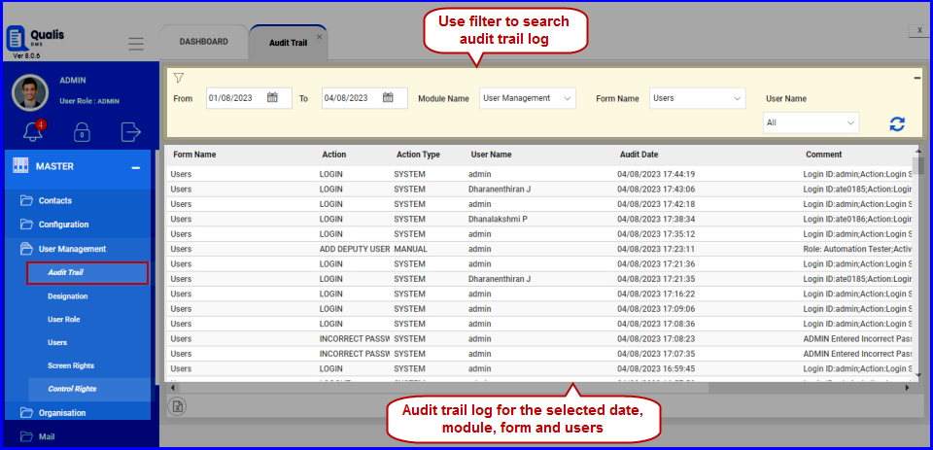
FIGURE: - Audit Trail Log Screen
You can filter records based on the Date range: Select the From and To date and then click to filter records based on the specified date range.
You can also filter records based on Module Name, Form Name and User Name.
- In the Module Name field, select a module. Forms/screens in the selected module appears in the Form Name field.
- In the Form Name field, select the form.
- In the User field, select user.
- Click.
Audit trail records for the selected date range and for the selected module, form and user appears as shown in the above figure.

Organisation

Setting up Organisational Hierarchy
Qualis DMS organisation hierarchy contains the following levels. There will be many to one mapping from the lower level to the higher level in the hierarchy.
Organisation: Consists of multiple sites
Site: Consists of multiple departments
Department: Consists of multiple sections
Sections: Consists of multiple labs
Labs: Mapped to multiple user

Site Master
Site master helps to create and manage sites.

Creating a New Site
To create a new site, follow these steps:
- On the Explorer, click MASTER, Organisation and then click Site. The Site master screen appears as shown in the figure:
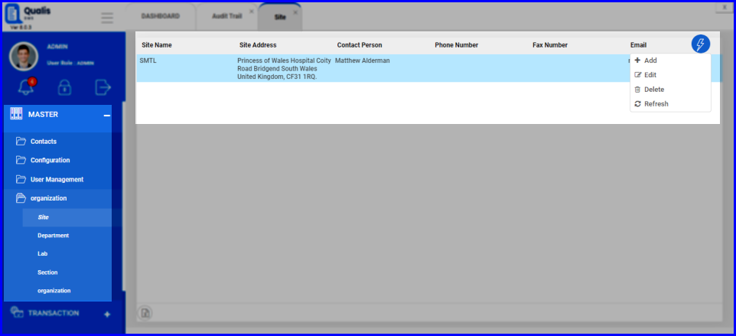
FIGURE: - Site Master Screen
In the Site master screen you can see the list of sites created for the organisation. Also options to add, edit and delete sites appear as shown in the above figure.
- In the site master screen, click action menu and then click Add. The Add Site dialog appears as shown in the figure:
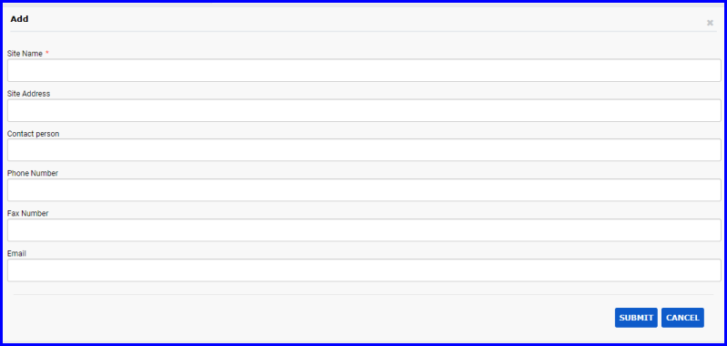
FIGURE: - Add Site Dialog
- In the Site Name field, type the name for the site you want to create.
- In the Site Address field, type the site address.
- Fill in other fields appropriately.
- Click SUBMIT.
You can see the site you just created listed in the Site master.

Editing and Deleting Sites
- To edit a site, in the Site master screen, select the site, click action menu and then click Edit. In the Edit Site dialog, do required changes and then click SUBMIT.
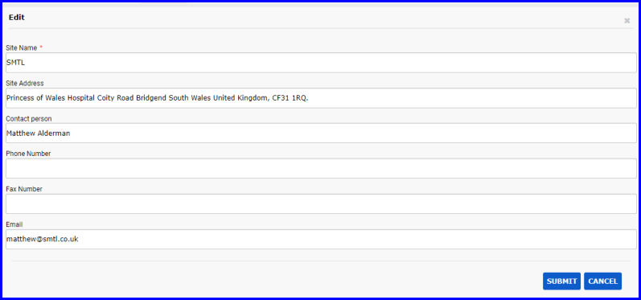
FIGURE: - Edit Site Dialog
- To delete a site, in the Site master screen, select the site you want to delete, click action menu and then click Delete.

Department Master
Department master is used to create and manage departments that are used in the organisation setup. Sections are grouped under departments.

Creating a New Department
To create a new department, follow these steps:
- On the Explorer, click MASTER, Organisation and then click Department. The Department master screen appears as shown in the figure:
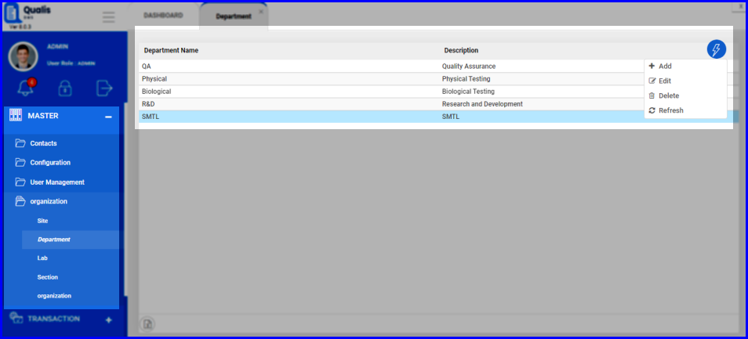
FIGURE: - Department Master Screen
In the department master screen you can see the list of departments created for the organisation. Also options to add, edit and delete departments appear as shown in the above figure.
- Click action menu and then click Add. The Add Department dialog appears as shown in the figure:
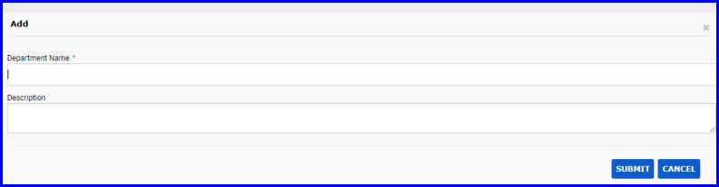
FIGURE: - Add Department Dialog
- In the Department Name field, type the name for the department you create.
- In the Description field, type the description.
- Click SUBMIT.
You can see the department you just created listed in the Department master.

Editing and Deleting Department
- To edit a department, in the Department master screen, select the department, click action menu and then click Edit. In the Edit Department dialog, do required changes and then click SUBMIT.
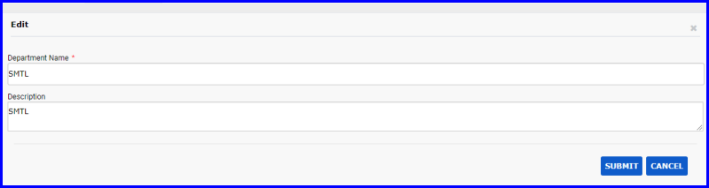
FIGURE: - Edit Department Dialog
- To delete a department, in the Department master screen, select the department you want to delete, click action menu and then click Delete.

Lab Master
Lab master is used to create and manage labs that are used in the organisation setup. Sections are mapped to labs.

Creating a New Lab
To create a new lab, follow these steps:
- On the Explorer, click MASTER, Organisation and then click Lab. The Lab master screen appears as shown in the figure:
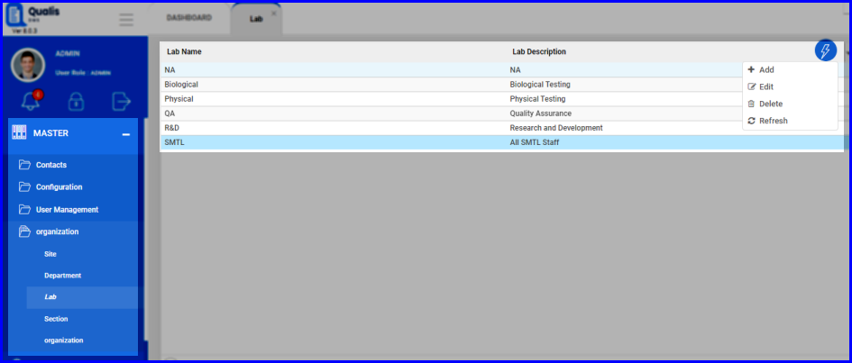
FIGURE: - Lab Master Screen
In the Lab master screen you can see the list of labs created for the organisation. Also options to add, edit and delete labs appear as shown in the above figure.
- Click action menu and then click Add. The Add Lab dialog appears as shown in the figure:
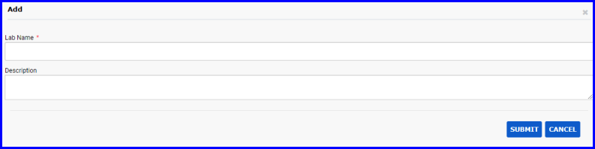
FIGURE: - Add Lab Dialog
- In the Lab Name field, type the name for the lab you create.
- In the Description field, type the description.
- Click SUBMIT.
You can see the lab you just created listed in the Lab master.

Editing and Deleting Labs
- To edit a lab, in the Lab master screen, select the lab, click action menu and then click Edit. In the Edit Lab dialog, do required changes and then click SUBMIT.
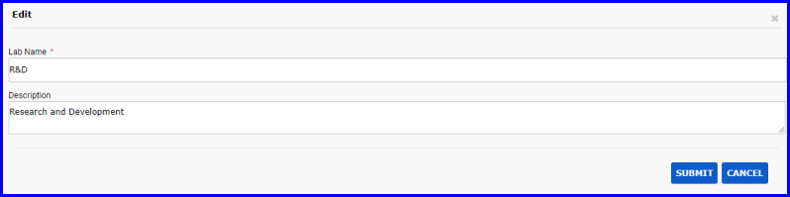
FIGURE: - Edit Lab Dialog
- To delete a lab, in the Lab master screen, select the lab you want to delete, click action menu and then click Delete.

Section Master
Section master is used to create and manage sections that are used in the organisation setup. Sections are grouped under labs.

Creating a New Section
To create a new section, follow these steps:
- On the Explorer, click MASTER, Organisation and then click Section. The Section master screen appears as shown in the figure:
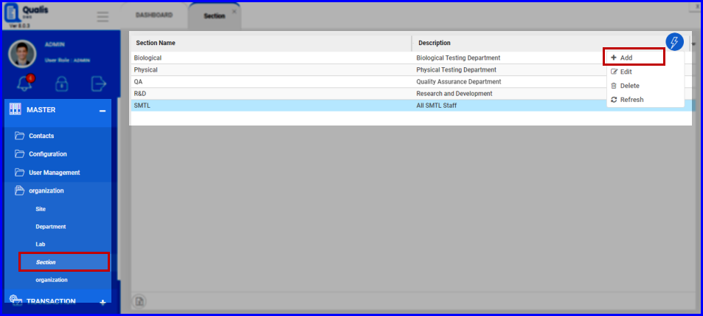
FIGURE: - Section Master Screen
In the Section master screen you can see the list of sections created for the organisation. Also options to add, edit and delete sections appear as shown in the above figure.
- Click action menu and then click Add. The Add Section dialog appears as shown in the figure:
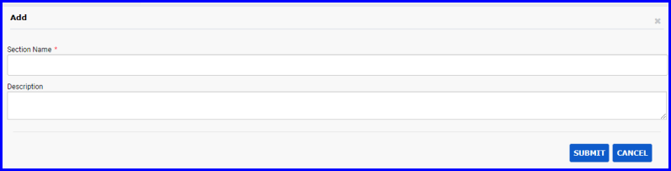
FIGURE: - Add Section Dialog
- In the Section Name field, type the name for the section you create.
- In the Description field, type the description.
- Click SUBMIT.
You can see the section you just created listed in the Section master.

Editing and Deleting Sections
- To edit a section, in the Section master screen, select the section, click action menu and then click edit. In the Edit Section dialog, do required changes and then click SUBMIT.
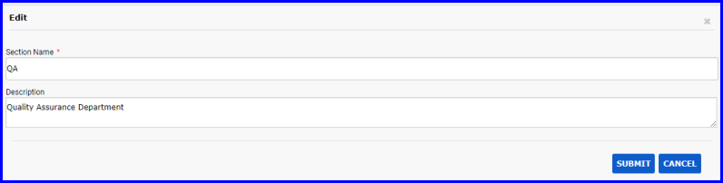
FIGURE: - Edit Section Dialog
- To delete a section, in the Section master screen, select the section you want to delete, click action menu and then click Delete.

Organisation Master
Organisation master is used to setup organisation hierarchy in Qualis DMS. Site from the Site master appears in the organisation master screen. You can do the following in the organisation master screen:
- Add departments to sites
- Add labs to departments
- Add sections to labs
- Map users to sections
- On the Explorer, click MASTER, Organisation and then click Organisation. The Organisation master screen appears as shown in the figure:
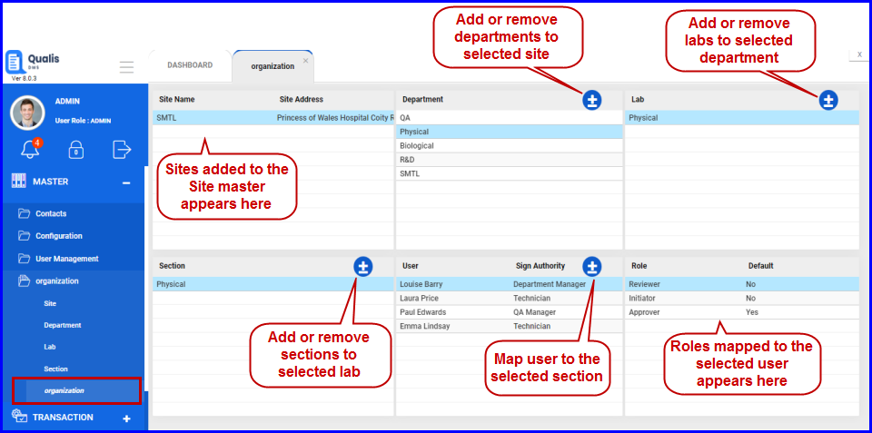
FIGURE: - Organisation Master Screen
In the Organisation master screen you can see the information organized in the following hierarchy:
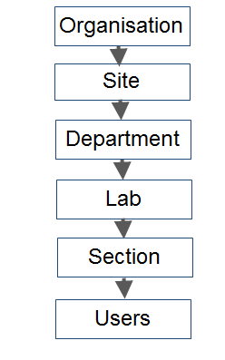
FIGURE: - Organisation Structure
Also options to add/remove departments, sections, labs and users appear.

Mail

Mail Host
The Mail Host screen helps you to add hosts to DMS. To do so, follow these steps:
- On the Explorer, click MASTER, Mail and then click Mail Host. The Mail Host screen appears as shown in the figure:
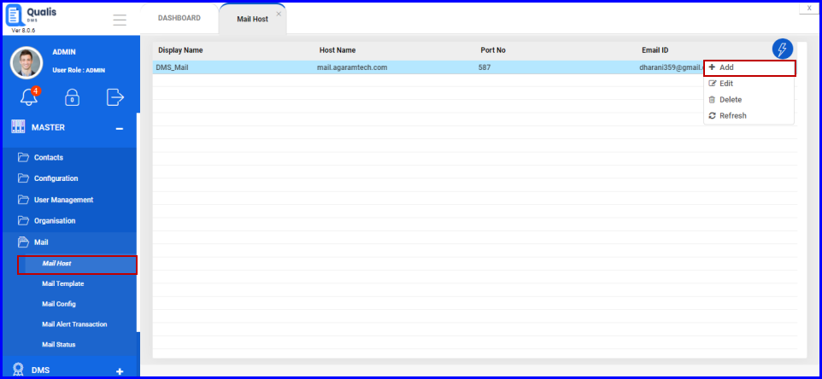
FIGURE: - Mail Host Screen
You can see the list of mail hosts added. Options to add, edit and delete hosts appear in the action menu.
- Click action menu and then click Add The Add Mail Host screen appears as shown in the figure:
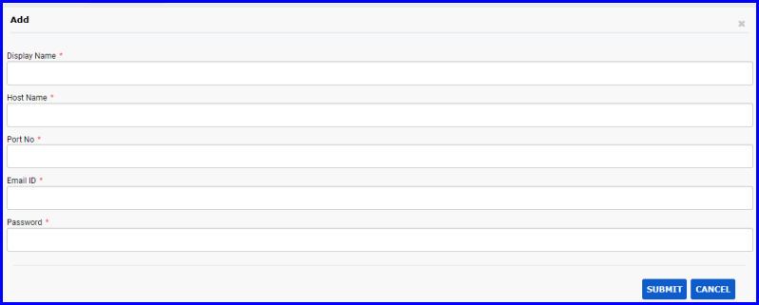
FIGURE: - Add Mail Host Screen
- In the Display Name field, Type the display name for the host you want to add.
- In the Host Name field, type host name.
- In the Port No field, type the default port number for the host. The default port numbers are 587 and 456.
- In the Email Id field, type the email id from which the mail will be triggered.
- In the Password field, type the password for the email id mentioned.
- Click SUBMIT.
You can see the mail host you just added listed in the mail host screen.

Mail Template
Mail Template is used to add and manage templates for the mails that are automatically triggered. Mail templates are used in the email configuration screen.

Adding a New Mail Template
To create a new template, follow these steps:
- On the Explorer, click Transaction, Mail and then click Mail Template. The Mail Template screen appears as shown in the figure:
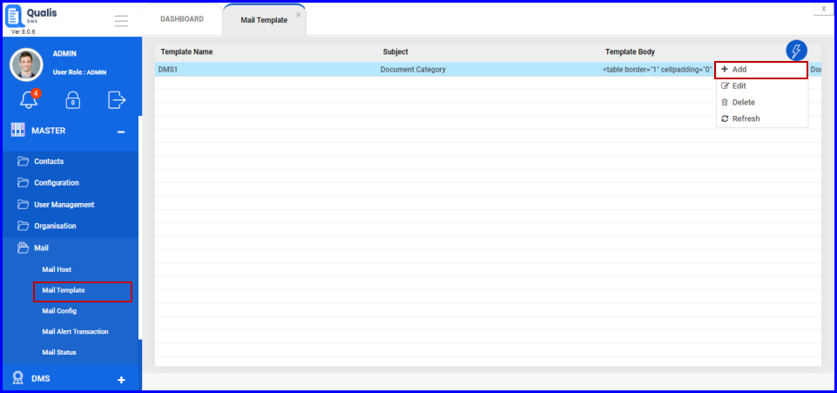
FIGURE: - Email Template Screen
In the mail template master screen you can see the list of templates added. Options to add, edit and delete mail templates appear in the action menu.
- Click action menu and then click Add. The Add Template screen appears as shown in the figure:
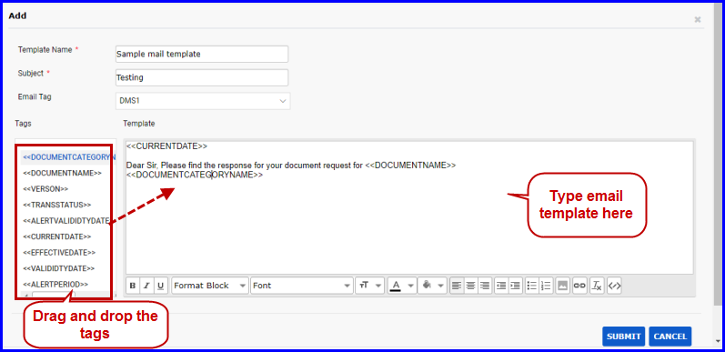
FIGURE: - Add Mail Template Screen
- In the Template Name field, type a name for the template you add.
- In the Subject field, type subject for the template.
- In the Email Tag field, select a screen name. Tags associated with the selected screen appear in the side as shown in the above figure.
- In the text field, type the mail content and add tags where ever applicable.
- Click SUBMIT.
You can see the mail template you just added listed in the Mail Template master.

Editing and Deleting Mail Template
- To edit email template details, in the mail template master screen, select the template, click action menu and then click Edit. In the Edit mail template screen, do required changes and then click Submit.
- To delete a template, in the mail template master screen, select the template you want to delete, click action menu and then click Delete.

Mail Config
Mail Config is used to add and manage mail configurations. You can configure mails to trigger automatically when a selected action appears in the screen.

Adding a New Mail Config
To create a new config, follow these steps:
- On the Explorer, click Transaction, Mail and then click Mail Config. The Mail Config screen appears as shown in the figure:
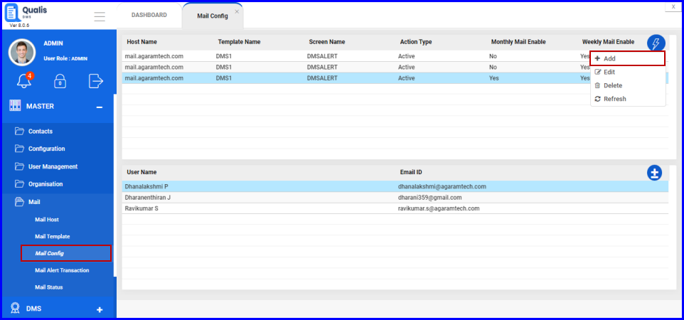
FIGURE: - Email Config Screen
In the mail config screen you can see the list of configurations added. Options to add, edit and delete mail configs appear in the action menu.
- Click action menu and then click Add The Add Mail Config screen appears as shown in the figure:
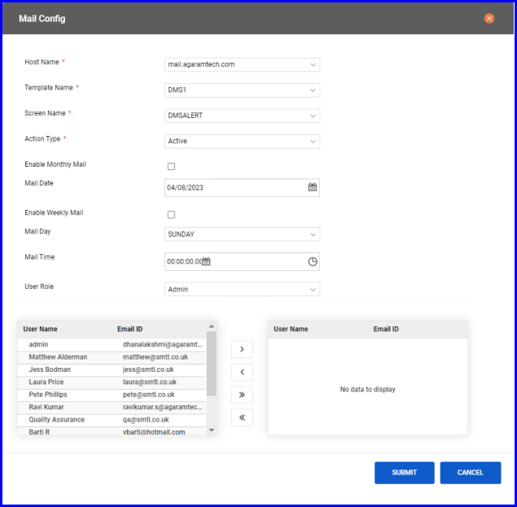
FIGURE: - Add Email Config Screen
- In the Host Name field, select the host to send mail.
- In the Template Name field, select a template for the email to configure.
- In the Screen Name field, select the screen.
- In the Action Type field, select an action when performed the mail has to be triggered.
- Click to check the Enable Monthly Mail field to enable automatic mail option monthly. In the Mail Date field, select date on which the monthly mail has to be sent.
- Click to check the Enable Weekly Mail field to enable automatic mail option weekly. In the Mail Day field, select day on which the weekly mail has to be sent.
- In the Mail Time field, select the time the mail has to be sent. when you check this field, then when the selected action is performed in the selected screen a mail will be automatically sent to the concerned users in the selected role.
- In the User Role field, select the role to receive mail. Users in the selected user role appears below.
- Select the users from the left side and click to add them to the recipient list.
- Click SUBMIT.
You can see the mail config you just added listed in the Mail Config master.

Editing and Deleting Mail Config
- To edit email config details, in the mail config master screen, select the config, click action menu and then click Edit. In the Edit mail config screen, do required changes and then click SUBMIT.
- To delete a configuration, in the mail config master screen, select the config you want to delete, click action menu and then click Delete.

Mail Alert Transaction
- On the Explorer, click Transaction, Mail and then click Mail Alert Transaction. The Mail Alert Transaction screen appears as shown in the figure:
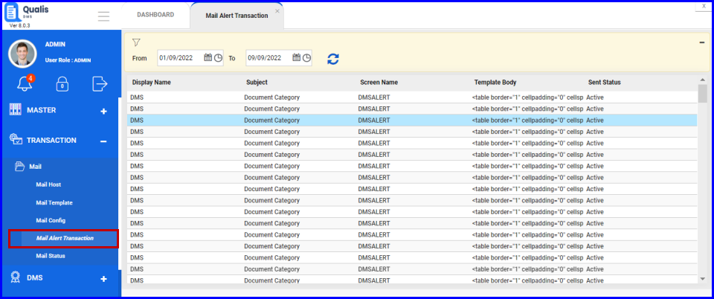
FIGURE: - Mail Alert Transaction Screen
Details like email subject, screen name, email template, sent status and date of email sent will appear as shown in the above figure.

Mail Status
Mail Status screen enables you to view details of emails that are automatically sent.
- On the Explorer, click Transaction, Mail and then click Mail Status. The Mail Status screen appears as shown in the figure:
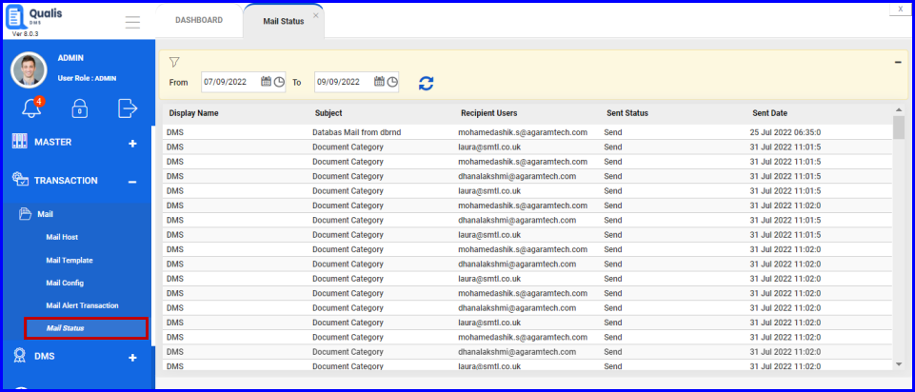
FIGURE: - Email Status Screen
Details like email subject, the recipient, sent status and date of email sent will appear as shown in the above figure.

Document Management

Workflows
Workflow guides you through the steps and organizes the information required to complete the document management process. This may include selecting the reviewers and approvers to manage document in each stage of the document lifecycle.
Qualis DMS enables you to create custom workflows that meet your specific requirements.

Creating workflow
To create a new workflow, follow these steps:
- On the Explorer, click DMS, click Document Management, and then click Document Workflow. The Document Workflow screen appears as shown in the figure:
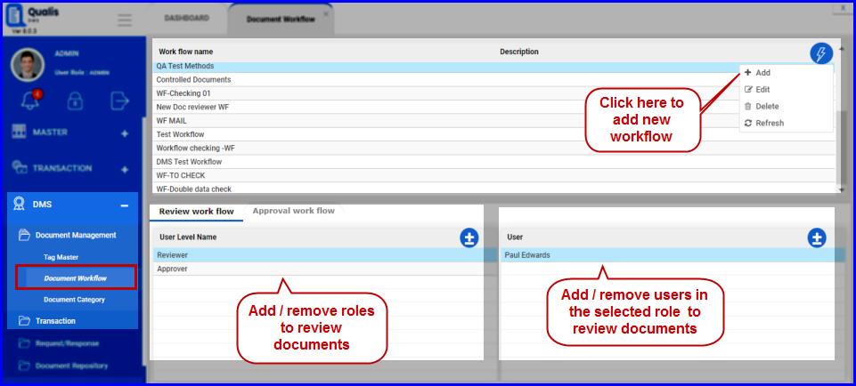
FIGURE: - Document Workflow Screen
- In the Document Workflow screen, click action menu and then click Add. The Add Workflow Dialog appears as shown in the figure:
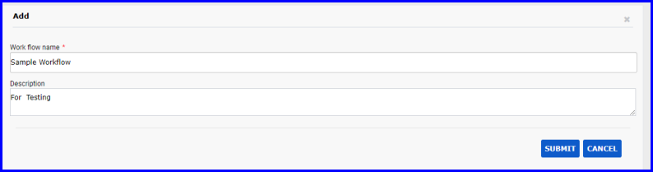
FIGURE: - Add Workflow Dialog
- In the Work flow Name field, type name for the workflow you create.
- In the Description field, type description for the workflow if any.
- Click SUBMIT.

Adding Role and User to Review Documents
You can add user roles and then add users to review the documents in the workflow. To do so, follow these steps:
- In the Document Workflow screen, under Work flow name, select the workflow you want to add role and user.
- In the Review Workflow tab, click. The Review Work flow add and remove role level dialog appears as shown in the figure:
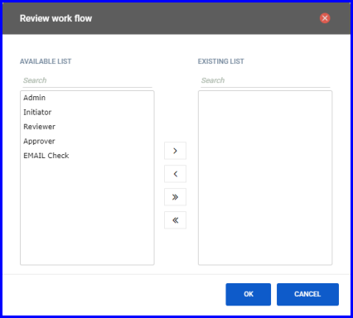
FIGURE: - Review Workflow - Add and Remove Role Level Dialog
- You can see the list of available roles in the left side. Select a role and click to add it to the workflow. You can add multiple or all roles to the workflow as required.
- Click OK.
- For each role, to add users, select the role, in the User section click. The Review workflow add and remove users dialog appears as shown in the figure:
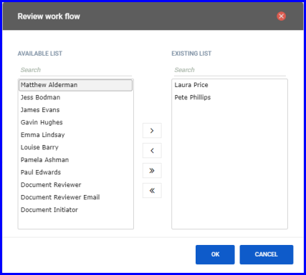
FIGURE: - Review Workflow - Add and Remove Users Dialog
- You can see the list of available users in the left side. Select a user and click to add them to the workflow. You can add multiple or all users to the workflow as required.
- Click OK. You can see the role and the users added to the review work flow as shown in the figure:
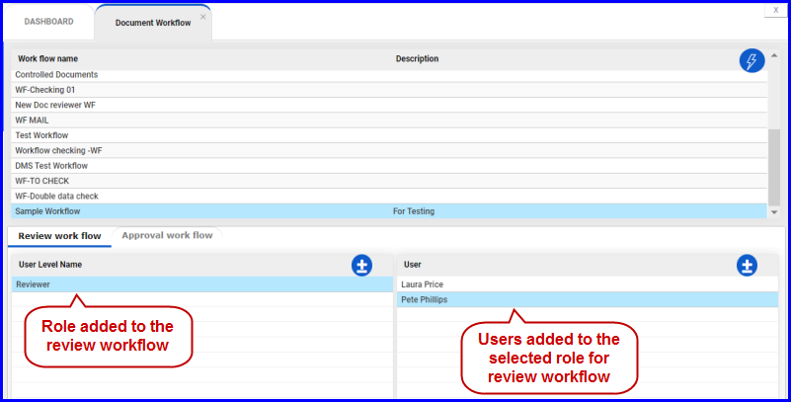
FIGURE: - Role and Users Added to the Review Workflow

Adding Role and User to Approve Documents
You can add user roles and then add users to approve the documents in the workflow. To do so, follow these steps:
- In the Approval Workflow tab, click. The Approval work flow add and remove role level dialog appears as shown in the figure:
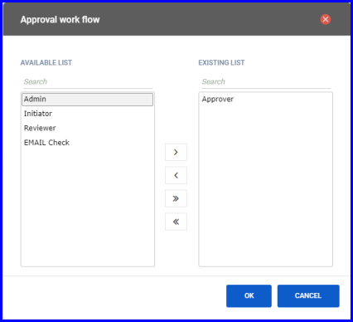
FIGURE: - Approval work flow - Add and Remove Role Level Dialog
- You can see the list of available roles in the left side. Select a role and click to add it to the workflow. You can add multiple or all roles to the workflow as required.
- Click OK. The roles added to the workflow appears as shown in the figure:
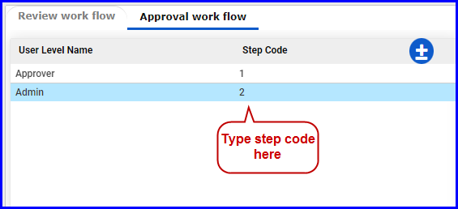
FIGURE: - Adding Step Code
You must add step code to each role here.
- In the Step Code field type the level of approval for each role to define the sequence of approval in the workflow.
- For each role, to add users, select the role and then click. The Approval work flow add and remove users dialog appears as shown in the figure:
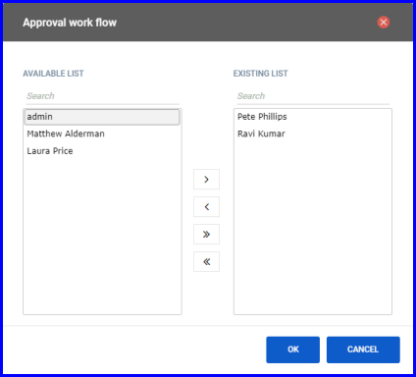
FIGURE: - Approval workflow - Add and Remove Users Dialog
- You can see the list of available users in the left side. Select a user and click to add them to the workflow. You can add multiple or all users to the workflow as required.
- Click OK. You can see the role and the users added to the approval work flow as shown in the figure:
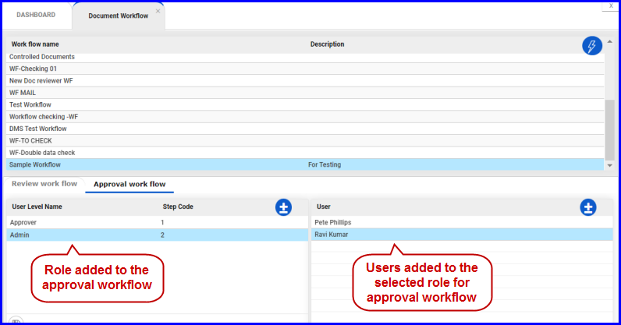
FIGURE: - Role and Users Added to the Approval Workflow

Document Category
Document categories are created to categorize documents based on the document type, workflow and template involved. You can create a document category and map the workflow to the category.
To create a document category, follow these steps:
- On the Explorer, click DMS, click Document Management, and then click Document Category. The Document Category screen appears as shown in the figure:
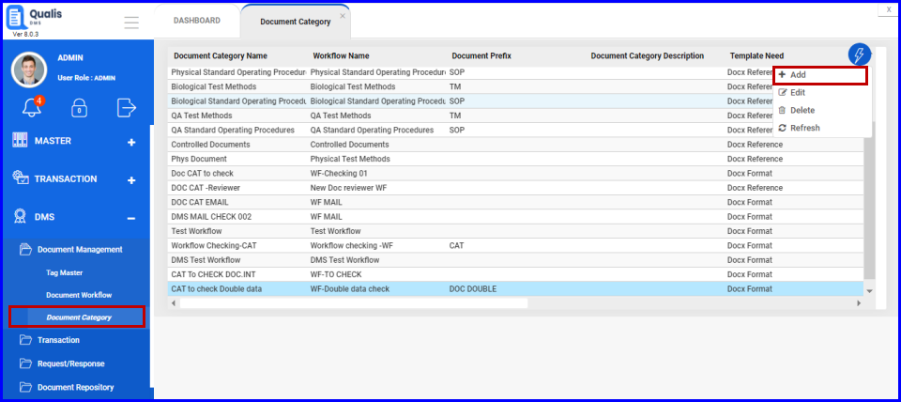
FIGURE: - Document Category Screen
You can see the list of document categories added and in the action menu you can see options to add, edit and delete document categories.
- In the Document Category screen, click action menu and then click Add. The Add Document Category dialog appears as shown in the figure:
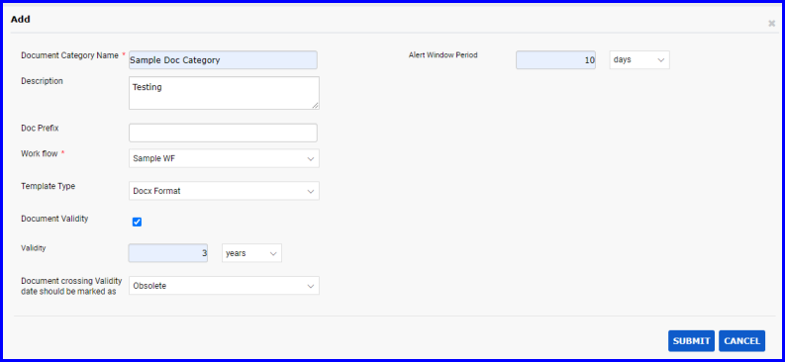
FIGURE: - Add Document Category Dialog
- In the Document Category Name field, type name for the category you create.
- In the Description field, type description if any.
- In the Doc Prefix field, type the document extension type: .Docx/PDF.
- In the Workflow field, select the workflow to map it to the category you create.
- In the Template Type field, select the template for the category.
- PDF : Select “PDF” if the document category does not require a template.
- Docx format: Select this option to make the tag mandatory. NA tags will be available.
- Doc reference: NA tags will not be available for this option
- Click to enable the Document Validity option. If this option is enabled, then the following fields are enabled:
- In the Validity field, type the number and select the period. For example, 3 years.
- In the Document crossing validity date should be marked as field, select Obsolete / Extend.
- In the Alert Window Period field, type the number and select period. For example, 10 days. Before which the system alerts about the expiry of document validity.
- Click SUBMIT. The document category is added and appears in the list.

Tag Master
When you initiate a document, you will have to add all tags relevant to the document in the Tag Master. To do so, follow these steps:
- On the Explorer, click DMS, click Document Management, and then click Tag Master. The Tag Master screen appears as shown in the figure:
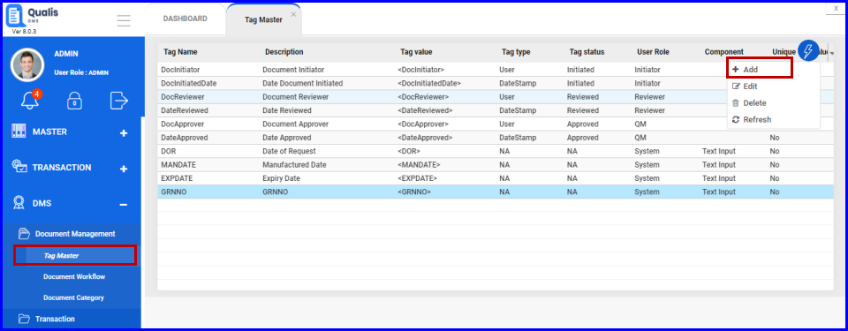
FIGURE: - Tag Master Screen
In the tag master screen you can see the list of tags added. Also options to add, edit and delete tags appear in the action menu as shown in the above figure.
- Click action menu and then click Add. The Tag Entry dialog appears as shown in the figure:
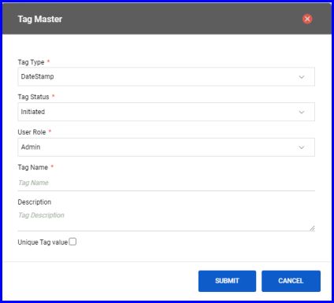
FIGURE: - Tag Master Dialog
- In the Tag Type field, select the type you want to add from the following list:
- NA
- E-Sign
- User
- DateStamp
- Role
- DateTimeStamp
- DocumentNumber
- DocumentName
If you select NA then you need to set tag value when you respond to a document request. All other tag type will be captured automatically.
- In the Tag Status field, select the status.
- In the User Role field, select the roles.
- In the Tag Name field, type the tag name.
Note: Type the tag name without space. The Tag Name field does not accept space.
- In the Tag Description field, type description for the tag.
- Check the Unique Tag Value check field to make the tag unique. If this option is checked, then you cannot create another tag with the same tag name.
- Click SUBMIT.
You can see the tag you just created listed in the tag master.

Editing/Deleting Tags
- To edit a tag, in the tag master screen, select the tag, click action menu and then click Edit. In the Edit Tag dialog, do required changes and then click SUBMIT.
- To delete a tag, in the tag master screen, select the tag, click action menu and then click Delete.

Document Initiation
The initiator initiates the document and the document initiation process consists of the following steps:
- Add document
- Add version
- Attach document
- Set tags
To initiate a document, follow these steps:
- On the Explorer, click DMS, click Transaction, and then click Document Initiation. The Document Initiation screen appears as shown in the figure:
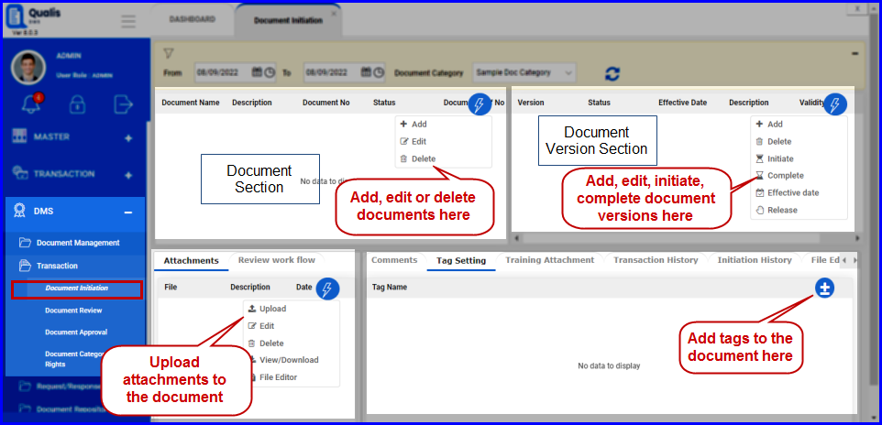
FIGURE: - Document Initiation Screen

Add Document
To add a document, follow these steps:
- In the Document Initiation screen, In the Document Section click action menu and then click Add. The Add Document screen appears as shown in the figure:
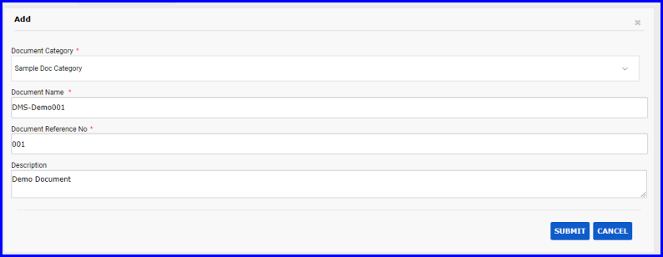
FIGURE: - Add Document Screen
- In the Document Category field, select document category to add the document.
- In the Document Name field, type the name of the document you add.
- In the Document Reference No field, type the reference number for the document.
- In the Description field, type description if any.
- Click SUBMIT. You can see the document you added in the document section listed as shown in the figure:
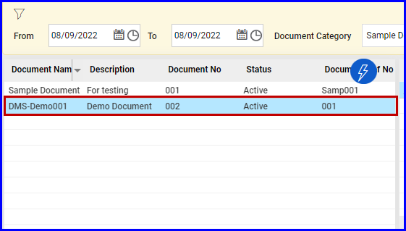
FIGURE: - Document Added

Add Version
Once you add a document, you must add document version. By default the document version will be in the “draft” status until it is changed manually.
To add a version for the document, follow these steps:
- In the Document Initiation screen, In the Document Section select the document to add a version.
- In the Document Version Section, click action menu and then click Add as shown in the figure:
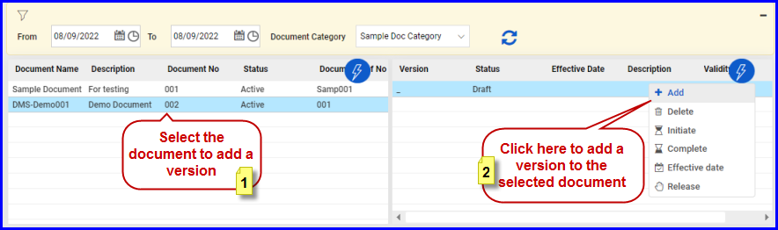
FIGURE: - Adding a Document Version
- In the confirmation dialog click OK. A version of the document is added and appears in the ‘Draft’ status as shown in the figure:
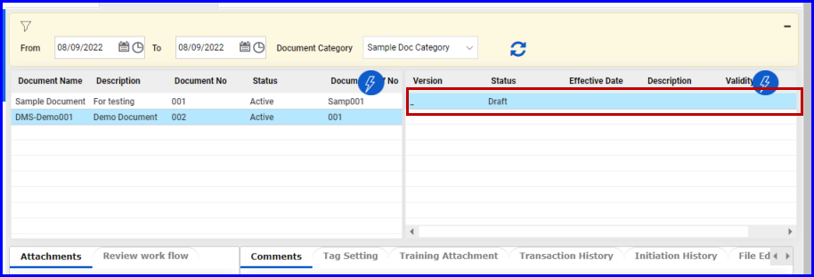
FIGURE: - Document Version Added

Add or Remove Users to the Review Workflow
You can add or remove users to the review workflow until the document is initiated. Once the document is initiated, you cannot modify the list of users in the workflow.
To add/remove users to the review workflow, follow these steps:
- In the Document Initiation screen, In the Review workflow tab, click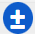.
- For more details on adding and removing roles/users to review workflow click here.

Add Attachments
You must add the document as attachment in the Document Initiation screen. Documents with Docx and PDF extension can be added.
To add attachment, follow these steps:
- In the Document Initiation screen, In the Document Version Section, select the document version to add attachment.
- In the Attachments tab, click action menu and then click Upload as shown in the figure:
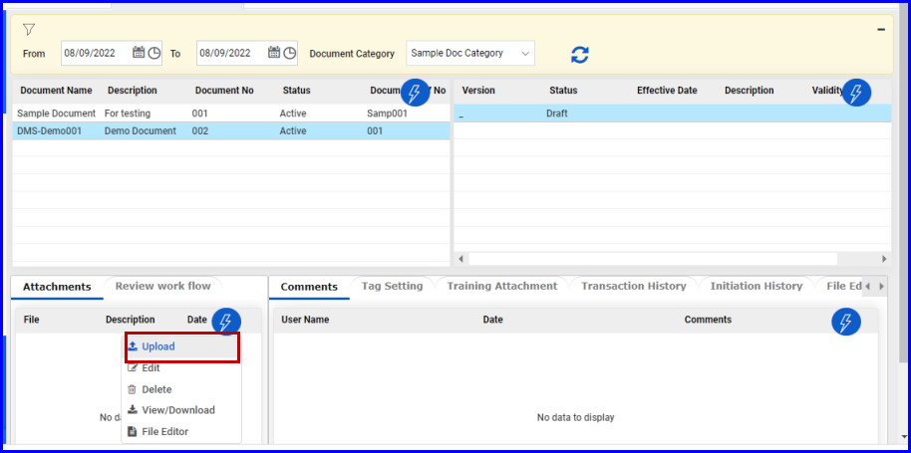
FIGURE: - Adding Attachments
The Attachment dialog appears as shown in the figure:
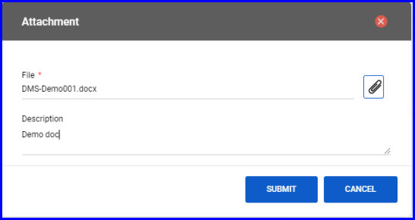
FIGURE: - File Attachment Dialog
- In the File field, click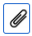. In the file Open dialog, locate the file and then click Open.
- In the Description field, type description about the file.
- Click SUBMIT. The attached file is listed as shown in the figure:
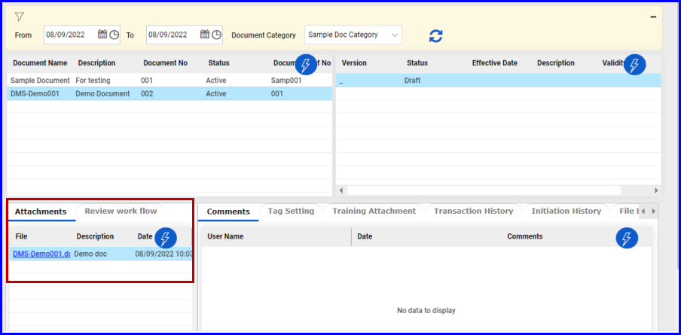
FIGURE: - File Attached
- Click action menu and then click File Editor. The attached file opens in ONLY OFFICE editor as shown in the figure:
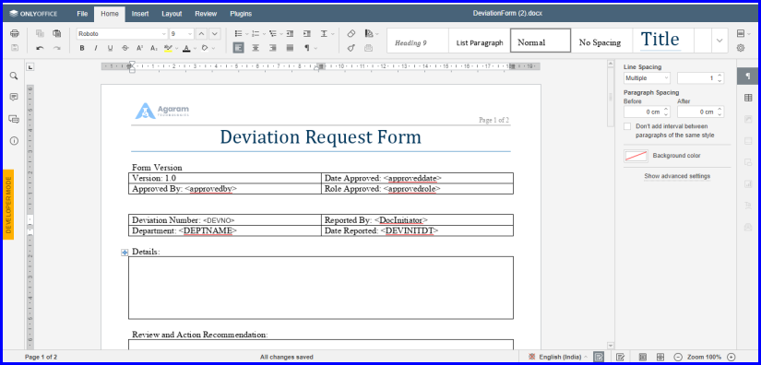
FIGURE: File Editor
- Do required edits and save.
Same way, you can add attachments in the Training Attachments tab as shown in the figure:
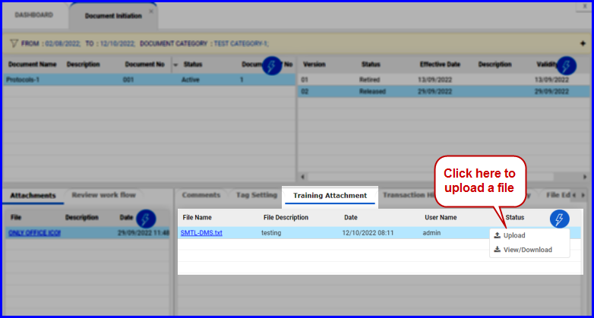
FIGURE: Uploading Training Attachment
Click View/Download to download the attached document to t he local storage as shown in the figure:
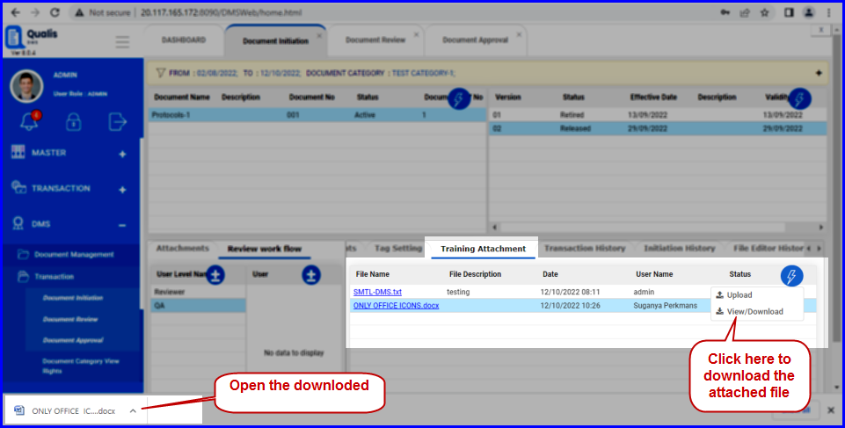
FIGURE: Downloading Training Attachment

Add Comments
You can add comments to the files attached. To do so, follow these steps:
- In the Attachment tab, select the file you want to add comments.
- In the Comments tab, click action menu and then click Add. The Add dialog appears as shown in the figure:
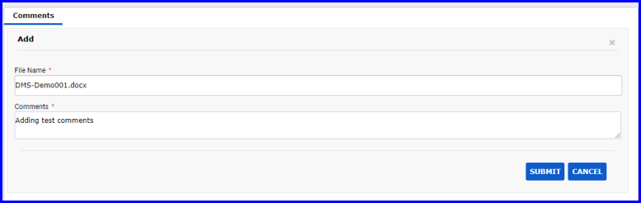
FIGURE: - Add Comments Dialog
- In the Comments field, type your comments and then click SUBMIT.
- Now you can see comments you just added appears in the grid.

Tag Setting
Note: Before adding tags here in the Tag Setting tab, go to the Tag Master and add all tags relevant to the current document.
To set tags to the document, follow these steps;
- In the Document Initiation screen, In the Attachment tab select the attached file to add tags. And then go to the Tag Setting tab.
- In the Tag Setting tab, click. The Add / Remove Tag dialog as shown in the figure:
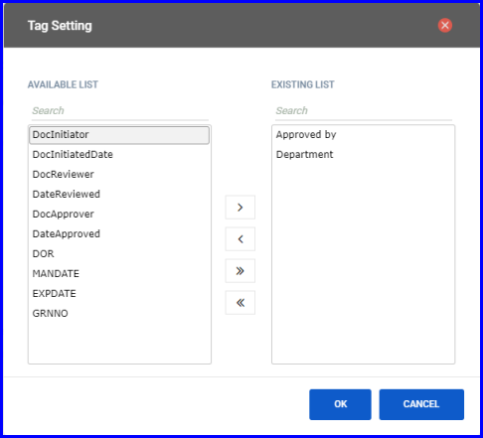
FIGURE: - Add / Remove Tags Dialog
- You can see the list of available tags in the left side. Select a tag and click to add them to the document. You can add multiple or all tags to the document as required.
- Click SUBMIT.
The added tags appear in the grid as shown in the figure:
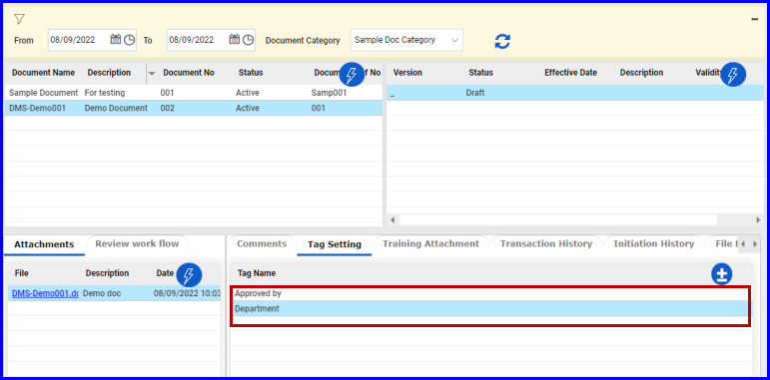
FIGURE: - Tag Setting Tab Showing Tags Added

Initiate Document
The document has to be initiated by the initiator to make the document available for review for the reviewer. To initiate the document follow these steps:
In the Document Initiation screen, after you add document, add version, add attachment and set tags, follow these steps to initiate the document:
- Select the document, select the version you want to initiate, click action menu and then click Initiate as shown in the figure:
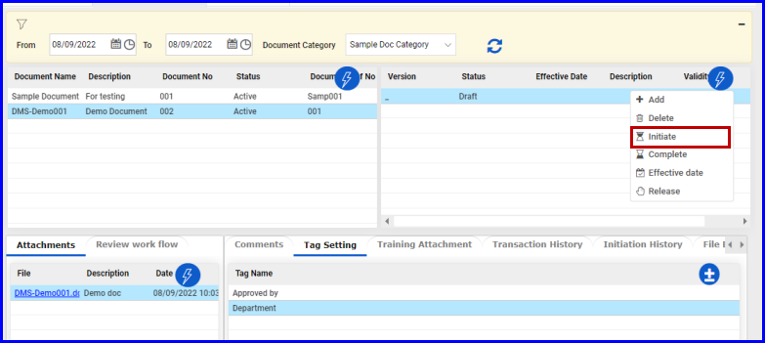
FIGURE: - Initiate Document
- The document is initiated and the status appears as Initiated as shown in the figure:
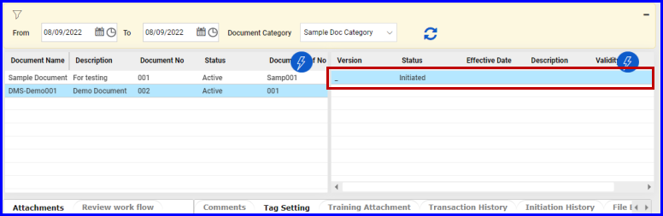

Document Review
Document Review screen enables the reviewer to review the initiated document.
- On the Explorer, click DMS, click Document Management, and then click Document Review. The Document Review screen appears as shown in the figure:
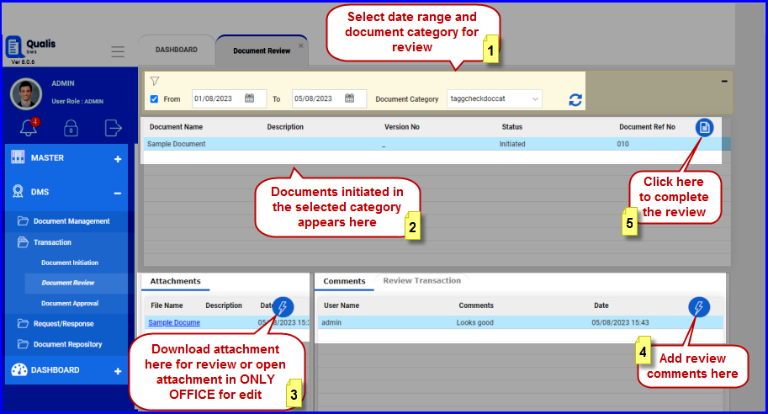
FIGURE: - Document Review Screen
In the Document Review screen the reviewer can do the following:
- Download attachments for review
- Add review comments
- View complete review transactions

Review Attached Document
To review the attached document, follow these steps:
- In the Document Review screen, select the date range and Document Category. Documents initiated for review appears.
- Click to select the document to review.
- In the Attachments tab, click action menu and then click View/Download to download the document for review.
- Review the downloaded document. Refer the above figure.

Add Review Comments
- In the Comments tab, click Add as shown in the figure:
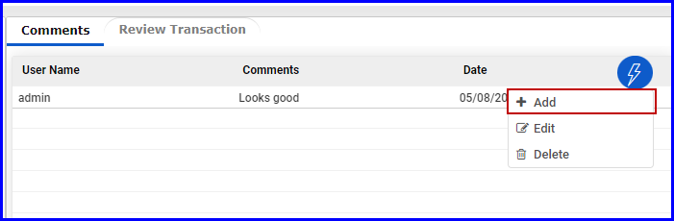
FIGURE: Adding Review Comments
- The Comments dialog appears as shown in the figure:
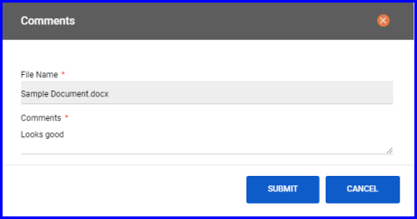
FIGURE: Comments Dialog
- In the File Name field, the attached file name appears.
- In the Comments field, type your review comments and then click SUBMIT.

Complete Review
- Click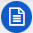 once you reviewed the document to complete the review as shown in the figure:
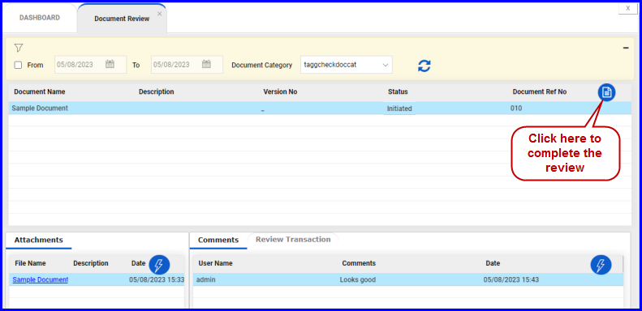
FIGURE: - Complete Reviewing the Document
The status of the document would appear as Reviewed as shown in the figure:
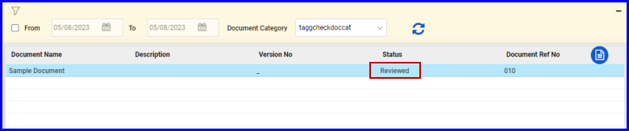
FIGURE: - Reviewed Document
Now the document goes to the initiator’s queue to complete the review process. The initiator shall address the comments for the review points given in the comments tab and then complete. The initiator can also attach document in the Attachment tab for approval.
To do so, follow these steps:
- In the Document Initiation screen, after addressing the review comments, click action menu and then click Complete as shown in the figure:
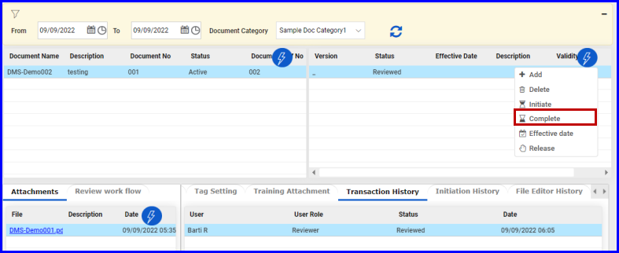
FIGURE: - Address Review Comments and Complete
The status of the document changes to “Completed” as shown in the figure:
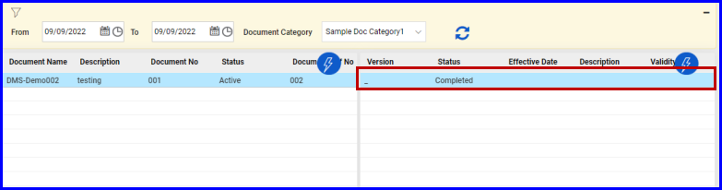
FIGURE: - Document Completed Status after Review
Once completed, the document goes to the Approver’s queue for approval.

Approving Documents
To approve documents, follow these steps:
- On the Explorer, click DMS, click Document Management, and then click Document Approval. The Document Approval screen appears as shown in the figure:
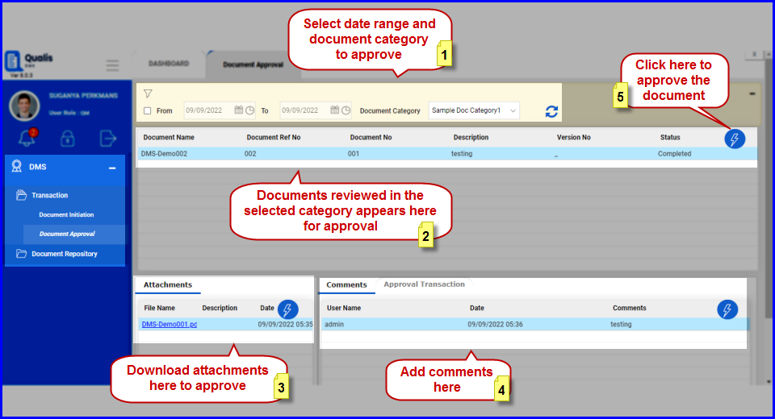
FIGURE: - Document Approval Screen
- Select the date range and Document Category. Documents completed review would appear as shown in the above figure.
- Click to select the document to approve.
- In the Attachments tab, click action menu and then click View/Download to download the document for review and approve.
- In the Document section click action menu and then click Approve to approve the document. The document status is changed to “Approved” as shown in the figure:
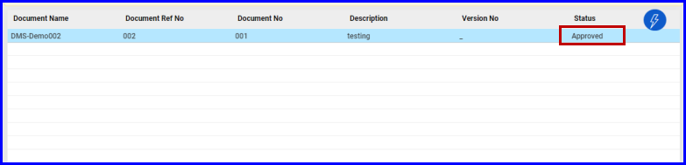
FIGURE: - Document Approval Screen Showing Approved Status
Note: The approver can reject the document if required. To reject a document, in the action menu select Reject.
The approved or rejected document goes to the initiator’s queue.
Note: All the approvers in the workflow should approve the document based on the step provided in the document workflow.

Effective Date
Now the approved document appears in the initiator’s queue. The initiator can set effective date for the approved document. To do so, follow these steps:
- In the Document Initiation screen, select the approved document, click action menu and then click Effective Date as shown in the figure:
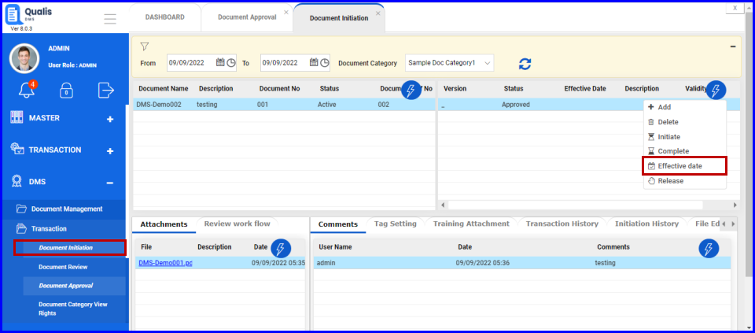
FIGURE: - Setting Effective Date
- The Choose Effective Date dialog appears as shown in the figure:
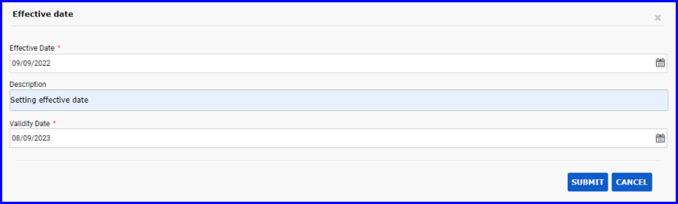
FIGURE: - Choose Effective Date Dialog
- In the Effective Date field, select effective date for the document.
- In the Description field, type description if any.
- In the Validity Date field, select the date until the document is valid.
- Click SUBMIT. The document will be available for document request for the users from the effective date.
The effective date appears with the description as shown in the figure:
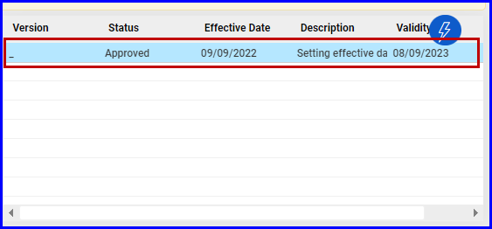
FIGURE: - Document Initiation Screen Showing Effective Date

Releasing the Document
After setting the effective date the document can be released. To release the document, follow these steps:
- In the Document Initiation screen, select the document click action menu and then click Release as shown in the figure:
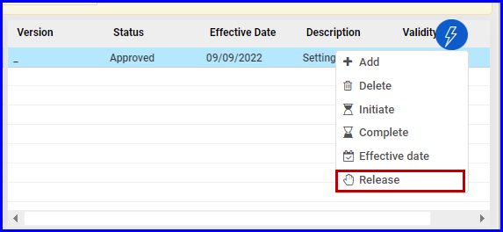
FIGURE: - Releasing the Document
- The status is changed to “Released” as shown in the figure:
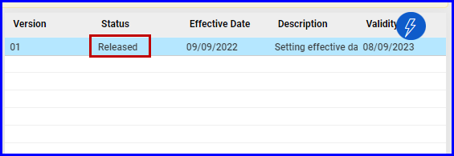
FIGURE: - Released Document

Viewing Initiation History
User can view the complete document initiation history in the Initiation History tab as shown in the figure:
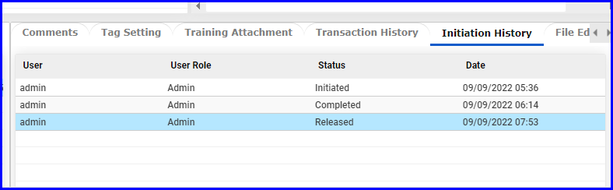
FIGURE: - Initiation History Tab

Viewing Transaction History
User can view the complete document transaction history in the Transaction History tab as shown in the figure:
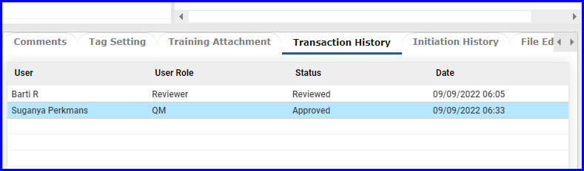
FIGURE: - Transaction History Tab

Document Category View Rights
Document Category View Rights screen enables you to grant or revoke view permissions for document category based on section and user.
Follow the on screen instructions to add or revoke permission for the selected document category.
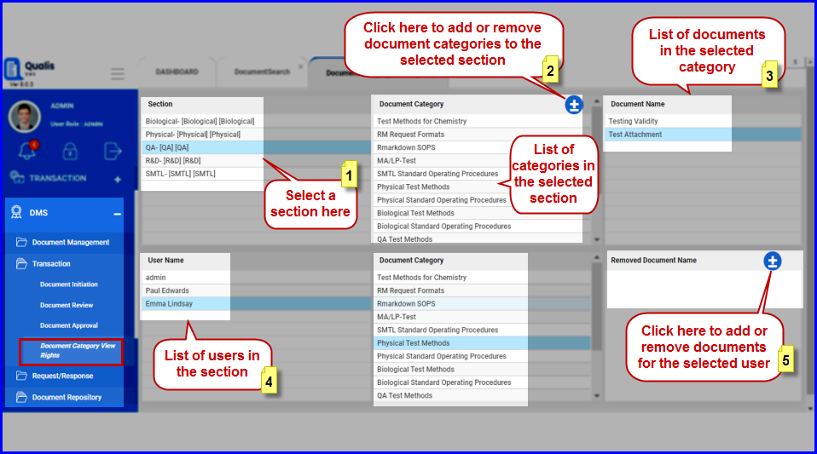
FIGURE: - Document Category View Rights Screen

Section Based Document Rights
To define document category rights based on section, follow these steps:
- On the Explorer, click DMS, click Transaction, and then click Document Category View Rights. The Document Category View Rights screen appears as shown in the figure:
- Under Section, select a section, under Document Category click . The Add and Remove Document Category dialog appears as shown in the figure:
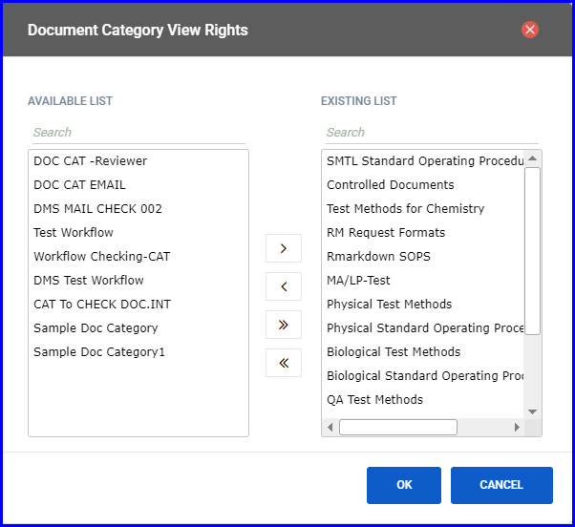
FIGURE: - Add and Remove Document Category Dialog
- Select a category under AVAILABLE LIST and then click to add to the EXISTING LIST.
- Click OK. You can see the category added under Document Category. And the list of documents in the selected Document Category appears under Document Name.

User Based Document Rights
To define document rights based on users, follow these steps:
- On the Explorer, click DMS, click Transaction, and then click Document Category View Rights.
- Under Section, select a section. You can see list of users in the selected section.
- Under User Name select a user you want to define rights. You can see list of categories the user has rights under Document Category.
- Under Removed Document Name, click. The Remove Document dialog appears as shown in the figure:
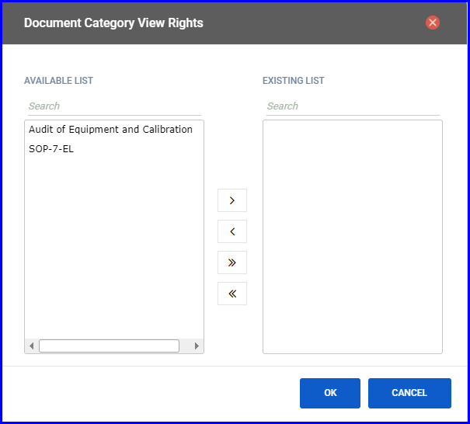
FIGURE: - Add and Remove Document Category Dialog
- Select a document under AVAILABLE LIST and then click to add to the EXISTING LIST. The documents added to the EXISTING LIST are hidden from the user.
- Click OK.
The documents added under EXISTING LIST appear under Removed Document Name and the user cannot view these documents.

Document Request
Once document is released, user with document request rights can request a document for print.
To request a document, follow these steps:
- On the Explorer, click DMS, Request/Response and then click Document Request. The Document Request screen appears as shown in the figure:
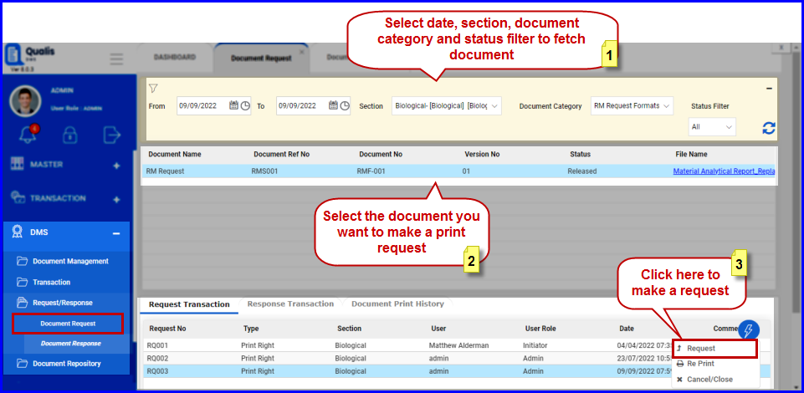
FIGURE: - Document Request Screen
- Select Date, Section, Document Category and Status Filter.
- Select the document you want to request for print.
- In the Request Transaction tab, click action menu and then click Request as shown in the above figure. The Request Transaction dialog appears as shown in the figure:
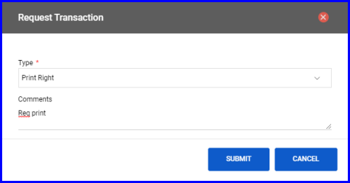
FIGURE: - Request Transaction Dialog
- In the Type field, select the request type: Print Right.
- In the Comments field, type your comments.
- Click SUBMIT. The request appears in the grid as shown in the figure:
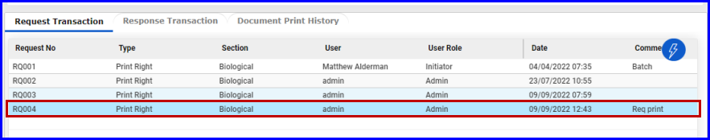
FIGURE: - Document Request Screen – Request Added

Document Response
User with document response rights can respond document request for print.
To respond to a document request, follow these steps:
- On the Explorer, click DMS, Request/Response and then click Document Response. The Document Response screen appears as shown in the figure:
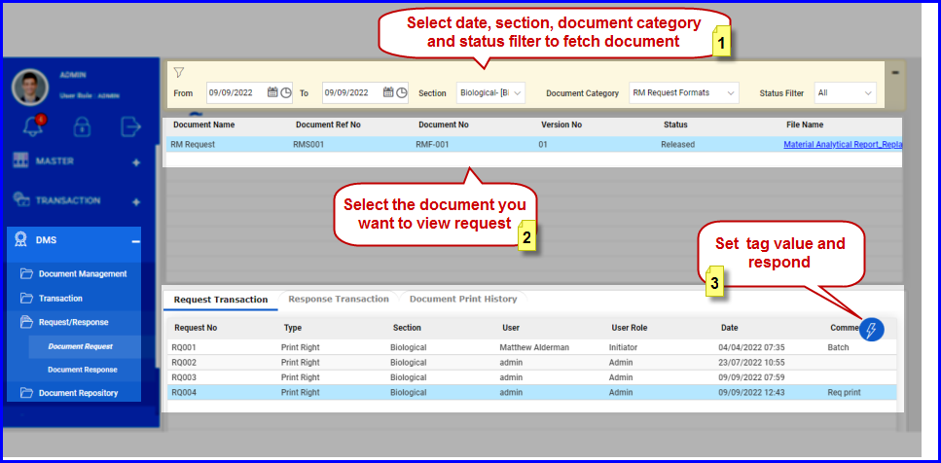
FIGURE: - Document Response Screen
- Select Date, Section, Document Category and Status Filter.
- Select the document you want to respond.
- Click action menu and then click Tag Values. In the Tag Values dialog, type value for the tags as shown in the figure:
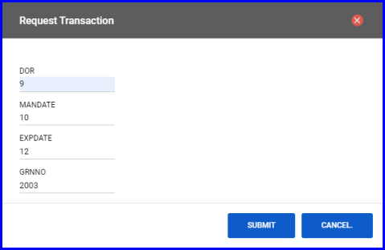
FIGURE: - Tag Values Dialog
Note: Tags of Tag Type “NA” set in Tag Master would appear here for value entry.
- In the Request Transactions tab, select the request click action menu and then click Response as shown in the figure:
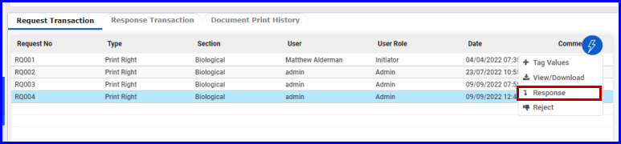
FIGURE: - Document Response
- The Request Transaction dialog appears as shown in the figure:
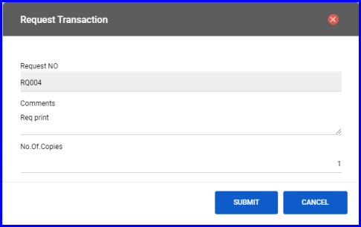
FIGURE: - Request Transaction Dialog
- In the Comments field, type your comments.
- In the No of Copies field, type number of copies for print.
- Click SUBMIT.
Users who made document requests can view the document responses

Printing the Document
Once the user receives document response, they can print the document. To do so, follow these steps:
- In the Document Request screen, go to the Response Transaction tab as shown in the figure:
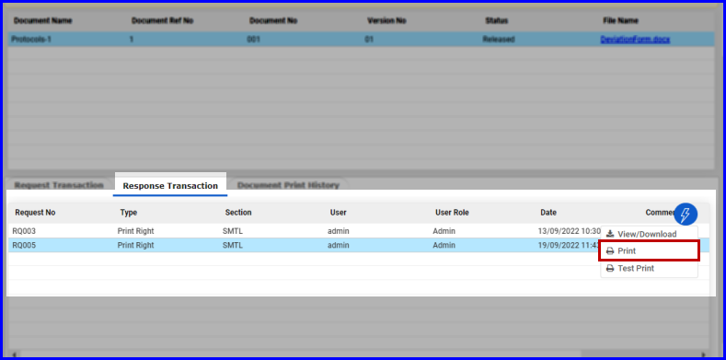
FIGURE: - Printing Document 1
- Select the request, click action menu and then click Print. The Print dialog appears as shown in the figure:
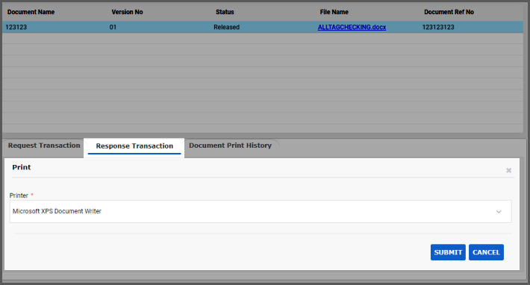
FIGURE: - Printing Document 2
- In the Printer field, select the printer and then click SUBMIT.
On successful printing, you will see an alert saying "Document printed successfully".

Test Print
Before you print a document, you can test print the document.
- Select the request, click action menu and then click Test Print. The Alert Dialog appears as shown in the figure:
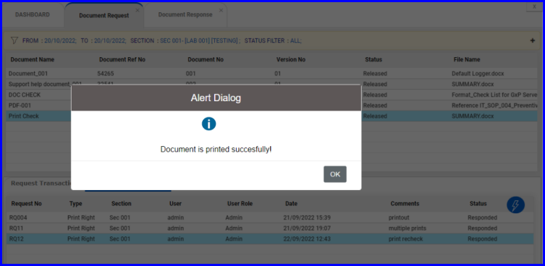
FIGURE: - Alert Dialog
You can see a success message saying "Document is printed successfully!".

Document Repository View
Document Repository View screen enables the user to view documents in the repository. You can filter documents based on selected date range, section, document category and status of the document.
To view documents in the document repository, follow these steps:
- On the Explorer, click DMS, Document Repository and then click Document Repository View. The Document Repository View screen appears as shown in the figure:
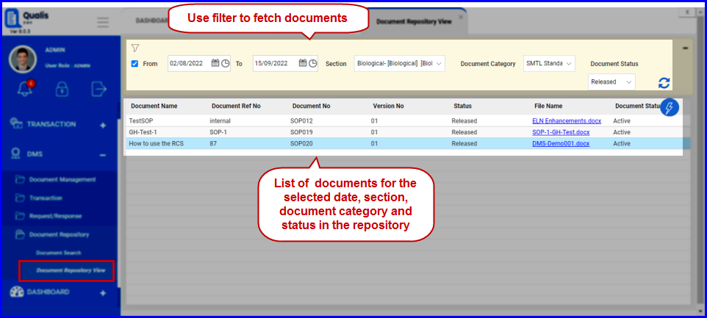
FIGURE: - Document Repository View
- Use the filter: Select From and To date, select Section, Document Category and Document Status and then click .
- You can see the list of documents in the repository for the selected fields in the filter as shown in the above figure.
- You can do the following in the Document Repository View screen:
- Select a document, click action menu and then click View/Download to download the document to local storage.
- Select a document, click action menu and then click Convert as PDF to convert the document to PDF.
- Select a document, click action menu and then click view as PDF to view the document in PDF format. The document opens in PDF format.
- Select a document, click action menu and then click Active to activate document.
- Select a document, click action menu and then click Inactive to deactivate the document.

Document Search
Document Search screen enables the user search documents in the repository. You can search documents based on selected document category and document name.
To search documents in the document repository, follow these steps:
- On the Explorer, click DMS, Document Repository and then click Document Search. The Document Search screen appears as shown in the figure:
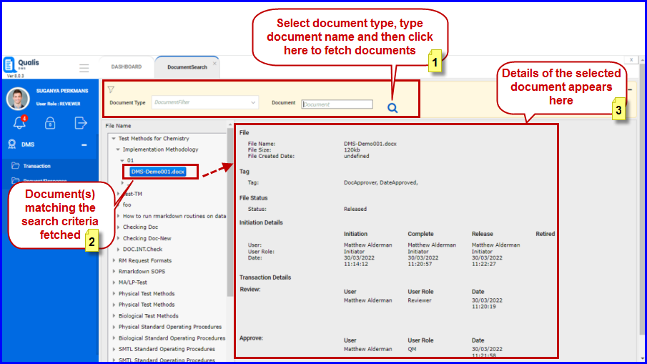
FIGURE: - Document Search
- In the Document Type field, select type.
- In the Document field, type name of the document and then click .
- Document matching the search criteria are fetched and appears in the left panel.
- select the document. details of the selected document appears in the right panel as shown in the above figure.

Dash Board

Dashboard Rights
Dashboard Rights screen enables you to set dashboard rights to the user. You can define dashboard rights in the user role level by adding/removing dashboard types for the selected role. You can also set dashboard rights to the individual user.
To set dashboard rights, follow these steps:
- On the Explorer, click DASHBOARD, DashBoard and then click Dashboard Rights. The Dashboard Rights screen rights to the individual user level.
- Under User Levels you can see the list of roles. Click to select a role. Now you can see the dashboards added to the role selected appears as shown in the figure:
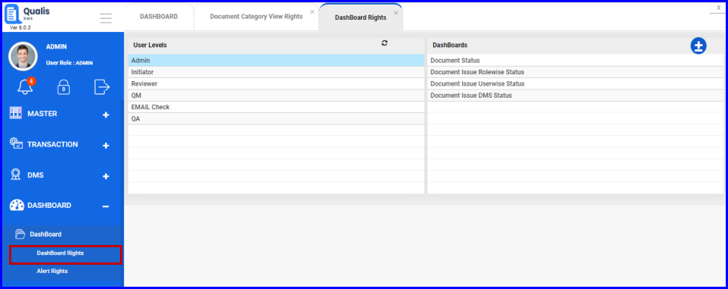
FIGURE: - Dashboard Rights Screen
- Under User Level, select the User Role to set dashboard rights to the role level.
- Click . The DashBoards dialog appears as shown in the figure:
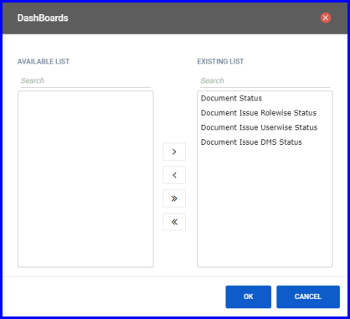
FIGURE: - Add / Remove Dashboard
- Add / remove dashboards for the selected user role and then click OK.
Same way, you can set dashboard rights for the other roles.

Alert Rights
Alert Rights screen enables you to set alert screen rights to the user. You can define alert screen rights in the user role level by adding/removing alert screens for the selected role. You can also set alert screen rights to the individual user.
To set alert screen rights, follow these steps:
- On the Explorer, click DASHBOARD, DashBoard and then click Alert Rights. The Alert Rights screen appears as shown in the figure:
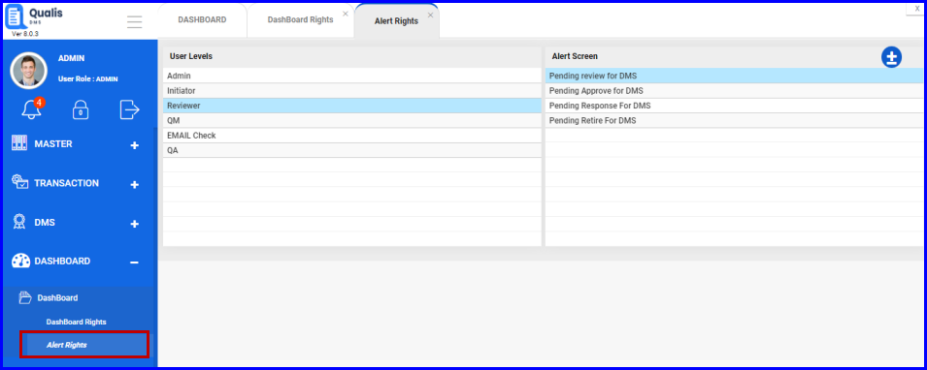
FIGURE: - Alert Rights Screen
- Under User Level, select the User Role to set alert screen rights to the role level.
- Under User Level you can see the list of roles. Click to select a role. Now you can see the alert screens added to the role selected under Alert Screens.
- Click . the Alert Screen dialog appears as shown in the figure:
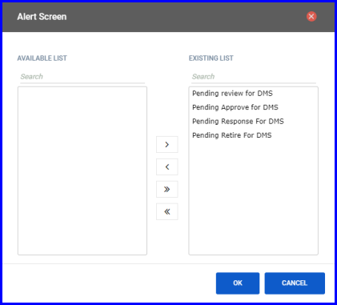
FIGURE: - Add / Remove Dashboard
- Add / remove alert screens for the selected user role and then click OK.
Same way, you can set alert screen rights for the other roles.

