Adam Garcia

Dr. Barton

CISA4324

1.

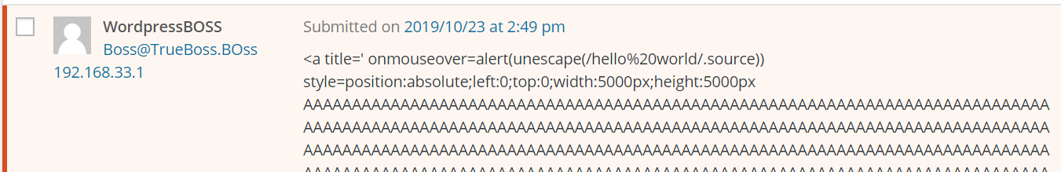

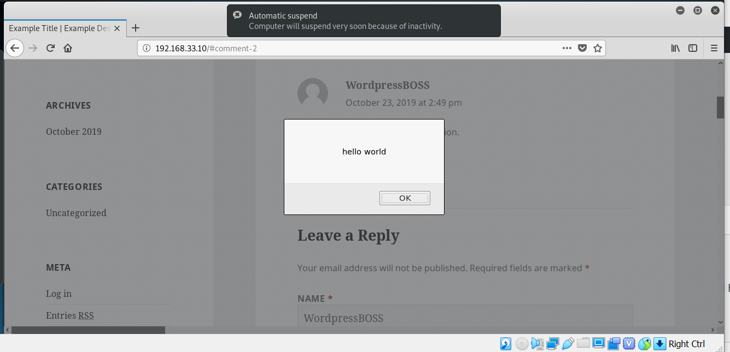

2.

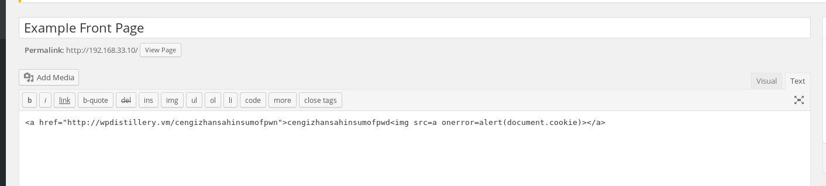

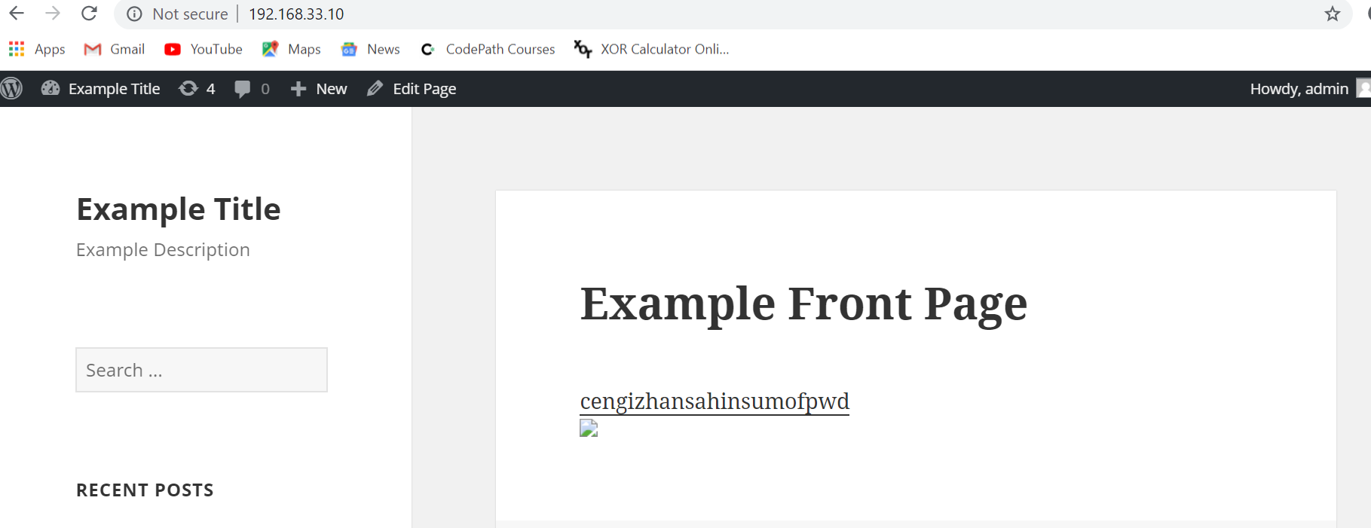

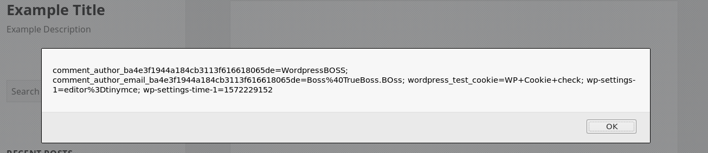

3.

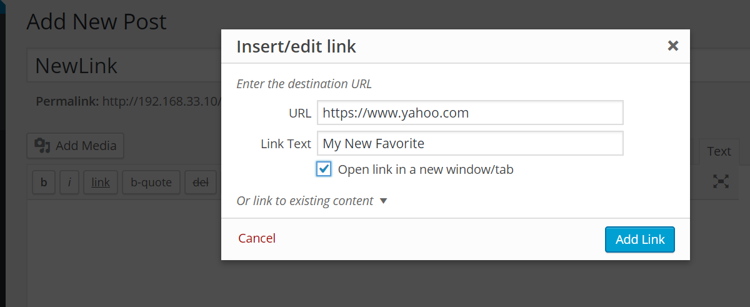

Tried injecting onmouseover=”alert(‘Error!’)” but it was showing up in html body for me to inject.

