**Overview**: Alphabets Soup is a non-profit organization dedicated to on predicting the which charity funding leads to more success. More than 34,000 foundations have been funded by Alphabet Soup.

**Results**:

* Data Preprocessing
  + What variable(s) are considered the target(s) for your model?
    - IS_SUCCESSFUL feature is the target.
  + What variable(s) are considered to be the features for your model?
    - All remaining features are the one-hot ending are versatile features to pass on.
  + What variable(s) are neither targets nor features, and should be removed from the input data?
    - EIN and Name features were removed.
* Compiling, Training, and Evaluating the Model
  + How many neurons, layers, and activation functions did you select for your neural network model, and why?
    - Two layers training model was used, this generated 5,981 trainable parameters.

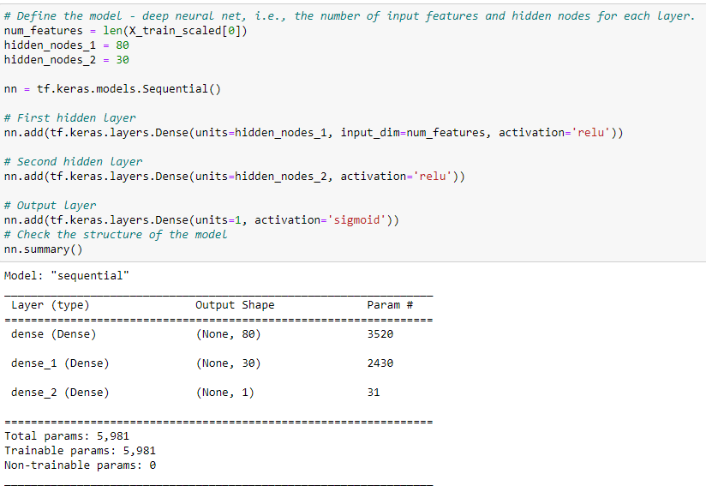

* + Were you able to achieve the target model performance?
    - Unfortunately, after three attempts I was unable to get the accuracy above 75%
  + What steps did you take to try and increase model performance?
    - I tried to increase the number of epochs by 200 each attempt, also an increased number of nodes.

**Summary**: I believe with more attempts I would have been able to achieve an accuracy of 75%. If more time was permitted, I believe I could attempt to add more layers, increase nodes and greatly increase the number of epochs.