ECE 5554 SU22 – Dr. Jones – HW1

**Part 2:**

Animals img size: (768, 1024, 3)

Stonehenge img size: (768, 1024, 3)

**Part 3:**

Animals red avg: 92.87458928426106

Animals green avg: 100.50979868570964

Animals blue avg: 128.48477045694986

Stonehenge red avg: 92.87458928426106

Stonehenge green avg: 100.50979868570964

Stonehenge blue avg: 128.48477045694986

**Part 5:**

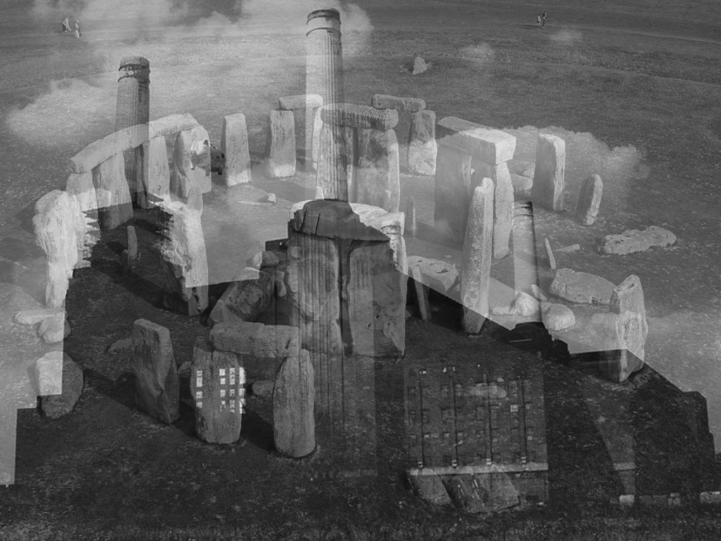

**Part 6:**

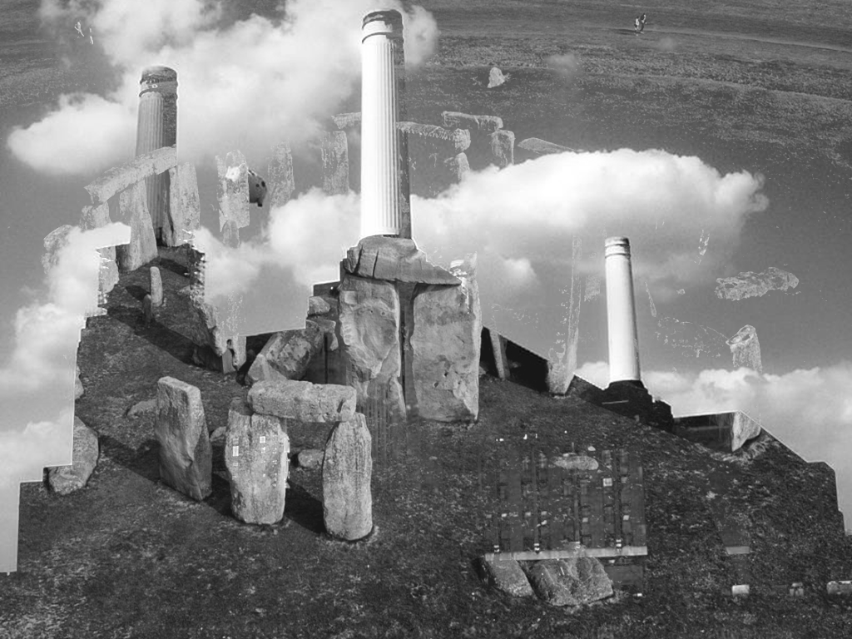

**Part 7:**

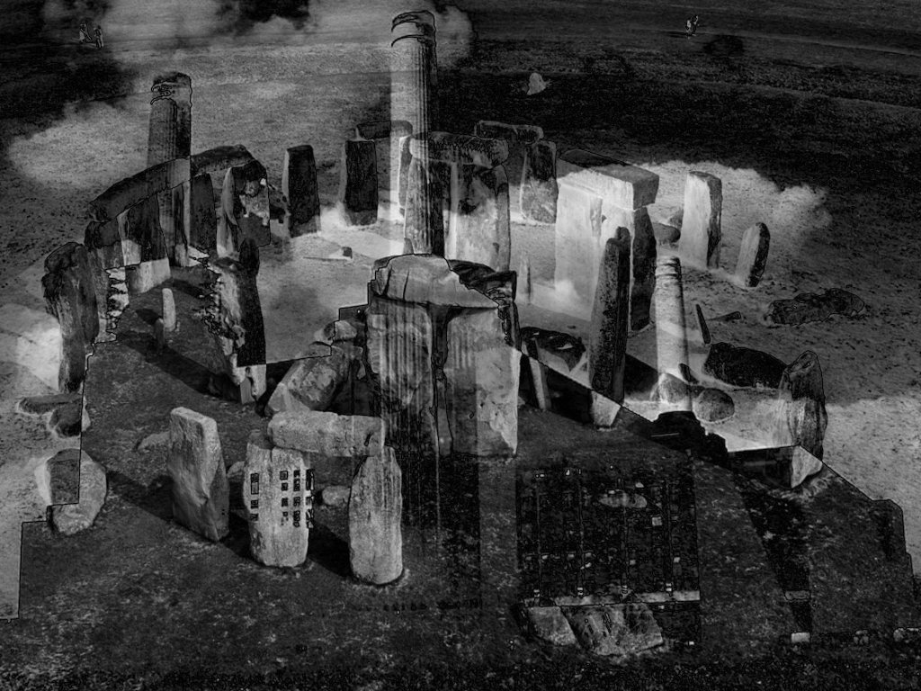

Code

Homework1.py:

import cv2

import numpy as np

#%%

# Part 1

animals = cv2.imread("animals.png")

# Part 2

height = len(animals)

width = len(animals[0])

depth = len(animals[0, 0])

print(f"Animals img size: {animals.shape}")

# Part 3

animals_red = animals[:,:,2]

animals_green = animals[:,:,1]

animals_blue = animals[:,:,0]

print(f"Animals red avg: {np.mean(animals_red)}")

print(f"Animals green avg: {np.mean(animals_green)}")

print(f"Animals blue avg: {np.mean(animals_blue)}")

#%%

# Part 1

stonehenge = cv2.imread("Stonehenge_1024x768.png")

# Part 2

height = len(stonehenge)

width = len(stonehenge[0])

depth = len(stonehenge[0, 0])

print(f"Stonehenge img size: {stonehenge.shape}")

# Part 3

stonehenge_red = stonehenge[:,:,2]

stonehenge_green = stonehenge[:,:,1]

stonehenge_blue = stonehenge[:,:,0]

print(f"Stonehenge red avg: {np.mean(animals_red)}")

print(f"Stonehenge green avg: {np.mean(animals_green)}")

print(f"Stonehenge blue avg: {np.mean(animals_blue)}")

#%% Pixel by Pixel Avg

def avg_pixel_by_pixel(img1, img2):

# Assuming both images are the same size

height = len(img1)

width = len(img1[0])

new_image = np.zeros((height, width), dtype = "uint8")

for y_pix in range(height):

for x_pix in range(width):

img1_value = img1[y_pix][x_pix]

img2_value = img2[y_pix][x_pix]

avg_value = np.mean([img1_value, img2_value])

new_image[y_pix, x_pix] = avg_value

return new_image

# Part 4

animals_grayscale = cv2.cvtColor(animals, cv2.COLOR_BGR2GRAY)

stonehenge_grayscale = cv2.cvtColor(stonehenge, cv2.COLOR_BGR2GRAY)

# Part 5

avg_image = avg_pixel_by_pixel(animals_grayscale, stonehenge_grayscale)

# show images

cv2.namedWindow('INPUT', flags=cv2.WINDOW_NORMAL)

cv2.imshow('INPUT',avg_image)

cv2.waitKey(0)

cv2.destroyAllWindows()

cv2.imwrite("part5_img.png", avg_image)

#%% Pixel by Pixel Max

def max_pixel_by_pixel(img1, img2):

# Assuming both images are the same size

height = len(img1)

width = len(img1[0])

new_image = np.zeros((height, width), dtype = "uint8")

for y_pix in range(height):

for x_pix in range(width):

img1_value = img1[y_pix][x_pix]

img2_value = img2[y_pix][x_pix]

max_value = np.max([img1_value, img2_value])

new_image[y_pix, x_pix] = max_value

return new_image

# Part 6

max_image = max_pixel_by_pixel(animals_grayscale, stonehenge_grayscale)

# show images

cv2.namedWindow('INPUT', flags=cv2.WINDOW_NORMAL)

cv2.imshow('INPUT',max_image)

cv2.waitKey(0)

cv2.destroyAllWindows()

cv2.imwrite("part6_img.png", max_image)

#%% Pixel by Pixel Difference

def diff_pixel_by_pixel(img1, img2):

# Assuming both images are the same size

height = len(img1)

width = len(img1[0])

new_image = np.zeros((height, width), dtype = "uint8")

for y_pix in range(height):

for x_pix in range(width):

img1_value = img1[y_pix][x_pix]

img2_value = img2[y_pix][x_pix]

diff_value = cv2.absdiff(np.array(img1_value), np.array(img2_value))

new_image[y_pix, x_pix] = diff_value

return new_image

# Part 7

diff_image = diff_pixel_by_pixel(animals_grayscale, stonehenge_grayscale)

# show images

cv2.namedWindow('INPUT', flags=cv2.WINDOW_NORMAL)

cv2.imshow('INPUT', diff_image)

cv2.waitKey(0)

cv2.destroyAllWindows()

cv2.imwrite("part7_img.png", diff_image)