**Battle of Toronto Neighborhoods**

Alden E. Garcia

September 20, 2020

**1. Introduction**

**1.A Background**

Toronto is widely considered one of the worlds’ top cities and attracts of number of people from all backgrounds from Canada and beyond. Like most major cities, Toronto offers a massively diverse city from ethnic backgrounds, restaurants, shops, amenities, landscapes, housing, and lifestyles. With the technology boom in recent years, more and more people are making their way into major cities in hope of landing the perfect job, lifestyle, or experiencing the big city life that is so often portrayed in media such as movies and tv shows. With the variety of different venues and offerings that Toronto has, it appeals to many people with all different types of backgrounds. All those backgrounds may look for different amenities and housing in different parts of the city.

**1.B Problem**

One of the biggest problems facing clients or users moving is simply where is the perfect place to move. Our application is to solve this problem by listing our communities, neighborhoods, and venues found all over Toronto. The data we use will allow the user to compare and decide to move to a specific area in Toronto.

**1.C Interest**

People looking to move to Toronto is the main target of this application. The application will cater its results to many people of different backgrounds as our data will show. Everyone from families, singles, and business associates can compare neighborhoods based on venues to try and pick the neighborhood that best suits them. From Downtown Toronto to the outskirts and suburbs, our application contains data from a variety of different places around Toronto.

**2.Data**

**2.A Data Sources**

#### In order to provide necessary information to our clients or to the stakeholders, Foursquare API to collect data such as type and frequency for venues in each neighborhood. By segmenting and clustering, we can find the top and most popular venues in each neighborhood in Toronto. This will give the end user an idea of what kind of amenities are and where there are located. The list of postal codes, communities, and neighborhoods in Toronto are sourced from a Wikipedia page found [here](https://en.wikipedia.org/wiki/List_of_postal_codes_of_Canada:_M).

#### 2.B Data Cleaning

#### Not all information from the Wikipedia page is relevant to our application. We first created a table that would organize the communities and neighborhoods to work with data easier. As you can see from the page, there are lines of data in community and neighborhood column that has “Not assigned” in them. This information is not useful to our application for no information. While creating the table, we needed to make sure these lines did not show up and cause unnecessary errors while using the application. We sourced the information from the Wikipedia page while scaping any line of data that included “ Not assigned” in the line. After the table was produced, we added geographical coordinates to each of the neighborhoods and mapped them out for a better visual display.

#### 2.C Feature Selection

#### After cleaning up our data, we had about 103 communities with some of those communities having multiple neighborhoods in each one. FourSquare API which is used for location data on venues around these neighborhoods and communities returned 2145 venues in 274 unique categories in those areas. With the geographical coordinates of the neighborhoods and venues to cross reference, we are able to cluster them and see the most common venues in each of the neighborhoods and communities to provide more specific information to the end user. We then listed out the 10 most common venues to get a more specific pictures of each of the different neighborhoods. We mapped our the neighborhoods and their cluster for our users to get a more visual display.

#### Table 1. Sample of Neighborhoods with coordinates

#### 

#### Table 2. Sample of Neighborhoods with venues

#### 

#### Table 3. Sample of map of neighborhoods.

#### 3.Methodology

In this project, we looked at what type of venues, where they are located, and how often does a specific type of venue appear within the various neighborhoods in Toronto.

First, our application took neighborhood data from a Wikipedia page in order to find the exact location (longitude and latitude) of each of the different neighborhoods. After marking the locations of each neighborhood, we were able to visualize where the neighborhoods are located by producing a map from the folium package.

Second, we used FourSquare API location data to find all the different types of venues located in the various neighborhoods around Toronto. This gave us an idea of what type and how many venues are located within a specific neighborhood. FourSquare returned **2145** venues around Toronto. This produced **274** unique categories that we can use to organize our data in.

Third, we were able to take the FourSquare and location data and place them into the neighborhoods they are located in. From there we can cluster the neighborhoods together then create a list of the **10** most common venues found.

Finally, after looking through the list of neighborhoods and their venues, we can choose which neighborhoods hold the most interest for our users and compare them. By comparing the neighborhoods side by side, we can see their locations and what the **10** most common venues are next to each other. This will give our user a very visual display of what the neighborhoods are like and use that information to help them decide.

Table 4. Sample of communities and their most common venues.

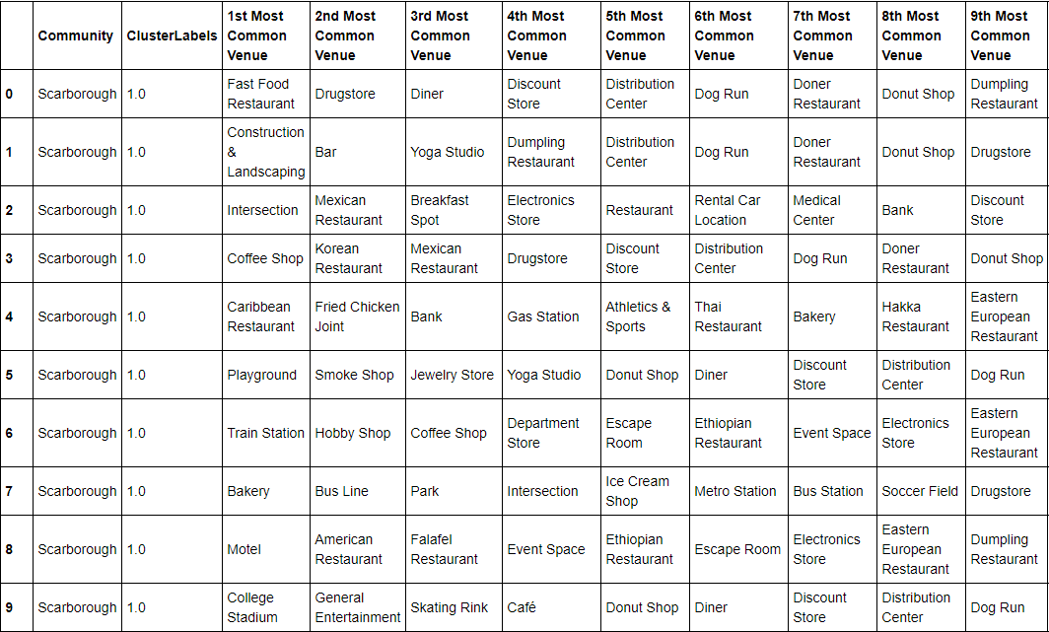

**3.A Analysis**

Next we clustered the neighborhoods together so we can get a better picture of what venues are where and even which neighborhoods are close to each other. This will allow our user to analyze the data and see not only what is in their neighborhood of choice, but also what may be nearby for them to travel too. After clustering the neighborhoods, we will be able to compare neighborhoods together to better see which neighborhoods suit our users best.

#### Table 5. Sample of most common venues based on neighborhoods.

#### Table 6. Sample of clustered neighborhoods mapped.

#### 

#### Table 6. Sample of test comparison of neighborhoods.

#### 

#### 4.Results and Discussion

There are many neighborhoods and even more venues to consider. If our clients or stakeholders had to do this by themselves manually, it would take hours if not days to even find a little information that there are looking for. Based on our analysis, we have found the 10 most common venues in each neighborhood. Our clients or end users may have the same top 3 venues there are looking for which would make several neighborhoods appear the same which would not provide enough distinction between them. With **2145** venues in **274** unique categories with **103** different communities with some of those communities having **2 or more** neighborhoods in each one. There is a lot of area to cover in order to pick the right neighborhood for our clients.

We started with listing all the neighborhoods with their geographical coordinates (longitude/latitude). After that we pulled FourSquare location data on all the different type venues located in the neighborhoods in Toronto. With all the location data on venues, we were able to organize them, and sort out the most common venues in each neighborhood. We cluster the neighborhoods together in their respective communities and print out a table.

The most informative part of this application is the section that the end user or client would use most. After looking at the list of neighborhoods and their venues, they can compare neighborhoods or communities together side by side to give them a more visual comparison. We pulled **Humber Summit** and **Christie** neighborhoods together for a side by side test comparison on their 10 most common venue. As mentioned before, the top 3 most common venues may be the same for a number of people, but what this application has is the 10 most common venues which may provide a more specific picture on the make up of the neighborhoods which would narrow down the search for our clients or end users.

Based on the comparison we ran with our test neighborhoods, **Humber Summit** located in **North York** seems more appealing in our test based on the number of restaurants and stores that families might like rather than **Christie** located in **Downtown Toronto** that seems to provide a more city lifestyle that appeals more to younger individuals or individuals without families as it has venues like nightclubs and athletics & sports.

**5.Conclusion**

The purpose of this application is to help our clients, end users, and stakeholders compare different neighborhoods in Toronto based on their most common venues. As people may have their top 3 most common venues the same, what separates our application from others is that it list out the **10** most common venues which may help users separate the different neighborhoods that may have the same top 3 venues. The list also includes neighborhoods and venues in different parts of Toronto that may offer a vastly different lifestyle from each other that appeal to several different people.

Whether the user is single, young, and looking to live it up in the city or part of a family looking for a quiet family friendly part of town just outside the hustle and bustle of the big city, our application is here to help people distinguish the different communities and neighborhoods that may cater to each and everyone's lifestyle. In depth information provide will help separate the neighborhoods apart and even show neighborhoods nearby that our users may also be interested in if they can live in a neighborhood nearby and travel just a short distance to even more venues making their choice of neighborhood. Addition factors can be added such as housing prices, school rating, and more to this base application. Those factors may not matter to everyone as income and family size if different. The types of venues, location, and frequency of them is something that would matter to more people due to the number of different businesses that cater to people of all backgrounds. So, no matter who you are, where you come from, this application can you help you find a neighborhood for you in Toronto!