*Name: Aldrick Gardiner*

*Course: Cop 4331 003*

*Homework: 2*

Question 2.1

Use Case: Erase all messages

1. Mailbox owner carries out **Log in**
2. Mailbox owner selects "retrieve messages" menu option
3. System plays message menu:
4. Press 1 to listen to the current message

 Press 2 to delete the current message

Press 3 to save the current message

 Press 4 to return to the mailbox menu

Press 5 to Delete selected sender’s messages

1. Mailbox owner selects "Delete selected sender’s message"
2. System ask mailbox owner to enter sender’s number
3. User enters sender’s number.
4. System Delete all messages from sender
5. Continue with step 3.

Use Case: Erase all messages

Variation #1

1. Start at step 6
2. User enters wrong number
3. System return “number not found in your mailbox”
4. System plays message menu

**Sequence Diagram for Use Case: Erase All Messages**

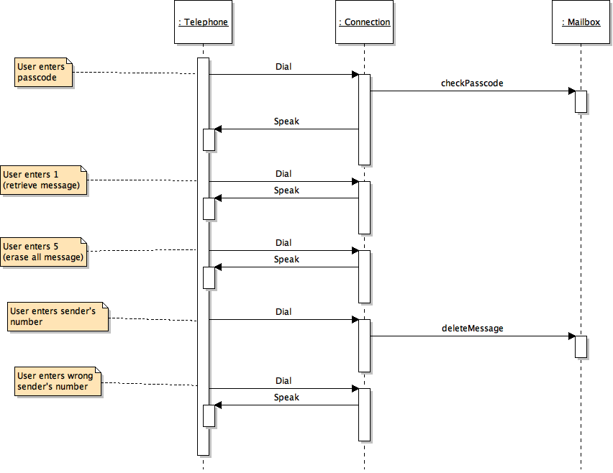

Question 2.2

Class Diagram

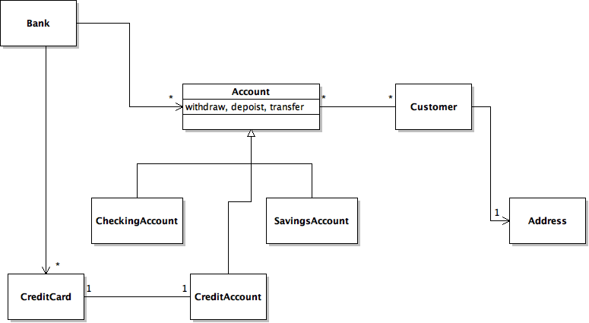

Question 2.3

|  |
| --- |
| Customers |
| Keeps customers information RentalSystem |
| Holds customers reservation information |
|  |

|  |
| --- |
| RentalSystem |
| Allow customers to log in Customers |
| Communicate with different classes to complete task CarList |
| Handles user input RentalCompany |
| Reservation |
| LocationNDates |

|  |
| --- |
| Cars |
| keeps list of available/unavailable cars RentalCompany |
|  |
|  |

|  |
| --- |
| CarList |
| Print Carlist RentalSystem |
|  |
|  |

|  |
| --- |
| Reservation |
| Make Reservation RentalSystem |
| Confirm Reservation and send it Rental Company & Customer RentalCompany |
| Customers |

|  |
| --- |
| LocationNDates |
| Set Dates and Location RentalSystem |
|  |
|  |

|  |
| --- |
| RentalComapny |
| Checks Availability of cars RentalSystem |
| Cars |
|  |

Class Diagram

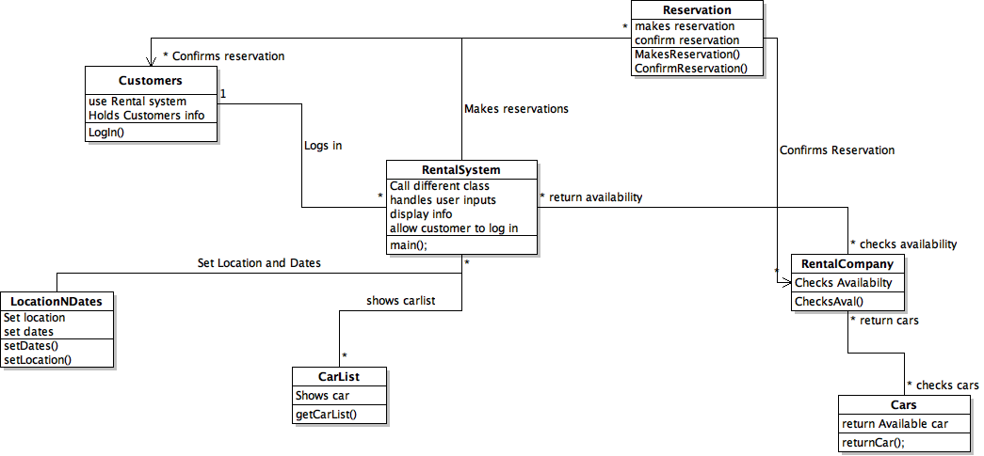

Sequence Diagram:

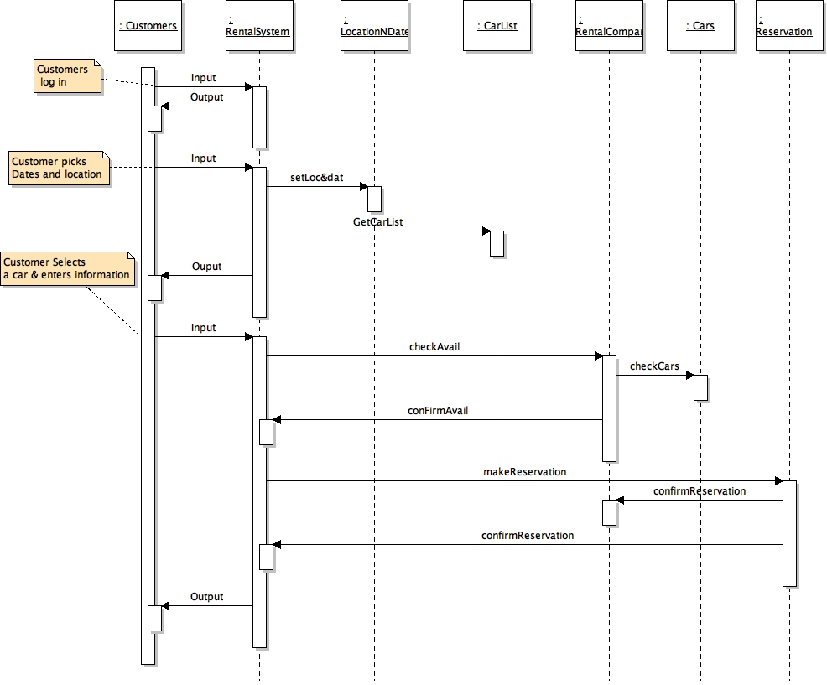

State Diagram:

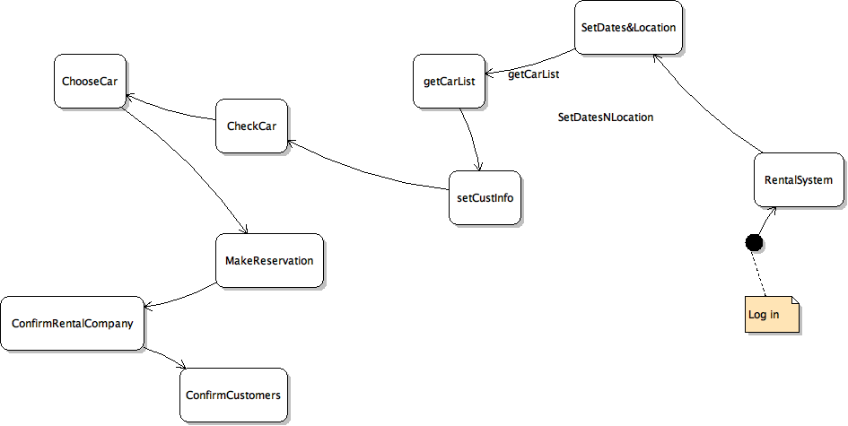

Question 2.4

CRC Diagram

|  |
| --- |
| Products |
| Keeps a list of product information CashierRegister |
| Holds selected items |
| Return total price |

|  |
| --- |
| CashierRegister |
| Scan products Receipt |
| Calls for methods from classes Products |
| Payment |
|  |

|  |
| --- |
| Receipt |
| Print printItem CashierRegister |
| Print Receipt |
|  |

|  |
| --- |
| Payment |
| Calculate Payment CashierRegister |
| Return change |
|  |

Sequence Diagram

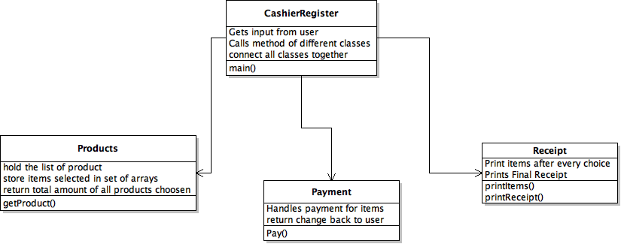

Sequence Diagram

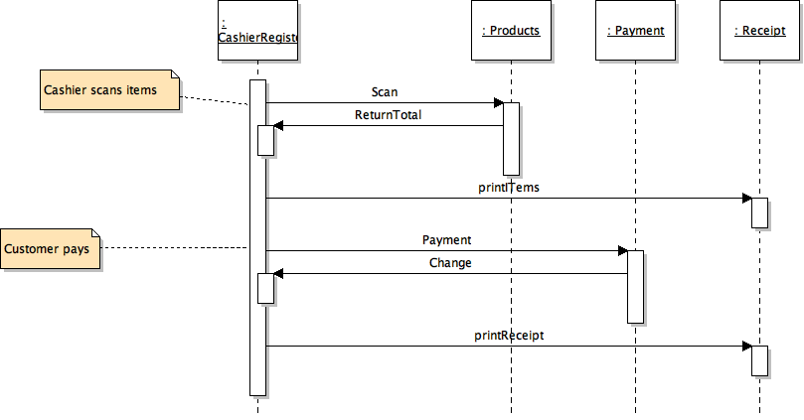

State Diagram:

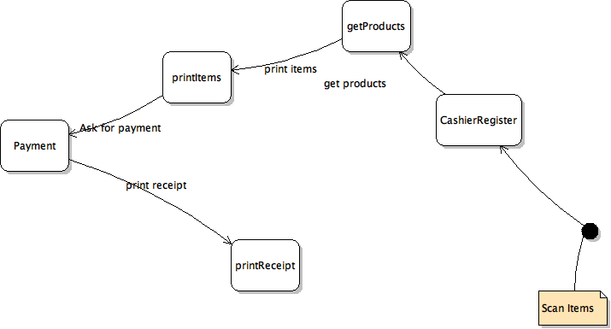

Java Code:

Filename: CashierRegister.java

package Q4;

import java.util.Scanner;

import Q4.Products;

import java.util.Arrays;

import static java.util.Collections.list;

/**

*

* @author Ace

*/

public class CashierRegister {

public static void main(String[] args){

// creating variables of the different classes

Products sList = new Products();

Payment p = new Payment();

Receipt r = new Receipt();

//Variables use in the code

int UpcCode = 0;

double change = 0.0;

double payment = 0.0;

double ftotal = 0.0;

String nextItem = "yes";

//while loop allow the user to enter multiple items.

while("yes".equals(nextItem))

{

//Prints a quick display

System.out.print("\n");

System.out.print("Welcome to Cashier App!!\n");

System.out.print("============================\n");

System.out.print("Items UPC code are from 100 to 105\n");

System.out.print("Shop!!! Enjoy\n");

System.out.print("============================\n");

System.out.print("\n");

//Try and Catch checks for errors as system gets input from user

try{

// Ask user for UPC code

System.out.print("\n");

System.out.print("Enter the UPC code for your item: ");

UpcCode = new Scanner(System.in).nextInt();

System.out.print("\n");

} catch (Exception eim) {

System.out.println(eim.getMessage());

}

//Call function from Products class and store return value in ftotal

ftotal = sList.getProduct(UpcCode);

//Try and Catch checks for errors as system gets input from user

try{

// Ask user If another UPC code

System.out.print("\n");

System.out.print("Do you want to add another item(yes/no): ");

nextItem = new Scanner(System.in).next();

System.out.print("\n");

} catch (Exception eim) {

System.out.println(eim.getMessage());

}

}

//Call function from Receipt class to print all items selected

r.printItems(ftotal);

//Try and Catch checks for errors as system gets input from user

try{

// Ask user If another UPC code

System.out.print("\n");

System.out.print("Enter your payment: $");

payment = new Scanner(System.in).nextDouble();

System.out.print("\n");

} catch (Exception eim) {

System.out.println(eim.getMessage());

}

//Call function from Payment class to process payment

//and store return value in change variable

change = p.Pay(ftotal, payment);

//Call Function from Receipt class to print receipt.

r.PrintReceipt(ftotal,change,payment);

}

}

Filename: Product.java

package Q4;

import java.util.ArrayList;

/**

*

* @author Ace

*/

public final class Products

{

//Create arrays to store items price,name and upc code.

public ArrayList<Double> priceArray = new ArrayList<>();

public ArrayList<String> nameArray = new ArrayList<>();

public ArrayList<Integer> UPCArray = new ArrayList<>();

//Create arrays to store items selected by user

public static ArrayList<Integer> UpcPrint = new ArrayList<>();

public static ArrayList<String> namePrint = new ArrayList<>();

public static ArrayList<Double> pricePrint = new ArrayList<>();

//variable that store the total price.

private static double total = 0;

public Products()

{

// add elements to the price array

priceArray.add(1.0);

priceArray.add(2.0);

priceArray.add(0.50);

priceArray.add(1.50);

priceArray.add(1.0);

priceArray.add(3.0);

// add elements to the name array

nameArray.add("Snickers");

nameArray.add("Water");

nameArray.add("Candy");

nameArray.add("Soda");

nameArray.add("Juice");

nameArray.add("Can Food");

// add elements to the upc array

UPCArray.add(100);

UPCArray.add(101);

UPCArray.add(102);

UPCArray.add(103);

UPCArray.add(104);

UPCArray.add(105);

}

// a function that gets the user products from the items array

// and store the items in an array for display.

public double getProduct(int UpcCode)

{

//create a variable of Product class

Products sList = new Products();

//create a int variable to store the index of the array

int index = 0;

//if statement check if the upccode is in the array

//if statement is array it prints it and store it to

//another that acts as a shopping cart.

if (sList.UPCArray.contains(UpcCode))

{

//Variables to store upc,price and name

int upc = 0;

double price = 0.0;

String name = null;

//gets the index of the UpcCode

index = sList.UPCArray.indexOf(UpcCode);

//Uses the Index gather to print the price, name and upc code

System.out.println(sList.UPCArray.get(index)+" "+sList.nameArray.get(index)+" "+"$"+sList.priceArray.get(index));

//Store the values at the index into variables

upc = sList.UPCArray.get(index);

name = sList.nameArray.get(index);

price = sList.priceArray.get(index);

//Add those values that was stored into

//the shopping cart arrays.

UpcPrint.add(upc);

namePrint.add(name);

pricePrint.add(price);

//Calculate the total of the items.

total += sList.priceArray.get(index);

}

else{

System.out.println("Code Not Found!");

}

// retun total price

return(total);

}

}

Filename: Payment.java

package Q4;

import java.util.ArrayList;

import java.util.Scanner;

/**

*

* @author Ace

*/

public class Payment {

// Constructor

public Payment()

{

}

// Function Calculates payment

public double Pay(double ftotal,double payment)

{

//Variable to store the change after payment

double change = 0.0;

//while loop to make sure user enters sufficient funds.

while(payment < ftotal)

{

System.out.print("Payment InSufficent!!!"+"\n");

System.out.print("Enter your payment: ");

payment = new Scanner(System.in).nextDouble();

}

//Statement calculate change

change = payment - ftotal;

return change;

}

}

Filename: Receipt.java

package Q4;

/**

*

* @author Ace

*/

public class Receipt {

public Receipt()

{

}

//Function prints items after user finish selecting.

public static void printItems(double ftotal)

{

// create variable of Product class

Products sList = new Products();

//for loops prints all the items in shopping cart arrays.

for(int i=0;i<sList.UpcPrint.size();i++){

System.out.print(sList.UpcPrint.get(i) + " " + sList.namePrint.get(i)

+ " "+"$"+ sList.pricePrint.get(i)+"\n");

}

System.out.print("Total: "+"$"+ftotal+"\n");

}

//Function prints the final receipt after payment

public static void PrintReceipt(double ftotal,double change,double payment)

{

// create variable of Product class

Products sList = new Products();

System.out.print("Thank you for Shopping with us!!\n");

System.out.print("-------------------------------------");

System.out.println("");

System.out.println("Your Receipt");

//Prints a formatted header

System.out.printf("%1s %11s %11s", "UPC", "Product", "Price($)\n");

//for loops print all the items in shopping cart arrays.

for(int i=0;i<sList.UpcPrint.size();i++){

System.out.print(sList.UpcPrint.get(i) + " " + sList.namePrint.get(i)

+ " "+"$"+ sList.pricePrint.get(i)+"\n");

}

System.out.print("Total: "+"$"+ftotal+"\n");

System.out.print("Your Payment: "+"$"+payment+"\n");

System.out.print("Your Change: "+"$"+change+"\n");

}

}