Exol AI Chatbot — BigQuery Conversational Agent Architecture
Architecture and system flow · June 22, 2026

1. Executive summary
This document describes how the Exol AI Chatbot API uses Google Cloud's Conversational Analytics API (Gemini Data Agents) to answer natural-language questions over BigQuery. BigQuery is the unified data plane for analytical, operational, and governance data — including the tenant_service_account_mapping table that resolves tenant_id to the correct service account.
From the client's perspective, the system has a single integration point: the FastAPI service (REST endpoints for conversations and chat). The browser sends JWT bearer tokens with tenant_id; FastAPI reads the mapping table, impersonates the tenant service account, and invokes the Conversational Analytics API. All BigQuery queries run under the tenant's IAM identity — other tenants' data is invisible at the IAM layer.

2. Architecture diagram
The diagram uses the same two-panel layout as the BigQuery MCP architecture document. It has two panels:
- Left — BigQuery unified data plane: analytical, operational, and governance datasets with tenant RLS.
- Right — Live chat (tenant RLS via Conversational Analytics API): User → FastAPI → tenant mapping → SA impersonation → Data Agent → BigQuery.
Inside the dashed Conversational Analytics Engine boundary: Credential Service impersonates the tenant SA, the Conversational Analytics API (geminidataanalytics.googleapis.com) orchestrates NL-to-SQL, and a per-tenant Data Agent runs stateful :chat sessions. Responses stream back to the browser as SSE.
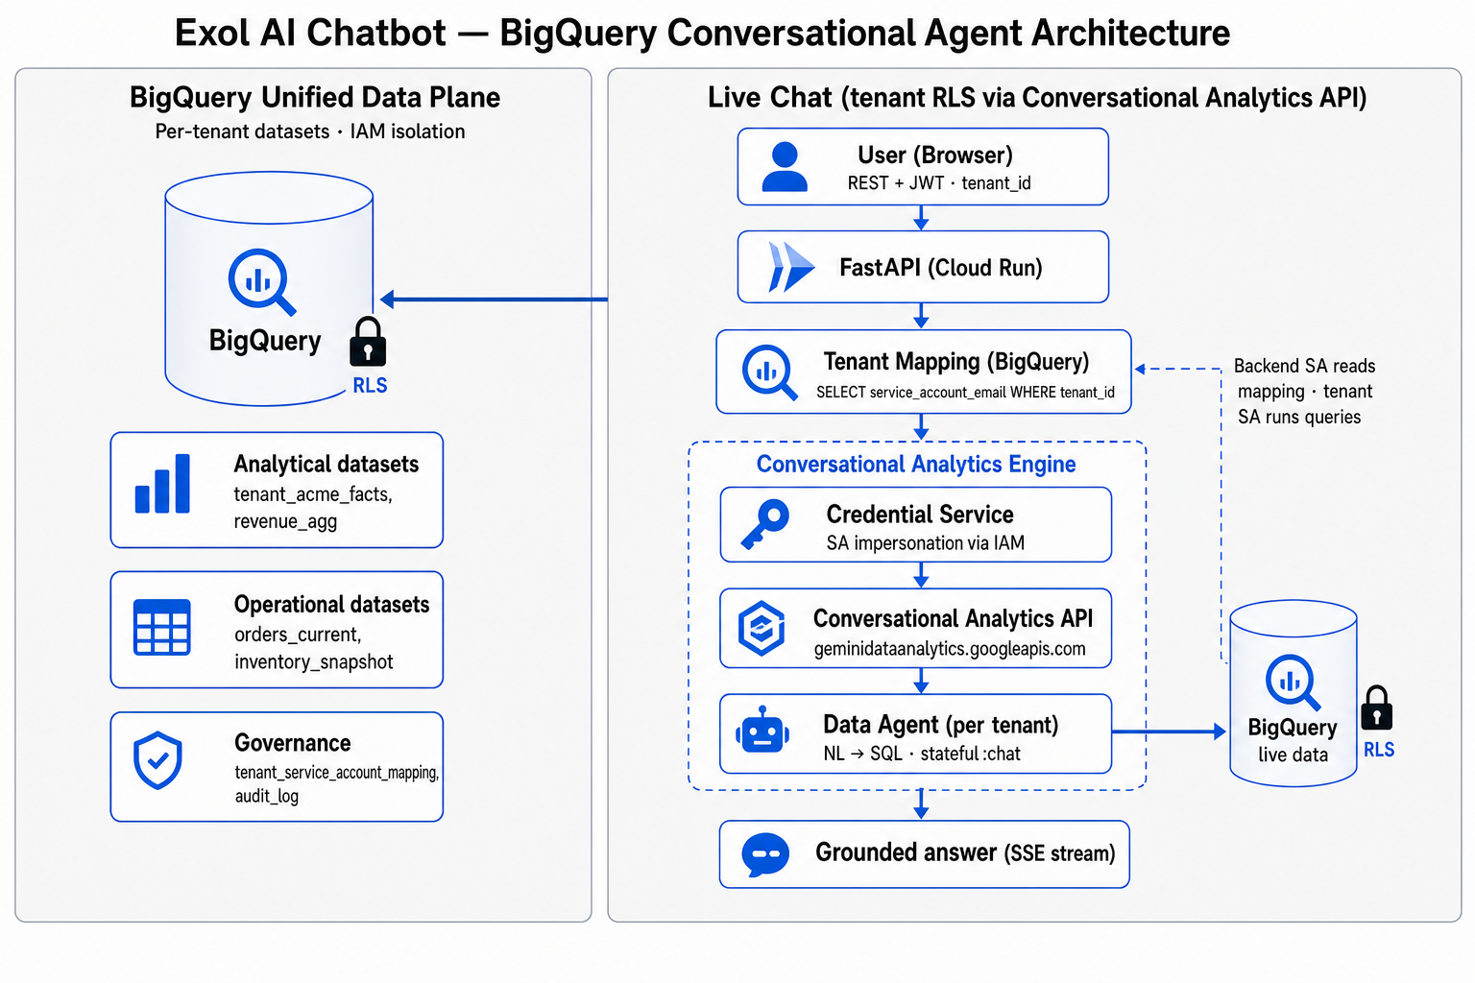

2.1 Diagram walkthrough

Left panel — BigQuery unified data plane
All live data lives in BigQuery. Row-level security (RLS) is enforced at query time via per-tenant service account impersonation and IAM dataset ACLs. The three dataset groups shown in the diagram are:
Dataset group | Example tables | Purpose
Analytical datasets | tenant_acme_facts, revenue_agg | Historical trends, KPIs, aggregations
Operational datasets | orders_current, inventory_snapshot | Near real-time operational state
Governance | tenant_service_account_mapping, audit_log | Tenant SA mapping, audit, policy metadata

Right panel — Live chat (tenant RLS via Conversational Analytics API)
- User (Browser) sends REST request with Bearer JWT containing tenant_id.
- FastAPI (Cloud Run) receives the request and validates the JWT.
- FastAPI reads Tenant Mapping (BigQuery): SELECT service_account_email WHERE tenant_id = @tenant_id AND is_active = TRUE.
- Credential Service impersonates the resolved tenant service account via IAM Credentials API.
- Conversational Analytics API receives :chat request authenticated as the tenant SA.
- Data Agent (per tenant) generates SQL from natural language and runs queries against BigQuery.
- BigQuery returns rows scoped to the tenant dataset (RLS padlock on left panel).
- Grounded answer streams back to the user via SSE (text, tables, charts).
Critical security note: the backend service account reads the mapping table; the tenant service account runs all data queries. The agent never uses the backend SA identity to access tenant datasets.

3. Design goals
- Single mapping source: tenant_service_account_mapping in BigQuery — no YAML or env-based tenant config.
- Correct SA on every call: mapping lookup → impersonation → GDA/BQ operations always use tenant identity.
- Single data plane: all tenant data in isolated BigQuery datasets.
- Managed NL-to-SQL: Conversational Analytics API replaces custom SQL tool code.
- Tenant isolation: dedicated GCP service account per tenant with dataset-scoped IAM.
- Stateful conversations: multi-turn chat with history managed by the Conversational Analytics API.
- Streaming responses: Server-Sent Events deliver incremental agent output.

4. Components
Component | Description
User (Browser) | Sends chat requests with JWT bearer token (tenant_id claim).
FastAPI | REST API — conversations, chat, auth. Sole entry point from client.
Tenant Mapping (BigQuery) | platform_config.tenant_service_account_mapping — resolves tenant_id → SA + dataset.
Credential Service | Impersonates tenant SA via IAM Credentials API (app/services/credentials.py).
Conversational Analytics API | geminidataanalytics.googleapis.com — NL-to-SQL data agents.
Data Agent (per tenant) | GDA resource scoped to tenant BigQuery tables; created on first use.
BigQuery | Unified data plane — analytical, operational, and governance datasets.

5. Tenant mapping table schema
DDL and sample rows: sql/tenant_service_account_mapping.sql
Column | Type | Description
tenant_id | STRING | Unique tenant identifier (matches JWT claim)
service_account_email | STRING | GCP SA to impersonate for this tenant
bigquery_project_id | STRING | Project containing tenant data
bigquery_dataset_id | STRING | Tenant's isolated dataset
bigquery_tables | ARRAY<STRING> | Optional table allowlist; empty = auto-discover
data_agent_id | STRING | Optional GDA agent ID (default: agent-{tenant_id})
is_active | BOOL | Set FALSE to disable a tenant

6. IAM roles
Principal | Role | Scope
API Backend SA | bigquery.dataViewer | Mapping table dataset (platform_config)
API Backend SA | iam.serviceAccountTokenCreator | Each tenant service account
Tenant SA | bigquery.dataViewer | Tenant dataset only
Tenant SA | geminidataanalytics.dataAgentCreator | GCP project
Tenant SA | geminidataanalytics.dataAgentUser | GCP project

7. API surface
Method | Endpoint | Purpose
GET | /health | Health check
POST | /api/v1/auth/token | Issue JWT (development)
POST | /api/v1/conversations | Create stateful conversation (returns service_account_email)
POST | /api/v1/conversations/{id}/messages | Send message (SSE stream)
GET | /api/v1/conversations/{id}/messages | List conversation history
DELETE | /api/v1/conversations/{id} | Delete conversation
POST | /api/v1/chat | Stateless single-turn chat

8. End-to-end request flow
- User submits a natural-language question with JWT (tenant_id).
- FastAPI validates JWT and extracts tenant_id.
- TenantRegistry queries BigQuery mapping table for service_account_email and dataset config.
- CredentialService impersonates the tenant service account.
- BQAgentService calls Conversational Analytics :chat as the tenant SA.
- Data Agent generates SQL and queries the tenant's BigQuery dataset only.
- Response streams to the client as SSE; logs record tenant_id and SA used.

9. Security and governance
- Tenant isolation: dedicated GCP service account per tenant; impersonated before every data operation.
- Mapping table: single source of truth — no hardcoded or file-based SA overrides.
- RLS: padlock on BigQuery in the diagram — IAM + dataset ACLs enforce boundaries.
- Conversation IDs prefixed with {tenant_id}- to prevent cross-tenant access.
- Create-conversation response includes service_account_email for verification.
- Onboard/offboard tenants by INSERT/UPDATE mapping table — no API redeploy required.

10. Internal module structure
- app/main.py — FastAPI entry point
- app/auth/jwt.py — JWT creation and validation
- app/services/tenant_registry.py — BigQuery mapping table lookup
- app/services/credentials.py — Service account impersonation
- app/services/bq_agent.py — Data agent lifecycle, conversations, chat streaming
- app/routers/chat.py — REST endpoints
- sql/tenant_service_account_mapping.sql — Mapping table DDL

11. Configuration
- GCP_PROJECT_ID — GCP project with Conversational Analytics API enabled
- TENANT_MAPPING_DATASET_ID=platform_config
- TENANT_MAPPING_TABLE_ID=tenant_service_account_mapping
- TENANT_MAPPING_CACHE_TTL_SECONDS=60

12. Required Google Cloud APIs
- geminidataanalytics.googleapis.com — Conversational Analytics / Data Agents
- bigquery.googleapis.com — BigQuery data warehouse and mapping table
- iamcredentials.googleapis.com — Service account impersonation

13. One-sentence summary
The user sends tenant_id via JWT to FastAPI; FastAPI reads the BigQuery mapping table, impersonates the tenant service account, and invokes the Conversational Analytics Data Agent to run NL-to-SQL against that tenant's BigQuery dataset only — with responses streamed back as SSE.

Diagram: docs/assets/bq-conversational-agent-architecture.png

