Legal Saathi — Project Timeline
Development schedule from August 25 to December 5, 2026, with a 50% completion milestone on September 21, 2026.
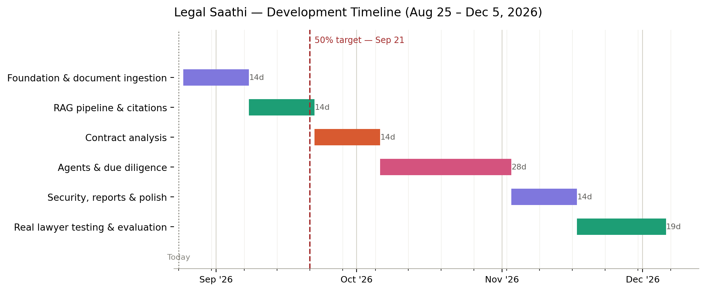

Phase breakdown
Phase | Dates | Duration
Foundation & document ingestion | Aug 25 – Sep 7, 2026 | 14 days
RAG pipeline & citations | Sep 8 – Sep 21, 2026 | 14 days
Contract analysis | Sep 22 – Oct 5, 2026 | 14 days
Agents & due diligence | Oct 6 – Nov 2, 2026 | 28 days
Security, reports & polish | Nov 3 – Nov 16, 2026 | 14 days
Real lawyer testing & evaluation | Nov 17 – Dec 5, 2026 | 19 days
50% milestone (Sep 21): Document ingestion pipeline and the RAG + citation-verification layer complete — the core retrieval infrastructure the remaining phases build on.

