FilMusic: automated film score generation
David Cummings

Introduction
In the days of silent films, a pianist or organist often scored films in theaters live. The performer was faced with the non-trivial task of appropriately following the mood of the film, sometimes supplying sound effects in addition to music. In a modern twist on this tradition, I decided to develop a computer program that would score film based on its visual content. In collaboration with the computer science department, I wrote a program that analyzes video and chooses accompaniment from a pool of pre-composed music clips.

Max/MSP/Jitter
The software environment in which I programmed the film score generator is called Max/MSP/Jitter, a set of media tools created by the company Cycling '74. Max provides a graphical programming language, in which modules and wires are used to visualize the flow of data, making it ideal for audio/visual applications. Jitter comes with tools for processing video data easily, allowing fast and simple analysis of video.
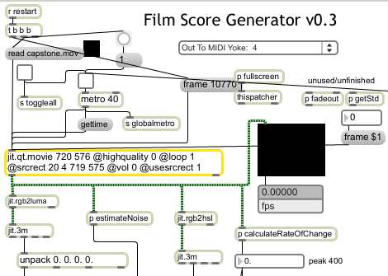Figure 1: Sample screenshot of Max/MSP

Video Analysis
The program performs a frame-by-frame analysis of four visual aspects: hue, saturation, brightness, and rate of change. Hue, saturation and brightness are measured as an average across all pixels in a frame. Hue refers to the shade of a color from red to blue. Saturation refers to the strength of the intensity of the hue, with the lowest saturation possible being a grayscale image. Brightness, also called lightness, is the placement of the color along the lightness-darkness axis (as perceived by humans.) The higher a frame's average brightness, the closer the frame is to pure white.
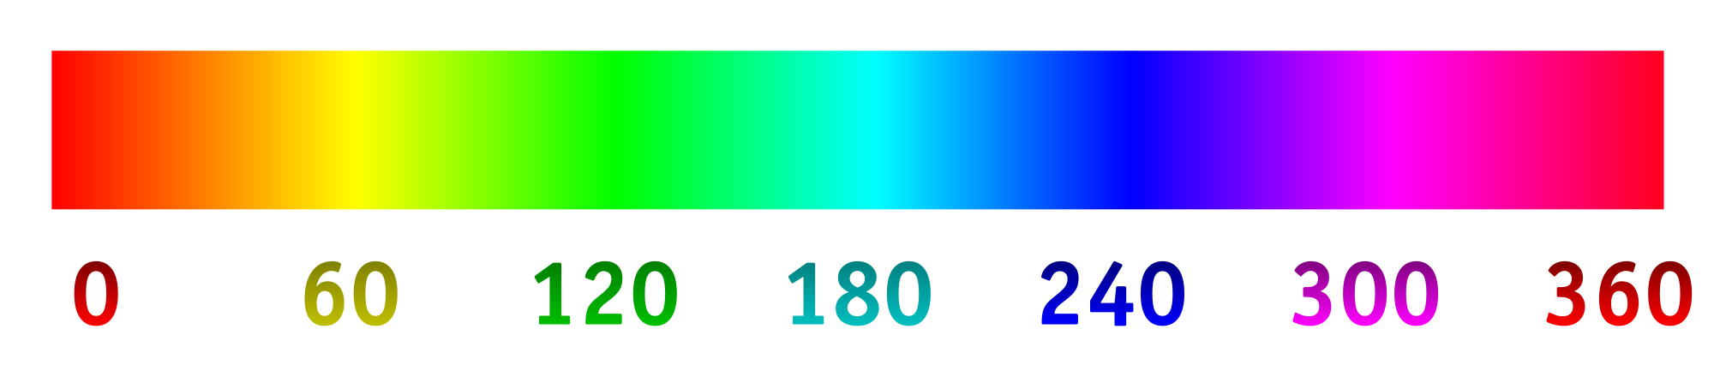Figure 2: Hue scale 0—360°
By default, video data in Jitter is stored as a matrix of pixels with RGB values. The RGB color model expresses colors as a sum of the three primary colors of light: red, green and blue. Each primary color can be a number from 0 to 255, with 255 being the highest possible value. For example, the color (255, 255, 255) is pure white, (0, 0, 0) is pure black and (255, 0, 0) is pure red.
To determine the average hue, saturation and brightness of a frame, the easiest method is to convert from the RGB color model to the HSL color model. HSL stands for hue, saturation and lightness. HSL colors can be visualized on a cylinder, with the angle corresponding to hue, the distance from the center corresponding to saturation, and the placement on the y-axis corresponding to lightness. Conversion from RGB to HSL can be done mathematically manually, but Jitter fortunately comes with a module that converts RGB to HSL.
Rate of change is computed by taking the average of the absolute differences of each pixel's color between the current frame and the previous frame. In a slow-moving segment of film, the colors do not change much from frame to frame, but they change quickly in a fast-moving segment of film.
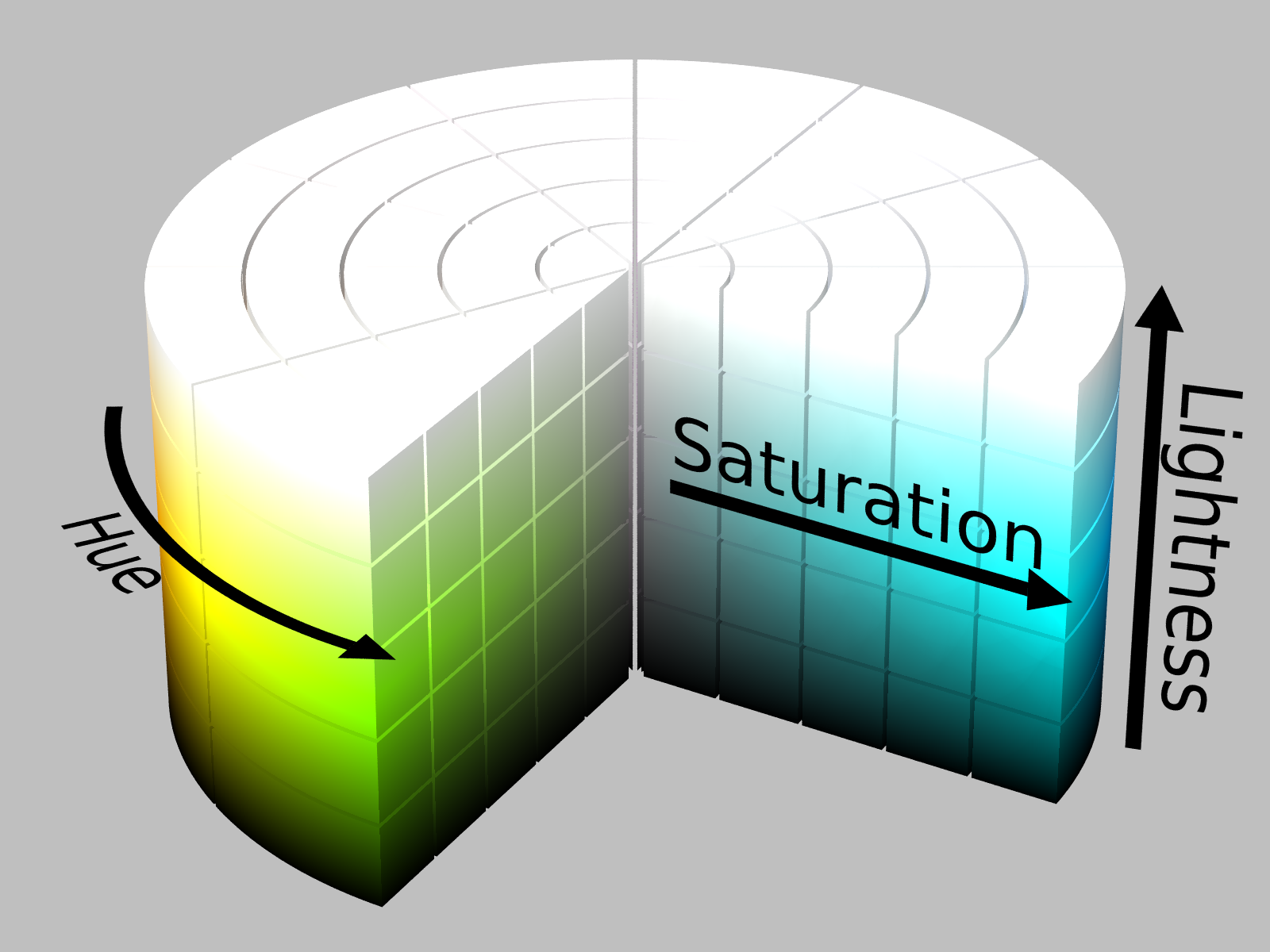Figure 3: The HSL cylinder

Music Analysis
Music clips are analyzed and tagged with a number of aspects. Some are computable automatically, while others must be input manually (see Table 1 for a complete list). User-defined aspects include the type of clip (drums, sound effects, melodic, harmonic, or other), number of voices, speed of internal rhythms, key (if applicable), amount of angst, whether the clip can be used as a loop (currently unused in the program), and the BPM (beats per minute) of the clip. Analyzed traits are the length of the clip, the average brightness of the clip, the average gain (volume), average noisiness, punch (onsets per second), and average frequency.
Brightness refers to a human's perception of a sound's timbre. It can be estimated with a spectral centroid measure, which takes the weighted mean of all frequencies in a clip after a fast Fourier transform (FFT). Any waveform can be expressed as the sum of multiple sine waves. FFT reverses this process, transforming a complex waveform into a set of frequencies and magnitudes of sine waves. The “brightness” of an audio clip can then be estimated by taking the weighted mean of all these sine waves, where the magnitudes provide the weights. This corresponds to the perceived “brightness” of a sound.
The “noisiness” of a clip is estimated by measuring spectral flatness, and characterizes how tone-like a sound is as opposed to how noise-like a sound is. An example of a tone-like sound is a pure sine wave or a note played by a pipe organ, while a noise-like sound would be a drum hit or a recording of a full orchestra. Spectral flatness is calculated by taking the power spectrum's geometric mean and dividing it by the arithmetic mean. (The geometric mean is calculated by multiplying all numbers in a set and taking the nth root, where n is the number of numbers in the set.) The power spectrum is simply the set of amplitudes, so a white noise signal has frequencies of the same power, and thus has a flat power spectrum.
Punchiness is calculated by detecting the number of onsets per second. This can be easily accomplished by looking for sudden changes in the amplitude of a wave. For example, a snare drum beat will be quite punchy: every time the snare drum is hit, the amplitude will suddenly jump up and quickly fade. Attacks can be detected whenever the amplitude jumps from below some threshold over another threshold within a certain amount of time.
To facilitate the process of tagging music clips, I developed a separate Max/MSP program that allows a user to choose manual traits and then perform audio analysis and write the information to the clip aspect database. The form of clip information is written as “Filename, Type Voices Speed Key Angst Loop BPM Length Brightness Gain Noisiness Punch Frequency;” followed by a newline. For example, the line “pist01-drm_Seq22.wav, 0 1 128 0 31 0 115. 4.173 2219.397949 0.072353 0.739365 5.271987 1053.136475;” in the database means that the file pist01-drm_Seq22.wav is a drum clip with 1 voice, medium internal rhythms, without a key and an angst-level of 31. It is not a loop, has a BPM of 115.0, is 4.173 seconds long, has an average brightness of 2219, an average gain of 0.07, average noisiness of 0.7, 5.27 onsets per second, and an average frequency of 1053 Hz.
Trait | Range | Notes
User Defined
Type | 0-4 | 0 is drums, 1 is sfx, 2 is melodic, 3 is harmonic, 4 is other/mixed
Voices | 1-16 | Number of voices in clip
Speed | 0-255 | Speed of internal rhythms, 0 is slowest, 255 is fastest.
Key | 0-24 | 0 is NA, 1 through 12 is A through A flat major, 13-24 is A through A flat minor
Angst | 0-255 | 0 is happiest, 255 is most angst-ridden
Loop | 0-1 | 0 is not a loop, 1 is a loop
BPM | 20-400 | Beats Per Minute
Analyzed
Length | (seconds) | Length of clip
Brightness | 0-10000 | Brightness of clip
Gain | 0-1 | Average gain
Noisiness | 0-1 | Noisiness of clip
Punch | 0-16 Hz | Calculated by number of onsets per second.
Frequency | 0-16000 Hz | Average frequency of clip
Table 1: Traits of music clips

Audio-Video mapping
The film score generator maps visual aspects to musical aspects by converting each set of traits into weighted, normalized vectors. The program calculates the angle between vectors for each music clip, and selects the clip with the closest angle. The mapping is as follows:
Video | → | Audio
Brightness | → | Brightness / Frequency
Saturation | → | Angst
Rate of change | → | Speed
Hue | → | Punch
Table 2: Video - Audio mapping
Each aspect is normalized by dividing it by the maximum possible value for that aspect. This ensures that each aspect is a number between 0 and 1. Aspects are then weighted by multiplying each aspect by its weight. Thus, some aspects can be made to be more important than others. Finally, the program calculates the angle between the video and audio vectors. The cosine of the angle between two vectors can be calculated by taking the dot product of the two vectors and dividing by the product of the length of the two vectors. The dot product is computed by taking the product of each aspect and adding them. The length is calculated by taking the square root of the sum of every aspect squared.
Figure 4: Calculating the angle between two vectors
The film score generator selects four clips to play simultaneously. To ensure that the clips match, it selects the melody clip first, then selects a drum clip, effects clip and harmony clip so that the latter three match the former in BPM. I also developed a module to ensure that every new clip chosen would match the previous by ensuring that new clips had similar BPM and were in the same or a related key, but removed this module because it resulted in too much repetition.

Composition and Performance
All the musical clips were composed and arranged on the computer, constructed mostly from synthesized sounds, with a few recorded samples as well. The clips were composed first as full songs, then split up into individual elements of short length (about 4 seconds.) The accompanying CD contains a collection of all 459 clips created. The two main programs used in composition were Renoise and Piston Collage, which allow sample and digital synthesis-based composition. To accompany the program in the live performance, additional clips were added and arranged in Ableton Live, which was also used to apply various effects to the musical clips chosen by the program.

Challenges
Although conceptually interesting, the results of the program can unfortunately seem somewhat aleatoric at times. It is often unclear why a particular clip is chosen for a given video frame. Another problem is that without a “smart transition module,” there are sometimes sudden changes between one clip and the next. The solution for these two problems was applying effects and volume control to the four channels. If a clip plays that does not fit the video or is too sudden a change, the performer can fade it out or apply an effect to it to make it conform more musically. As mentioned above, the manual addition of musical material in live performance allows a construction of a more coherent score, with the film score generator providing unexpected elements to accompany the planned elements.

Conclusion
There is plenty of room for improvement upon this film score generator. A more sophisticated algorithm could ensure smoother transitions between clips. A larger music clip database would also allow for more options, to match a variety of films. An artificial intelligence learning system could also be implemented, so that a performer (or even an audience) could rate the film score generated in any one instance of running the program, and the program could learn what types of clips to play for certain types of video based on the rating.
It is doubtful that a computer program will ever be able to match humans in the world of music composition. However, computers can act as a useful tool for inspiration for composers by providing material in new and unexpected ways. Although the results of the automatic film score generator are somewhat aleatoric, there are often times when the music fits the film in unexpected ways, and it is these moments that a composer can harness and incorporate into a final product. Thus, the film score generator provides not a replacement for the composer and performer, but an aide to the process.

Hue and HSV diagrams courtesy of Wikimedia Commons (images under a public domain license.) Max/MSP screenshots included for educational purposes only.

