**Installation of the Program for Automatization of Survey Creation**

1. **Microsoft store -> Install Python 3.10**
2. **Install PyCharm** (if advanced user you can use different Development Environment, but PyCharm is recommended and this manual is for this one)
3. **Find where the python is installed**

**In command prompt type:**

**Type:** python

**Then type:**

import os

import sys

os.path.dirname(sys.executable)

**Result in my case:** 'C:\\Users\\mladen.srzic.UNIVERSALSURVEY\\AppData\\Local\\Microsoft\\WindowsApps\\PythonSoftwareFoundation.Python.3.10_qbz5n2kfra8p0'

This folder above we will call the Python root folder.

**Type (exit Python):** CTRL+Z (ENTER)

1. **Create virtual environment and activate it**

**Still in command prompt, type in one line (change folder to Python folder):**

cd C:\Users\mladen.srzic.UNIVERSALSURVEY\AppData\Local\Microsoft\WindowsApps\PythonSoftwareFoundation.Python.3.10_qbz5n2kfra8p0

**Type (now we are in the path so following should work)**

pip install virtualenv

**Create virtual environment (in this case it is named “env”, but could be different name):**

python -m venv env

**Activate virtual environment env (or if differently named instead “env”):**

cd env\Scripts

activate

**When environment is activated (env) appears at the beginning of the path in the command line (in yellow below):**

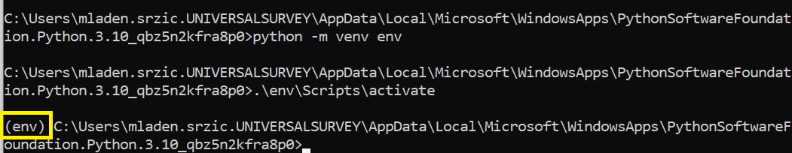

1. **Install packages in current virtual environment so we can use it latter on in the PyCharm**

In the Python root folder go to **env\Scripts** and paste the file **requirements.txt** where all packages with versions are listed.

**Type (in command prompt):** pip install -r requirements.txt



**Type (check installed packages in environment env):** pip list

**Type(after instalation):** deactivate

1. **Pycharm: Create a new project**

File -> New Project (in my case I will call it pythonProject1)

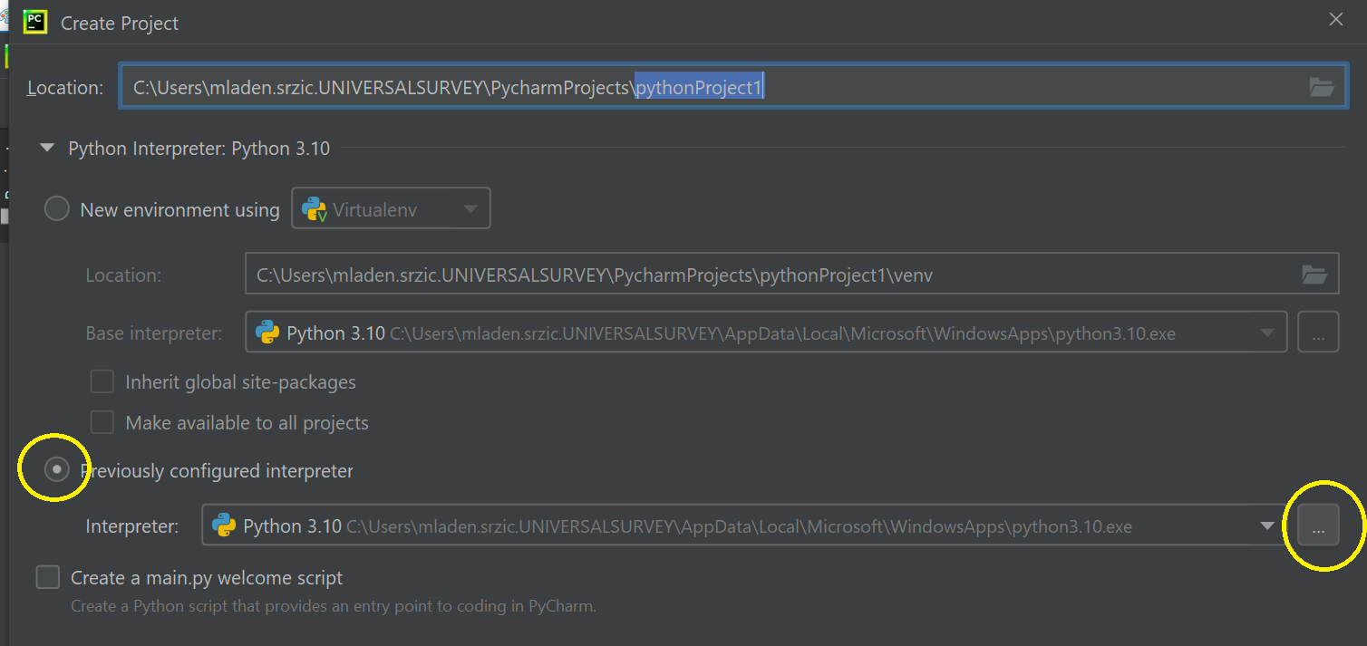

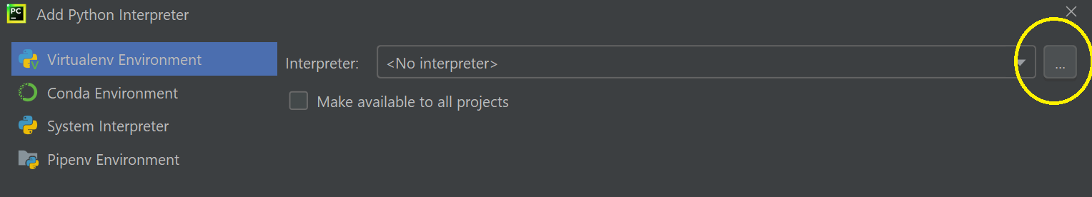

1. **Paste the Program in Pycharm Project Folder**

**Pycharm Project Folder =** C:\Users\mladen.srzic.UNIVERSALSURVEY\PycharmProjects\pythonProject1

1. Ajustment in PyCharm

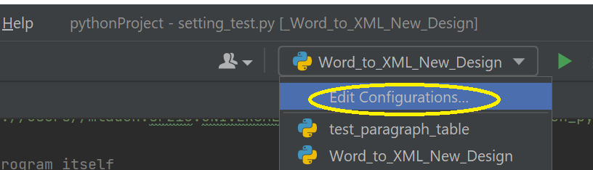

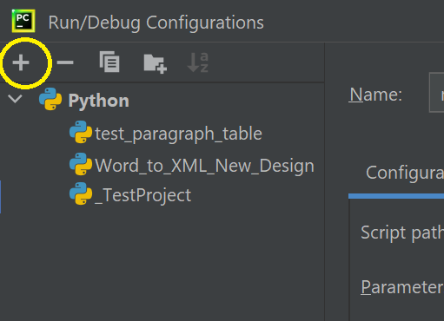

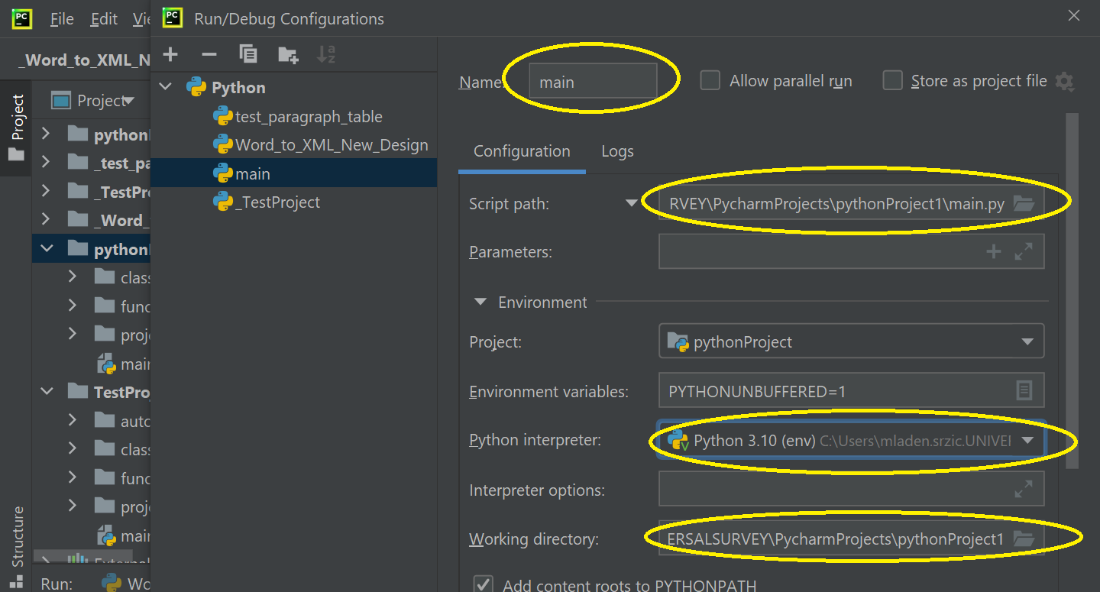

1. **Check the installation**

File->Settings

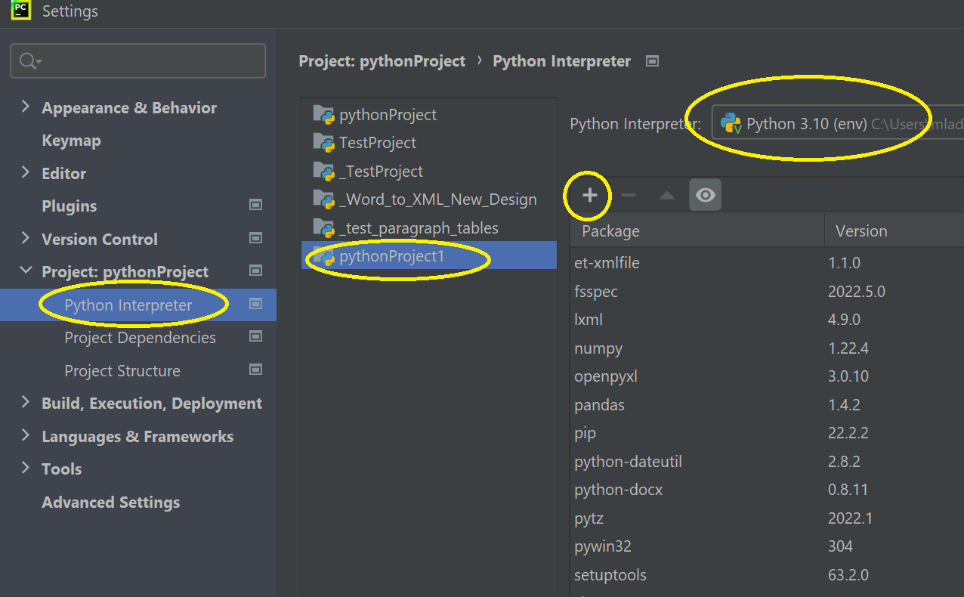

Check if all packages listed in **requirements.txt** are also listed in Python enterpriter and enviroment(env) connected to our project pythonProject1. If not all packages are installed then we must use “+” sign and added it manually.

Manual adding of packages is shown below (only if packages not installed).

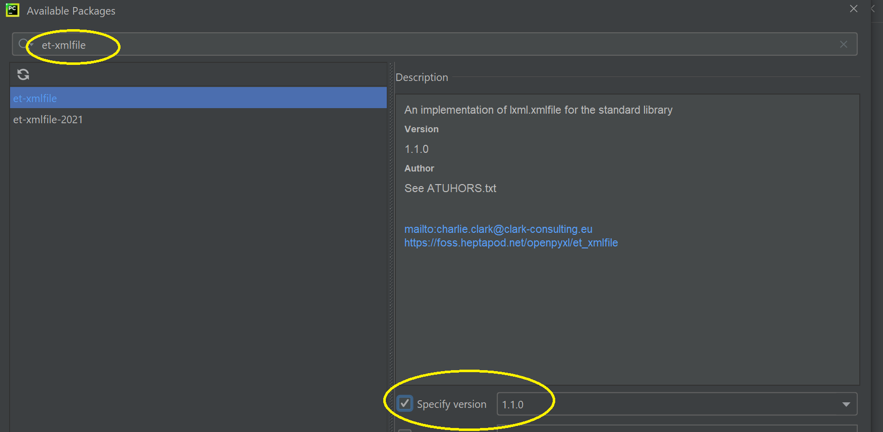

1. **Copying the program in PyCharm program**

Pycharm project is usually placed the following folder: “C:\Users\mladen.srzic.UNIVERSALSURVEY\PycharmProjects\pythonProject1”

Copy and place program here (look below):

1. **Setup of program**

In folder function setting_test.py file need to be adjusted as below in the picture. In yellow are settings that should be setuped once and in orange for each project.

1. **Edit Configuration**

Run-> Edit Configuration

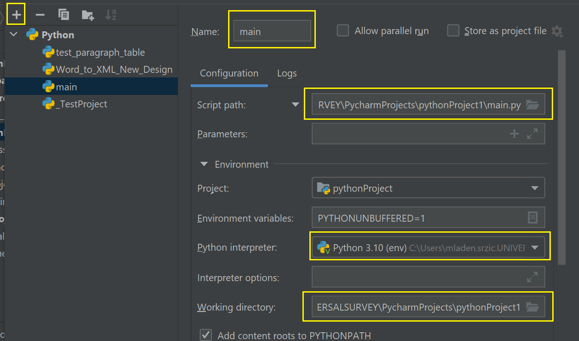

1. **Setting VBA Macros** (Small portion of code that VBA need to do before Python)

In folder ***program\projects\_basic_working_documents*** there is the file **MacroBackup.vba.** Edit in text editor and copy the Macro.

In Microsoft Word Options enable Developer tab:

In Developer tab find Visual Basic and in Noramal.dot place Macro:

* Insert -> module
* Rename module to **bbhelpFunctions**
* paste the Macro from Text Editor

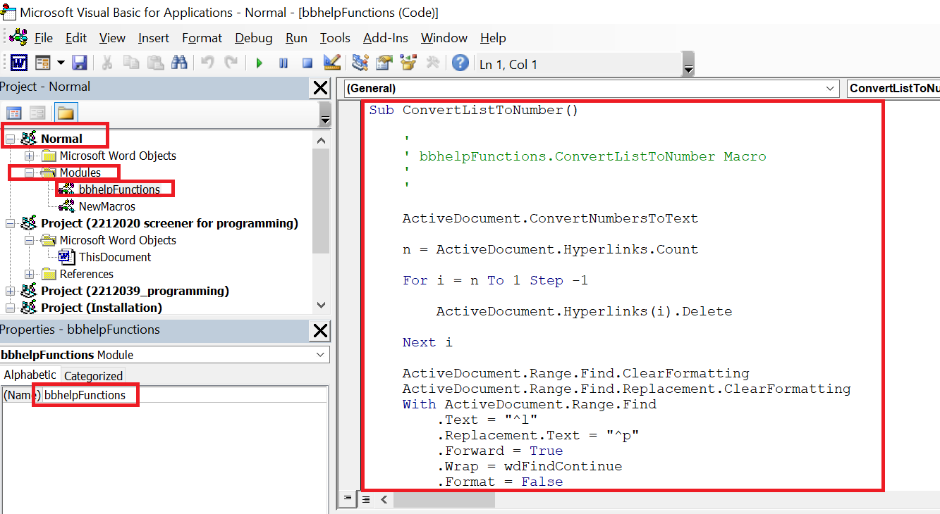

1. **Running the program in Python**

