**PROBLEM – 2**

For the given dataset named as ‘distA.csv’ ,in my opinion the Laplace QQ plot fits the data best.

Reason being : The nature of the histogram which can be seen below makes me believe that the best fit QQ plot for data set ‘distA.csv’ would be a Laplace QQ plot. In addition from the Laplace QQ plot, it can be seen that the data points are fairly close to the line. Hence that makes me believe that the best fit plot is a Laplace QQ plot.

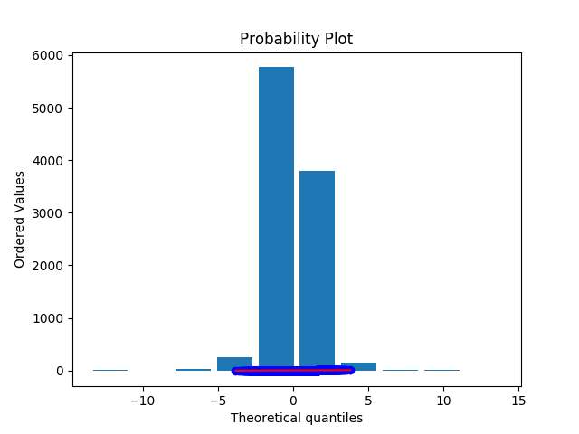

The Laplace QQ plot is attached:

For the given dataset named as ‘distB.csv’ , in my opinion the Exponential QQ plot fits the data best.

Reason being : The nature of the histogram which can be seen below makes me believe that the best fit QQ plot for data set ‘distB.csv’ would be a Exponential QQ plot. In addition, from the Exponential QQ plot, it can be seen that the data points are fairly close to the line and from the histogram it can be seen how the trajectory followed is very similar to an ‘Exponential Nature’. Hence that makes me believe that the best fit plot is a Exponential QQ plot.

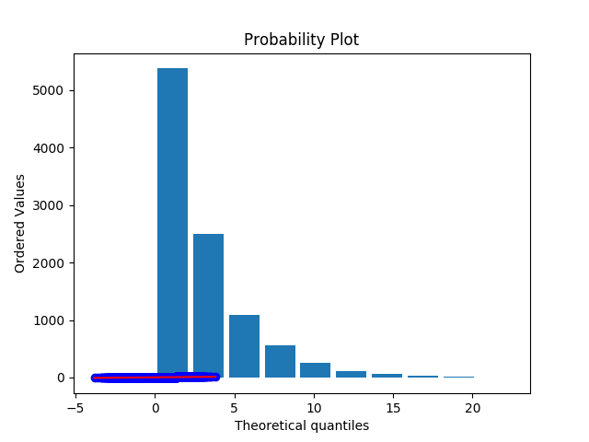

The Exponential QQ plot is attached:

For the given dataset named as ‘distC.csv’ , in my opinion the Gaussian QQ plot fits the data best.

Reason being : The nature of the histogram which can be seen below makes me believe that the best fit QQ plot for data set ‘distC.csv’ would be a Gaussian QQ plot. In addition from the Gaussian QQ plot, it can be seen that the data points are fairly close to the line. Hence that makes me believe that the best fit plot is a Gaussian QQ plot.

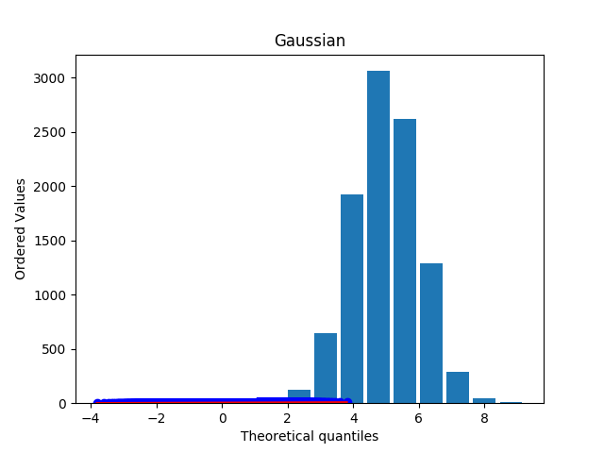

The Gaussian QQ plot is attached:

The QQ plots with respect to every data namely, distA.csv, distB.csv and distC.csv are as follows:

Please Note: The title corresponding to every QQ plot is on the plot image file.

1. QQ plots for distA.csv are as follows: A close up of a map

   Description automatically generatedA close up of a map

   Description automatically generatedA screenshot of a map

   Description automatically generatedA close up of a map

   Description automatically generatedA close up of a map

   Description automatically generatedA close up of a map

   Description automatically generatedA picture containing screenshot

   Description automatically generatedA close up of a map

   Description automatically generated

1. QQ plots for distC.csv are as follows:

