**Problem – 1**

**Question -1:** Complete the functions in polyfit.py, which accepts as input a dataset to be fit and polynomial degrees to be tried, and outputs a list of fitted models. The specifications for the main, feature matrix, and least squares functions are contained as comments in the skeleton code. The key steps are parsing the input data, creating the feature matrix, and solving the least squares equations.

**Answer-1:**

Result obtained after running the program:

**Question-2:** Use your completed polyfit.py to find fitted polynomial coefficients for n = 1, 2, 3, 4, 5 on the poly.txt dataset. Write out the resulting estimated functions y^n(x) for each n.

**Answer-2:**

**For n = 1**, we get the following result:

**For n = 2**, we get the following result:

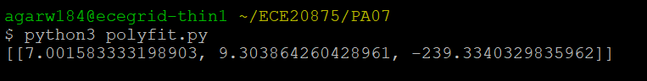

**For n = 3**, we get the following result:

**For n = 4**, we get the following result:

**For n = 5**, we get the following result:

**In totality, for n = [1,2,3,4,5], we get the following result:**



**Question – 3 :** Use the scatter and plot functions in the matplotlib.pyplot module to visualize the dataset and these fitted models on a single graph (i.e., for each x, plot y, ˆy1(x), ..., ˆy5(x)). Be sure to vary colors and include a legend so that each curve can be distinguished. What degree polynomial does the relationship seem to follow? Explain.

**Answer-3:**

**Plot obtained:**

**Equations obtained for various degree values are as follows :**

**For n = 1:**  
y1(x) = 952.1580538017472(x) - 189.86610574097068

**For n = 2:**y2(x) = 7.0015833331989175(x2) + 9.303864260428915(x) - 239.33403298359644

**For n = 3:**  
y3(x) = 0.820138098852604(x3) + 0.26176712315855943(x2) - 0.010327670472049966(x) - 175.27713200891736

**For n = 4:**  
y4(x) = 0.005987963794389907(x4) + 0.7552180459272604(x3) + 0.2345598538373384(x2) + 1.176363603226044(x) - 175.88028826172624

**For n = 5:**  
y5(x) = 0.0008531198983950695(x5) - 0.004698036593507177(x4) + 0.7528113266207637(x3) + 0.5260849950250703(x2) + 0.9659162450397061(x) - 176.8373688921246

**Observation:**It is observed that the polynomial seems to follow the 5th degree order.  
We decided that because it is observed that the dataset curve completely overlaps the obtained fit curve corresponding to degree being 5.

**Question 4:** If we measured a new datapoint x = 2, what would be the predicted value ˆy of y?

**Answer 4:**

**Output obtained:**

**Code Snippet Used:**

