**DSP PROJECT**

**Objective:**  Write a program to read a speech file and filter it to the bandwidth of 5.5khz 4khz 3. 2khz.Listem to each of the resultant filter speech files and describe the effect of low pass filtering on speech intelligibility and quality.

**Software used:** MATLAB 2016a

**Code**

clc;

close all;

clear all;

[y, fs]=audioread('sample1.wav');

y1=y;

figure(1);

plot(y1);

fs1=fs;

figure(2);

freqz(y1); %frequency response of original speech signal

fc1=5500; %cutoff freq

w1=fc1/(2*fs1); %normalised freq

%Design a LPF with above specification

[b1, a1]=butter(5,w1,'low'); %5th order butterworth filter

[h1, w1]=freqz(b1, a1, 1024); %freq response of the filter

x1=filter(b1,a1,y1); %pass the i/p signal from filter

figure(3);

freqz(x1);

title('cut off 5.5kHz');

figure(4);

plot(w1/(pi*2*fs1),abs(h1));

title('frequency response of 5th order filter');

ylabel('Magnitude');

xlabel('Freq(Hz)');

grid on

soundsc(x1,fs1);

fc2=4000; %cutoff freq

w2=fc2/(2*fs1); %normalised freq

%Design a LPF with above specification

[b2, a2]=butter(5,w2,'low'); %5th order butterworth filter

[h2, w2]=freqz(b2, a2, 1024); %freq response of the filter

x2=filter(b2,a2,y1); %pass the i/p signal from filter

figure(5);

freqz(x2);

title('cut off 4kHz');

figure(6);

plot(w2/(pi*2*fs1),abs(h2));

title('frequency response of 5th order filter');

ylabel('Magnitude');

xlabel('Freq(Hz)');

grid on

soundsc(x2,fs1);

fc2=3200; %cutoff freq

w2=fc2/(2*fs1); %normalised freq

%Design a LPF with above specification

[b2, a2]=butter(5,w2,'low'); %5th order butterworth filter

[h2, w2]=freqz(b2, a2, 1024); %freq response of the filter

x3=filter(b2,a2,y1); %pass the i/p signal from filter

figure(7);

freqz(x2);

title('cut off 3.2kHz');

figure(8);

plot(w2/(pi*2*fs1),abs(h2));

title('frequency response of 5th order filter');

ylabel('Magnitude');

xlabel('Freq(Hz)');

grid on

soundsc(x3,fs1);

**OUTPUT:**

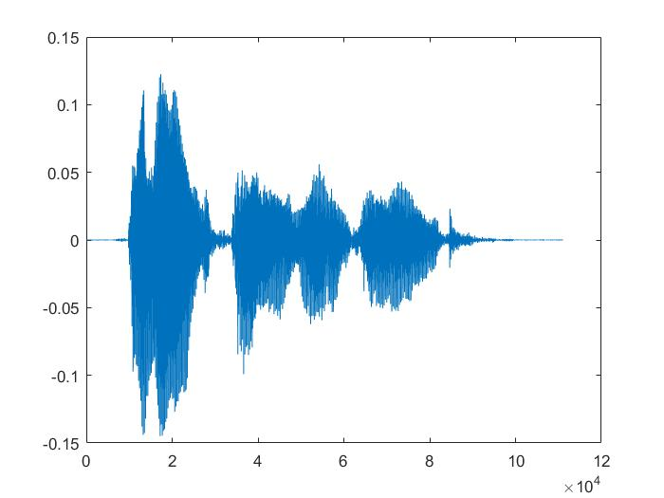

Original Signal

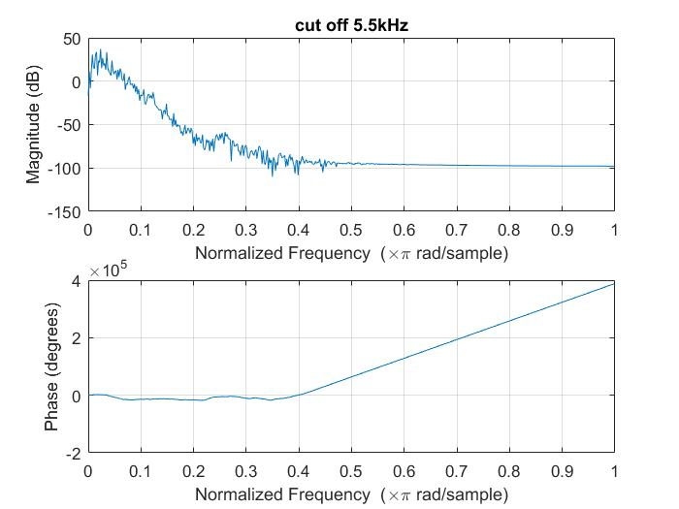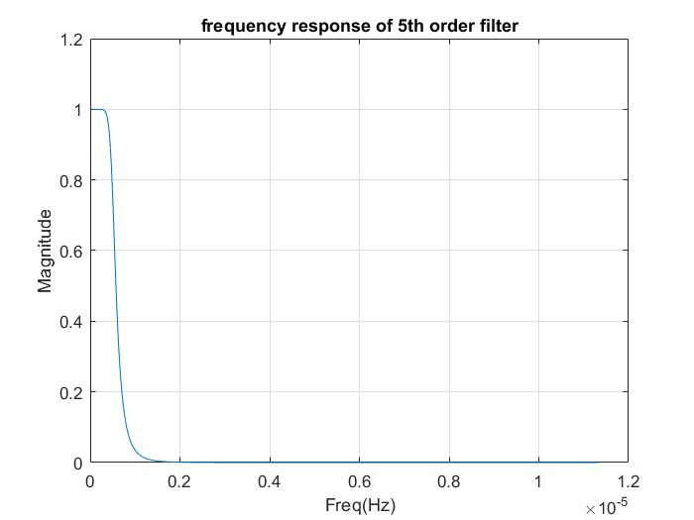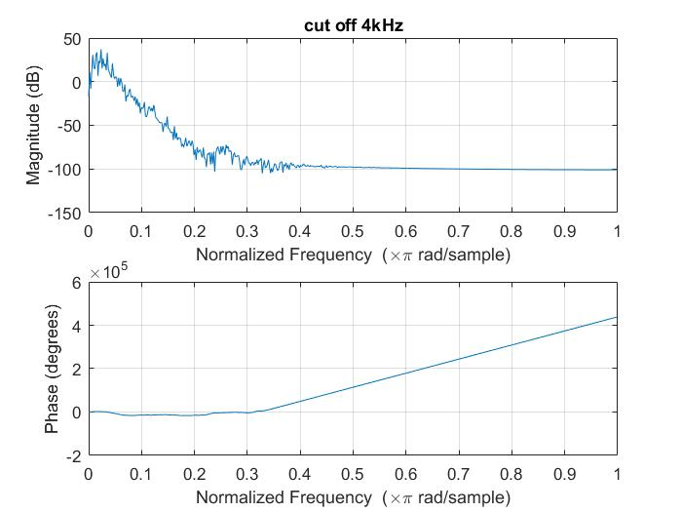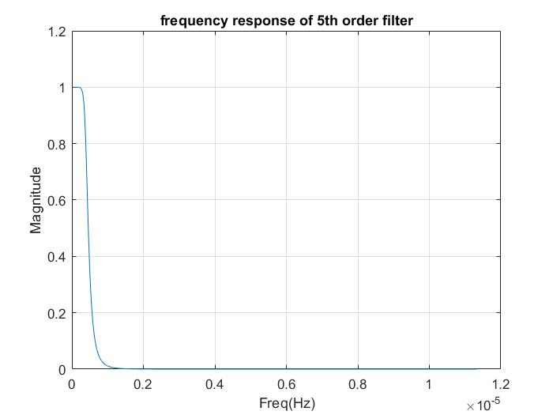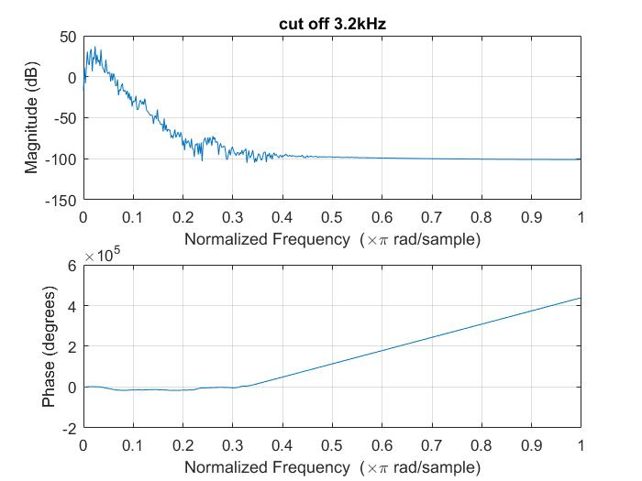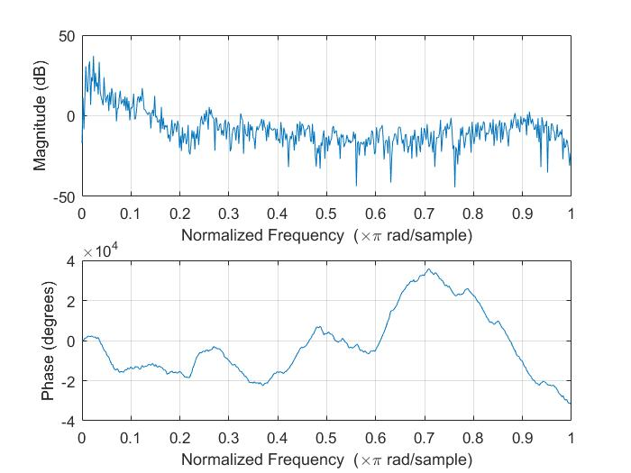

Magnitude and Phase response of origina

