**Experiment 7**

**AIM:** Write a program to determine time and frequency domain response of all the windows taking N = 25 using direct command FFT.

**SOFTWARE:** MATLAB R2016

**CODE:**

clear all;

close all;

N=25;

n = 1:1:N

w1 =@(n) 0.5-0.5*cos(2*pi*(n-1)/N);

w2 =@(n) 0.54 - 0.46*cos(2*pi*(n-1)/N);

w3 =@(n) 0.42 - 0.5*cos(2*pi*(n-1)/(N-1))+0.08*cos(4*pi*(n-1)/(N-1));

w4 = @(n) 1 - n*0

subplot(4,2,1)

stem(n-1,w1(n))

title('Hanning Window');

xlabel('time');

ylabel('h(n)');

subplot(4,2,3)

stem(n-1,w2(n))

title('Hamming Window');

xlabel('time');

ylabel('h(n)');

subplot(4,2,5)

stem(n-1,w3(n))

title('Blackman Window');

xlabel('time');

ylabel('h(n)');

subplot(4,2,7)

stem(n-1,w4(n))

title('Rectangular Window');

xlabel('time');

ylabel('h(n)');

f1 = fftshift(fft(w1(n)));

f2 = fftshift(fft(w2(n)));

f3 = fftshift(fft(w3(n)));

f4 = fftshift(fft(w4(n)));

f1=abs(f1)/max(f1);

f2=abs(f2)/max(f2);

f3=abs(f3)/max(f3);

f4=abs(f4)/max(f4);

f1=20*log(f1);

f2=20*log(f2);

f3=20*log(f3);

f4=20*log(f4)

subplot(4,2,2)

stem(n-1,f1)

title('Hanning Window');

xlabel('frequency');

ylabel('h(n)');

subplot(4,2,4)

stem(n-1,f2)

title('Hamming Window');

xlabel('frequency');

ylabel('h(n)');

subplot(4,2,6)

stem(n-1,f3)

title('Blackman Window');

xlabel('frequency');

ylabel('h(n)');

subplot(4,2,8)

stem(n-1,f4)

title('Rectangular Window');

xlabel('frequency');

ylabel('h(n)');

**GRAPH:**

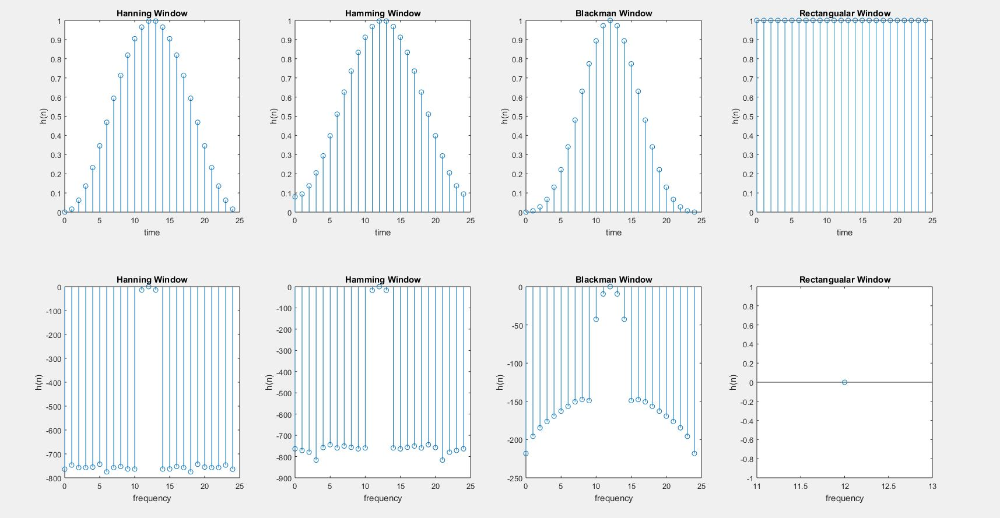

**Experiment 8**

**AIM:** Write a program to design a FIR low pass filter using all windows using

pass band = 1.5kHz

transition width = 0.5 kHz

stop band attenuation>20dB

sampling frequency = 8kHz

pass band attenuation < 1dB

**SOFTWARE:** MATLAB R2016

**CODE:**

clear all;

close all;

fc = 1500;

fw = 500;

sb = 20;

fs = 8000;

wc = 2*pi*fc/fs;

Nr = ceil(0.9*fs/fw);

if(mod(Nr,2) == 0)

Nr=Nr+1;

end

Nb = ceil(5.5*fs/fw);

if(mod(Nb,2) == 0)

Nb=Nb+1;

end

Nm = ceil(3.3*fs/fw);

if(mod(Nm,2) == 0)

Nm=Nm+1;

end

Nn = ceil(3.1*fs/fw);

if(mod(Nn,2) == 0)

Nn=Nn+1;

end

for n =0:Nr-1

rec(n+1)=1;

if(n~=0)

hd1(n+1)=2*fc*sin(n*wc);

else

hd1(n+1)=2*fc;

end

h1(n+1)=rec(n+1)*hd1(n+1);

end

n1=0:Nr-1;

f1=abs(h1);

d1=fft(f1)

subplot(2,4,1)

plot(n1,f1)

title('Rectangular Window');

xlabel('Time');

ylabel('Amplitude');

subplot(2,4,5)

plot(n1,d1)

title('Rectangular Window');

xlabel('Frequency');

ylabel('Amplitude');

for n =0:Nn-1

han(n+1)= 0.5-0.5*cos(2*pi*n/Nn);

if(n~=0)

hd2(n+1)=2*fc*sin(n*wc);

else

hd2(n+1)=2*fc;

end

h2(n+1)=han(n+1)*hd2(n+1);

end

n2=0:Nn-1;

f2=abs(h2);

d2=fft(f2);

subplot(2,4,2)

plot(n2,f2)

title('Hanning Window');

xlabel('Time');

ylabel('Amplitude');

subplot(2,4,6)

plot(n2,d2)

title('Hanning Window');

xlabel('Frequency');

ylabel('Amplitude');

for n =0:Nm-1

ham(n+1)= 0.54 - 0.46*cos(2*pi*n/Nm);

if(n~=0)

hd3(n+1)=2*fc*sin(n*wc);

else

hd3(n+1)=2*fc;

end

h3(n+1)=ham(n+1)*hd3(n+1);

end

n3=0:Nm-1;

f3=abs(h3);

d3=fft(f3);

subplot(2,4,3)

plot(n3,f3)

title('Hamming Window');

xlabel('Time');

ylabel('Amplitude');

subplot(2,4,7)

plot(n3,d3)

title('Hamming Window');

xlabel('Frequency');

ylabel('Amplitude');

for n =0:Nb-1

b(n+1)= 0.42 - 0.5*cos(2*pi*n/Nb)+0.08*cos(4*pi*n/(Nb-1));;

if(n~=0)

hd4(n+1)=2*fc*sin(n*wc);

else

hd4(n+1)=2*fc;

end

h4(n+1)=b(n+1)*hd4(n+1);

end

n4=0:Nb-1;

f4=abs(h4);

d4=fft(f4);

subplot(2,4,4)

plot(n4,f4)

title('Blackman Window');

xlabel('Time');

ylabel('Amplitude');

subplot(2,4,8)

plot(n4,d4)

title('Blackman Window');

xlabel('Frequency');

ylabel('Amplitude');

**GRAPH:**

