Is Fine-Tuning a Small AI Model Worth It?
Plain-language abstract and summary of the research paper
Paper title: What Does Fine-Tuning Buy a Small Vision-Language Decision Model?

The job
We want a small, publicly available AI model that reads text and pictures to pick one answer from a list of choices and to say how sure it is. Think of sorting a request, flagging a message or choosing a tool.

1. The problem with the untouched model
- It was not trained for this job, so it gets fewer answers right than it could.
- It is overconfident: it says it is very sure even when it is wrong, so its stated certainty cannot be trusted.
- It answers by naming a letter (A, B, C ...), which leads to the next two problems.

2. The problem with letter labels
- The alphabet has 26 letters, so a question with more than 26 choices cannot be labelled.
- The model can favour certain letters or positions, so shuffling the same choices can change its answer.
- Training the model to answer with letters did not beat our method on accuracy, and its stated certainty was less reliable.

3. The problem with longer labels such as "AA", "AB" or numbers
- The model reads one piece of text at a time, and a label like "AA" or "37" can be split into several pieces. One probability for the whole label is then no longer available.
- Such labels are unnatural to the model, so it is less accurate with them. We did not test them ourselves.

4. Our solution: an answer-picking part (the "answer head")
Instead of letters, we add a small part that reads the words of each choice and compares them with the question. It works in three short steps:
- The model reads the question, any picture and the situation, and condenses them into one summary of the question.
- Each choice is condensed into its own summary in the same way.
- The part compares the question summary with each choice summary and gives every choice a score. A higher score means a better match.
The model is also lightly adjusted so it works well with this part (about 27 million adjustable numbers, a small fraction of the model, with the picture-reading part left unchanged). Because choices are compared by their own words, no labels are needed and there is no limit of 26: it handled up to 100 choices in our tests, and the design allows 255.

Results by number of choices
Table 1. Share of questions answered correctly (%). The untouched model has had the simple confidence adjustment described below, so the comparison is fair. About 5,000 questions from 21 datasets, plus 700 questions with 27 to 100 choices.
Number of choices | Untouched model | Fine-tuned model | Verdict
2 (yes / no) | 66.1 | 77.4 | Better by 11 points
3 to 4 | 72.6 | 82.2 | Better by 10 points
5 to 10 | 74.7 | 76.4 | Slightly better
11 to 26 | 58.7 | 54.2 | Worse by 4 points
27 to 100 | cannot answer | 48.4 | Only option that works
Shuffling the order of the choices and averaging over four orders lifts the 11 to 26 result to 56.9, which is still below the untouched model.
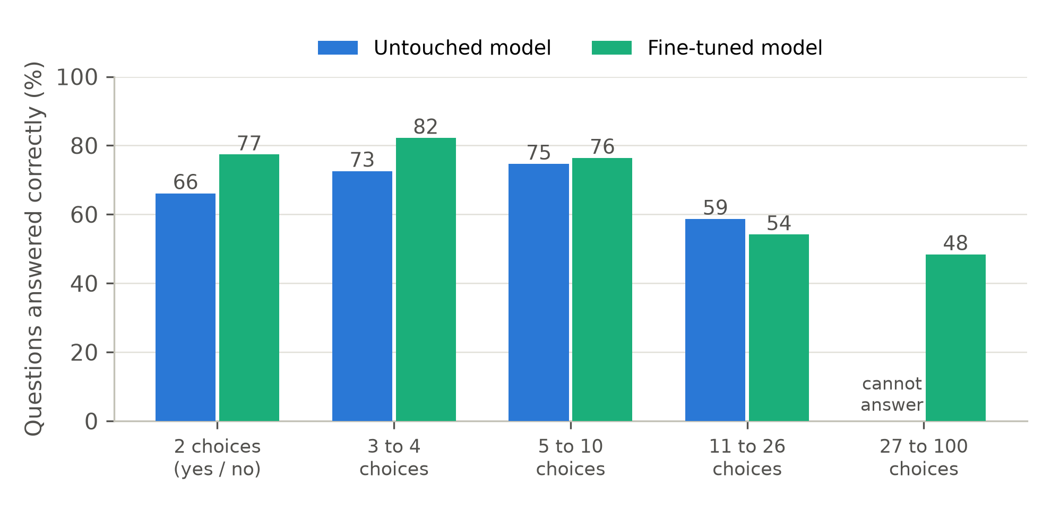
Figure 1. Questions answered correctly, by number of choices.
In short: the fine-tuned model is clearly better for 2 to 4 choices, slightly better for 5 to 10, worse for 11 to 26, and the only one that works beyond 26. Over 16 datasets used while developing the model it was about 7 points more accurate, and over 11 datasets set aside for the final check, about 3 points.

Results on datasets the model had not seen
The most trustworthy test uses data that played no part in building the model: 11 datasets assembled after all design decisions were made, and 3 sources whose type of task the model was never trained on (14 datasets, 3,026 questions, all with 26 or fewer choices).
Table 2. Questions answered correctly (%) and error between stated certainty and actual accuracy (lower is better). The range in brackets is how far the gain could move by chance.
Unseen data | Untouched model | Fine-tuned model | Gain (range) | Certainty error: untouched, then fine-tuned
11 datasets set up after the comparison | 69.2 | 72.0 | +2.8 (+1.2 to +4.4) | 0.255, then 0.044
3 sources of a task type never trained on | 68.3 | 70.0 | +1.7 (-1.3 to +4.3), could be chance | 0.266, then 0.070
All 14 together | 69.0 | 71.5 | +2.5 (+1.1 to +4.1) | 0.257, then 0.047
The untouched model has had the simple confidence adjustment (section 5) for the accuracy comparison. The certainty error of the untouched model is shown before that adjustment.
The gain on unseen data is real but modest: about 2.5 points. It is not even across datasets. The fine-tuned model was better on 7 of the 14 datasets, equal on 1 and worse on 6. The largest gains were on tweet sentiment (+20 points), a sentence-pair logic task (+16) and a word-meaning task (+8). The largest drops were on tweet stance (-6) and tweet emotion (-5).

5. Making the stated certainty trustworthy: temperature scaling
After training, the model's certainty is still a little off. We fix this with one number, the temperature T, found by trying values on a set of questions kept aside and keeping the one that gives the most honest probabilities. The score of each choice is divided by T before it is turned into a probability:
Probability of choice j = e^(score_j / T) divided by the sum of e^(score_k / T) over all choices k
- T above 1 makes the model less sure of itself; T below 1 makes it more sure.
- Dividing every score by the same T never changes which choice wins, so accuracy stays the same and only the honesty of the stated certainty improves.
- The untouched model needs a large T (about 4 to 7) because it is so overconfident. Our model needs only a small one (0.7 to 1.3).
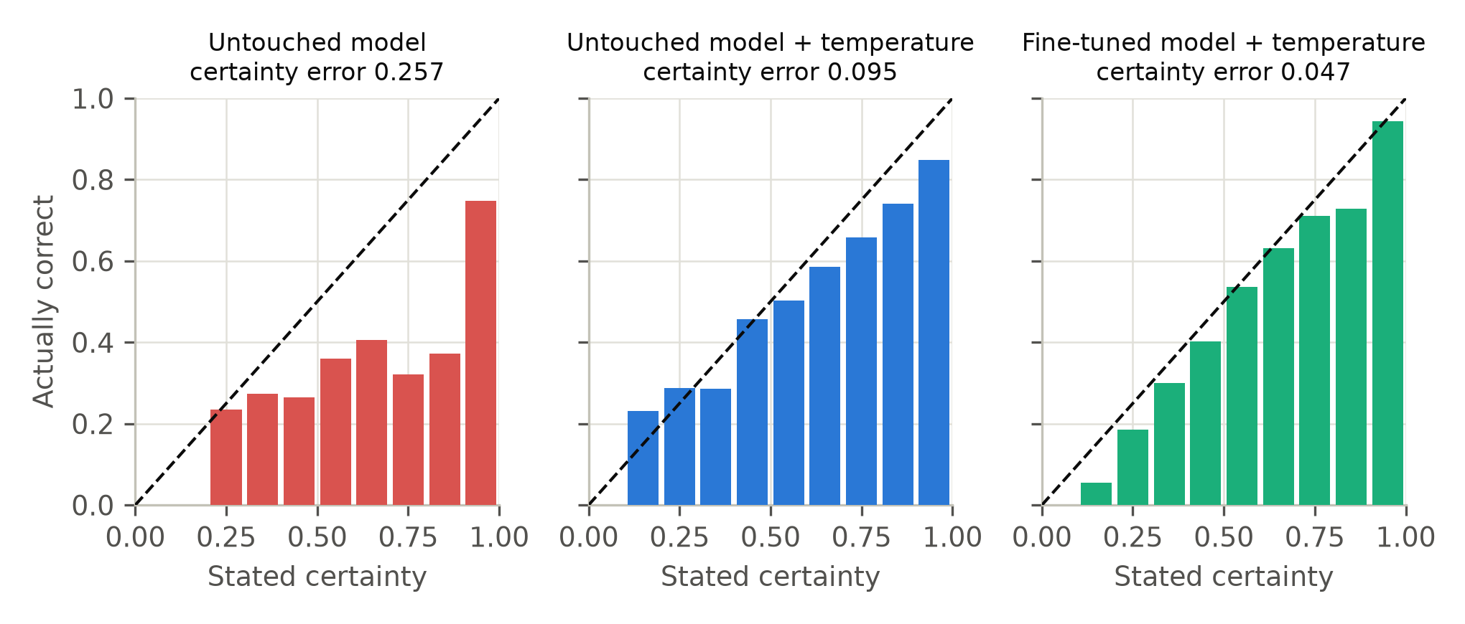
Figure 2. Does the model's stated certainty match reality? Each bar groups questions by how sure the model said it was (left to right: unsure to very sure) and shows how often it was actually right. Bars on the dashed line mean the stated certainty is honest. Data: the 14 unseen datasets.
Table 3. Error between stated certainty and actual accuracy (lower is better), on the 14 unseen datasets.
 | Untouched model | Untouched model + temperature | Fine-tuned model + temperature
Certainty error | 0.257 | 0.095 | 0.047
Average stated certainty (%) | 94.7 | 77.5 | 76.1
Actually correct (%) | 69.0 | 69.0 | 71.5
The untouched model claims about 95% certainty but is right about 69% of the time. The simple temperature fix removes most of that overconfidence, and training halves the remaining error.

6. Next steps to improve the 11 to 26 choice case
These are ideas that have not been tested yet. One attempt, adding more training examples with long lists, did not help, so the first step is to find out why the model struggles here.
- Find the cause first. Check whether the model is biased toward certain positions in a long list, or confuses choices that look alike.
- More varied long-list training. Add many more questions with 11 to 26 choices from many different kinds of tasks, not only longer lists.
- Train it to ignore the order of choices. Shuffle the choices more during training and penalise answers that change when the order changes.
- Answer in two steps. First narrow a long list to a few likely choices, then pick among them.
- Average over several orders when answering. This already helps a little (54.2 to 56.9) but costs more time.
- Try a larger model or longer training, which may handle long lists better.

