

Customer Sales Analysis – Superstore

Dataset

Data Analytics Internship – Project Report
TASK - 2

Organization: Alfido Tech
Internship: Data Analytics Internship
Project: Superstore Sales Performance & Customer Insights Analysis
Submitted by: Kishu Agarwal

Executive Summary
This project analyses the Superstore Sales dataset to understand sales performance across product categories, geographical regions, customer segments, and shipping modes. A total of 9,800 transaction records were examined using Python and data analysis techniques.
The dataset recorded total sales of 2,261,536.78 across 4,922 unique orders and 793 unique customers, with an average order value of 459.48.
The analysis identified Technology as the highest-performing product category, while the West region generated the largest share of total sales at 31.40%. At the sub-category level, Phones recorded the highest sales, and the Canon image CLASS 2200 Advanced Copier was the top-performing individual product by sales value.
Customer analysis revealed that the top 30 customers contributed 15.64% of total sales, indicating that sales were distributed across a broad customer base. The average shipping duration was 3.96 days, while Standard Class recorded the longest average shipping duration at 5.01 days.
The findings provide insights into product performance, regional sales patterns, customer contributions, and shipping timelines. Based on these observations, practical recommendations have been developed to support improved sales planning, product management, and order fulfilment.
Note: The dataset represents historical Superstore transactions and is not actual Alfido Tech sales data.

1. Introduction
Sales data plays an important role in understanding business performance, customer preferences, and market trends. Analysing transaction records helps businesses identify high-performing products, evaluate regional sales patterns, understand customer segments, and review order fulfilment performance.
This project focuses on analysing the Superstore Sales dataset using Python-based data analytics techniques. The dataset contains 9,800 transaction records covering product categories, customer segments, geographical regions, order dates, shipping modes, and sales values.
The analysis involves data understanding, data cleaning, statistical analysis, exploratory data analysis (EDA), and data visualization. Different analytical techniques are used to identify meaningful patterns and translate them into practical business insights.
The project aims to demonstrate how structured data analysis can support informed business decisions related to sales planning, product management, customer engagement, and shipping operations.

2. Project Objectives
The key objectives of this project are:
- Understand the Dataset: Examine the dataset structure, dimensions, data types, and key variables.
- Perform Data Cleaning: Identify missing values, check duplicate records, convert date columns, and prepare the dataset for analysis.
- Conduct Statistical Analysis: Calculate descriptive statistics such as mean, median, mode, and standard deviation.
- Analyse Sales Performance: Evaluate sales across product categories, sub-categories, regions, and customer segments.
- Study Sales Trends: Examine monthly and yearly sales patterns to identify changes over time.
- Understand Customer Behaviour: Identify high-value customers and analyse customer-level sales contributions.
- Evaluate Shipping Performance: Compare average shipping durations across different shipping modes.
- Create Data Visualizations: Present analytical findings through suitable charts and graphs.
- Develop Business Insights: Translate the results into meaningful observations and actionable recommendations.

3. Dataset Description
The project uses the Superstore Sales dataset, obtained from Kaggle. It contains 9,800 transaction records and 18 columns describing customer orders, products, geographical details, shipping information, and sales.
The dataset includes the following key information:
Data category | Details
Order Information | Row ID, Order ID, Order Date, Ship Date, Ship Mode
Customer Information | Customer ID, Customer Name, Segment
Geographical Information | Country, City, State, Postal Code, Region
Product Information | Product ID, Category, Sub-Category, Product Name
Sales Information | Sales
Dataset Overview
Parameter | Value
Total records | 9,800
Total columns | 18
Unique orders | 4,922
Unique customers | 793
Unique products | 1,861
Product categories | 3
Product sub-categories | 17
Geographical regions | 4
The dataset provides a suitable foundation for examining sales distribution, customer contributions, product performance, regional patterns, and shipping duration.
Dataset Source: Kaggle – Superstore Sales Dataset
Note: The dataset does not contain profit, cost, quantity, or discount fields. Therefore, the project focuses on sales value and the variables available in the dataset.

4. Tools and Technologies Used
The following tools and technologies were used to perform the analysis:
Tool / Technology | Purpose
Python | Main programming language for data analysis
Google Colab | Cloud-based environment for writing and executing code
Pandas | Data loading, cleaning, manipulation, and analysis
NumPy | Numerical operations and calculations
Matplotlib | Creating data visualizations
Seaborn | Statistical charts and visual presentation
Jupyter Notebook (.ipynb) | Organizing code, outputs, charts, and observations
Kaggle | Source of the Superstore Sales dataset

5. Data Understanding and Initial Inspection
The initial inspection was performed to understand the structure, size, and characteristics of the Superstore Sales dataset before conducting detailed analysis.
A total of 9,800 records and 18 columns were identified. The dataset contains information about customer orders, products, geographical locations, shipping methods, and sales values.
The following checks were performed during the initial inspection:
5.1 Dataset Dimensions
The dataset contains:
- 9,800 rows representing transaction records.
- 18 columns containing different order, customer, product, and sales attributes.
5.2 Data Types
The data types of the columns were examined to identify numerical, categorical, and date-related variables. The Order_Date and Ship_Date columns were converted into appropriate date formats during preprocessing to support time-based analysis.
5.3 Unique Value Analysis
Unique values were examined to understand the dataset's coverage:
- 4,922 unique orders
- 793 unique customers
- 1,861 unique products
- 3 product categories
- 17 product sub-categories
- 4 geographical regions
5.4 Initial Data Quality Checks
The dataset was checked for:
- Missing values
- Duplicate records
- Incorrect data types
- Invalid sales values
- Inconsistent order and shipping dates
These checks helped identify data quality issues and determine the preprocessing steps required before exploratory data analysis.
Observation: The dataset contains multiple records for individual orders because an order can include multiple product line items. Therefore, the number of transaction records is higher than the number of unique orders.

6. Data Cleaning and Preprocessing
Data cleaning and preprocessing were performed to improve data quality and prepare the dataset for reliable analysis. The original dataset was retained, and a separate working copy was created for preprocessing.
6.1 Creating a Working Copy
A copy of the original dataset was created to ensure that the source data remained unchanged during the cleaning process.
6.2 Missing Value Analysis
The dataset was examined for missing values. A total of 11 missing values were identified in the Postal_Code column.
All 11 records belonged to Burlington, Vermont, in the East region. These values were retained rather than filled with assumed postal codes or removed, as the missing information did not prevent the sales analysis.
6.3 Duplicate Record Check
The dataset was checked for exact duplicate rows. No duplicate records were identified.
6.4 Date Format Conversion
The Order_Date and Ship_Date columns were converted into appropriate datetime formats. This step enabled accurate date-based calculations and supported monthly and yearly sales analysis.
6.5 Sales Value Validation
The Sales column was examined for invalid values. No zero or negative sales values were identified in the dataset.
6.6 Shipping Date Validation
Order dates and shipping dates were compared to identify invalid date sequences. No records were found where the shipping date occurred before the order date.
6.7 Final Data Preparation
After completing the checks, the cleaned working dataset was used for further analysis and visualization.
Data Cleaning Summary
Data Quality Check | Result
Total records | 9,800
Missing values | 11 in Postal_Code
Exact duplicate rows | 0
Zero or negative sales values | 0
Shipping date before order date | 0
Date columns converted | Yes
Missing postal codes | Retained
Observation: The dataset was suitable for further exploratory analysis after the required preprocessing. The 11 missing postal codes were retained because they did not affect the sales-related analysis.

7. Exploratory Data Analysis (EDA)
Exploratory Data Analysis (EDA) was performed to identify patterns, relationships, and trends within the Superstore Sales dataset. Different analytical techniques and visualizations were used to examine sales performance across product categories, geographical regions, customer segments, time periods, and shipping methods.
The analysis focused on the following areas:
- Overall Sales Performance
- Sales Performance by Product Category
- Regional Sales Analysis
- Customer Segment Analysis
- Monthly Sales Trend
- Year-wise Sales Performance
- Sub-category Sales Analysis
- Shipping Time Analysis
- Top 10 Products by Sales
- Customer-Level Sales Analysis
- Regional Sales and Customer Distribution
Each analysis is supported by relevant visualizations and observations to make the findings easier to understand and interpret.
7.1 Overall Sales Performance
The overall sales performance was examined to understand the total sales generated, number of unique orders, customer count, and average order value.
Key Performance Indicator | Result
Total Sales | 2,261,536.78
Unique Orders | 4,922
Unique Customers | 793
Average Order Value | 459.48
Observation: The dataset recorded total sales of 2,261,536.78 across 4,922 unique orders. The average order value was 459.48, providing an overview of the sales value generated per order.

7.2 Sales Performance by Product Category
Sales performance was analysed across the three product categories to identify which category contributed the highest sales.
Category-wise Sales
Product Category | Total Sales
Technology | 827,455.87
Furniture | 728,658.58
Office Supplies | 705,422.33

Figure 1: Sales Distribution by Product Category
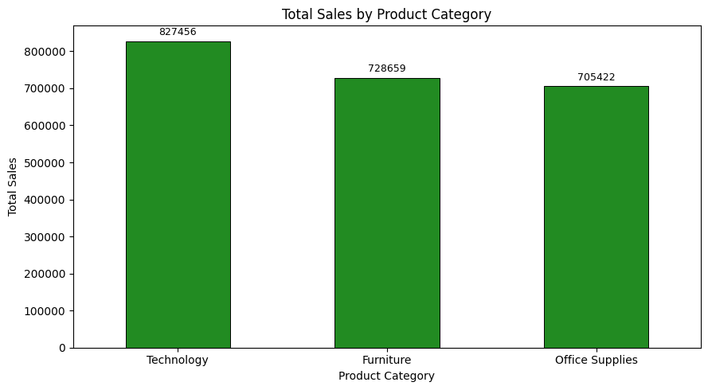
Key Observations:
- Technology recorded the highest sales, amounting to 827,455.87.
- Furniture ranked second with sales of 728,658.58.
- Office Supplies recorded sales of 705,422.33.
- The sales values across all three categories were relatively close, although Technology maintained the lead.
Business Insight: Technology products represented the strongest sales category in this dataset. Businesses can use this finding when reviewing product assortment, inventory planning, and category-level sales strategies.11

7.3 Regional Sales Analysis
The dataset was analysed across four geographical regions to identify differences in regional sales performance and understand each region's contribution to overall sales.
Region-wise Sales
Region | Total Sales | Sales Contribution
West | 710,219.68 | 31.40%
East | 669,518.73 | 29.60%
Central | 492,646.91 | 21.78%
South | 389,151.46 | 17.21%
Figure 2: Regional Sales Comparison
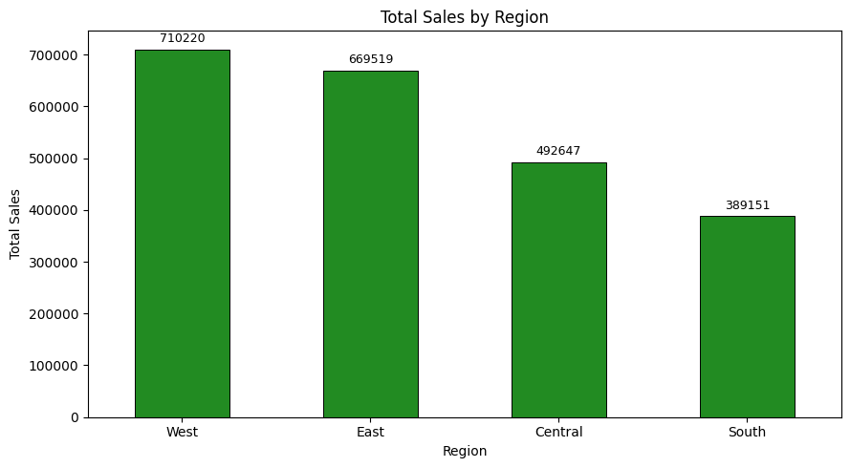
.Key Observations:
- The West region generated the highest sales, contributing 31.40% of total sales.
- The East region ranked second, contributing 29.60%.
- The Central region contributed 21.78% of total sales.
- The South region recorded the lowest sales contribution at 17.21%.
Business Insight: The West and East regions together contributed approximately 61% of total sales. Businesses can study the factors supporting their performance while reviewing opportunities to improve sales in the Central and South regions.

7.4 Customer Segment Analysis
The dataset was analysed across three customer segments to understand their contribution to overall sales. The segments included Consumer, Corporate, and Home Office.
Segment-wise Sales
Customer Segment | Total Sales
Consumer | 1,148,060.53
Corporate | 688,494.07
Home Office | 424,982.18
Figure 3: Sales by Customer Segment
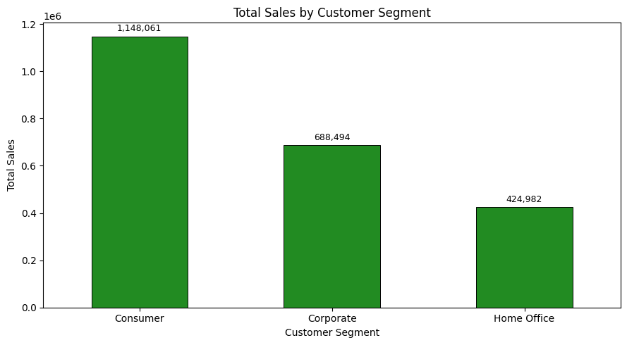
Key Observations:
- The Consumer segment generated the highest sales of 1,148,060.53.
- The Corporate segment ranked second with sales of 688,494.07.
- The Home Office segment recorded the lowest sales of 424,982.18.
- Consumer customers contributed approximately 50.75% of total sales.
Business Insight: The Consumer segment represents the largest sales contributor in the dataset. Businesses can study its purchasing patterns while developing suitable engagement strategies for Corporate and Home Office customers.

7.5 Monthly Sales Trend
Monthly sales were analysed to understand how sales performance changed over time and to identify periods of relatively high and low sales activity.
The monthly analysis helps in identifying seasonal patterns and understanding variations in sales throughout the study period.
Figure 5: Monthly Sales Trend
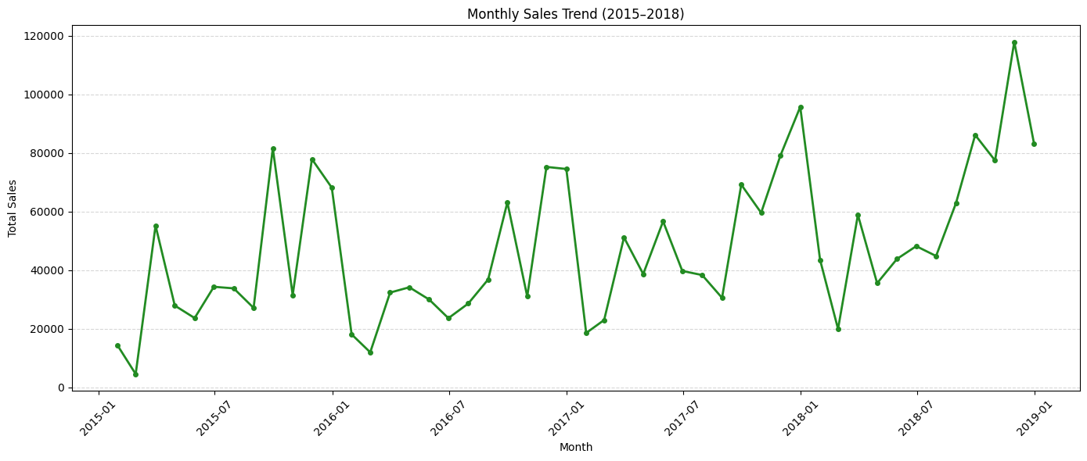
Key Observations:
- Monthly sales showed variations throughout the analysis period.
- November 2018 recorded the highest monthly sales of 117,938.15.
- February 2015 recorded the lowest monthly sales of 4,519.89.
- The monthly trend provides a view of changing sales activity across the four-year period.
Business Insight: Businesses can use monthly sales patterns to support demand forecasting, inventory planning, and promotional scheduling. However, the observed peaks and declines alone do not establish their underlying causes.

7.6 Year-wise Sales Performance
Year-wise sales analysis was conducted to examine the overall sales performance across the four years covered by the dataset, from 2015 to 2018.
Year-wise Sales
Year | Total Sales
2015 | 479,856.21
2016 | 459,436.01
2017 | 600,192.55
2018 | 722,052.02
Figure 6: Year-wise Sales Performance
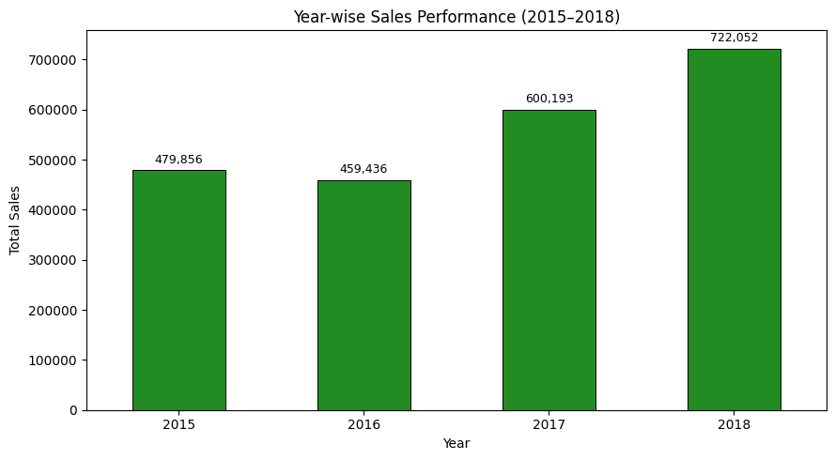
Key Observations:
- Sales decreased slightly from 479,856.21 in 2015 to 459,436.01 in 2016.
- Sales increased to 600,192.55 in 2017.
- 2018 recorded the highest annual sales of 722,052.02.
- Overall, the dataset shows an increase in annual sales between 2016 and 2018.
Business Insight: The increase in annual sales during 2017 and 2018 indicates stronger sales performance in the later years of the dataset. Businesses can examine the product and regional trends associated with this growth when planning future sales strategies.

7.7 Sub-category Sales Analysis
Sales performance was examined across 17 product sub-categories to identify the products contributing the highest and lowest sales values.
Top and Bottom Performing Sub-categories
Sub-category | Total Sales
Phones | 327,782.45
Chairs | 322,822.73
Storage | 219,343.39
Tables | 202,810.63
Fasteners | 3,001.96
Figure 7: Sales Performance by Product Sub-category
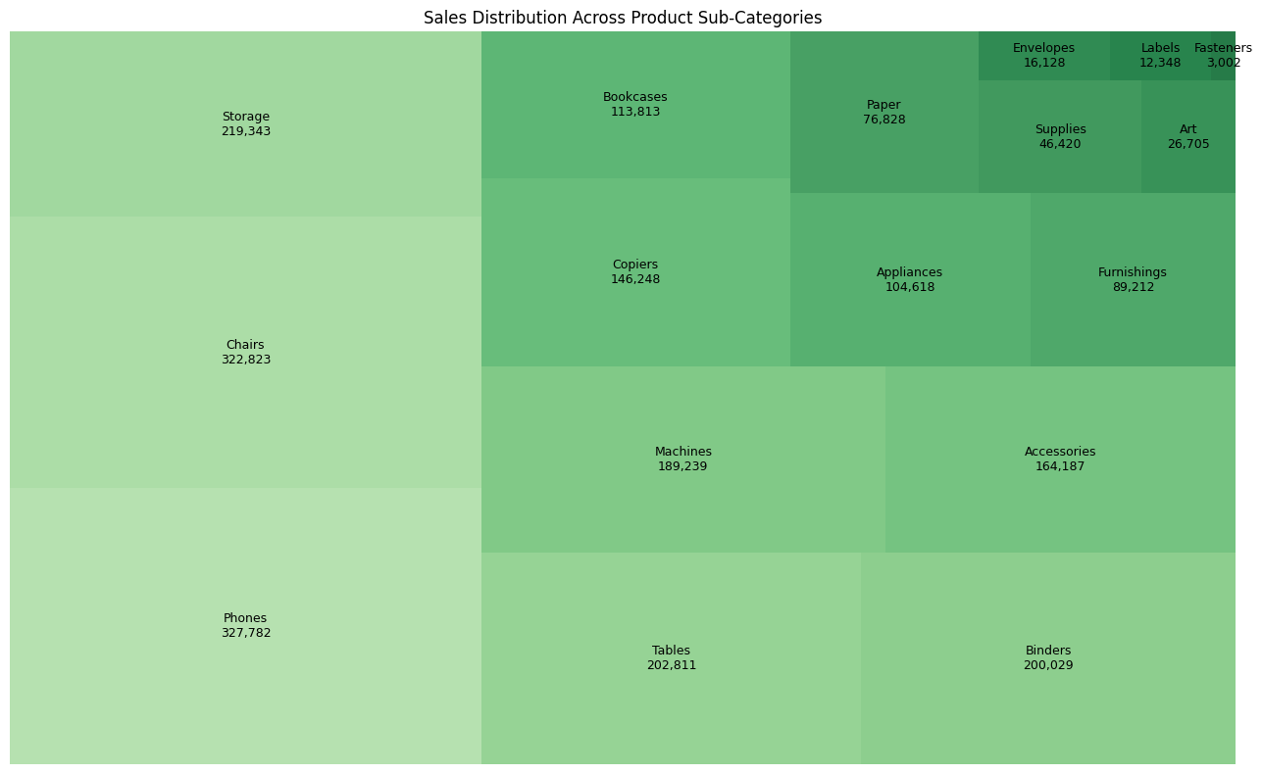
Key Observations:
- Phones recorded the highest sales among all sub-categories, with 327,782.45.
- Chairs ranked second with sales of 322,822.73.
- Storage and Tables also contributed significantly to overall sales.
- Fasteners recorded the lowest sales at 3,001.96.
- Sales performance varied considerably across the different sub-categories.
Business Insight: Phones and Chairs represent strong sales-performing sub-categories in this dataset. Businesses can review their product assortment and inventory planning based on category-level demand, while examining the reasons behind lower-performing sub-categories.

7.8 Shipping Time Analysis
Shipping performance was analysed to understand the average time taken to deliver orders across different shipping modes. The shipping duration was calculated using the difference between the order date and shipping date.
The overall average shipping duration across all records was 3.96 days.
Average Shipping Duration by Mode
Shipping Mode | Average Shipping Duration
Same Day | 0.04 days
First Class | 2.18 days
Second Class | 3.25 days
Standard Class | 5.01 days
Figure 8: Average Shipping Duration by Shipping Mode
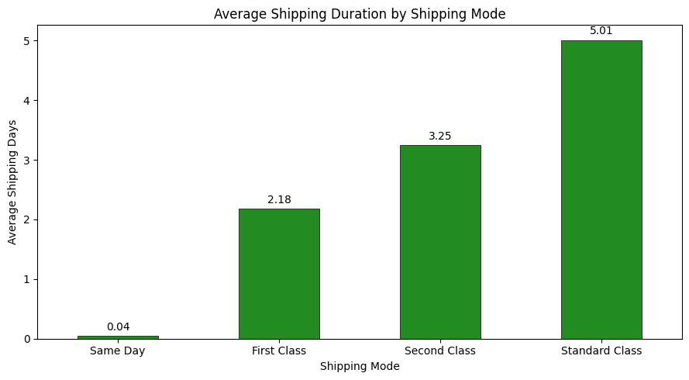
Key Observations:
- Same Day recorded the lowest average shipping duration at 0.04 days.
- First Class orders took an average of 2.18 days.
- Second Class orders took an average of 3.25 days.
- Standard Class recorded the longest average shipping duration at 5.01 days.
- The overall average shipping duration was 3.96 days.
Business Insight: Shipping duration varies across shipping modes. Businesses can use these findings to review delivery timelines, set realistic customer expectations, and evaluate fulfilment performance.

7.9 Top 10 Products by Sales
The product-level sales analysis was performed to identify the ten individual products generating the highest sales values. This analysis helps highlight products that made significant contributions to overall sales.
Top Performing Product
The Canon image CLASS 2200 Advanced Copier recorded the highest sales value of 61,599.82.
Figure 9: Top 10 Products by Sales
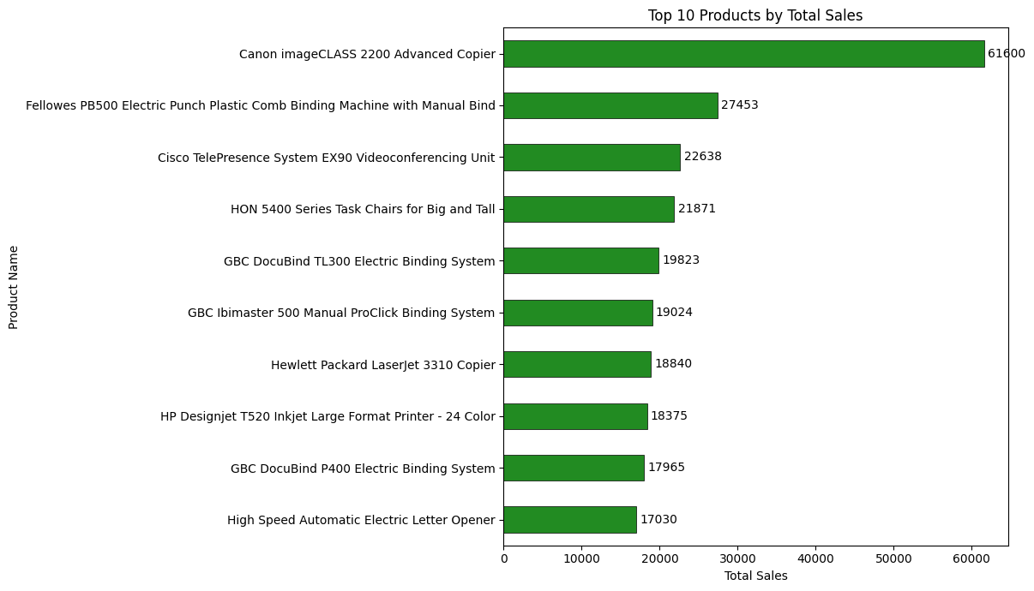
Key Observations:
- Canon image CLASS 2200 Advanced Copier ranked first with sales of 61,599.82.
- Fellowes PB500 Electric Punch ranked second with sales of 27,453.38.
- The top-performing products generated different levels of sales, indicating variations in product-level sales contribution.
- The analysis highlights the individual products contributing significantly to total sales.
Business Insight: Businesses can use product-level sales performance to review product availability, inventory planning, and sales strategies. High-performing products may deserve closer attention to ensure their availability meets customer demand.

7.10 Customer-Level Sales Analysis
Customer-level sales analysis was performed to understand how sales were distributed among individual customers. The analysis identified the highest-contributing customers and examined the combined contribution of the top 10 and top 30 customers.
Key Customer Findings
Metric | Result
Total unique customers | 793
Highest sales by an individual customer | 25,043.05
Top 10 customers' combined sales | 153,811.17
Top 10 customers' contribution | 6.80%
Top 30 customers' contribution | 15.64%
Remaining 763 customers' contribution | 84.36%
The customer with the highest sales was Sean Miller, with total sales of 25,043.05.
Figure 10: Top 30 Customers – Sales Contribution Analysis
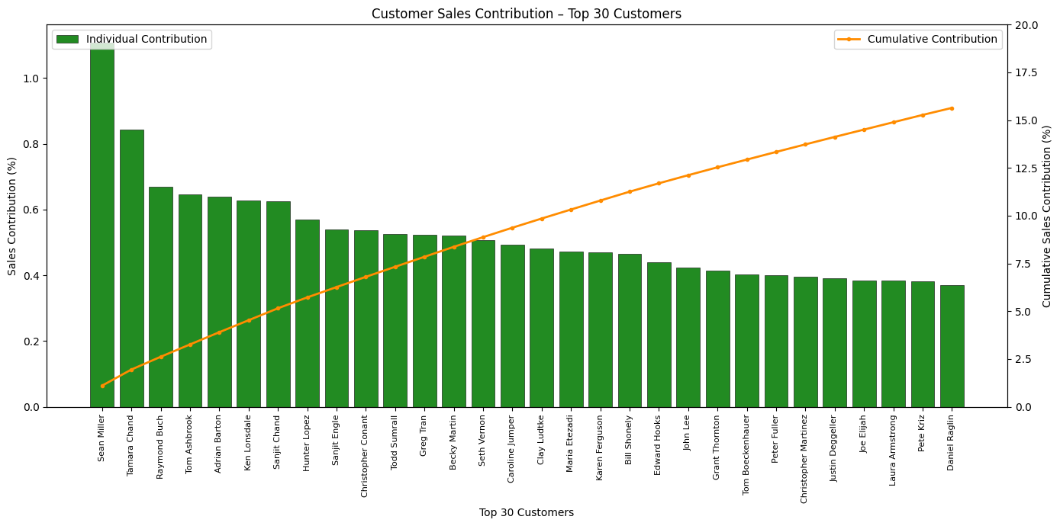
Key Observations:
- Sean Miller recorded the highest individual customer sales of 25,043.05.
- The top 10 customers collectively contributed 6.80% of total sales.
- The top 30 customers accounted for 15.64% of total sales.
- The remaining 763 customers contributed 84.36% of total sales.
- Sales were distributed across a broad customer base rather than being concentrated among a small group of customers.
Business Insight: The broad distribution of sales highlights the importance of maintaining engagement across the customer base. Businesses can focus on customer retention while identifying opportunities to increase repeat purchases and strengthen customer relationships.

7.11 Regional Sales and Customer Distribution
This analysis examines regional sales performance alongside the number of unique customers recorded in each region. It helps compare sales contribution and customer distribution across the four geographical regions.
Regional Sales and Customer Distribution
Region | Total Sales | Unique Customers
West | 710,219.68 | 681
East | 669,518.73 | 669
Central | 492,646.91 | 626
South | 389,151.46 | 509
Figure 11: Regional Sales and Customer Distribution
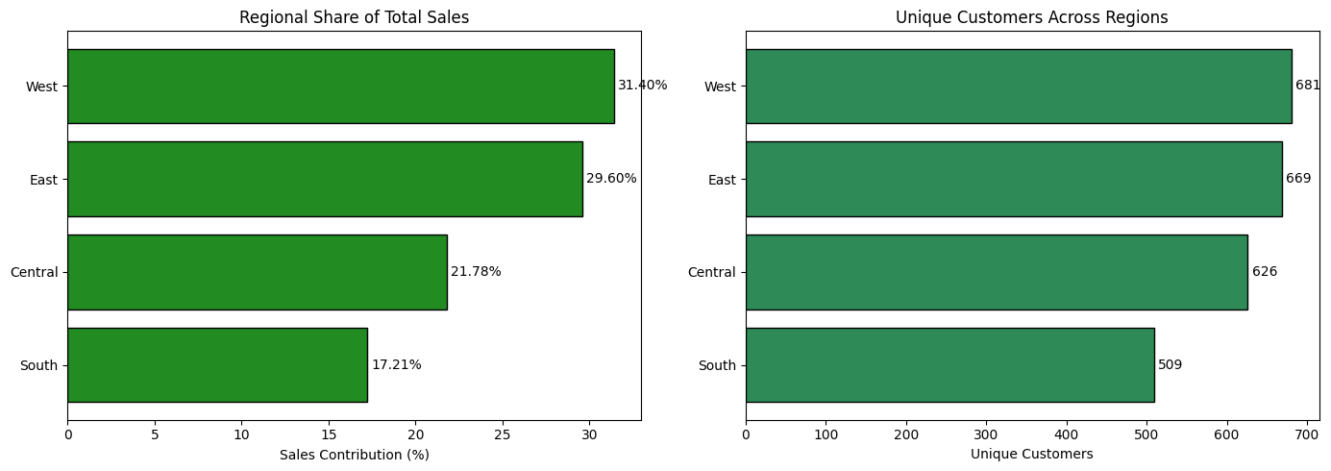
Key Observations:
- The West region recorded the highest sales and the largest number of unique customers.
- The East region ranked second in both sales and customer count.
- The Central region recorded 492,646.91 in sales and 626 unique customers.
- The South region recorded the lowest sales and customer count among the four regions.
- Regional customer counts are not mutually exclusive because some customers placed orders in multiple regions.
Business Insight: Comparing sales and customer distribution provides a broader understanding of regional performance. Businesses can examine regional customer engagement and sales patterns to identify opportunities for improving market coverage.

8. Final KPI Review
The final KPI review consolidates the major performance indicators identified during the analysis. These metrics provide an overall view of sales performance, customer activity, and order fulfilment.
Key Performance Indicator | Result
Total Sales | 2,261,536.78
Total Records Analysed | 9,800
Unique Orders | 4,922
Unique Customers | 793
Unique Products | 1,861
Average Order Value | 459.48
Highest Performing Category | Technology
Highest Performing Region | West
Highest Performing Sub-category | Phones
Top-Selling Product | Canon image CLASS 2200 Advanced Copier
Average Shipping Duration | 3.96 days
Highest Sales Year | 2018
Overall Observation:
The analysis highlights Technology as the leading product category, West as the highest-performing region, and Phones as the top-performing sub-category. Annual sales reached their highest level in 2018, while customer-level analysis showed that sales were distributed across a broad customer base.
The KPI review brings together the major findings and provides a concise reference for business interpretation and decision-making.

9. Business Recommendations
Based on the findings of the Superstore Sales analysis, the following recommendations are proposed to support better sales planning, product management, customer engagement, and order fulfilment.
1. Strengthen High-Performing Product Categories
Technology recorded the highest sales among the three product categories. Businesses can review the demand for Technology products and plan inventory and promotional activities accordingly.
2. Develop Region-Specific Sales Strategies
The West and East regions generated the highest sales contributions. Businesses can study the factors behind their performance and identify opportunities to improve sales in the Central and South regions.
3. Focus on High-Performing Products
Products such as the Canon image CLASS 2200 Advanced Copier generated significant sales. Monitoring the performance and availability of popular products can help support inventory planning.
4. Review Shipping and Fulfilment Performance
Standard Class recorded the longest average shipping duration at 5.01 days. Businesses can review fulfilment processes and delivery expectations to improve the customer experience.
5. Strengthen Customer Engagement
The top 30 customers contributed 15.64% of total sales, while the remaining customers contributed 84.36%. Businesses should maintain engagement across the wider customer base while identifying opportunities to encourage repeat purchases.
6. Use Historical Sales Trends for Planning
Annual sales were highest in 2018. Businesses can use historical sales patterns to support demand forecasting, resource allocation, and future sales planning.
Overall Recommendation
Businesses should adopt a data-driven approach by regularly monitoring sales KPIs, product performance, regional trends, customer contributions, and shipping timelines. These practices can support more informed operational and strategic decisions.

10. Project Limitations
Although the analysis provides useful insights into sales performance and customer distribution, certain limitations should be considered while interpreting the findings.
- Limited Financial Information: The dataset contains sales values but does not include profit, cost, or discount information. Therefore, profitability and profit margins could not be evaluated.
- No Product Quantity Information: The dataset does not contain quantity sold. As a result, the analysis focuses on sales value rather than the number of units sold.
- Missing Postal Codes: Eleven records had missing values in the Postal_Code column. These values were retained because they did not affect the main sales analysis.
- Historical Dataset: The analysis is based on historical transactions from 2015 to 2018. The findings may not represent current market conditions or customer behaviour.
- Dataset Source: The analysis uses a publicly available Superstore Sales dataset obtained from Kaggle. It does not represent actual sales records of Alfido Tech.
- Limited Causal Analysis: The analysis identifies patterns and relationships in the available data but does not establish the reasons behind sales performance or customer behaviour.
Overall Note: These limitations define the scope of the project and should be considered when interpreting the results and recommendations.

11. Conclusion
The Superstore Sales Performance and Customer Insights Analysis provided an opportunity to explore real-world sales data using Python and data analytics techniques.
A total of 9,800 transaction records were analysed to understand sales performance across product categories, geographical regions, customer segments, individual products, and shipping modes.
The analysis identified Technology as the highest-performing product category, the West as the leading sales region, and Phones as the top-performing sub-category. The Canon image CLASS 2200 Advanced Copier recorded the highest individual product sales. The study also highlighted annual sales growth in the later years, a broad distribution of customer contributions, and differences in shipping durations across shipping modes.
The project involved data cleaning, statistical analysis, exploratory data analysis, data visualization, and business interpretation. It strengthened practical understanding of Python libraries such as Pandas, NumPy, Matplotlib, and Seaborn.
Overall, this project demonstrates how data analytics can transform raw transaction records into meaningful business insights. The findings and recommendations provide a foundation for better sales planning, product management, customer engagement, and operational decision-making.

