

Website Traffic & User Engagement Analysis
Data Analytics Internship – Project Report
TASK - 3
Organization: Alfido Tech
Internship: Data Analytics Internship
Project: Website Traffic & User Engagement Analysis
Submitted by: Kishu Agarwal

Executive Summary
This project analyses website traffic event data to understand how users interact with content, which locations drive the most activity, and how traffic changed over time. The dataset has 226,278 recorded events from 19 to 25 August 2021, covering 211 countries, 11,993 cities and 2,419 artists. Python, Pandas, NumPy, Matplotlib and Seaborn were used for cleaning, analysis and visualisation.
Pageviews made up 62.76% of all events, followed by clicks (24.63%) and previews (12.61%). Saudi Arabia (47,334 events) and India (42,992) were the top countries, and Jeddah and Riyadh were the busiest cities. Tesher and the track Jalebi Baby led the content ranking with 40,841 events, around 18% of the known-artist events. Thursday, 19 August, was the busiest day in the week observed.
The data has no user or session IDs, so all results are based on recorded event counts, not unique visitors. Based on the findings, the report suggests focusing on the leading markets, promoting top content and improving event tracking.
1. Introduction and Objectives
Website event data shows what visitors do on a platform. Looking at pageviews, clicks and previews by date, location and content helps a business see where engagement is coming from and where it can improve. The main objectives of this project were:
- Clean and understand the website traffic dataset.
- Analyse the split of pageviews, clicks and previews and the daily trend.
- Find the top countries and cities by event activity.
- Find the top artists, albums, tracks and links.
- Compare interaction ratios across countries, cities and artists.
- Give practical recommendations to improve digital engagement.
2. Dataset and Data Cleaning
The Website Traffic Analysis dataset was taken from Kaggle. Each row is one event (click, pageview or preview) with its date, location and music content details.
Parameter | Details
Total records | 226,278
Columns | 9 (event, date, country, city, artist, album, track, isrc, linkid)
Event types | Pageview, Click, Preview
Time period | 19 August 2021 – 25 August 2021 (7 days)
Countries / Cities | 211 / 11,993
Artists / Tracks | 2,419 / 3,562

Cleaning steps:
- Date: converted the date column to datetime format.
- Missing values: country and city had 11 missing values each, artist 37, album and track 5 each, and isrc 7,121. These were filled with "Unknown" and excluded from the rankings where needed.
- Duplicates: exact duplicate rows were found but kept, because repeated events can be genuine activity and the data has no field to tell them apart from logging repeats.
3. Key Findings
3.1 Overall activity
Out of 226,278 events, 142,015 were pageviews, 55,732 were clicks and 28,531 were previews. For every 100 pageviews there were about 39 clicks and 20 previews. The dashboard below gives the overall picture.
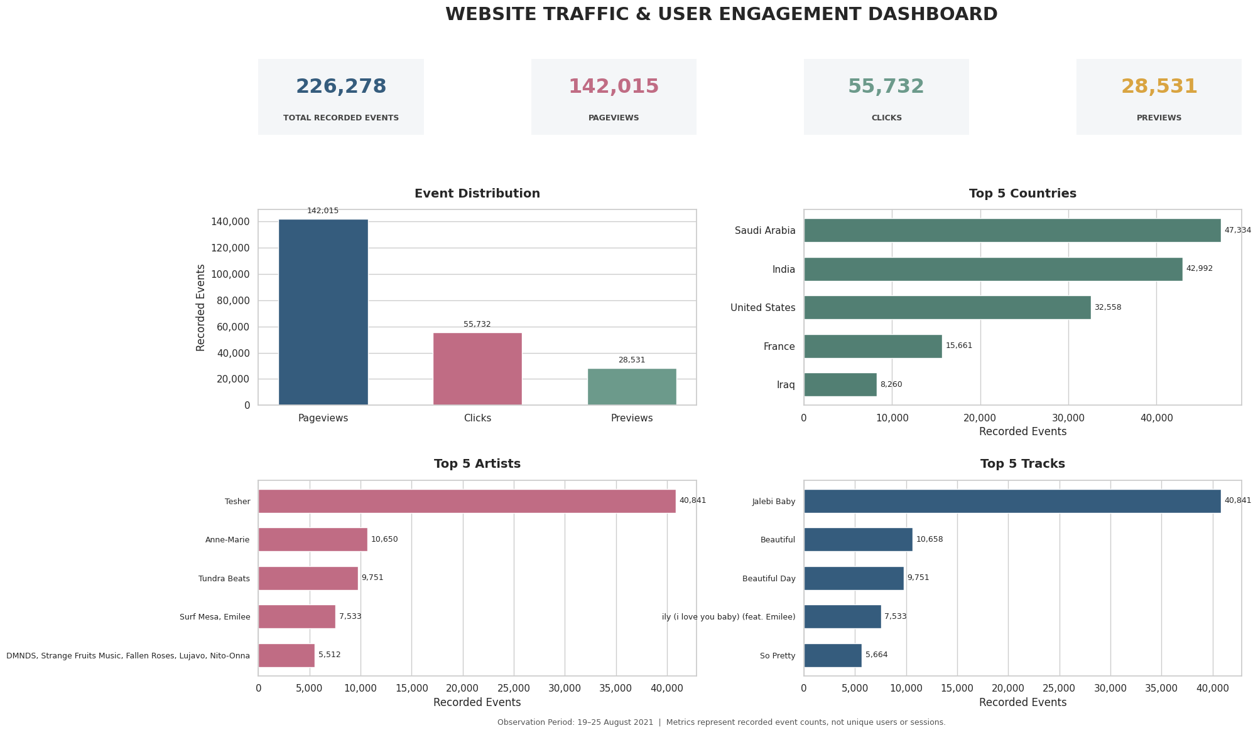
Figure 1: Overview of events, top countries, artists and tracks
3.2 Daily trend
Pageviews were highest on 19 August (22,366) and lowest on 23 August (18,646). Clicks also fell from 9,207 on 19 August to about 7,300 by 24 August. Previews peaked on 21 August at 4,663. The share of the three event types stayed almost the same every day, with pageviews at 62.55% to 63.25%.
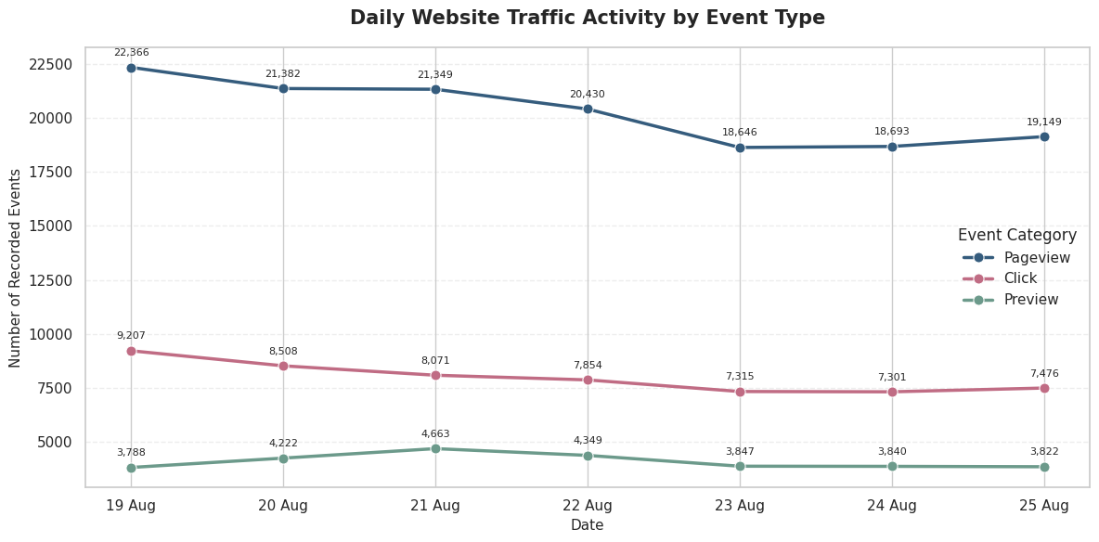
Figure 2: Daily pageviews, clicks and previews
3.3 Geography
Saudi Arabia (20.92%), India (19.00%) and the United States (14.39%) together gave about 54% of events with a known country, and the top ten countries gave 77.28%. At city level, Jeddah (22,791 events) and Riyadh (17,454) were far ahead of the third city, Hyderabad (3,682). India led in click volume (11,609), while Saudi Arabia led in pageviews and previews. Pakistan had the highest click-to-pageview ratio (51.46%) and Iraq the highest preview-to-pageview ratio (31.18%).
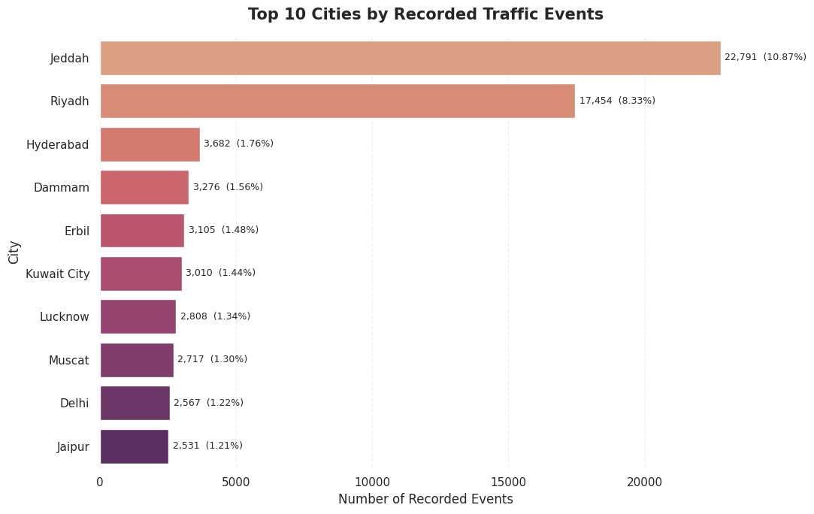
Figure 3: Top 10 cities by recorded events
3.4 Content performance
Activity was concentrated on a few items. Tesher had 40,841 events, which is 3.83 times Anne-Marie (10,650) and 18.05% of known-artist events. Jalebi Baby led both the album and track rankings with the same 40,841 events. The top three artists together made up 27.07% of events, and the top ten links made up 43.42%. Tesher was also first in all five leading countries. The artist with the most events was not the one with the best interaction ratio: Roddy Ricch had the highest click-to-pageview ratio (45.20%) and Tundra Beats the highest preview-to-pageview ratio (26.26%).
3.5 Day of the week
Thursday was the most active day (35,361 events) and Monday the least (29,808). Since the data covers only one week, this cannot be treated as a regular weekly pattern.
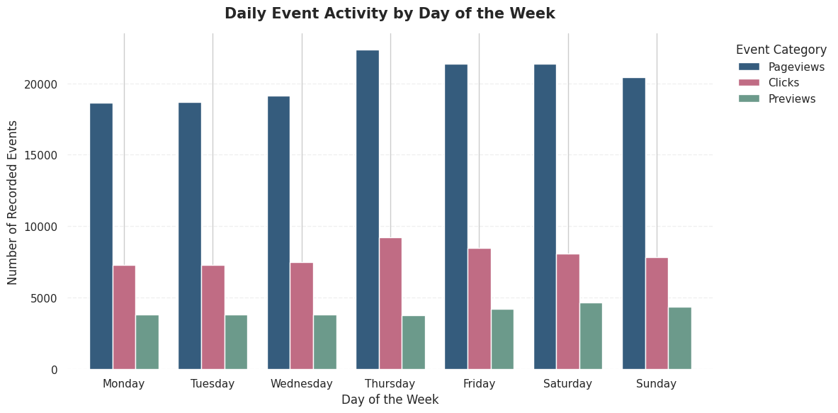
Figure 4: Events by day of the week
4. Business Insights and Recommendations
Insights
- Browsing dominates: pageviews are close to two-thirds of all activity, so getting more visitors to click or preview is the main chance to improve engagement.
- Traffic is concentrated: a few countries, two cities and a handful of artists and links give a large share of all events.
- Volume is not the same as engagement: markets like Pakistan and cities like Jaipur click more relative to their pageviews than the biggest markets do.
Recommendations
- Strengthen leading markets: study Saudi Arabia and India more closely to improve reach and engagement.
- Promote popular content: feature the high-activity artists, albums and tracks to help discovery.
- Look at smaller high-interaction markets: check Pakistan, Jaipur, Lucknow and Erbil before planning location-specific campaigns.
- Improve tracking: add user IDs, session IDs, page URLs and referral source so sessions, bounce rate and user journeys can be measured.
- Track for longer: analyse several weeks or months to find repeating patterns, and build a regular dashboard for pageviews, clicks, previews and location.
5. Limitations
The data covers only seven days, so the results may not hold over a longer period. There are no user IDs, session IDs, page URLs or referral sources, which means unique visitors, bounce rate and real conversion rates cannot be calculated. The click-to-pageview and preview-to-pageview ratios are based on total event counts and are not conversion rates. Exact duplicate rows were retained, which may slightly inflate event counts.
6. Conclusion
The analysis of 226,278 events showed that pageviews drive most of the activity, that traffic is concentrated in a few countries, cities and content items, and that high volume does not always mean high interaction. Although the dataset could not support user-level or session-level analysis, it gives a clear base for understanding the traffic and for planning better tracking and engagement efforts. The project also built my practical skills in data cleaning, EDA, visualisation and turning data into business recommendations.
Code and Notebook
GitHub repository: [paste your repository link here]
Notebook: Alfido_Task3_Website_Traffic_Analysis.ipynb (Task3_Website_Traffic_Analysis folder)

