Hotel Room Allotment System
Project Report
Student Name  Program  Institution  Subject / Course  Submission Type  Repository | Ritika Agrawal  B.Tech Computer Science & Engineering  VIT Bhopal University  B.Tech CSE AIML  Flipped Course Evaluation — Build Your Own Project https://github.com/agarwalritika706-cell/hotel-management.gi

1. Introduction

Hotels and small guesthouses that rely on manual, paper-based, or spreadsheet-based booking records commonly run into avoidable problems: rooms get double-booked, frontdesk staff lose track of which rooms are occupied, and simple tasks like finding a guest's booking or calculating a checkout bill take longer than they should.
This project implements a Hotel Room Allotment System as a command-line Python application. It models a small hotel's rooms and bookings using core Python data structures — lists and dictionaries — and provides a menu-driven interface through which front-desk staff can view rooms, book a room for a guest, search and manage existing bookings, process checkouts with automatic billing, and view an overall occupancy summary.
The project was built as part of a first-semester Computer Science course to demonstrate practical use of variables, data types, conditionals, loops, functions, lists, dictionaries, string formatting, and basic input validation — all within a single, coherent, working application rather than isolated exercises.

2. Problem Statement

Small hotels managing bookings manually face three recurring issues:
- Double-booking — the same room can be assigned to two guests if staff do not carefully cross-check a register.
- Slow lookups — finding a specific guest's booking, or checking a room's current status, requires manually scanning paper records.
- Manual billing errors — calculating a checkout bill (nights stayed × room rate) by hand is error-prone.
The system addresses these by keeping a single, consistent, in-memory record of every room's status and every active booking, and by enforcing rules (such as blocking a booking on an already-occupied room) directly in code rather than relying on staff vigilance.

3. Functional Requirements

The system is organized into three major functional modules:
Module 1 — Room & Availability Management
Display all rooms with type, price, and current status
Filter and display only currently available rooms
•
•
Track room status (
Available
/
Booked
)
in real time
Module 2 — Booking Management
Accept guest details: name, age, phone number, number of guests
Validate room existence and availability before confirming a booking
Block double-booking of an already-occupied room
Generate a unique Booking ID (
B001
,
B002
, …) per booking
Display a booking confirmation summary
Module 3 — Search, Cancellation & Checkout
Retrieve booking details by Booking ID
Search bookings by guest name
Cancel a booking and revert the room to
Available
Process checkout: total = nights × room price, then free the room
Generate a hotel-wide occupancy summary by status and room type
•
•
•
•
•
•
•
•
•
•
•

Input / Output Structure
Action | Input | Output
View rooms | Menu choice | Table of all rooms with status
View available rooms | Menu choice | List of currently free rooms
Book a room | Room number, guest details, Y/N confirmation | Booking confirmation with  Booking ID
View booking details | Booking ID | Full booking record
Search guest | Guest name | Matching booking details
Cancel booking | Booking ID, Y/N confirmation | Cancellation confirmation, room freed
Checkout | Booking ID, number of nights | Total bill, checkout confirmation
Hotel summary | Menu choice | Occupancy statistics

User Workflow
The application runs as a continuous loop: the main menu is displayed, the user selects an option (1–9), the corresponding module executes, a result is shown, and control returns to the menu until the user selects Exit. See Section 7.2 for the full workflow diagram.

4. Non-Functional Requirements

Requirement | How it is addressed
Usability | A clear, numbered menu (1–9) with descriptive labels allows a nontechnical user to operate the system without instructions. Y/N confirmation prompts precede irreversible actions such as booking and cancellation.
Reliability | Room status and booking records stay consistent — a room is only marked Booked after a successful booking and is reliably reverted to Available on cancellation or checkout.
Error Handling /  Robustness | Input is validated at each step using try/except ValueError for numeric fields; invalid menu choices and non-existent rooms/bookings are handled with clear messages instead of crashing.
Maintainability | The code is organized into small, single-purpose functions  ( book_room() , cancel_booking() , check_out() , etc.), making each feature independently modifiable.
Resource  Efficiency | The system uses lightweight in-memory lists and dictionaries with no external database or network dependency, so it runs instantly on any machine with a standard Python interpreter.

5. System Architecture

The system follows a simple three-layer structure appropriate for a single-file, firstsemester Python project: a presentation layer (the menu loop), a business logic layer (the feature functions), and a data layer (in-memory lists of dictionaries).
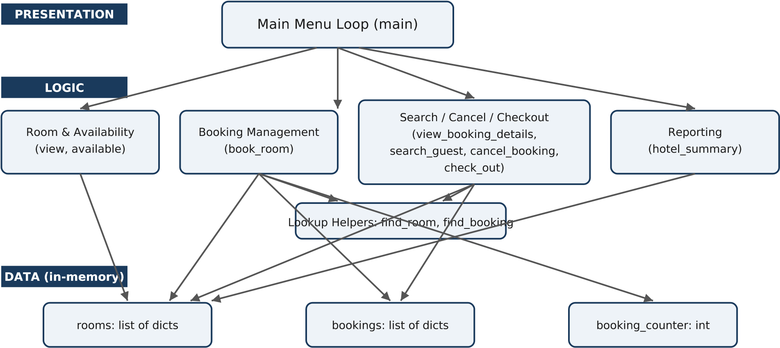
Figure 1: System Architecture Diagram

7. Design Diagrams

7.1 Use Case Diagram
F
r
o
n
t
D
e
s
k
S
t
a
f
f
V
i
e
w
A
l
l
R
o
o
m
s
V
i
e
w
A
v
a
i
l
a
b
l
e
R
o
o
m
s
B
o
o
k
a
R
o
o
m
V
i
e
w
B
o
o
k
i
n
g
D
e
t
a
i
l
s
S
e
a
r
c
h
G
u
e
s
t
C
a
n
c
e
l
B
o
o
k
i
n
g
C
h
e
c
k
O
u
t
G
u
e
s
t
V
i
e
w
H
o
t
e
l
S
u
m
m
a
r
y
Figure 2: Use Case Diagram — Front Desk Staff

7.2 Workflow Diagram
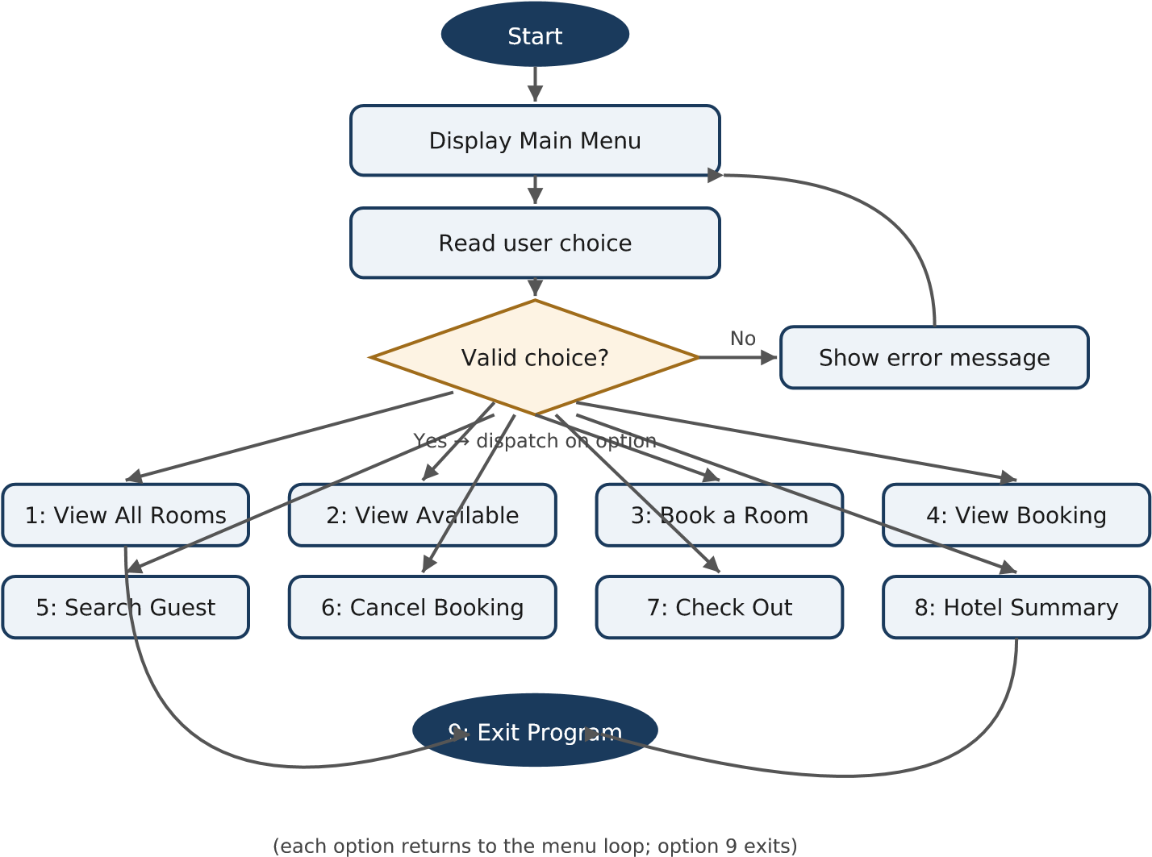
Figure 3: Main Menu Workflow

7.3 Class / Component Diagram
The implementation is function-based rather than class-based, consistent with firstsemester scope. This diagram represents the system as functional components operating on two record types.
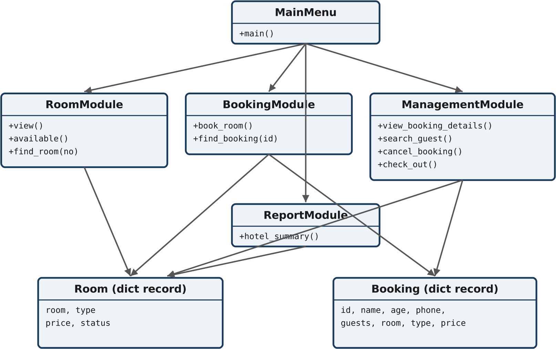
Figure 4: Component Diagram

7.4 Sequence Diagram — Booking a Room
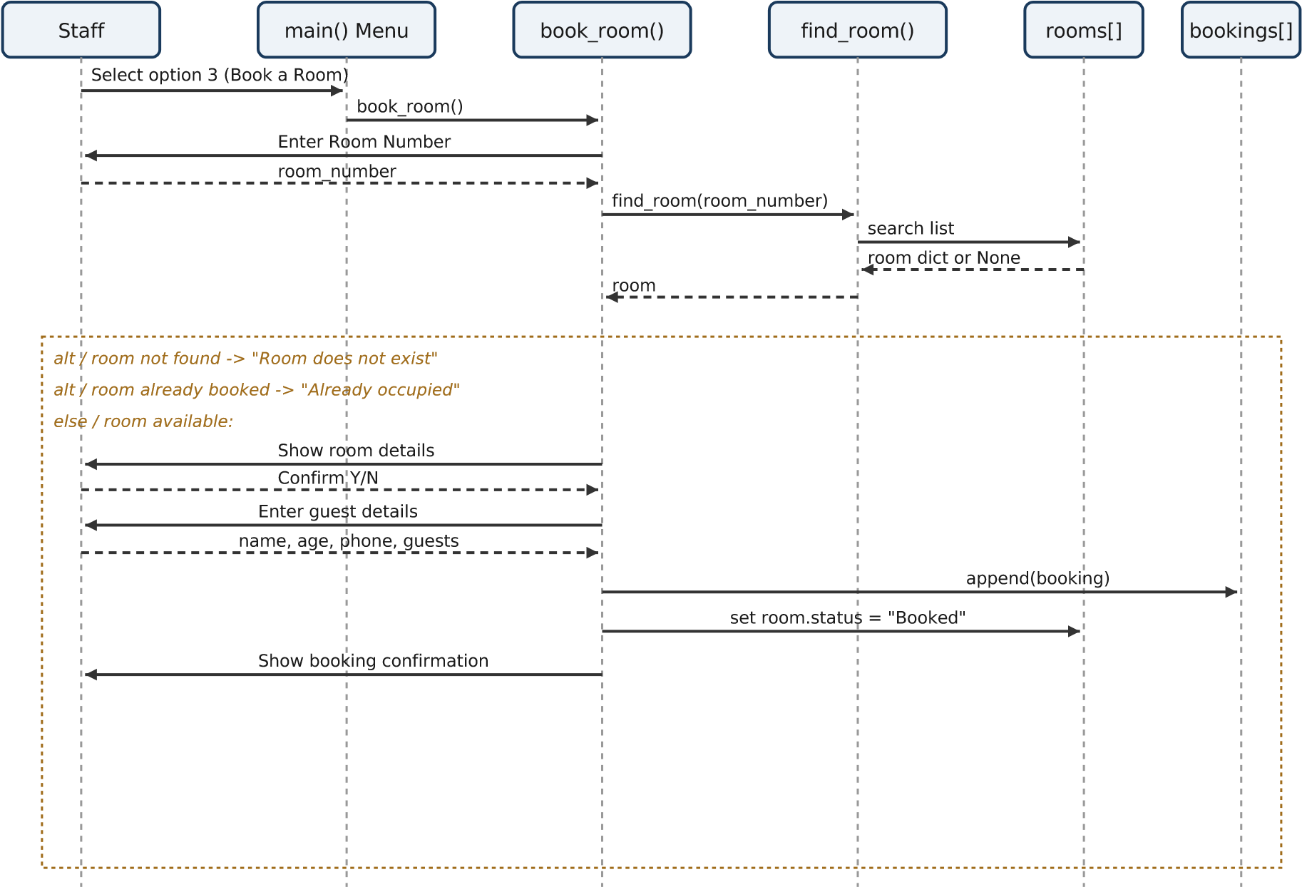
Figure 5: Sequence Diagram for the Booking flow

7.5 Storage / Schema Design
No external database is used; all data is held in memory using two lists of dictionaries for the duration of program execution.
rooms record
Field |  | Type |  | Description
room |  | int |  | Unique room number (primary key)
type |  | str |  | Single / Double / Deluxe
price |  | int |  | Price per night (₹)
status |  | str |  | Available / Booked
bookings record
Field | Type |  | Description
id | str |  | Unique Booking ID (primary key), e.g. B001
name | str |  | Guest name
age | int |  | Guest age
phone | str |  | Guest phone number
guests | int |  | Number of guests staying
room | int |  | Foreign key referencing rooms.room
type , price | str, int |  | Snapshot of room type/price at booking time (for stable billing/display)
Relationship: one room can have at most one active booking at a time, enforced in book_room() via the status check before a new booking is created.
FILL IN YOURSELF
looking them up from
rooms
?
•

9. Implementation Details
The system is implemented in a single Python file, hotel.py , using only the standard library — no external dependencies are required. Key implementation points:
- Data storage: rooms and bookings are module-level lists of dictionaries, acting as an in-memory database for the program's runtime.
- Lookup helpers: find_room(room_number) and find_booking(booking_id) centralize the linear-search logic used by multiple features, avoiding duplicated loops.
- Booking ID generation: a module-level counter ( booking_counter ) is incremented and zero-padded ( str(n).zfill(3) ) to produce IDs like B001 , B002 .
- Validation: numeric inputs (room number, age, number of guests, nights) are parsed inside try/except ValueError blocks so malformed input produces a friendly error instead of a crash.
- State transitions: a room's status field is the single source of truth for availability, updated by book_room() , cancel_booking() , and check_out() .
- Menu loop: main() runs a while True loop reading a menu choice and dispatching to the relevant function via if/elif , exiting cleanly on option 9.

10. Screenshots / Results
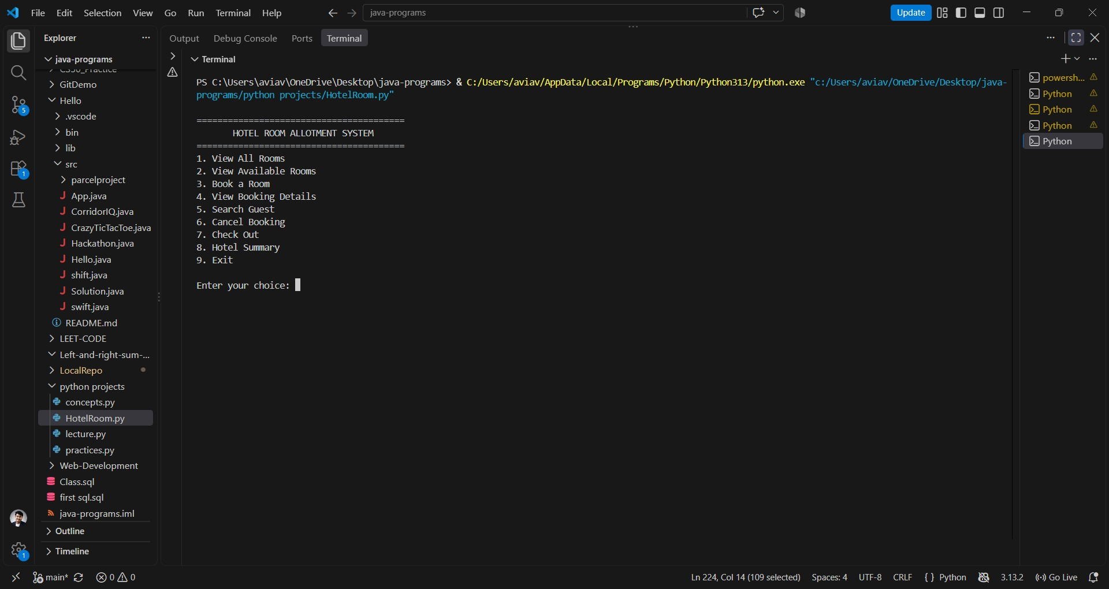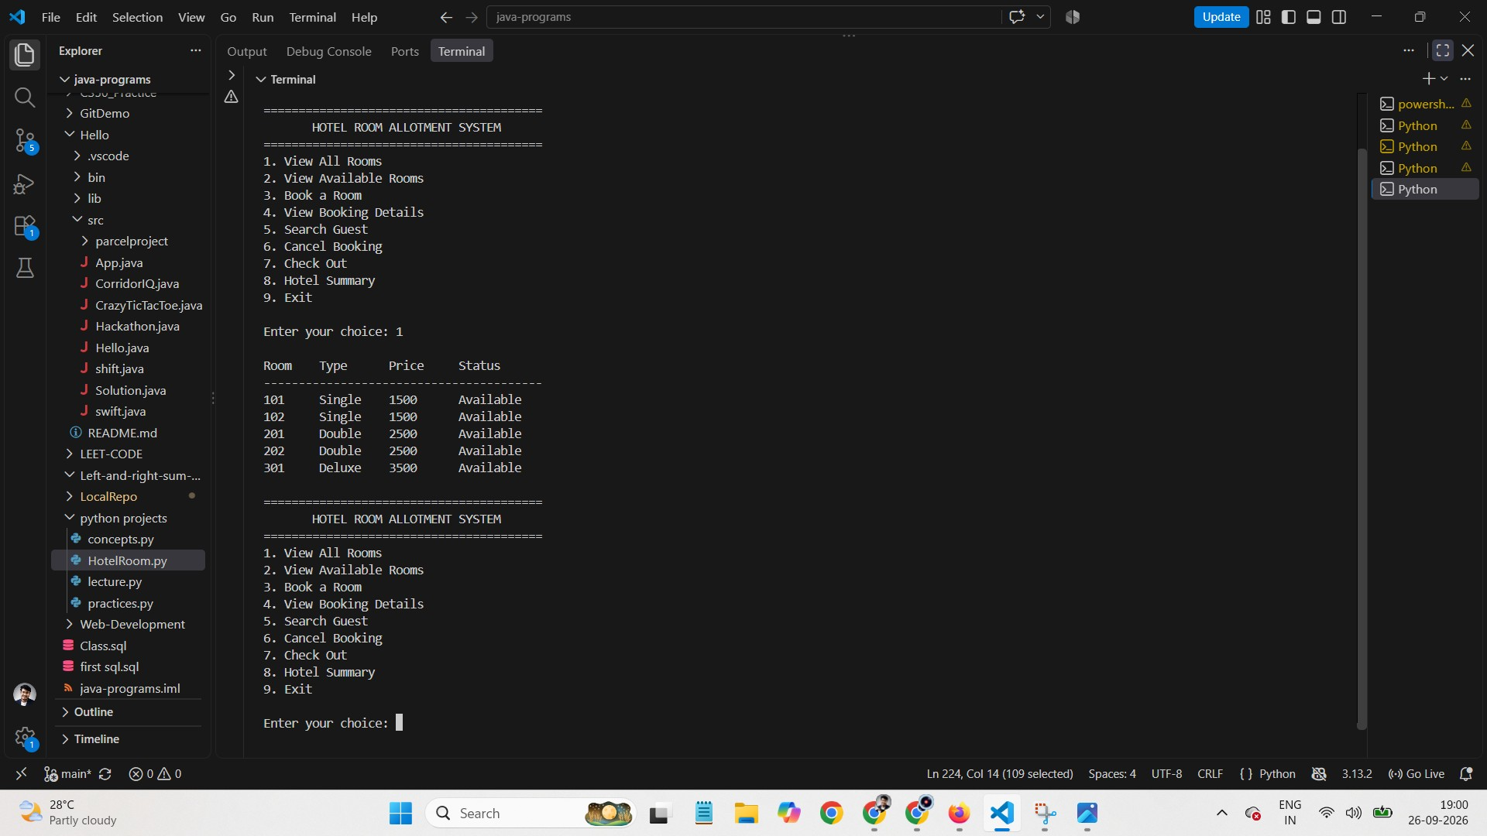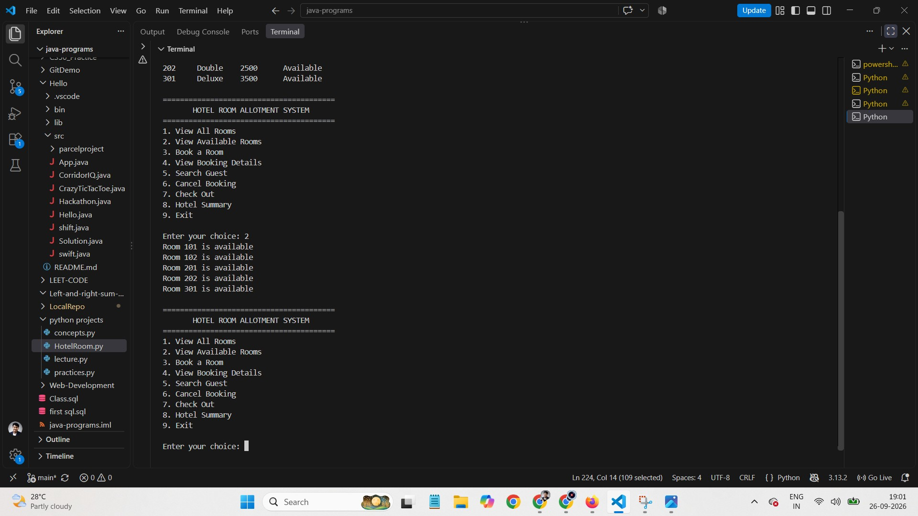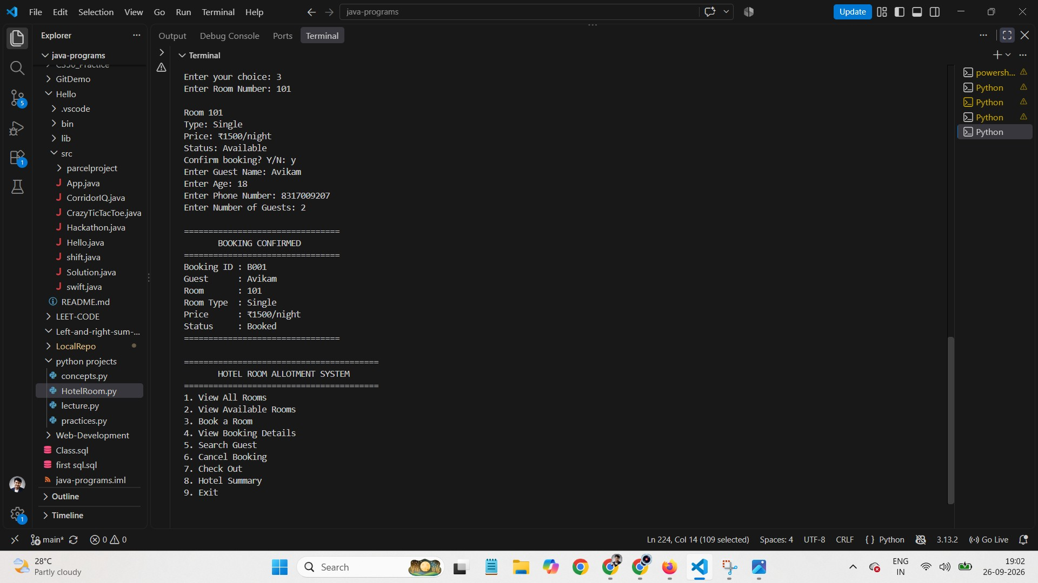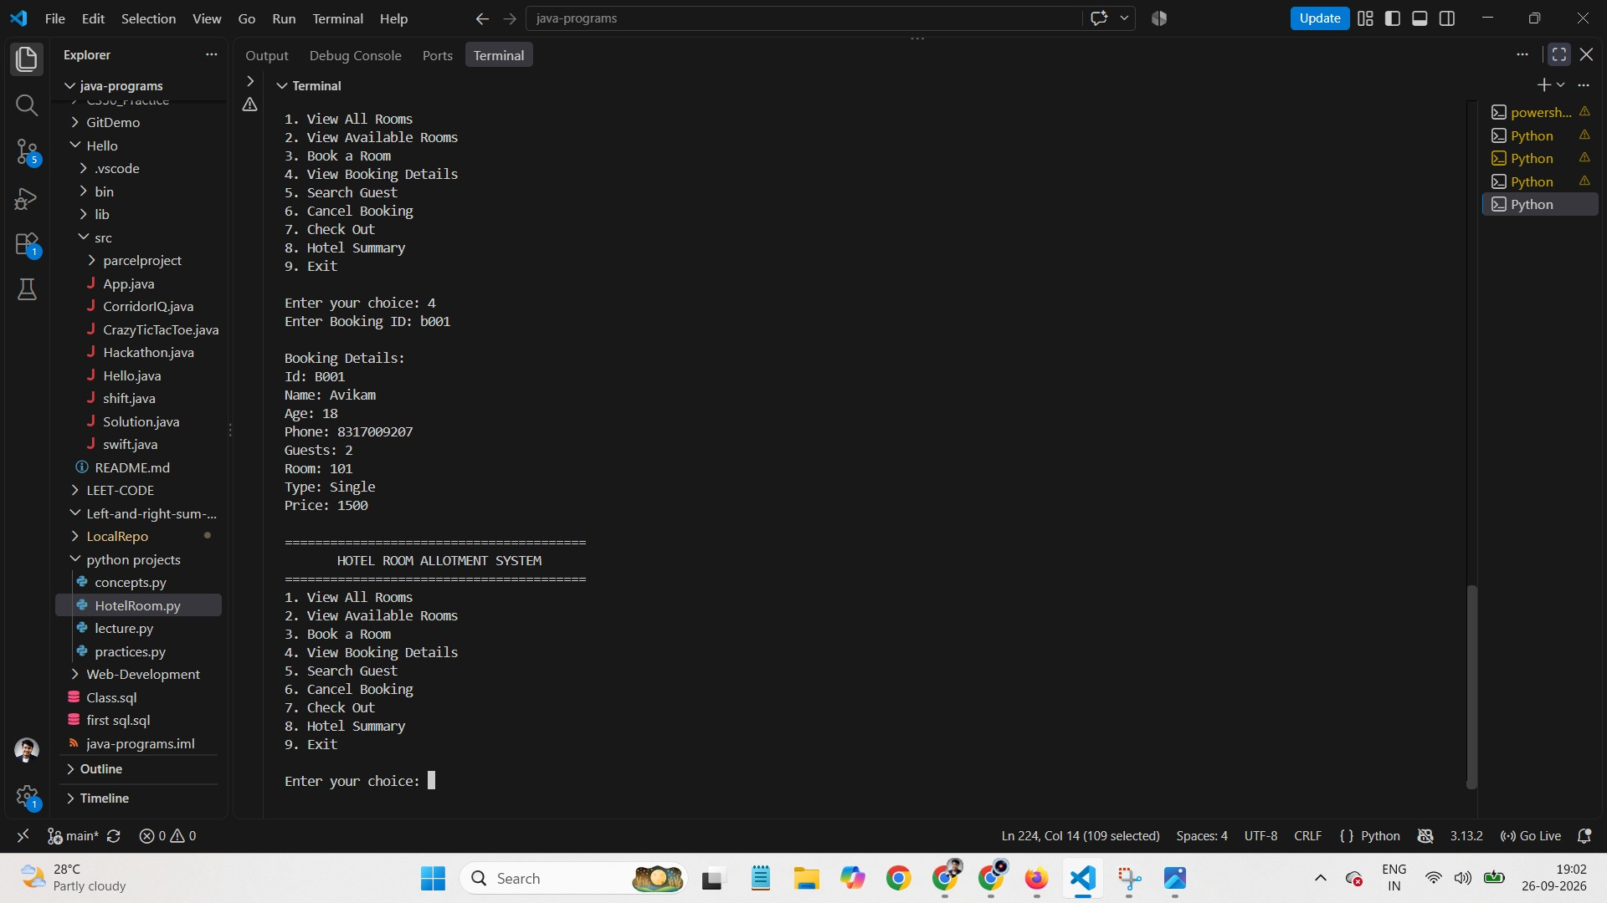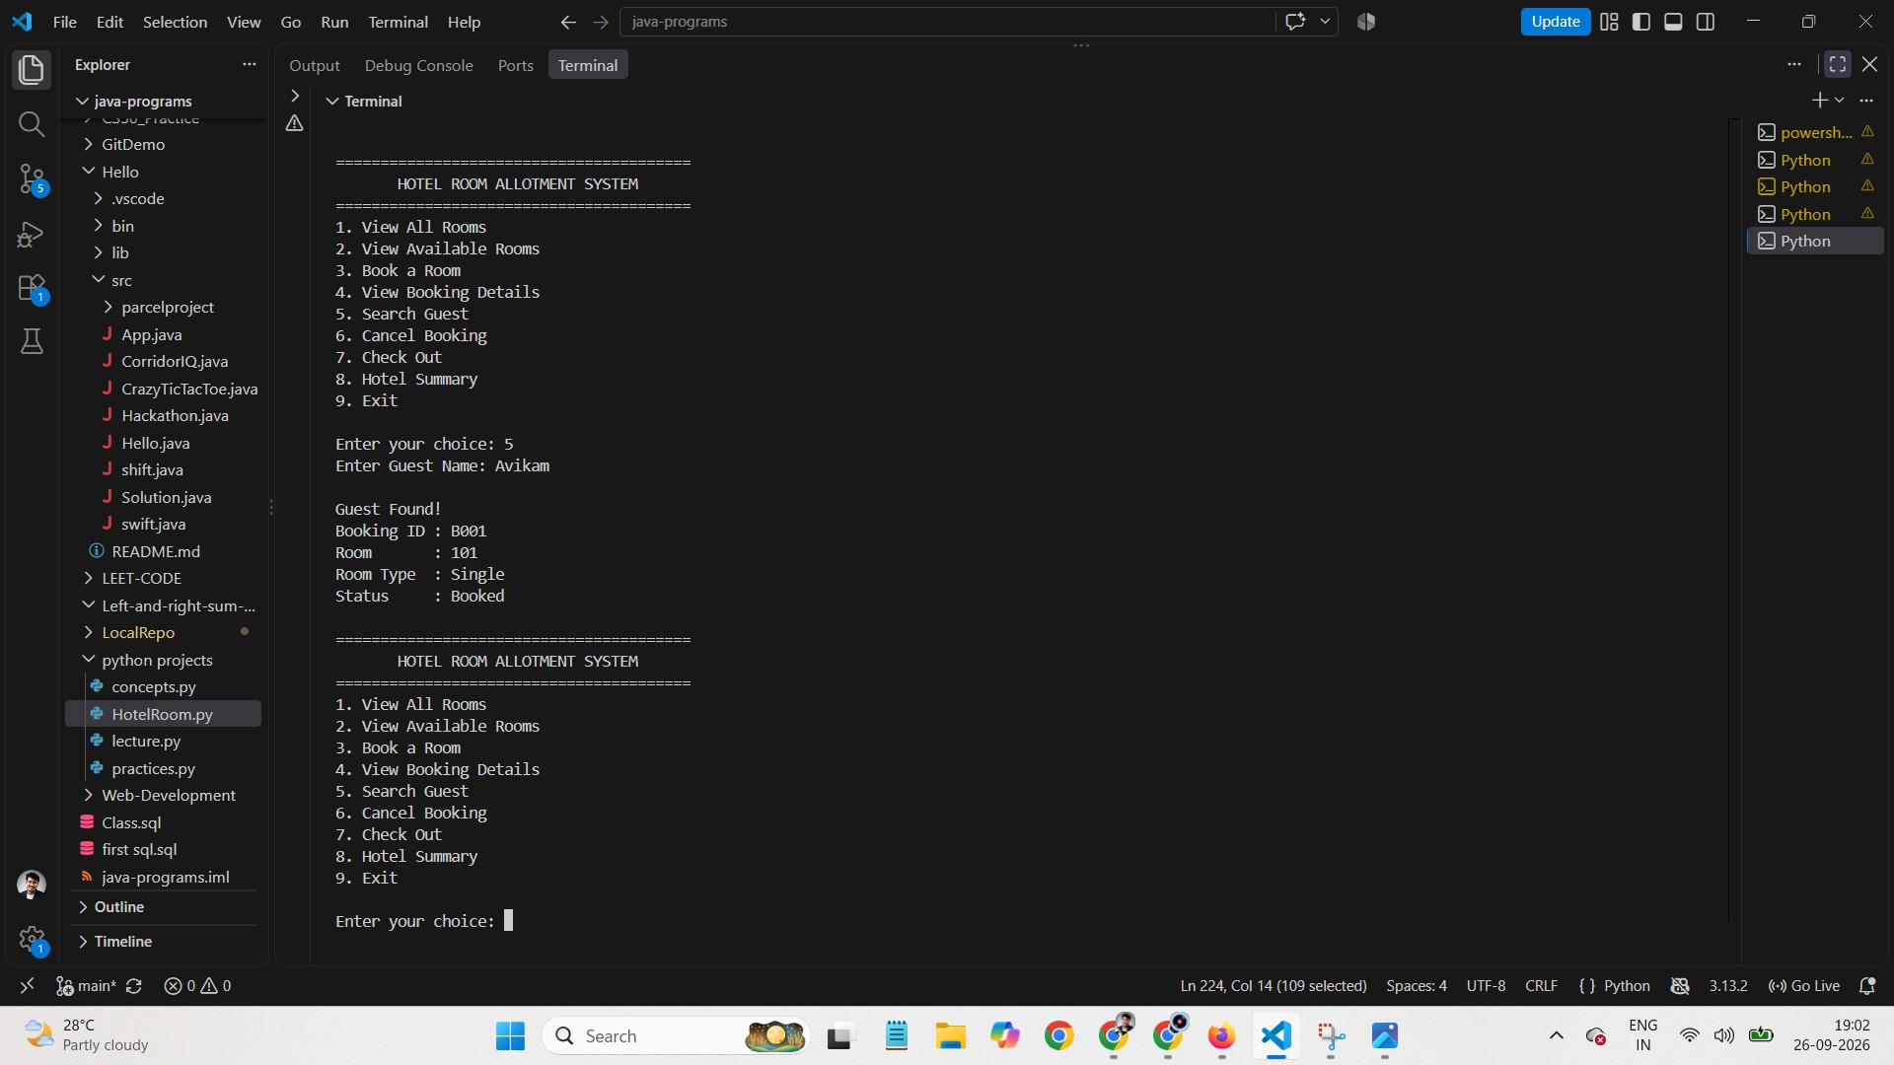
ADD YOUR OWN SCREENSHOTS
Run
python3 hotel.py
in your terminal and capture screenshots of:
The main menu
A successful booking (option 3)
An attempt to book an already-occupied room (showing the error message)
A search or booking-details lookup (option 4 or 5)
A checkout with the calculated bill (option 7)
The hotel summary (option 8)
Paste each screenshot below its corresponding heading before final submission.
•
•
•
•
•
•

14. Future Enhancements

Possible directions to extend this project beyond first-semester scope:
- Persist data between runs using a file (JSON/CSV) or a database (SQLite)
- Add a graphical interface (Tkinter) instead of a command-line menu
- Support multiple hotels or branches
- Add date-based bookings using Python's datetime module instead of a manual "number of nights" entry
- Add authentication for different staff roles (admin vs. front-desk)

15. References

- Python Software Foundation, The Python Standard Library — https://docs.python.org/ 3/library/
- Python Software Foundation, Python Tutorial — Data Structures — https:// docs.python.org/3/tutorial/datastructures.html
]
11

